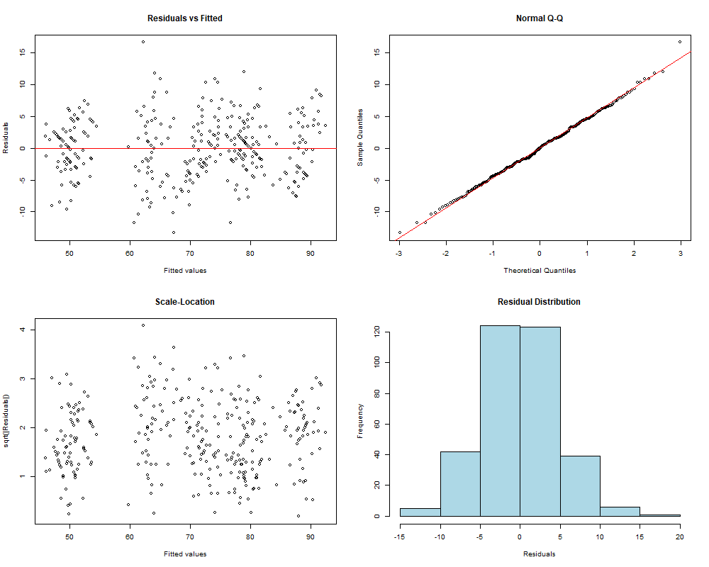
Figure S1. Diagnostic tests for mHHS model. The residuals followed a normal distribution, and there was no significant autocorrelation.

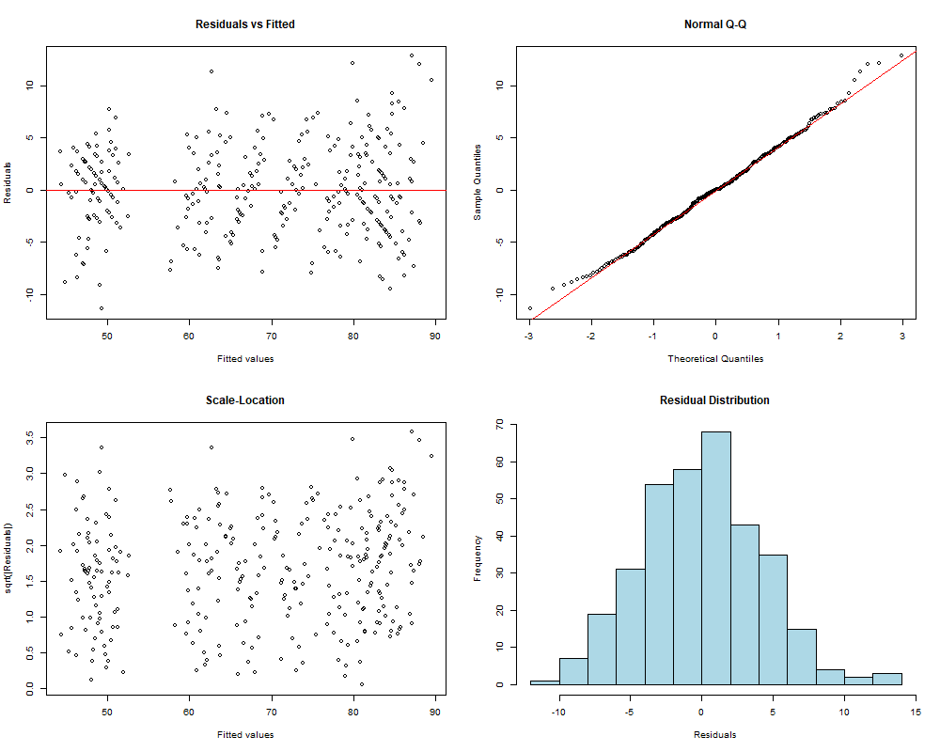
Figure S2. Diagnostic tests for NAHS model. The residuals followed a normal distribution, and there was no significant autocorrelation.

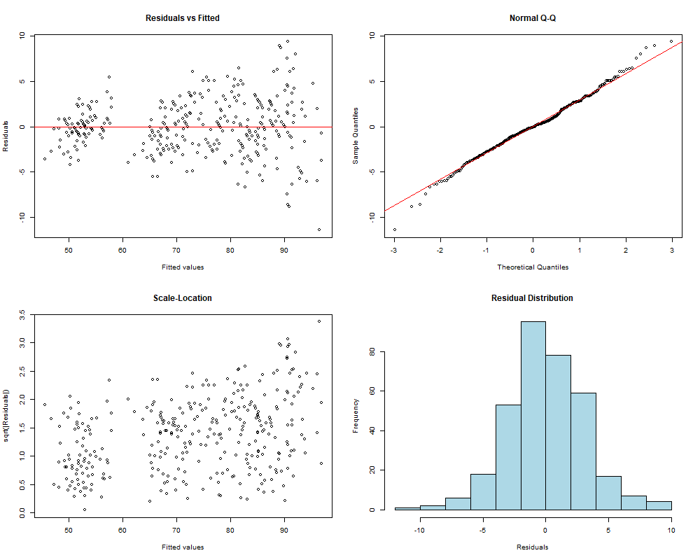
Figure S3. Diagnostic tests for HOS_ADL model. The residuals followed a normal distribution, and there was no significant autocorrelation.

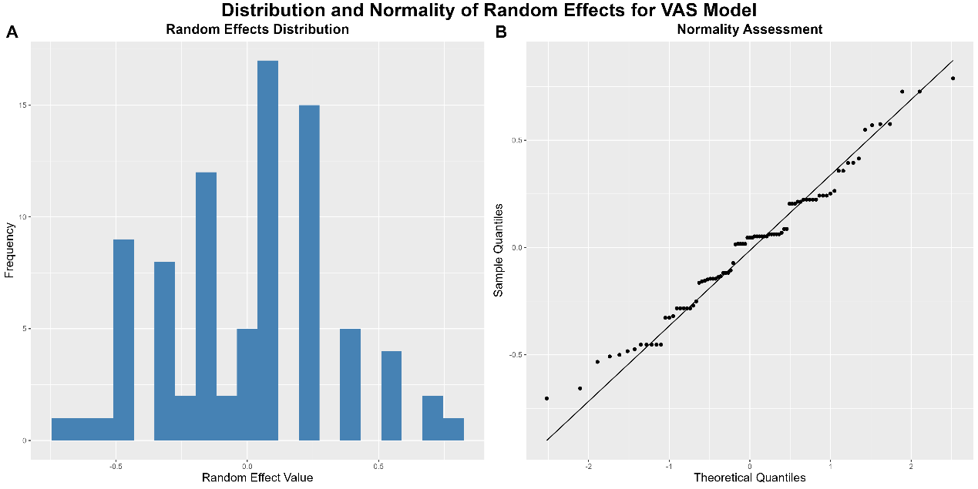
Figure S4. Distribution and normality for random effects for VAS model. The individual intercepts are approximately normally distributed.

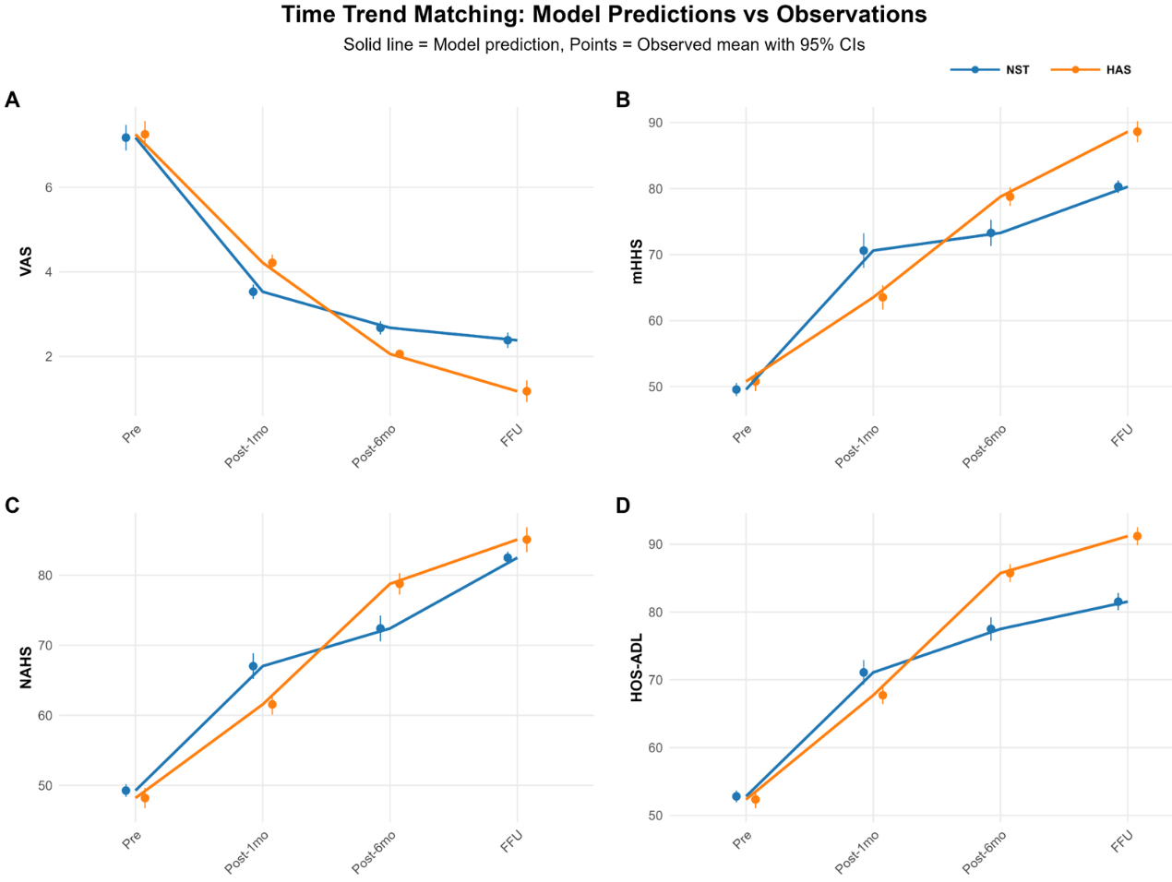
Figure S5. Time trend matching of the model predications and observations for VAS (A), Mhhs (B), NAHS (C), and HOS_ADL (D). There are good time trend matching between model predications and observations for these four outcomes.

Table S1 Sensitivity analysis of mixed models.
Outcome | Main_Effect | Complete_Case | GEE_Result | Bootstrap_CI | Robust
VAS | -0.22 (-0.41 to -0.02) | -0.22 (Δ0.0%) | -0.22 (SE=0.09) | [-0.39, -0.06] | ✓
mHHS | 1.99 (0.45 to 3.53) | 1.99 (Δ0.0%) | 1.99 (SE=0.79) | [0.73, 3.28] | ✓
NAHS | 0.61 (-0.85 to 2.07) | 0.61 (Δ0.0%) | 0.61 (SE=0.71) | [-0.35, 1.71] | ✓
HOS-ADL | 3.52 (1.99 to 5.06) | 3.52 (Δ0.0%) | 3.52 (SE=0.77) | [2.40, 4.46] | ✓

