Supplementary Table 1. DeLong Test
 | p-value
RF vs SVM | <0.01
RF vs GBM | <0.01
RF vs C5.0 | <0.01
RF vs GP | 0.89
RF vs KNN | <0.01
RF vs LR | <0.01
RF vs MLP | <0.01
RF vs NB | <0.01
RF vs NN | <0.01
RF vs XGB | <0.01
SVM vs GBM | 0.27
SVM vs C5.0 | <0.01
SVM vs GP | <0.01
SVM vs KNN | <0.01
SVM vs LR | <0.01
SVM vs MLP | <0.01
SVM vs NB | <0.01
SVM vs NN | <0.01
SVM vs XGB | <0.01
GBM vs C5.0 | <0.01
GBM vs GP | <0.01
GBM vs KNN | <0.01
GBM vs LR | <0.01
GBM vs MLP | <0.01
GBM vs NB | <0.01
GBM vs NN | <0.01
GBM vs XGB | <0.01
C5.0 vs GP | <0.01
C5.0 vs KNN | <0.01
C5.0 vs LR | <0.01
C5.0 vs MLP | <0.01
C5.0 vs NB | <0.01
C5.0 vs NN | <0.01
C5.0 vs XGB | <0.01
GP vs KNN | <0.01
GP vs LR | <0.01
GP vs MLP | <0.01
GP vs NB | <0.01
GP vs NN | <0.01
GP vs XGB | <0.01
KNN vs LR | 0.09
KNN vs MLP | 0.67
KNN vs NB | <0.01
KNN vs NN | <0.01
KNN vs XGB | <0.01
LR vs MLP | 0.2
LR vs NB | <0.01
LR vs NN | <0.01
LR vs XGB | <0.01
MLP vs NB | <0.01
MLP vs NN | <0.01
MLP vs XG | <0.01
NB vs NN | <0.01
NB vs XGB | <0.01
NN vs XGB | <0.01

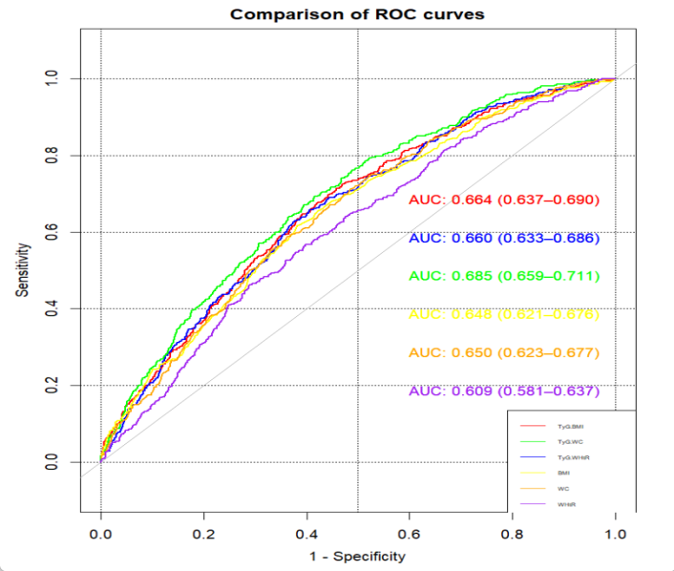
Supplementary Figure 1.Comparison of receiver operating characteristic (ROC) curves for predicting the first cholecystectomy based on TyG-derived and traditional obesity indices.Axes: The X-axis represents 1 – Specificity (false positive rate), and the Y-axis represents Sensitivity (true positive rate). ROC curves illustrate the predictive performance of the TyG index–derived composite indices and conventional anthropometric measures in assessing the risk of first cholecystectomy. TyG.BMI, triglyceride–glucose index × body mass index; TyG.WC, triglyceride–glucose index × waist circumference; TyG.WHtR, triglyceride–glucose index × waist-to-height ratio; BMI, body mass index; WC, waist circumference; WHtR, waist-to-height ratio.

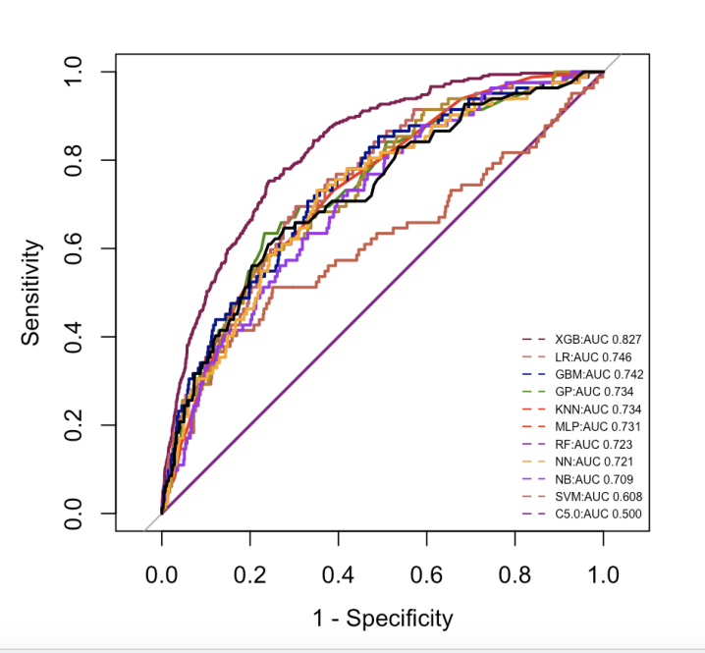
Supplementary Figure 2. ROC curves for model comparison in predicting the first cholecystectomy. ROC curves are presented for 11 different machine learning models, comparing their performance in predicting the risk of first cholecystectomy. The AUC (Area Under the Curve) for each model is indicated in the legend. The X-axis represents 1 – Specificity (false positive rate), and the Y-axis represents Sensitivity(true positive rate).

