Supplementary Material
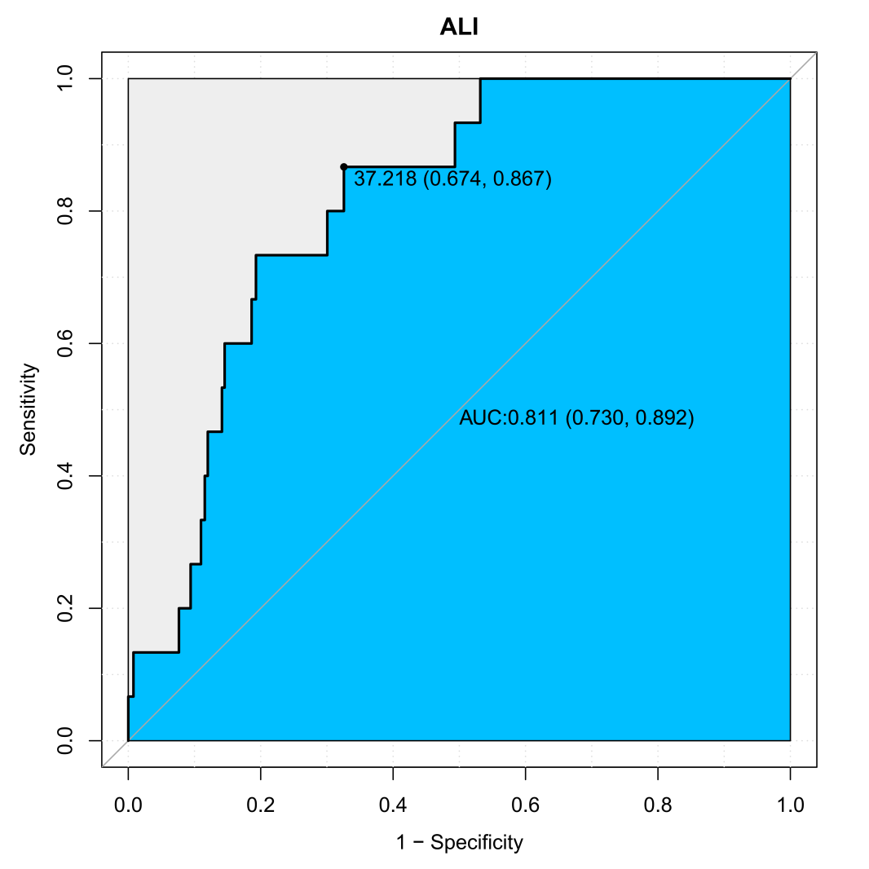
Figure S1 ROC Curve for ALI in Predicting 90-Day Mortality

Table S1 ROC curve analysis of ALI, PLR, NLR，Albumin
index | AUC | 95% CI | sensitivity | specificity | cutoff value
ALI | 0.81 | 0.73-0.89 | 86.7 | 67.4 | 37.22
PLR | 0.77 | 0.67-0.87 | 60.0 | 85.8 | 15.28
NLR | 0.76 | 0.76-0.86 | 73.3 | 75.7 | 3.04
Albumin | 0.78 | 0.64-0.91 | 73.3 | 75.4 | 3.95
ALI: The Advanced Lung Cancer Inflammation Index; PLR: platelet-to-lymphocyte ratio; NLR: neutrophil-to-lymphocyte ratio

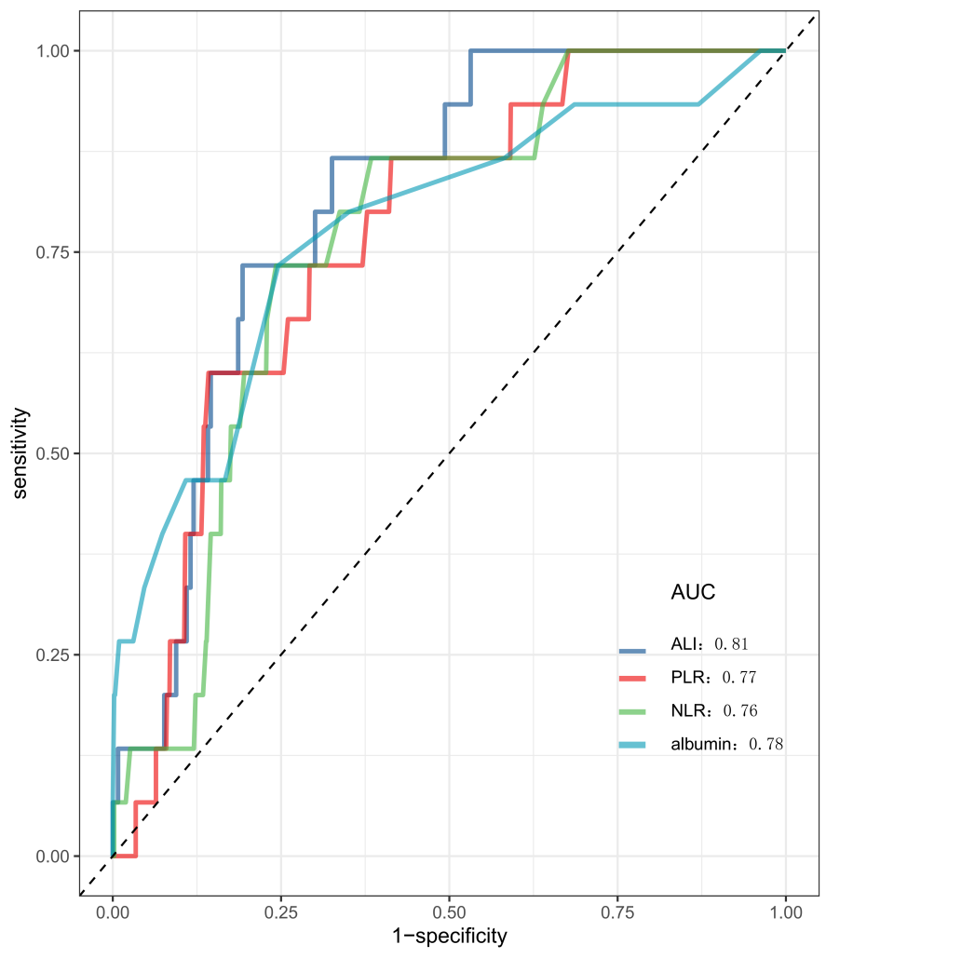
Figure S2 ROC Curves for ALI 、PLR、NLR andalbumin in Predicting 90-Day Mortality.The area under the curve (AUC) values for each biomarker are displayed. ALI, Advanced Lung Cancer Inflammation Index; PLR, platelet-to-lymphocyte ratio; NLR, neutrophil-to-lymphocyte ratio.

Table S2 Sensitivity analysis after removing patients with Emergency surgery
Variable | Model I |  | Model II |  | Model III
Variable | HR (95% CI) | p | HR (95% CI) | p | HR (95% CI) | p
Primary outcomes
90-day mortality
ALI | 0.95 (0.93~0.98) | <0.001 | 0.95 (0.92~0.99) | 0.004 | 0.97 (0.94~1) | 0.034
<37.22 | Ref |  | Ref |  | Ref
≥37.22 | 0.09 (0.02,0.4) | <0.001 | 0.12 (0.03~0.54) | 0.006 | 0.22 (0.05~0.99) | 0.048
Secondary outcomes
180-day mortality
ALI | 0.96 (0.94~0.98) | <0.001 | 0.96 (0.94~0.98) | <0.001 | 0.97(0.95~0.99) | 0.003
<37.22 | Ref |  | Ref |  | Ref
≥37.22 | 0.16 (0.07~0.36) | <0.001 | 0.24 (0.11~0.55) | 0.001 | 0.34 (0.14~0.81) | 0.015
365-day mortality
ALI | 0.98 (0.97~0.99) | <0.001 | 0.99(0.98~1) | 0.003 | 0.99(0.98~1) | 0.166
<37.22 | Ref |  | Ref |  | Ref
≥37.22 | 0.38 (0.25~0.58) | <0.001 | 0.52 (0.34~0.81) | 0.003 | 0.71 (0.44~1.14) | 0.161
In-hospital mortalityª
ALI | 0.96 (0.94~0.98) | <0.001 | 0.96 (0.94~0.99) | 0.002 | 0.97 (0.95~1) | 0.03
<37.22 | Ref |  | Ref |  | Ref
≥37.22 | 0.19 (0.07~0.5) | <0.001 | 0.27 (0.1~0.71) | 0.008 | 0.4 (0.14~1.18) | 0.097
Model I: non-adjusted.
Model II: adjusted for age, sex, ASA classification, Operative programme.
Model III adjusted for model II plus HGB, WBC, PLT, HCT, CRP, Scr, Sodium, Glucose, Lactate.
ªLogistic regression was used to evaluate the association between ALI and in-hospital mortality. The results were expressed as odds ratio (95% CIs). HR, hazard ratio; CI, confidence interval; HGB, hemoglobin; WBC, white blood cell; PLT, platelet; HCT, hematocrit; CRP, C-Reactive Protein; Scr, serum creatinine

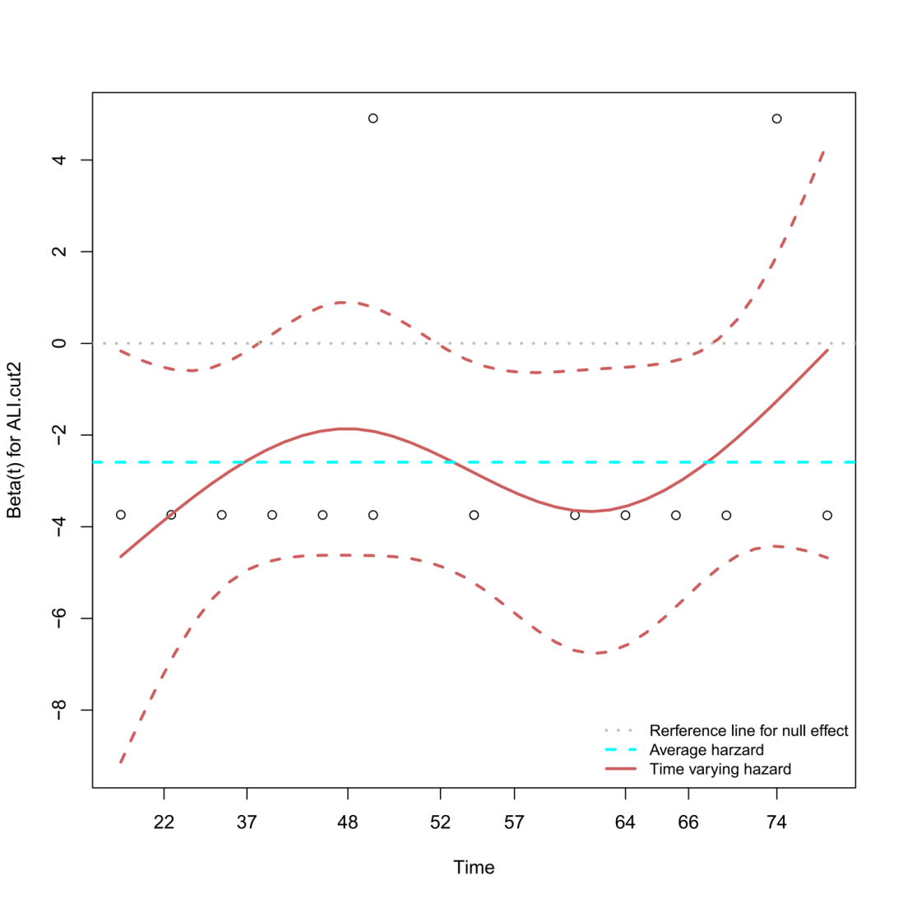
Figure S3. Schoenfeld residuals plot for ALI.
Assessment of the proportional hazards assumption for the Advanced Lung Cancer Inflammation Index (ALI) using Schoenfeld residuals. The plot displays the scaled Schoenfeld residuals (beta) for the ALI variable over time. A horizontal reference line at zero indicates the null effect. The solid red line represents the smoothed average hazard, while the dashed red lines indicate its confidence band. The relatively flat and horizontal trajectory of the smoothed line, with residuals evenly distributed around zero, suggests no systematic change in the hazard ratio over time. This visual assessment is supported by the non-significant global test result (χ² = 0.55, df = 1, p = 0.458), confirming that the proportional hazards assumption was not violated for ALI.

Table S3 The proportional hazards assumption
Variable | chisq | df | p.value
ALI | 0.55 | 1 | 0.458
GLOBAL | 0.55 | 1 | 0.458

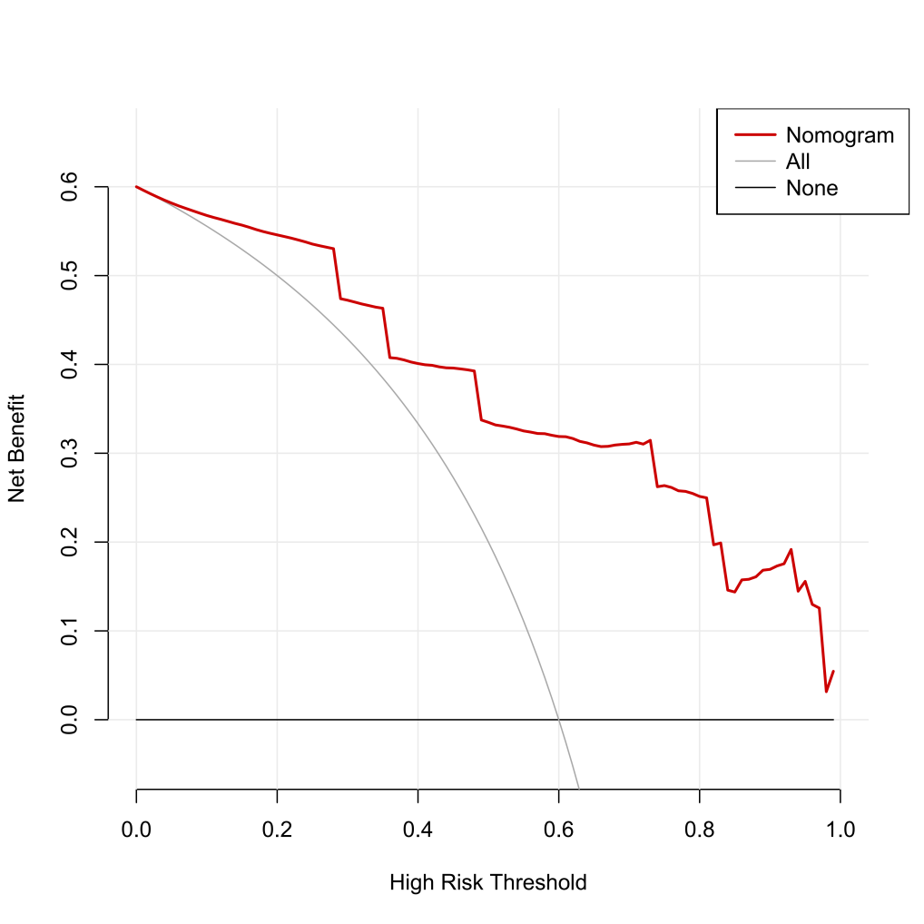

Figure S4. Decision Curve Analysis(DCA) foe the ALI model

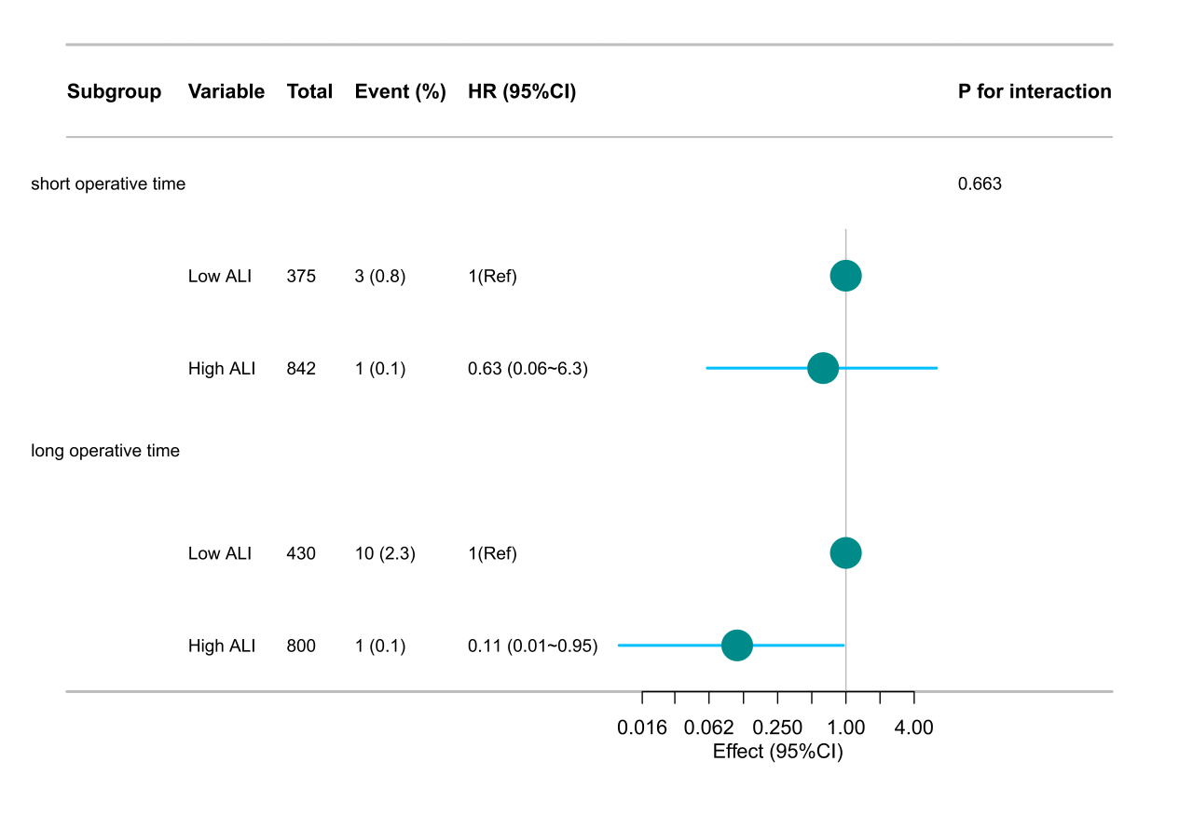
Figure S5. Forest plot of subgroup analysis for the associatio
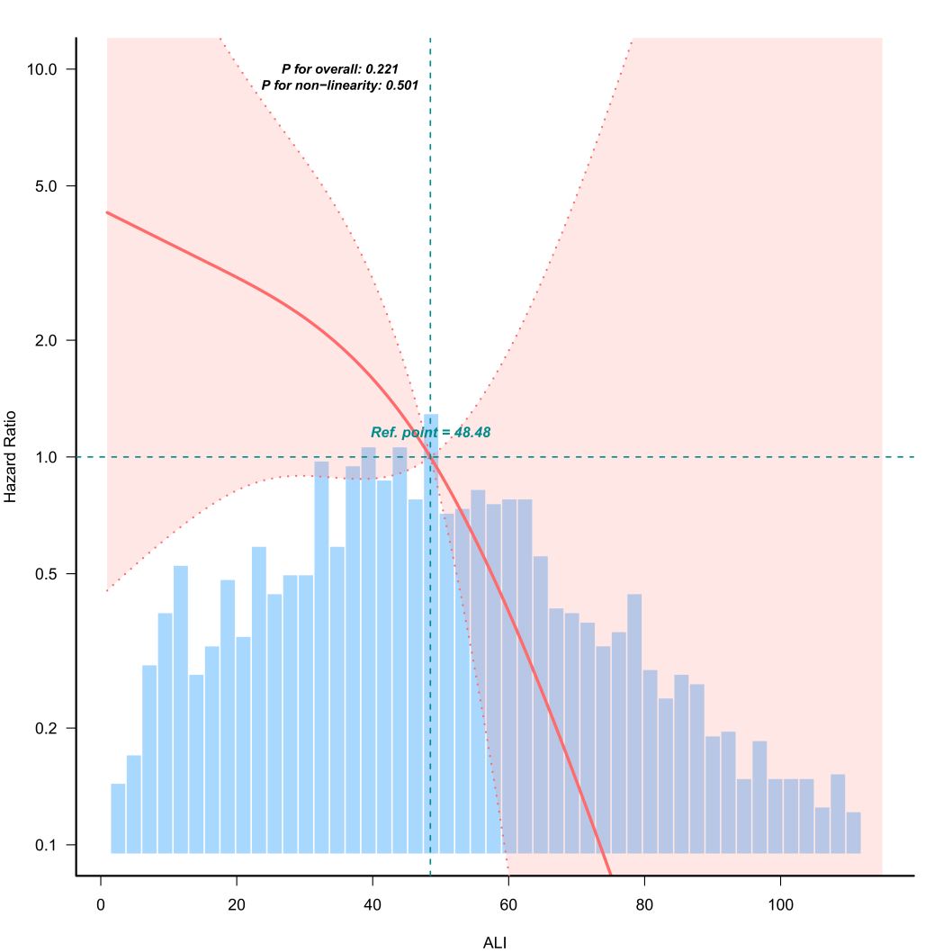

Figure S6
Curve fitting of ALI and 180-day mortality in patients following lung cancer resection.

