Supplementary materials for Title: Nonlinear Associations between Serum Vitamin Mixtures and Cardiovascular Disease Risk: Insights from a National Cross-Sectional Analysis
Short Title: Vitamin Mixtures and Cardiovascular Disease Risk

Authors: Menglin Tian, MD^{1a}, Jilei Zhang, MD^{1 a},Chaoliang Nian, MD^{2 a}, MengTing Wei, MD³, Wenzhang Kuang, MD⁴, Wenyin Du, MD¹, Sen Yang, MD¹, Xiaohua Zhao, MD¹, Qiwei Liao, MD¹, Qiang Xue, MD¹*, Fuding Guo, MD, PhD¹*

Affiliation:
¹ Key Laboratory of Cardiovascular Disease of Yunnan Province, Kun Ming, Yunnan, China, Department of Cardiology, Yan’an Hospital Affiliated to Kunming Medical University, China , Department of Cardiology, Yan’an Hospital of Kunming City, Kunming, China, Kunming Cardiovascular Interventional Imaging Institute, Kunming 650000, PR China.
²Department of Cardiovascular Surgery, Yan’an Affiliated Hospital of Kunming Medical University, Kunming, Yunnan, China
³The Second Hospital of Baoshan, 266 Baita Road, Longyang District, Baoshan City 678000, Yunnan,China
⁴Department of General Practice, Yan'an Hospital Affiliated to Kunming Medical University, Kunming, Yunnan, China
ªThese authors contributed equally to this work.

*Correspondence:
Qiang Xue, MD, PhD
Department of Cardiology, Yan’an Hospital Affiliated to Kunming Medical University, No. 245, E Renmin Rd, Kunming 650051, Yunnan, P.R. China
E-mail: xueqiang3513@126.com

Fuding Guo, MD, PhD
Department of Cardiology, Yan’an Hospital Affiliated to Kunming Medical University, No. 245, E Renmin Rd, Kunming 650051, Yunnan, P.R. China
E-mail: whuguofuding@163.com

Table S1. Multivariable Logistic Regression Analysis of the Association Between Serum Vitamin Levels and Cardiovascular Disease
Vitamins | Continuous | Q1 | Q2 | Q3 | Q4 | P.adj.  FDR | p for  trend*
 | OR (95%  CI) |  | OR (95%  CI) | OR (95%  CI) | OR (95%  CI)
Vitamin A
Model 1 | 5.22 (3.50, 7.84） | 1.00  (reference) | 2.05 (1.40, 3.05) | 1.71 (1.16, 2.57) | 3.49 (2.45, 5.08) | < 0.001 | < 0.001
Model 3 | 2.03 (1.32, 3.19） | 1.00  (reference) | 1.67 (1.09, 2.58) | 1.06 (0.68, 1.66) | 1.69 (1.12, 2.59) | 0.006 | 0.077
Vitamin C
Model 1 | 0.77 (0.67, 0.90) | 1.00  (reference) | 0.64 (0.47, 0.88) | 0.62 (0.44, 0.86) | 0.75 (0.55, 1.02) | 0.004 | 0.063
Model 3 | 0.71 (0.60, 0.84) | 1.00  (reference) | 0.71 (0.49, 1.02) | 0.62 (0.43, 0.90) | 0.48 (0.33, 0.70) | 0.001 | < 0.001
Vitamin E
Model 1 | 1.34 (0.98, 1.83) | 1.00  (reference) | 1.05 (0.75, 1.48) | 1.01 (0.71, 1.42) | 1.40 (1.02, 1.94) | 0.104 | 0.049
Model 3 | 0.59 (0.40, 0.85) | 1.00  (reference) | 0.93 (0.63, 1.37) | 0.66 (0.44, 0.98) | 0.63 (0.42, 0.93) | 0.015 | 0.022
Vitamin D
Model 1 | 0.53 (0.39, 0.71) | 1.00  (reference) | 0.77 (0.57, 1.03) | 0.57 (0.41, 0.78) | 0.56 (0.40, 0.78) | < 0.001 | < 0.001
Model 3 | 0.48 (0.32, 0.71) | 1.00  (reference) | 0.68 (0.48, 0.96) | 0.45 (0.30, 0.66) | 0.56 (0.37, 0.84) | 0.001 | 0.002
Vitamin B12
Model 1 | 1.04 (0.84, 1.29) | 1.00  (reference) | 0.89 (0.64, 1.23) | 0.84 (0.60, 1.17) | 1.02 (0.74, 1.40) | 0.841 | 0.797
Model 3 | 0.97 (0.77, 1.23) | 1.00  (reference) | 0.90 (0.62, 1.30) | 0.83 (0.57, 1.20) | 0.85 (0.59, 1.22) | 0.880 | 0.469
Vitamin B6
Model 1 | 1.39 (1.26, 1.52) | 1.00  (reference) | 1.08 (0.74, 1.59) | 1.74 (1.23, 2.47) | 2.39 (1.72, 3.37) | < 0.001 | < 0.001
Model 3 | 1.12(0.99, 1.25) | 1.00  (reference) | 0.80 (0.52, 1.22) | 0.96 (0.64, 1.45) | 0.97 (0.65, 1.47) | 0.106 | 0.742
Note: Model 1: unadjusted; Model 2: adjusted for sex, age, BMI, race, educational level, marital status, poverty income ratio (PIR), alcohol consumption and smoking status. P.adj.: P.adj values represent P-values adjusted for multiple comparisons using the Benjamini–Hochberg method to control the false discovery rate (FDR). A threshold of P.adj. < 0.05 was considered statistically significant; *P values for trend analyses were corrected for multiple comparisons using the Benjamini–Hochberg procedure.

Table S2. Convergence diagnostics for BKMR inclusion indicators (δ): R-hat and effective sample size (ESS)
Label | R-hat | R-hat (97.5% UCI) | ESS
Vitamin A | 1.02 | 1.03 | 8672
Vitamin C | 1.03 | 1.04 | 5454
Vitamin E | 1.03 | 1.03 | 9630
Vitamin D | 1.01 | 1.02 | 9850
Vitamin B12 | 1.02 | 1.02 | 13725
Vitamin B6 | 1.03 | 1.04 | 6697
Notes: Univariate Gelman–Rubin statistics (R-hat) with 97.5% upper confidence limits (UCI) are reported across multiple MCMC chains, along with effective sample sizes (ESS) computed via coda. Abbreviations: BKMR, Bayesian Kernel Machine Regression; ESS, effective sample size.

Figure S1. MCMC trace plots for BKMR inclusion indicators (δ) of vitamin terms.
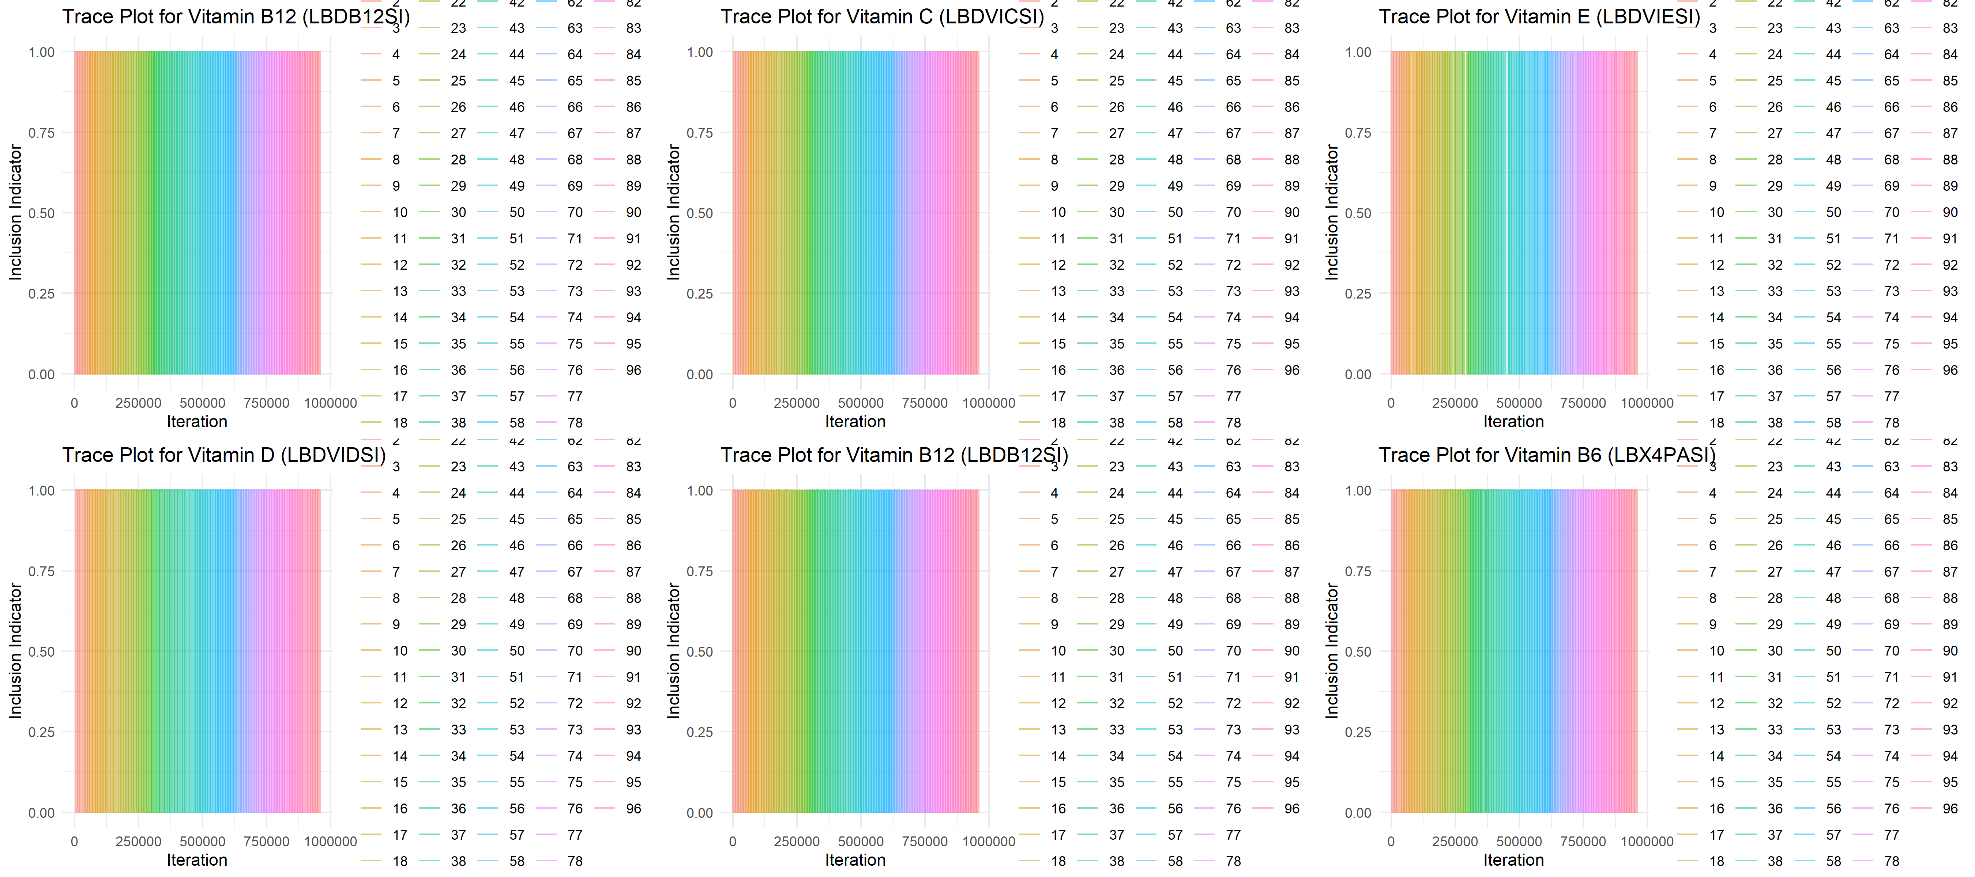
Notes: Colors denote different chains; traces exhibit good mixing and no apparent trends, supporting convergence.

Figure S2. Variance Inflation Factor (VIF) analysis for covariates in the multivariable logistic regression model.
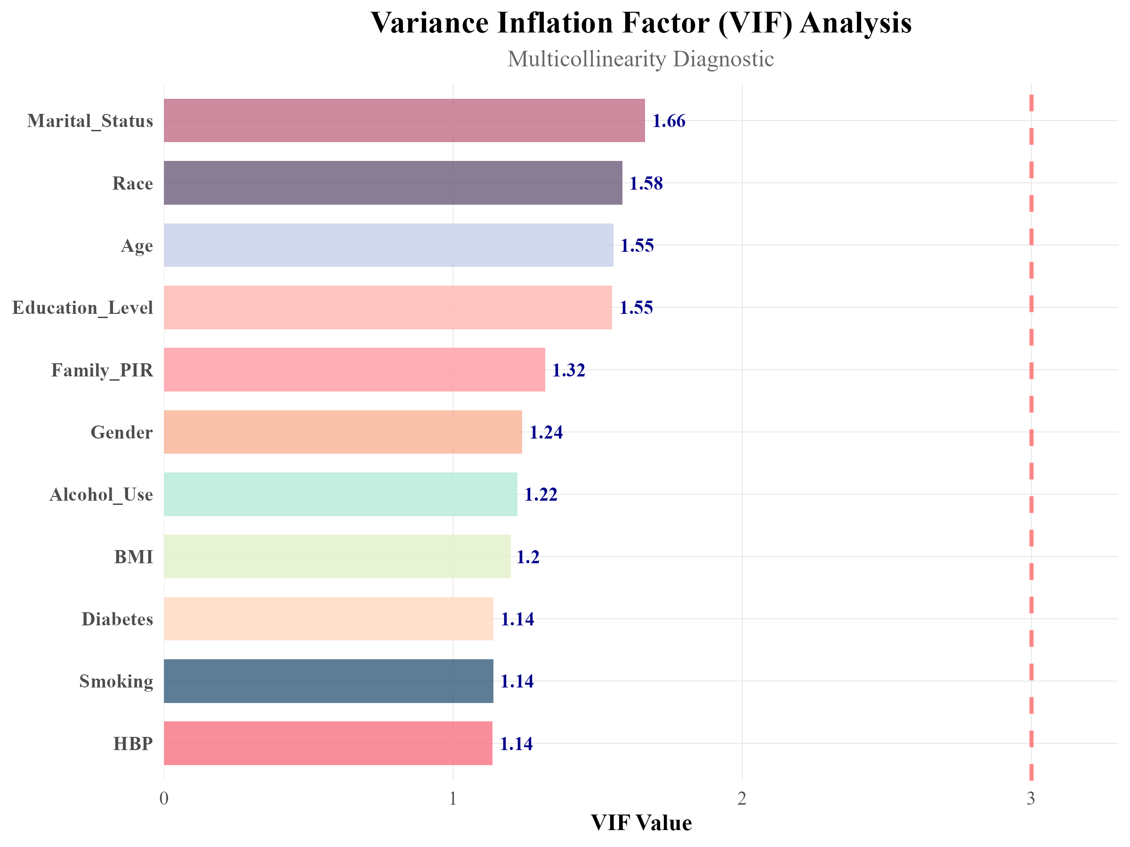
Notes: This figure presents the VIF values for each covariate used in the multivariable logistic regression to evaluate multicollinearity. All VIFs were well below the conventional threshold of 3 (dashed red line), indicating no serious multicollinearity concerns. Each bar is labeled with its corresponding VIF value, and colors are used to distinguish variables. Abbreviations: BMI: Body Mass Index; PIR: Poverty–Income Ratio; HBP: High Blood Pressure.

