Alterations in gut microbiome and fecal metabolome in functional dyspepsia patients: insights into pathophysiological mechanisms
Honghua Zhou¹ ², Ronghua Lu ¹, You Lv ¹, Yanbing Ding ^{1 *}
¹ Department of Gastroenterology, The Affiliated Hospital of Yangzhou University, Yangzhou University, Yangzhou 225000, Jiangsu, China.
² Department of Gastroenterology, People's Hospital of Tianchang, Chuzhou 239000, Anhui, China.
* Corresponding author: Yanbing Ding：ybding@yzu.edu.cn

Table S1 The detailed information on the baseline characteristics of all subjects.
Table S2 The gut microbiota α-diversity indices between two groups.
Fig S1 Annotated cladogram of differential species displaying statistically significant taxa between the two groups.
Fig S2 Visualization of STAMP differential analysis results: based on KEGG Level 1 database.
Fig S3 Visualization of STAMP differential analysis results: based on KEGG Level 3 database.
Fig S4 The volcano plot showed the differentially expressed metabolites between the two groups.
Fig S5 ROC plots of the top 5 differential metabolites with the smallest P-values.
Fig S6 Bubble plot of the 20 pathways with the lowest p-values.
Fig S7 Network diagram of the correlation between differential phylum–level microbiota and differential metabolites (Spearman’s correlation analysis, | rho | > 0.50 and P < 0.05).
Fig S8 Network diagram of the correlation between differential family – level microbiota and differential metabolites (Spearman’s correlation analysis, | rho | > 0.50 and P < 0.05).

Table S1 The detailed information on the baseline characteristics of all subjects.
Group | Age | Sex | Hight | Weight | BMI | Education level | Place of residence | Cigarette smoking | Alcohol drinking | Symptom duration | Type of FD
1 | 25 | 1 | 1.74 | 85 | 28.08 | 1 | 2 | 1 | 1 | 1 | 1
1 | 38 | 1 | 1.68 | 72 | 25.51 | 2 | 1 | 2 | 2 | 2 | 1
1 | 45 | 2 | 1.58 | 58 | 23.23 | 1 | 2 | 1 | 1 | 1 | 1
1 | 68 | 1 | 1.82 | 88 | 26.57 | 1 | 2 | 1 | 1 | 2 | 3
1 | 41 | 2 | 1.77 | 75 | 23.94 | 2 | 1 | 2 | 1 | 2 | 3
1 | 70 | 2 | 1.66 | 55 | 19.96 | 2 | 1 | 2 | 2 | 1 | 1
1 | 22 | 1 | 1.74 | 74 | 24.44 | 1 | 2 | 1 | 1 | 2 | 2
1 | 53 | 2 | 1.70 | 62 | 21.45 | 1 | 1 | 1 | 1 | 1 | 1
1 | 49 | 2 | 1.6 | 53 | 20.70 | 2 | 1 | 2 | 2 | 2 | 1
1 | 54 | 1 | 1.79 | 90 | 28.09 | 2 | 1 | 2 | 2 | 2 | 3
1 | 47 | 2 | 1.72 | 69 | 23.32 | 1 | 2 | 2 | 1 | 2 | 2
1 | 31 | 2 | 1.69 | 66 | 23.11 | 1 | 1 | 2 | 2 | 2 | 1
1 | 61 | 2 | 1.65 | 72 | 26.44 | 2 | 1 | 2 | 2 | 2 | 3
1 | 66 | 1 | 1.67 | 75 | 26.89 | 2 | 1 | 2 | 2 | 2 | 1
1 | 50 | 2 | 1.75 | 69 | 22.53 | 1 | 2 | 1 | 1 | 2 | 3
1 | 54 | 1 | 1.83 | 93 | 27.78 | 1 | 1 | 2 | 2 | 2 | 1
1 | 47 | 2 | 1.60 | 61 | 23.83 | 2 | 1 | 2 | 2 | 2 | 1
1 | 35 | 1 | 1.65 | 72 | 26.45 | 2 | 2 | 2 | 2 | 2 | 1
1 | 44 | 2 | 1.76 | 88 | 28.41 | 2 | 1 | 2 | 2 | 2 | 1
1 | 37 | 2 | 1.58 | 51 | 20.43 | 1 | 1 | 1 | 1 | 1 | 3
1 | 55 | 2 | 1.79 | 85 | 26.53 | 2 | 1 | 2 | 1 | 2 | 1
1 | 50 | 2 | 1.66 | 64 | 23.23 | 1 | 2 | 2 | 2 | 2 | 1
1 | 57 | 1 | 1.84 | 90 | 26.58 | 2 | 1 | 1 | 1 | 2 | 1
1 | 64 | 2 | 1.65 | 68 | 24.98 | 1 | 1 | 1 | 2 | 2 | 3
1 | 43 | 2 | 1.62 | 64 | 24.39 | 2 | 2 | 2 | 2 | 2 | 1
1 | 63 | 1 | 1.65 | 65 | 23.88 | 2 | 1 | 2 | 2 | 2 | 1
1 | 51 | 1 | 1.77 | 70 | 22.34 | 2 | 1 | 1 | 1 | 2 | 1
1 | 47 | 2 | 1.73 | 74 | 24.72 | 1 | 2 | 1 | 1 | 2 | 1
1 | 60 | 2 | 1.72 | 70 | 23.66 | 1 | 1 | 2 | 2 | 2 | 3
1 | 57 | 1 | 1.66 | 64 | 23.23 | 2 | 2 | 2 | 2 | 1 | 3
2 | 28 | 2 | 1.64 | 55 | 20.45 | 2 | 1 | 2 | 2
2 | 32 | 2 | 1.68 | 68 | 24.09 | 1 | 1 | 1 | 2
2 | 46 | 1 | 1.60 | 66 | 25.78 | 2 | 1 | 2 | 1
2 | 68 | 1 | 1.84 | 89 | 26.29 | 2 | 1 | 2 | 1
2 | 57 | 2 | 1.76 | 85 | 27.44 | 1 | 2 | 1 | 2
2 | 42 | 2 | 1.74 | 86 | 28.41 | 2 | 1 | 2 | 1
2 | 66 | 1 | 1.68 | 62 | 21.97 | 2 | 1 | 2 | 2
2 | 38 | 2 | 1.66 | 60 | 21.77 | 1 | 1 | 1 | 2
2 | 40 | 2 | 1.75 | 77 | 25.14 | 1 | 2 | 2 | 2
2 | 42 | 1 | 1.78 | 79 | 24.93 | 2 | 1 | 2 | 2
2 | 58 | 2 | 1.7 | 69 | 23.88 | 1 | 2 | 2 | 2
2 | 44 | 2 | 1.69 | 80 | 28.01 | 2 | 1 | 2 | 1
2 | 60 | 1 | 1.83 | 84 | 25.08 | 1 | 2 | 2 | 2
2 | 45 | 1 | 1.8 | 90 | 27.78 | 1 | 2 | 1 | 2
2 | 50 | 2 | 1.73 | 78 | 26.06 | 2 | 1 | 1 | 1
2 | 22 | 2 | 1.77 | 69 | 22.02 | 2 | 2 | 2 | 2
2 | 36 | 1 | 1.79 | 84 | 26.22 | 2 | 1 | 2 | 1
2 | 47 | 1 | 1.71 | 82 | 28.04 | 1 | 2 | 1 | 2
2 | 33 | 1 | 1.65 | 75 | 27.55 | 1 | 2 | 1 | 2
Group (FD = 1, HC = 2); Age, years; Sex (Male = 1, Female = 2); Hight, m; Weight,kg; BMI, kg/m²; Education level (High school or less = 1, College and above = 2); Place of residence (Urban area = 1, Rural area = 2); Cigarette smoking (Current or former = 1, Never or almost never = 2); Alcohol drinking (Current or former = 1, Never or almost never = 2); Symptom duration (6 - 12 months = 1, More than 12 months = 2); Type of FD (PDS = 1, EPS = 2, PDS+EPS = 3).
FD, functional dyspepsia; HC, healthy control; BMI, body mass index; PDS, postprandial distress syndrome; EPS, epigastric pain syndrome.

Table S2 The gut microbiota α-diversity indices between two groups.
α - diversity | FD (n = 30) | HCs (n = 19) | P
Chao1 | 478.877±93.963 | 357.906±112.261 | <0.001
Goods_coverage | 0.999±0.0005 | 0.999±0.0004 | <0.001
Observed_species | 463.800±88.461 | 348.842±109.759 | <0.001
Pielou_E | 0.625±0.101 | 0.609±0.135 | 0.98
Shannnon | 5.507±0.884 | 5.112±1.177 | 0.43
Simpson | 0.917±0.080 | 0.883±0.157 | 0.69
Ace | 480.461±93.558 | 359.108±112.608 | <0.001
P < 0.05 was considered statistically significant.

Fig S1 Annotated cladogram of differential species displaying statistically significant taxa between the two groups.
P, phylum; C, class; O, order; F, family ;G, genus; S, species.

Fig S2 Visualization of STAMP differential analysis results: based on KEGG Level 1 database. P < 0.05 was considered statistically significant.
STAMP, Statistical Analysis of Metagenomic Profiles ; KEGG, Kyoto Encyclopedia of Genes and Genomes.

Fig S3 Visualization of STAMP differential analysis results: based on KEGG Level 3 database. STAMP, statistical analysis of metagenomic profiles; KEGG, kyoto encyclopedia of genes and genomes.

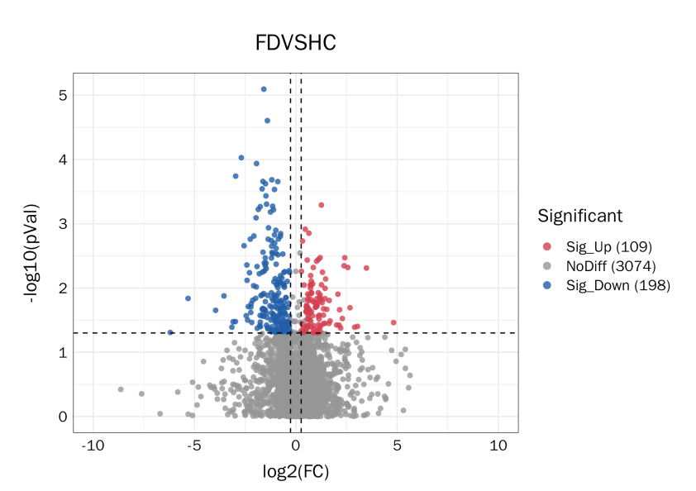

Fig S4 The volcano plot showed the differentially expressed metabolites between the two groups. FC, Fold Change.

Fig S5 ROC plots of the top 5 differential metabolites with the smallest P-values.

PG, Phosphatidylglycerols; PS, Phosphatidylserine; ST, Sterol lipids; AUC, Area Under the Curve.

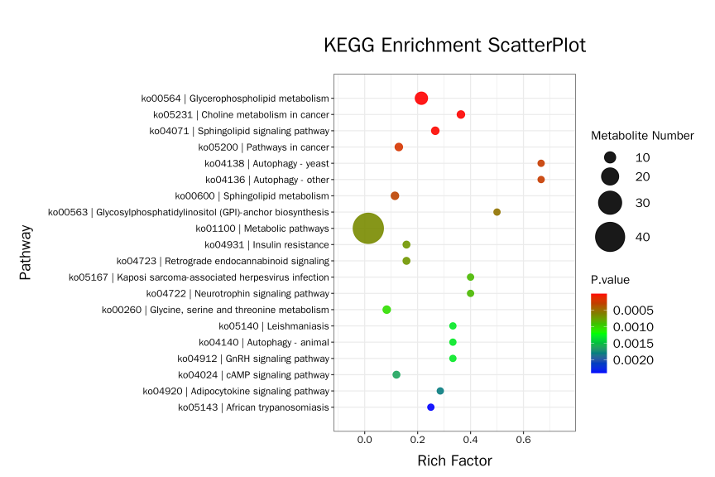

Fig S6 Bubble plot of the 20 pathways with the lowest p-values. KEGG, Kyoto encyclopedia of genes and genomes

Fig S7 Network diagram of the correlation between differential phylum–level microbiota and differential metabolites (Spearman’s correlation analysis, | rho | > 0.50 and P < 0.05).

Fig S8 Network diagram of the correlation between differential family–level microbiota and differential metabolites (Spearman’s correlation analysis, | rho | > 0.50 and P < 0.05).

