Appendix 3. Measurement Model Evaluation and Psychometric Evidence
This appendix reports Confirmatory Factor Analysis (CFA) -based reliability, convergent validity, discriminant validity, and standardized factor loadings for all reflective multi-item constructs. Because the Campbell Index of Well-Being (CIWB) is computed as a weighted composite index and represents a formative rather than reflective measurement structure, CFA is not appropriate. Its internal consistency indices are therefore reported in the main text. Accordingly, this appendix presents CFA results only for reflective latent constructs, including Compassion Fatigue Scale (CFSS), Perceived Stress Scale (PSS-14), the Perceived Social Support Scale (PSSS), Connor–Davidson Resilience Scale (CD-RISC-10), and Simplified Coping Style Scale (SCSS).

Part A
Interpretation: The measurement properties of all scales were satisfactory. Reliability indices were acceptable across constructs, and both convergent and discriminant validity criteria were achieved, indicating that the constructs were measured consistently and remained empirically distinct. Although the coping dimensions showed slightly lower AVE values, their strong reliability indices support their retention.

Table 1. Summary of Measurement Reliability and Validity
Scale | Construct | α | ω | CR | AVE | √AVE | Highest shared variance (r²) | Discriminant validity
CFSS | Compassion fatigue | 0.95 | 0.95 | 0.95 | 0.60 | 0.77 | 0.18 | Supported (AVE > r²)
PSS-14 | Perceived distress | 0.78 | 0.80 | 0.79 | 0.42 | 0.65 | 0.12 | Supported (AVE > r²)
PSS-14 | Loss of control | 0.86 | 0.88 | 0.86 | 0.56 | 0.75 | 0.12 | Supported (AVE > r²)
PSSS | Social Support | 0.93 | 0.93 | 0.93 | 0.53 | 0.73 | 0.16 | Supported (AVE > r²)
CD-RISC-10 | Psychological resilience | 0.87 | 0.89 | 0.88 | 0.56 | 0.75 | 0.25 | Supported (AVE > r²)
SCSS | Positive coping | 0.89 | 0.96 | 0.89 | 0.47 | 0.69 | 0.269 | Supported (AVE > r²)
SCSS | Negative coping | 0.85 | 0.90 | 0.86 | 0.46 | 0.68 | 0.269 | Supported (AVE > r²)

Part B
Interpretation: Across all CFA results, items generally exhibited satisfactory standardized loadings, supporting the structural validity of each construct. Although a small number of indicators within the PSS-14 and SCSS showed comparatively weaker loadings, these did not materially compromise overall model fit or psychometric quality. In contrast, the social support, resilience, and compassion fatigue scales demonstrated consistently strong item performance, further reinforcing their reliability and construct validity.

Table B1. Compassion Fatigue Scale (CFSS): Unidimensional CFA model
Scale | Item | Standardized loading (λ) | Error variance (θ) | Remarks ª
CFSS | CFSS1 | 0.601 | 0.639 | Good
CFSS | CFSS2 | 0.502 | 0.769 | Acceptable
CFSS | CFSS3 | 0.738 | 0.455 | Good
CFSS | CFSS4 | 0.746 | 0.443 | Good
CFSS | CFSS5 | 0.797 | 0.365 | Very good
CFSS | CFSS6 | 0.849 | 0.279 | Very good
CFSS | CFSS7 | 0.764 | 0.416 | Very good
CFSS | CFSS8 | 0.861 | 0.259 | Very good
CFSS | CFSS9 | 0.852 | 0.274 | Very good
CFSS | CFSS10 | 0.835 | 0.303 | Very good
CFSS | CFSS11 | 0.782 | 0.388 | Very good
CFSS | CFSS12 | 0.810 | 0.344 | Very good
CFSS | CFSS13 | 0.844 | 0.288 | Very good
Note. ª Factor loading interpretation followed SEM consensus benchmarks (Hair et al., 2022): λ < .40 = poor; .40 ≤ λ < .60 = acceptable; .60 ≤ λ < .75 = good; λ ≥ .75 = very good.

Table B2. Perceived Stress Scale (PSS-14): two-factor CFA model
Scale | Item | Standardized loading (λ) | Error variance (θ) | Remarks ª
PSS – Perceived distress | PSS1 | 0.69 | 0.52 | Good
PSS – Perceived distress | PSS2 | 0.75 | 0.44 | Very good
PSS – Perceived distress | PSS3 | 0.60 | 0.64 | Good
PSS – Perceived distress | PSS8 | 0.51 | 0.74 | Acceptable
PSS – Perceived distress | PSS11 | 0.57 | 0.68 | Acceptable
PSS – Perceived distress | PSS12 | 0.29 | 0.92 | Poor
PSS – Perceived distress | PSS14 | 0.71 | 0.49 | Good
PSS – Loss of control | PSS4 | 0.77 | 0.41 | Very good
PSS – Loss of control | PSS5 | 0.82 | 0.33 | Very good
PSS – Loss of control | PSS6 | 0.77 | 0.41 | Very good
PSS – Loss of control | PSS7 | 0.58 | 0.66 | Acceptable
PSS – Loss of control | PSS9 | 0.67 | 0.55 | Good
PSS – Loss of control | PSS10 | 0.54 | 0.71 | Acceptable
PSS – Loss of control | PSS13 | 0.58 | 0.66 | Acceptable
Note. ª Factor loading interpretation followed SEM consensus benchmarks (Hair et al., 2022): λ < .40 = poor; .40 ≤ λ < .60 = acceptable; .60 ≤ λ < .75 = good; λ ≥ .75 = very good.

Table B3. Perceived Social Support Scale (PSSS): Unidimensional CFA model
Scale | Item | Standardized loading (λ) | Error variance (θ) | Remarks ª
PSSS | PSSS1 | 0.66 | 0.56 | Good
PSSS | PSSS2 | 0.65 | 0.57 | Good
PSSS | PSSS3 | 0.67 | 0.56 | Good
PSSS | PSSS4 | 0.73 | 0.46 | Good
PSSS | PSSS5 | 0.74 | 0.46 | Good
PSSS | PSSS6 | 0.81 | 0.35 | Very good
PSSS | PSSS7 | 0.77 | 0.41 | Very good
PSSS | PSSS8 | 0.69 | 0.53 | Good
PSSS | PSSS9 | 0.77 | 0.41 | Very good
PSSS | PSSS10 | 0.75 | 0.44 | Very good
PSSS | PSSS11 | 0.68 | 0.54 | Good
PSSS | PSSS12 | 0.81 | 0.34 | Very good
Note. ª Factor loading interpretation followed SEM consensus benchmarks (Hair et al., 2022): λ < .40 = poor; .40 ≤ λ < .60 = acceptable; .60 ≤ λ < .75 = good; λ ≥ .75 = very good.
Table B4. Connor–Davidson Resilience Scale (CD-RISC-10): Unidimensional CFA model
Scale | Item | Standardized loading (λ) | Error variance (θ) | Remarks ª
CD-RISC-10 | CDRISC101 | 0.701 | 0.508 | Good
CD-RISC-10 | CDRISC102 | 0.727 | 0.471 | Good
CD-RISC-10 | CDRISC103 | 0.750 | 0.437 | Very good
CD-RISC-10 | CDRISC104 | 0.779 | 0.392 | Very good
CD-RISC-10 | CDRISC105 | 0.729 | 0.468 | Good
CD-RISC-10 | CDRISC106 | 0.775 | 0.399 | Very good
CD-RISC-10 | CDRISC107 | 0.723 | 0.477 | Good
CD-RISC-10 | CDRISC108 | 0.788 | 0.379 | Very good
CD-RISC-10 | CDRISC109 | 0.813 | 0.339 | Very good
CD-RISC-10 | CDRISC1010 | 0.797 | 0.365 | Very good
Note. ª Factor loading interpretation followed SEM consensus benchmarks (Hair et al., 2022): λ < .40 = poor; .40 ≤ λ < .60 = acceptable; .60 ≤ λ < .75 = good; λ ≥ .75 = very good.

Table B5. Simplified Coping Style Scale (SCSS): two-factor CFA model
Scale | Item | Standardized loading (λ) | Error variance (θ) | Remarks ª
Positive coping | SCSS201 | 0.576 | 0.338 | Acceptable
Positive coping | SCSS202 | 0.613 | 0.384 | Good
Positive coping | SCSS207 | 0.692 | 0.264 | Good
Positive coping | SCSS204 | 0.748 | 0.238 | Good
Positive coping | SCSS205 | 0.675 | 0.312 | Good
Positive coping | SCSS206 | 0.637 | 0.308 | Good
Positive coping | SCSS203 | 0.727 | 0.264 | Good
Positive coping | SCSS208 | 0.693 | 0.307 | Good
Positive coping | SCSS209 | 0.794 | 0.299 | Very good
Positive coping | SCSS2010 | 0.753 | 0.270 | Very good
Positive coping | SCSS2011 | 0.698 | 0.320 | Good
Positive coping | SCSS2012 | 0.711 | 0.320 | Good
Negative coping | SCSS2013 | 0.314 | 0.513 | Poor
Negative coping | SCSS2014 | 0.713 | 0.432 | Good
Negative coping | SCSS2015 | 0.763 | 0.299 | Very good
Negative coping | SCSS2016 | 0.767 | 0.411 | Very good
Negative coping | SCSS2017 | 0.778 | 0.270 | Very good
Negative coping | SCSS2018 | 0.744 | 0.320 | Good
Negative coping | SCSS2019 | 0.758 | 0.320 | Very good
Negative coping | SCSS2020 | 0.341 | 0.605 | Poor
Note. ª Factor loading interpretation followed SEM consensus benchmarks (Hair et al., 2022): λ < .40 = poor; .40 ≤ λ < .60 = acceptable; .60 ≤ λ < .75 = good; λ ≥ .75 = very good.

Part C
Interpretation: For the SCSS, the CFA supported a correlated two‐factor structure, with positive and negative coping modelled as two related but distinct first-order latent factors (see Figure S1). Modification indices indicated small cross‐loading tendencies for SCSS2013 and SCSS2020 on the opposite factor; however, these did not meaningfully affect model fit. The original correlated two-factor structure was retained as the most parsimonious representation of coping in this sample.
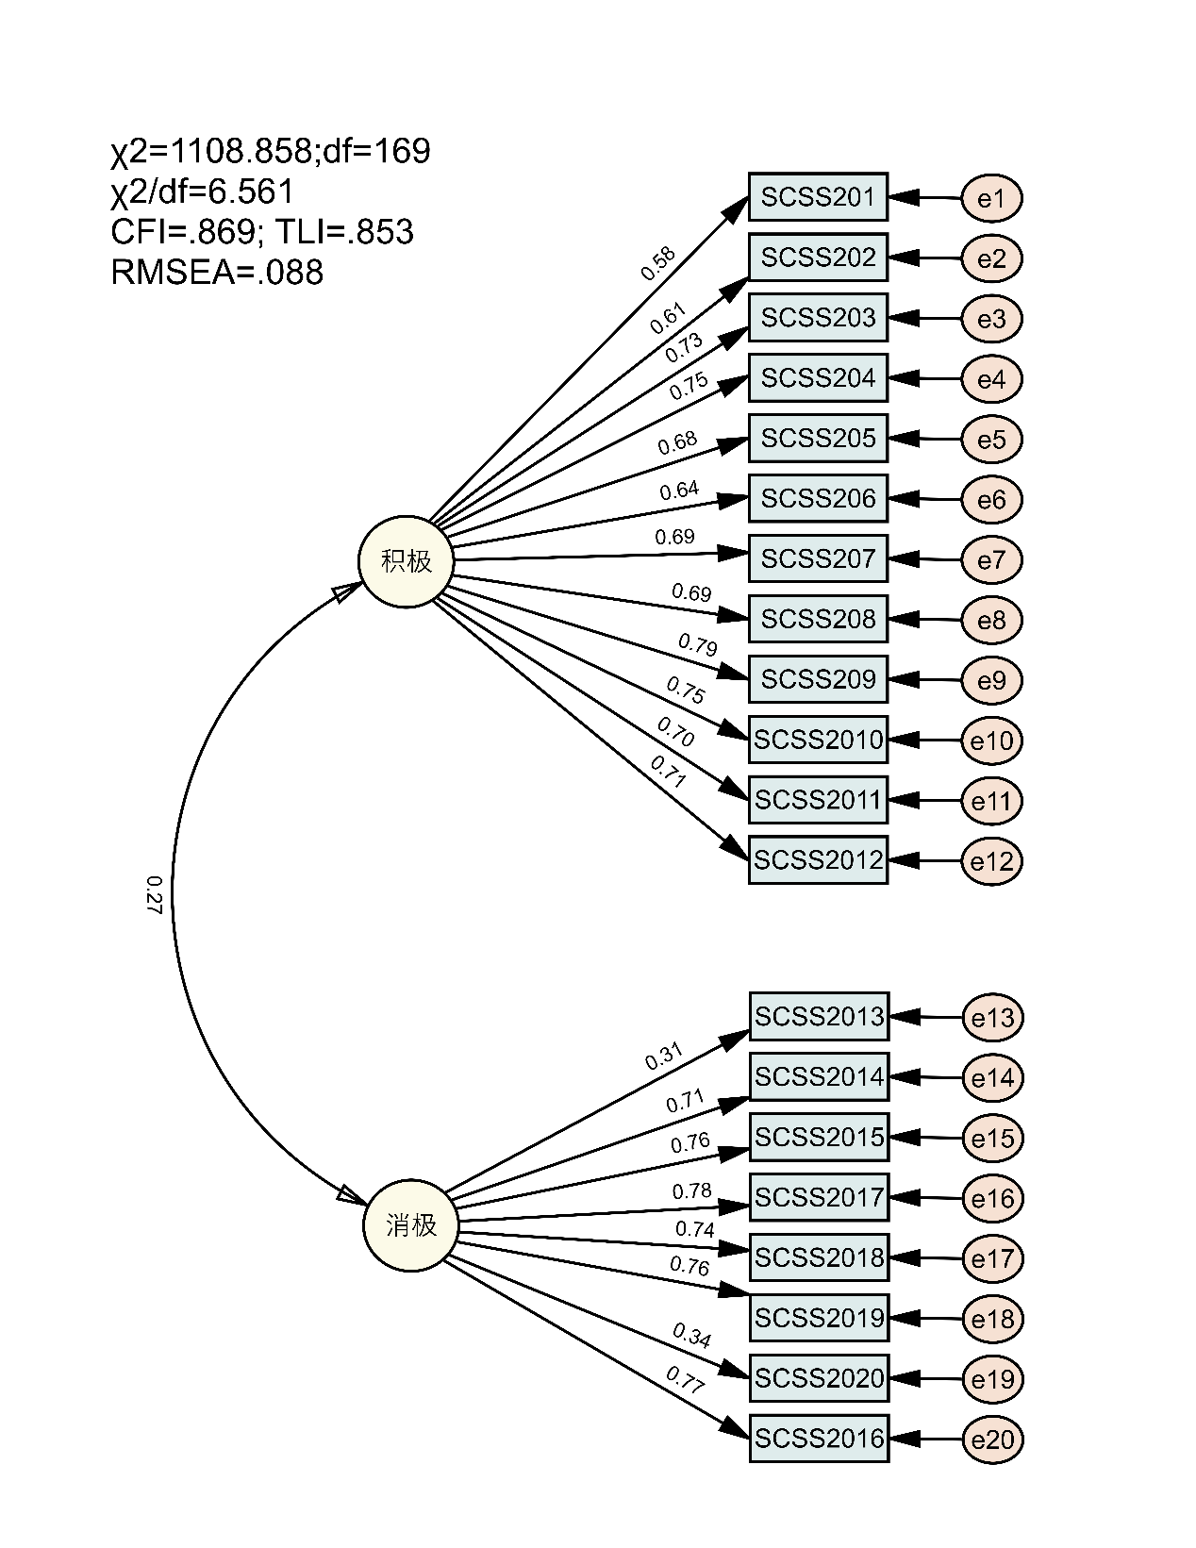
Figure S1. Correlated two-factor CFA model for coping (SCSS)
Reference
Hair, J., Hult, G. T. M., Ringle, C., & Sarstedt, M. (2022). A Primer on Partial Least Squares Structural Equation Modeling (PLS-SEM). Sage.

