Supplementary Figure 1
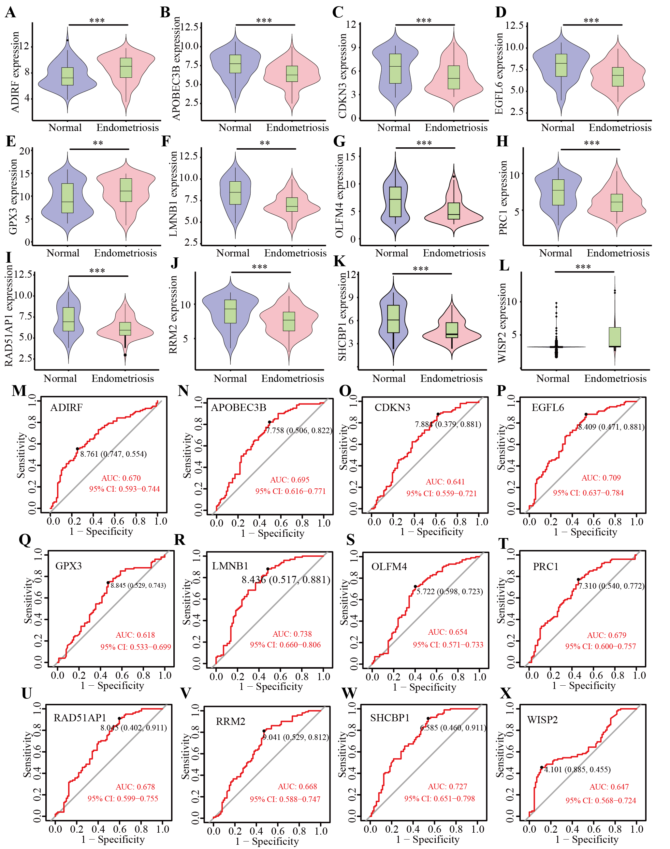
Supplementary Figure 1. The key genes screened out through Least Absolute Shrinkage and Selection Operator (LASSO) and Support Vector Machine (SVM) algorithm.
(A–E) The expression of signature genes between the endometriosis and healthy cohort. (F–J) ROC showed the diagnostic performance of the signature genes.

Supplementary Figure 2
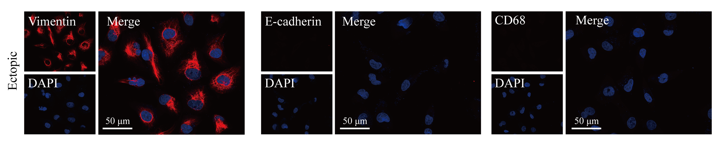
Supplementary Figure 2. Immunohistochemical staining of isolated primary endometriotic stromal cells. The purity of the endometriotic stromal cells was assessed by immunofluorescence staining for Vimentin, E-cadherin, and CD68.

Supplementary Figure 3
The original gels of Figure 4B in manuscript .
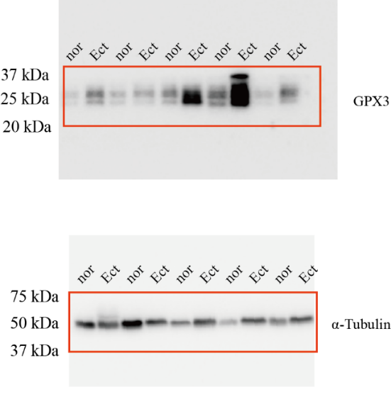
The original gels of Figure 4D in manuscript.
