Supplementary Material

Supplementary Figures
Figure S1. Funnel plot
A.Response to therapy
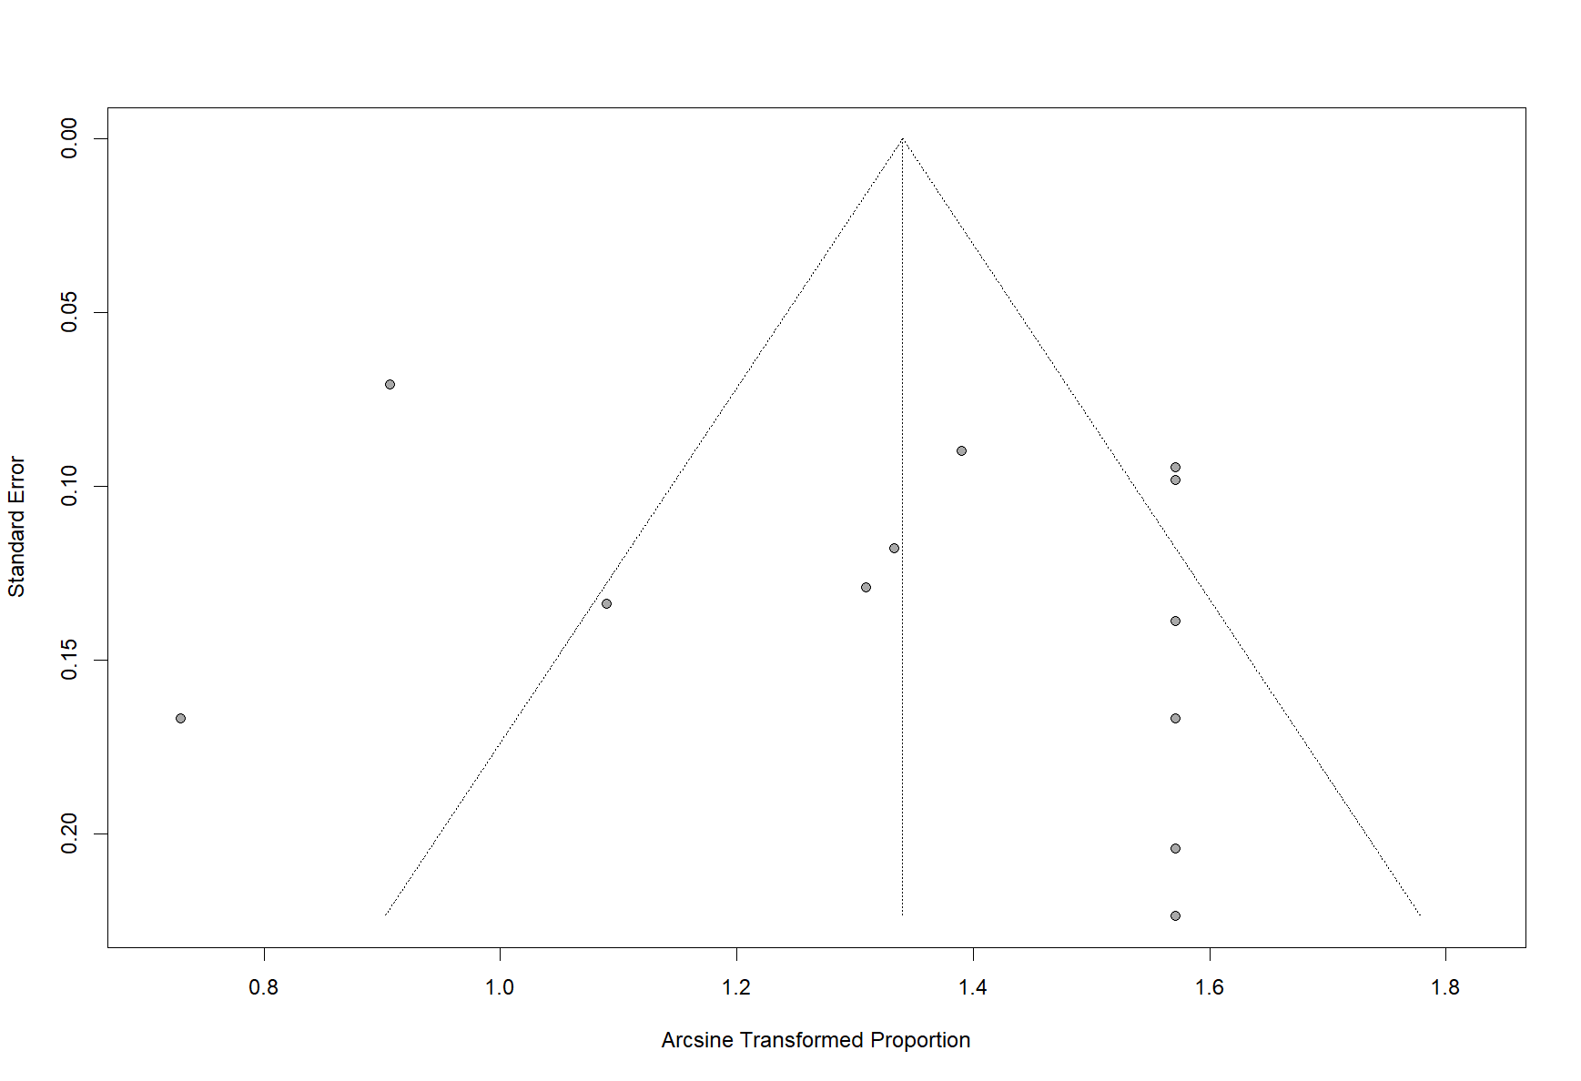
- Disappearance of hydronephrosis
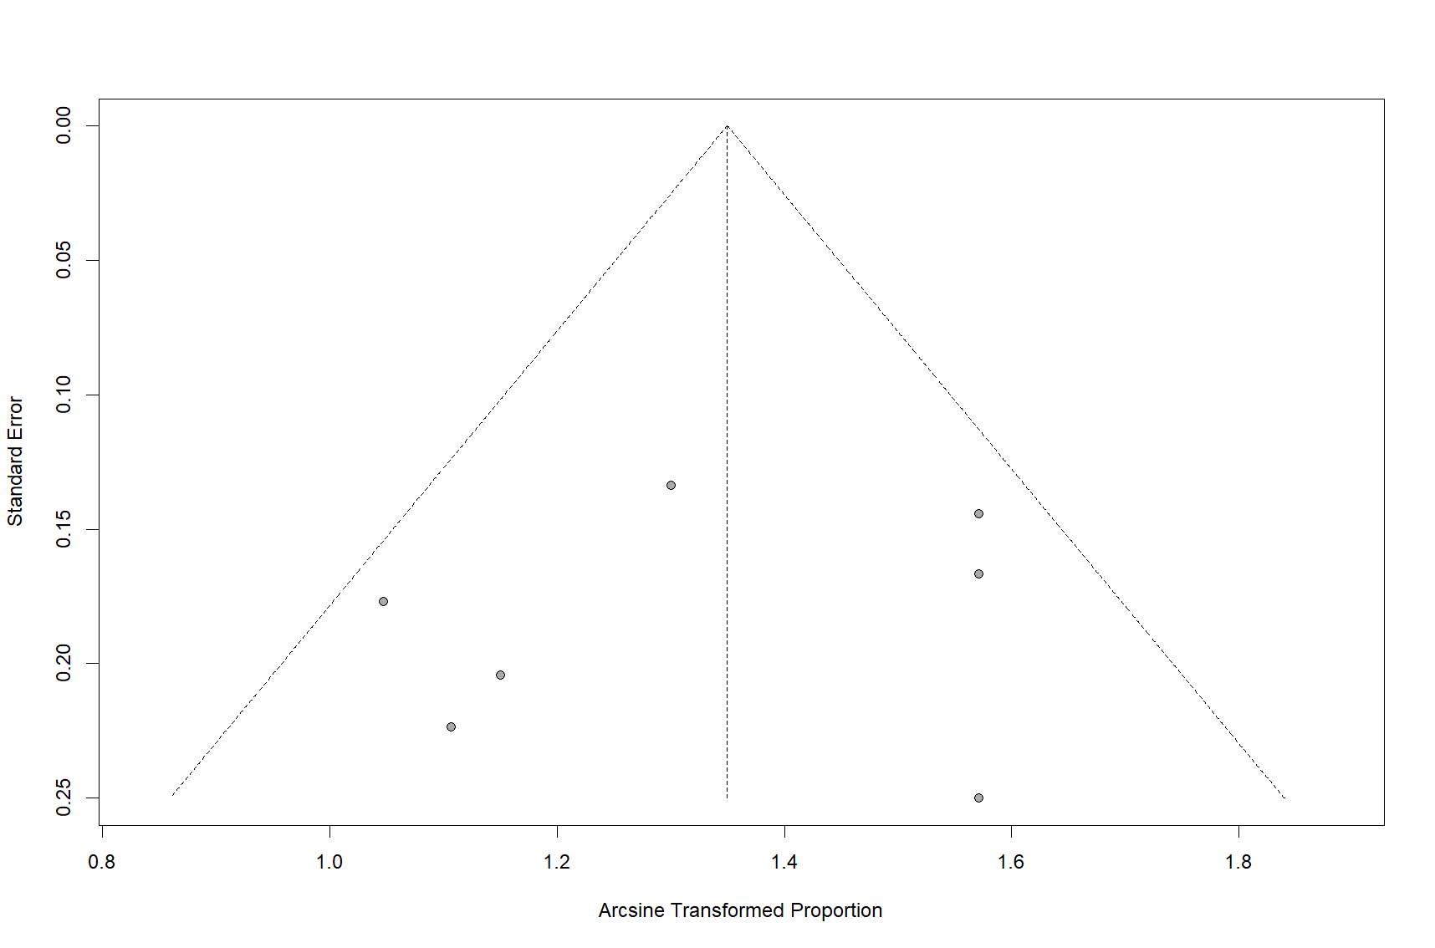
- Disease recurrence
12m
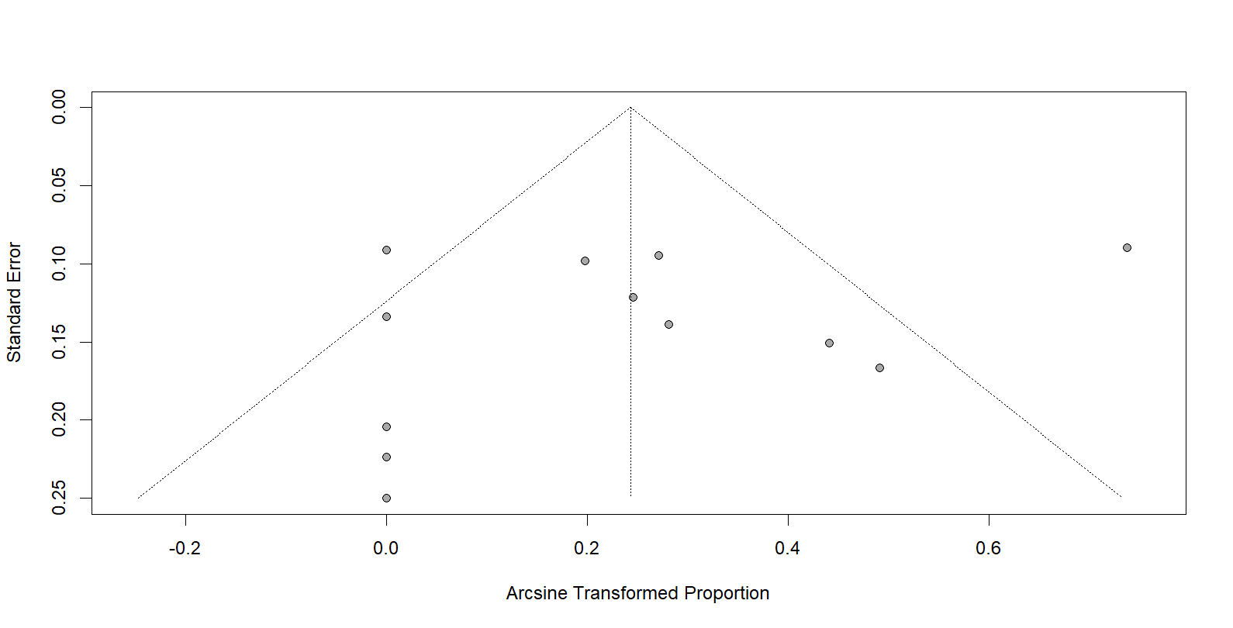
24m
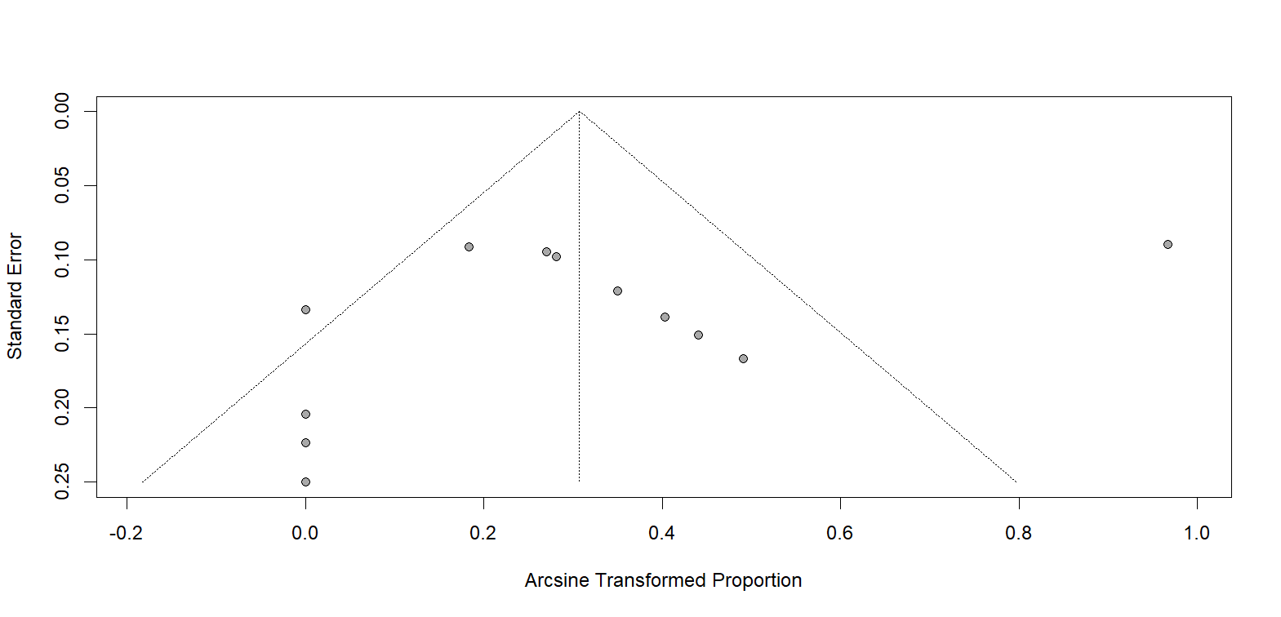
36m 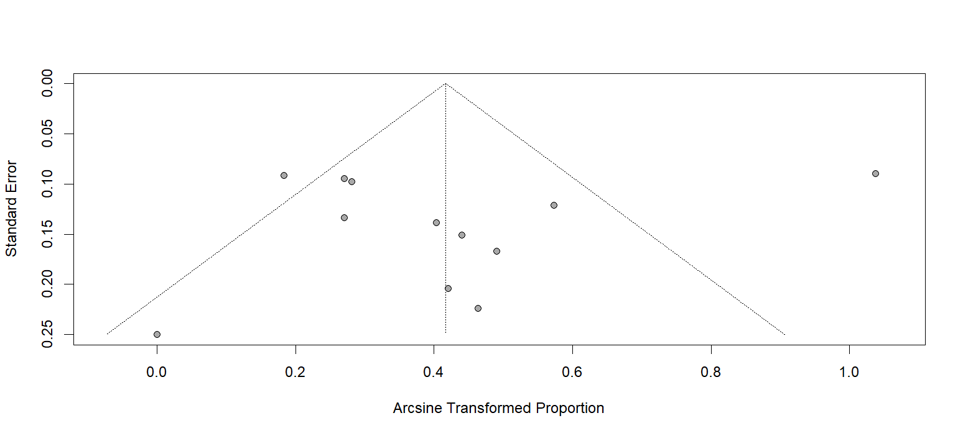
Overall recurrence rates 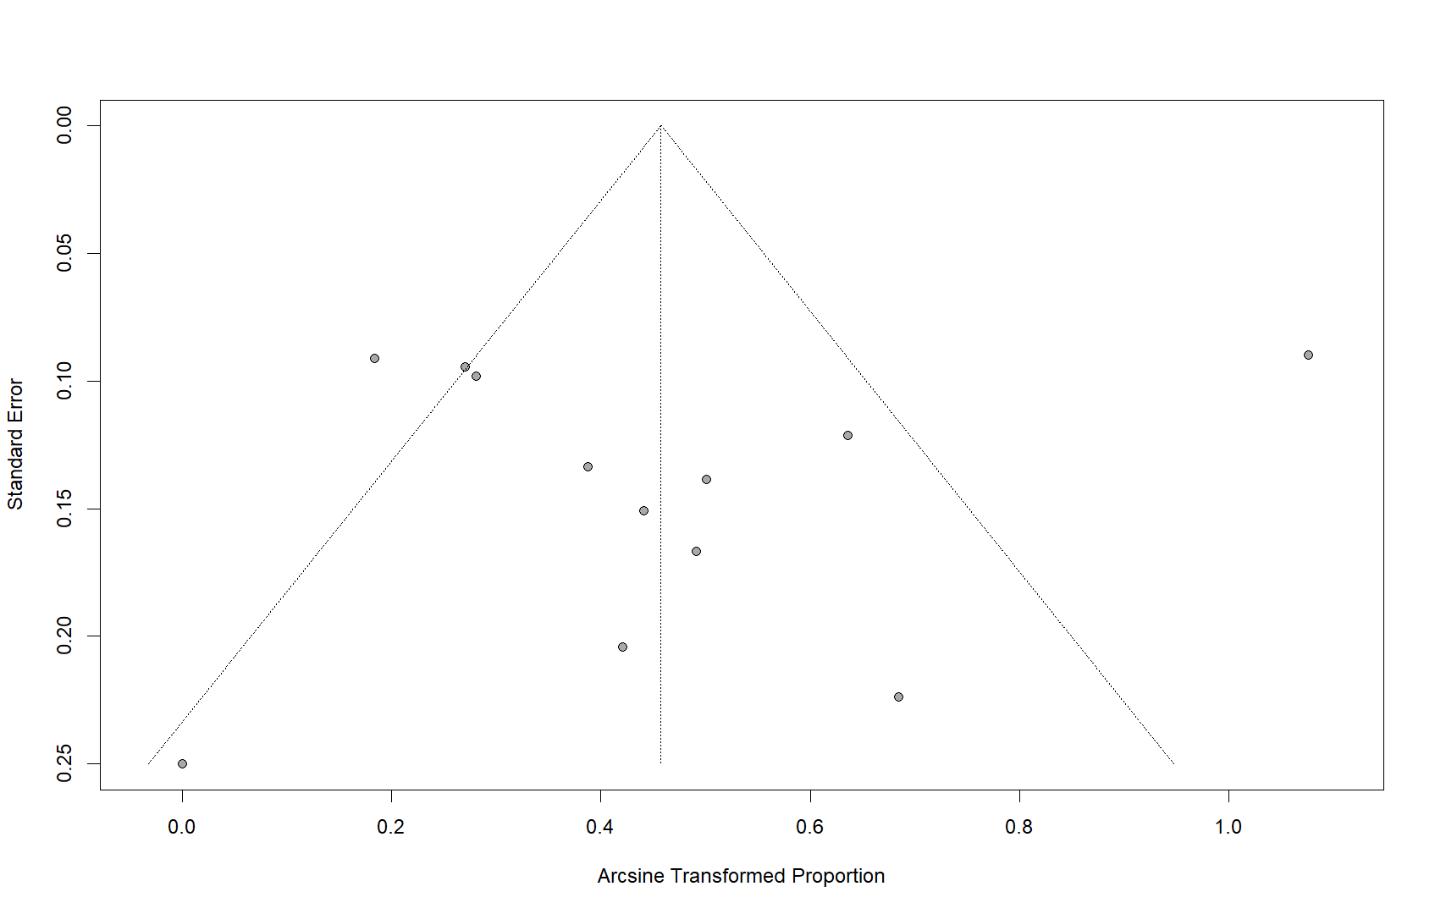
Figure S2. Sensitivity analysis
- Response to therapy
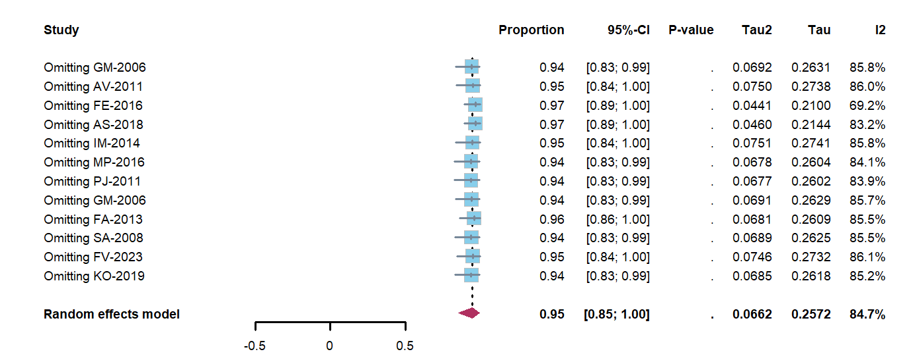
- Disappearance of hydronephrosis
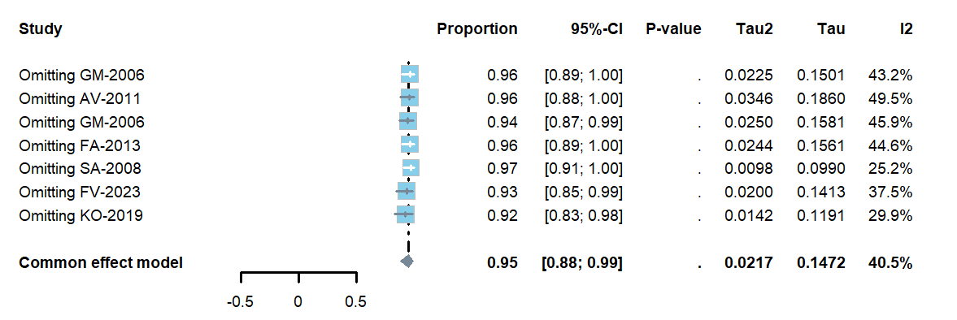
- Disease recurrence
12m
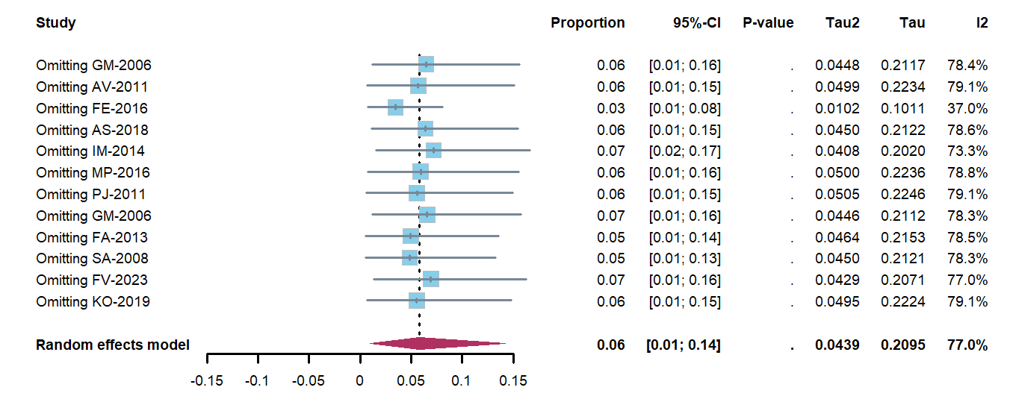
24m
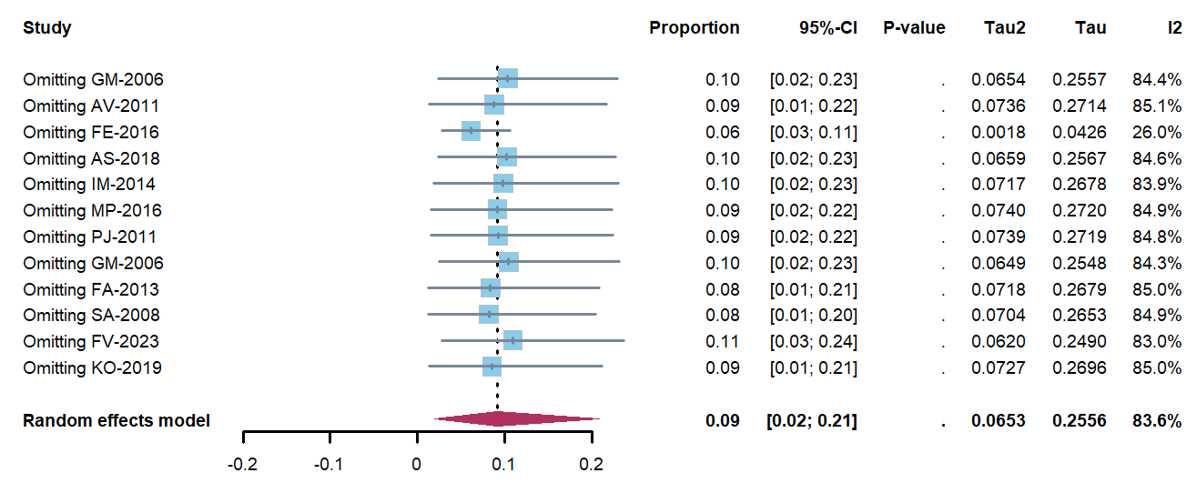
36m
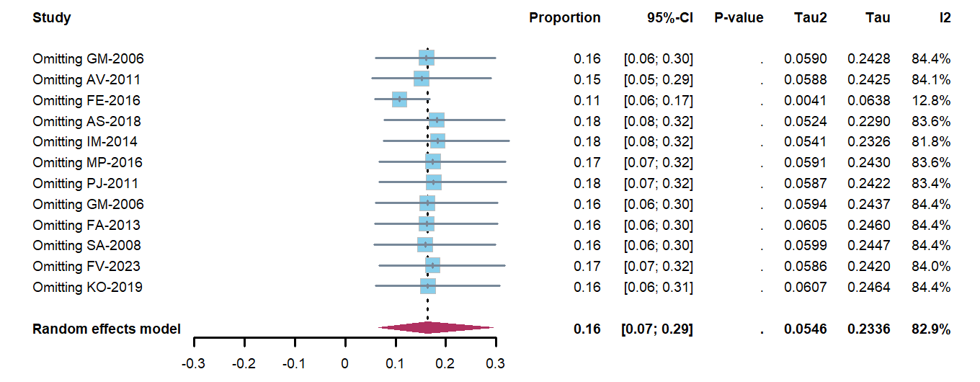
Overall recurrence rates
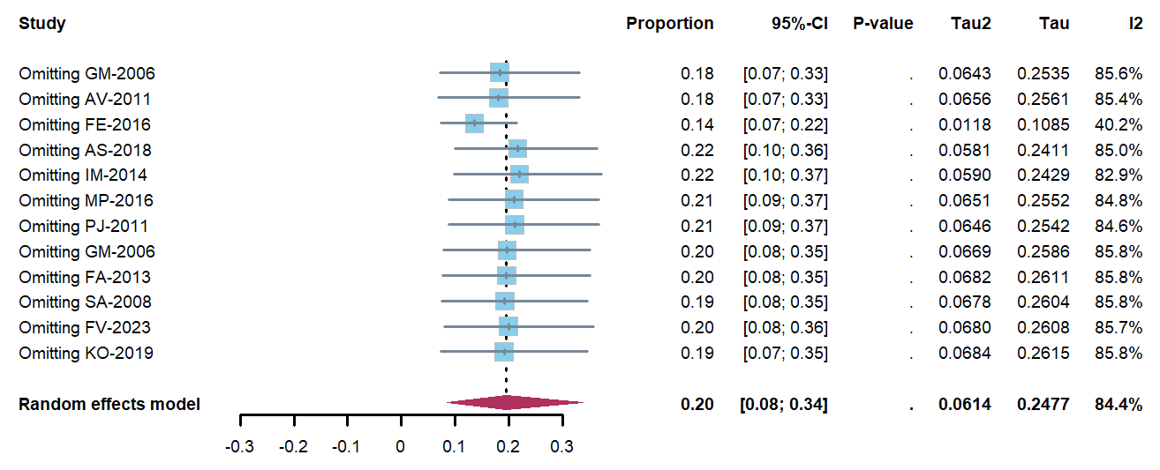

Supplementary Tables
Table S1. Search strategy
Pubmed
1 | Prednisone[mesh] or Prednisone*[Title/Abstract] | 59300
2 | Hydrocortisone[mesh] or Hydrocortisone*[Title/Abstract] | 86566
3 | steroid[mesh] or steroid*[Title/Abstract] | 1108439
4 | Glucocorticoids[mesh] or Glucocorticoids*[Title/Abstract] | 98776
5 | Methylprednisolone[mesh] or Methylprednisolone*[Title/Abstract] | 31983
6 | #1 or #2 or #3 or #4 or #5 | 1173034
7 | Immunosuppressive Agents[mesh] or Immunosuppressive Agents*[Title/Abstract] | 116040
8 | Mycophenolate Mofetil[mesh] or Mycophenolate Mofetil*[Title/Abstract] | 15547
9 | Cyclophosphamide[mesh] or Cyclophosphamide*[Title/Abstract] | 83381
10 | Azathioprine[mesh] or Azathioprine*[Title/Abstract] | 25481
11 | Tacrolimus[mesh] or Tacrolimus*[Title/Abstract] | 27177
12 | Cyclosporine[mesh] or Cyclosporine*[Title/Abstract] | 55245
13 | Methotrexate[mesh] or Methotrexate*[Title/Abstract] | 63321
14 | Leflunomide[mesh] or Leflunomide*[Title/Abstract] | 3029
15 | Hydroxychloroquine[mesh] or Hydroxychloroquine*[Title/Abstract] | 11375
16 | Sulfasalazine[mesh] or Sulfasalazine*[Title/Abstract] | 6683
17 | #7 or #8 or #9 or #10 or #11 or #12 or #13 or #14 or #15 or #16 | 304144
18 | retroperitoneal fibrosis[mesh] or retroperitoneal fibrosis*[Title/Abstract] | 3384
19 | (#6 or #17) and #18 | 763
20 | Filters applied: Clinical Study, Clinical Trial, Comparative Study, Controlled Clinical Trial, Multicenter Study, Observational Study, Randomized Controlled Trial | 33
Embase
1 | ‘Prednisone’/exp or ‘Prednisone’:ab,ti | 227697
2 | ‘Hydrocortisone’/exp or ‘Hydrocortisone’:ab,ti | 171733
3 | ‘steroid’/exp or ‘steroid’:ab,ti | 2120386
4 | ‘Glucocorticoids’/exp or ‘Glucocorticoids’:ab,ti | 978335
5 | ‘Methylprednisolone’/exp or ‘Methylprednisolone’:ab,ti | 137840
6 | 1 or 2 or 3 or 4 or 5 | 2132936
7 | ‘Immunosuppressive Agents’/exp or ‘Immunosuppressive Agents’:ab,ti | 1532832
8 | ‘Mycophenolate Mofetil’/exp or ‘Mycophenolate Mofetil’:ab,ti | 79596
9 | ‘Cyclophosphamide’/exp or ‘Cyclophosphamide’:ab,ti | 277821
10 | ‘Azathioprine’/exp or ‘Azathioprine’:ab,ti | 120138
11 | ‘Tacrolimus’/exp or ‘Tacrolimus’:ab,ti | 110361
12 | ‘Cyclosporine’/exp or ‘Cyclosporine’:ab,ti | 182494
13 | ‘Methotrexate’/exp or ‘Methotrexate’:ab,ti | 233435
14 | ‘Leflunomide’/exp or ‘Leflunomide’:ab,ti | 17174
15 | ‘Hydroxychloroquine’/exp or ‘Hydroxychloroquine’:ab,ti | 51577
16 | ‘Sulfasalazine’/exp or ‘Sulfasalazine’:ab,ti | 32619
17 | 7 or 8 or 9 or 10 or 11 or 12 or 13 or 14 or 15 or 16 | 1573310
18 | ‘retroperitoneal fibrosis’/exp or ‘retroperitoneal fibrosis’:ab,ti | 5279
19 | (6 or 17) and 18 | 2031
20 | 19 and ('case control study'/de or 'clinical trial'/de or 'comparative study'/de or 'controlled clinical trial'/de or 'controlled study'/de or 'multicenter study'/de or 'observational study'/de or 'randomized controlled trial'/de) | 259
21 | 20 and ('article'/it or 'article in press'/it) | 123
Cochrane library
1 | (Prednisone or Prednisone*):ti,ab,kw | 11379
2 | (Hydrocortisone or Hydrocortisone*):ti,ab,kw | 10711
3 | (steroid or steroid*):ti,ab,kw | 38813
4 | (Glucocorticoids or Glucocorticoids*):ti,ab,kw | 8815
5 | (Methylprednisolone or Methylprednisolone*):ti,ab,kw | 6267
6 | #1 or #2 or #3 or #4 or #5 | 66197
7 | (Immunosuppressive Agents or Immunosuppressive Agents*):ti,ab,kw | 8057
8 | (Mycophenolate Mofetil or Mycophenolate Mofetil*):ti,ab,kw | 3290
9 | (Cyclophosphamide or Cyclophosphamide*):ti,ab,kw | 13862
10 | (Azathioprine or Azathioprine*):ti,ab,kw | 3649
11 | (Tacrolimus or Tacrolimus*):ti,ab,kw | 5972
12 | (Cyclosporine or Cyclosporine*):ti,ab,kw | 6461
13 | (Methotrexate or Methotrexate*):ti,ab,kw | 13371
14 | (Leflunomide or Leflunomide*):ti,ab,kw | 792
15 | (Hydroxychloroquine or Hydroxychloroquine*):ti,ab,kw | 2162
16 | (Sulfasalazine or Sulfasalazine*):ti,ab,kw | 1228
17 | #7 or #8 or #9 or #10 or #11 or #12 or #13 or #14 or #15 or #16 | 42483
18 | (retroperitoneal fibrosis or retroperitoneal fibrosis*):ti,ab,kw | 36
19 | (comparative study or comparative study*):ti,ab,kw | 115931
20 | (clinical trial or clinical trial*):ti,ab,kw | 863237
21 | (randomized controlled trial or randomized controlled trial*):ti,ab,kw | 829056
22 | #19 or #20 or #21 or #22 | 1092955
23 | (#6 or #17) and #18 and #23 | 12
Web of Science
1 | (TI=(Prednisone)) or AB=(Prednisone) | 45450
2 | (TI=(Hydrocortisone)) or AB=(Hydrocortisone) | 28196
3 | (TI=(steroid)) or AB=(steroid) | 354864
4 | (TI=(Glucocorticoids)) or AB=(Glucocorticoids) | 55541
5 | (TI=(Methylprednisolone)) or AB=(Methylprednisolone) | 27344
6 | #1 or #2 or #3 or #4 or #5 | 480834
7 | (TI=(Immunosuppressive Agents)) or AB=(Immunosuppressive Agents) | 29296
8 | (TI=(Mycophenolate Mofetil)) or AB=(Mycophenolate Mofetil) | 17308
9 | (TI=(Cyclophosphamide)) or AB=(Cyclophosphamide) | 82462
10 | (TI=(Azathioprine)) or AB=(Azathioprine) | 23012
11 | (TI=(Tacrolimus)) or AB=(Tacrolimus) | 31935
12 | (TI=(Cyclosporine)) or AB=(Cyclosporine) | 52119
13 | (TI=(Methotrexate)) or AB=(Methotrexate) | 73318
14 | (TI=(Leflunomide)) or AB=(Leflunomide) | 4311
15 | (TI=(Hydroxychloroquine)) or AB=(Hydroxychloroquine) | 13298
16 | (TI=(Sulfasalazine)) or AB=(Sulfasalazine) | 6352
17 | #7 or #8 or #9 or #10 or #11 or #12 or #13 or #14 or #15 or #16 | 279035
18 | (TI=(retroperitoneal fibrosis)) or AB=(retroperitoneal fibrosis) | 4137
19 | (#6 or #17) and #18 | 596
20 | #19 and Preprint Citation Index (Exclude–Database) and Article or Clinical Trial (Document Types) and English (Languages) and Open Access | 150
ProQuest
1 | title(Prednisone) OR abstract(Prednisone) | 7246
2 | title(Hydrocortisone) OR abstract(Hydrocortisone) | 0
3 | title(steroid) OR abstract(steroid) | 43311
4 | title(Glucocorticoids) OR abstract(Glucocorticoids) | 16299
5 | title(Methylprednisolone) OR abstract(Methylprednisolone) | 5150
6 | [S1] OR [S3] OR [S4] OR [S5] | 66657
7 | title(Immunosuppressive Agents) OR abstract(Immunosuppressive Agents) | 4300
8 | title(Mycophenolate Mofetil) OR abstract(Mycophenolate Mofetil) | 3046
9 | title(Cyclophosphamide) OR abstract(Cyclophosphamide) | 11501
10 | title(Azathioprine) OR abstract(Azathioprine) | 4113
11 | title(Tacrolimus) OR abstract(Tacrolimus) | 4521
12 | title(Cyclosporine) OR abstract(Cyclosporine) | 4577
13 | title(Methotrexate) OR abstract(Methotrexate) | 13612
14 | title(Leflunomide) OR abstract(Leflunomide) | 1136
15 | title(Hydroxychloroquine) OR abstract(Hydroxychloroquine) | 3760
16 | title(Sulfasalazine) OR abstract(Sulfasalazine) | 1248
17 | [S7] OR [S8] OR [S9] OR [S10] OR [S11] OR [S12] OR [S13] OR [S14] OR [S15] OR [S16] | 41568
18 | title(retroperitoneal fibrosis) OR abstract(retroperitoneal fibrosis) | 742
19 | [S18] AND ([S6] OR [S17]) | 107
Pubmed + Embase + Cochrane library + Web of Science + ProQuest = 425
425 - duplicates =425 - 54= 371

Table S2. Summary of excluded studies
Study | Title | Reason
Rhys D R Evans 2019 | Clinical Manifestations and Long-term Outcomes of IgG4-Related Kidney and Retroperitoneal Involvement in a United Kingdom IgG4-Related Disease Cohort | Including other disease (IgG4-RKD), impossible to accurately judge the treatment effect on RPF
Wang, Y 2019 | Leflunomide in combination with glucocorticoids is superior to conventional glucocorticoids monotherapy in preventing relapse in IGG4-related disease: a randomized, open-label, controlled trial | impossible to obtain the full text
Yasufumi Masaki 2017 | A multicenter phase II prospective clinical trial of glucocorticoid for patients with untreated IgG4-related disease | Including other disease, impossible to accurately judge the treatment effect on RPF
R N Jois 2007 | Mycophenolate mofetil for maintenance of remission in idiopathic retroperitoneal fibrosis | Case report
Hongyan Liu 2024 | Outcomes of retroperitoneal fibrosis-related hydronephrosis and its risk factors for poor prognosis: a multi-center retrospective cohort study in Chinese patients | Including other drugs (tamoxifen)
Augusto Vaglio 2007 | Prednisone Versus Tamoxifen in Idiopathic Retroperitoneal Fibrosis | Duplicates (NCT00440349)
Augusto Vaglio 2011 | Prednisone Versus Tamoxifen in Idiopathic Retroperitoneal Fibrosis | Duplicates (NCT00440349)
Augusto Vaglio 2003 | Tamoxifen vs prednisone in patients with retroperitoneal fibrosis: preliminary results of a randomised clinical trial | Duplicates (NCT00440349)
Hai-Jiang Zhou 2015 | Retroperitoneal Fibrosis: A Retrospective Clinical Data Analysis of 30 Patients in a 10-year Period | Including other drugs (tamoxifen)
Andrew C Fry 2008 | Successful Use of Steroids and Ureteric Stents in 24 Patients with Idiopathic Retroperitoneal Fibrosis: A Retrospective Study | impossible to obtain the full text
Bimba F. Hoyer 2016 | Efficacy of cyclophosphamide therapy in idiopathic retroperitoneal fibrosis in a retrospective monocentric analysis | impossible to obtain the full text

Table S3. Risk of bias assessments according to Cochrane risk-of-bias tool (Rob 2)

 | D1 | D2 | D3 | D4 | D5 | Overall
Augusto.2011 |  |  |  |  |  | 
Domains:
Low risk
Some concerns
High risk
D1: Bias arising from the randomization process.
D2: Bias due to deviations from intended intervention.
D3: Bias due to missing outcome data.
D4: Bias in measurement of the outcome.
D5: Bias in selection of the reported result.
?
?
Table S4. Risk of bias assessments according to Newcastle-Ottawa Scale
Reference | Study design | Selection | Comparability | Exposure/Outcome | Total
Gabriella et al. | Prospective  Cohort | **** | ** | *** | 9
Floor et al. | Retrospective Cohort | **** | ** | ** | 8
Andrea et al. | Retrospective and Prospective Cohort | *** | * | *** | 7
Ichiro et al. | Multicentric Retrospective Cohort | **** | * | ** | 7
Miroslav et al. | Retrospective Cohort | *** | 0 | ** | 5
Paul et al. | Prospective  Cohort | *** | 0 | *** | 6
F. Vianello et al. | Retrospective Cohort | *** | 0 | *** | 6
Katarina et al. | Retrospective Cohort | *** | 0 | *** | 6

Table S5. Risk of bias assessments according to Methodological lndex for Non-Randomized Studies
Reference | Federico et al. | S. Adleret al.
Items
A clearly stated aim | 2 | 2
Inclusion of consecutive patients | 1 | 1
Prospective collection of data | 2 | 0
Endpoints appropriate to the aim of the study | 1 | 1
Unbiased assessment of the study endpoint | 0 | 0
Follow-up period appropriate to the aim of the study | 2 | 2
Loss to follow up less than 5% | 0 | 2
Prospective calculation of the study size | 0 | 0
Score | 8 | 8

