Supplementary Online Content

Prospective Association Between the Triglyceride-Glucose Index and Frailty in Middle-aged and Older Adults: Insights From a Nationwide Cohort Study

Table of Contents:

Supplementary tables:

eTable 1: The Construction of Frailty Index
eTable 2. Association Between the TyG Index and Frailty at Baseline in 2011

Supplementary figures:

eFigure 1. Selection of Covariates Using the Boruta Algorithm
eFigure 2. The Distribution of TyG and the Incidence of Frailty
eFigure 3. Kaplan-Meier Curves for Frailty-Free Survival Probability According to TyG Index Tertiles
eFigure 4. Restricted Cubic Spline Analysis of the Association Between the TyG Index and Risk of New-onset Frailty
eFigure 5. Subgroup Analyses of the Association Between the TyG index and Risk of New-Onset Frailty

eTable 1. The Construction of Frailty Index
1 | Self-reported physician diagnosed hypertension | Yes/No =1/ 0
2 | Self-reported physician diagnosed diabetes | Yes/No =1/ 0
3 | Self-reported physician diagnosed cancer | Yes/No =1/ 0
4 | Self-reported physician diagnosed arthritis | Yes/No =1/ 0
5 | Self-reported physician diagnosed chronic lung disease | Yes/No =1/ 0
6 | Self-reported physician diagnosed any emotional, nervous, or psychiatric problems | Yes/No =1/ 0
7 | Self-reported physician diagnosed memory-related disease ª | Yes/No =1/ 0
8 | Self-reported vision problems | Yes/No =1/ 0
9 | Self-reported hearing problems | Yes/No =1/ 0
10 | Self-reported general health status | Very poor or poor = 1,  Very good, good, or fair = 0
11 | Difficulty with dressing | Yes/No =1/ 0
12 | Difficulty with bathing or showering | Yes/No =1/ 0
13 | Difficulty with eating | Yes/No =1/ 0
14 | Difficulty with getting in and out of bed | Yes/No =1/ 0
15 | Difficulty with using the toilet | Yes/No =1/ 0
16 | Difficulty with managing money | Yes/No =1/ 0
17 | Difficulty with taking medication | Yes/No =1/ 0
18 | Difficulty with shopping for groceries | Yes/No =1/ 0
19 | Difficulty with preparing meals | Yes/No =1/ 0
20 | Mobility: difficulty with walking 100 yards or one block | Yes/No =1/ 0
21 | Mobility: difficulty with getting up from a chair after sitting for long periods | Yes/No =1/ 0
22 | Mobility: difficulty with climbing several flights of stairs without resting | Yes/No =1/ 0
23 | Mobility: difficulty with lifting or carrying weights over 10 pounds/jins | Yes/No =1/ 0
24 | Mobility: difficulty with picking up a coin from the table | Yes/No =1/ 0
25 | Mobility: difficulty with stooping, kneeling, or crouching | Yes/No =1/ 0
26 | Mobility: difficulty with reaching arms above shoulder level | Yes/No =1/ 0
27 | Depression: CESD-10 questionnaire ^{b} | Yes/No =1/ 0
28 | Cognition: (memory test score + orientation test score ^{c}) / 14 | CESD-10 ＞10 =1,  CESD-10 ≤10 =0
Continuous variable, ranging
from 0 to 1
ª Memory-related disease included Alzheimer’s disease, dementia, organic brain senility, and other severe memory impairment.
^{b} Depression was assessed using the Center for Epidemiologic Studies Depression Scale (CESD), with the CESD-10 version employed. The total score on this scale ranged from 0 to 30, with higher scores indicating more severe depressive symptoms.
^{c} The memory score was calculated as the average number of words not recalled in the immediate and delayed word recall tasks, with a range of 0 to 10. The orientation test comprised four questions regarding the day of the week, month, date, and year. One point was assigned for each incorrect answer, with a total score ranging from 0 to 4.
eTable 2. Association Between the TyG Index and Frailty at Baseline in 2011
N = 6003  Various | Model 1 ª |  | Model 2 ^{b}
N = 6003  Various | OR (95%CI) | P | OR (95%CI) | P
TyG | 1.20(1.07-1.35) | <0.01 | 1.16(0.99-1.34) | 0.06
TyG tertiles
T1 | reference | - | reference | -
T2 | 1.24(1.01-1.52) | 0.04 | 1.20(0.96-1.50) | 0.11
T3 | 1.40(1.15-1.72) | <0.01 | 1.27(0.99-1.62) | 0.06
Abbreviations: TyG, triglyceride-glucose; OR, odds ratio; CI, confidence interval.
ª Model 1 was the crude model.
^{b} Model 2 was adjusted for age, sex, education level, smoking status, alcohol consumption, history of heart disease, systolic blood pressure, body mass index, waist circumference, high-density lipoprotein cholesterol, C-reactive protein and estimated glomerular filtration rate.
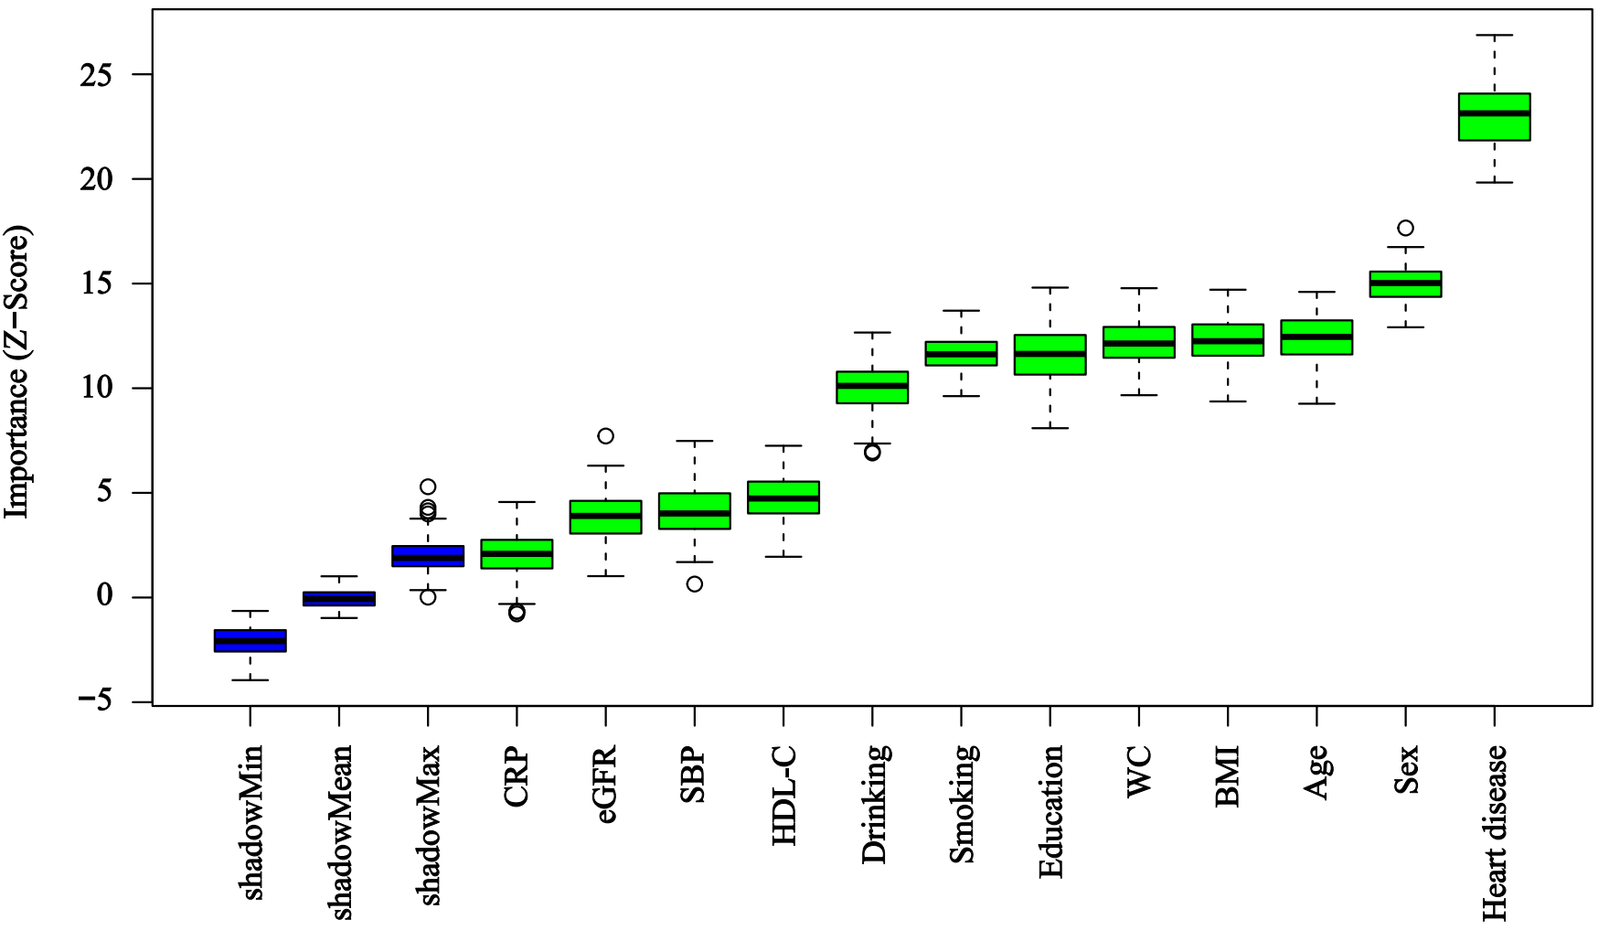eFigure 1. Selection of Covariates Using the Boruta Algorithm. Abbreviations: CRP, C-reactive protein; eGFR, estimated glomerular filtration rate; SBP, systolic blood pressure; HDL-C, high-density lipoprotein cholesterol; WC, waist circumference BMI, body mass index. The boxplots illustrate the importance of candidate covariates relative to shadow attributes (blue). All candidate covariates (green) exhibited importance Z-scores higher than the maximum shadow attribute (shadowMax), justifying their inclusion in the final multivariate models.

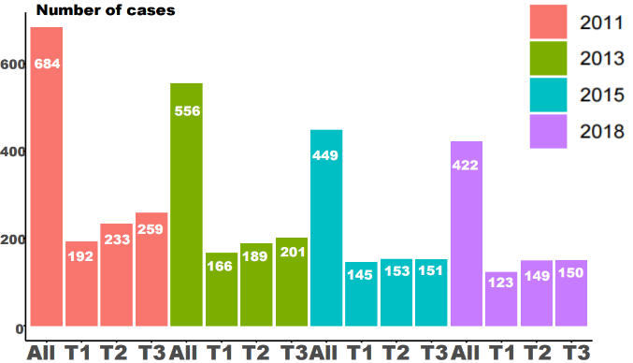
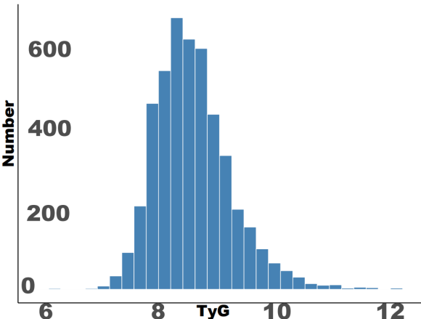
A. The distribution of TyG at baseline B. Distribution of frailty cases by survey year
C. The incidence rate of new-onset frailty (% or Per 1000 person-years)
 | Participants (n) | Frailty events (n) | Incidence of frailty (%) | Per 1000 person-years (95%CI)
Total | 3957 | 1427 | 36.06 | 60.54 (57.44-63.76)
T1 | 1344 | 434 | 32.39 | 53.30 (48.40-58.56)
T2 | 1319 | 491 | 37.23 | 62.72 (57.29-68.52)
T3 | 1294 | 502 | 38.79 | 66.05 (60.40-72.09)
P _{for trend} |  |  |  | 0.001
eFigure 2. The Distribution of TyG and the Incidence of Frailty. Abbreviations: TyG, triglyceride-glucose; CI, confidence interval. P value for trend was calculated using Poisson regression.

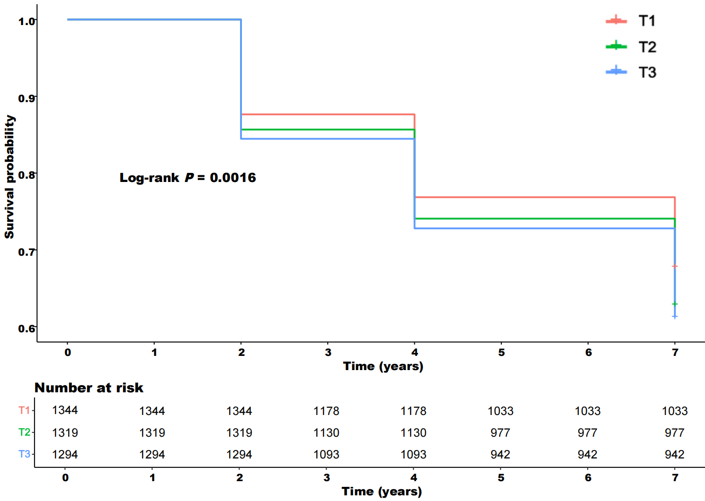
eFigure 3. Kaplan-Meier Curves for Frailty-Free Survival Probability According to TyG Index Tertiles. Abbreviations: TyG, triglyceride-glucose.

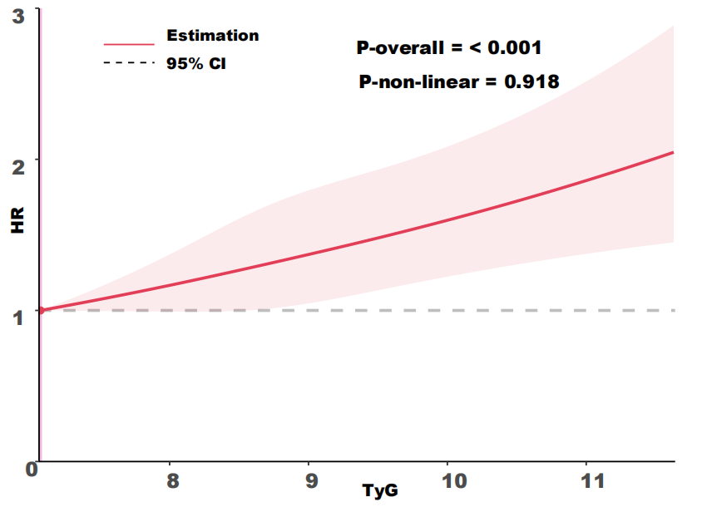
eFigure 4. Restricted Cubic Spline Analysis of the Association Between the TyG Index and Risk of New-onset Frailty. Abbreviations: TyG, triglyceride-glucose; HR, hazard ratio; CI, confidence interval.

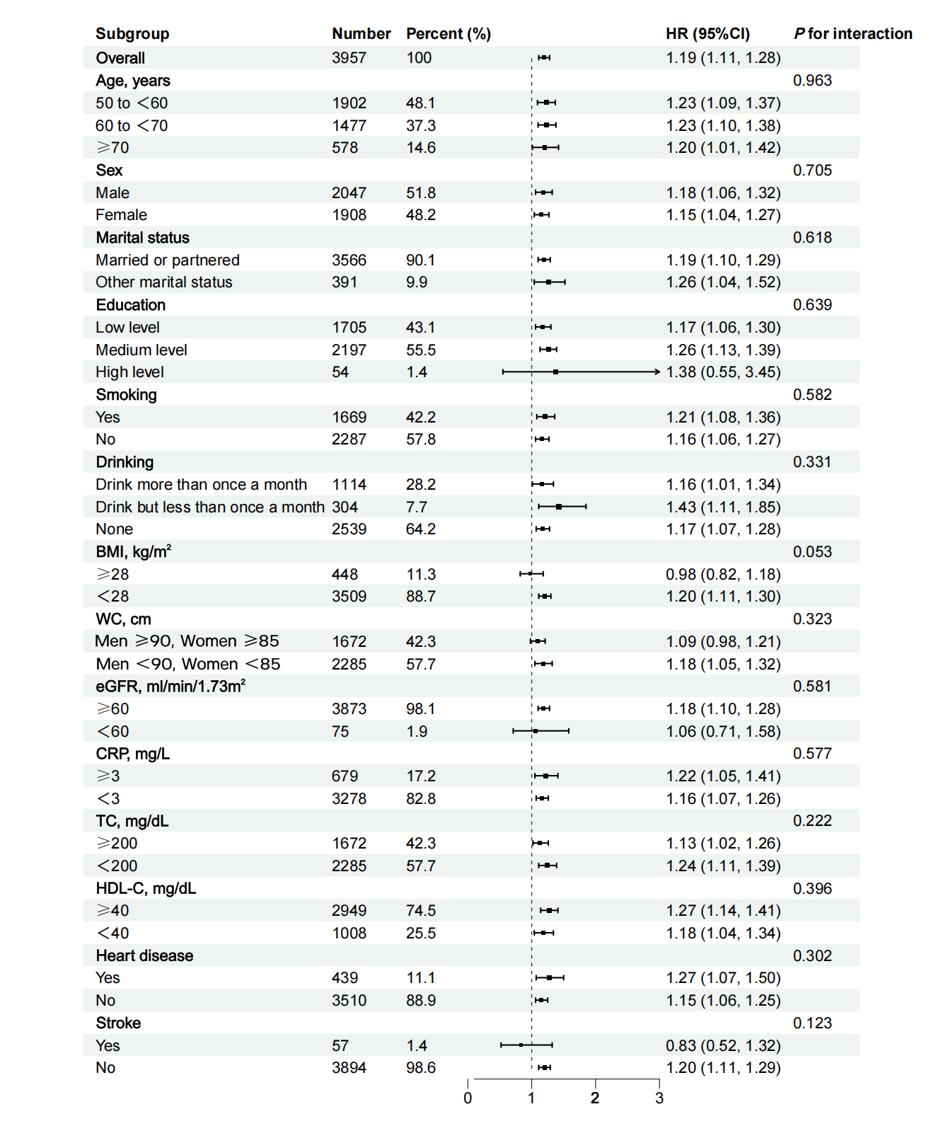
eFigure 5. Subgroup Analyses of the Association Between the TyG index and Risk of New-Onset Frailty. Abbreviations: HR, hazard ratio; CI, confidence interval; BMI, body mass index; WC, waist circumference; eGFR, estimated glomerular filtration rate; CRP, C-reactive protein; TC, total cholesterol; HDL-C, high-density lipoprotein cholesterol.

