Supplementary Material
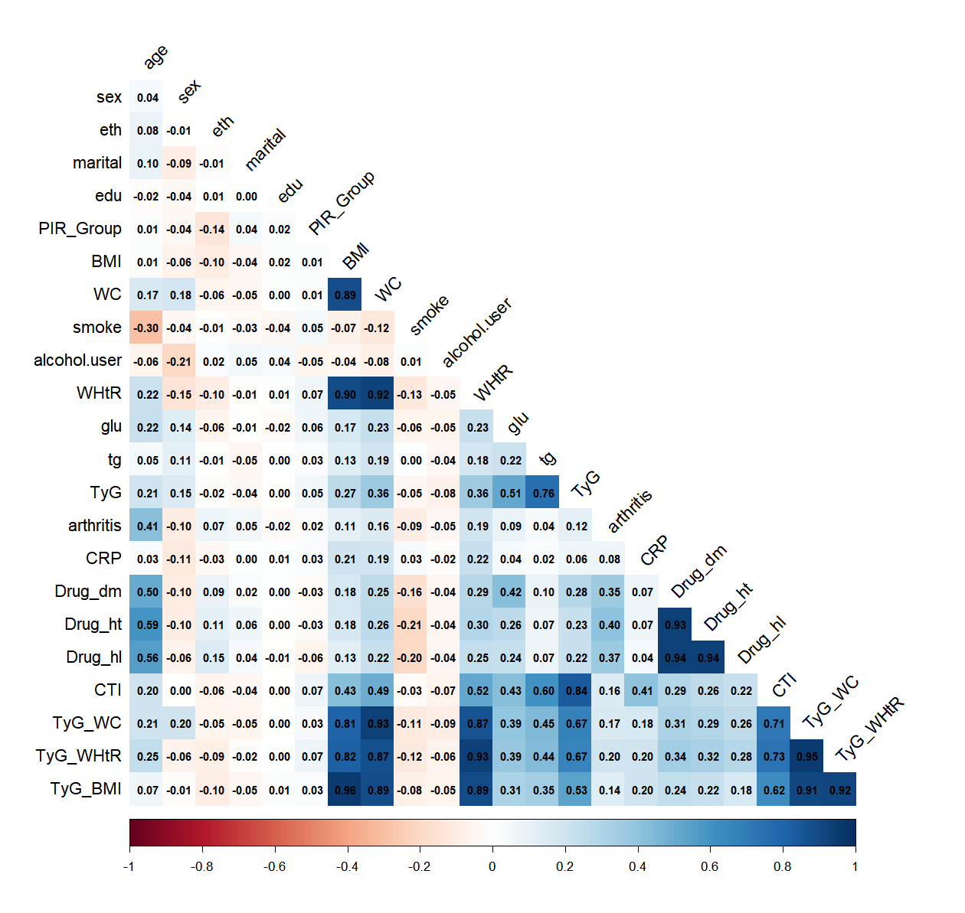
Figure S1. Collinearity heatmap of the variables.
note: Drug_dm: antidiabetic medications, Drug_ht:antihypertensive medications, Drug_hl:antihyperlipidemic medications

Table S1 Associations of CTI, TyG, and their derived indices with arthritis after combining Q2–Q4.
Categories | Model1 |  |  | Model2 |  |  | Model3
Categories | OR | 95% CI | P value | OR | 95% CI | P  value | OR | 95% CI | P value
CTI
Q1  (4.7581, 7.3445) | Ref. | Ref. |  | Ref. | Ref. |  | Ref. | Ref.
Q2-Q4  (7.3445, 13.2969) | 2.5116 | 2.1771,  2.8975 | <0.001 | 1.7213 | 1.4576,  2.0327 | <0.001 | 1.5220 | 1.2653,  1.8307 | <0.001
TyG
Q1  (6.6554,8.2260) | Ref. | Ref. |  | Ref. | Ref. |  | Ref. | Ref.
Q2-Q4  (8.2260, 13.4045) | 1.9725 | 1.7224,  2.2588 | <0.001 | 1.3746 | 1.1735,  1.6102 | <0.001 | 1.2044 | 1.0014,  1.4485 | 0.048
TyG-WHtR
Q1  (2.6850, 4.2687) | Ref. | Ref. |  | Ref. | Ref. |  | Ref. | Ref.
Q2-Q4  (4.2687,10.3396) | 2.4986 | 2.1276,  2.9344 | <0.001 | 1.5619 | 1.3034, 1.8716 | <0.001 | 1.4008 | 1.1399, 1.7214 | 0.002
TyG-WC
Q1  (431.5272, 721.46899) | Ref. | Ref. |  | Ref. | Ref. |  | Ref. | Ref.
Q2  (721.4689, 1638.9111) | 2.2602 | 1.9521, 2.6168 | <0.001 | 1.6549 | 1.4038, 1.9508 | <0.001 | 1.4832 | 1.2345, 1.7819 | <0.001
TyG-BMI
Q1  (116.2463, 201.0409) | Ref. | Ref. |  | Ref. | Ref. |  | Ref. | Ref.
Q2-Q4  (201.0409, 679.4618) | 1.8305 | 1.5895, 2.1080 | <0.001 | 1.5416 | 1.3160, 1.8059 | <0.001 | 1.4087 | 1.1851, 1.6744 | <0.001
Model one: Uncorrected for covariates
Model two: Adjusted for age, gender, race, education level, and PIR
Model three: Adjusted for age, sex, eth, education level, PIR, marital status, smoking status, alcohol consumption, metabolic drug use
Note: CTI, C-reactive protein-triglyceride glucose index; TyG, triglyceride-glucose index; TyG-BMI: triglyceride-glucose-body mass index; TyG-WC: triglyceride-glucose-waist circumference index; TyG-WHtR: triglyceride-glucose-waist-to-height ratio index; OR, odds ratio; 95% CI, 95% confidence interval.

Table S2.Associations of CTI, TyG, and their derived indices with arthritis after replacing diabetes, hypertension, and hyperlipidemia with metabolic medication use among adults with sarcopenia in NHANES 2000–2010 (n = 9567).
Categories | Model1 |  |  | Model2 |  |  | Model3
Categories | OR | 95% CI | P value | OR | 95% CI | P value | OR | 95% CI | P value
CTI
Continuous | 1.5962 | 1.4996, 1.6990 | <0.001 | 1.3402 | 1.2434, 1.4445 | <0.001 | 1.2478 | 1.1436, 1.3615 | <0.001
Quartile
Q1 | Ref. | Ref. |  | Ref. | Ref. |  | Ref. | Ref.
Q2 | 2.0495 | 1.7115, 2.4543 | <0.001 | 1.5086 | 1.2350, 1.8429 | <0.001 | 1.4433 | 1.1712, 1.7785 | <0.001
Q3 | 2.5524 | 2.1485, 3.0321 | <0.001 | 1.6336 | 1.3325, 2.0028 | <0.001 | 1.4817 | 1.2003, 1.8292 | <0.001
Q4 | 3.3588 | 2.8223, 3.9973 | <0.001 | 2.0833 | 1.6867, 2.5731 | <0.001 | 1.7251 | 1.3363, 2.2270 | <0.001
P for trend | 2.3674 | 2.0970,  2.6728 | <0.001 | 1.6555 | 1.4371, 1.9303 | <0.001 | 1.4502 | 1.2181, 1.7264 | 0.001
TyG
Continuous | 1.6251 | 1.5049, 1.7549 | <0.001 | 1.3137 | 1.1909, 1.4492 | <0.001 | 1.1566 | 1.0387, 1.2880 | 0.007
Quartile
Q1 | Ref. | Ref. |  | Ref. | Ref. |  | Ref. | Ref.
Q2 | 1.6519 | 1.3829, 1.9732 | <0.001 | 1.2968 | 1.0681, 1.5744 | 0.009 | 1.2968 | 0.9872, 1.5195 | 0.065
Q3 | 2.0711 | 1.7604, 2.4365 | <0.001 | 1.3953 | 1.1601, 1.6783 | <0.001 | 1.3953 | 1.0112, 1.5196 | 0.039
Q4 | 2.7219 | 2.2995, 3.2219 | <0.001 | 1.7528 | 1.4330, 2.1440 | <0.001 | 1.7528 | 1.1189, 1.8324 | 0.005
P for trend | 2.0591 | 1.8405,  2.3037 | <0.001 | 1.4812 | 1.2923, 1.6974 | <0.001 | 1.2757 | 1.0796, 1.5075 | 0.006
TyG-WHtR
Continuous | 1.6390 | 1.5414, 1.7427 | <0.001 | 1.3719 | 1.2745, 1.4767 | <0.001 | 1.3173 | 1.2080, 1.4366 | <0.001
Quartile
Q1 | Ref. | Ref. |  | Ref. | Ref. |  | Ref. | Ref.
Q2 | 1.7393 | 1.4314, 2.1135 | <0.001 | 1.2086 | 0.9721, 1.5025 | 0.087 | 1.1691 | 0.9220, 1.4823 | 0.2
Q3 | 2.5917 | 2.1017, 3.1958 | <0.001 | 1.5554 | 1.2335, 1.9614 | <0.001 | 1.4810 | 1.1502, 1.9069 | 0.003
Q4 | 3.9649 | 3.3319, 4.7182 | <0.001 | 2.1352 | 1.7583, 2.5928 | <0.001 | 1.8252 | 1.4436, 2.3077 | <0.001
P for trend | 2.7545 | 2.4285, 3.1242 | <0.001 | 1.7599 | 1.5281, 2.0269 | <0.001 | 1.5785 | 1.3350, 1.8664 | <0.001
TyG-WC
Continuous | 1.0024 | 1.0021, 1.0027 | <0.001 | 1.0020 | 1.0015, 1.0024 | <0.001 | 1.0017 | 1.0012, 1.0022 | <0.001
Quartile
Q1 | Ref. | Ref. |  | Ref. | Ref. |  | Ref. | Ref.
Q2 | 1.6199 | 1.3486, 1.9459 | <0.001 | 1.2637 | 1.0229, 1.5613 | 0.031 | 1.2342 | 0.9875, 1.5426 | 0.064
Q3 | 2.2608 | 1.8942, 2.6984 | <0.001 | 1.6446 | 1.3470, 2.0079 | <0.001 | 1.5688 | 1.2571, 1.9577 | <0.001
Q4 | 3.1342 | 2.6140, 3.7580 | <0.001 | 2.3162 | 1.8944, 2.8319 | <0.001 | 2.0088 | 1.5755, 2.5612 | <0.001
P for trend | 2.3184 | 2.0501, 2.6218 | <0.001 | 1.8633 | 1.6221, 2.1404 | <0.001 | 1.6846 | 1.4246, 1.9922 | <0.001
TyG-BMI
Continuous | 1.0054 | 1.0045, 1.0064 | <0.001 | 1.0052 | 1.0040, 1.0064 | <0.001 | 1.0048 | 1.0035, 1.0061 | <0.001
Quartile
Q1 | Ref. | Ref. |  | Ref. | Ref. |  | Ref. | Ref.
Q2 | 1.4270 | 1.1997, 1.6973 | <0.001 | 1.1541 | 0.9615, 1.3853 | 0.12 | 1.1469 | 0.9513, 1.3827 | 0.15
Q3 | 1.7728 | 1.4770, 2.1279 | <0.001 | 1.4392 | 1.1687, 1.7724 | <0.001 | 1.4276 | 1.1429, 1.7833 | 0.002
Q4 | 2.7049 | 2.2692, 3.2242 | <0.001 | 2.4002 | 1.9743, 2.9180 | <0.001 | 2.1965 | 1.7512, 2.7551 | <0.001
P for trend | 2.0463 | 1.8129, 2.3098 | <0.001 | 1.8902 | 1.6496, 2.1660 | <0.001 | 1.7804 | 1.5205, 2.0847 | <0.001
Model one: Uncorrected for covariates
Model two: Adjusted for age, gender, race, education level, and PIR
Model three: Adjusted for age, gender, race, education level, PIR, marital status, BMI, smoking status, alcohol consumption, diabetes, hypertension, and hyperlipidemia
Note: CTI, C-reactive protein-triglyceride glucose index; TyG, triglyceride-glucose index; TyG-BMI: triglyceride-glucose-body mass index; TyG-WC: triglyceride-glucose-waist circumference index; TyG-WHtR: triglyceride-glucose-waist-to-height ratio index; OR, odds ratio; 95% CI, 95% confidence interval.

Categories | Model1 |  |  | Model2 |  |  | Model3
Categories | OR | 95% CI | P value | OR | 95% CI | P value | OR | 95% CI | P value
CTI
Continuous | 1.5651 | 1.4615, 1.6760 | <0.001 | 1.3468 | 1.2407, 1.4620 | <0.001 | 1.2342 | 1.1238, 1.3555 | <0.001
Quartile
Q1(4.7581, 7.3445) | Ref. | Ref. |  | Ref. | Ref. |  | Ref. | Ref.
Q2(7.3445, 7.9717) | 1.7279 | 1.3893, 2.1492 | <0.001 | 1.2805 | 1.0040, 1.6333 | 0.046 | 1.1926 | 0.9286, 1.5317 | 0.200
Q3(7.9717, 8.5994) | 2.1610 | 1.8138, 2.5747 | <0.001 | 1.4670 | 1.2058, 1.7848 | <0.001 | 1.3008 | 1.0654, 1.5883 | 0.011
Q4(8.5994, 13.2969) | 2.9945 | 2.4760, 3.6216 | <0.001 | 1.9393 | 1.5500, 2.4263 | <0.001 | 1.5750 | 1.2291, 2.0182 | <0.001
P for trend | 2.1940 | 1.9248,  2.5010 | <0.001 | 1.6075 | 1.3787, 1.8743 | <0.001 | 1.3828 | 1.1661, 1.6398 | <0.001
TyG
Continuous | 1.6206 | 1.4707, 1.7858 | <0.001 | 1.3234 | 1.1734, 1.4926 | <0.001 | 1.1842 | 1.0347, 1.3554 | 0.012
Quartile
Q1(6.6554,8.2260) | Ref. | Ref. |  | Ref. | Ref. |  | Ref. | Ref.
Q2(8.2260, 8.6188) | 1.6001 | 1.2870, 1.9892 | <0.001 | 1.2457 | 0.9929, 1.5627 | 0.057 | 1.1679 | 0.9169, 1.4878 | 0.200
Q3(8.6188, 9.0551) | 2.0781 | 1.6757, 2.5770 | <0.001 | 1.4275 | 1.1325, 1.7994 | 0.003 | 1.2797 | 1.0066, 1.6268 | 0.044
Q4(9.0551, 13.4045) | 2.7103 | 2.2056, 3.3305 | <0.001 | 1.7538 | 1.3927, 2.2084 | <0.001 | 1.4601 | 1.1292, 1.8880 | 0.005
P for trend | 2.0695 | 1.7925,  2.3892 | <0.001 | 1.5028 | 1.2779, 1.7672 | <0.001 | 1.3157 | 1.0986, 1.5757 | 0.004
TyG-WHtR
Continuous | 1.6254 | 1.5175, 1.7411 | <0.001 | 1.3924 | 1.2795, 1.5153 | <0.001 | 1.3262 | 1.2096, 1.4541 | <0.001
Quartile
Q1(2.6850, 4.2687) | Ref. | Ref. |  | Ref. | Ref. |  | Ref. | Ref.
Q2(4.2687, 4.9413) | 1.7991 | 1.4245, 2.2723 | <0.001 | 1.2078 | 0.9301, 1.5683 | 0.200 | 1.1538 | 0.8837, 1.5065 | 0.300
Q3(4.9413, 5.6575) | 2.4813 | 1.9664, 3.1310 | <0.001 | 1.4578 | 1.1215, 1.8949 | 0.006 | 1.3582 | 1.0369, 1.7791 | 0.027
Q4(5.6575, 10.3396) | 3.8564 | 3.1474, 4.7251 | <0.001 | 2.1293 | 1.6895, 2.6836 | <0.001 | 1.8394 | 1.4334, 2.3603 | <0.001
P for trend | 2.6573 | 2.3025,  3.0668 | <0.001 | 1.7316 | 1.4707, 2.0389 | <0.001 | 1.5609 | 1.3090, 1.8613 | <0.001
TyG-WC
Continuous | 1.0024 | 1.0020, 1.0028 | <0.001 | 1.0021 | 1.0016, 1.0026 | <0.001 | 1.0018 | 1.0012, 1.0023 | <0.001
Quartile
Q1  (431.5272,721.46899) | Ref. | Ref. |  | Ref. | Ref. |  | Ref. | Ref.
Q2  (721.4689, 837.7003) | 1.7187 | 1.3814, 2.1383 | <0.001 | 1.3271 | 1.0361, 1.6999 | 0.026 | 1.2640 | 0.9811, 1.6285 | 0.069
Q3  (837.7003,962.5009) | 2.2449 | 1.7960, 2.8060 | <0.001 | 1.5653 | 1.2079, 2.0285 | 0.001 | 1.4695 | 1.1182, 1.9312 | 0.007
Q4  (962.5009,1638.9111) | 3.1978 | 2.5686, 3.9811 | <0.001 | 2.3981 | 1.8736, 3.0696 | <0.001 | 2.0823 | 1.6019, 2.7066 | <0.001
P for trend | 2.3153 | 1.9878, 2.6968 | <0.001 | 1.8658 | 1.5674, 2.2209 | <0.001 | 1.6916 | 1.4022, 2.0408 | <0.001
TyG-BMI
Continuous | 1.0056 | 1.0044, 1.0067 | <0.001 | 1.0055 | 1.0042, 1.0069 | <0.001 | 1.0050 | 1.0036, 1.0065 | <0.001
Quartile
Q1  (116.2463, 201.0409) | Ref. | Ref. |  | Ref. | Ref. |  | Ref. | Ref.
Q2  (201.0409, 238.7938) | 1.5939 | 1.3459, 1.8876 | <0.001 | 1.2162 | 1.0057, 1.4707 | 0.044 | 1.2020 | 0.9826, 1.4703 | 0.073
Q3  (238.7938, 283.3747) | 1.8956 | 1.5517, 2.3157 | <0.001 | 1.4832 | 1.1680, 1.8834 | 0.002 | 1.4389 | 1.1134, 1.8597 | 0.006
Q4  (283.3747, 679.4618) | 2.8155 | 2.3233, 3.4121 | <0.001 | 2.4475 | 1.9735, 3.0353 | <0.001 | 2.2471 | 1.7757, 2.8437 | <0.001
P for trend | 2.0816 | 1.8114, 2.3922 | <0.001 | 1.9056 | 1.6265, 2.2326 | <0.001 | 1.7921 | 1.5098, 2.1271 | <0.001
Model one: Uncorrected for covariates
Model two: Adjusted for age, gender, race, education level, and PIR
Model three: Adjusted for age, sex, eth, education level, PIR, marital status, smoking status, alcohol consumption, metabolic drug use,PA.
Note: CTI, C-reactive protein-triglyceride glucose index; TyG, triglyceride-glucose index; TyG-BMI: triglyceride-glucose-body mass index; TyG-WC: triglyceride-glucose-waist circumference index; TyG-WHtR: triglyceride-glucose-waist-to-height ratio index; OR, odds ratio; 95% CI, 95% confidence interval.PIR, poverty income ratio;PA, physical activity.

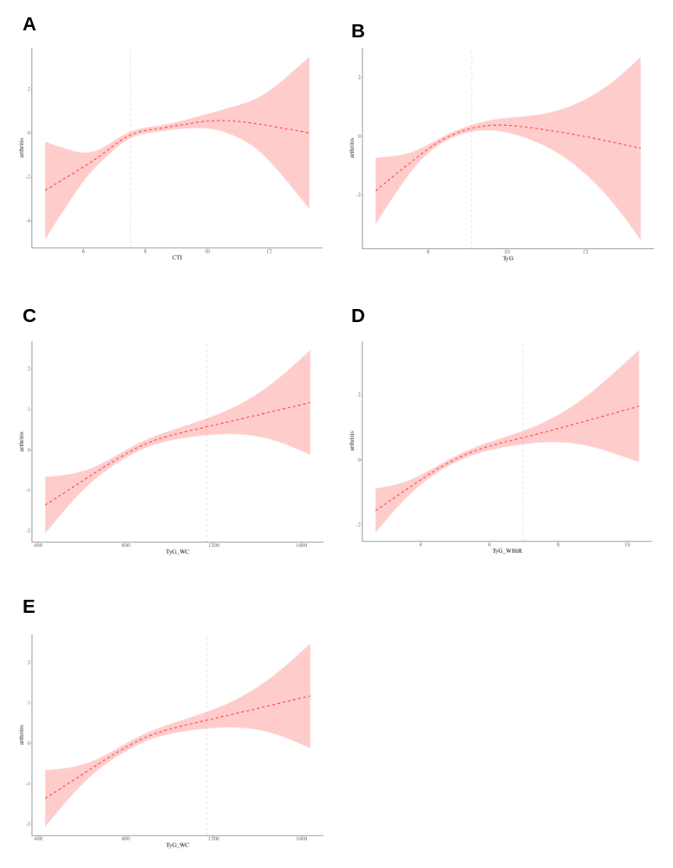
Figure S2 Threshold effect analysis plots of the associations between CTI, TyG, their derived indices, and arthritis.

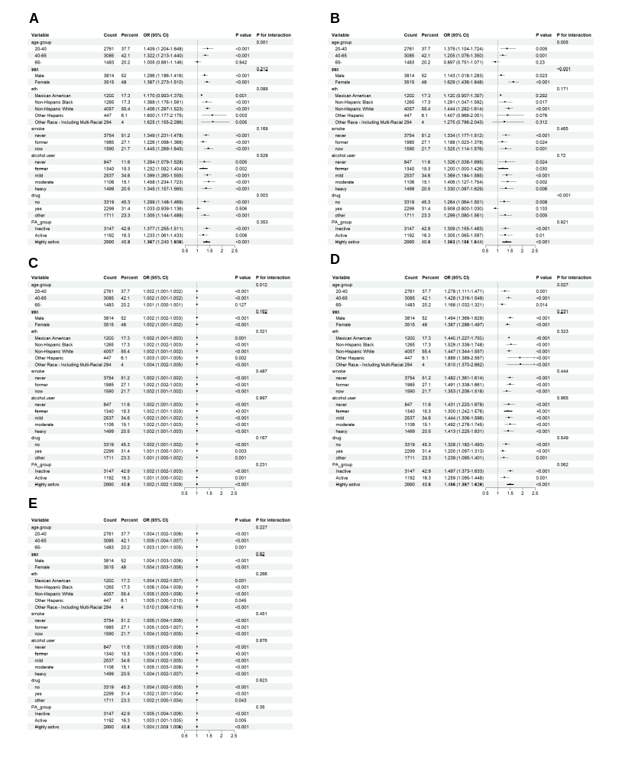
Figure S3 Subgroup analysis of the associations of CTI, TyG, TyG–BMI, TyG–WC, and TyG–WHtR with arthritis in Model 3 after adjusting for physical activity.

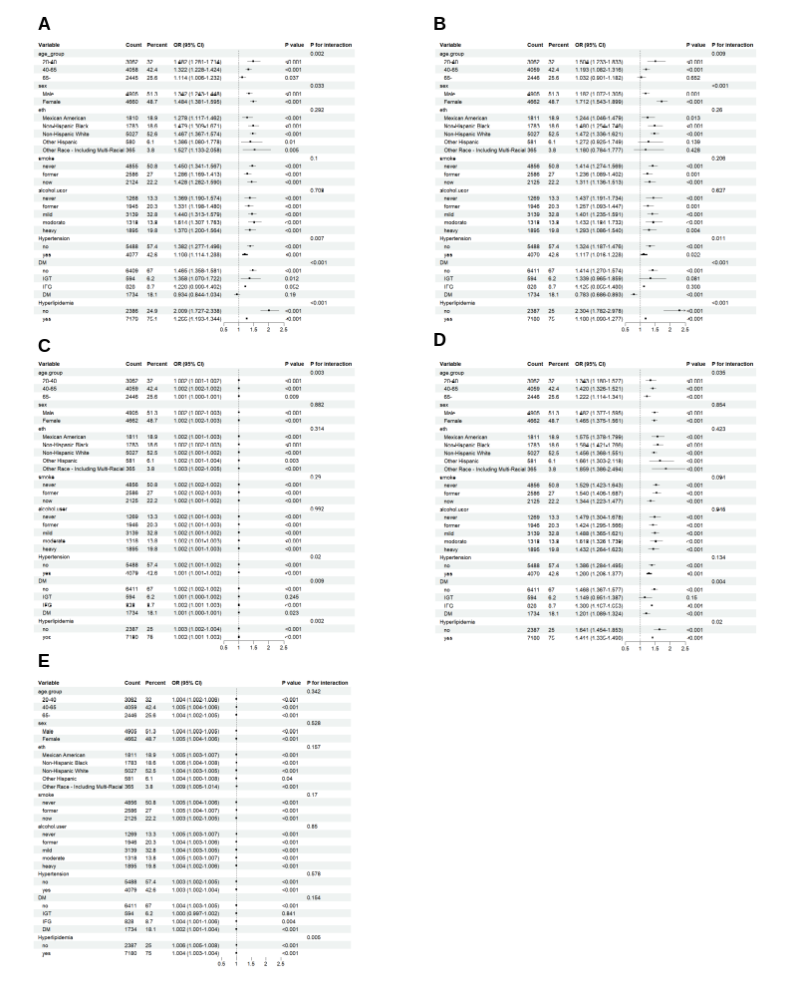
Figure S4 Subgroup analysis of the associations of CTI, TyG, TyG–BMI, TyG–WC, and TyG–WHtR with arthritis in Model 3 after replacing metabolic medication use with specific metabolic disease

