Supplementary Material 1: Composition of THP

Supplementary Figure 1: Isolation and characterization of polysaccharide. (A) Anion-exchange chromatogram of crude polysaccharides on a DEAE-52 cellulose column; 9 mL eluents were collected in each tube, and absorbance was measured at 490 nm. (B) Gel chromatographic on a Superdex-200 column; 6 mL eluents were collected in each tube, and absorbance was measured at 490 nm. (C) Monosaccharide composition of STHP-5. (D)Light scattering (LS) and refractive index (RI) signals of STHP-5. (E) Molar mass and Mw of STHP-5.

Supplementary Material 2: Abundance of other complement proteins
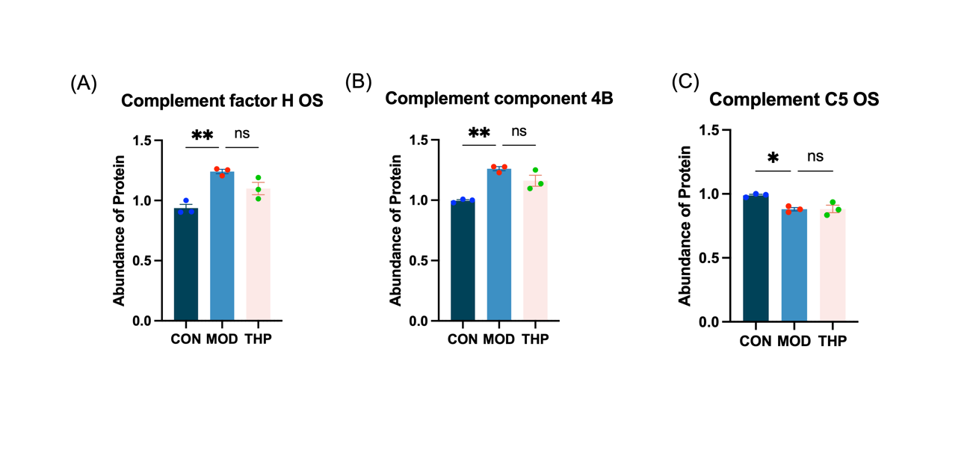
Supplementary Figure 2: Abundance of other complement proteins. (A) Abundance of complement factor H OS. (B) Abundance of complement component 4B. (C) Abundance of complement C5. * p < 0.01, ** p < 0.001, compared with the CON group.

