Supplementary data
S1 Searching Strategy and Databases:
A comprehensive literature search was performed in the following eight electronic databases from inception to July 2025:
English-language databases: PubMed, Cochrane Library, Web of Science (WOS), and Embase.
Chinese-language databases: China National Knowledge Infrastructure (CNKI), Wanfang Data, VIP Information (VIP), and SinoMed (China Biology Medicine, CBM).
No restrictions were applied regarding language, publication type, or publication status. Search strategies were adapted to the syntax and indexing terms of each database, using a combination of subject headings and free-text keywords.
PubMed: 15
#1 "fospropofol"[Supplementary Concept]
#2 "anesthesia, general"[MeSH Terms]
#3 ((((((((((fospropofol[Title/Abstract]) OR (fospropofol disodium[Title/Abstract])) OR (methanol, (2,6-bis(1-methylethyl)phenoxy)-, dihydrogen phosphate, disodium salt[Title/Abstract])) OR (GPI 15715[Title/Abstract])) OR (GPI15715[Title/Abstract])) OR (Aquavan[Title/Abstract])) OR (Lusedra[Title/Abstract])) OR (2, 6 diisopropylphenoxymethyl phosphate disodium[Title/Abstract])) OR (lusedra[Title/Abstract])) OR (pq 1002[Title/Abstract])) OR (pq1002[Title/Abstract])
#4 (((((Anesthesia, General[Title/Abstract]) OR (anaesthesia, general[Title/Abstract])) OR (general anaesthesia[Title/Abstract])) OR (Anesthesias, General[Title/Abstract])) OR (General Anesthesias[Title/Abstract])) OR (General Anesthesia[Title/Abstract])
#5 #1 OR #3
#6 #2 OR #4
#7 #5 AND #6
Cochrane Library: 27
#1 MeSH descriptor: [Anesthesia, General] explode all trees
#2 (Anesthesia, General):ti,ab,kw OR (anaesthesia, general):ti,ab,kw OR (general anaesthesia):ti,ab,kw OR (Anesthesias, General):ti,ab,kw OR (General Anesthesias):ti,ab,kw OR (General Anesthesia):ti,ab,kw
#3 (fospropofol):ti,ab,kw OR (fospropofol disodium):ti,ab,kw OR (GPI 15715):ti,ab,kw OR (GPI15715):ti,ab,kw OR (Aquavan):ti,ab,kw OR (Lusedra):ti,ab,kw OR (lusedra):ti,ab,kw OR (pq 1002):ti,ab,kw OR (pq1002):ti,ab,kw
#4 #1 OR #2
#5 #4 AND #3
Web Of Science: 49
#1 TS=(fospropofol OR fospropofol disodium OR methanol, (2,6-bis(1-methylethyl)phenoxy)-, dihydrogen phosphate, disodium salt OR GPI 15715 OR GPI15715 OR Aquavan OR Lusedra OR 2, 6 diisopropylphenoxymethyl phosphate disodium OR lusedra OR pq 1002 OR pq1002)
#2 TS=(Anesthesia, General OR anaesthesia, general OR general anaesthesia OR Anesthesias, General OR General Anesthesias OR General Anesthesia)
#3 #1 AND #2
Embase: 58
#1 'fospropofol'/exp
#2 'anesthesia, general'/exp
#3 'fospropofol':ti,ab,kw OR 'fospropofol disodium':ti,ab,kw OR 'methanol, (2,6-bis(1-methylethyl)phenoxy)-, dihydrogen phosphate, disodium salt':ti,ab,kw OR 'gpi 15715':ti,ab,kw OR 'gpi15715':ti,ab,kw OR 'aquavan':ti,ab,kw OR '2, 6 diisopropylphenoxymethyl phosphate disodium':ti,ab,kw OR 'lusedra':ti,ab,kw OR 'pq 1002':ti,ab,kw OR 'pq1002':ti,ab,kw
#4 'anesthesia, general':ti,ab,kw OR 'anaesthesia, general':ti,ab,kw OR 'general anaesthesia':ti,ab,kw OR 'anesthesias, general':ti,ab,kw OR 'general anesthesias':ti,ab,kw OR 'general anesthesia':ti,ab,kw
#5 #1 OR #3
#6 #2 OR #4
#7 #5 AND #6
CNKI: 13
(SU='磷丙泊酚' OR SU='磷丙泊酚二钠' OR SU='磷丙泊酚钠') AND (SU='全身麻醉' OR SU='麻醉, 全身' OR SU='麻醉')
Wanfang Data: 250
(主题=磷丙泊酚 OR 主题=磷丙泊酚二钠 OR 主题=磷丙泊酚钠) AND (主题=全身麻醉 OR 主题=麻醉, 全身 OR 主题=麻醉)
VIP: 320
(M=磷丙泊酚 + M=磷丙泊酚二钠 + M=磷丙泊酚钠) * (M=全身麻醉 + M="麻醉, 全身" + M=麻醉)
SinoMed: 11
("磷丙泊酚"[常用字段:智能] OR "磷丙泊酚二钠"[常用字段:智能] OR "磷丙泊酚钠"[常用字段:智能]) AND ("全身麻醉"[常用字段:智能] OR "麻醉, 全身"[常用字段:智能] OR "麻醉"[常用字段:智能])

Table S1. Trim-and-fill analysis results for all outcomes.
Item | Induction success rate | Injection pain
number of study | 11 | 16
studies trimmed | 11 | 16
Effect size | 0.983 | 0.282
(95%CI) | (0.949,1.002) | （0.220,0.363）

Table S2. PRISMA 2020 Checklist for Reporting of the Systematic Review and Meta-analysis.
Section and Topic | Item # | Checklist item | Location where item is reported
TITLE
Title | 1 | Identify the report as a systematic review. | 1
ABSTRACT
Abstract | 2 | See the PRISMA 2020 for Abstracts checklist. | 2-3
INTRODUCTION
Rationale | 3 | Describe the rationale for the review in the context of existing knowledge. | 4-5
Objectives | 4 | Provide an explicit statement of the objective(s) or question(s) the review addresses. | 5
METHODS
Eligibility criteria | 5 | Specify the inclusion and exclusion criteria for the review and how studies were grouped for the syntheses. | 5
Information sources | 6 | Specify all databases, registers, websites, organisations, reference lists and other sources searched or consulted to identify studies. Specify the date when each source was last searched or consulted. | 5
Search strategy | 7 | Present the full search strategies for all databases, registers and websites, including any filters and limits used. | 5
Selection process | 8 | Specify the methods used to decide whether a study met the inclusion criteria of the review, including how many reviewers screened each record and each report retrieved, whether they worked independently, and if applicable, details of automation tools used in the process. | 6
Data collection process | 9 | Specify the methods used to collect data from reports, including how many reviewers collected data from each report, whether they worked independently, any processes for obtaining or confirming data from study investigators, and if applicable, details of automation tools used in the process. | 6
Data items | 10a | List and define all outcomes for which data were sought. Specify whether all results that were compatible with each outcome domain in each study were sought (e.g. for all measures, time points, analyses), and if not, the methods used to decide which results to collect. | 6-7
Data items | 10b | List and define all other variables for which data were sought (e.g. participant and intervention characteristics, funding sources). Describe any assumptions made about any missing or unclear information. | 6-7
Study risk of bias assessment | 11 | Specify the methods used to assess risk of bias in the included studies, including details of the tool(s) used, how many reviewers assessed each study and whether they worked independently, and if applicable, details of automation tools used in the process. | 7
Effect measures | 12 | Specify for each outcome the effect measure(s) (e.g. risk ratio, mean difference) used in the synthesis or presentation of results. | 7-8
Synthesis methods | 13a | Describe the processes used to decide which studies were eligible for each synthesis (e.g. tabulating the study intervention characteristics and comparing against the planned groups for each synthesis (item #5)). | 6
Synthesis methods | 13b | Describe any methods required to prepare the data for presentation or synthesis, such as handling of missing summary statistics, or data conversions. | 7-8
Synthesis methods | 13c | Describe any methods used to tabulate or visually display results of individual studies and syntheses. | 7-8
Synthesis methods | 13d | Describe any methods used to synthesize results and provide a rationale for the choice(s). If meta-analysis was performed, describe the model(s), method(s) to identify the presence and extent of statistical heterogeneity, and software package(s) used. | 7-8
Synthesis methods | 13e | Describe any methods used to explore possible causes of heterogeneity among study results (e.g. subgroup analysis, meta-regression). | 7-8
Synthesis methods | 13f | Describe any sensitivity analyses conducted to assess robustness of the synthesized results. | 7-8
Reporting bias assessment | 14 | Describe any methods used to assess risk of bias due to missing results in a synthesis (arising from reporting biases). | 7-8
Certainty assessment | 15 | Describe any methods used to assess certainty (or confidence) in the body of evidence for an outcome. | 8
RESULTS
Study selection | 16a | Describe the results of the search and selection process, from the number of records identified in the search to the number of studies included in the review, ideally using a flow diagram. | 8-9
Study selection | 16b | Cite studies that might appear to meet the inclusion criteria, but which were excluded, and explain why they were excluded. | 6
Study characteristics | 17 | Cite each included study and present its characteristics. | 8-9
Risk of bias in studies | 18 | Present assessments of risk of bias for each included study. | 8-9
Results of individual studies | 19 | For all outcomes, present, for each study: (a) summary statistics for each group (where appropriate) and (b) an effect estimate and its precision (e.g. confidence/credible interval), ideally using structured tables or plots. | 9-15
Results of syntheses | 20a | For each synthesis, briefly summarise the characteristics and risk of bias among contributing studies. | 9-15
Results of syntheses | 20b | Present results of all statistical syntheses conducted. If meta-analysis was done, present for each the summary estimate and its precision (e.g. confidence/credible interval) and measures of statistical heterogeneity. If comparing groups, describe the direction of the effect. | 9-15
Results of syntheses | 20c | Present results of all investigations of possible causes of heterogeneity among study results. | 15-16
Results of syntheses | 20d | Present results of all sensitivity analyses conducted to assess the robustness of the synthesized results. | 19-20
Reporting biases | 21 | Present assessments of risk of bias due to missing results (arising from reporting biases) for each synthesis assessed. | 9-15
Certainty of evidence | 22 | Present assessments of certainty (or confidence) in the body of evidence for each outcome assessed. | 9-15
DISCUSSION
Discussion | 23a | Provide a general interpretation of the results in the context of other evidence. | 16
Discussion | 23b | Discuss any limitations of the evidence included in the review. | 19-21
Discussion | 23c | Discuss any limitations of the review processes used. | 19-21
Discussion | 23d | Discuss implications of the results for practice, policy, and future research. | 16-21
OTHER INFORMATION
Registration and protocol | 24a | Provide registration information for the review, including register name and registration number, or state that the review was not registered. | 23
Registration and protocol | 24b | Indicate where the review protocol can be accessed, or state that a protocol was not prepared. | 23
Registration and protocol | 24c | Describe and explain any amendments to information provided at registration or in the protocol. | 23
Support | 25 | Describe sources of financial or non-financial support for the review, and the role of the funders or sponsors in the review. | 23
Competing interests | 26 | Declare any competing interests of review authors. | 23
Availability of data, code and other materials | 27 | Report which of the following are publicly available and where they can be found: template data collection forms; data extracted from included studies; data used for all analyses; analytic code; any other materials used in the review. | 23

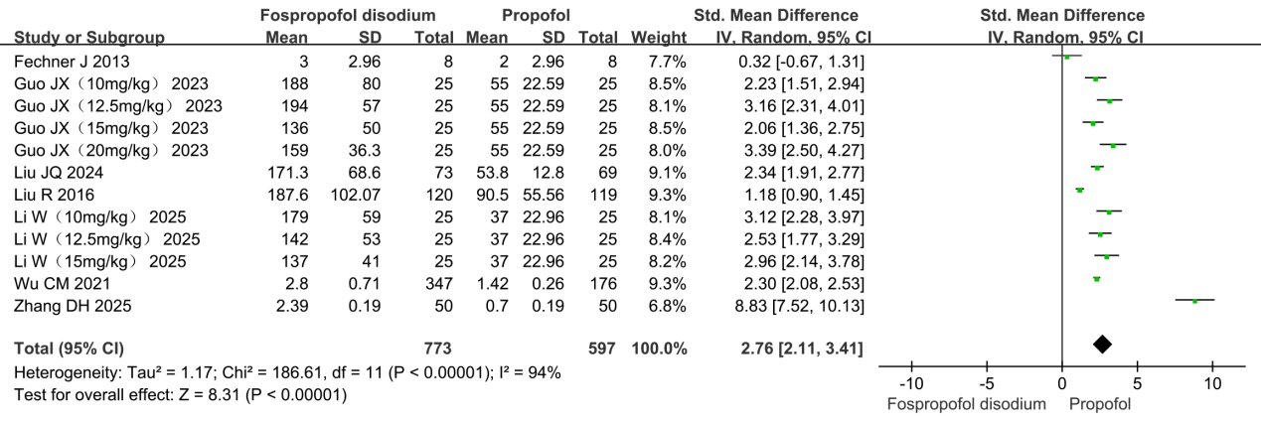
Figure S1. Forest plot comparing anesthesia induction time between fospropofol disodium and propofol during general anesthesia induction.

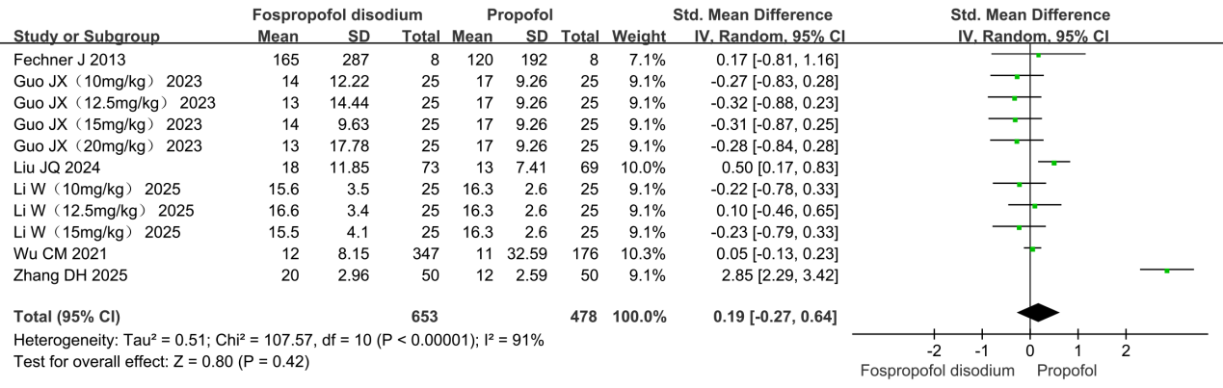
Figure S2. Forest plot comparing recovery time between fospropofol disodium and propofol during general anesthesia induction.

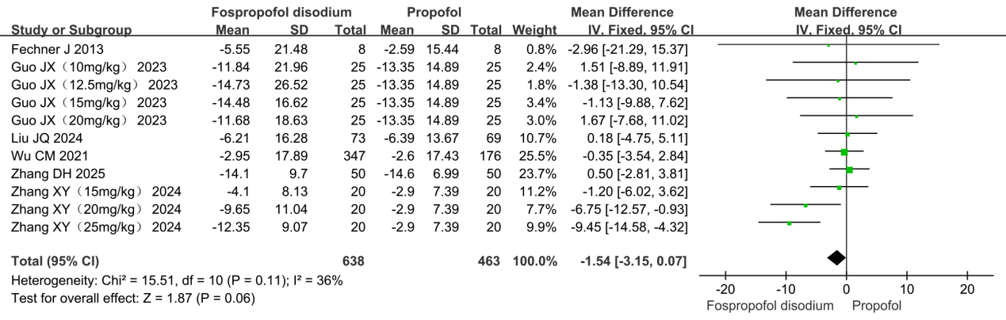
Figure S3. Forest plot of heart rate change during induction: fospropofol disodium vs. propofol.

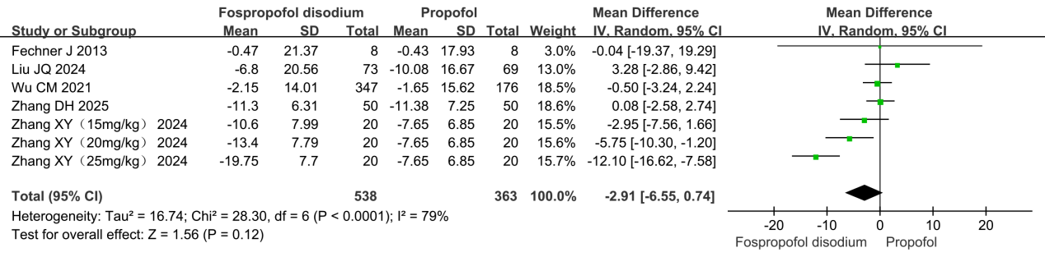
Figure S4. Forest plot of mean arterial pressure change during Induction: fospropofol disodium vs. propofol.

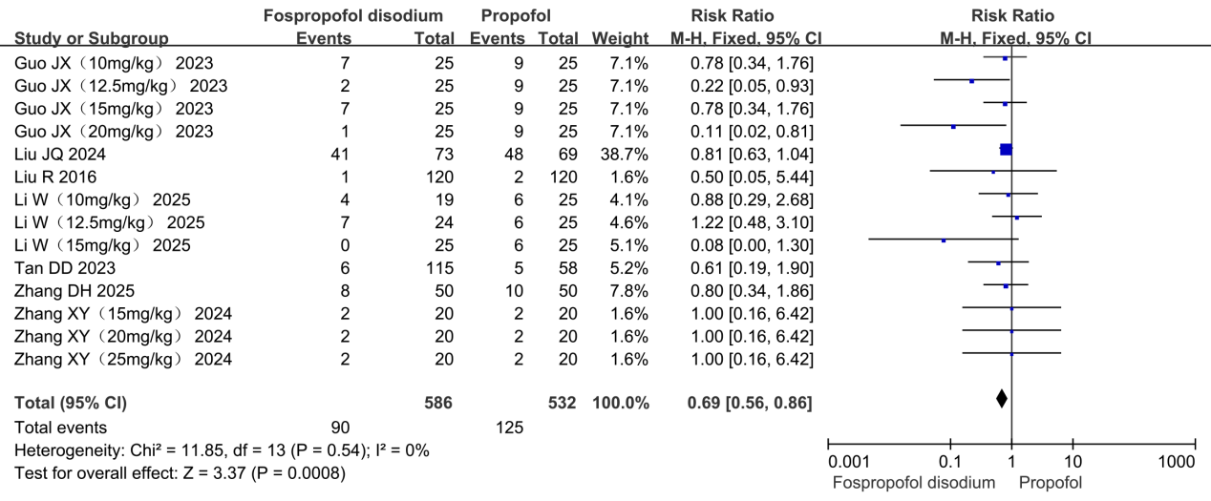
Figure S5. Forest plot comparing the incidence of bradycardia between fospropofol disodium and propofol during general anesthesia induction.

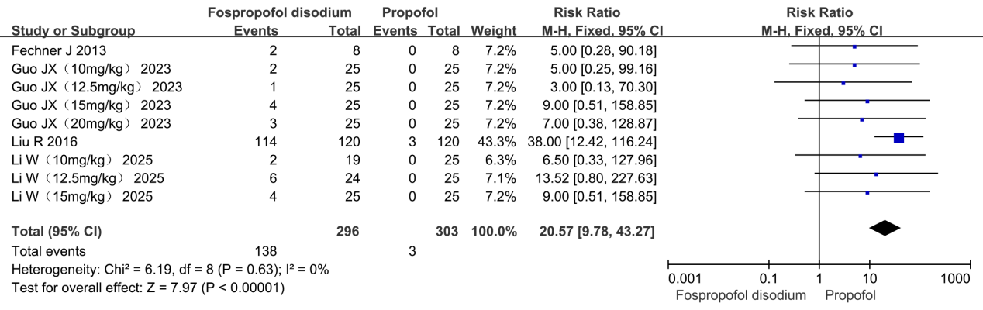
Figure S6. Forest plot comparing the incidence of pruritus between fospropofol disodium and propofol during general anesthesia induction.

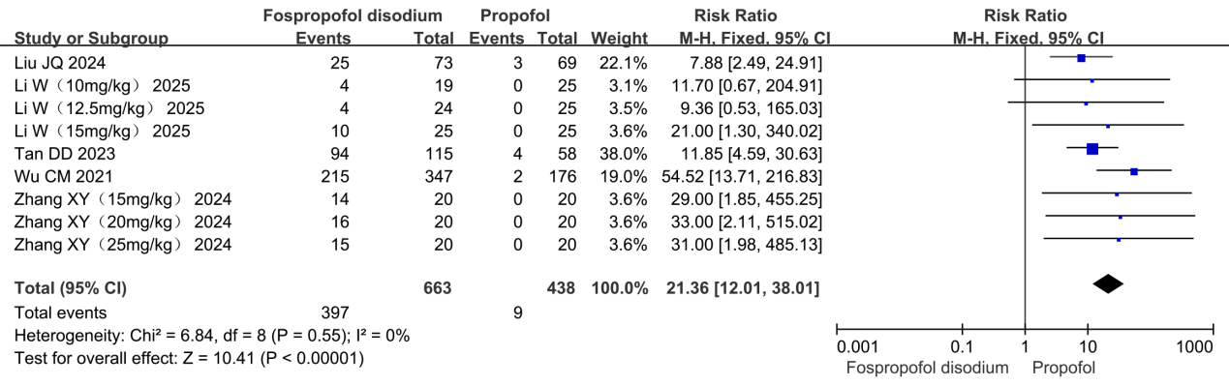
Figure S7. Forest plot comparing the incidence of paresthesia between fospropofol disodium and propofol during general anesthesia induction.

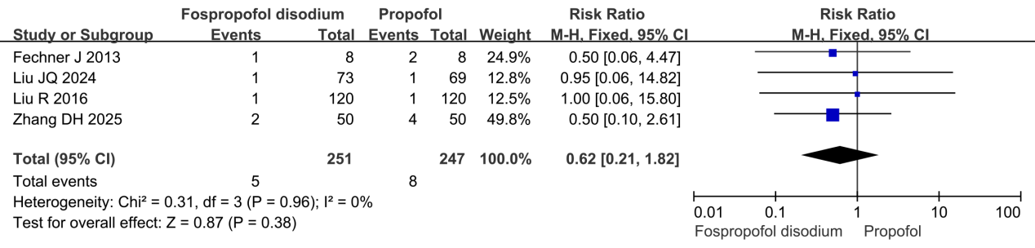
Figure S8. Forest plot comparing the incidence of nausea between fospropofol disodium and propofol during general anesthesia induction.

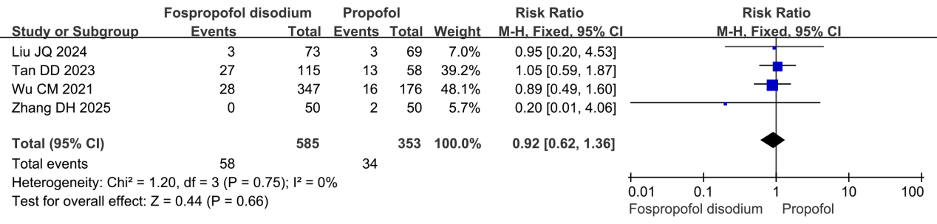
Figure S9. Forest plot comparing the incidence of oxygen desaturation between fospropofol disodium and propofol during general anesthesia induction.

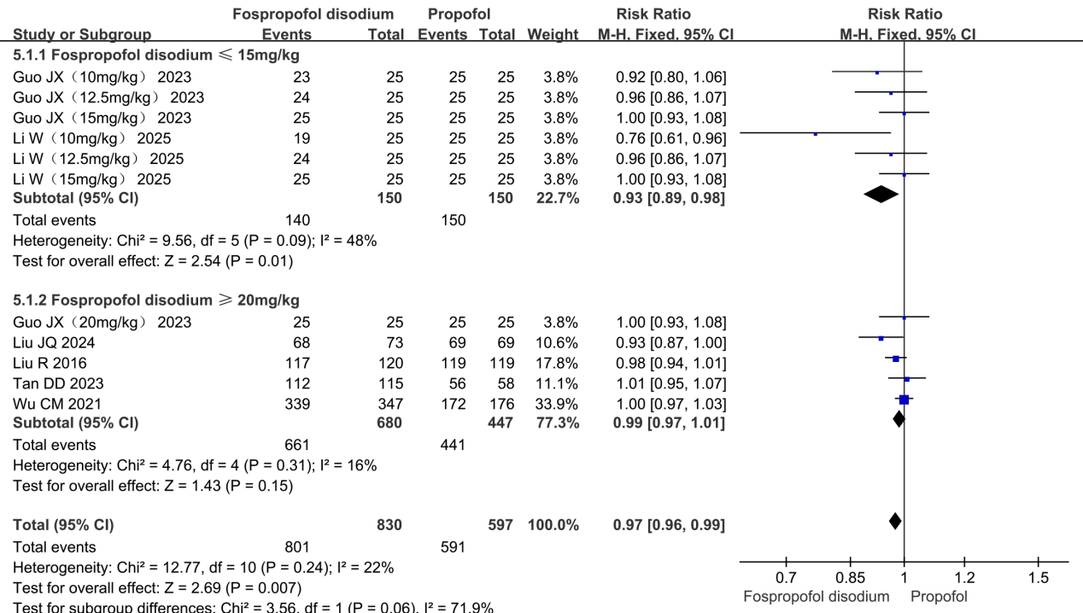
Figure S10. Subgroup analysis forest plot of induction success rate comparing fospropofol disodium and propofol.

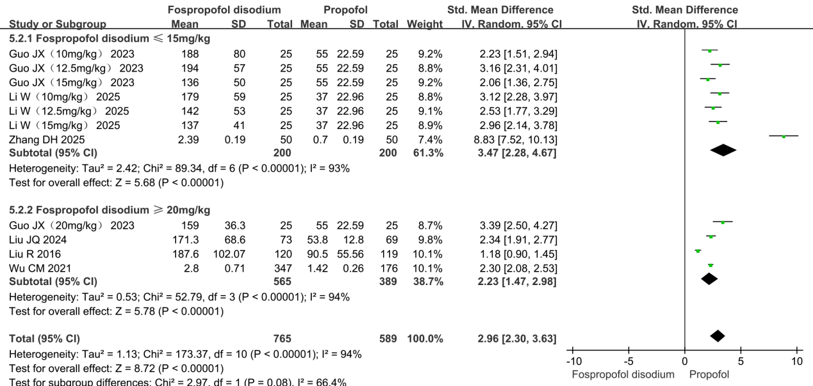
Figure S11. Subgroup analysis forest plot of anesthesia induction time comparing fospropofol disodium and propofol.

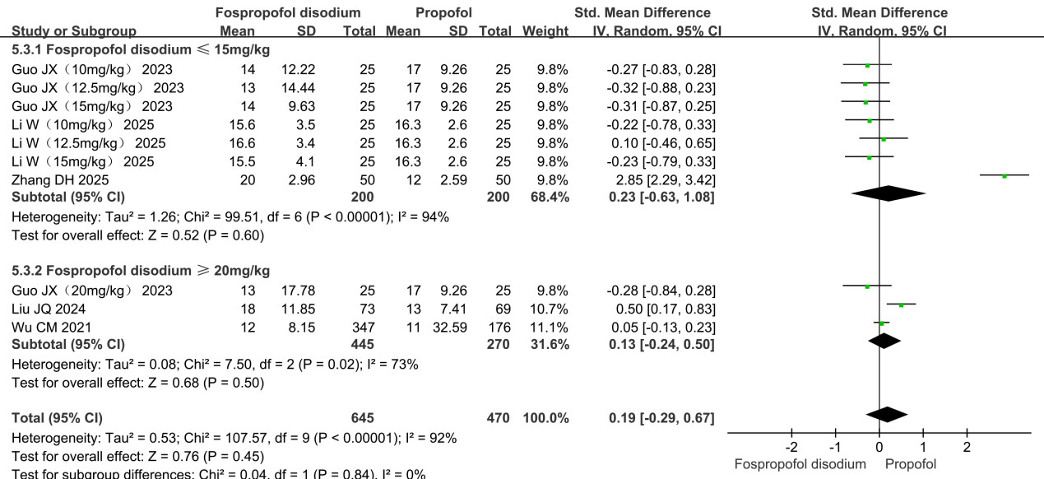
Figure S12. Subgroup analysis forest plot of recovery time comparing fospropofol disodium and propofol.

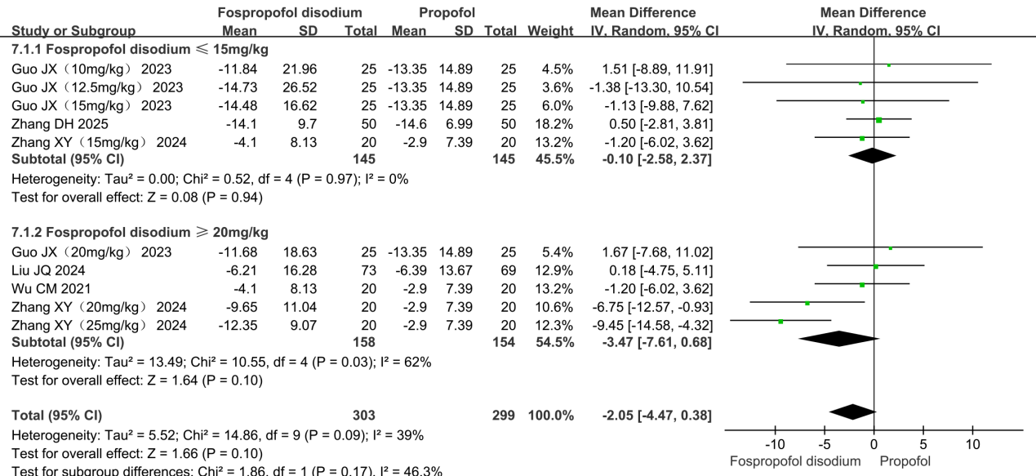
Figure S13. Subgroup analysis forest plot of heart rate change during induction comparing fospropofol disodium and propofol.

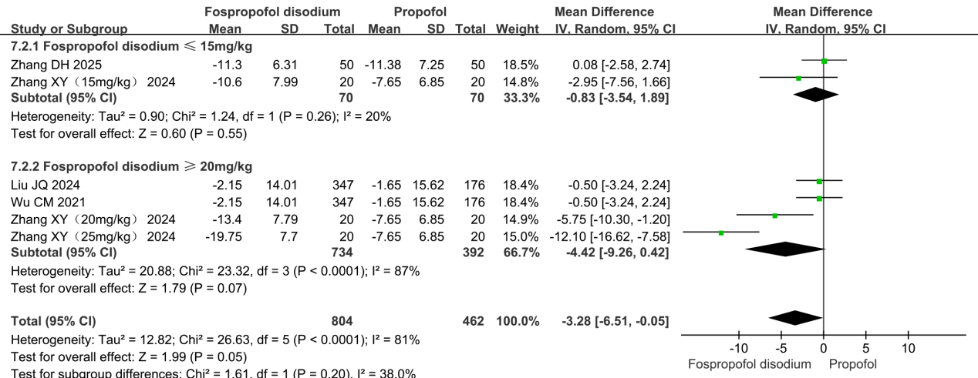
Figure S14. Subgroup analysis forest plot of mean arterial pressure change during induction comparing fospropofol disodium and propofol.

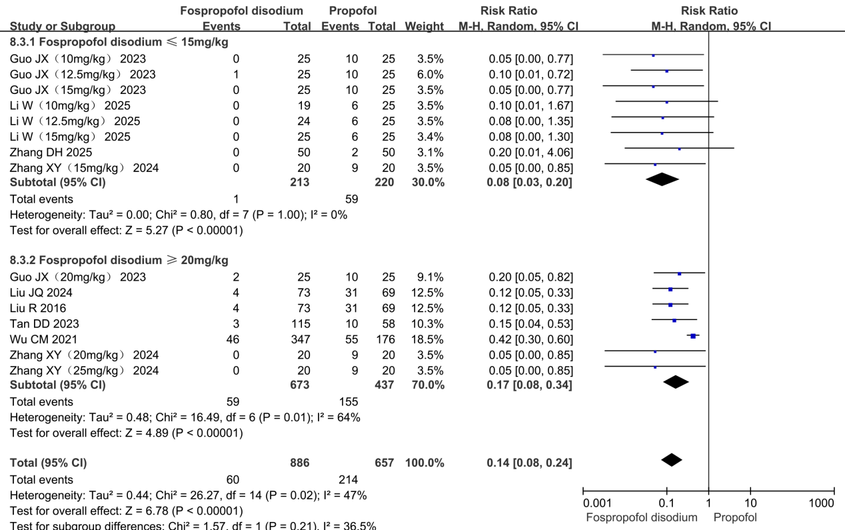
Figure S15. Subgroup analysis forest plot of the incidence of injection pain comparing fospropofol disodium and propofol.

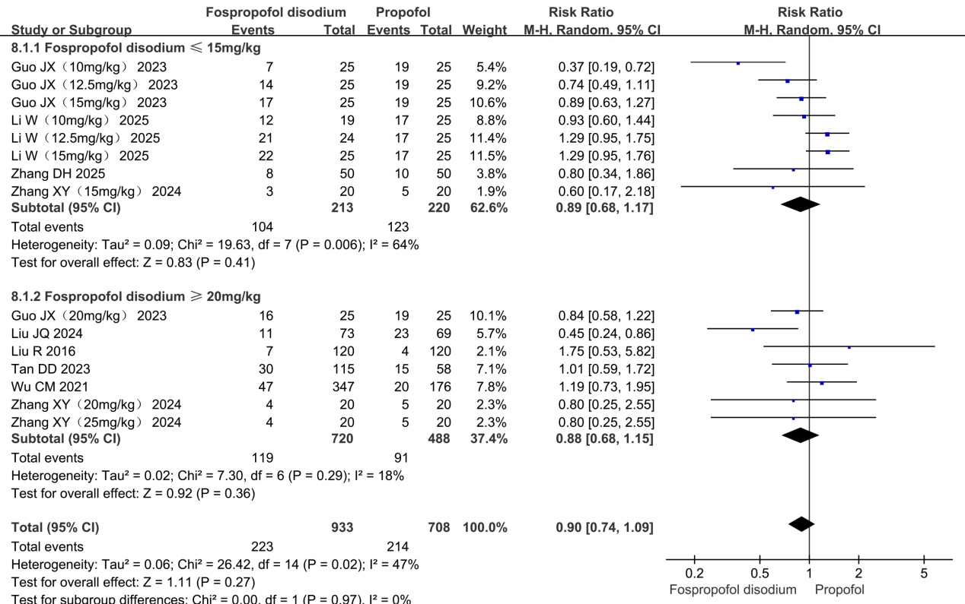
Figure S16. Subgroup analysis forest plot of the incidence of hypotension comparing fospropofol disodium and propofol.

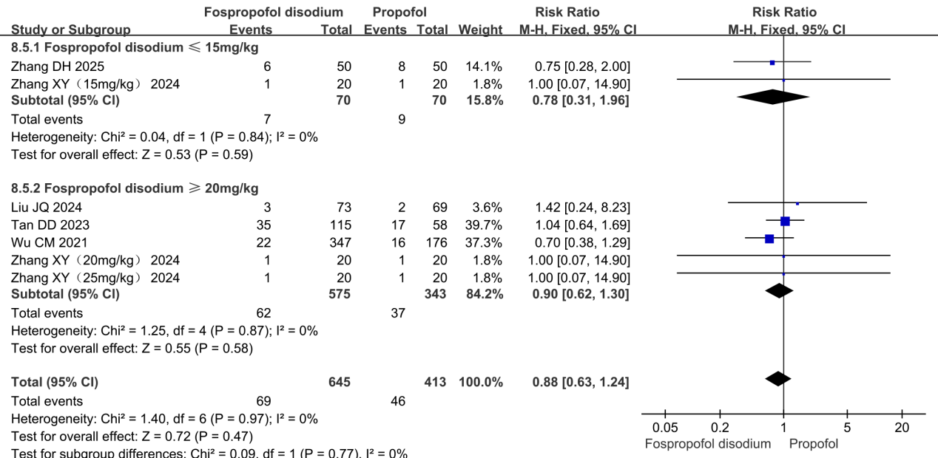
Figure S17. Subgroup analysis forest plot of the incidence of hypertension comparing fospropofol disodium and propofol.

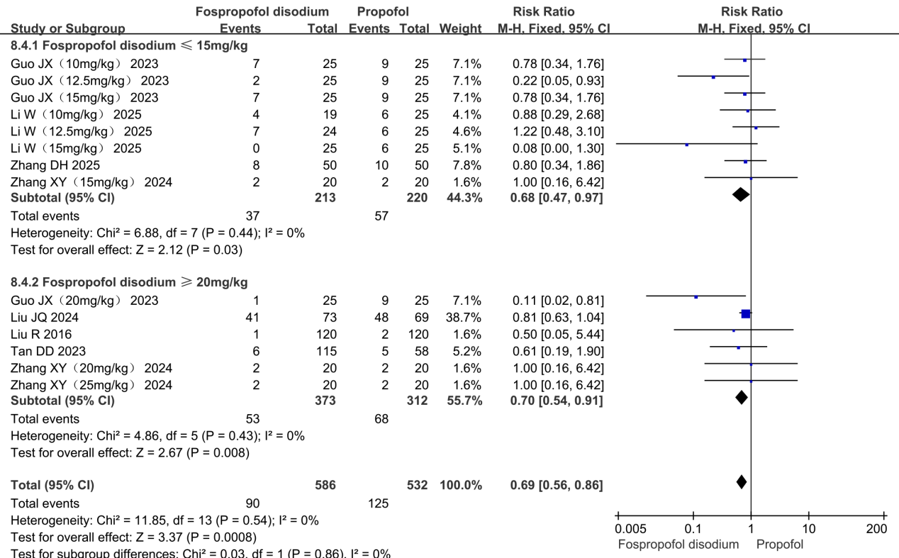
Figure S18. Subgroup analysis forest plot of the incidence of bradycardia comparing fospropofol disodium and propofol.

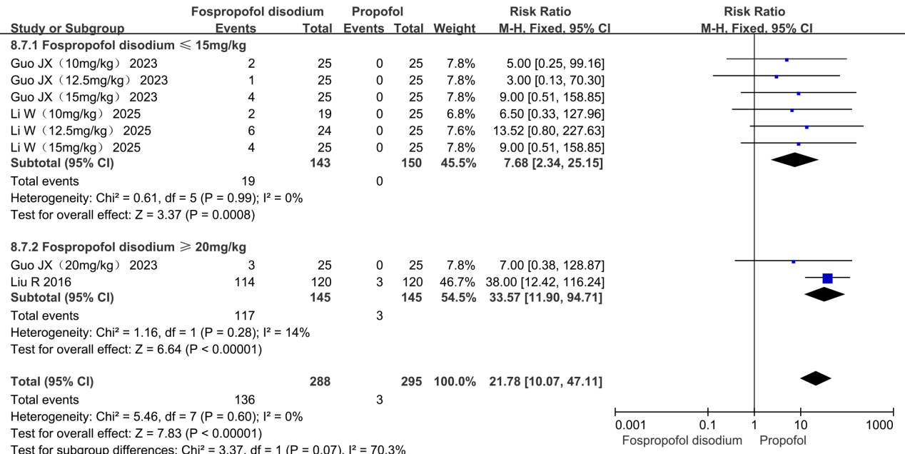
Figure S19. Subgroup analysis forest plot of the incidence of pruritus comparing fospropofol disodium and propofol.

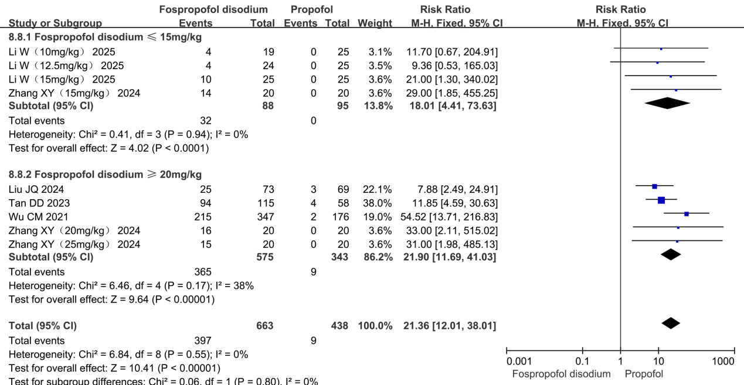
Figure S20. Subgroup analysis forest plot of the incidence of paresthesia comparing fospropofol disodium and propofol.

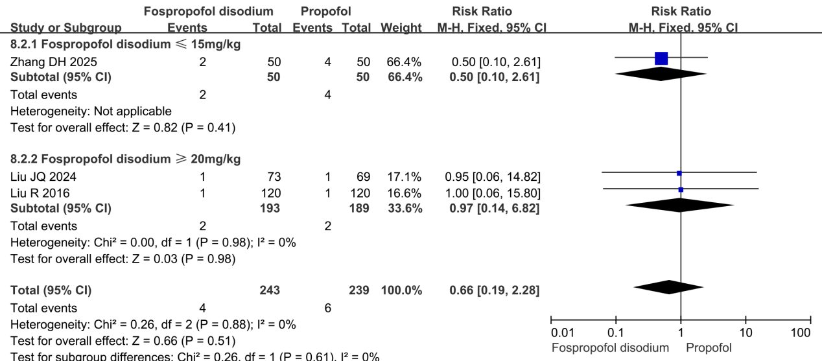
Figure S21. Subgroup analysis forest plot of the incidence of nausea comparing fospropofol disodium and propofol.

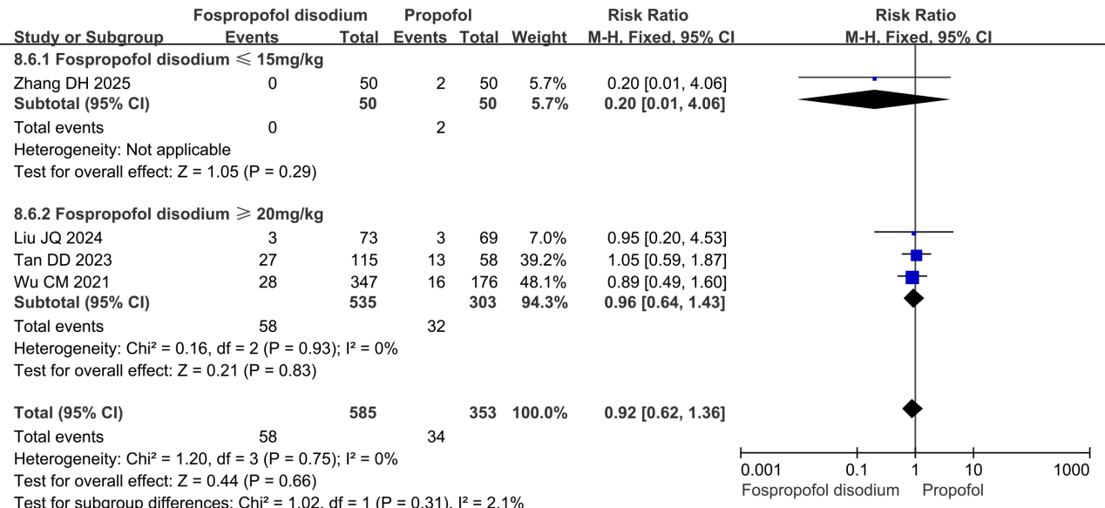
Figure S22. Subgroup analysis forest plot of the incidence of oxygen desaturation comparing fospropofol disodium and propofol.

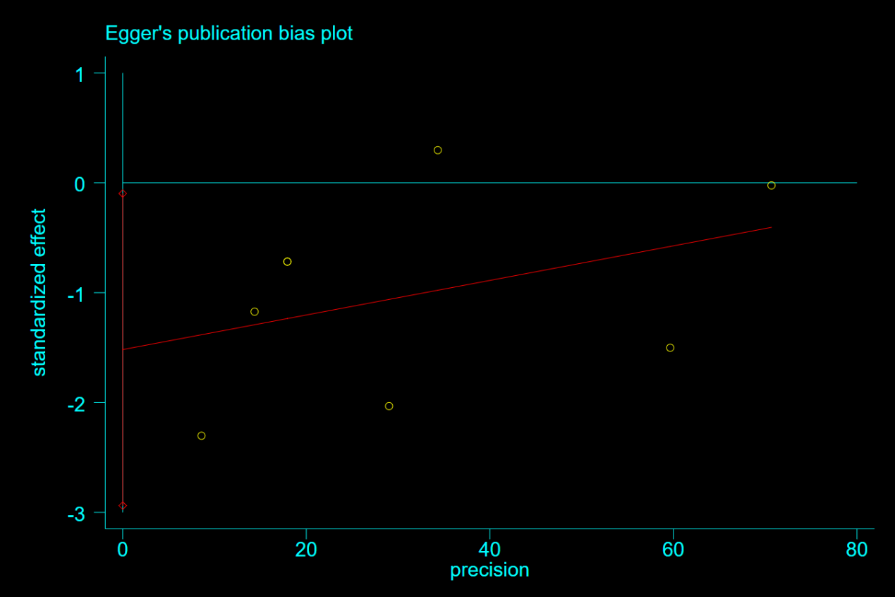
Figure S23. Egger’s test plot for publication bias assessment of induction success rate.

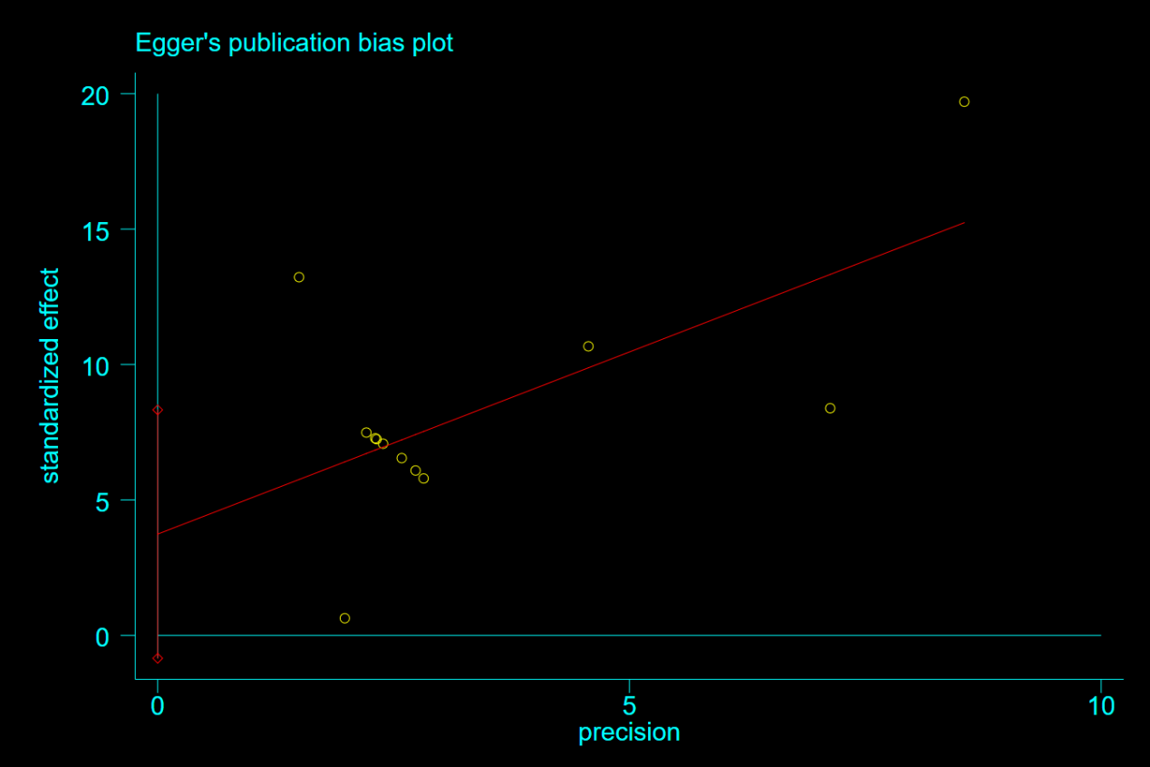
Figure S24. Egger’s test plot for publication bias assessment of anesthesia induction time.

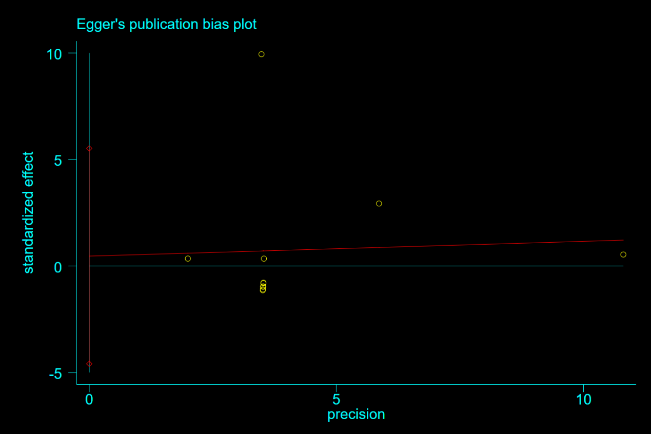
Figure S25. Egger’s test plot for publication bias assessment of recovery time.

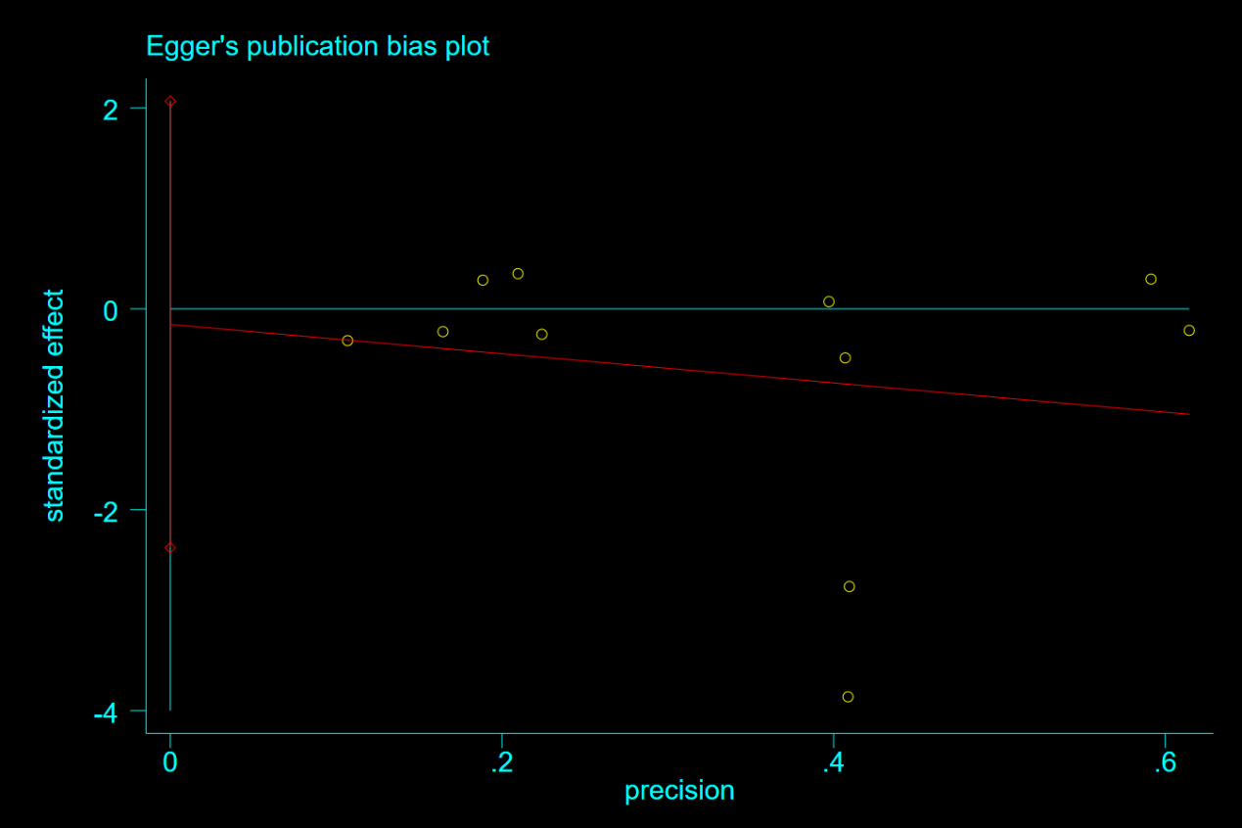
Figure S26. Egger’s test plot for publication bias assessment of heart rate change during induction.

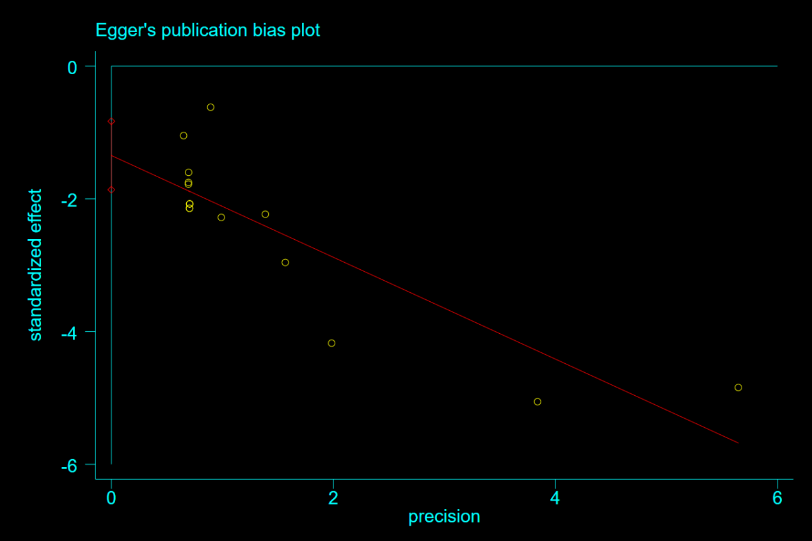
Figure S27. Egger’s test plot for publication bias assessment of injection pain.

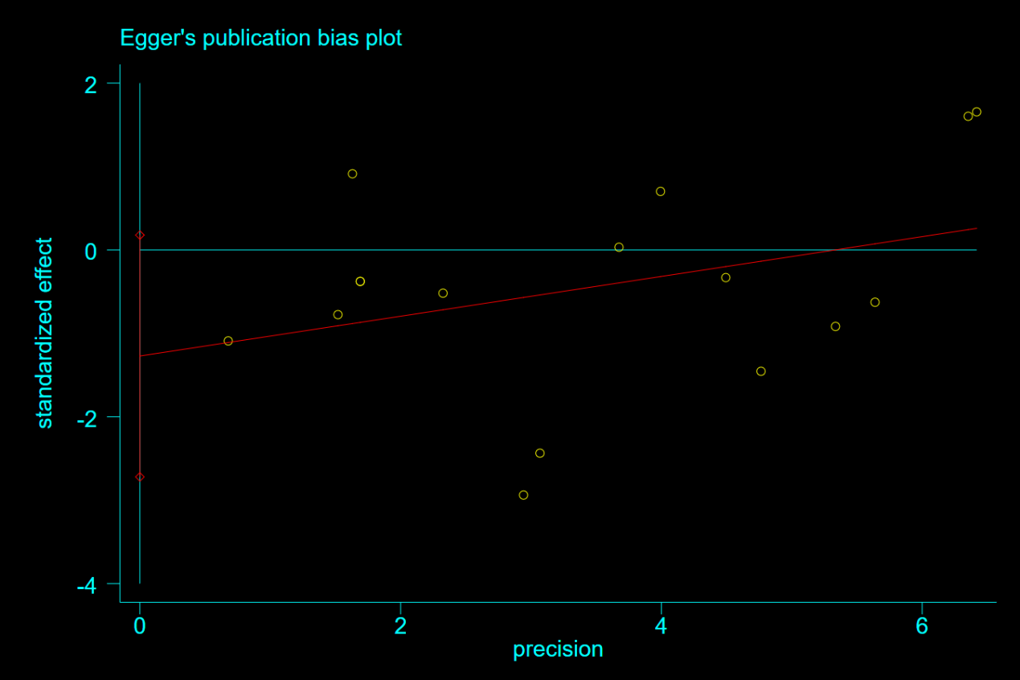
Figure S28. Egger’s test plot for publication bias assessment of hypotension.

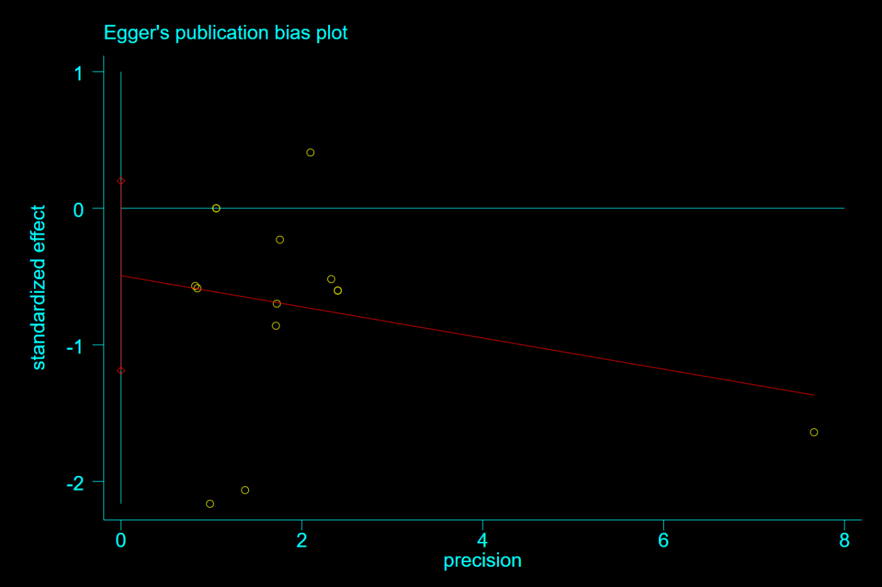
Figure S29. Egger’s test plot for publication bias assessment of bradycardia.

