Sensitivity analysis
- Sensitivity analysis of study between bALP and bone metastases (U/L)
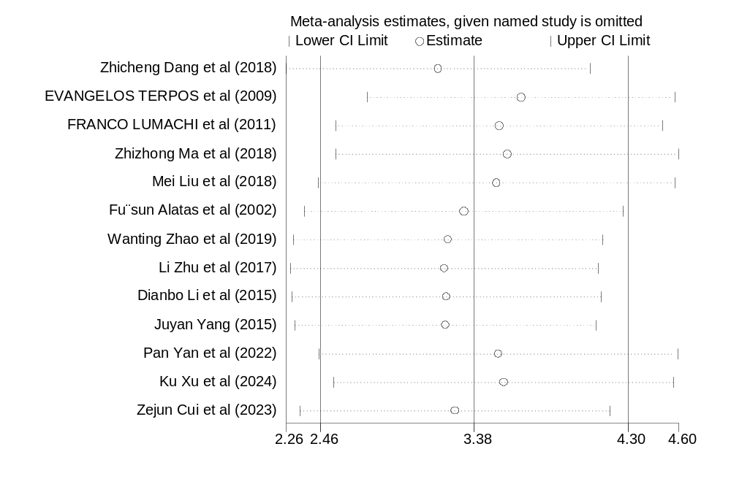
- Sensitivity analysis of study between bALP and bone metastases (μg/l)
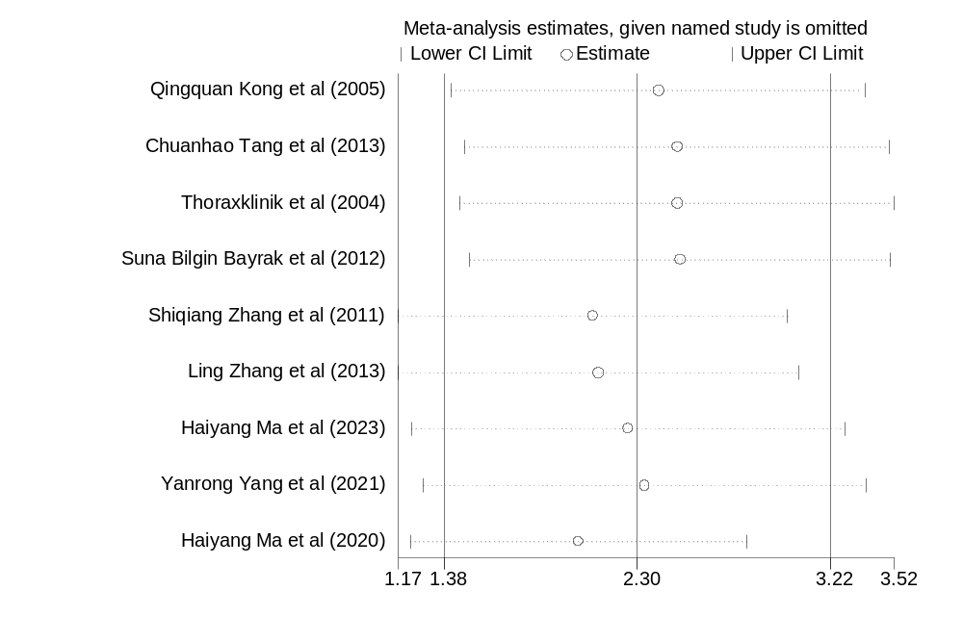

- Sensitivity analysis of study between BSP and bone metastases (ng/ml)
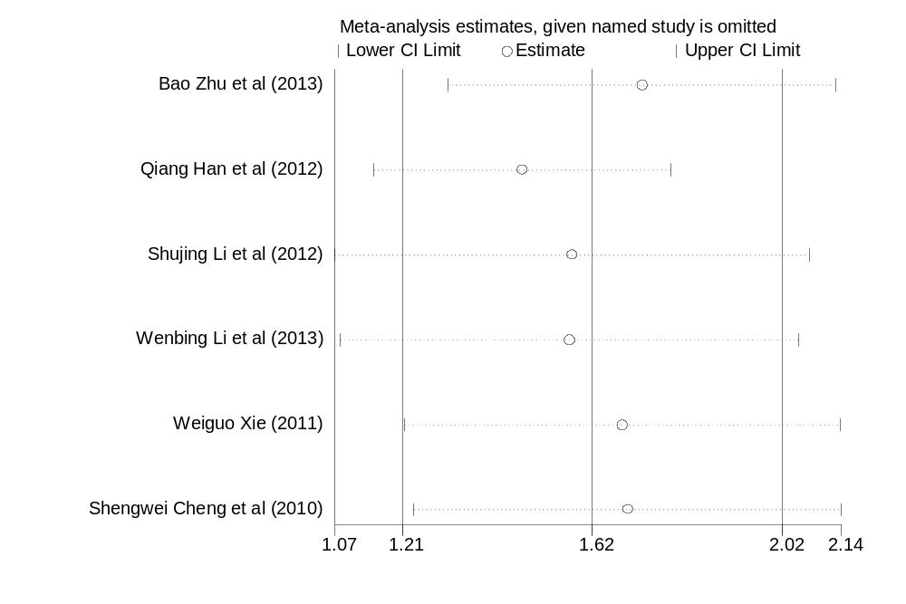
- Sensitivity analysis of study between calcium and bone metastases (mg/dl)
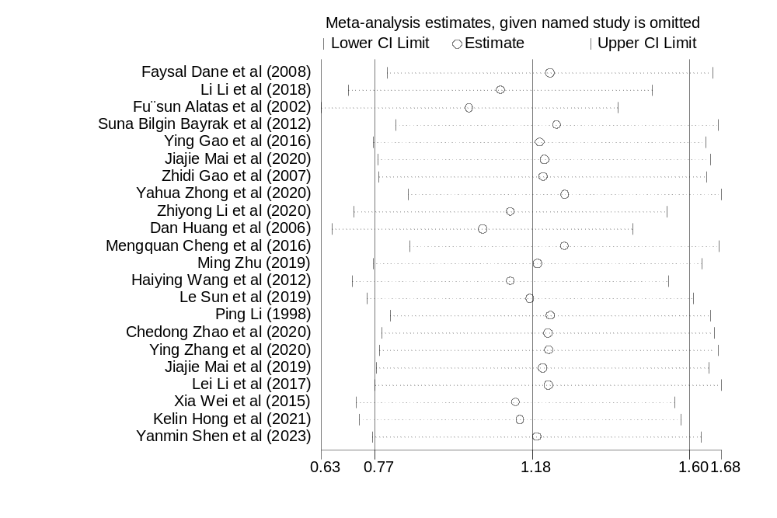

- Sensitivity analysis of study between CA125 and bone metastases (U/ml)
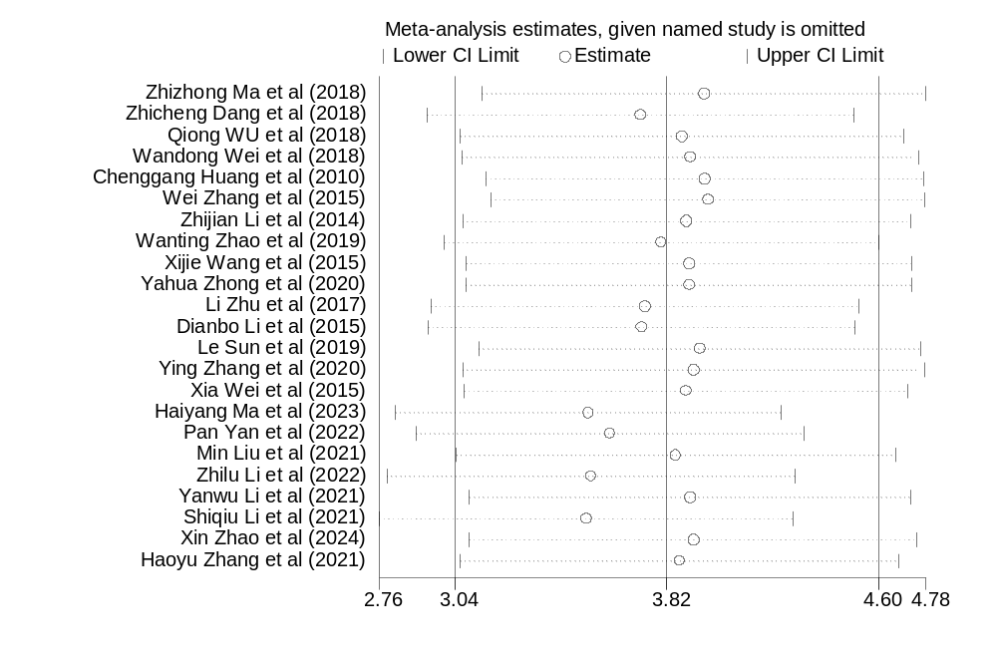
- Sensitivity analysis of study between CA153 and bone metastases (U/ml)
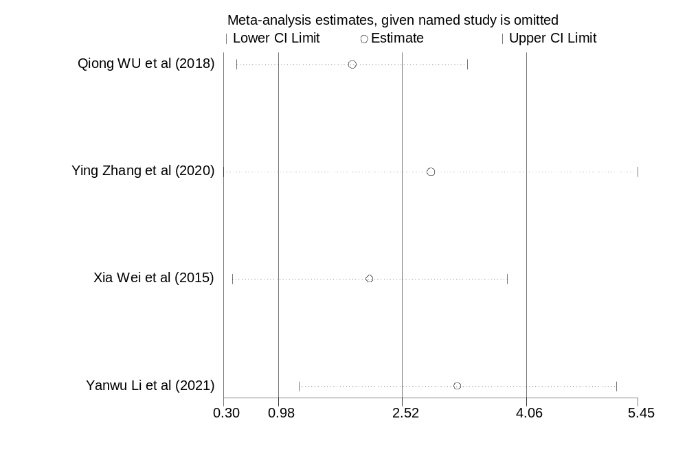

- Sensitivity analysis of study between CA199 and bone metastases (U/ml)
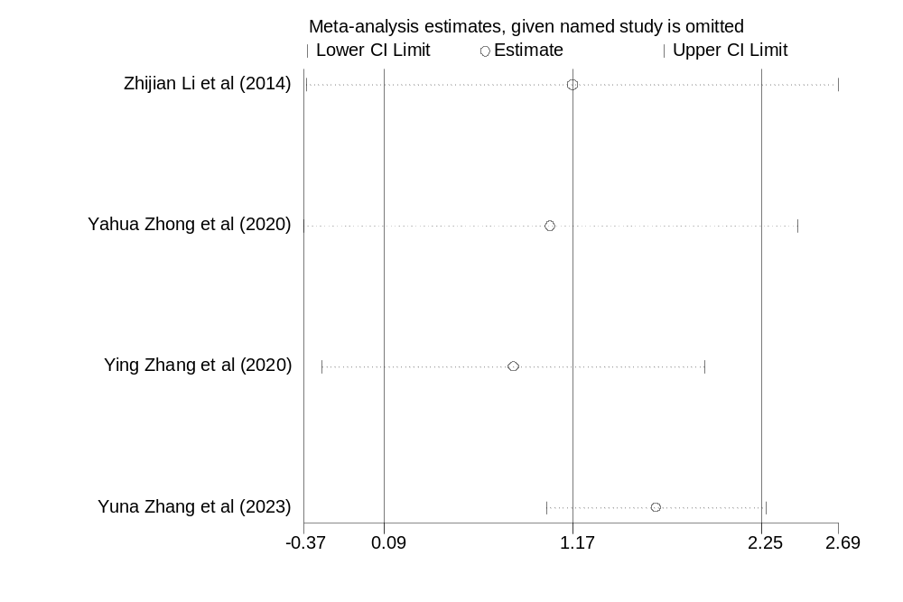
- Sensitivity analysis of study between calcitonin and bone metastases (pg/ml)
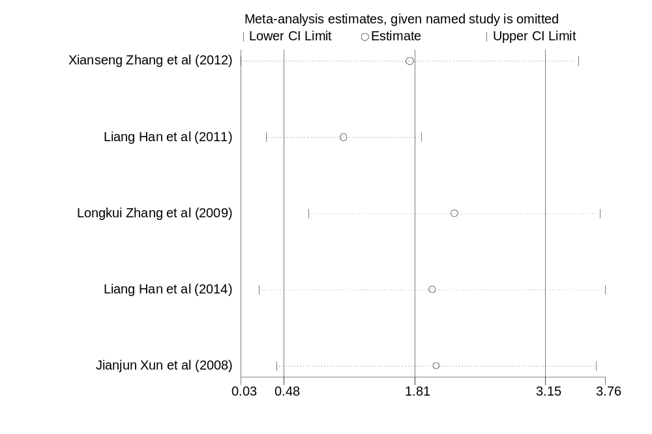

- Sensitivity analysis of study between CaN and bone metastases (U/ml)
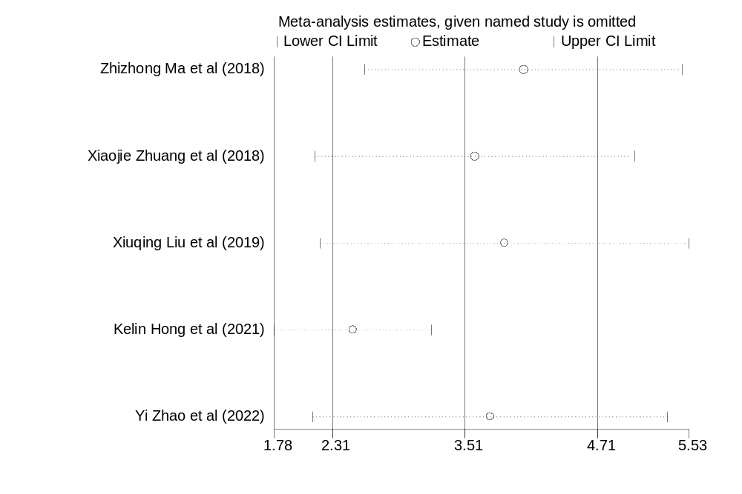
- Sensitivity analysis of study between CEA and bone metastases (ng/ml)
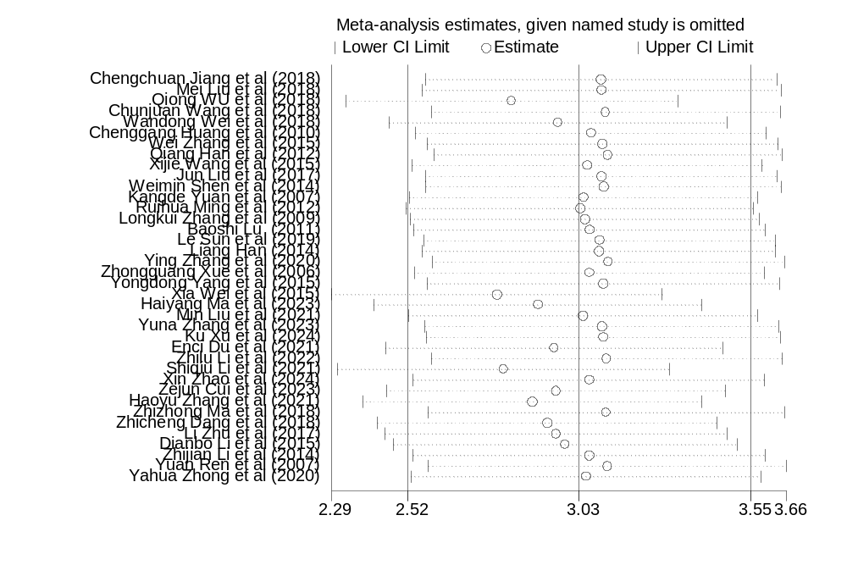

- Sensitivity analysis of study between CTX and bone metastases (ng/ml)
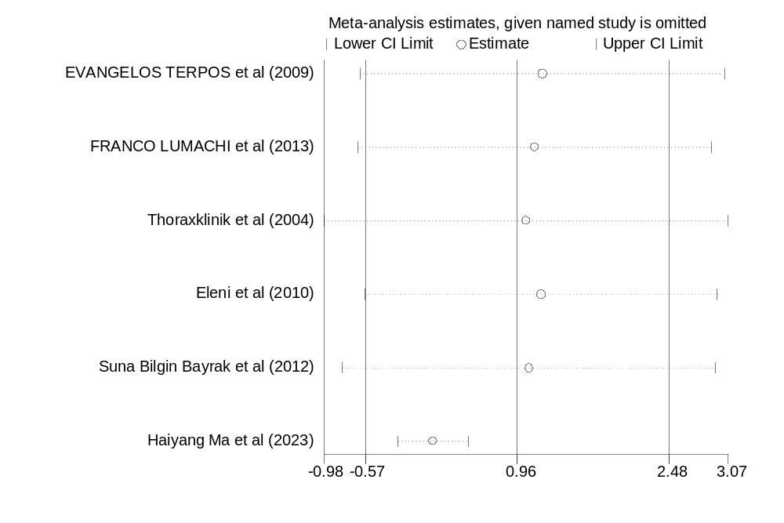
- Sensitivity analysis of study between CYFRA21-1 and bone metastases (ng/ml)
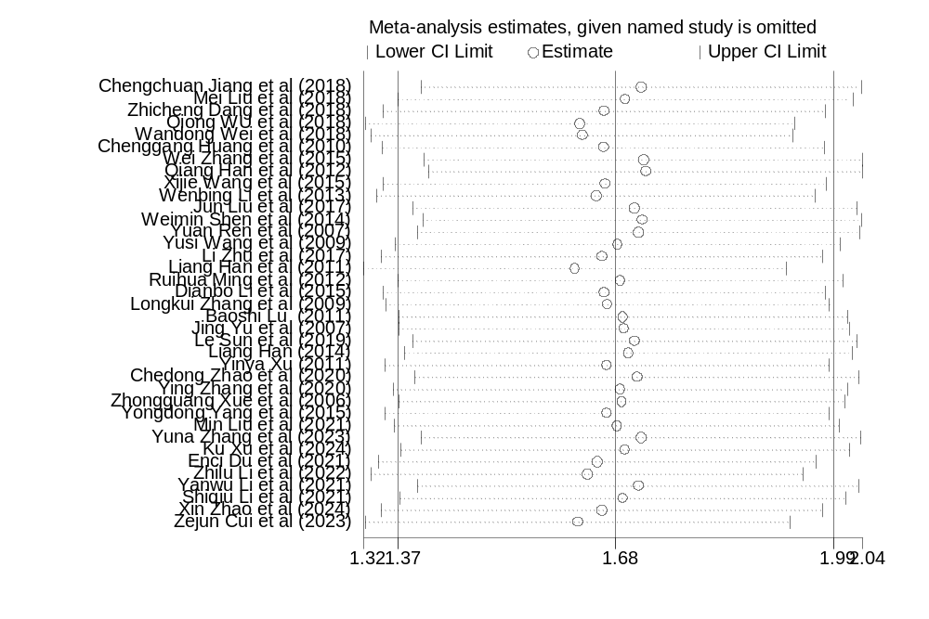

- Sensitivity analysis of study between ICTP and bone metastases (μg/l)
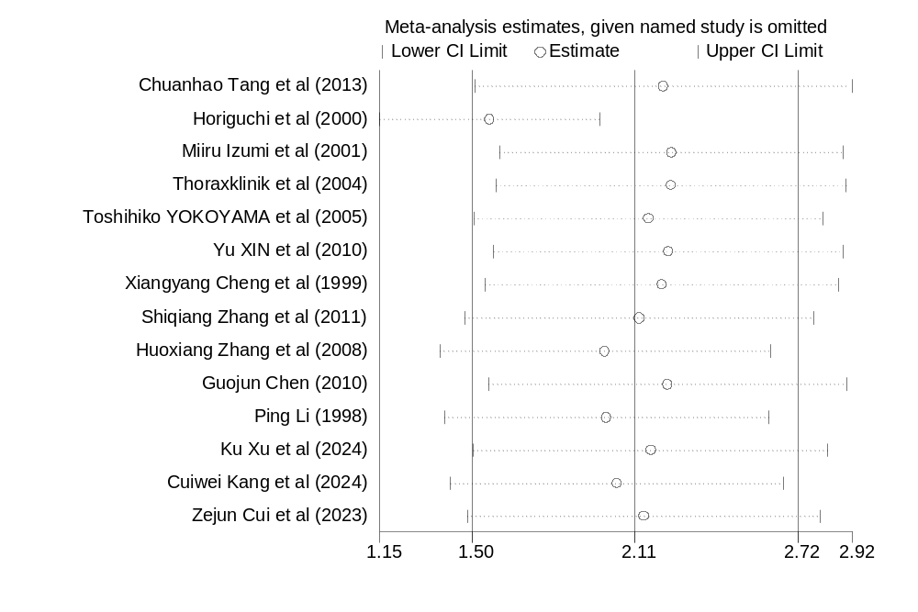
- Sensitivity analysis of study between N-MID and bone metastases (μg/l)
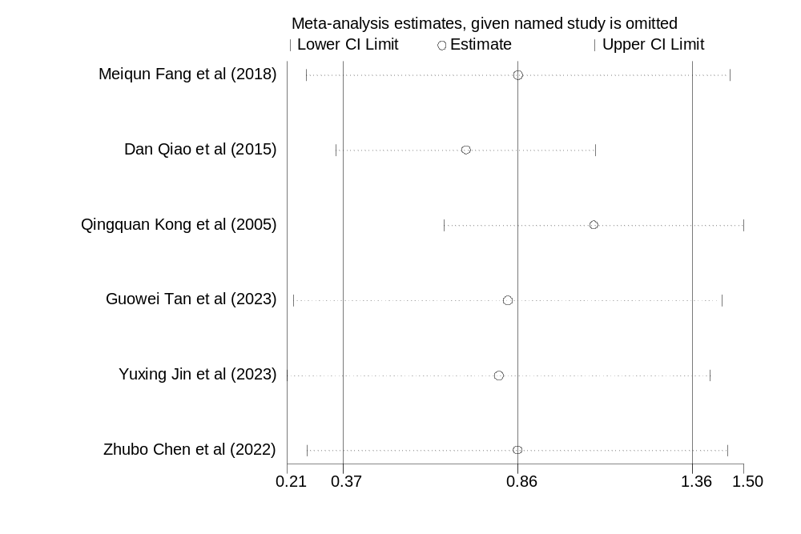

- Sensitivity analysis of study between NSE and bone metastases (ng/ml)
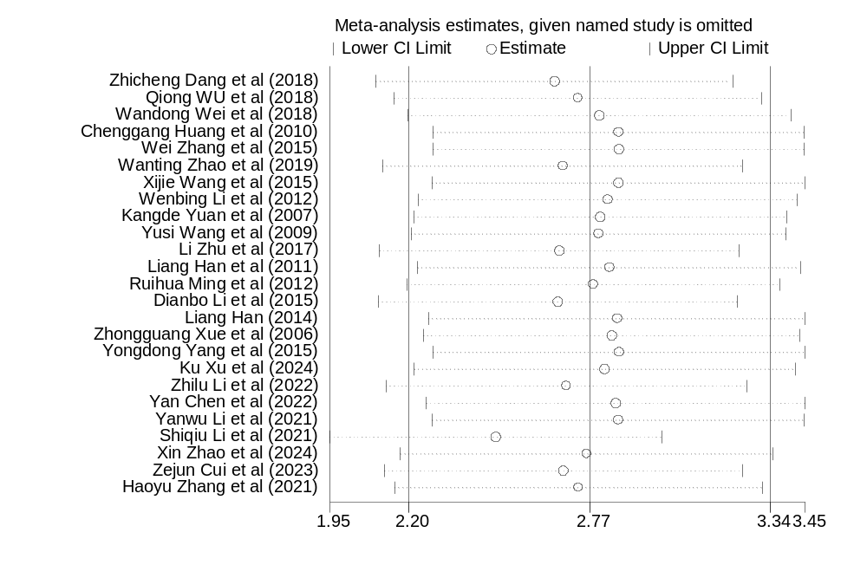
- Sensitivity analysis of study between NSE and bone metastases (U/ml)
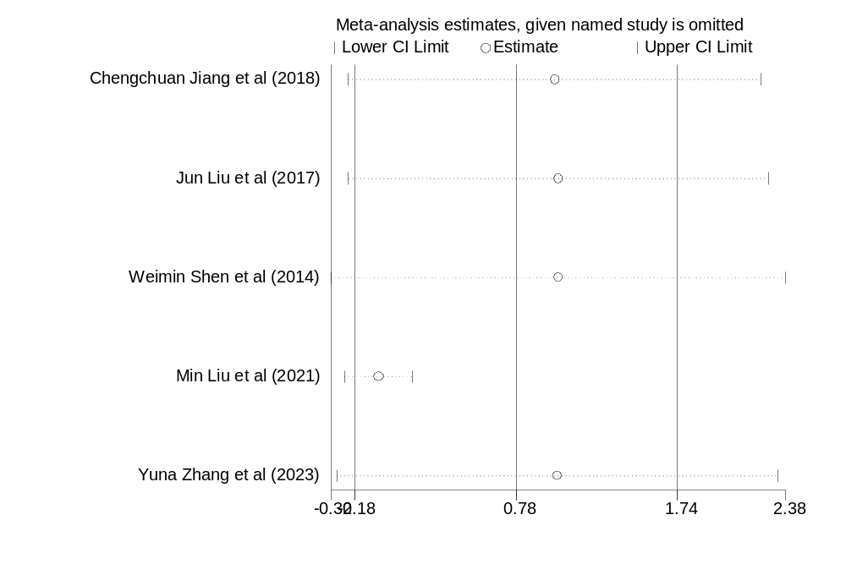

- Sensitivity analysis of study between NTx and bone metastases (nmol/l)
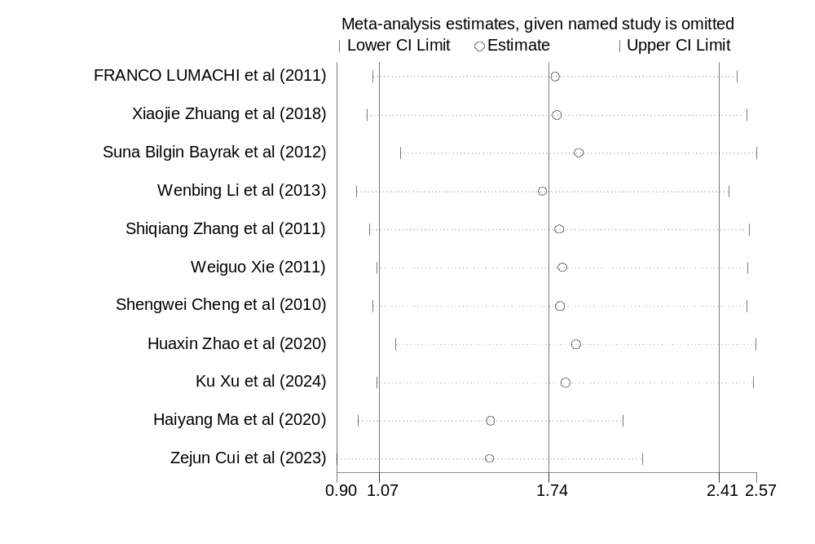
- Sensitivity analysis of study between OC and bone metastases (ng/ml)
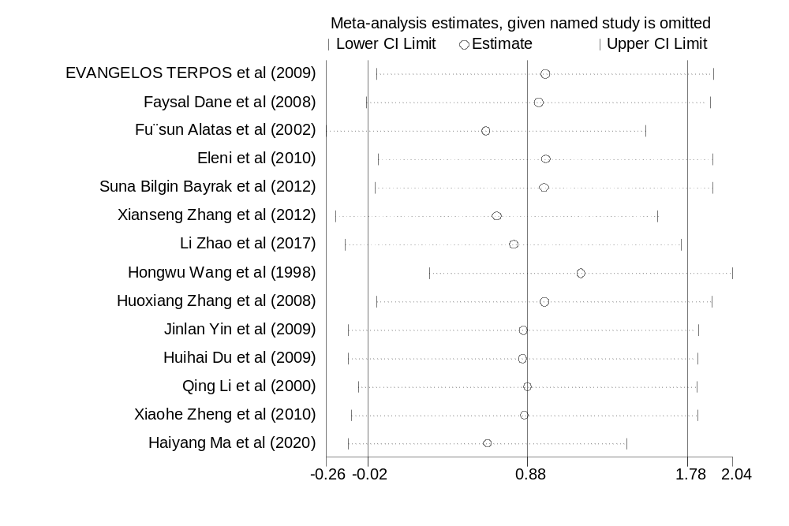

- Sensitivity analysis of study between OCIF and bone metastases (ng/l)
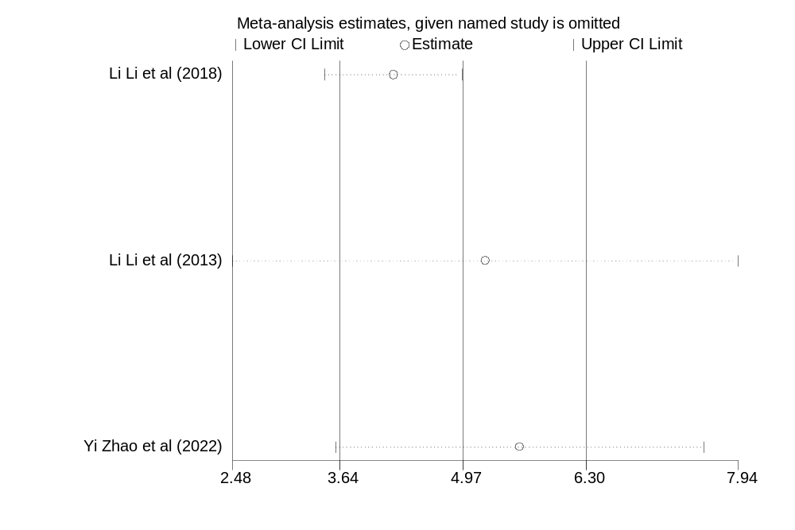
- Sensitivity analysis of study between ODF and bone metastases (ng/l)
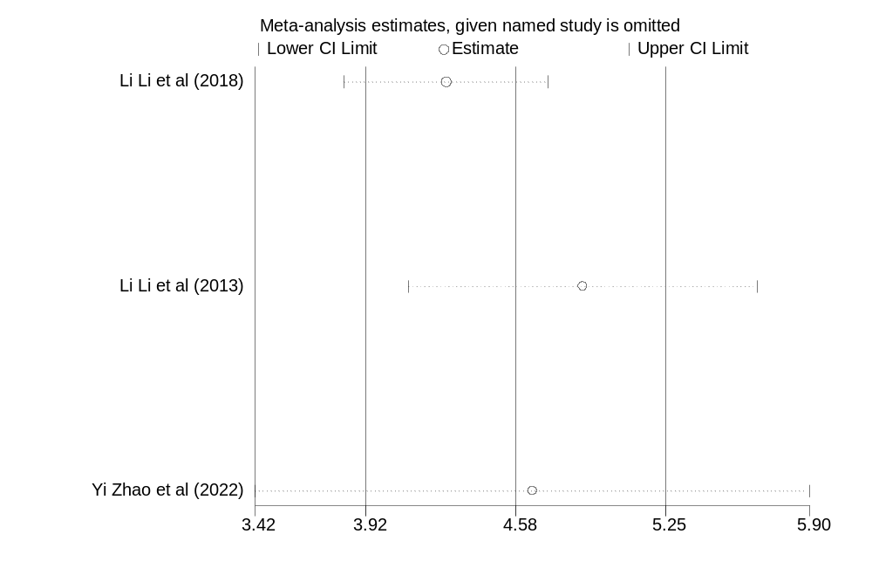

- Sensitivity analysis of study between OPG and bone metastases (pmol/l)
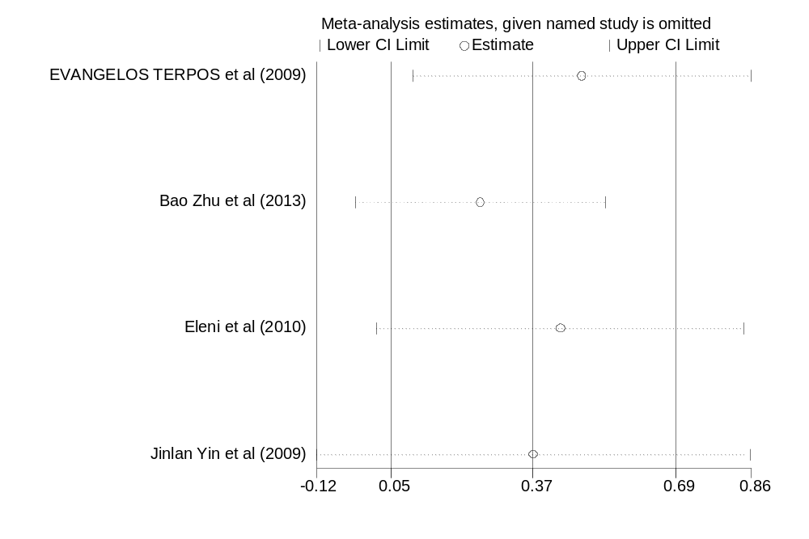

- Sensitivity analysis of study between PINP and bone metastases (ng/ml)
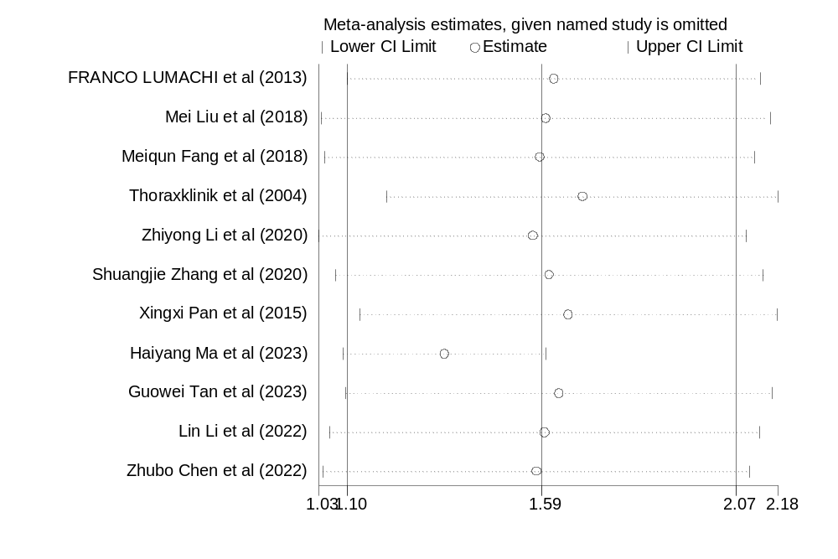

- Sensitivity analysis of study between PTHRP and bone metastases (ng/ml)
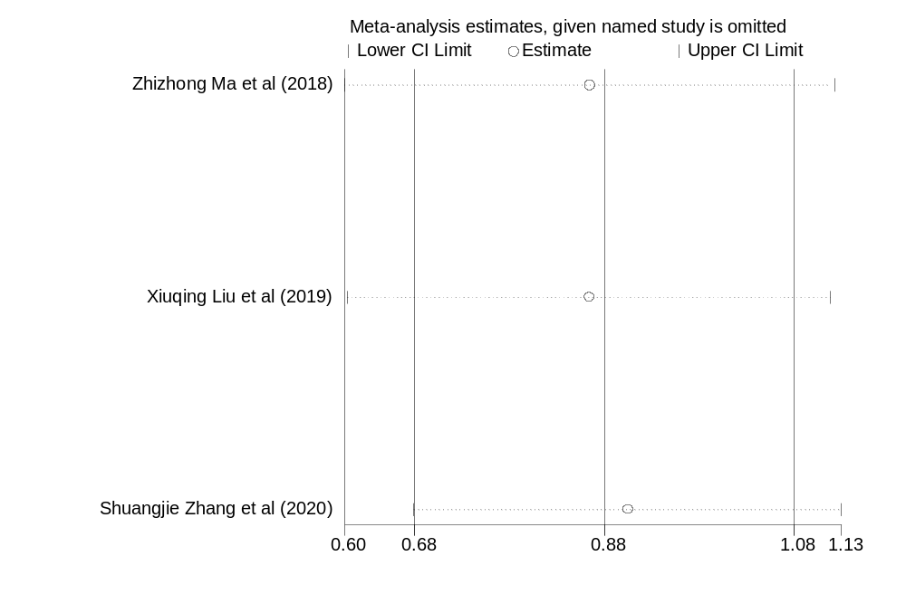

- Sensitivity analysis of study between T-ALP and bone metastases (IU/ml)
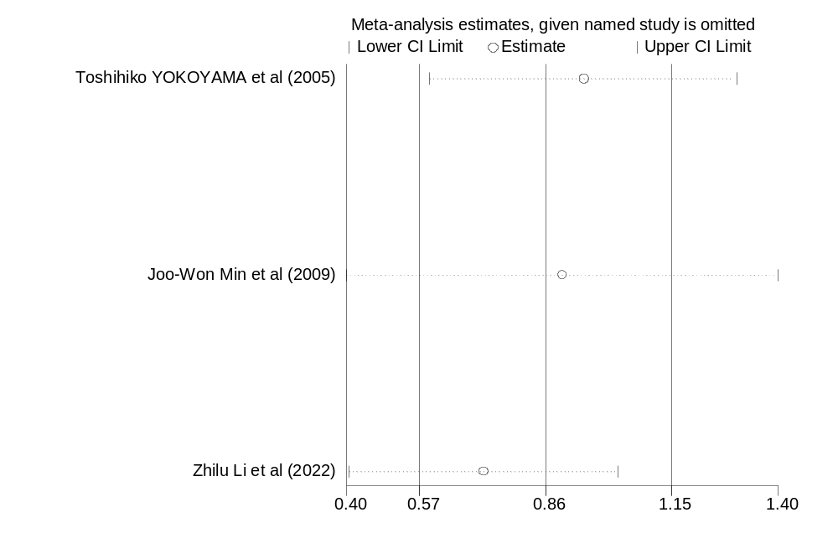

- Sensitivity analysis of study between T-ALP and bone metastases (U/L)
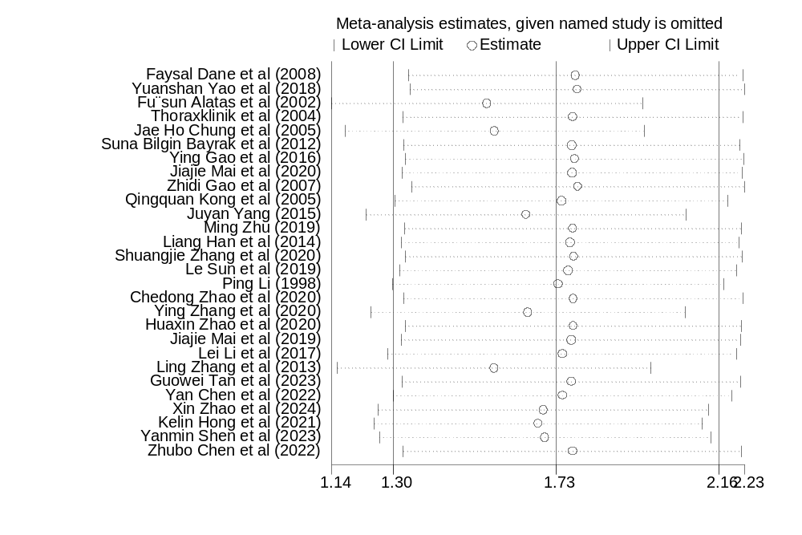
- Sensitivity analysis of study between TRACP-5b and bone metastases (pg/ml)
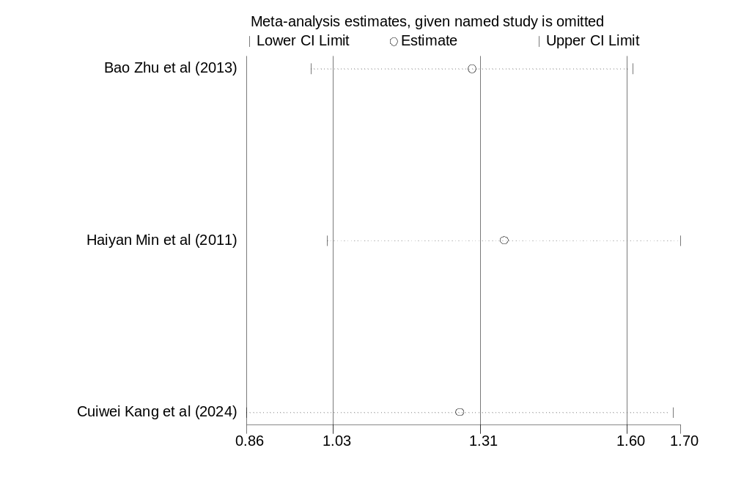

- Sensitivity analysis of study between TRACP-5b and bone metastases (U/L)
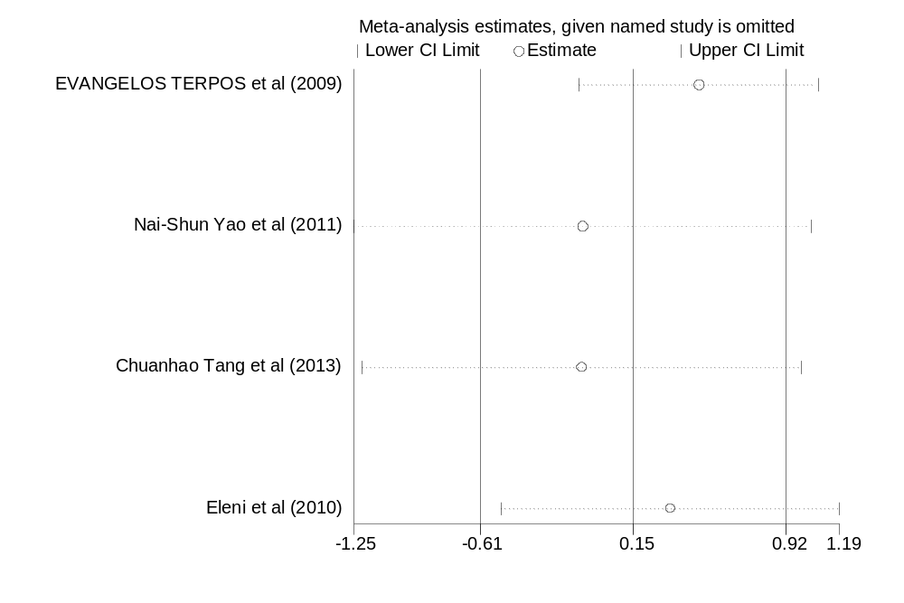
- Sensitivity analysis of study between VEGF and bone metastases (pg/ml)
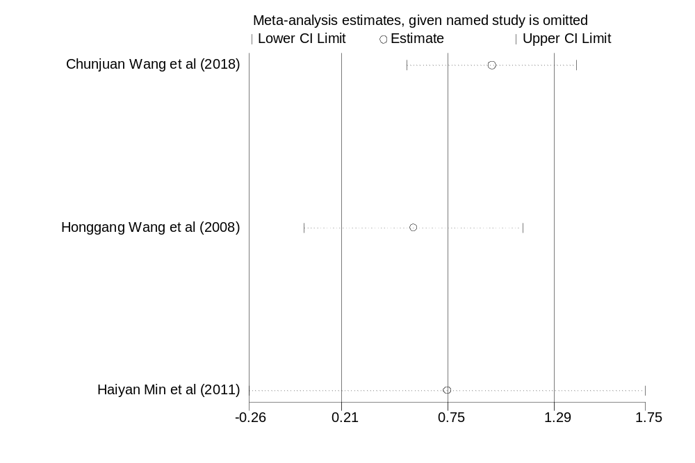

- Sensitivity analysis of study between β-CTX and bone metastases (ng/ml)
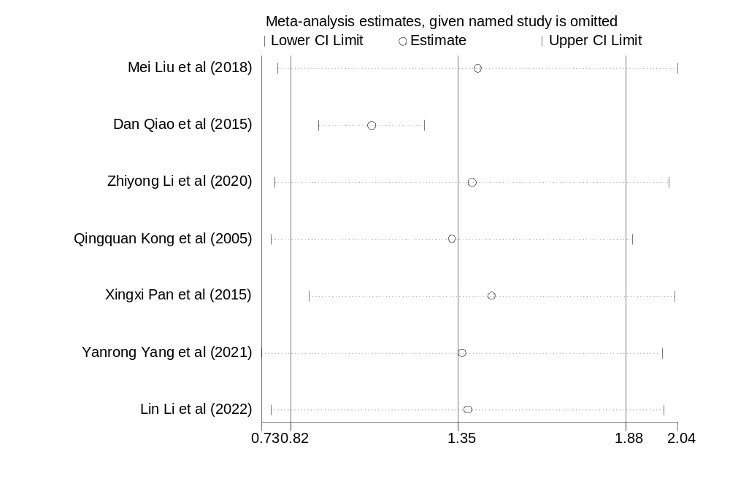Conversion table
Unit | Conversion relationship
1 ng/ml | = 1000 ng/l = 1 μg/l = 10⁶ pg/l = 10⁹ ng/l
1 μg/l | = 0.001 μg/ml = 0.001 ng/μl = 1000 pg/l
1 pg/ml | = 1000 pg/l = 0.001 ng/ml
1 ng/l | = 0.001 μg/l = 0.000001 ng/ml
1 mg/dl | = 10000 ng/ml
1 U/ml | = 1000 U/L
1 IU/ml | = 1000 U/L

