Figure S1 Covariate screening using LASSO and Boruta
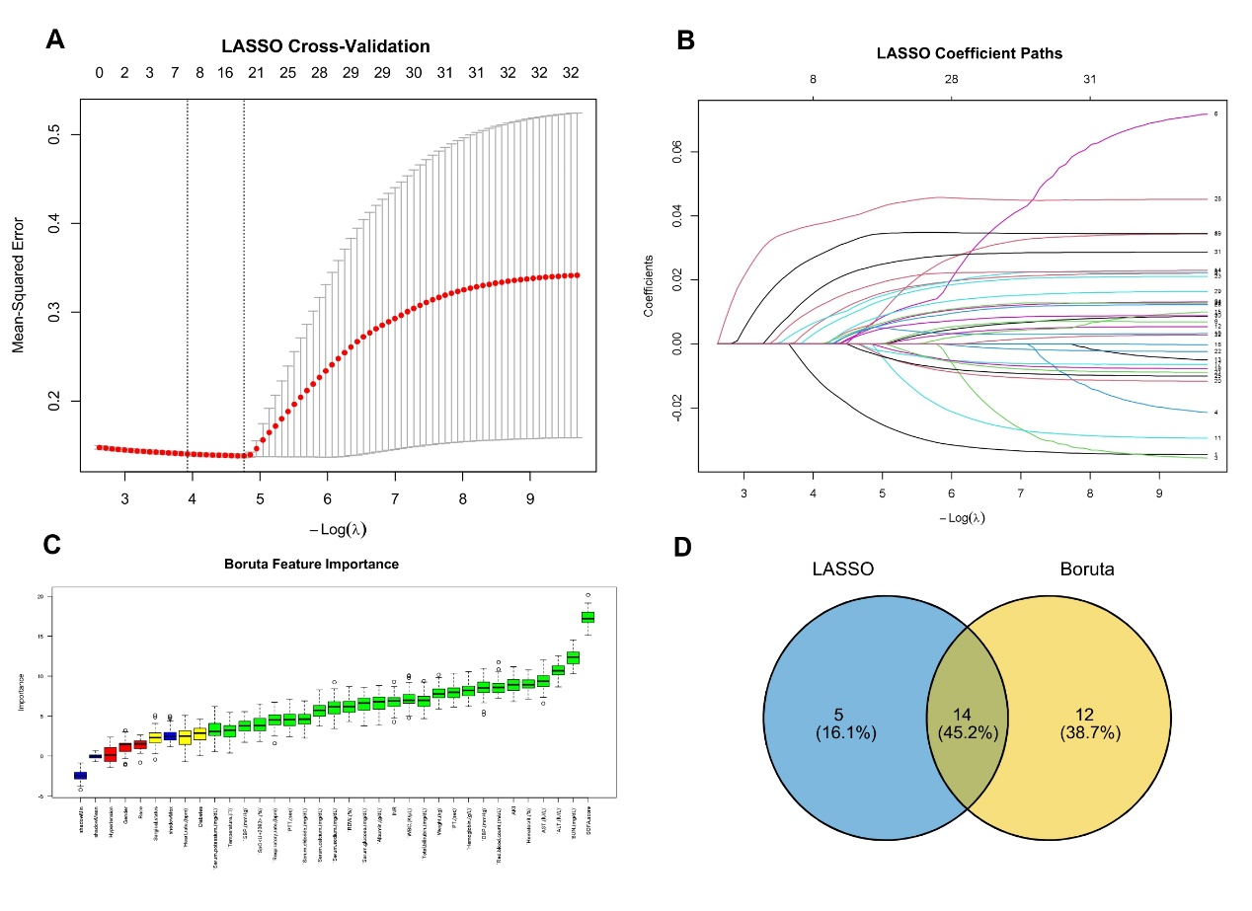
Notes: (A, B) Variable selection with LASSO regression. (C) Candidate predictors identified by the Boruta algorithm. (D) Venn diagram showing the overlap of covariates from LASSO and Boruta.
(1) Due to the calculation formulas for the Age-Adjusted Endothelial Activation and Stress Index (aEASIX = age * (Scr * LDH / PLT)), age, Scr, LDH, and PLT were excluded as variables. (2) A Venn diagram was used to identify the intersection variables, including weight, respiratory rate, SpO2, temperature, WBC, RDW, hematocrit, serum sodium, serum calcium, PTT, ALT, BUN, SOFA score, and AKI (yes/no). Age and gender were also included as demographic covariates in the final model adjustment. (3) All variance inflation factor (VIF) values were less than 5, as shown in Table S2.
Abbreviations: Scr, serum creatinine; LDH, lactate dehydrogenase; PLT, platelet count; aEASIX, Age-Adjusted Endothelial Activation and Stress Index; AKI, acute kidney injury; WBC, white blood cell; RDW, red cell distribution width; BUN, blood urea nitrogen. PTT, partial thromboplastin time; ALT, alanine aminotransferase; SpO₂, pulse oxygen saturation; SOFA, Sequential Organ Failure Assessment.

Table S1 The variance inflation factor test
Variable | VIF
Gender | 1.112
AKI | 1.137
Age at admission (years) | 1.303
Weight (kg) | 1.181
WBC (K/µL) | 1.036
RDW (%) | 1.324
Hematocrit (%) | 1.288
Serum sodium (mg/dL) | 1.036
Serum calcium (mg/dL) | 1.044
PTT (sec) | 1.071
ALT (IU/L) | 1.139
BUN (mg/dL) | 1.439
Respiratory rate (bpm) | 1.034
SpO₂ (%) | 1.003
Temperature (℃) | 1.017
SOFA score | 1.635
Abbreviations: AKI, acute kidney injury; WBC, white blood cell; RDW, red cell distribution width; BUN, blood urea nitrogen. PTT, partial thromboplastin time; ALT, alanine aminotransferase; SpO₂, pulse oxygen saturation; SOFA, Sequential Organ Failure Assessment.

Table S2 Missing Number (%) for Included Variables in Dataset
variables | Missing (%)
PTT (sec) | 194 (4.42%)
PT (sec) | 180 (4.10%)
INR | 182 (4.14%)
ALT (IU/L) | 114 (2.59%)
AST (IU/L) | 63 (1.43%)
Total bilirubin (mg/dL) | 86 (1.96%)
SBP (mmHg) | 45 (1.02%)
DBP (mmHg) | 45 (1.02%)
Mean arterial pressure (mmHg) | 45 (1.02%)
Temperature (℃) | 8 (0.18%)
Weight (kg) | 36 (0.82%)
Hemoglobin (g/L) | 3 (0.07%)
WBC (K/µL) | 3 (0.07%)
Serum potassium (mg/dL) | 3 (0.07%)
Serum calcium (mg/dL) | 3 (0.07%)
BUN (mg/dL) | 3 (0.07%)
RDW (%) | 6 (0.14%)
Hematocrit (%) | 4 (0.09%)
Serum chloride (mg/dL) | 2 (0.05%)
Serum sodium (mg/dL) | 1 (0.02%)
Abbreviations: WBC, white blood cell; PLT, platelet; RDW, red cell distribution width; PT, prothrombin time; PTT, partial thromboplastin time.

