Supplementary Information

Supplementary Method 1. Search strategy for PubMed
Supplementary Method 2. Search strategy for Cochrane
Supplementary Method 3. Search strategy for Embase
Supplementary Method 4. Search strategy for Web of science
Supplementary Table 1. Quality assessment of included studies.
Supplementary Figure 1. Sensitivity analysis
Supplementary Figure 2. Implantation rate
Supplementary Figure 3. Clinical pregnancy rate
Supplementary Figure 4. Term delivery rate
Supplementary Figure 5. Abortion rate
Supplementary Figure 6. High-risk pregnancy events

Supplementary Method 1. Search strategy for PubMed
(((((Implantation[Title/Abstract]) OR (blastocyst[Title/Abstract])) OR (Embryo[Title/Abstract])) OR ((((((((((Fertilization in Vitro[MeSH Terms]) OR (In Vitro Fertilization*[Title/Abstract])) OR (Test Tube Fertilization*[Title/Abstract])) OR (Test Tube Bab*[Title/Abstract])) OR (Fertilization, Test-Tube[Title/Abstract])) OR (Fertilizations, Test-Tube[Title/Abstract])) OR (Fertilizations in Vitro[Title/Abstract])) OR (Babies, Test-Tube[Title/Abstract])) OR (Baby, Test-Tube[Title/Abstract])) OR (IVF[Title/Abstract]))) OR ((((((((Embryo Transfer[MeSH Terms]) OR (Embryo Transfers[Title/Abstract])) OR (Transfer, Embryo[Title/Abstract])) OR (Transfers, Embryo[Title/Abstract])) OR (Blastocyst Transfer[Title/Abstract])) OR (Tubal Embryo Transfer[Title/Abstract])) OR (Tubal Embryo Stage Transfer[Title/Abstract])) OR (ET[Title/Abstract]))) OR (((((((Sperm Injections, Intracytoplasmic[MeSH Terms]) OR (Injection, Intracytoplasmic Sperm[Title/Abstract])) OR (Injections, Intracytoplasmic Sperm[Title/Abstract])) OR (Intracytoplasmic Sperm Injection*[Title/Abstract])) OR (Sperm Injection, Intracytoplasmic[Title/Abstract])) OR (Injections, Sperm, Intracytoplasmic[Title/Abstract])) OR (ICSI[Title/Abstract])) AND (((((((((((((((assisted hatching[Title/Abstract]) OR (assisted zona hatching[Title/Abstract])) OR (zona drilling[Title/Abstract])) OR (zona pellucida drilling[Title/Abstract])) OR (zona pellucida opening[Title/Abstract])) OR (zona opening[Title/Abstract])) OR (zona free[Title/Abstract])) OR (zona pellucida dissection[Title/Abstract])) OR (zona pellucida removal[Title/Abstract])) OR (zona pellucida thinning[Title/Abstract])) OR (zona thinning[Title/Abstract])) OR (laser-assisted hatching[Title/Abstract])) OR (laser assisted[Title/Abstract])) OR (laser drilling[Title/Abstract])) OR (laser hatching[Title/Abstract])) OR (laser thinning[Title/Abstract])

Supplementary Method 2. Search strategy for Cochrane
#1 MeSH descriptor: [Fertilization in Vitro] explode all trees
#2 (In Vitro Fertilization):ab,ti,kw OR (In Vitro Fertilizations):ab,ti,kw OR (Test Tube Fertilization):ab,ti,kw OR (Test-Tube Fertilization):ab,ti,kw OR (Test-Tube Fertilizations):ab,ti,kw OR (Test Tube Bab):ab,ti,kw OR (Test-Tube Babies):ab,ti,kw OR (Test Tube Babies):ab,ti,kw OR (Test-Tube Baby):ab,ti,kw OR (Fertilization, Test-Tube):ab,ti,kw OR (Fertilizations, Test-Tube):ab,ti,kw OR (Fertilizations in Vitro):ab,ti,kw OR (Babies, Test-Tube):ab,ti,kw OR (Baby, Test-Tube):ab,ti,kw OR (IVF):ab,ti,kw
#3 #1 OR #2
#4 [Embryo Transfer] explode all trees
#5 (Embryo Transfers):ab,ti,kw OR (Transfer, Embryo):ab,ti,kw OR (Transfers, Embryo):ab,ti,kw OR (Blastocyst Transfer):ab,ti,kw OR (Tubal Embryo Transfer):ab,ti,kw OR (Tubal Embryo Stage Transfer):ab,ti,kw OR (ET):ab,ti,kw
#6 #4 OR #5
#7 [Sperm Injections, Intracytoplasmic] explode all trees
#8 (Injection, Intracytoplasmic Sperm):ab,ti,kw OR (Injections, Intracytoplasmic Sperm):ab,ti,kw OR (Intracytoplasmic Sperm Injection*):ab,ti,kw OR (Intracytoplasmic Sperm Injection):ab,ti,kw OR (Intracytoplasmic Sperm Injections):ab,ti,kw OR (Sperm Injection, Intracytoplasmic):ab,ti,kw OR (Injections, Sperm, Intracytoplasmic):ab,ti,kw OR (ICSI):ab,ti,kw
#9 #7 OR #8
#10 #3 OR #6 OR #9

#11 [Lasers] explode all trees
#12 (laser):ab,ti,kw OR (laser assisted):ab,ti,kw OR (assisted hatching):ab,ti,kw OR (assisted zona hatching):ab,ti,kw OR (zona drilling):ab,ti,kw OR (zona pellucida drilling):ab,ti,kw OR (zona pellucida opening):ab,ti,kw OR (zona opening):ab,ti,kw OR (zona free):ab,ti,kw OR (zona pellucida dissection):ab,ti,kw OR (zona pellucida removal):ab,ti,kw OR (zona pellucida thinning):ab,ti,kw OR (zona thinning):ab,ti,kw OR (laser-assisted hatching):ab,ti,kw OR (laser assisted):ab,ti,kw OR (laser drilling):ab,ti,kw OR (laser hatching):ab,ti,kw OR (laser thinning):ab,ti,kw
#13 #11 OR #12
#14 #10 AND #13

Supplementary Method 3. Search strategy for Embase
#1 'in vitro fertilization'/exp OR ' fertilization in vitro':ab,ti OR 'in vitro fertilizations':ab,ti OR 'test tube fertilization':ab,ti OR 'test-tube fertilization':ab,ti OR 'test-tube fertilizations':ab,ti OR 'test tube bab':ab,ti OR 'test-tube babies':ab,ti OR 'test tube babies':ab,ti OR 'test-tube baby':ab,ti OR 'fertilization, test-tube':ab,ti OR 'fertilizations, test-tube':ab,ti OR 'fertilizations in vitro':ab,ti OR 'babies, test-tube':ab,ti OR 'baby, test-tube':ab,ti OR 'ivf':ab,ti
#2 'embryo transfer'/exp OR 'embryo transfers':ab,ti OR 'transfer, embryo':ab,ti OR 'transfers, embryo':ab,ti OR 'blastocyst transfer':ab,ti OR 'tubal embryo transfer':ab,ti OR 'tubal embryo stage transfer':ab,ti OR 'et':ab,ti
#3 'intracytoplasmic sperm injection'/exp OR 'injection, intracytoplasmic sperm':ab,ti OR 'injections, intracytoplasmic sperm':ab,ti OR 'sperm injections, intracytoplasmic':ab,ti OR 'intracytoplasmic sperm injections':ab,ti OR 'sperm injection, intracytoplasmic':ab,ti OR 'injections, sperm, intracytoplasmic':ab,ti OR 'icsi':ab,ti
#4 #1 OR #2 OR #3

#5 'laser'/exp OR 'assisted hatching'/exp OR 'assisted zona hatching':ab,ti OR 'zona drilling':ab,ti OR 'zona pellucida drilling':ab,ti OR 'zona pellucida opening':ab,ti OR 'zona opening':ab,ti OR 'zona free':ab,ti OR 'zona pellucida dissection':ab,ti OR 'zona pellucida removal':ab,ti OR 'zona pellucida thinning':ab,ti OR 'zona thinning':ab,ti OR 'laser-assisted hatching':ab,ti OR 'laser assisted':ab,ti OR 'laser drilling':ab,ti OR 'laser hatching':ab,ti OR 'laser thinning':ab,ti
#6 #4 AND #5

Supplementary Method 4. Search strategy for Web of science
TS=(Fertilizations in Vitro OR In Vitro Fertilization OR In Vitro Fertilization OR In Vitro Fertilizations OR Test Tube Fertilization OR Test-Tube Fertilization OR Test-Tube Fertilizations OR Test Tube Bab OR Test-Tube Babies OR Test Tube Babies OR Test-Tube Baby OR Fertilization, Test-Tube OR Fertilizations, Test-Tube OR Fertilizations in Vitro OR Babies, Test-Tube OR Baby, Test-Tube OR IVF OR Embryo Transfer OR Embryo Transfers OR Transfer, Embryo OR Transfers, Embryo OR Blastocyst Transfer OR Tubal Embryo Transfer OR Tubal Embryo Stage Transfer OR ET OR Sperm Injections, Intracytoplasmic OR Injection, Intracytoplasmic Sperm OR Injections, Intracytoplasmic Sperm OR Intracytoplasmic Sperm Injection* OR Intracytoplasmic Sperm Injection OR Intracytoplasmic Sperm Injections OR Sperm Injection, Intracytoplasmic OR Injections, Sperm, Intracytoplasmic OR ICSI)

TS=(laser OR laser assisted OR assisted hatching OR assisted zona hatching OR zona drilling OR zona pellucida drilling OR zona pellucida opening OR zona opening OR zona free OR zona pellucida dissection OR zona pellucida removal OR zona pellucida thinning OR zona thinning OR laser-assisted hatching OR laser assisted OR laser drilling OR laser hatching OR laser thinning)

Supplementary Table 1. Quality assessment of the included publications, based on the ROBINS-I tool (low, moderate, serious, critical, no information)
Author, year | Types of bias |  |  |  |  |  |  | Overall rating
Author, year | Bias due to confounding | Bias in selection of participants into the study | Bias in classification of interventions | Bias due to deviations from intended interventions | Bias due to missing data | Bias in measurement of outcomes | Bias in selection of the reported result | Overall rating
Antinori 1996 | Low | Moderate | Low | Low | Low | Low | Low | Moderate
Antinori 1996 | Moderate | Moderate | Low | Low | Low | Low | Low | Moderate
Baruffi 2000 | Low | Low | Low | Low | Low | Low | Low | Low
Mantoudis 2001 | Low | Low | NI | Low | Low | Low | Low | Low
Abdelmassih 2002 | NI | Low | Low | Low | Low | Low | Low | Low
Ebner 2002 | Low | Low | Low | Low | Low | Low | Low | Low
Hsieh 2002 | Low | Low | Low | Low | Low | Low | Low | Low
Petersen 2002 | NI | Moderate | Low | Low | Low | Low | Low | Moderate
Ali 2003 | Low | NI | NI | Low | Low | Low | Low | Low
Joris 2003 | NI | Low | Low | Low | Low | Low | Low | Low
Wong 2003 | Low | Serious | Low | Low | Low | Low | Moderate | Serious
Primi 2004 | Moderate | Low | Low | Low | Moderate | Low | Low | Moderate
Chatzimeletiou 2005 | NI | Low | NI | Low | Low | Low | Low | Low
Nadir Ciray 2005 | Low | Low | Low | Low | Low | Low | Low | Low
Ng 2005 | Low | Low | Low | Low | Low | Low | Low | Low
Petersen 2005 | Low | Low | Low | Low | Low | Low | Low | Low
Aktan 2006 | NI | Low | Low | Low | Low | Low | Low | Low
Balaban 2006 | Low | Low | Low | Low | Low | Low | Low | Low
Demirol 2006 | Low | Low | Low | Low | Low | Low | Low | Low
Frydman 2006 | Low | Low | Low | Low | Low | Low | Low | Low
Ghobara 2006 | Low | Moderate | Low | Low | Low | Low | Low | Moderate
Jones 2006 | Low | Low | Low | Low | Low | Low | Low | Low
Makrakis 2006 | Low | Low | Low | Low | Low | Low | Low | Low
Petersen 2006 | Moderate | Low | Low | Low | Low | Low | Low | Moderate
Richter 2006 | Low | Low | Low | Low | Low | Low | Low | Low
Yano 200 | NI | Low | Low | Low | Low | Low | Low | Low
Hiraoka 2007 | NI | Moderate | Low | Low | Low | Low | Low | Moderate
Lanzendorf 2007 | Low | Low | Low | Low | Low | Low | Low | Low
Sagoskin 200 | Low | Low | Low | Low | Low | Low | Low | Low
Ernest 200 | Low | Low | Low | Low | Low | Low | Low | Low
Ge 2008 | Low | Low | Low | Low | Low | Low | Low | Low
Hiraoka 2008 | Low | Low | Low | Low | Low | Low | Low | Low
Kappa | 0.698 | 0.766 | 0.75 | 0.712 | 1 | 1 | 1

Supplementary Figure 1. Sensitivity analysis for Implantation rate (A); Clinical pregnancy rate (B); Abortion rate (C) and Term delivery rate (D)
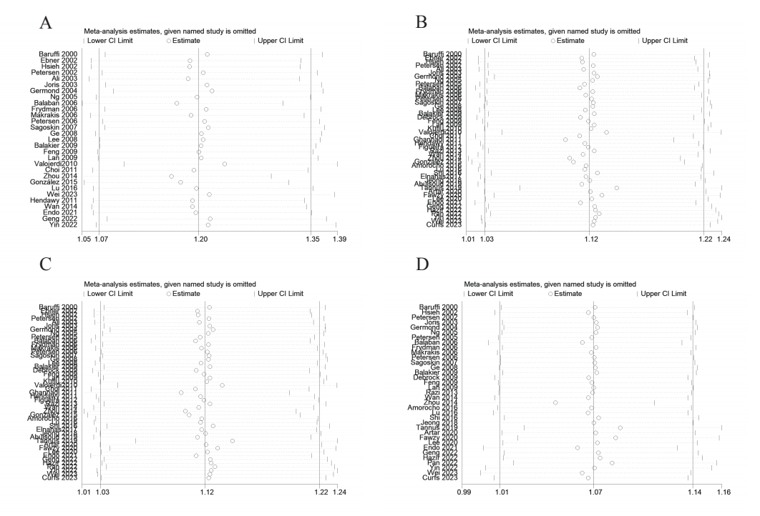

Supplementary Figure 2. Implantation rate
Fig. 2.1 Egger’s test (A), Begg’s test (B), Funnel plot (C) and Labbe plot (D) of OR from the included studies for the detection of publication.
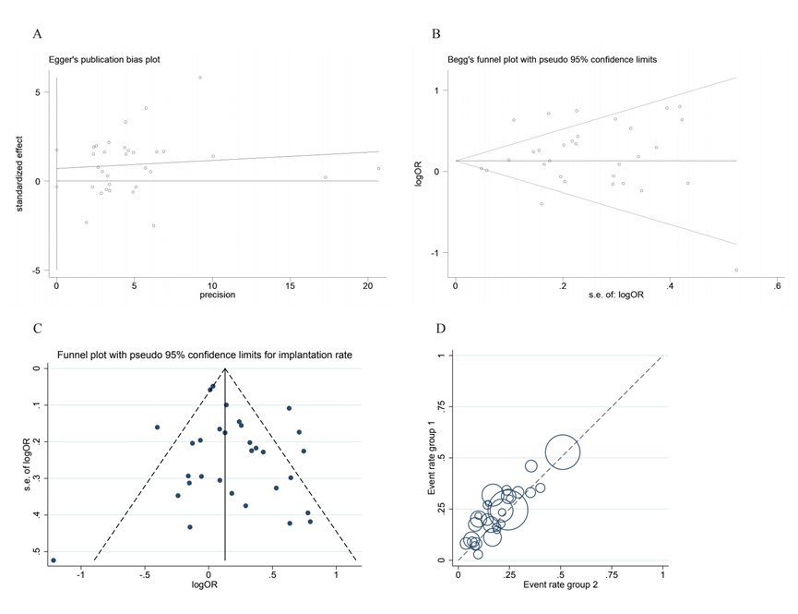Fig 2.2 Subgroup analysis: Forest plot of Implantation rate according to age(A) and embryonic status(B).

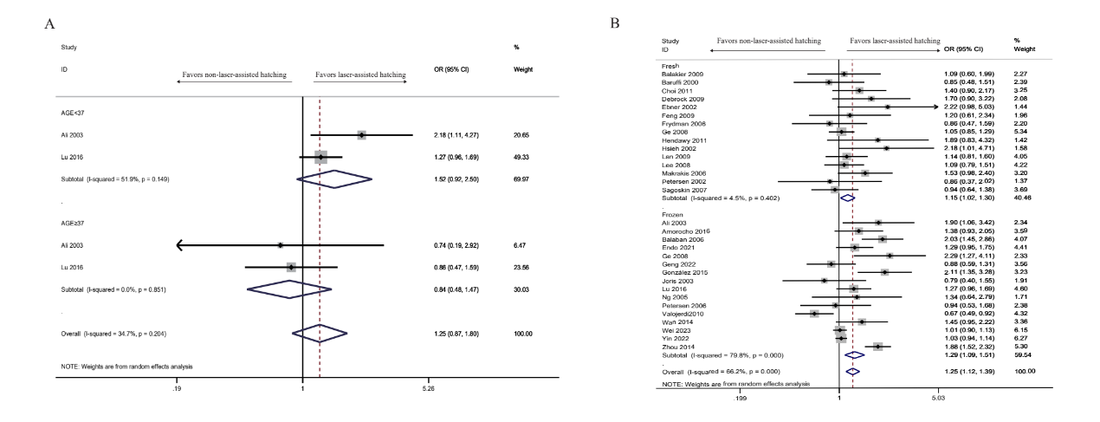

Supplementary Figure 3 Clinical pregnancy rate
Fig 3.1 Egger’s test (A), Begg’s test (B), Funnel plot (C) and Labbe plot (D) of OR from the included studies for the detection of publication.
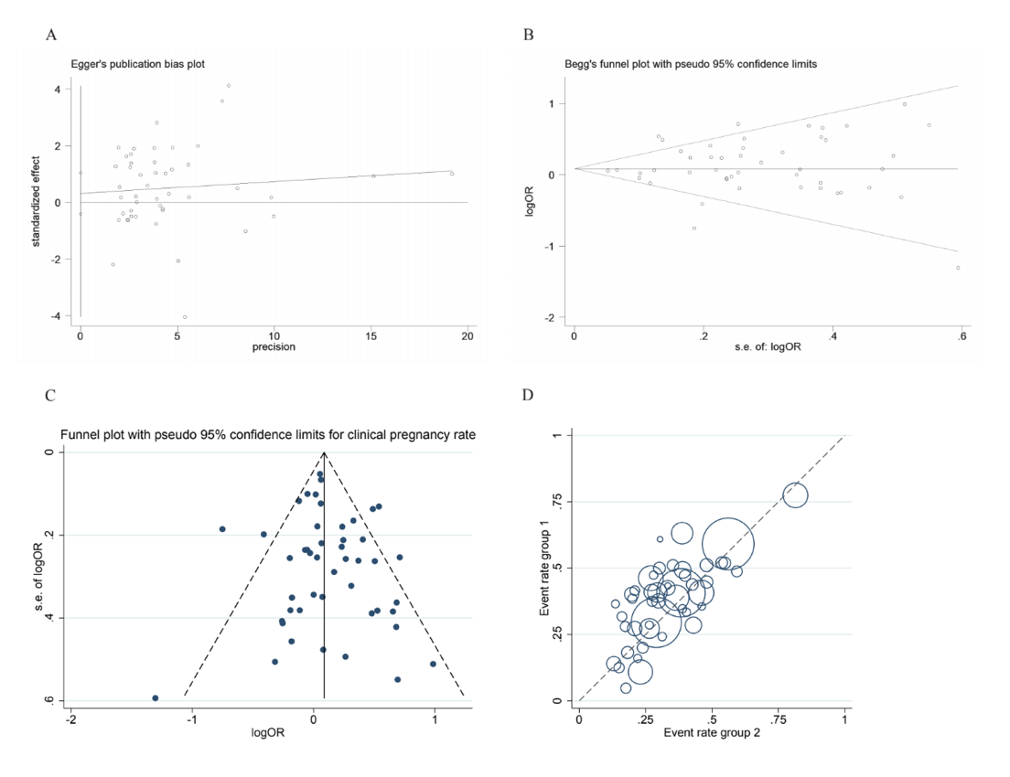

Fig 3.2 Subgroup analysis: Forest plot of clinical pregnancy rate according to(A-C); ways of assisted hatching(D).
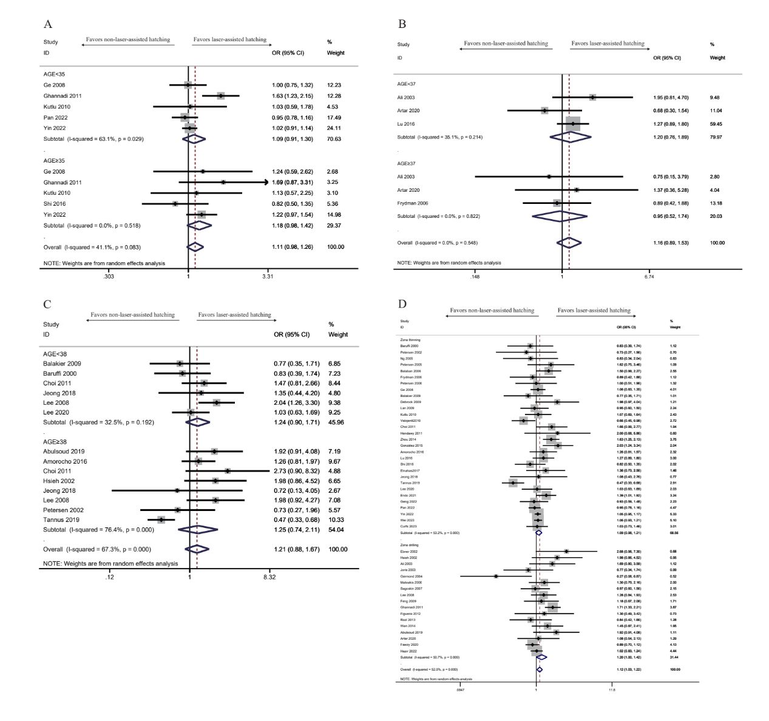
Supplementary Figure 4. Term delivery rate
Fig 4.1 Egger’s test (A), Begg’s test (B), Funnel plot (C) and Labbe plot (D) of OR from the included studies for the detection of publication.
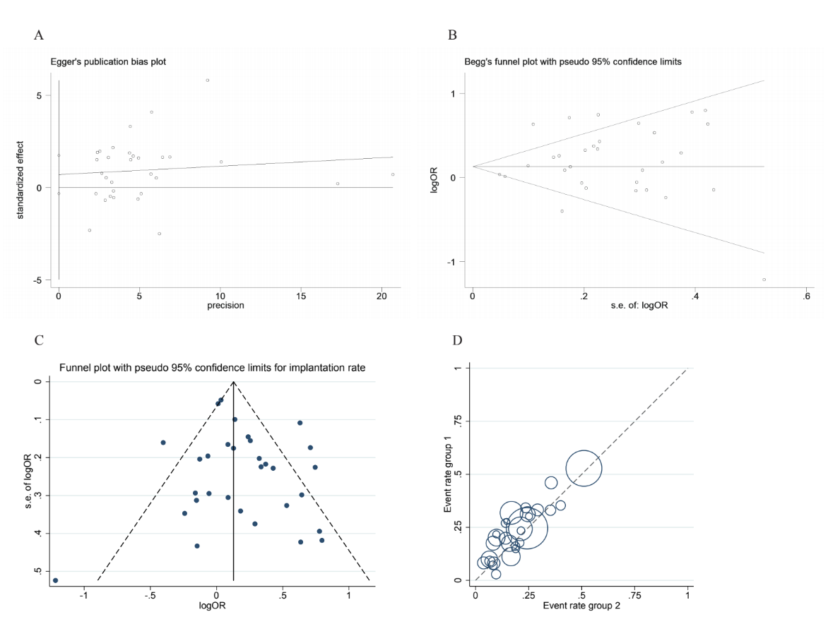

Fig 4.2 Subgroup analysis: Forest plot of term delivery rate according to age (A-C); embryonic phase (D); ways of assisted hatching (E).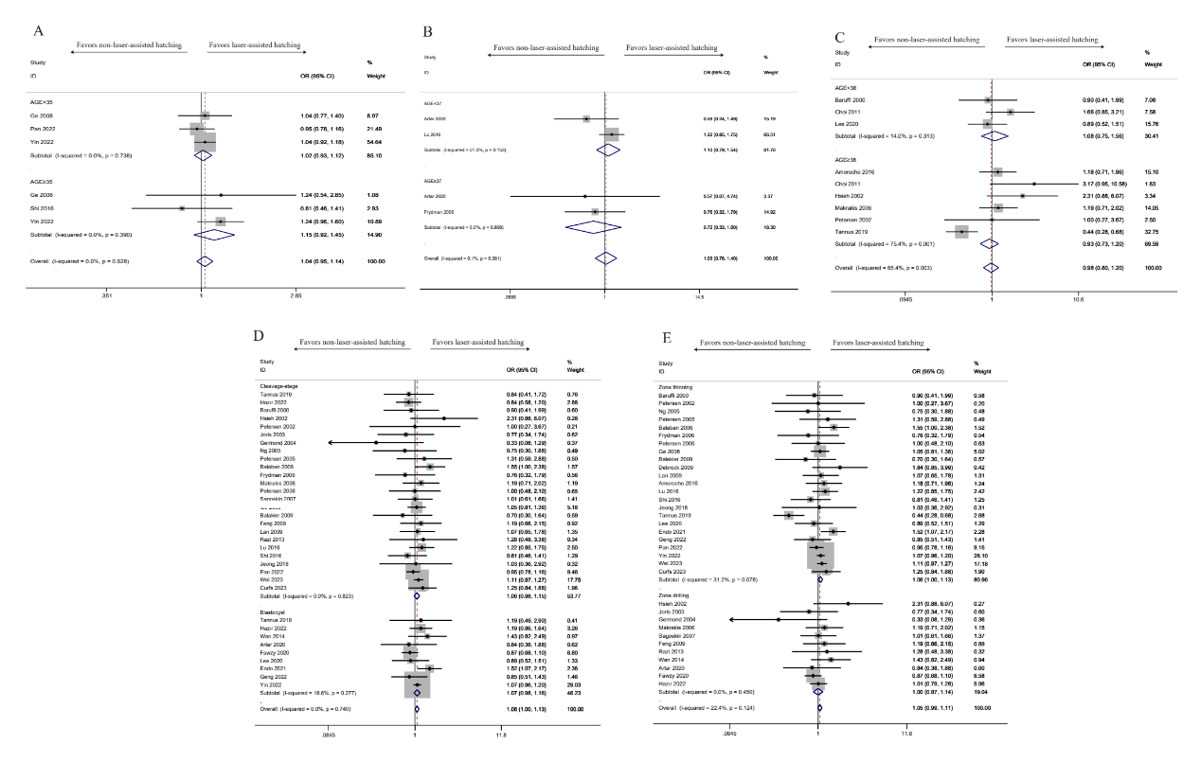
Supplementary Figure 5 Abortion rate
Fig 5.1 Egger’s test (A), Begg’s test (B), Funnel plot (C) and Labbe plot (D) of OR from the included studies for the detection of publication.
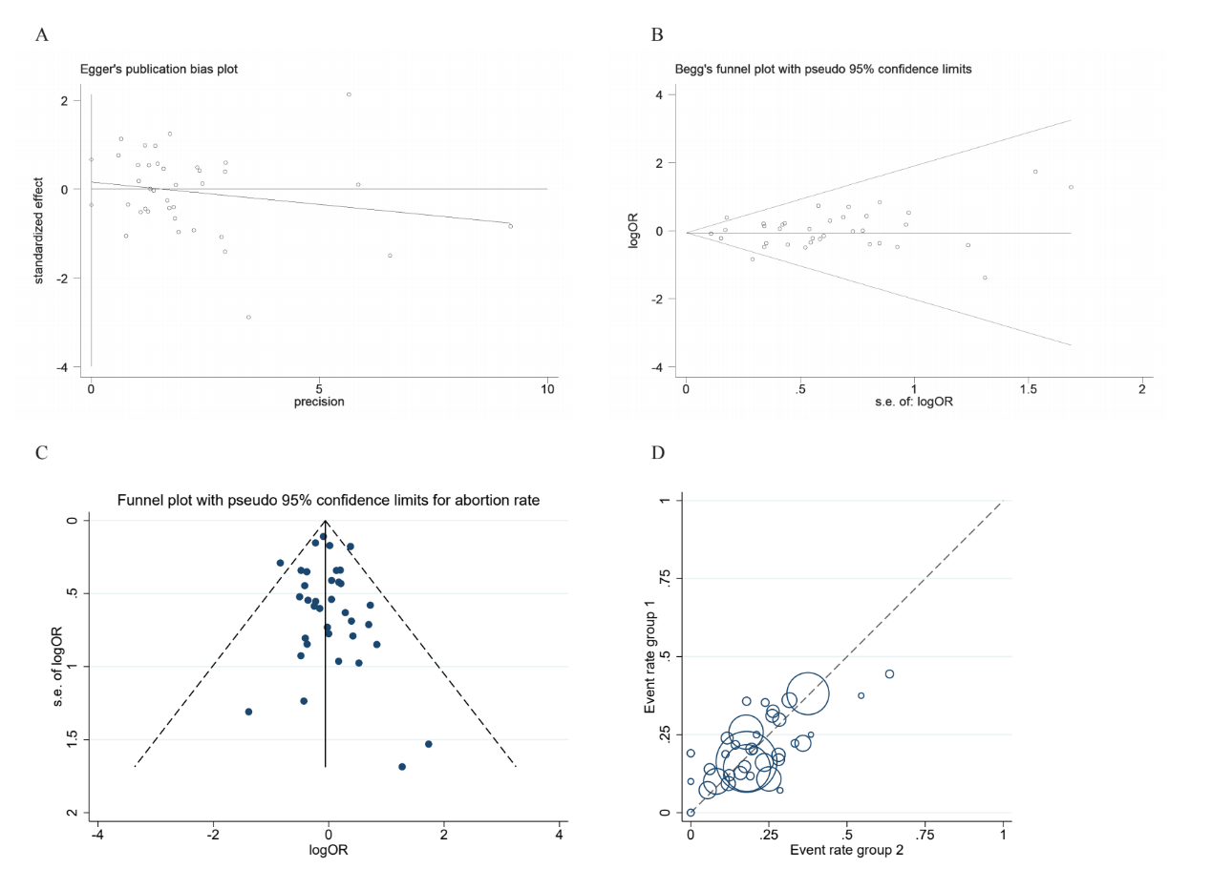

Fig 5.2 Subgroup analysis: Forest plot of abortion rate according to age (A-C); embryonic phase(D); embryonic status(E); ways of assisted hatching(F).
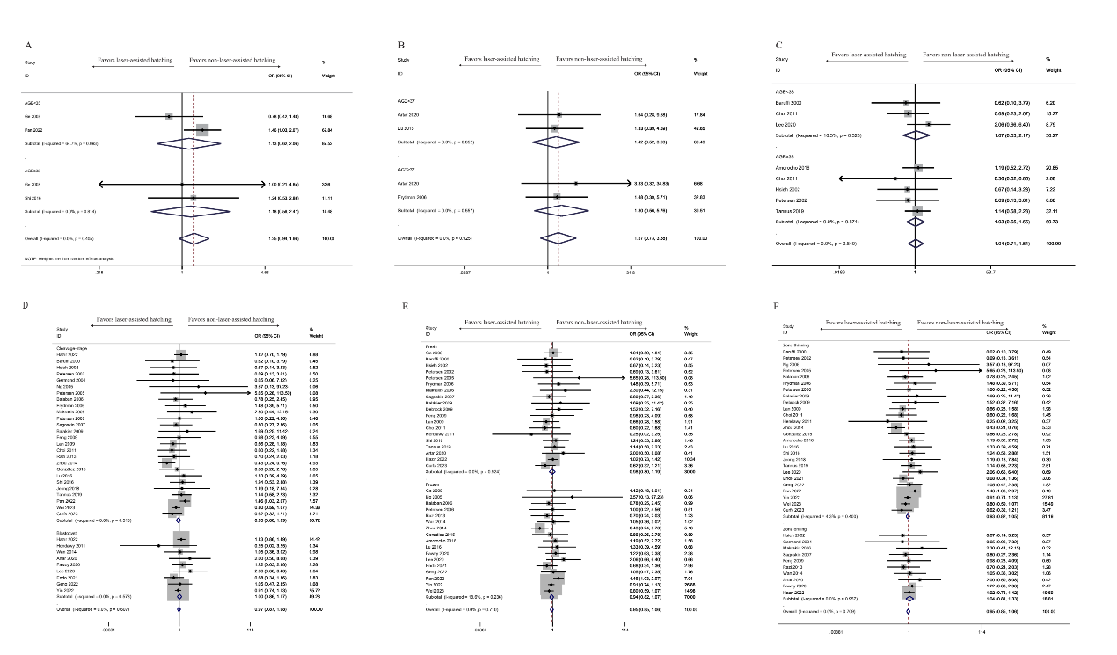
Supplementary Figure 6 RR and 95% CI for multiple pregnancy rate (A); ectopic pregnancy rate (B); perinatal adverse outcomes.
