Section 1:

Methods:
1. ROC AUC power (Hanley & McNeil SE; α = 0.05, two-sided) for power analysis for our small sample size as follows;

A) T2D discrimination (n_pos = 28 T2D; n_neg = 78 non-T2D)
miR-210-5p: AUC = 0.811
SE ≈ 0.0528, z ≈ 5.89 → Power ≈ 0.99996 (~100%)
miR-195-5p: AUC = 0.723
SE ≈ 0.0599, z ≈ 3.72 → Power ≈ 0.9609 (~96%)

Given the observed AUCs and group sizes (28 vs 78), the study had high power (>95%) to detect ROC performance above chance for miR-210-5p and miR-195-5p.

B) Severe AMI discrimination (LVEF ≤40%; n_pos = 22 severe; n_neg = 84 non-severe)
miR-1-5p: AUC = 0.765
SE ≈ 0.0631, z ≈ 4.20 → Power ≈ 0.987 (~99%)
Combined panel (miR-1-5p + eGFR + NT-proBNP): AUC = 0.823
SE ≈ 0.0573, z ≈ 5.64 → Power ≈ 0.99988 (~100%)

2. Logistic regression / panel power analysis for our small sample size as follows;

Our multivariable model reports OR = 8.04 for the combined panel predicting severe AMI.
To approximate power without knowing the exact panel prevalence:

Sensitivity ≈ 65%
Specificity ≈ 83%
Severe AMI prevalence ≈ 22/106 = 20.7%
From this, expected counts are approximately:
TP ≈ 0.65×22 = 14.3
FN ≈ 7.7
TN ≈ 0.83×84 = 69.7
FP ≈ 14.3

So panel-positive n ≈ 28.6 (~29), panel-negative n ≈ 77.4 (~77), with:
severe rate in panel+ ≈ 14.3/28.6 ≈ 50%
severe rate in panel− ≈ 7.7/77.4 ≈ 9.9%

Which implies our resultsare consistent.

Using a two-proportion z/χ² approximation at α = 0.05 (two-sided), the power ≈ 0.989 (~99%) to detect that association. Given the observed effect size (OR ≈ 8) and event rate (~21%), the analysis was well powered to detect the panel–severity association; however, the limited number of severe events may still affect model stability and generalizability.

Section 2:
Results:
- Treatment Regimens at baseline

Supplemental Table 1. Relevant treatment at baseline and after 26 weeks.

 | DIABETES post-AMI |  |  | NON-DIABETES post-AMI
 | 0 week (baseline) | 26th week (treatment) | P value | 0 week (baseline) | 26th week (treatment) | P value
ACE-I/ARB, n (%) | 25 (89) | 25 (89) | 1.000 | 77 (99) | 72 (99) | 1.000
ARNI, n (%) | 1 (4) | 1 (4) | 1.000 | 0 (0) | 0 (0) | -
Beta-blocker, n (%) | 27 (96) | 27 (96) | 1.000 | 73 (94) | 69 (95) | 1.000
MRA, n (%) | 13 (46) | 13 (46) | 1.000 | 33 (42) | 29 (40) | 1.000
Loop diuretic, n (%) | 4 (14) | 4 (14) | 1.000 | 9 (12) | 6 (8) | 1.000
Statin, n (%) | 28 (100) | 28 (100) | - | 75 (96) | 70 (96) | 1.000
Ezetimibe, n (%) | 5 (18) | 4 (14) | 1.000 | 16 (21) | 16 (22) | 1.000
Calcium channel blocker, n (%) | 5 (18) | 5 (18) | 1.000 | 6 (8) | 4 (6) | 1.000
Platelet-lowering drugs, n (%) | 28 (100) | 28 (100) | - | 78 (100) | 73 (100) | -
Anticoagulation drugs, n (%) | 4 (14) | 4 (14) | 1.000 | 7 (9) | 6 (8) | 1.000
Metformin, n (%) | 24 (86) | 22 (79) | 0.500 | 0 (0) | 0 (0) | -
DPP4 inhibitor, n (%) | 5 (18) | 5 (18) | 1.000 | 0 (0) | 0 (0) | -
Sulfonylurea, n (%) | 2 (7) | 2 (7) | 1.000 | 0 (0) | 0 (0) | -
GLP1-RA, n (%) | 3 (11) | 3 (11) | 1.000 | 0 (0) | 0 (0) | -
Insulin, n (%) | 7 (25) | 7 (25) | 1.000 | 0 (0) | 0 (0) | -

- Diagnostic utility of baseline troponin T, LVEF, NT-proBNP, and eGFR for diabetes status in patients with AMI
We did not observe any significant association between T2D status and baseline levels of troponin T, LVEF, NT-proBNP, or eGFR. The area under the ROC curve (AUC) for troponin T was 0.523 (95% CI, 0.39–0.65; p = 0.723) (Figure 1). The AUC for LVEF was 0.553 (95% CI, 0.42–0.68; p = 0.414) (Figure 2). The AUC for NT-proBNP was 0.518 (95% CI, 0.39–0.65; p = 0.783) (Figure 3). The AUC for eGFR was 0.486 (95% CI, 0.36–0.62; p = 0.830) (Figure 4).
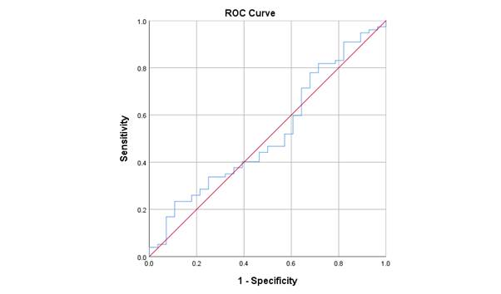
Figure 1. Troponin T central baseline ROC curve for diagnostic utility of diabetes
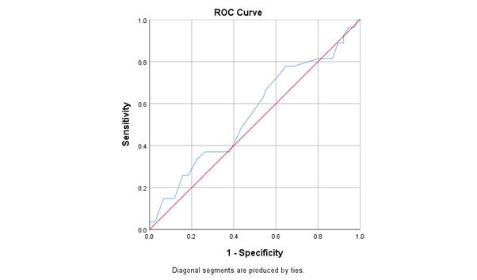
Figure 2. LVEF baseline ROC curve for diagnostic utility of diabetes
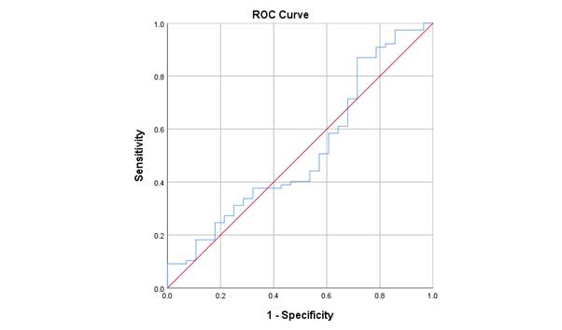

Figure 3. NT-proBNP baseline ROC curve for diagnostic utility of diabetes
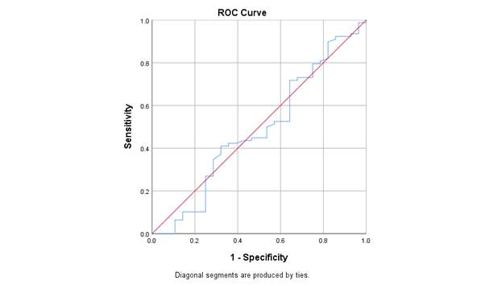
Figure 4. eGFR baseline ROC curve for diagnostic utility of diabetes

