Table S1. Median of Total Costs after an Unscheduled Return Visit by Analgesics (Data after IPTW)
Total costs (NT$) | Total, N=228 |  | Not received CT at the index visit, N=170 |  | Impressed with nonspecific abdominal pain at the index visit, N=155
 | median | IQR | median | IQR | median | IQR
Morphine | 43746.0 | 28743.0-71540.0 | 43746.0 | 32603.0-67826.0 | 58097.0 | 32112.0-78092.0
Ketorolac | 64202.0 | 31244.0-75890.0 | 65616.0 | 32215.0-76910.0 | 67601.0 | 35738.0-78656.0
Δ% | +46.76 % |  | +49.99 % |  | +16.36 %
IPTW: Inverse probability of treatment weighting; NT$: New Taiwan Dollars; IQR: Interquartile Range; CT: computed tomography. Δ%: difference %

Calculation of Total Medical Costs
Total medical costs were extracted directly from the hospital's electronic billing system and are reported in New Taiwan Dollars (NT$). The total cost encompasses all direct medical expenses incurred during the unscheduled return visit, including both the Emergency Department (ED) encounter and the subsequent inpatient stay. The specific subcomponents included in this calculation are:
- Provider and Nursing Fees: Physician consultation, daily ward rounds, and nursing care fees.
- Diagnostic Fees: Laboratory tests and advanced imaging (e.g., computed tomography, ultrasonography).
- Procedural and Surgical Fees: Costs associated with invasive interventions (e.g., surgery, PTCD, PTGBD, ERCP), including anesthesia and operating room utilization.
- Pharmacy and Material Fees: Medications, intravenous fluids, and medical supplies.
- Accommodation Fees: ED observation fees and inpatient ward bed fees.
Note: These costs reflect the actual claimed points under Taiwan’s National Health Insurance (NHI) administration, where 1 point is historically equivalent to approximately 1 NT$.
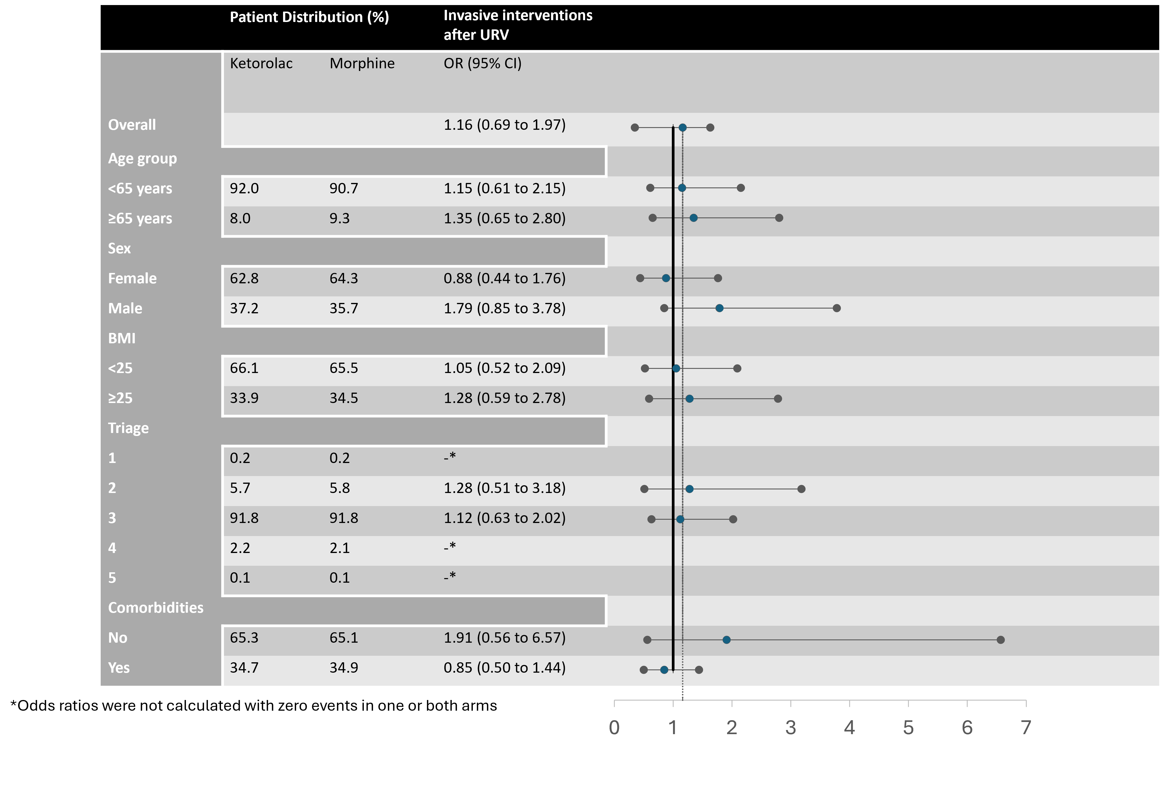
Fig.S1 Subgroup analyses of the association between the use of ketorolac or morphine and the risk of invasive interventions following an unscheduled return visit.
Table S2. Baseline characteristics of the analyzed ED encounters stratified by single versus multiple visits per patient.
Characteristic |  | Single visit (n=13557) |  | Multiple visits (n=4871) | p value
Drug, n (%) |  |  |  |  | <0.001
ketorolac |  | 12127 (89.4) |  | 3970 (81.5)
morphine |  | 1430 (10.6) |  | 901 (18.5)
Age (years),  mean ± SD |  | 38.3 ± 15.6 |  | 40.2 ± 17.1 | <0.001
Sex, n (%) |  |  |  |  | 0.007
Male |  | 5127 (37.8) |  | 1736 (35.6)
Female |  | 8430 (62.2) |  | 3135 (64.4)
BMI, kg/m²,  mean ± SD |  | 23.9 ± 25.5 |  | 24.2 ± 25.9 | 0.440
Any comorbidities (CCI ≥ 1), n (%) |  | 4349 (32.1) |  | 2056 (42.2) | <0.001
Triage level, n (%) |  |  |  |  | <0.001
Level 1 |  | 30 (0.2) |  | 11 (0.2)
Level 2 |  | 704 (5.2) |  | 355 (7.3)
Level 3 |  | 12526 (92.4) |  | 4385 (90.0)
Level 4 |  | 288 (2.1) |  | 117 (2.4)
Level 5 |  | 9 (0.1) |  | 3 (0.1)
HR (bpm),  mean ± SD |  | 87.0 ± 16.2 |  | 86.6 ± 16.5 | 0.116
SBP (mmHg), mean ± SD |  | 127.8 ± 22.2 |  | 128.9 ± 22.7 | 0.003
DBP (mmHg), mean ± SD |  | 80.6 ± 14.5 |  | 80.8 ± 12.6 | 0.402
BT (°C),  mean ± SD |  | 36.6 ± 0.6 |  | 36.5 ± 0.6 | <0.001
RR (breaths/min), mean ± SD |  | 19.4 ± 1.5 |  | 19.4 ± 1.6 | 0.372

