Supplementary Table S1. Comparison and harmonization of laboratory measurement units between the derivation (MIMIC-IV) and external validation (Kunshan) cohorts
Variable | MIMIC-IV | Kunshan cohort | Conversion
HbA1c | % | % | Not required
WBC | 10^9/L | 10^9/L | Not required
BUN | mg/dL | mmol/L | Converted to mg/dL
Hemoglobin | g/L | g/L | Not required
LDL-C | mmol/L | mmol/L | Not required
Troponin T | ng/mL | ng/mL | Not required
Glucose | mg/dL | mmol/L | Converted to mmol/L
Standard conversion factors were applied to harmonize laboratory units across cohorts before analysis
Abbreviations: HbA1c, glycated hemoglobin; WBC, white blood cell; BUN, blood urea nitrogen; LDL-C, low-density lipoprotein cholesterol.

Supplementary Table S2. Variance inflation factor (VIF) analysis for the assessment of multicollinearity among candidate predictors
Variables | VIF
SHR | 2.1
AMI | 1.4
Sex | 1.5
Age | 2
Hypertension | 1.4
Congestive heart failure | 1.4
Atrial fibrillation | 1.4
Peripheral vascular disease | 1.3
Cerebrovascular disease | 1.4
Diabetes mellitus | 3.1
qSOFA score | 1.4
HbA1c | 3
Heart rate | 1.4
BMI | 1.3
WBC | 1.4
BUN | 1.5
Hemoglobin | 1.7
LDL-C | 1.4
Troponin T | 1.3
eGFR | 2.9
Diuretics | 1.4
ACEI/ARB | 1.6
β-blocker | 1.5
Statins | 2.6
Antiplatelet drugs | 1.9
Calcium channel blockers | 1.7
Glucose-lowering therapy | 3
History of PCI | 1.3
History of CABG | 1.8
History of RRT | 3
Variance inflation factors (VIFs) were calculated to assess multicollinearity; VIF < 5 indicates no significant collinearity.
Abbreviations: SHR, stress hyperglycemia ratio; AMI, acute myocardial infarction; BMI, body mass index; WBC, white blood cell; BUN, blood urea nitrogen; LDL-C, low-density lipoprotein cholesterol; eGFR, estimated glomerular filtration rate; ACEI/ARB, angiotensin-converting enzyme inhibitors or angiotensin receptor blockers; CABG, coronary artery bypass grafting; RRT, renal replacement therapy.

Supplementary Table S3. Missing data for candidate variables in the study cohort
Variable | Missing values, n (%)
Laboratory parameters and vital signs
Troponin T | 62 (10.23%)
BMI | 52 (8.58%)
LDL-C | 31 (5.12%)
WBC | 1 (0.17%)
Variables with complete data
SHR | 0 (0.00%)
Age | 0 (0.00%)
Sex | 0 (0.00%)
Heart rate | 0 (0.00%)
Hemoglobin | 0 (0.00%)
BUN | 0 (0.00%)
HbA1c | 0 (0.00%)
eGFR | 0 (0.00%)
qSOFA | 0 (0.00%)
AMI type | 0 (0.00%)
Hypertension | 0 (0.00%)
Congestive heart failure | 0 (0.00%)
Atrial fibrillation | 0 (0.00%)
Peripheral vascular disease | 0 (0.00%)
Cerebrovascular disease | 0 (0.00%)
Diabetes mellitus | 0 (0.00%)
Diuretic | 0 (0.00%)
ACEI/ARB | 0 (0.00%)
β-blocker | 0 (0.00%)
Statins | 0 (0.00%)
Antiplatelet drugs | 0 (0.00%)
Calcium channel blocker | 0 (0.00%)
Glucose-lowering therapy | 0 (0.00%)
History of PCI | 0 (0.00%)
History of CABG | 0 (0.00%)
History of RRT | 0 (0.00%)
Abbreviations: BMI, body mass index; LDL-C, low-density lipoprotein cholesterol; WBC, white blood cell; SHR, stress hyperglycemia ratio; BUN, blood urea nitrogen; HbA1c, glycated hemoglobin; eGFR, estimated glomerular filtration rate; qSOFA, quick Sequential Organ Failure Assessment; AMI, acute myocardial infarction; ACEI/ARB, angiotensin-converting enzyme inhibitors or angiotensin receptor blockers; PCI, percutaneous coronary intervention; CABG, coronary artery bypass grafting; RRT, renal replacement therapy.

Supplementary Table S4. Sensitivity analysis of the association between SHR and 1-year mortality across different missing data handling strategies
Imputation Strategy | Hazard Ratio (95% CI) for SHR (per 1-SD) | P value
Primary Analysis (missForest imputation) | 1.14 (1.03–1.26) | 0.009
Sensitivity Analysis 1: Complete-Case Analysis | 1.17 (1.05–1.29) | 0.003
Sensitivity Analysis 2: Multiple Imputation (MICE) | 1.14 (1.03–1.26) | 0.009
Hazard ratios were derived from the fully adjusted Cox model (Model 3).
Abbreviations: SHR, stress hyperglycemia ratio; SD, standard deviation; CI, confidence interval; MICE, multivariate imputation by chained equations.

Supplementary Table S5. Baseline characteristics of included patients and those excluded due to missing HbA1c in the MIMIC-IV cohort
Variables | Included cohort (n = 606) | Excluded due to missing HbA1c (n = 904) | P value
Age, years | 71.0 (63.0–78.0) | 77.0 (68.0–85.0) | <0.001
Male sex, n (%) | 431 (71.1) | 572 (63.3) | 0.002
eGFR, mL/min/1.73 m² | 30.0 (16.0–45.0) | 20.7 (12.8–34.1) | <0.001
Congestive heart failure, n (%) | 419 (69.1) | 677 (74.9) | 0.016
Diabetes mellitus, n (%) | 401 (66.2) | 532 (58.8) | 0.004
1-year mortality, n (%) | 325 (53.6) | 496 (54.9) | 0.673
Data are presented as median (interquartile range) or n (%). Group comparisons were performed using appropriate statistical tests.
Abbreviations: HbA1c, glycated hemoglobin; eGFR, estimated glomerular filtration rate.

Supplementary Table S6. Proportional hazards (PH) assumption diagnostics for covariates in the multivariable Cox regression model (Model 3)
Variables | χ2 (Chi-square) | df | P-value
SHR (per 1-SD increase) | 7.26 | 1 | 0.007
Age | 14.10 | 1 | <0.001
Sex | 0.13 | 1 | 0.721
BMI | 0.42 | 1 | 0.519
Type of AMI | 4.16 | 1 | 0.041
Hypertension | 0.001 | 1 | 0.980
Congestive heart failure | 5.92 | 1 | 0.015
Atrial fibrillation | 1.61 | 1 | 0.204
Peripheral vascular disease | 0.03 | 1 | 0.857
Cerebrovascular disease | 3.99 | 1 | 0.046
Diabetes mellitus | 5.16 | 1 | 0.023
eGFR | 1.14 | 1 | 0.285
GLOBAL TEST | 51.00 | 12 | <0.001
Proportional hazards assumption was assessed using Schoenfeld residuals; P < 0.05 indicates violation.
Abbreviations: SHR, stress hyperglycemia ratio; SD, standard deviation; BMI, body mass index; eGFR, estimated glomerular filtration rate; AMI, acute myocardial infarction.

Supplementary Table S7. Time-varying sensitivity analysis of the association between SHR and 1-year mortality using a 90-day time-split Cox model
Variables | Hazard Ratio (HR) | 95% Confidence Interval | P-value
SHR (per 1-SD increase)
< 90 Days | 1.32 | 1.16–1.51 | <0.001
> 90 Days | 1.06 | 0.92–1.22 | 0.407
Age | 1.01 | 1.00–1.02 | 0.121
Sex (Female vs. Male) | 0.85 | 0.67–1.09 | 0.201
BMI | 1.00 | 0.98–1.02 | 0.926
eGFR | 0.98 | 0.97–0.99 | <0.001
Hypertension | 0.70 | 0.47–1.04 | 0.074
Peripheral vascular disease | 1.08 | 0.80–1.44 | 0.620
Atrial fibrillation | 1.14 | 0.89–1.45 | 0.295
A time-varying Cox model with a 90-day time split was used to account for violation of the proportional hazards assumption. Variables that violated the proportional hazards assumption (including congestive heart failure, cerebrovascular disease, diabetes mellitus, and AMI type) were incorporated into the model as stratification factors; therefore, hazard ratios for these variables are not presented.
Abbreviations: HR, hazard ratio; CI, confidence interval; SHR, stress hyperglycemia ratio; SD, standard deviation; BMI, body mass index; eGFR, estimated glomerular filtration rate.

Supplementary Table S8. Predictive performance of the full model and the pre-treatment baseline model
Model | Predictor Set | AUC (95% CI)
Full model | Baseline clinical variables + early treatment variables | 0.872 (0.846–0.898)
Pre-treatment model | Baseline clinical variables | 0.809 (0.777–0.840)
The full model included baseline and early treatment variables, whereas the pre-treatment model included baseline variables only.
Abbreviations: AUC, area under the receiver operating characteristic curve; CI, confidence interval.

Supplementary Table S9. Classification performance metrics of the four machine learning models for predicting 1-year mortality in the external validation cohort.
Model | Sensitivity (95% CI) | Specificity (95% CI) | Accuracy (95% CI) | PPV (95% CI) | NPV (95% CI) | F1 Score
Logistic | 0.773 (0.662–0.862) | 0.468 (0.372–0.566) | 0.592 (0.518–0.664) | 0.500 (0.406–0.594) | 0.750 (0.630–0.847) | 0.607
SVM | 0.987 (0.928–1.000) | 0.009 (0.000–0.050) | 0.408 (0.336–0.482) | 0.407 (0.335–0.482) | 0.500 (0.013–0.987) | 0.576
RF | 0.947 (0.869–0.985) | 0.183 (0.116–0.269) | 0.495 (0.420–0.569) | 0.444 (0.365–0.524) | 0.833 (0.626–0.953) | 0.604
XGBoost | 0.787 (0.677–0.873) | 0.624 (0.526–0.715) | 0.690 (0.618–0.756) | 0.590 (0.487–0.687) | 0.810 (0.709–0.887) | 0.674
CI, confidence interval; PPV, positive predictive value; NPV, negative predictive value; XGBoost, extreme gradient boosting; F1 score, harmonic mean of precision and recall.

Supplementary Table S10. External calibration performance of the XGBoost model before and after logistic recalibration
Model Status | AUC (95% CI) | Brier Score (95% CI) | Calibration Intercept (95% CI) | Calibration Slope (95% CI)
Pre-recalibration  (raw model) | 0.718 (0.644–0.792) | 0.253 (0.208–0.299) | −0.269 (−0.590–0.053) | 0.298 (0.151–0.492)
Post-recalibration | 0.718 (0.644–0.792) | 0.242 (0.210–0.280) | 0.003 (−0.180–0.185) | 0.982 (0.612–1.487)
Logistic recalibration updated the intercept and slope in the external cohort.
Abbreviations: AUC, area under the receiver operating characteristic curve; CI, confidence interval.

Supplementary Table S11. Sensitivity analysis of external model performance after excluding patients admitted during the COVID-19 pandemic
Cohort Subset | AUC (95% CI) | Brier Score (95% CI) | Calibration Intercept (95% CI) | Calibration Slope (95% CI)
Full External Cohort  (2019–2025) | 0.718 (0.644–0.792) | 0.242 (0.239–0.245) | 0.000 (−0.182–0.186) | 1.000 (0.591–2.590)
Non-Pandemic Subset  (2019, 2023–2025) | 0.686 (0.613–0.759) | 0.220 (0.201–0.240) | 0.000 (−0.313–0.330) | 1.000 (0.598–1.483)
Sensitivity analysis excluding patients admitted during the COVID-19 pandemic (2020–2022). Calibration metrics are based on post-recalibration models.
Abbreviations: AUC, area under the receiver operating characteristic curve; CI, confidence interval.

Supplementary Figure S1. Restricted cubic spline (RCS) curve for the dose-response relationship between continuous SHR and 1-year mortality.
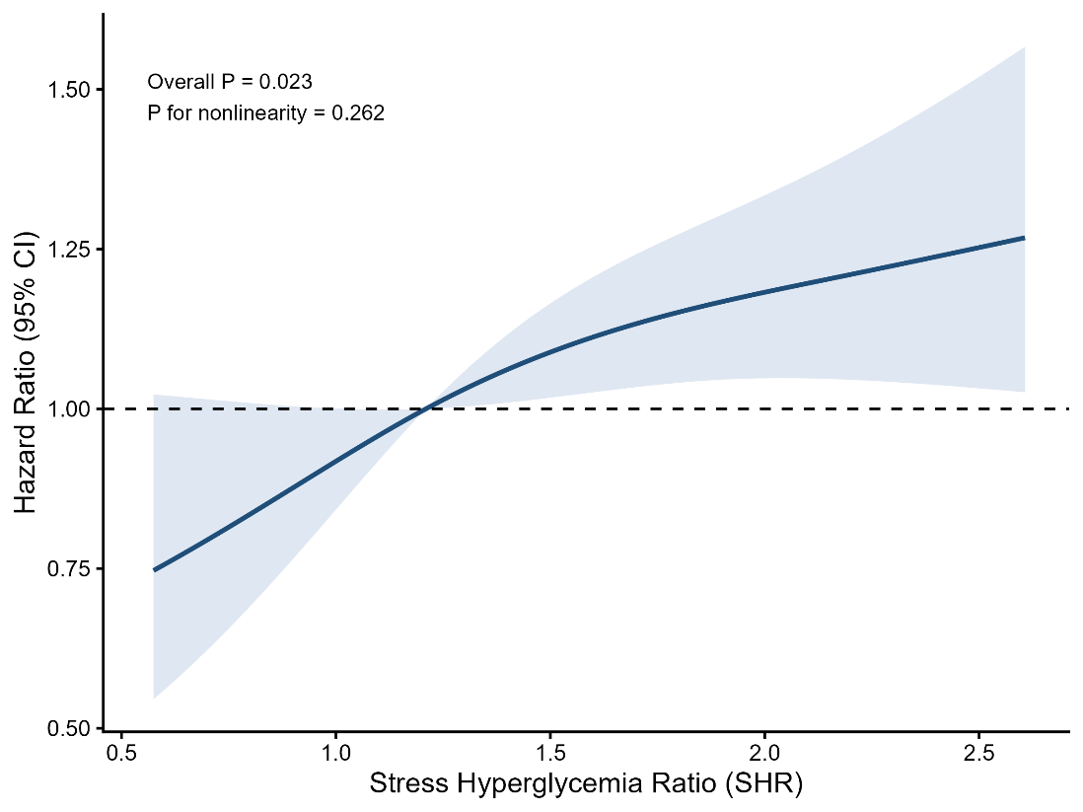

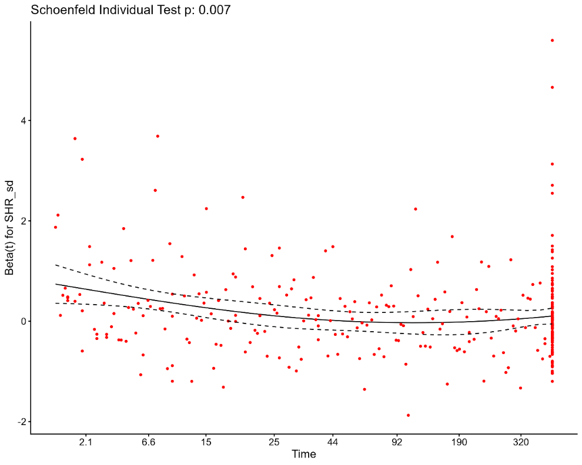
Supplementary Figure S2. Schoenfeld residuals plot for testing the proportional hazards assumption of the stress hyperglycemia ratio (SHR).
The plot displays the scaled Schoenfeld residuals for SHR over the follow-up time (in days), accompanied by a fitted smooth curve (solid line) and its 95% confidence bands (dashed lines).

Supplementary Figure S3. Calibration plots of the machine learning models in the external validation cohort.
(a) LOG: Logistic regression; (b) RF: Random forest; (c) SVM: Support vector machine; (d) XGB: Extreme gradient boosting. The x-axis represents predicted probability of 1-year all-cause mortality, and the y-axis represents observed event frequency. The red solid line indicates perfect calibration, and the blue dashed line represents the apparent calibration of the original model without recalibration.
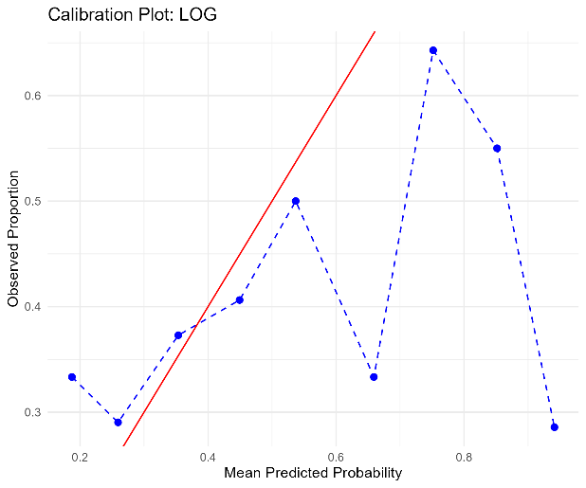 | 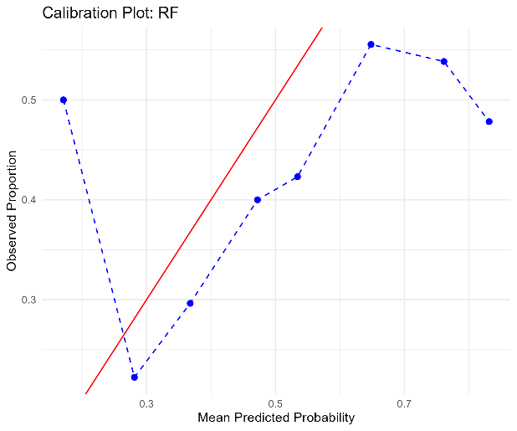
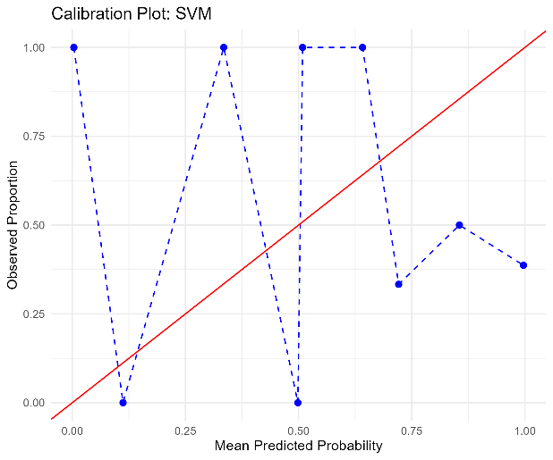 | 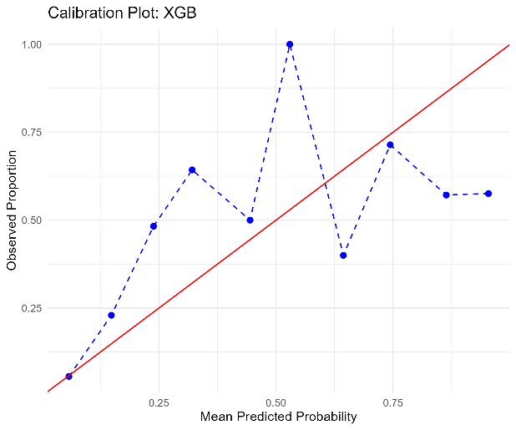

Supplementary Figure S4. Decision curve analysis of the four machine learning models in the external validation cohort.
The x-axis represents threshold probability, and the y-axis represents net benefit.
Decision curve analysis was performed using post-recalibration probabilities.
