Correlation Between Angiopoietin-2 Levels and Layered Plaques in Acute Coronary Syndrome: Insights from an Optical Coherence tomography
Jiaojiao Wen*1, Chancui Deng*1, Changlong Yang1, Xi Wang1, Xingwei Hu1, Bei Shi1*, and Yi Ma1*
Department of Cardiology, Affiliated Hospital of Zunyi Medical University, Zunyi, China.

Correspondence: Bei Shi shibei2147@163.com
Yi Ma mayimayizmc@126.com

Additional file 1: Supplementary Fig. 1

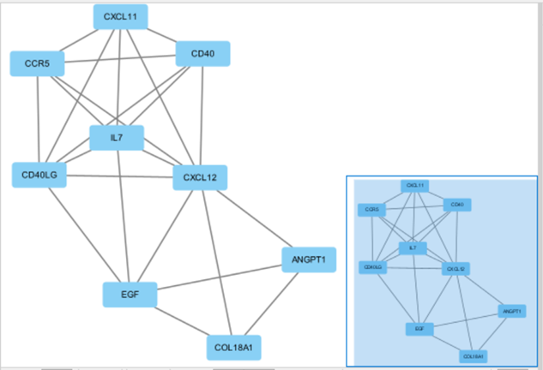
Fig. 1 Cytoscape diagram. ANGPT1=Ang1.

Additional file 2: Supplementary Fig. 2
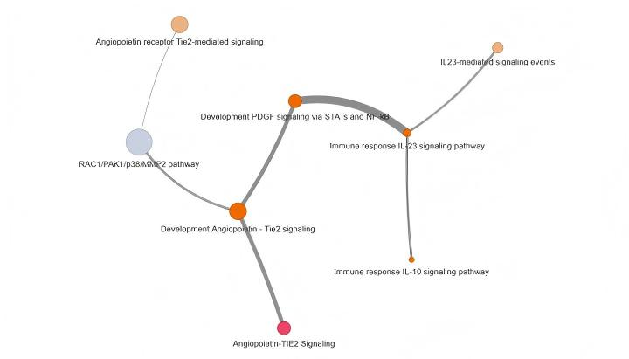
Fig. 2 Pathway diagram. the pathways related to Ang2 are presented.

Additional file 3: Data Collection and Angiographic Analysis
Basic information included patient admission number, name, gender, age(years), Angiopoietin-2(Ang2,ng/mL), Heart rate(HR,times/min), systolic blood pressure(SBP, mmHg)(based on medical history), Diastolic blood pressure(DBP, mmHg), Smoking(based on medical history), Hypertension, Diabetes(based on medical history), Dyslipidemia, as well as Previous Percutaneous Coronary Intervention(PCI), Previous Myocardial Infarction(MI),Admission event(Admission event includes paroxysmal malignant arrhythmia or shock), Clinical presentation(Acute myocardial infarction and unstable angina), Statin, Clopidogrel, Aspirin, β-blocker, Diuretic, Indobufen, ACEI/ARB(Angiotensin-Converting Enzyme Inhibitor/Angiotensin Receptor Blocker), Mechanical support, Killip classification(Killip classification includes Killip grade I, Killip grade II, Killip grade III and Killip grade IV). During hospitalization, the auxiliary examination data include the results of the first cardiac ultrasound on admission, as well as the results of coronary angiography (one target lesion per patient), etc. Optical coherence tomography(OCT) image data encompasses the nature of target lesion plaques, presence of thrombosis, Fiber cap thickness (FCT), lipid arc, Lipid length, Thin-cap fibroatheroma (TCFA), characteristics of thrombosis, microchannels, Macrophage, calcification, minimum lumen area (MLA), area stenosis (AS), and reference vessel area (RA).
Additional file 4: Collection of blood samples and detection of Ang2 concentration
Prior to CAG, peripheral blood was collected in the catheter chamber utilizing a serum-separating gel as well as a coagulant stimulating tube (a red standard serum-separating tube) through the sheath of the radial artery or the femoral artery. Besides, the serum was separated after standing at room temperature for 2 hours or in the refrigerator at 4 degrees Celsius overnight, and subsequently, the coagulant tubes were placed in the centrifuge, and centrifuged at 3000 RPM at room temperature for 10 minutes. Moreover, the serum supernatant was meticulously absorbed and divided into 2mL EP tubes, and stored in the ultra-low temperature refrigerator at -80 degrees Celsius for subsequent detection of Ang2 concentration, and the storage time was not more than 6 months. Furthermore, using an enzyme-linked immunosorbent assay (Mlbio, YJ023338, China) with a detection range of 0-24ng/mL, the serum Ang2 concentration was determined.
Additional file 4.1: laboratory examination
Preoperative clinical laboratory test results re collectweed, including white blood cell count (WBC), neutrophil count, high-sensitivity C-reactive protein (Hs-CRP), blood glucose, hemoglobin A1c (HbA1c), blood lipids (HDL-C, LDL-C, TC, TG), potassium, myoglobin, cardiac troponin T (cTnT), N-terminal pro-B-type natriuretic peptide (NT-proBNP), blood platelet count, D-dimer, and ejection fraction (EF). The detection methods and instruments are as follows:
1. Biochemical indicators (blood lipids, blood glucose, potassium): Detected by Beckman AU5821 automatic biochemical analyzer (USA); 2. Creatinine: Detected by CRE-N enzyme solution method; 3. Cardiac markers (cTnT, myoglobin, NT-proBNP): Detected by electrochemiluminescence immunoassay (ECLIA) using Roche Cobas e601 analyzer (Switzerland); 4. Hs-CRP, D-dimer: Detected by immunoturbidimetry; 5. Blood cell indicators (WBC, neutrophil, blood platelet): Detected by Sysmex XN-9000 automatic hematology analyzer (Japan);6. HbA1c: Detected by high-performance liquid chromatography (HPLC).

Additional file 4.2: standard curve

standard curve

Additional file 5: Supplementary Tables
Supplementary Table S1 Univariate logistic regression analysiscs for LP
 | Univariate analysis
 | OR（95%CI） | p Value
Admission event | 2.533(0.804～7.978) | 0.112
HR | 0.977(0.945～1.101) | 0.166
Mechanical support | 3.588(0.625～20.617) | 0.152
Hs-CRP | 1.011(0.983～1.04) | 0.454
Ang2 | 1.110(1.015～1.214) | 0.022
Smoking | 0.508(0.217～1.190) | 0.119
Dyslipidemia | 0.508(0.211～1.224) | 0.131
DSB | 0.962(0.930～0.996) | 0.030
statin | Not estimable | 0.999
HR: Heart rate; Hs-CRP: Hypersensitive c-reactive protein; Ang2: Angiopoietin-2; CI: confidence interval; DSB: Diastolic blood pressure; LP: layered plaque; OR: odds ratio.

Additional file 6: Supplementary Fig. 3
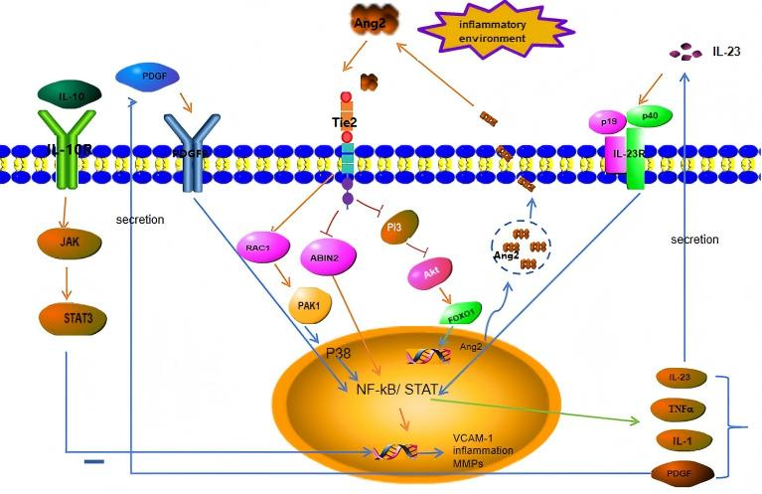

Fig. 3 Ang2 Possible Pathway Crosstalk. This is a hypothetical model based on the previous literatures, rather than the path verified by the current experimental results. In the inflammatory environment, Ang2 release is stimulated, and Tie2 is competitively combined to block Ang1-mediated PI3/Akt, which promotes Foxo1 to transcribe more Ang2 and aggravates the inflammatory response. At the same time, the activation inhibition of NF-kB by ABIN2 was relieved. On this basis, it may activate RAC1/PAK1/ p38 ( enhance matrix degradation) and STAT/NF-κB (drive cytokine release), while inhibiting the IL-10 anti-inflammatory pathway. In addition, IL-23 expression is indirectly up-regulated to further amplify the inflammatory cascade. The PDGF pathway regulated by STAT / NF-κB will promote the abnormal proliferation and migration of vascular smooth muscle cells and interfere with the normal structure of plaque.

