Supplementary Information
Figure S1. K‒M survival analysis of 14 RNA methylation-associated genes associated with LSCC prognosis.
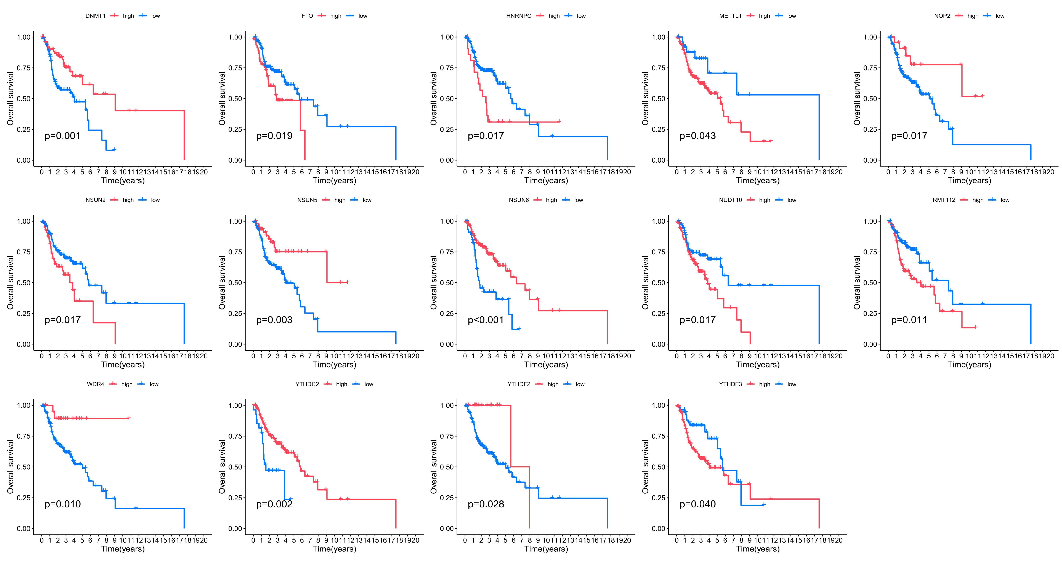

Figure S2. A total of 570 genes associated with different RNA methylation subtypes were identified.
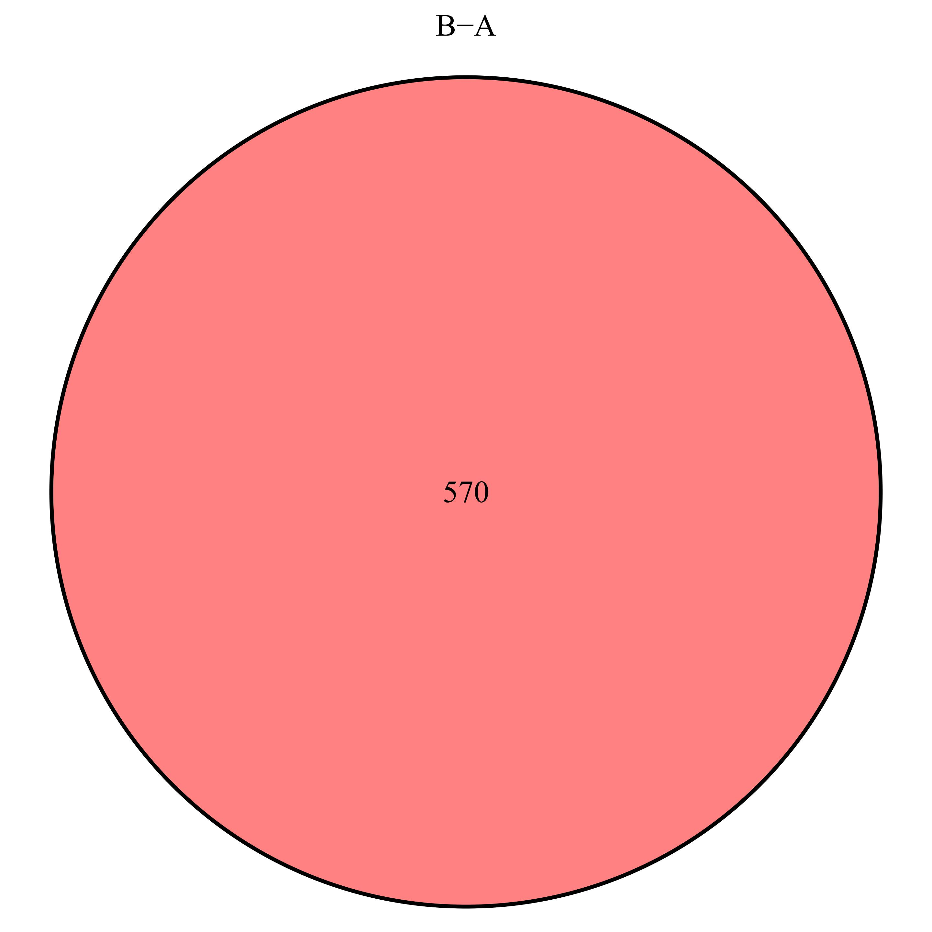

Figure S3. Correlation analysis of immune cell infiltration levels and the RS.
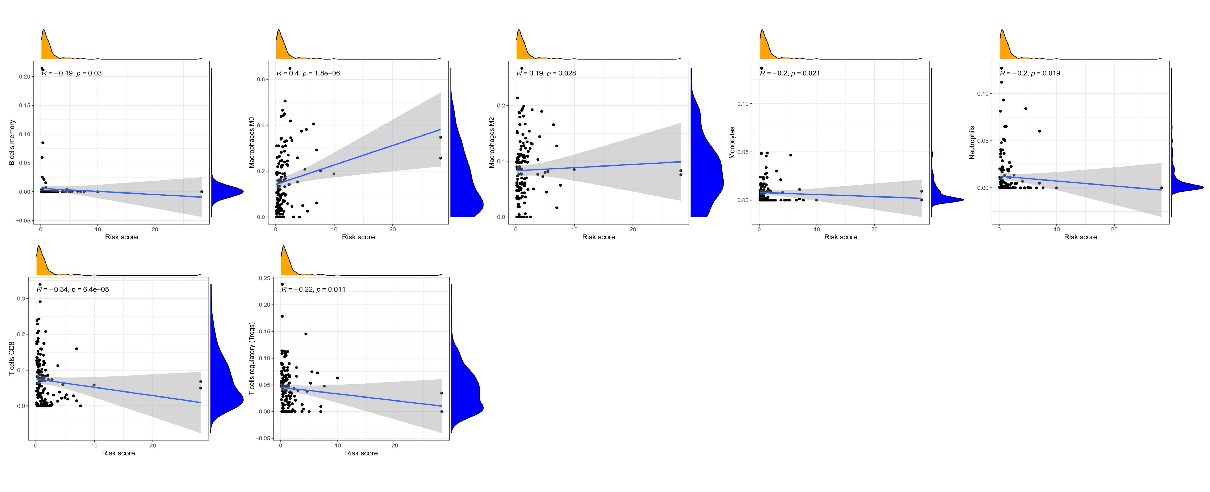

Figure S4. Drug sensitivity analysis in the high- and low-risk groups.
