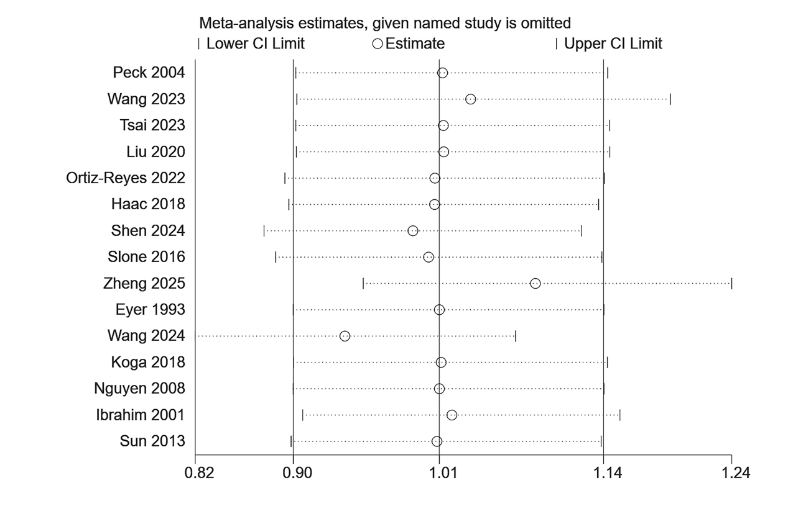

Supplementary Figure 1 Sensitivity analysis for 30-day mortality.

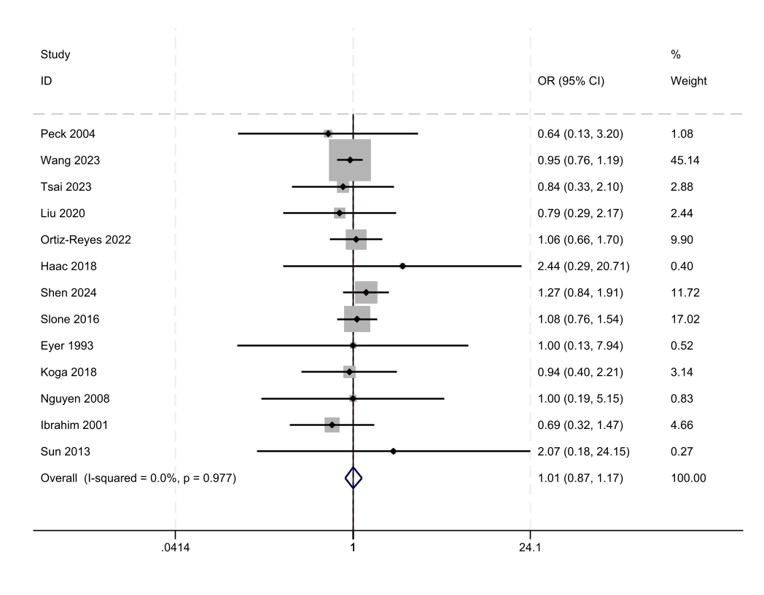
Supplementary Figure 2 Forest plot for 30-day mortality after excluding potential confounders (Zheng 2025 and Wang 2024).

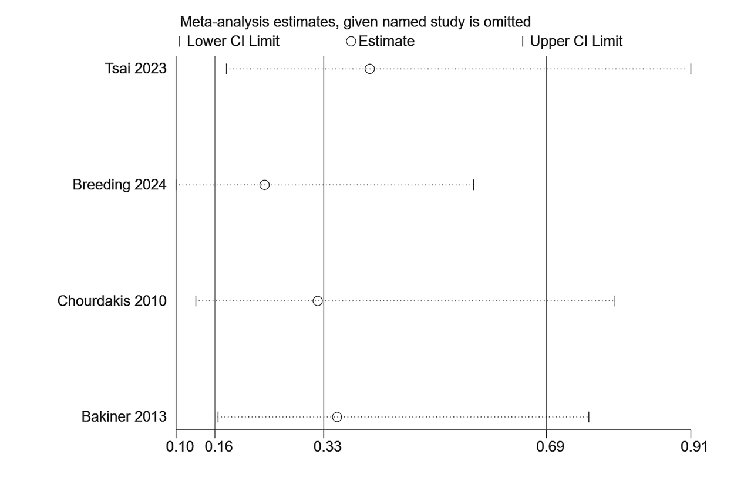
Supplementary Figure 3 Sensitivity analysis for infectious complications

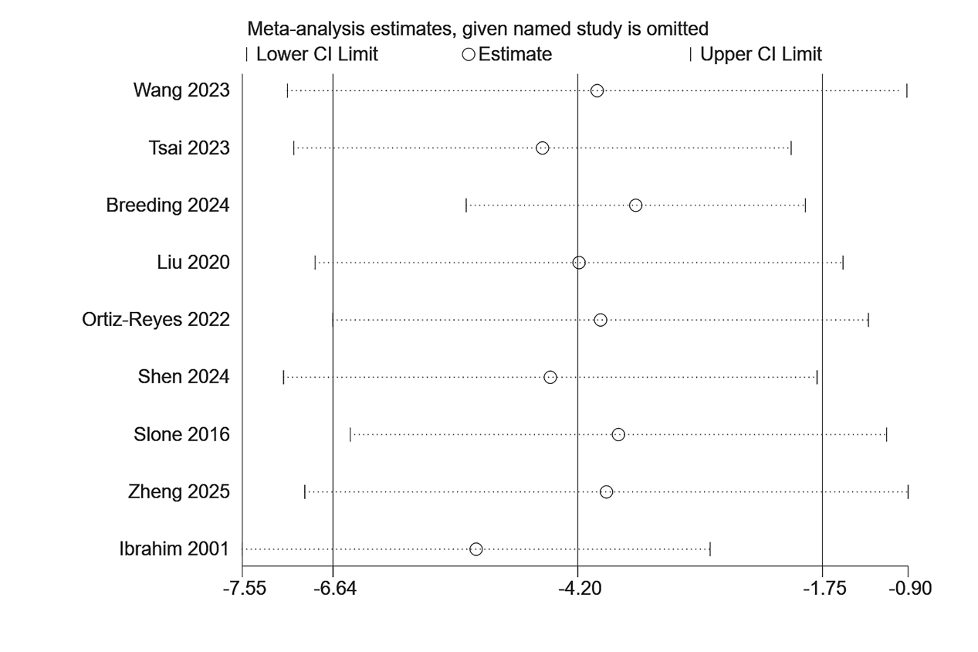
Supplementary Figure 4 Sensitivity analysis for length of hospital stay.

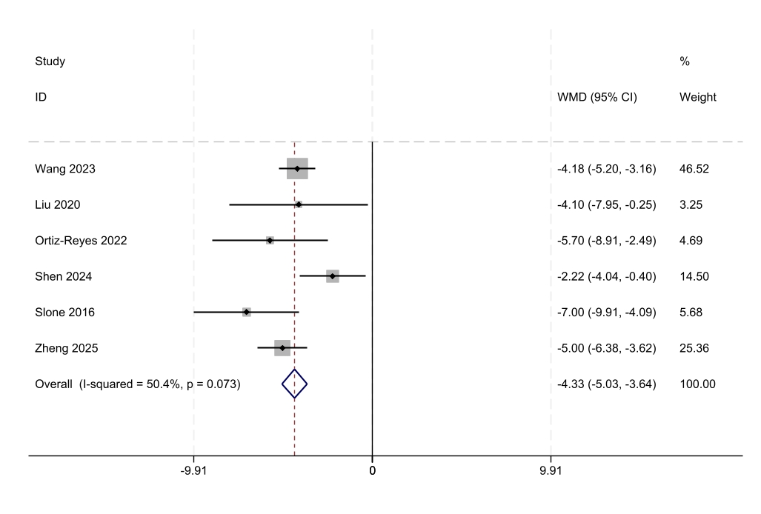
Supplementary Figure 5 Forest plot for hospital stay after excluding potential confounders (Tsai 2023, Breeding 2024, and Ibrahim 2001).

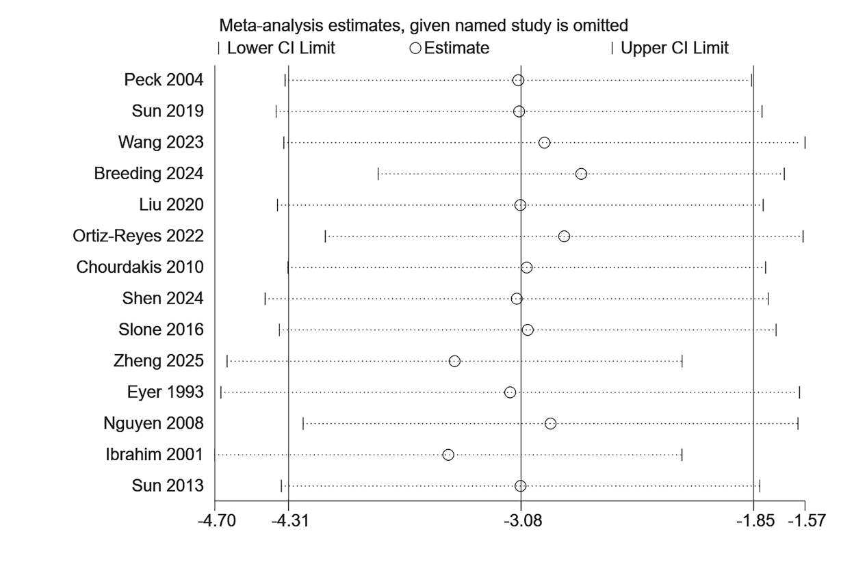
Supplementary Figure 6 Sensitivity analysis for ICU stay

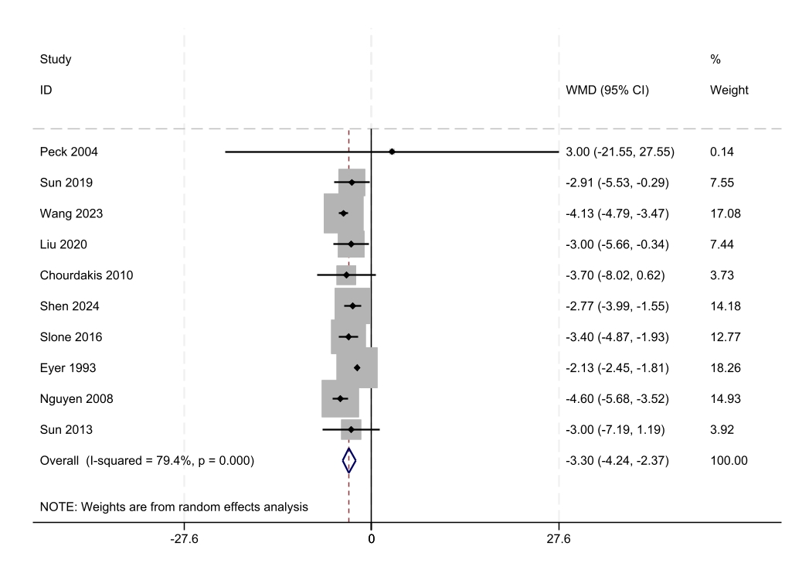
Supplementary Figure 7 Forest plot for lCU stay after excluding potential confounders (Ibrahim 2001, Zheng 2025, Ortiz-Reyes 2022, and Breeding 2024).

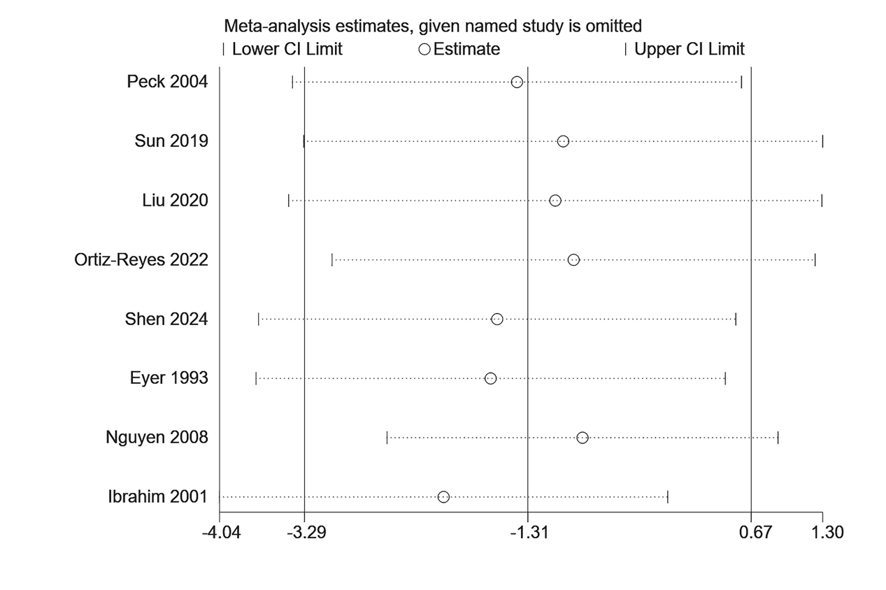
Supplementary Figure 8 Sensitivity analysis for mechanical ventilation days.

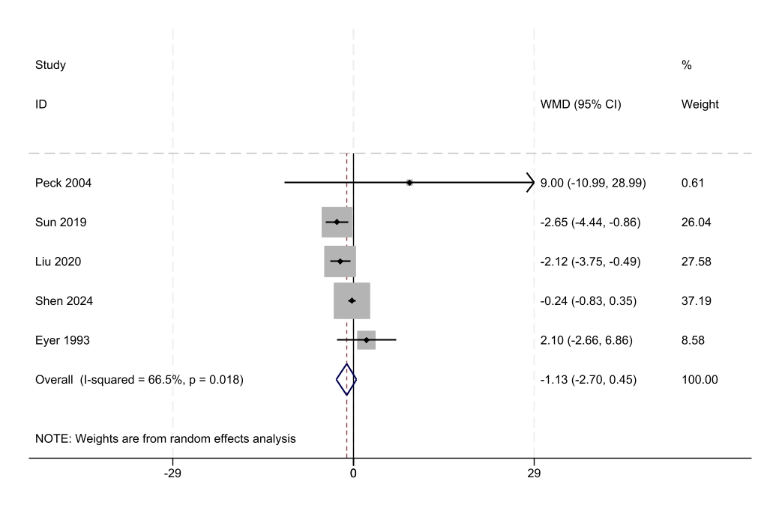
Supplementary Figure 9 Forest plot for the number of days of mechanical ventilation after excluding potential confounders (Ortiz-Reyes 2022, Nguyen 2008, and Ibrahim 2001).

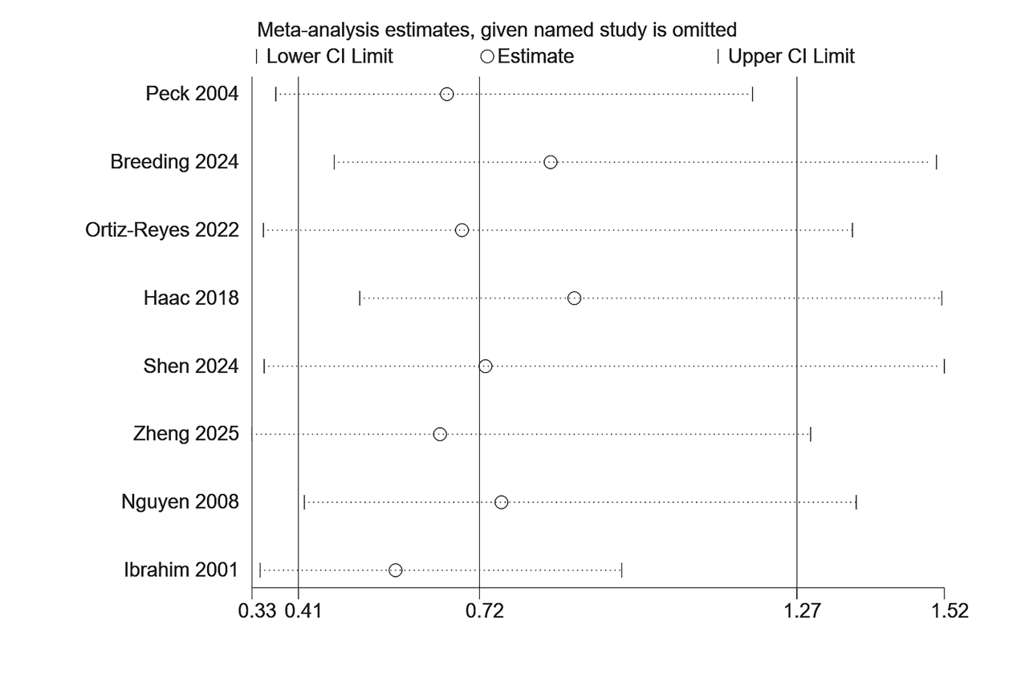
Supplementary Figure 10 Sensitivity analysis for other complications.
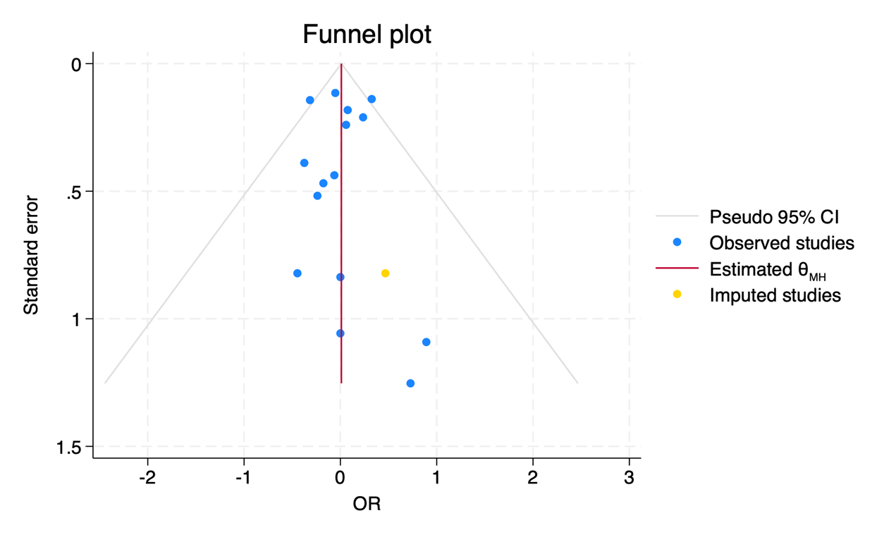
Supplementary Figure 11 Trim-and-fill method for 30-day mortality.
Following the inclusion of an additional study, the results of the pooled analysis remained consistent in their direction (OR= 1.010; 95% CI=0.897, 1.138).

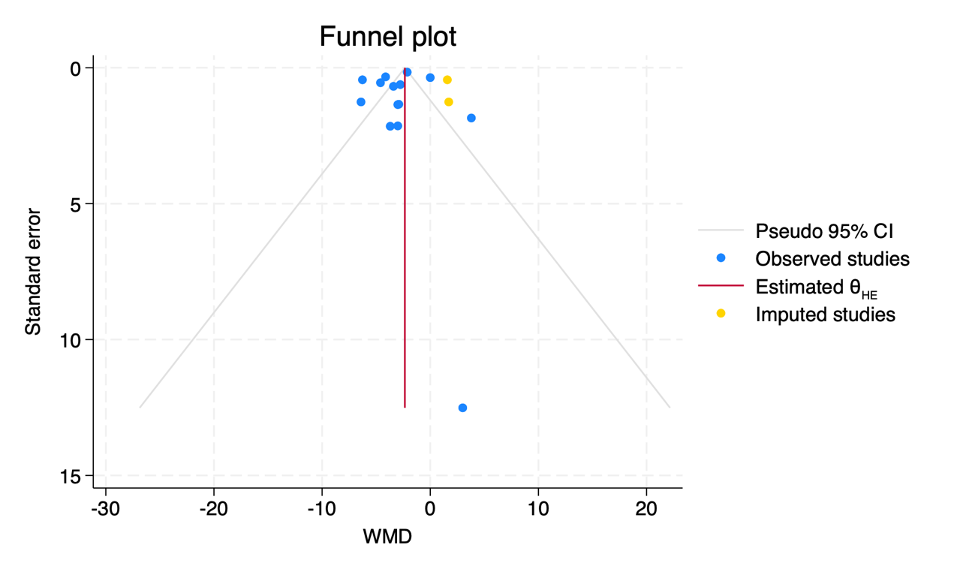
Supplementary Figure 12 Trim-and-fill method for length of ICU stay.
Following the inclusion of an additional study, the results of the pooled analysis remained consistent in their direction (OR= -2.345; 95% CI=-2.570, -2.119).

