Supplementary Figures
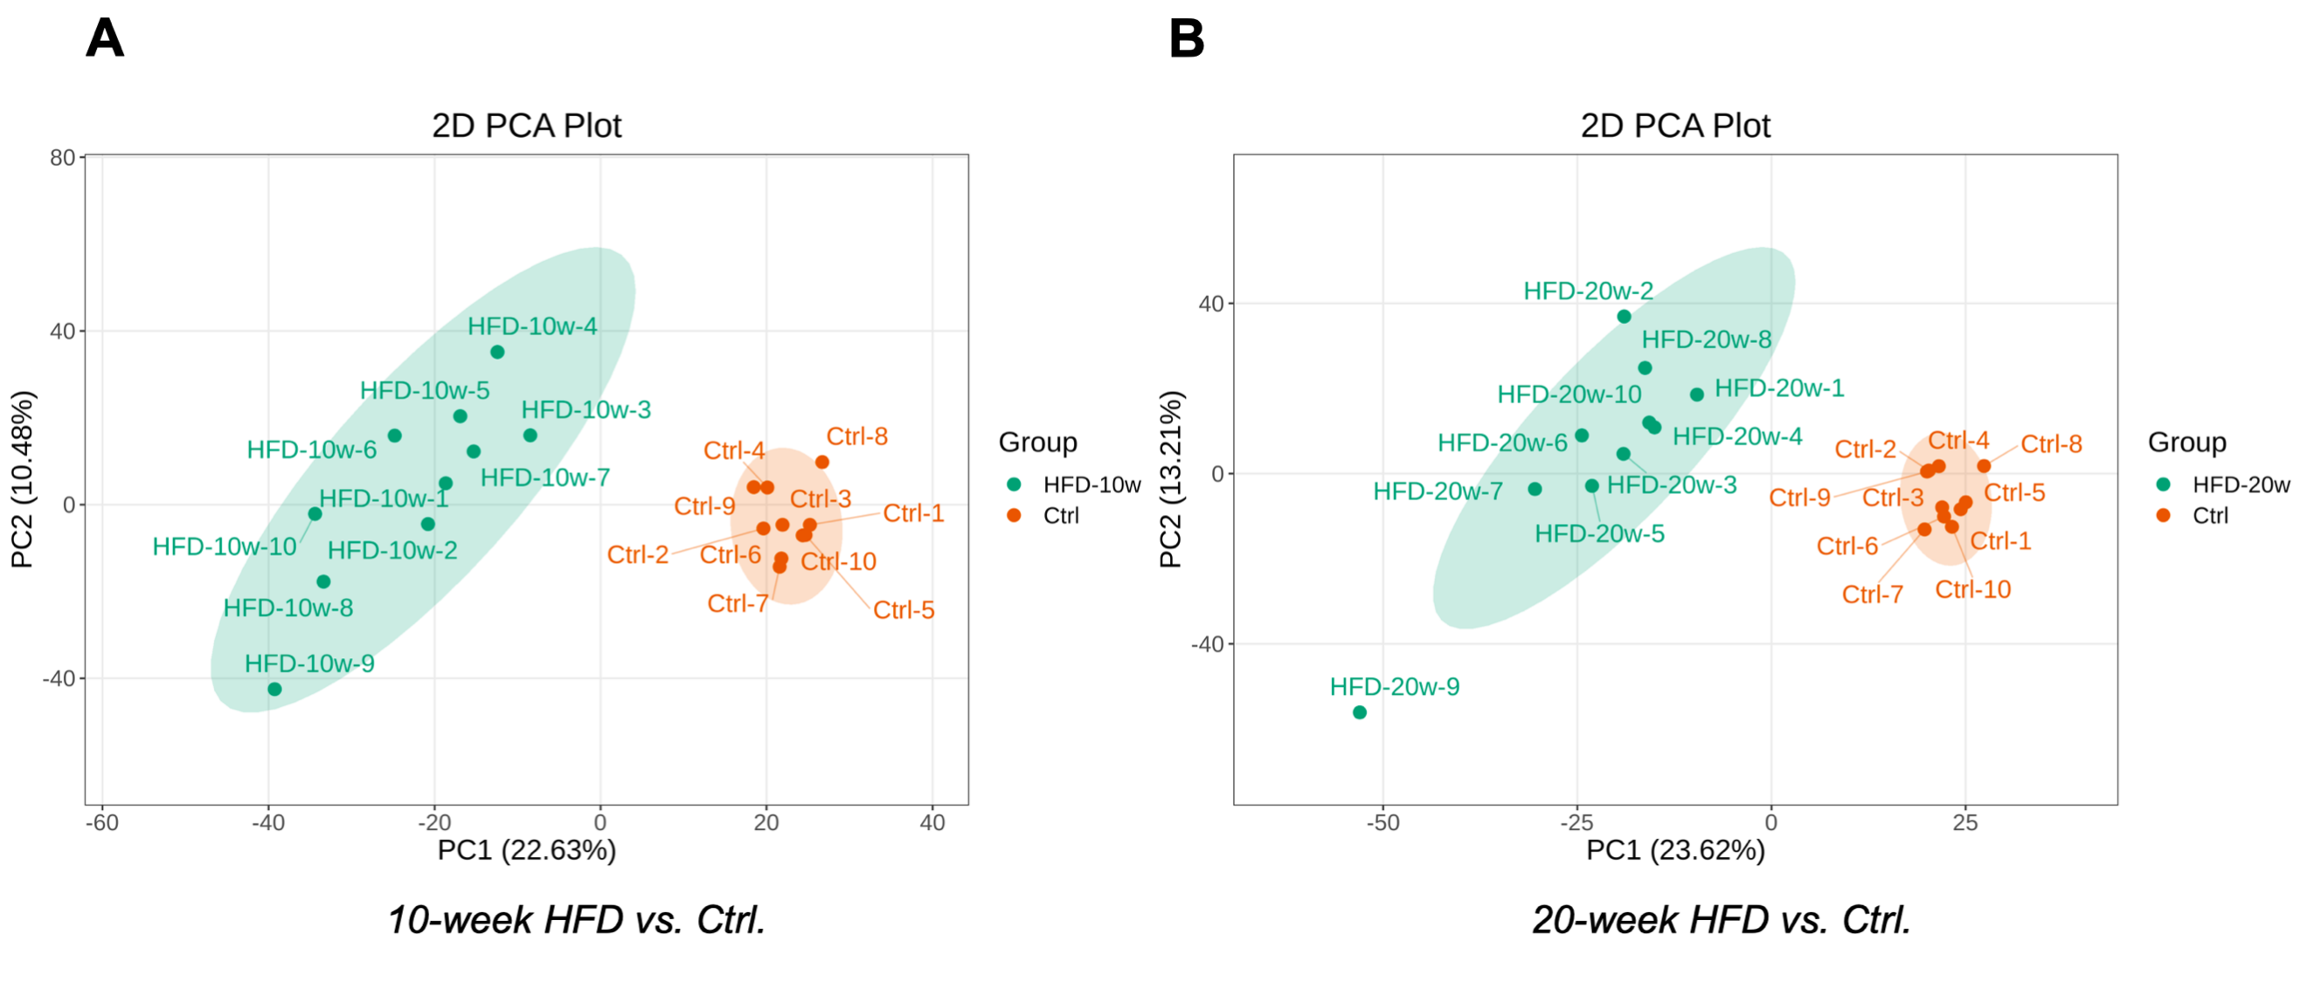

Supplementary Fig. 1. PCA plot. A. 2D PCA plot comparing the 10-week HFD group and the Ctrl group, with PC1 accounting for 22.63% of the total variance and PC2 accounting for 13.2% of the total variance. B. 2D PCA plot comparing the 20-week HFD group and Ctrl group, with PC1 accounting for 23.62% of the total variance and PC2 accounting for 13.2% of the total variance. Abbreviations: PCA, principal component analysis.

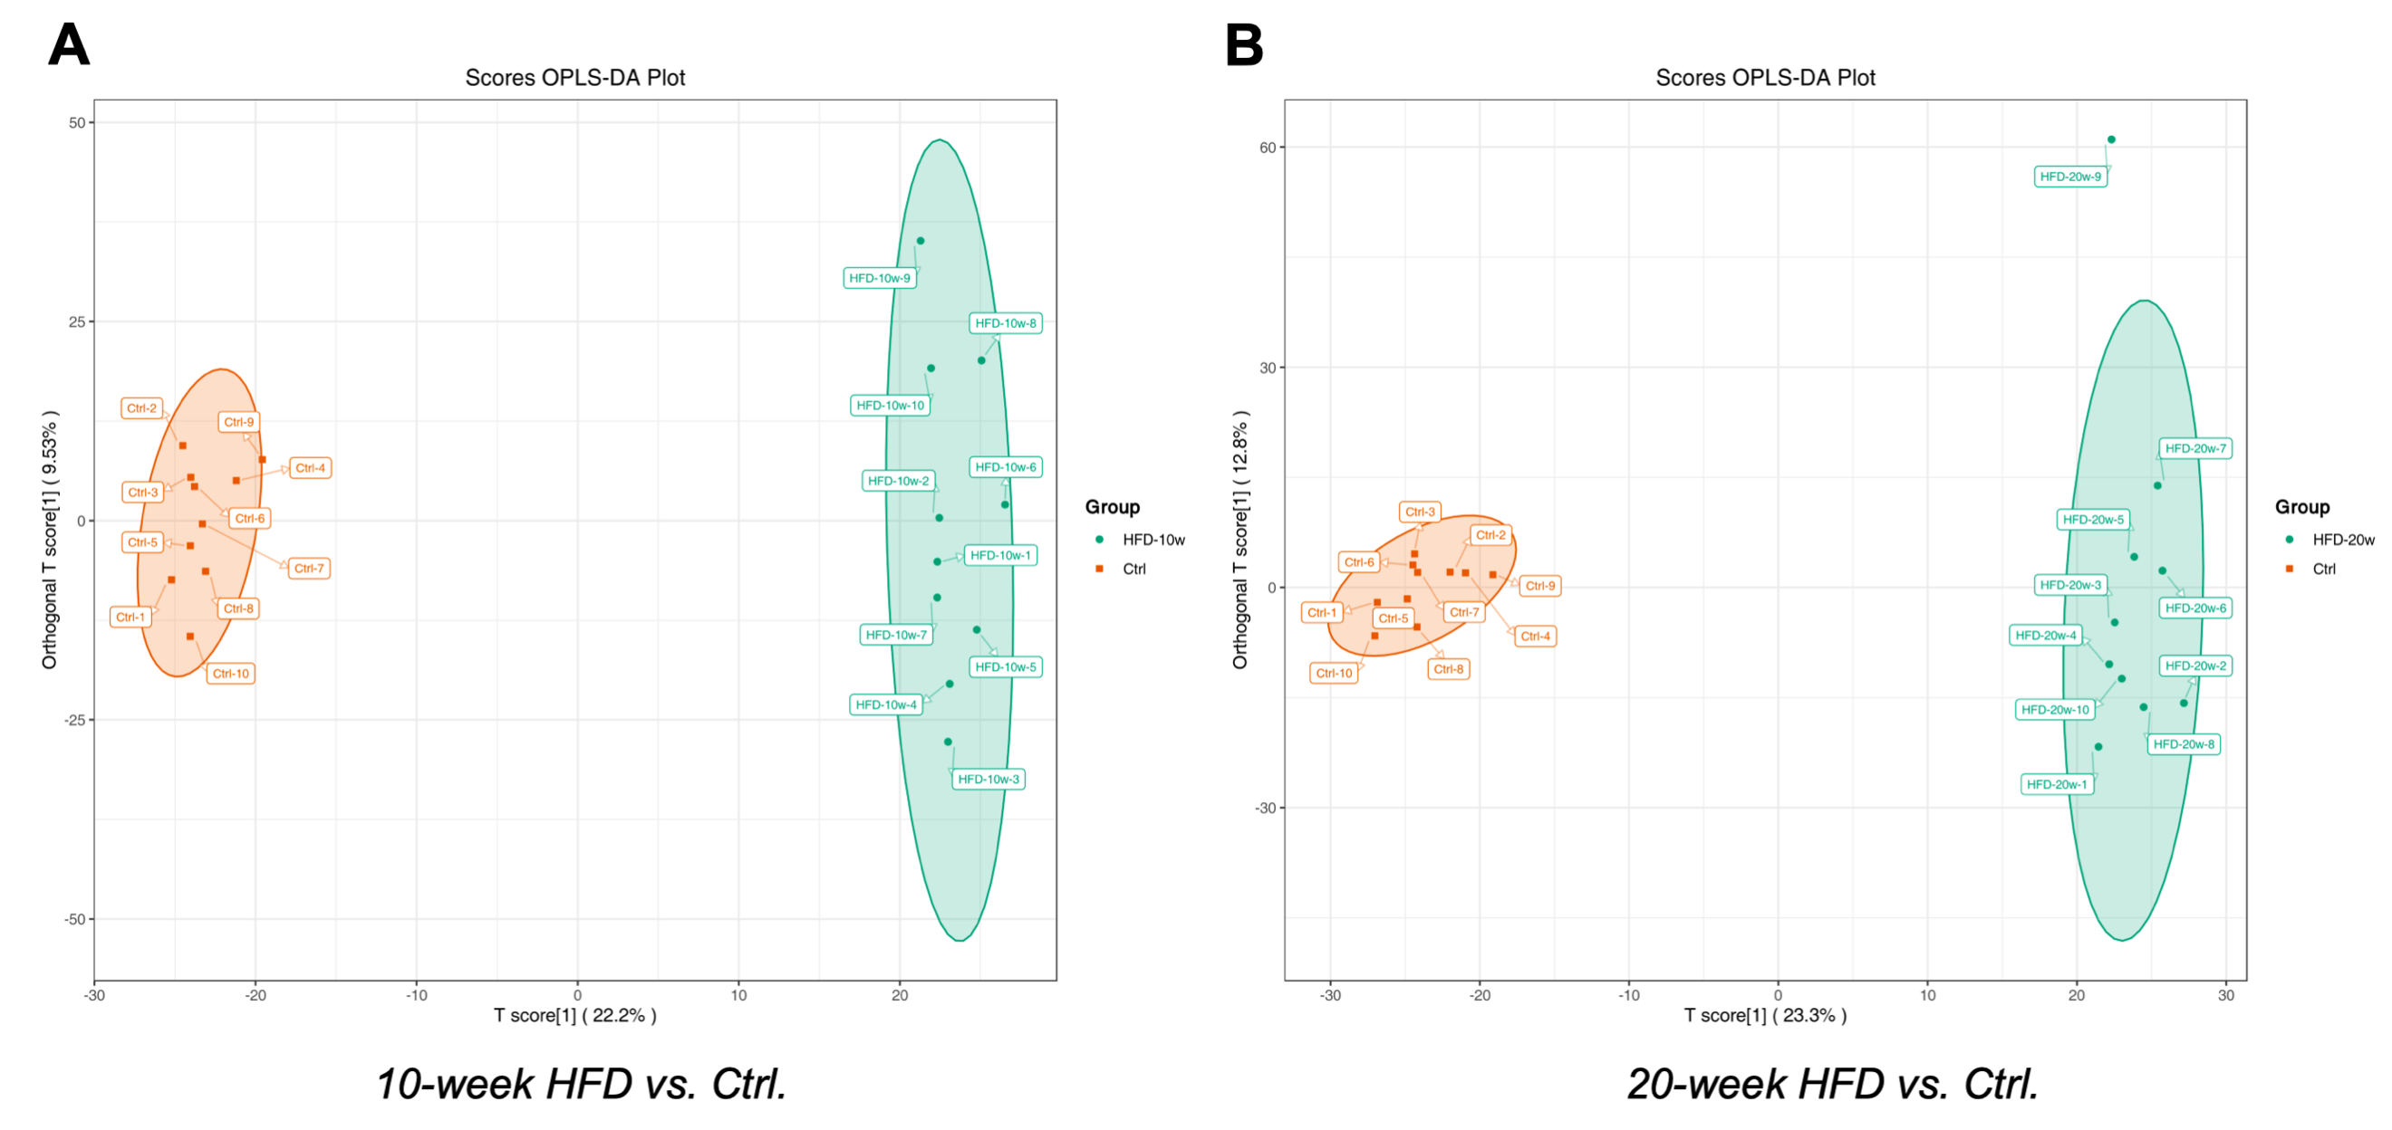

Supplementary Fig. 2. OPLS-DA score plot. A. Comparison between the 10-week HFD group and the Ctrl group. The OPLS-DA model for this comparison yielded R²Y = 0.995 and Q² = 0.946. B. Comparison between the 20-week HFD group and the Ctrl group. The OPLS-DA model for this comparison yielded R²Y = 0.992 and Q² = 0.948. Abbreviations: OPLS-DA, orthogonal partial least squares discriminant analysis.

