Supplementary materials

Sensitivity and Power Analysis

1.1 Equal window comparison
Sensitivity analysis was performed using an equal window comparison by restricting the baseline seizure frequency to the most recent 6 months (n = 24 patients with ≥24 months baseline data). The change in seizure frequency (Δseizure frequency) was recalculated using this shortened baseline period and correlated with ΔGABA+ volume using Pearson correlation in SPSS.
​ The sensitivity analysis confirmed the robustness of the primary correlation. Restricting baseline to 6 months yielded a similar correlation (r = 0.68) compared to the original 12-month baseline (r = 0.72), demonstrating consistent Δseizure frequency patterns.

1.2 GABAergic vs non-GABAergic exposure and AEDs load
AED data were categorized as GABAergic (direct GABA modulators) vs. non-GABAergic. LMM (time × responder) and Mediation Models covaried for total AED load and GABAergic exposure.

1.3 Prospective power analysis
Post-hoc power analyses confirmed the study's modest statistical power. For the group t-test comparing baseline EMTL GABA+ change vs follow-up EMTL GABA+ (dz = 0.50, ρ = 0.50, n = 24), power was 65%. For the primary paired t-test comparing EMTL GABA+ change vs CMTL GABA+ (dz = 0.50, ρ = 0.50, n = 46), power was 91%. The multiple linear regression model (f² = 0.15, 8 predictors, n = 24) yielded only 15% power to detect the observed small effect. Post-hoc power for the mediation analysis (bootstrap indirect effect) was approximately 0.33 (n = 24), consistent with simulation studies indicating that mediation models typically require 50–100 subjects to achieve >80% power for medium-sized effects.
Post-hoc power analyses confirm modest statistical power. Paired comparisons (65–91%) and between-group tests adequately detect observed effects, but mediation analysis has low power (≈33%, n = 24), consistent with the need for larger samples (50–100) to achieve >80% power for medium effects. The study is hypothesis-generating: significant findings are hopeful but require replication in larger cohorts.

Tables
Table S1 Patients’ clinical information and Magnetic resonance spectroscopy data during the six-month follow-up period
The follow-up patients (n = 24)
Clinical  information | Patients’ nos | 1 | 2 | 3 | 4 | 5 | 6 | 7 | 8 | 9 | 10 | 11 | 12 | 13 | 14 | 15 | 16 | 17
Clinical  information | Gender | F | F | M | M | F | F | M | M | M | F | F | M | F | M | M | M | M
Clinical  information | Age (years) | 28 | 40 | 52 | 24 | 24 | 21 | 33 | 30 | 26 | 38 | 39 | 36 | 55 | 28 | 29 | 30 | 49
Clinical  information | Seizure Frequency/month^{b} (Initial examination) | 0.330 | 0.170 | 1.000 | 1.000 | 2.000 | 0.170 | 0 | 2 | 0.000 | 1.000 | 5.000 | 0.250 | 0.250 | 0.167 | 4.000 | 1.000 | 0.500
Clinical  information | Seizure Frequency/month ^{c} (Follow-up examination) | 0.170 | 0 | 0 | 0 | 0.330 | 0 | 3.000 | 1.000 | 0 | 0 | 10.00 | 0 | 0 | 0 | 0 | 2.000 | 0
 | HAMD-17 (Initial examination) | 0 | 16 | 10 | 10 | 16 | 6 | 4 | 8 | 4 | 9 | 13 | 10 | 8 | 6 | 11 | 3 | 9
 | HAMD-17 (Follow-up examination) | 0 | 8 | 5 | 5 | 10 | 2 | 4 | 3 | 4 | 6 | 12 | 4 | 6 | 3 | 6 | 3 | 5
 | HAMA-14 (Initial examination) | 0 | 12 | 8 | 8 | 10 | 7 | 8 | 15 | 7 | 10 | 9 | 9 | 8 | 4 | 10 | 1 | 8
 | HAMA-14 (Follow-up examination) | 0 | 7 | 6 | 4 | 9 | 4 | 3 | 1 | 4 | 5 | 9 | 4 | 5 | 4 | 8 | 3 | 6
GABA+  concentration | Epileptogenic MTL^{d}  (Initial examination) | 3.053 | 2.587 | 1.928 | 1.881 | 1.331 | 1.052 | 2.375 | 1.589 | 3.597 | 1.347 | 2.574 | 2.154 | 2.543 | 1.804 | 3.123 | 2.723 | 3.001
GABA+  concentration | Epileptogenic MTL (Follow-up examination) | 3.001 | 3.293 | 2.821 | 2.586 | 2.815 | 2.717 | 2.347 | 2.723 | 3.000 | 2.915 | 1.157 | 3.591 | 3.356 | 3.413 | 3.717 | 2.161 | 3.459
GABA+  concentration | Contralateral MTL (Initial examination) | 3.081 | 3.450 | 2.585 | 2.057 | 1.500 | 1.724 | 3.125 | 3.482 | 2.475 | 2.304 | 1.895 | 3.025 | 2.708 | 1.896 | 2.954 | 3.199 | 2.442
GABA+  concentration | Contralateral MTL (Follow-up examination) | 2.442 | 2.880 | 2.371 | 1.902 | 3.110 | 2.596 | 3.826 | 3.199 | 2.252 | 2.569 | 1.442 | 3.065 | 2.563 | 3.077 | 3.914 | 1.319 | 1.973
GABA+  concentration | Epileptogenic PFC ^{e}  (Initial examination) | 2.123 | 3.015 | 2.611 | 2.589 | 2.536 | 2.417 | 2.152 | 1.066 | 2.540 | 2.704 | 1.998 | 2.340 | 2.500 | 2.217 | 1.878 | 2.089 | 3.125
GABA+  concentration | Epileptogenic PFC (Follow-up examination) | 2.154 | 3.156 | 2.214 | 2.805 | 2.059 | 2.062 | 1.751 | 2.089 | 2.390 | 2.880 | 2.356 | 3.059 | 1.260 | 3.247 | 3.560 | 2.828 | 2.654
GABA+  concentration | Contralateral PFC (Initial examination) | 3.016 | 2.540 | 1.965 | 3.62 | 1.11 | 2.684 | 3.002 | 3.605 | 3.056 | 2.081 | 2.540 | 1.235 | 3.066 | 2.014 | 2.865 | 0.609 | 2.637
GABA+  concentration | Contralateral PFC (Follow-up examination) | 2.899 | 3.540 | 2.071 | 2.491 | 2.726 | 2.498 | 2.983 | 0.609 | 1.524 | 3.002 | 1.827 | 2.112 | 3 | 1.028 | 2.543 | 1.33 | 2.158
Difference value (Follow-up examination-initial examinationª | Seizure Frequency change | -0.160 | -0.170 | -1.000 | -1.000 | -1.670 | -0.170 | 3.000 | -1.000 | 0 | -1.000 | 5.000 | -0.250 | -0.250 | -0.167 | -4.000 | 1.000 | -0.5
Difference value (Follow-up examination-initial examinationª | GABA+ concentration change in epileptogenic MTL | -0.052 | 0.706 | 0.893 | 0.705 | 1.484 | 1.665 | -0.028 | 1.134 | -0.597 | 1.568 | -1.417 | 1.437 | 0.813 | 1.609 | 0.594 | -0.562 | 0.428
Difference value (Follow-up examination-initial examinationª | GABA+ concentration change in contralateral MTL | 0.639 | -0.570 | -0.214 | -0.155 | 1.610 | 0.872 | 0.701 | -0.283 | -0.223 | 0.265 | -0.453 | 0.040 | -0.145 | 1.181 | 0.960 | -1.880 | -0.469
Difference value (Follow-up examination-initial examinationª | GABA+ concentration change in epileptogenic PFC | 0.031 | 0.141 | 0.397 | 0.216 | -0.477 | -0.355 | -0.401 | 1.023 | -0.150 | 0.176 | 0.358 | 0.719 | -1.240 | 1.030 | 1.682 | 0.739 | -0.471
Difference value (Follow-up examination-initial examinationª | GABA+ concentration change in contralateral PFC | -0.117 | 1 | 0.106 | -1.129 | 1.616 | -0.186 | -0.019 | -2.996 | -1.532 | 0.921 | -0.713 | 0.877 | -0.066 | -0.986 | -0.322 | 0.721 | -0.479
 | HAMD-17 scores changes | 0 | -8 | -5 | -5 | -6 | -4 | 0 | -5 | 0 | -3 | -1 | -6 | -2 | -3 | -5 | 0 | -4
 | HAMA-14 scores changes | 0 | -5 | -2 | -4 | -1 | -3 | -5 | -14 | -3 | -5 | 0 | -5 | -3 | -2 | -2 | 2 | -2

The follow-up patients (n = 24)
Clinical  information | Patients’ nos | 18 | 19 | 20 | 21 | 22 | 23 | 24
Clinical  information | Gender | F | F | F | F | F | M | M
Clinical  information | Age (years) | 22 | 26 | 23 | 27 | 26 | 26 | 48
Clinical  information | Seizure Frequency/month^{b} (Initial examination) | 0.25 | 4 | 2 | 0.17 | 0.16 | 1 | 0.67
Clinical  information | Seizure Frequency/month ^{c} (Follow-up examination) | 0 | 3 | 4 | 0 | 0 | 0 | 0
 | HAMD-17 (Initial examination) | 5 | 6 | 2 | 8 | 7 | 5 | 4
 | HAMD-17 (Follow-up examination) | 3 | 1 | 2 | 5 | 2 | 1 | 2
 | HAMA-14 (Initial examination) | 4 | 7 | 1 | 9 | 6 | 5 | 5
 | HAMA-14 (Follow-up examination) | 2 | 3 | 1 | 7 | 1 | 1 | 2
GABA+  concentration | Epileptogenic MTL^{d}  (Initial examination) | 3.155 | 3.086 | 2.109 | 3.123 | 2.603 | 4.321 | 2.841
GABA+  concentration | Epileptogenic MTL (Follow-up examination) | 3.481 | 4.552 | 1.441 | 2.557 | 1.500 | 1.724 | 3.125
GABA+  concentration | Contralateral MTL (Initial examination) | 3.396 | 3.661 | 2.813 | 3.131 | 2.872 | 2.779 | 3.527
GABA+  concentration | Contralateral MTL (Follow-up examination) | 4.280 | 2.834 | 2.190 | 3.746 | 3.287 | 2.326 | 4.311
GABA+  concentration | Epileptogenic PFCe  (Initial examination) | 2.695 | 2.106 | 2.231 | 2.365 | 2.561 | 3.106 | 2.083
GABA+  concentration | Epileptogenic PFC (Follow-up examination) | 2.238 | 2.660 | 0.931 | 2.721 | 2.797 | 3.860 | 2.388
GABA+  concentration | Contralateral PFC (Initial examination) | 2.403 | 2.547 | 1.638 | 2.440 | 2.372 | 2.328 | 2.213
GABA+  concentration | Contralateral PFC (Follow-up examination) | 2.537 | 3.170 | 2.259 | 3.181 | 1.159 | 3.641 | 3.102
Difference value (Follow-up examination-initial examinationª | Seizure Frequency change | -0.25 | -1 | 2 | -0.17 | -0.16 | -0.1 | -0.67
Difference value (Follow-up examination-initial examinationª | GABA+ concentration change in epileptogenic MTL | 0.326 | 1.466 | -0.668 | -0.566 | 1.088 | -0.634 | 0.729
Difference value (Follow-up examination-initial examinationª | GABA+ concentration change in contralateral MTL | 0.884 | -0.827 | -0.623 | 0.615 | 0.415 | -0.453 | 0.784
Difference value (Follow-up examination-initial examinationª | GABA+ concentration change in Epileptogenic PFC | -0.457 | 0.554 | 1.3 | 0.356 | 0.236 | -0.754 | 0.305
Difference value (Follow-up examination-initial examinationª | GABA+ concentration change in contralateral PFC | 0.134 | 0.623 | 0.621 | 0.741 | -1.213 | 1.313 | 0.889
 | HAMD-17 scores changes | -2 | -5 | 0 | -3 | -5 | -4 | -2
 | HAMA-14 scores changes | -2 | -4 | 0 | -2 | -5 | -4 | -3

ª Difference value = (Follow-up examination value - initial examination value)
^{b} Seizure Frequency/month, seizure frequency per month in recent year (the initial examination of the past 12 months), for example, 2 times/month=2, 4 times/year=4/12=0.330, 1 times/year=2/12=0.167, 0 time/year=0
^{c} Seizure Frequency/month, seizure frequency per month in the follow-up phase (From the initial examination to the follow-up examination)
^{d} Epileptogenic MTL: Epileptogenic MTL as indicated by EEG
^{e} Epileptogenic PFC: PFC in the epileptogenic hemisphere
MTL mesial temporal lobe, PFC prefrontal cortex, EEG electroencephalography
HAMD-17, the 17-item Hamilton Depression Rating Scale; HAMA-14, the 14-item Hamilton Anxiety Rating Scale
Table S2. Antiepileptic drug (AED) exposure by class (n = 24)
AED Class | Baseline (n = 24) | Follow-up (n = 24) | Changes
GABAergic | Total patients n = 5 | Total patients n = 4 | Switch 1
VPA | 4 | 4
TPM | 1 | 0
Non-GABAergic | Total patients n = 23 | Total patients n = 35 | Add-on 12
LEV | 8 | 10
OXC | 6 | 5
LTG | 9 | 13
PER | 3 | 7

LEV Levetiracetam, LTG Lamotrigine, OXC Oxcarbazepine, PER Perampanel, TPM Topiramate, VPA Valproate
Table S3 Baseline comparisons between follow-up completers and non-completers
 | Follow-up completer | Follow-up  non-completer
 | (n = 24) | (n = 22) | t/Z | p-value
Age | 32.50 ± 0.96 | 30.32 ± 10.02 | t = 0.740 | 0.464
Number of female (%) | 12 (50%) | 10（45.5%） | X²=46 | ＜0.001
Education (years) | 15.08 ± 1.77 | 15.05±1.21 | t = -0.107 | 0.915
HAMD-17 | 7.67 ± 3.91 | 6.00 ± 3.20 | t = -1.475 | 0.148
HAMA-14 | 6.91 ± 3.59 | 5.11 ± 2.61 | t = -1.805 | 0.079
Disease duration (years) | 24.08 | 21.76 | Z = -0.603 | 0.547
Age of onset for initial seizure (years) | 26.13 ± 8.95 | 25.45 ± 8.67 | t = -0.258 | 0.789
Seizure frequency in recent year (per month) | 18.22 | 16.86 | Z = -0.399 | 0.695
The intervals days  since the last seizure (days) | 21.56 | 23.63 | Z = -0.535 | 0.593

Table S4 Magnetic resonance spectroscopy data of healthy controls and patients.

 | HCs |  |  |  |  | MRI-negative TLE (Initial examination) |  |  |  | MRI-negative TLE  (Follow-up examination)
 | R hemisphere | L hemisphere | Test statistic  (t) |  | p | EEG spike originated hemisphere | Contralateral hemisphere | Test statistic  (t) | p | EEG spike originated hemisphere | Contralateral hemisphere | Test statistic  (t) | p
MTL
GABA+ level (IU) | 2.76 ± 0.55 | 2.65 ± 0.50 | 0.716 | 0.483 |  | 2.42 ± 0.88 | 2.76 ± 0.75 | -2.438 | 0.019 | 2.92 ± 0.83 | 2.73 ± 0.76 | 1.652 | 0.112
GABA+ CRLB (%) | 12.82 ± 1.59 | 11.76 ± 2.54 | 1.328 | 0.203 |  | 11.50 ± 3.41 | 11.71 ± 2.68 | -0.405 | 0.689 | 11.17 ± 1.90 | 11.29 ± 1.83 | 1.000 | 0.330
FWHM (Hz) | 12.21 ± 1.36 | 12.42 ± 1.12 | -0.639 | 0.860 |  | 12.63 ± 1.06 | 12.65 ± 1.06 | -0.101 | 0.920 | 12.58 ± 1.02 | 12.37 ± 1.31 | 0.738 | 0.468
PFC
GABA+ level (IU) | 2.58 ± 0.54 | 2.89 ± 0.48 | -1.081 | 0.316 |  | 2.35 ± 0.61 | 2.40 ± 0.63 | -0.322 | 0.750 | 2.53 ± 0.67 | 2.40 ± 0.81 | 0.607 | 0.550
GABA+ CRLB (%) | 11.50 ± 2.31 | 11.69 ± 2.91 | -0.204 | 0.841 |  | 10.42 ± 2.69 | 10.29 ± 2.94 | 0.181 | 0.858 | 10.17 ± 1.93 | 10.71 ± 1.83 | -1.134 | 0.269
FWHM (Hz) | 7.94 ± 1.99 | 7.84 ± 1.61 | 0.179 | 0.531 |  | 7.74 ± 1.06 | 7.83 ± 0.95 | -0.418 | 0.678 | 7.71 ± 0.86 | 7.80 ± 1.02 | -0.385 | 0.704
Data are presented as mean ± SD
p < 0.05
HCs healthy controls, TLE temporal lobe epilepsy, MTL mesial temporal lobe, PFC prefrontal cortex, CRLB Cramer-Rao Lower Bound, FWHM full-width at half-maximum, EEG electroencephalography

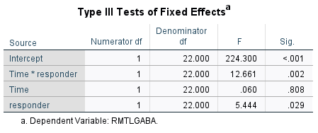
Table S5-(1-6). LMM Results (Covariate-Adjusted Estimated Marginal Means)
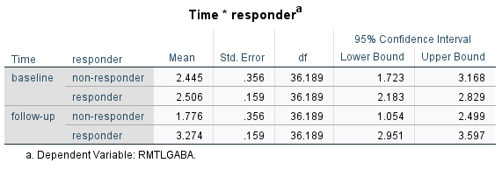
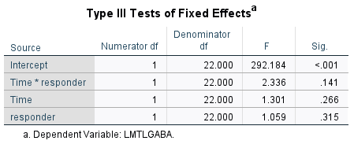
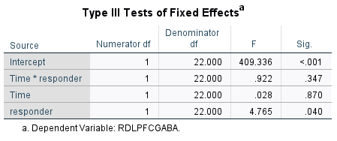
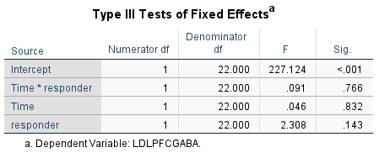
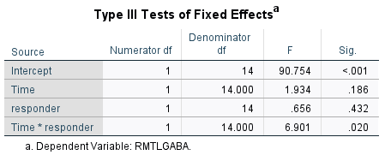
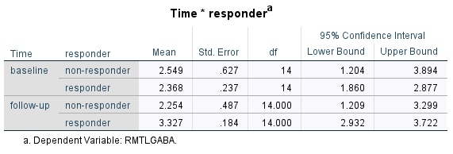
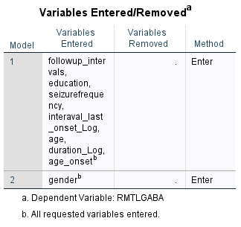
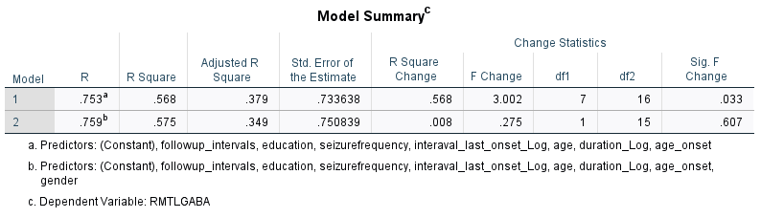
Table S6. Linear regression analysis between multiple clinical indicators and GABA+ levels of EMTL
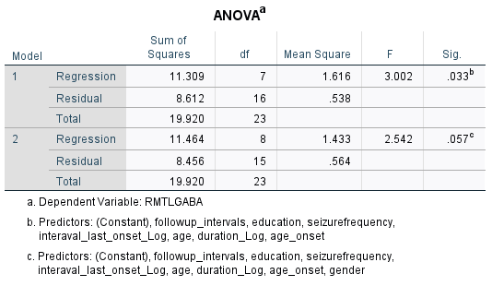
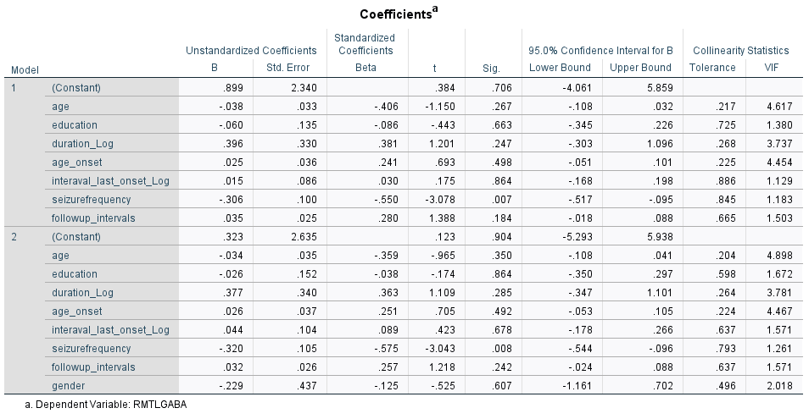
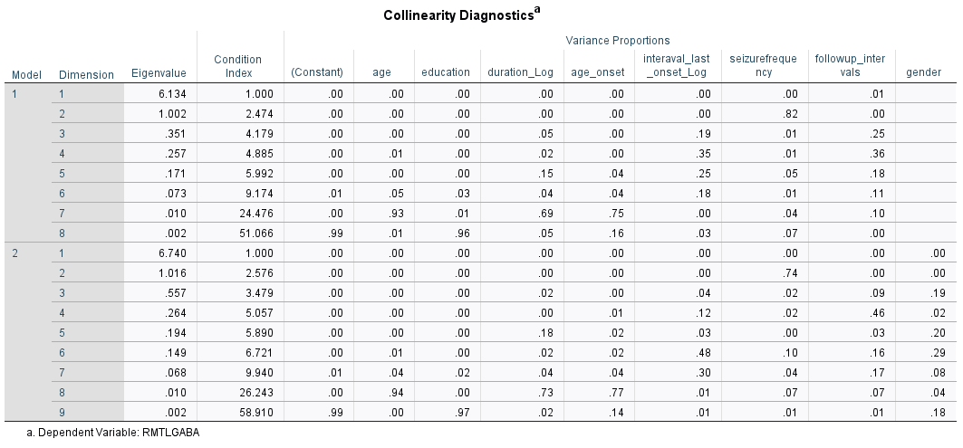
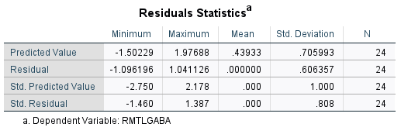
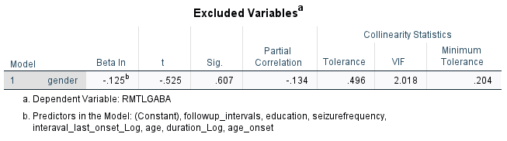
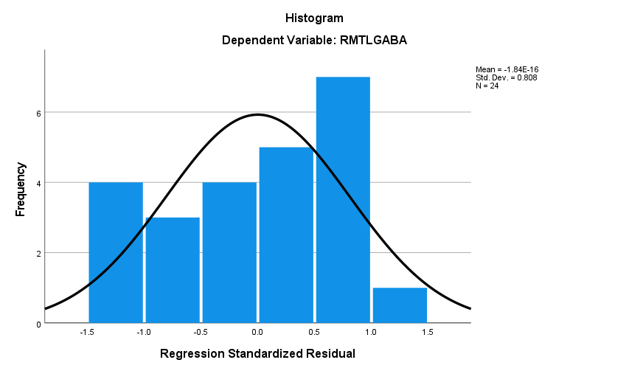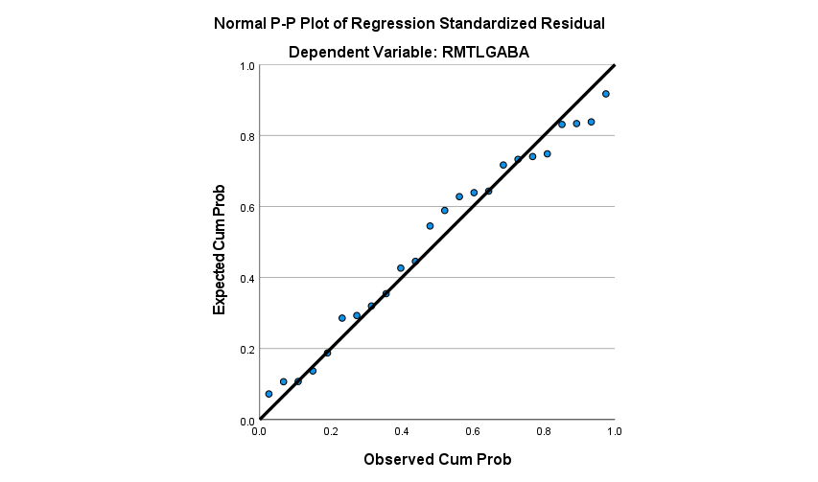
Table S7 Correlation between changes in GABA+ levels and clinical features in follow-up patients with MRI-negative TLE

 |  | Seizure frequency  changes | EMTL GABA+  changes | EPFC GABA+  changes | CMTL GABA+  changes | CPFC GABA+ changes | HAMD-17 scores changes | HAMA-14 scores  changes
Seizure frequency  changes | r | 1 | -.614 | -.358 | -.316 | -.066 | .527 | .215
Seizure frequency  changes | p |  | .001 | .086 | .132 | .760 | .008 | .312
EMTL GABA+  changes ª | r | -.614 | 1 | .149 | .369 | -.023 | -.649 | -.376
EMTL GABA+  changes ª | p | .001 |  | .488 | .076 | .917 | .001 | .070
EPFC GABA+  changes ^{b} | r | -.358 | .149 | 1 | -.018 | -.180 | -.326 | -.241
EPFC GABA+  changes ^{b} | p | .086 | .488 |  | .935 | .400 | .120 | .256
CMTL GABA+  changes ^{c} | r | -.316 | .369 | -.018 | 1 | .093 | -.247 | -.041
CMTL GABA+  changes ^{c} | p | .132 | .076 | .935 |  | .664 | .244 | .850
CPFC GABA+ changes ^{d} | r | -.066 | -.023 | -.180 | .093 | 1 | -.066 | .479
CPFC GABA+ changes ^{d} | p | .760 | .917 | .400 | .664 |  | .760 | .018
HAMD-17 scores  changes | r | .527 | -.649 | -.326 | -.247 | -.066 | 1 | .483
HAMD-17 scores  changes | p | .008 | .001 | .120 | .244 | .760 |  | .017
HAMA-14 scores  changes | r | .215 | -.376 | -.241 | -.041 | .479 | .483 | 1
HAMA-14 scores  changes | p | .312 | .070 | .256 | .850 | .018 | .017
*The correlation is significant at the 0.01 level (two-tailed)
The correlation is significant at the 0.05 level (two-tailed).
ª EMTL: epileptogenic MTL as indicated by EEG
^{b} EPFC: PFC in the epileptogenic hemisphere
^{c} CMTL: MTL in the contralateral hemisphere
^{d} CPFC: PFC in the contralateral hemisphere
MTL mesial temporal lobe, PFC prefrontal cortex, EEG electroencephalography
HAMD-17 the 17-item Hamilton Depression Rating Scale; HAMA-14 the 14-item Hamilton Anxiety Rating Scale

Table S8. Exploratory partial mediation analysis of the total, direct, and indirect effects of seizure frequency changes on GABA+ level changes, adjusting only for age and sex

Effects on GABA+ levels changes | Variables | B (Effect) | SE | p-value | Bootstrap 95% CI |  | Effect  size
 |  |  |  |  | LL | UL
Total effect | Seizure frequency changes | -0.363 | 0.098 | 0.001 | -0.538 | -.0.159
Direct effect | Seizure frequency changes | -0.230 | 0.104 | 0.040 | -0.414 | -0.449 | 63.3%
Indirect effect | Depressive symptoms levels | -0.133 | 0.091 | 0.028 | -0.395 | -0.048 | 36.7%
Depressive symptoms levels = HAMD-17 the 17-item Hamilton Depression Rating Scale, LL Lower limit, UL Upper limit, CI Confidence interval

Table S9. Exploratory partial mediation analysis of the total, direct, and indirect effects of seizure frequency changes on GABA+ level changes, adjusting for the full set of clinical covariates

Effects on GABA+ levels changes | Variables | B (Effect) | SE | p-value | Bootstrap 95% CI |  | Effect  size
 |  |  |  |  | LL | UL
Total effect | Seizure frequency changes | -0.320 | 0.105 | 0.008 | -0.544 | -.0.096
Direct effect | Seizure frequency changes | -0.167 | 0.102 | 0.124 | -0.386 | 0.518 | 52.2%
Indirect effect | Depressive symptoms levels | -0.153 | 0.174 | 0.013 | -0.602 | -0.023 | 47.8%

Table S10. Exploratory mediation analysis of the total, direct, and indirect effects of seizure frequency changes on GABA+ level changes, with change in anxiety levels as the mediating variable

Effects on GABA+ levels changes | Variables | B (Effect) | SE | p-value | Bootstrap 95% CI |  | Effect  size
 |  |  |  |  | LL | UL
Total effect | Seizure frequency changes | -0.342 | 0.937 | 0.001 | -0.536 | -.0.096
Direct effect | Seizure frequency changes | -0.311 | 0.931 | 0.003 | -0.505 | -0.117 | 91%
Indirect effect | Depressive symptoms levels | -0.031 | 0.043 | 0.142 | -0.145 | 0.025 | 9%

Figures
Figure S1. Diagram of the study protocol
TLE temporal lobe epilepsy, EEG electroencephalography, AEDs antiepileptic drug
Figure S2. A representative patient using Osprey segment for partial volume correction
Osprey Segment depicts different tissue types segmented in a patient’s bilateral MTL on axial T1WI.
WM white matter, GM gray matter, CSF cerebrospinal fluid

Figure S3. GABA+ levels in the bilateral MTL and PFC of the patients and health controls groups
The images show right and left MTL GABA+ levels in HCs (a), right and left PFC GABA+ levels in HCs (b), MTL GABA+ levels on the epileptogenic and contralateral sides in initial patients’ group (c), and PFC GABA+ levels on the epileptogenic and contralateral sides in initial patients’ group (d).
MTL mesial temporal lobe, PFC prefrontal cortex
EMTL1 epileptogenic mesial temporal lobe, initial patients’ group

CMTL1 Contralateral mesial temporal lobe, initial patients’ group
EPFC1 Epileptogenic prefrontal lobe, initial patients’ group
CPFC1 Contralateral prefrontal lobe, initial patients’ group
Figure S4. Associations between GABA+ levels in different brain regions and HAMD-17 scores changes in follow-up period.

(a) GABA+ in the epileptogenic MTL negatively correlated with HAMD-17 score changes (r = -0.649, p = 0.0006, p < 0.001, n = 24); (b) GABA+ in the contralateral MTL negatively correlated with seizure frequency (r = -0.247, p = 0.244, n = 24); (c) GABA+ in the epileptogenic PFC negatively correlated with seizure frequency (r = -0.326, p = 0.120, n = 24); (d) GABA+ in the contralateral PFC negatively correlated with seizure frequency (r = -0.066, p = 0.760, n = 24).
MTL mesial temporal lobe, PFC prefrontal cortex
p < 0.05

