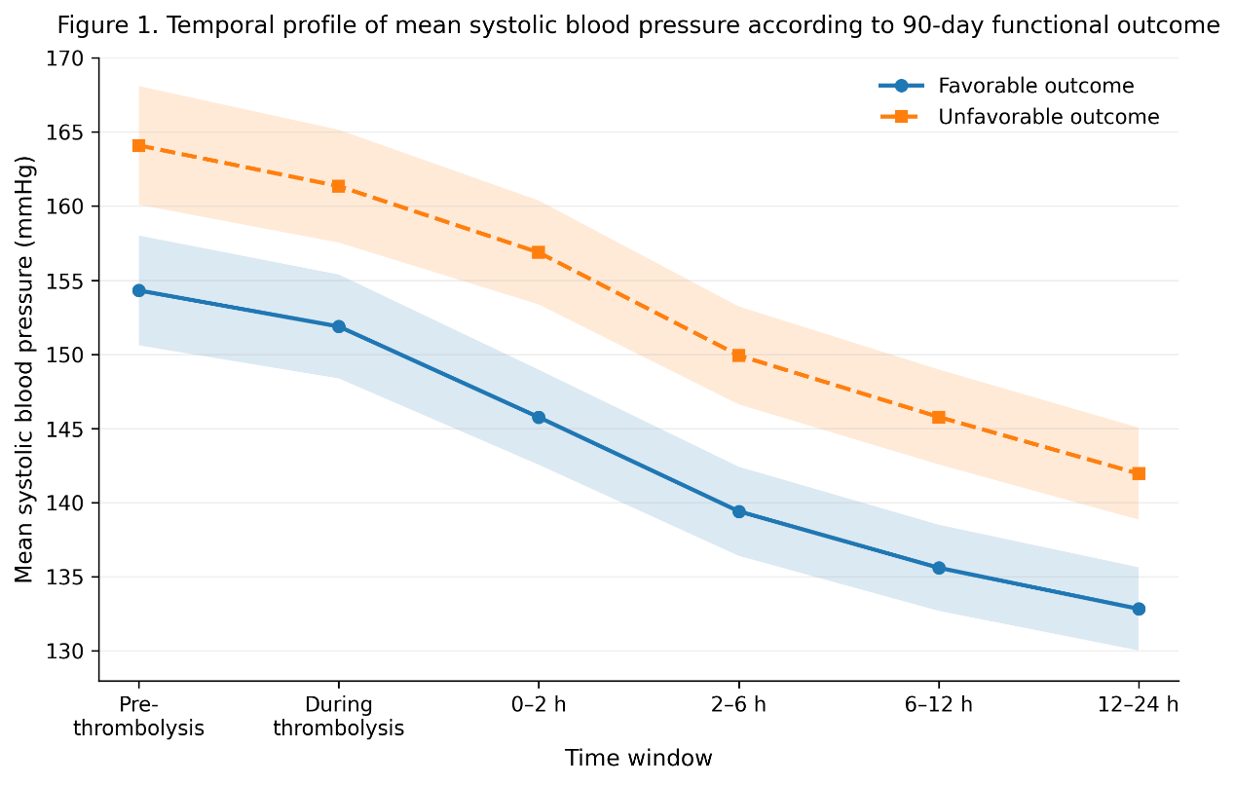
Supplementary Figure 1. Temporal profile of mean systolic blood pressure according to 90-day functional outcome.
Group-specific mean systolic blood pressure trajectories are shown for patients with favorable and unfavorable 90-day functional outcomes. Favorable outcome was defined as a modified Rankin Scale (mRS) score of 0–2 and unfavorable outcome as an mRS score of 3–6 at 90 days. Blood pressure was assessed across the pre-thrombolysis period, during thrombolysis, and the 0–2 h, 2–6 h, 6–12 h, and 12–24 h post-thrombolysis time windows. Shaded areas represent 95% confidence intervals.
Supplementary Table S1. Sensitivity analyses of the association between mean systolic blood pressure at 0–2 h after thrombolysis and poor 90-day functional outcome under alternative sample restrictions
Sensitivity analysis scenario | Analytic sample, n | Poor functional outcome, n (%) | Adjusted OR per 10-mmHg increase (95% CI) | P value
Primary analysis | 340 | 126 (37.06) | 1.25 (1.06–1.49) | 0.010
Excluding patients with fewer than 3 post-thrombolysis SBP measurements | 321 | 117 (36.45) | 1.24 (1.04–1.48) | 0.015
Excluding patients with any missing covariates in the fully adjusted model | 312 | 113 (36.22) | 1.23 (1.02–1.48) | 0.028
Excluding patients with baseline NIHSS score >20 | 298 | 96 (32.21) | 1.22 (1.01–1.47) | 0.036
Excluding patients with 24-h intracranial hemorrhage | 296 | 98 (33.11) | 1.21 (1.01–1.46) | 0.041
Excluding patients with cardioembolic stroke subtype | 266 | 85 (31.95) | 1.23 (1.02–1.49) | 0.031
Excluding patients with onset-to-needle time >240 min | 327 | 119 (36.39) | 1.24 (1.04–1.48) | 0.017
Note: Odds ratios were estimated using logistic regression with poor functional outcome at 90 days (modified Rankin Scale [mRS] 3–6) as the dependent variable. Mean systolic blood pressure at 0–2 h after thrombolysis was modeled as a continuous variable, and effect estimates are presented per 10-mmHg increase. All models were adjusted for age, sex, baseline NIHSS score, hypertension, diabetes mellitus, atrial fibrillation, previous stroke, current smoking, onset-to-needle time, baseline glucose, and large vessel occlusion, unless the corresponding variable was excluded as part of the sensitivity restriction.

Supplementary Table S2. Additional adjusted models and alternative outcome definitions for the association between mean systolic blood pressure at 0–2 h after thrombolysis and functional outcome
Model / outcome definition | Analytic sample, n | Outcome events, n (%) | Adjusted OR per 10-mmHg increase (95% CI) | P value
Additional adjustment models
Model 1: age and sex adjusted | 340 | 126 (37.06) | 1.31 (1.12–1.54) | 0.001
Model 2: additionally adjusted for baseline NIHSS score and onset-to-needle time | 340 | 126 (37.06) | 1.27 (1.08–1.50) | 0.004
Model 3: primary fully adjusted model | 340 | 126 (37.06) | 1.25 (1.06–1.49) | 0.010
Model 4: additionally adjusted for baseline SBP and baseline DBP | 340 | 126 (37.06) | 1.22 (1.02–1.47) | 0.031
Model 5: additionally adjusted for TOAST subtype and coronary artery disease | 340 | 126 (37.06) | 1.21 (1.01–1.46) | 0.038
Alternative outcome definitions
Unfavorable outcome defined as mRS 2–6 vs. 0–1 | 340 | 171 (50.29) | 1.19 (1.02–1.40) | 0.029
Severe disability/death defined as mRS 4–6 vs. 0–3 | 340 | 72 (21.18) | 1.28 (1.06–1.55) | 0.011
Ordinal mRS shift analysis (per 1-category increase in mRS)* | 340 | — | 1.17 (1.04–1.31) | 0.008
Note: Mean systolic blood pressure at 0–2 h after thrombolysis was modeled as a continuous variable, and effect estimates are presented per 10-mmHg increase. The primary fully adjusted model included age, sex, baseline National Institutes of Health Stroke Scale score, hypertension, diabetes mellitus, atrial fibrillation, previous stroke, current smoking, onset-to-needle time, baseline glucose, and large vessel occlusion. For binary outcome definitions, odds ratios were estimated using logistic regression.
*For ordinal mRS shift analysis, the effect estimate represents the common odds ratio from an ordinal logistic regression model for a 1-category worsening in the 90-day mRS distribution.

