Supplementary Table1. Univariate analysis of demographics and baseline characteristics between the pulmonary hemorrhage group and the non-pulmonary hemorrhage group
Characteristic | Pulmonary hemorrhage  (n = 137) | Non-pulmonary hemorrhage  (n = 826) | Statistic | p-value
Maternal age, Median (Q1, Q3), years | 30.0 (28.0, 34.0) | 31.0 (27.0, 33.0) | W = 57868.500 | 0.669¹
GDM, n (%) |  |  | χ² = 0.045 | 0.833²
No | 117 (85.4%) | 711 (86.1%)
Yes | 20 (14.6%) | 115 (13.9%)
PIH, n (%) |  |  | χ² = 3.249 | 0.071²
No | 110 (80.3%) | 603 (73.0%)
Yes | 27 (19.7%) | 223 (27.0%)
Placental abruption, n (%) |  |  |  | 0.771³
No | 133 (97.1%) | 805 (97.5%)
Yes | 4 (2.9%) | 21 (2.5%)
PROM, n (%) |  |  | χ² = 0.991 | 0.319²
No | 116 (84.7%) | 670 (81.1%)
Yes | 21 (15.3%) | 156 (18.9%)
Prenatal anti-infection, n (%) |  |  | χ² = 13.653 | <0.001²
No | 121 (88.3%) | 792 (95.9%)
Yes | 16 (11.7%) | 34 (4.1%)
Antenatal glucocorticoid, n (%) |  |  | χ² = 1.993 | 0.158²
No | 101 (73.7%) | 559 (67.7%)
Yes | 36 (26.3%) | 267 (32.3%)
Intrauterine growth restriction, n (%) |  |  | χ² = 0.197 | 0.657²
No | 127 (92.7%) | 774 (93.7%)
Yes | 10 (7.3%) | 52 (6.3%)
Amniotic fluid turbidity, n (%) |  |  | χ² = 5.742 | 0.017²
No | 119 (86.9%) | 767 (92.9%)
Yes | 18 (13.1%) | 59 (7.1%)
Delivery mode, n (%) |  |  | χ² = 0.199 | 0.655²
Vaginal delivery | 68 (49.6%) | 393 (47.6%)
C-section | 69 (50.4%) | 433 (52.4%)
1min Apgar, Median (Q1, Q3) | 7.00 (5.00, 8.00) | 8.00 (7.00, 8.00) | W = 41119.000 | <0.001¹
5min Apgar, Median (Q1, Q3) | 8.00 (7.00, 9.00) | 9.00 (8.00, 9.00) | W = 37903.000 | <0.001¹
Gestational age, Median (Q1, Q3), weeks | 28.29 (27.00, 30.29) | 29.57 (28.14, 31.14) | W = 40893.500 | <0.001¹
Birthweight, Median (Q1, Q3), g | 1,100 (930, 1,350) | 1,220 (1,050, 1,380) | W = 45673.000 | <0.001¹
Sex, n (%) |  |  | χ² = 10.209 | 0.001²
Male | 89 (65.0%) | 415 (50.2%)
Female | 48 (35.0%) | 411 (49.8%)
Intubation in DR, n (%) |  |  | χ² = 34.376 | <0.001²
No | 97 (70.8%) | 737 (89.2%)
Yes | 40 (29.2%) | 89 (10.8%)
Epinephrine in DR, n (%) |  |  |  | 0.300³
No | 135 (98.5%) | 796 (96.4%)
Yes | 2 (1.5%) | 30 (3.6%)
Arterial blood gas pH at birth, Median (Q1, Q3) | 7.29 (7.23, 7.32) | 7.33 (7.29, 7.36) | W = 36556.000 | <0.001¹
Arterial blood gas PaO₂ at birth, Median (Q1, Q3), mmHg | 72 (57, 83) | 76 (69, 83) | W = 49114.000 | 0.013¹
Arterial blood gas PaCO₂ at birth, Median (Q1, Q3), mmHg | 46 (41, 54) | 41 (38, 45) | W = 73771.500 | <0.001¹
Arterial blood gas BE at birth, Median (Q1, Q3), mmol/l | -5.50 (-7.90, -3.79) | -4.04 (-5.17, -3.22) | W = 40620.500 | <0.001¹
Arterial blood gas FiO₂ at birth, Median (Q1, Q3), % | 38 (30, 50) | 30 (24, 30) | W = 85179.500 | <0.001¹
Ventilation MAP after birth, Median (Q1, Q3), cmH₂O | 12.0 (10.5, 13.5) | 6.0 (5.0, 11.0) | W = 88390.500 | <0.001¹
White blood cell count after birth, Median (Q1, Q3), 10^9/l | 10 (6, 13) | 9 (7, 13) | W = 55154.000 | 0.636¹
Neutrophil count after birth, Median (Q1, Q3), 10^9/l | 4.0 (2.3, 6.2) | 4.4 (2.5, 7.3) | W = 49961.000 | 0.028¹
Platelet count after birth, Median (Q1, Q3), 10^9/l | 181 (133, 233) | 194 (153, 244) | W = 48168.000 | 0.005¹
Hemoglobin after birth, Median (Q1, Q3), g/l | 149 (132, 167) | 166 (148, 185) | W = 38025.000 | <0.001¹
Procalcitonin after birth, Median (Q1, Q3), ng/ml | 2 (0, 13) | 0 (0, 1) | W = 75957.500 | <0.001¹
Birth temperature, Median (Q1, Q3), ℃ | 36.00 (35.50, 36.50) | 36.00 (35.50, 36.10) | W = 65185.000 | 0.004¹
Surfactant using times within 6 hours of birth, Median (Q1, Q3) | 2.00 (1.00, 2.00) | 1.00 (1.00, 2.00) | W = 80509.500 | <0.001¹
First day fluid intake, Median (Q1, Q3), ml/kg | 80 (72, 87) | 79 (74, 83) | W = 58872.500 | 0.447¹
Postnatal hyperglycemia of newborns, n (%) |  |  | χ² = 17.293 | <0.001²
No | 81 (59.1%) | 628 (76.0%)
Yes | 56 (40.9%) | 198 (24.0%)
Postnatal vasoactive drug administration, n (%) |  |  | χ² = 24.126 | <0.001²
None | 47 (34.3%) | 470 (56.9%)
One kind | 90 (65.7%) | 356 (43.1%)
Two kinds | 109 (79.6%) | 312 (37.8%)
IMV duration, Median (Q1, Q3), days | 7 (4, 15) | 0 (0, 4) | W = 93605.500 | <0.001¹
NIV duration, Median (Q1, Q3), days | 1 (0, 16) | 10 (2, 29) | W = 40540.500 | <0.001¹
PDA, n (%) |  |  |  | <0.001³
No | 20 (14.6%) | 307 (37.2%)
Yes | 114 (83.2%) | 516 (62.5%)
Not assessed | 3 (2.2%) | 3 (0.4%)
BPD, n (%) |  |  | χ² = 4.063 | 0.044²
No | 104 (75.9%) | 686 (83.1%)
Yes | 33 (24.1%) | 140 (16.9%)
ROP, n (%) |  |  | χ² = 6.035 | 0.014²
No | 102 (74.5%) | 687 (83.2%)
Yes | 35 (25.5%) | 139 (16.8%)
IVH (≥ grade III), n (%) |  |  | χ² = 93.733 | <0.001²
No | 85 (62.0%) | 757 (91.6%)
Yes | 52 (38.0%) | 69 (8.4%)
NEC (≥ stage II), n (%) |  |  | χ² = 34.655 | <0.001²
No | 112 (81.8%) | 787 (95.3%)
Yes | 25 (18.2%) | 39 (4.7%)
Death, n (%) | 72 (52.6%) | 76 (9.2%) | χ² = 169.809 | <0.001²
Survive to 36 weeks PMA, n (%) |  |  | χ² = 152.920 | <0.001²
No | 68 (49.6%) | 75 (9.1%)
Yes | 69 (50.4%) | 751 (90.9%)
Length of stay, Median (Q1, Q3), days | 23 (4, 57) | 45 (32, 58) | W = 41482.500 | <0.001¹
¹Wilcoxon rank sum test; ²Pearson's Chi-squared test; ³Fisher's exact test
Abbreviations: GDM: gestational diabetes mellitus; PIH: pregnancy-induced hypertension; PROM: premature rupture of membranes; DR: delivery room; PaO₂: partial pressure of oxygen in arterial blood; PaCO₂: partial pressure of carbon dioxide in arteries; BE: base excess; FiO₂: fraction of inspired oxygen; MAP: mean airway pressure; IMV: invasive mechanical ventilation; NIV: noninvasive ventilation; PDA: patent ductus arteriosus; BPD: bronchopulmonary dysplasia; ROP: retinopathy of prematurity; IVH: intraventricular hemorrhage; NEC: necrotizing enterocolitis.

Supplementary Figure1. Directed acyclic graph (DAG) illustrating the hypothesized causal relationships between pulmonary hemorrhage, confounders, and BPD (GA: gestational age; BW: birthweight; BE: base excess; CBC: complete blood count; HFOV: high-frequency oscillatory ventilation; PDA: patent ductus arteriosus; PH: pulmonary hemorrhage; BPD: bronchopulmonary dysplasia)

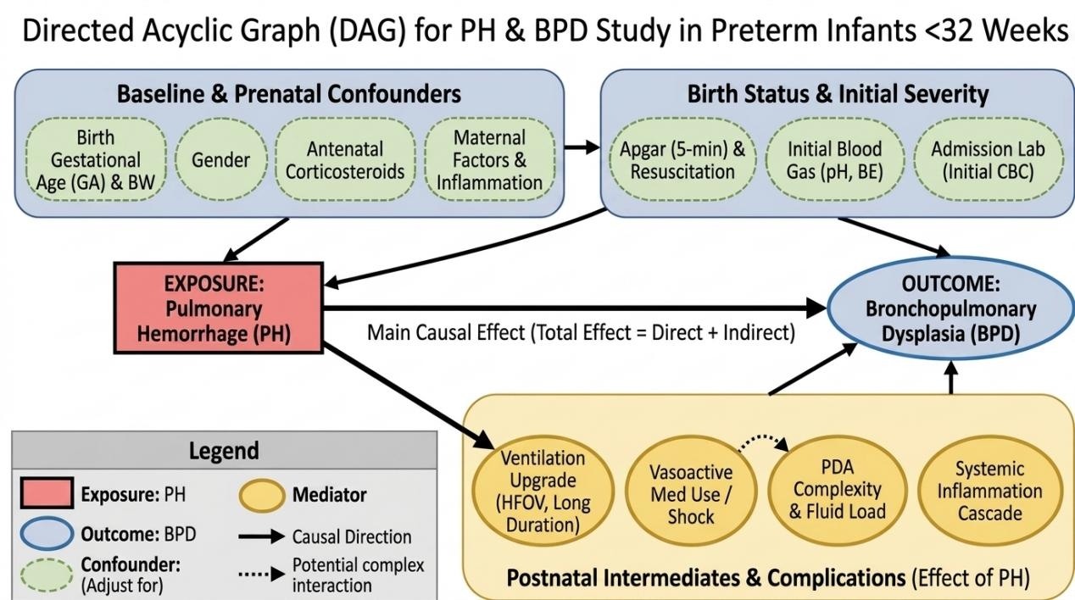

Supplementary Table2. Literature-based rationale for causal associations and covariate selection in the DAG
Causal pathway in the DAG | Theoretical and empirical justification | Relevance to covariate selection | Representative references
Gestational age → pulmonary hemorrhage | Lower gestational age is strongly associated with pulmonary immaturity, surfactant deficiency, fragile pulmonary capillaries, and severe early respiratory instability, all of which increase the risk of pulmonary hemorrhage in very preterm infants. | Common cause of the exposure; included as an a priori core confounder | [1-3]
Gestational age → BPD | Gestational age is one of the most established predictors of BPD because more immature lungs are more vulnerable to oxygen toxicity, inflammation, impaired alveolarization, and prolonged respiratory support. | Common cause of the outcome; included as an a priori core confounder | [4-6]
Birthweight → pulmonary hemorrhage | Lower birthweight reflects greater developmental immaturity and reduced pulmonary reserve, which are associated with more severe respiratory disease and increased susceptibility to pulmonary hemorrhage. | Common cause of the exposure; included as an a priori core confounder | [1-3]
Birthweight → BPD | Lower birthweight is a well-recognized risk factor for BPD and is closely related to impaired lung development, greater illness severity, and increased need for invasive respiratory support. | Common cause of the outcome; included as an a priori core confounder | [4-6]
Sex → pulmonary hemorrhage | Male preterm infants are known to have delayed lung maturation and a higher incidence of severe respiratory disease, which may predispose them to pulmonary hemorrhage. | Potential common cause of the exposure; included as an a priori core confounder | [7-8]
Sex → BPD | Male sex has been consistently associated with a higher risk of BPD in very preterm infants, likely due to sex-related differences in lung development and vulnerability to lung injury. | Common cause of the outcome; included as an a priori core confounder | [7-8]
Antenatal corticosteroid exposure → pulmonary hemorrhage | Antenatal corticosteroids promote fetal lung maturation, improve surfactant production, and reduce early respiratory instability, thereby potentially lowering the risk of pulmonary hemorrhage. | Potential common cause of the exposure; included as an a priori core confounder | [9-10]
Antenatal corticosteroid exposure → BPD | By enhancing lung maturity and reducing severe neonatal respiratory morbidity, antenatal corticosteroids may influence the subsequent risk of BPD. | Potential common cause of the outcome; included as an a priori core confounder | [9-10]
PROM >18 h → pulmonary hemorrhage | Prolonged rupture of membranes may indicate intrauterine inflammation or infection, which can impair pulmonary vascular/endothelial integrity and contribute to early postnatal respiratory instability, thereby increasing pulmonary hemorrhage risk. | Potential common cause of the exposure; included as an a priori core confounder | [11-13]
PROM >18 h → BPD | Intrauterine inflammatory exposure related to PROM has been associated with altered fetal lung development and a higher risk of BPD in preterm infants. | Potential common cause of the outcome; included as an a priori core confounder | [11-13]
Prenatal anti-infection treatment → pulmonary hemorrhage | Prenatal anti-infection treatment may serve as a clinical proxy for suspected maternal infection or inflammation, which can affect fetal lung condition and early postnatal respiratory stability, thereby influencing pulmonary hemorrhage risk. | Proxy of an underlying common-cause structure; included as an a priori core confounder | [11-13]
Prenatal anti-infection treatment → BPD | Maternal infection/inflammation is implicated in disrupted lung development and inflammatory lung injury; prenatal anti-infection treatment may therefore reflect a prenatal condition associated with later BPD risk. | Proxy of an underlying common-cause structure; included as an a priori core confounder | [11-13]
5-minute Apgar score → pulmonary hemorrhage | A low 5-minute Apgar score reflects poor perinatal adaptation, possible hypoxia/asphyxia, and greater cardiopulmonary instability after birth, all of which may predispose infants to pulmonary hemorrhage. | Marker of early severity and potential common cause; included as an a priori core confounder | [14-16]
5-minute Apgar score → BPD | Poor early neonatal condition is associated with more severe respiratory illness and a greater likelihood of prolonged respiratory support, both of which are linked to later BPD development. | Marker of early severity and potential common cause; included as an a priori core confounder | [14-16]
Umbilical/early postnatal pH → pulmonary hemorrhage | Low pH indicates perinatal acidosis and severe early physiological compromise, which may destabilize pulmonary hemodynamics and increase the risk of pulmonary hemorrhage. | Marker of early severity and potential common cause; included as an a priori core confounder | [14-16]
Umbilical/early postnatal pH → BPD | Early acid-base derangement reflects severe respiratory and systemic compromise, which is associated with greater lung injury burden and increased risk of BPD. | Marker of early severity and potential common cause; included as an a priori core confounder | [14-16]
Base excess → pulmonary hemorrhage | Abnormal base excess reflects metabolic acidosis and inadequate tissue perfusion, both of which may accompany severe perinatal illness and increase susceptibility to pulmonary hemorrhage. | Marker of early severity and potential common cause; included as an a priori core confounder | [14-16]
Base excess → BPD | Early metabolic derangement is associated with severe illness, aggressive respiratory support, and subsequent chronic lung injury, thereby contributing to BPD risk. | Marker of early severity and potential common cause; included as an a priori core confounder | [14-16]
Postnatal WBC count → pulmonary hemorrhage | Abnormal WBC count may indicate systemic inflammation, infection, or stress response, all of which can aggravate pulmonary endothelial injury and respiratory instability associated with pulmonary hemorrhage. | Proxy for inflammatory common causes; included as an a priori core confounder | [17-20]
Postnatal WBC count → BPD | Inflammation plays a central role in the pathogenesis of BPD; abnormal early WBC count may reflect inflammatory burden associated with impaired lung development and injury. | Proxy for inflammatory common causes; included as an a priori core confounder | [17-20]
Postnatal platelet count → PH | Thrombocytopenia or platelet dysfunction may directly predispose preterm infants to bleeding complications, including pulmonary hemorrhage. | Direct determinant of the exposure and part of the confounding structure; included as an a priori core confounder | [21-22]
Postnatal platelet count → BPD | Platelets are increasingly recognized as being involved in inflammatory and vascular processes relevant to neonatal lung injury; abnormal platelet count may also reflect overall disease severity associated with BPD risk. | Potential common cause / severity-related marker; included as an a priori core confounder | [21-22]
Abbreviations: DAG: directed acyclic graph; BPD: bronchopulmonary dysplasia; PROM: premature rupture of membranes; WBC: white blood cell.

Related references:
1.Raju TN, Langenberg P. Pulmonary hemorrhage and exogenous surfactant therapy: a metaanalysis. J Pediatr. 1993 Oct;123(4):603-10. doi: 10.1016/s0022-3476(05)80963-1. PMID: 8410518.
2.Kluckow M, Evans N. Ductal shunting, high pulmonary blood flow, and pulmonary hemorrhage. J Pediatr. 2000 Jul;137(1):68-72. doi: 10.1067/mpd.2000.106569. PMID: 10891824.
3.Ahmad KA, Bennett MM, Ahmad SF, Clark RH, Tolia VN. Morbidity and mortality with early pulmonary haemorrhage in preterm neonates. Arch Dis Child Fetal Neonatal Ed. 2019 Jan;104(1):F63-F68. doi: 10.1136/archdischild-2017-314172. Epub 2018 Jan 27. PMID: 29374627.
4.Jobe AH, Bancalari E. Bronchopulmonary dysplasia. Am J Respir Crit Care Med. 2001 Jun;163(7):1723-9. doi: 10.1164/ajrccm.163.7.2011060. PMID: 11401896.
5.Thébaud B, Goss KN, Laughon M, Whitsett JA, Abman SH, Steinhorn RH, Aschner JL, Davis PG, McGrath-Morrow SA, Soll RF, Jobe AH. Bronchopulmonary dysplasia. Nat Rev Dis Primers. 2019 Nov 14;5(1):78. doi: 10.1038/s41572-019-0127-7. PMID: 31727986; PMCID: PMC6986462.
6.Jensen EA, Dysart K, Gantz MG, McDonald S, Bamat NA, Keszler M, Kirpalani H, Laughon MM, Poindexter BB, Duncan AF, Yoder BA, Eichenwald EC, DeMauro SB. The Diagnosis of Bronchopulmonary Dysplasia in Very Preterm Infants. An Evidence-based Approach. Am J Respir Crit Care Med. 2019 Sep 15;200(6):751-759. doi: 10.1164/rccm.201812-2348OC. PMID: 30995069; PMCID: PMC6775872.
7.Peacock JL, Marston L, Marlow N, Calvert SA, Greenough A. Neonatal and infant outcome in boys and girls born very prematurely. Pediatr Res. 2012 Mar;71(3):305-10. doi: 10.1038/pr.2011.50. Epub 2012 Jan 18. PMID: 22258087.
8.Kent AL, Wright IM, Abdel-Latif ME; New South Wales and Australian Capital Territory Neonatal Intensive Care Units Audit Group. Mortality and adverse neurologic outcomes are greater in preterm male infants. Pediatrics. 2012 Jan;129(1):124-31. doi: 10.1542/peds.2011-1578. Epub 2011 Dec 19. PMID: 22184652.
9.Roberts D, Dalziel S. Antenatal corticosteroids for accelerating fetal lung maturation for women at risk of preterm birth. Cochrane Database Syst Rev. 2006 Jul 19;(3):CD004454. doi: 10.1002/14651858.CD004454.pub2. Update in: Cochrane Database Syst Rev. 2017 Mar 21;3:CD004454. doi: 10.1002/14651858.CD004454.pub3. PMID: 16856047.
10.Carlo WA, McDonald SA, Fanaroff AA, Vohr BR, Stoll BJ, Ehrenkranz RA, Andrews WW, Wallace D, Das A, Bell EF, Walsh MC, Laptook AR, Shankaran S, Poindexter BB, Hale EC, Newman NS, Davis AS, Schibler K, Kennedy KA, Sánchez PJ, Van Meurs KP, Goldberg RN, Watterberg KL, Faix RG, Frantz ID 3rd, Higgins RD; Eunice Kennedy Shriver National Institute of Child Health and Human Development Neonatal Research Network. Association of antenatal corticosteroids with mortality and neurodevelopmental outcomes among infants born at 22 to 25 weeks' gestation. JAMA. 2011 Dec 7;306(21):2348-58. doi: 10.1001/jama.2011.1752. PMID: 22147379; PMCID: PMC3565238.
11.Been JV, Zimmermann LJ. Histological chorioamnionitis and respiratory outcome in preterm infants. Arch Dis Child Fetal Neonatal Ed. 2009 May;94(3):F218-25. doi: 10.1136/adc.2008.150458. Epub 2009 Jan 8. PMID: 19131431.
12.Been JV, Zimmermann LJ. Histological chorioamnionitis and respiratory outcome in preterm infants. Arch Dis Child Fetal Neonatal Ed. 2009 May;94(3):F218-25. doi: 10.1136/adc.2008.150458. Epub 2009 Jan 8. PMID: 19131431.
13.Yu H, Li D, Zhao X, Fu J. Fetal origin of bronchopulmonary dysplasia: contribution of intrauterine inflammation. Mol Med. 2024 Sep 3;30(1):135. doi: 10.1186/s10020-024-00909-5. PMID: 39227783; PMCID: PMC11373297.
14.Klinger G, Sokolover N, Boyko V, Sirota L, Lerner-Geva L, Reichman B; Israel Neonatal Network. Perinatal risk factors for bronchopulmonary dysplasia in a national cohort of very-low-birthweight infants. Am J Obstet Gynecol. 2013 Feb;208(2):115.e1-9. doi: 10.1016/j.ajog.2012.11.026. Epub 2012 Nov 21. PMID: 23178245.
15.De Luca D, Bonadies L, Neri C, Loi B, Silva-Garcia TM, Noguera GR, Vivalda L, Res G, Cidoncha-Fuertes MLN, Baena-Palomino C, Zanetto L, Vedovelli L, Gregori D, Baraldi E, Alonso-Ojembarrena A. Lung aeration and gas exchange in preterm infants developing moderate-to-severe bronchopulmonary dysplasia: a multicentre prospective study from the PATH-BPD cohort. Lancet Reg Health Eur. 2026 Jan 10;63:101584. doi: 10.1016/j.lanepe.2025.101584. PMID: 41567169; PMCID: PMC12818268.
16.Romijn M, Dhiman P, Finken MJJ, van Kaam AH, Katz TA, Rotteveel J, Schuit E, Collins GS, Onland W, Torchin H. Prediction Models for Bronchopulmonary Dysplasia in Preterm Infants: A Systematic Review and Meta-Analysis. J Pediatr. 2023 Jul;258:113370. doi: 10.1016/j.jpeds.2023.01.024. Epub 2023 Apr 13. PMID: 37059387.
17.Speer CP. Inflammation and bronchopulmonary dysplasia: a continuing story. Semin Fetal Neonatal Med. 2006 Oct;11(5):354-62. doi: 10.1016/j.siny.2006.03.004. Epub 2006 May 15. PMID: 16702036.
18.Xie T, Hong L, Yi R, Cao Y, Wang F, Fan S, Li Y, Liu T, Liu P, Zhong X. Maternal Neutrophil Inflammation Markers Predict Bronchopulmonary Dysplasia in Preeclamptic Pregnancies. Am J Reprod Immunol. 2025 May;93(5):e70078. doi: 10.1111/aji.70078. PMID: 40298166.
19.Liu Y, Fang C, Zhao S. Maternal inflammatory biomarkers and neonatal characteristics as predictors of bronchopulmonary dysplasia in preterm infants: a retrospective cohort study. Front Med (Lausanne). 2026 Jan 8;12:1735582. doi: 10.3389/fmed.2025.1735582. PMID: 41585247; PMCID: PMC12823951.
20.Wang M, Luo C, Shi Z, Cheng X, Lei M, Cao W, Zhang J, Ge J, Song M, Ding W, Zhang Y, Zhao M, Zhang Q. The Relationship Between Cord Blood Cytokine Levels and Perinatal Characteristics and Bronchopulmonary Dysplasia: A Case-Control Study. Front Pediatr. 2022 Apr 7;10:807932. doi: 10.3389/fped.2022.807932. PMID: 35463904; PMCID: PMC9021742.
21.Del Vecchio A, Latini G, Henry E, Christensen RD. Template bleeding times of 240 neonates born at 24 to 41 weeks gestation. J Perinatol. 2008 Jun;28(6):427-31. doi: 10.1038/jp.2008.10. Epub 2008 Feb 14. PMID: 18273029.
22.Thanhaeuser M, Binder C, Derhaschnig U, Jilma B, Kornsteiner-Krenn M, Huber-Dangl M, Repa A, Kreissl A, Berger A, Haiden N. Can Sequential Coagulation Monitoring Predict Major Haemorrhage in Extremely Low Birth Weight Infants? Thromb Haemost. 2018 Jul;118(7):1185-1193. doi: 10.1055/s-0038-1655744. Epub 2018 Jun 4. PMID: 29864780.

Supplementary Table 3. Variance inflation factor and tolerance of variables included in multivariate analysis
Term | VIF | VIF_CI_low | VIF_CI_high | SE_factor | Tolerance | Tolerance_CI_low | Tolerance_CI_high
Gestational age | 1.521593 | 1.408789 | 1.665524 | 1.233529 | 0.6572061 | 0.6004117 | 0.7098294
Birthweight | 1.447854 | 1.344172 | 1.582770 | 1.203268 | 0.6906773 | 0.6318038 | 0.7439522
Sex | 1.077512 | 1.030675 | 1.195866 | 1.038033 | 0.9280635 | 0.8362138 | 0.9702381
Antenatal glucocorticoid | 1.054942 | 1.015636 | 1.193055 | 1.027104 | 0.9479196 | 0.8381844 | 0.9846047
PROM > 18 hours | 1.082630 | 1.034366 | 1.198673 | 1.040495 | 0.9236769 | 0.8342560 | 0.9667755
Prenatal anti-infection | 1.045680 | 1.010333 | 1.201933 | 1.022585 | 0.9563155 | 0.8319933 | 0.9897722
5min Apgar | 1.051173 | 1.013398 | 1.195449 | 1.025267 | 0.9513179 | 0.8365055 | 0.9867787
Arterial blood gas pH at birth | 1.272802 | 1.191768 | 1.388077 | 1.128185 | 0.7856684 | 0.7204212 | 0.8390895
Arterial blood gas BE at birth | 1.286365 | 1.203488 | 1.402995 | 1.134180 | 0.7773845 | 0.7127609 | 0.8309180
Platelet count after birth | 1.244479 | 1.167378 | 1.357097 | 1.115562 | 0.8035488 | 0.7368670 | 0.8566205
White blood cell count after birth | 1.137806 | 1.077478 | 1.245107 | 1.066680 | 0.8788847 | 0.8031441 | 0.9280931
Abbreviation: BE: base excess; PROM: premature rupture of membranes

Supplementary Table 4. The coefficients of LASSO regression analysis (λ = 0.0338197552439493)
Variable | Coefficient
(Intercept) | 26.2888094720
Gestational age | -0.3810230556
Birthweight | -0.0013380470
Sex | -0.0649873515
Antenatal glucocorticoid | 0.0000000000
PROM >18 hours | 0.0000000000
Prenatal anti-infection | 0.0000000000
5min Apgar | -0.1071636157
Arterial blood gas pH at birth | -1.7589713790
Arterial blood gas BE at birth | -0.0480584107
Platelet count after birth | -0.0005243615
White blood cell count after birth | 0.0000000000
Abbreviation: BE: base excess; PROM: premature rupture of membranes

Supplementary Figure2. The variables screened by LASSO regression (Cross validation curve. The horizontal axis represents the Log Lambda value. The vertical axis represents the mean squared error.) (10-fold cross-validation was applied to select the most suitable feature)
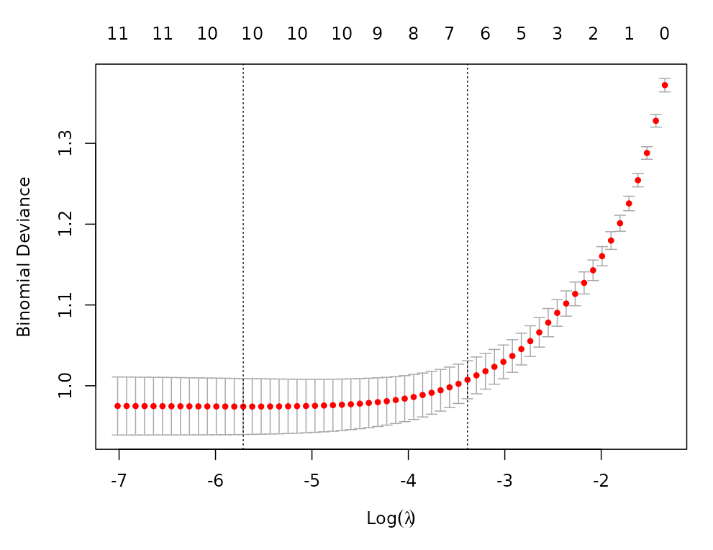

Supplementary Figure3. The variables screened by LASSO regression (Coefficient path plot. The horizontal axis represents the Log Lambda value. The vertical axis represents the coefficient.) (10-fold cross-validation was applied to select the most suitable feature)
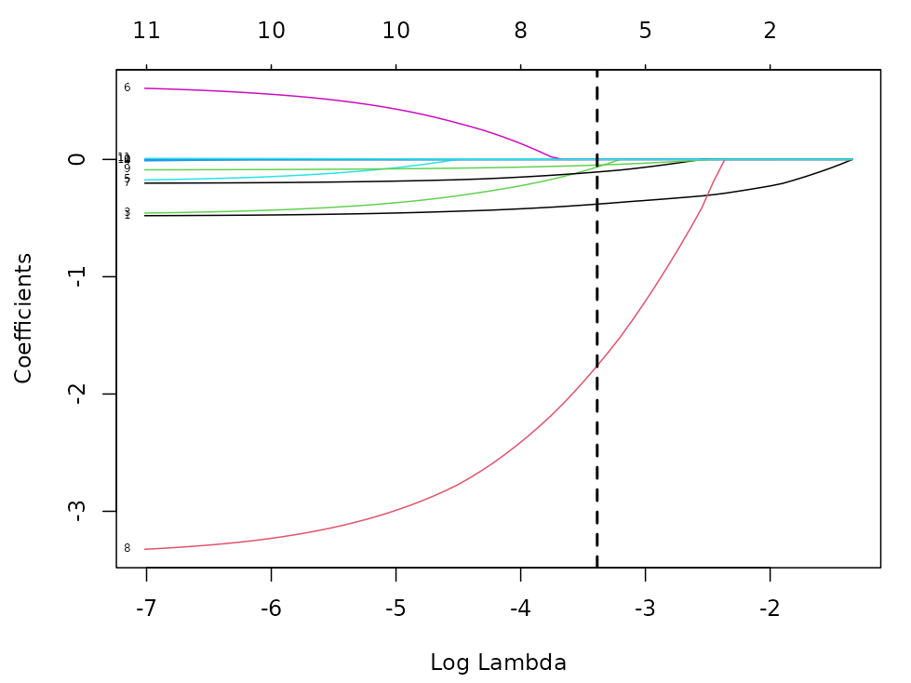

Supplementary Table5. Association between pulmonary hemorrhage and BPD by multi-model analysis based on competing risk regression
Characteristic | Model 1 |  |  | Model 2 |  |  | Model 3 |  |  | Model 4
Characteristic | HR | 95% CI | P-value | HR | 95% CI | P-value | HR | 95% CI | P-value | HR | 95% CI | P-value
Pulmonary hemorrhage
No | Reference | Reference |  | Reference | Reference |  | Reference | Reference |  | Reference | Reference
Yes | 0.55 | 0.40, 0.77 | <0.001 | 0.50 | 0.35, 0.72 | <0.001 | 0.58 | 0.41, 0.83 | 0.003 | 0.57 | 0.39, 0.81 | 0.002
Model 1 : no covariates were adjusted
Model 2 : adjusted for demographic variables
Model 3 : adjusted for variables screened by DAG+LASSO (GA, birthweight, sex, 5min Apgar, arterial blood gas (pH, BE), and postnatal PLT counts)
Model 4 : adjusted for variables screened by DAG (GA, birthweight, sex, antenatal corticosteroid use, PROM > 18 h, prenatal anti-infection, 5min Apgar, arterial blood gas (pH, BE), and postnatal WBC and PLT counts)
Abbreviations: CI: confidence Interval; OR: odds ratio.

Supplementary Table6. Association between pulmonary hemorrhage and moderate to severe BPD (vs. None/Mild BPD) by the logistic regression
Characteristic | N | Event N | OR | 95% CI | P-value
Pulmonary hemorrhage (unadjusted)
No | 751 | 14 | Reference | Reference
Yes | 69 | 8 | 6.90 | 2.79, 17.10 | <0.001
Pulmonary hemorrhage (adjusted)
No | 751 | 14 | Reference | Reference
Yes | 69 | 8 | 4.37 | 1.55, 12.30 | 0.005
Abbreviations: CI: confidence interval; OR: odds ratio.
Adjusted for GA, birthweight, sex, antenatal corticosteroid use, PROM > 18 h, prenatal anti-infection, 5min Apgar, arterial blood gas (pH, BE), and postnatal WBC and PLT counts.

Supplementary Table7. Characteristics of previous pulmonary hemorrhage studies related to BPD
Research | Sample size | Matching | Multi-variable analysis | Pulmonary hemorrhage criteria | BPD type | BPD criteria | Composite outcome  (BPD or death) | Study results
Lee M ²³ | 14,  GA: 24-30 weeks | No | No | Not mentioned | BPD; Moderate to severe BPD | 2001NICHD criteria | Not reported | All cases developed BPD; None moderate to severe BPD cases
Wang TT ¹² | 30 vs. 130,  ELBWIs | No | No | Bright red blood secretion from the  endotracheal tube; associated with clinical deterioration; increased ventilator support with a FiO₂ increase of > 0.3 | Moderate to severe BPD | 2001NICHD criteria | Yes | Not relevant with moderate to severe BPD
Ahmad KA ²⁵ | 1363 vs. 2726,  GA: <28 weeks | Yes | No | International Classification of Disease Revision 9 code 770.3 | Severe BPD | Not mentioned | Not reported | Lower incidence in pulmonary hemorrhage group
Bozkaya A ¹⁰ | 28 vs. 56,  GA: 25-32 weeks | Yes | No | Fresh blood from the endotracheal tube or trachea and the hematocrit of the hemorrhagic fluid seen in the endotracheal tube or trachea is close to venous hematocrit levels and one of the following signs: The need for transfusion of erythrocyte suspension; Increased oxygen need; Increased ventilation pressure requirement MAP≥2 units increase or PEEP increase to 6–8 cm H₂O; Abnormal radiological findings | BPD; Moderate to severe BPD | Diagnostic criteria from American National Institute of Pediatrics, National Heart, Lung and Blood Institute and the Department of Rare Diseases in 2000 (Philadelphia (PA):  Saunders/Elsevier; 2008. p. 428) | Not reported | Associated with BPD and moderate to severe BPD
Kappico JM ²⁴ | 16 vs. 32,  ELBWIs | Yes | No | Pink-tinged or frank bloody secretions from the endotracheal tube combined with significant clinical deterioration characterized by worsening and increased ventilatory settings | BPD | Oxygen requirement at 36 weeks post-menstrual age (Pediatrics 1988;82:527–32.) | Not reported | Not relevant with BPD
Wang L ¹¹ | 262 vs. 524,  GA: 24-32 weeks | Yes | Yes | International Classification of Disease Revision 9 code 770.3 | Moderate to severe BPD | 2018 NICHD criteria | Not reported | Associated with moderate to severe BPD
Abbreviations: GA: gestational age; ELBWI: extremely low birthweight infants; FiO₂: fraction of inspired oxygen; MAP: mean airway pressure; PEEP: positive end-expiratory pressure; NICHD: national institute of child health and human development.

