Effects of GLP-1 Receptor Agonists on Liver Outcomes and Mortality in Patients with Alcohol Use Disorder and Alcohol-Related Liver Disease: A Systematic Review and Meta-Analysis

Supplementary Table1. Comprehensive search line used in this systematic review and meta-analysis study
Supplementary Table 2. PRISMA Checklist
Supplementary Table 3. Excluded studies evaluating the association of GLP-1RAs and alcohol consumption
Supplementary Table 4. Detailed findings of the included studies
Supplementary Figure 1. Risk of bias assessment in observational studies according to the ROBINS-I
Supplementary Figure 2. Risk of bias in Klausen et al (2022) according to the Cochrane risk-of-bias tool for randomized trials (RoB-2)
Supplementary Figure 3. Publication bias assessment regarding the hepatic decompensation finsings in alcohol-related liver disease.

Supplementary Table1. Comprehensive search line used in this systematic review and meta-analysis study
Search was conducted until July 1st
PubMed | (("GLP-1 Receptor Agonists"[Mesh] OR "GLP-1 receptor agonist" OR "GLP-1 agonist" OR Exenatide OR Liraglutide OR Dulaglutide OR Semaglutide OR Lixisenatide OR Albiglutide OR Efpeglenatide OR Tirzepatide OR "GIP/GLP-1 receptor agonist") AND ("Alcohol-Related Disorders"[Mesh] OR "Alcohol use disorder" OR alcohol OR "Chronic Alcohol Use" OR "Heavy Drinking" OR "Alcohol Consumption" OR "Alcohol Abuse" OR "Alcohol Dependence" OR "Alcoholic Liver Disease"[Mesh] OR "Alcoholic Liver Disease" OR "alcohol-related liver disease")) | 238
Web of Science | TS=("GLP-1 Receptor Agonists" OR "GLP-1 receptor agonist" OR "GLP-1 agonist" OR Exenatide OR Liraglutide OR Dulaglutide OR Semaglutide OR Lixisenatide OR Albiglutide OR Efpeglenatide OR Tirzepatide OR "GIP/GLP-1 receptor agonist")  AND  TS=("Alcohol-Related Disorders" OR "Alcohol use disorder" OR alcohol OR "Chronic Alcohol Use" OR "Heavy Drinking" OR "Alcohol Consumption" OR "Alcohol Abuse" OR "Alcohol Dependence" OR "Alcoholic Liver Disease" OR "alcohol-related liver disease") | 164
Embase | ('glp 1 receptor agonist'/exp OR 'glp-1 receptor agonist':ti,ab,kw OR 'glp-1 agonist':ti,ab,kw OR exenatide:ti,ab,kw OR liraglutide:ti,ab,kw OR dulaglutide:ti,ab,kw OR semaglutide:ti,ab,kw OR lixisenatide:ti,ab,kw OR albiglutide:ti,ab,kw OR efpeglenatide:ti,ab,kw OR tirzepatide:ti,ab,kw OR 'gip/glp-1 receptor agonist':ti,ab,kw)  AND  ('alcoholism'/exp OR 'alcohol use disorder':ti,ab,kw OR 'alcohol':ti,ab,kw OR 'chronic alcohol use':ti,ab,kw OR 'heavy drinking':ti,ab,kw OR 'alcohol consumption':ti,ab,kw OR 'alcohol abuse':ti,ab,kw OR 'alcohol dependence':ti,ab,kw OR 'alcoholic liver disease'/exp OR 'alcohol-related liver disease':ti,ab,kw) | 856
Scopus | (TITLE-ABS-KEY("GLP-1 Receptor Agonists" OR "GLP-1 receptor agonist" OR "GLP-1 agonist" OR Exenatide OR Liraglutide OR Dulaglutide OR Semaglutide OR Lixisenatide OR Albiglutide OR Efpeglenatide OR Tirzepatide OR "GIP/GLP-1 receptor agonist")  AND  TITLE-ABS-KEY("Alcohol-Related Disorders" OR "Alcohol use disorder" OR alcohol OR "Chronic Alcohol Use" OR "Heavy Drinking" OR "Alcohol Consumption" OR "Alcohol Abuse" OR "Alcohol Dependence" OR "Alcoholic Liver Disease" OR "alcohol-related liver disease")) | 443
Cochrane | (MH "Glucagon-Like Peptide-1 Receptor Agonists" OR "GLP-1 receptor agonist" OR "GLP-1 agonist" OR Exenatide OR Liraglutide OR Dulaglutide OR Semaglutide OR Lixisenatide OR Albiglutide OR Efpeglenatide OR Tirzepatide OR "GIP/GLP-1 receptor agonist")  AND  (MH "Alcohol-Related Disorders" OR "Alcohol use disorder" OR alcohol OR "Chronic Alcohol Use" OR "Heavy Drinking" OR "Alcohol Consumption" OR "Alcohol Abuse" OR "Alcohol Dependence" OR MH "Alcoholic Liver Disease" OR "alcohol-related liver disease") | 215
Clinical Trials.gov | (glp-1 OR "glp-1 receptor agonist" OR exenatide OR liraglutide OR dulaglutide OR semaglutide OR lixisenatide OR albiglutide OR efpeglenatide OR tirzepatide OR "gip/glp-1")  AND  (alcohol OR "alcohol use disorder" OR "alcohol dependence" OR "alcohol abuse" OR "heavy drinking" OR "alcoholic liver disease" OR "alcohol-related liver disease") | 17

Supplementary Table 2. PRISMA Checklist
Section and Topic | Item # | Checklist item | Location where item is reported
Title | 1 | Identify the report as a systematic review. | P1
ABSTRACT
Abstract | 2 | See the PRISMA 2020 for Abstracts checklist. | P4
INTRODUCTION
Rationale | 3 | Describe the rationale for the review in the context of existing knowledge. | P6-lines 57-71
Objectives | 4 | Provide an explicit statement of the objective(s) or question(s) the review addresses. | P6 and 7, lines 71-74
METHODS
Eligibility criteria | 5 | Specify the inclusion and exclusion criteria for the review and how studies were grouped for the syntheses. | P8, 87-94
Information sources | 6 | Specify all databases, registers, websites, organisations, reference lists and other sources searched or consulted to identify studies. Specify the date when each source was last searched or consulted. | P7, lines 77-86
Search strategy | 7 | Present the full search strategies for all databases, registers and websites, including any filters and limits used. | Supplementary  Table 1
Selection process | 8 | Specify the methods used to decide whether a study met the inclusion criteria of the review, including how many reviewers screened each record and each report retrieved, whether they worked independently, and if applicable, details of automation tools used in the process. | P8, line 95-97
Data collection process | 9 | Specify the methods used to collect data from reports, including how many reviewers collected data from each report, whether they worked independently, any processes for obtaining or confirming data from study investigators, and if applicable, details of automation tools used in the process. | P8, lines 98-102
Data items | 10a | List and define all outcomes for which data were sought. Specify whether all results that were compatible with each outcome domain in each study were sought (e.g. for all measures, time points, analyses), and if not, the methods used to decide which results to collect. | P8, lines 100-102
Data items | 10b | List and define all other variables for which data were sought (e.g. participant and intervention characteristics, funding sources). Describe any assumptions made about any missing or unclear information. | -
Study risk of bias assessment | 11 | Specify the methods used to assess risk of bias in the included studies, including details of the tool(s) used, how many reviewers assessed each study and whether they worked independently, and if applicable, details of automation tools used in the process. | P9, lines 102-107
Effect measures | 12 | Specify for each outcome the effect measure(s) (e.g. risk ratio, mean difference) used in the synthesis or presentation of results. | P9, 109-112
Synthesis methods | 13a | Describe the processes used to decide which studies were eligible for each synthesis (e.g. tabulating the study intervention characteristics and comparing against the planned groups for each synthesis (item #5)). | P9, 109-112
Synthesis methods | 13b | Describe any methods required to prepare the data for presentation or synthesis, such as handling of missing summary statistics, or data conversions. | -
Synthesis methods | 13c | Describe any methods used to tabulate or visually display results of individual studies and syntheses. | P9, 109-112
Synthesis methods | 13d | Describe any methods used to synthesize results and provide a rationale for the choice(s). If meta-analysis was performed, describe the model(s), method(s) to identify the presence and extent of statistical heterogeneity, and software package(s) used. | P9, 109-112
Synthesis methods | 13e | Describe any methods used to explore possible causes of heterogeneity among study results (e.g. subgroup analysis, meta-regression). | -
Synthesis methods | 13f | Describe any sensitivity analyses conducted to assess robustness of the synthesized results. | -
Reporting bias assessment | 14 | Describe any methods used to assess risk of bias due to missing results in a synthesis (arising from reporting biases). | P9, 109-112
Certainty assessment | 15 | Describe any methods used to assess certainty (or confidence) in the body of evidence for an outcome. | -
RESULTS
Study selection | 16a | Describe the results of the search and selection process, from the number of records identified in the search to the number of studies included in the review, ideally using a flow diagram. | P9, lines 114-118
Study selection | 16b | Cite studies that might appear to meet the inclusion criteria, but which were excluded, and explain why they were excluded. | Supplementary  Table 3
Study characteristics | 17 | Cite each included study and present its characteristics. | P10-14 Table 1
Risk of bias in studies | 18 | Present assessments of risk of bias for each included study. | P11, lines 131-134 Supplementary figures 1 and 2
Results of individual studies | 19 | For all outcomes, present, for each study: (a) summary statistics for each group (where appropriate) and (b) an effect estimate and its precision (e.g. confidence/credible interval), ideally using structured tables or plots. | P5, lines 147-152
Results of syntheses | 20a | For each synthesis, briefly summarise the characteristics and risk of bias among contributing studies. | Supplementary figures 1 and 2
Results of syntheses | 20b | Present results of all statistical syntheses conducted. If meta-analysis was done, present for each the summary estimate and its precision (e.g. confidence/credible interval) and measures of statistical heterogeneity. If comparing groups, describe the direction of the effect. | P5, lines 147-152
Results of syntheses | 20c | Present results of all investigations of possible causes of heterogeneity among study results. | -
Results of syntheses | 20d | Present results of all sensitivity analyses conducted to assess the robustness of the synthesized results. | -
Reporting biases | 21 | Present assessments of risk of bias due to missing results (arising from reporting biases) for each synthesis assessed. | -
Certainty of evidence | 22 | Present assessments of certainty (or confidence) in the body of evidence for each outcome assessed. | -
DISCUSSION
Discussion | 23a | Provide a general interpretation of the results in the context of other evidence. | P22, lines 206—208
Discussion | 23b | Discuss any limitations of the evidence included in the review. | P23, lines 223-245
Discussion | 23c | Discuss any limitations of the review processes used. | P24, lines 236-241
Discussion | 23d | Discuss implications of the results for practice, policy, and future research. | P23, lines 223-230
OTHER INFORMATION
Registration and protocol | 24a | Provide registration information for the review, including register name and registration number, or state that the review was not registered. | CRD420251050088
Registration and protocol | 24b | Indicate where the review protocol can be accessed, or state that a protocol was not prepared. | P4, line 40
Registration and protocol | 24c | Describe and explain any amendments to information provided at registration or in the protocol. | -
Support | 25 | Describe sources of financial or non-financial support for the review, and the role of the funders or sponsors in the review. | None
Competing interests | 26 | Declare any competing interests of review authors. | None
Availability of data, code and other materials | 27 | Report which of the following are publicly available and where they can be found: template data collection forms; data extracted from included studies; data used for all analyses; analytic code; any other materials used in the review. | All data

Supplementary Table 3. Excluded studies evaluating the association of GLP-1RAs and alcohol consumption
N | First author | Title | Study design | Population | Test group treatment
1 | O'Farrell, 2025 (1) | Glucagon-like peptide-1 analogues reduce alcohol intake | Prospective cohort | BMI ≥27 kg/m2 who were drinkers | Liraglutide or  Semaglutide
2 | Quddos, 2023 (2) | Semaglutide and Tirzepatide reduce alcohol consumption in individuals with obesity | Remote Study & Social Media Analysis | Adults self-reporting GLP-1 RAs use via Reddit; off-label for weight loss (BMI ≥ 30) or T2DM; no prescribed concomitant AUD | Semaglutide or  Tirzepatide
3 | Richards, 2023 (3) | Significant Decrease in Alcohol Use Disorder Symptoms Secondary to Semaglutide Therapy for Weight Loss: A Case Series | Case Series | Patients with obesity (BMI: 25.4-47.2 kg/m²) treated for weight loss | In-label Semaglutide 0.25-1.00 mg weekly
4 | Wium-Andersen, 2022 (4) | Use of GLP-1 Receptor Agonists and Subsequent Risk of Alcohol-Related Events: A Nationwide Register-Based Cohort and Self-Controlled Case Series Study | Nationwide Register-Based Cohort and Self-Controlled Case Series Study | New users of GLP-1 RAs and DPP-4i | GLP-1 RAs
5 | Qeadan, 2025 (5) | The Association Between Glucose-Dependent Insulinotropic Polypeptide and/or Glucagon-Like Peptide-1 Receptor Agonist Prescriptions and Substance-Related Outcomes in Patients With Opioid and Alcohol Use Disorders: A Real-World Data Analysis | Retrospective Cohort Study | Adults (≥18 years) with OUD or AUD between 2014 and 2022. | GIP/GLP-1 RAs prescriptions
6 | Lähteenvuo, 2025 (6) | Repurposing Semaglutide and Liraglutide for Alcohol Use Disorder | Observational Cohort Study | - | Exenatide, Liraglutide, Dulaglutide, and Semaglutide
7 | Wang, 2024 (7) | Associations of semaglutide with incidence and recurrence of alcohol use disorder in real-world population | Retrospective Cohort Study | Adults with obesity or type 2 diabetes, with or without prior AUD | Semaglutide (Wegovy 2.4 mg for obesity; Ozempic 0.5–1 mg for T2DM)
8 | Farokhnia, 2025 (8) | Glucagon-like peptide-1 receptor agonists but not dipeptidyl peptidase-4 inhibitors reduce alcohol intake | Retrospective Cohort Study | - | Exenatide, Albiglutide, Dulaglutide, Liraglutide, and Semaglutide
9 | E. Jensen, 2024 (9) | Blood phosphatidylethanol measurements indicate GLP-1 receptor stimulation causes delayed decreases in alcohol consumption | Secondary analysis of a randomized placebo-controlled trial | Adults with alcohol use disorder (AUD) and comorbid obesity (BMI ≥ 30 kg/m²) | Exenatide extended-release (Bydureon®), administered as 2 mg once-weekly injections
10 | Probst, 2023 (10) | Effects of dulaglutide on alcohol consumption during smoking cessation | Randomized, Double-Blinded, Placebo-Controlled Clinical Trial | Adult smokers (ages 18–75) with at least moderate nicotine dependence (Fagerström score ≥5), predominantly obese (BMI > 29.9 in ~91%), undergoing smoking cessation therapy with varenicline and behavioral counseling | Dulaglutide (weekly, subcutaneous 1.5 mg for 12 weeks)
11 | Hendershot, 2025 (11) | Once-Weekly Semaglutide in Adults With Alcohol Use Disorder: A Randomized Clinical Trial | Randomized Clinical Trial | Non–treatment-seeking adults aged 21–65 with AUD, consuming above-threshold levels of alcohol (women >7 drinks/week; men >14) and not attempting to reduce drinking. | Once-weekly subcutaneous Semaglutide (0.25 mg/week for 4 weeks, 0.5 mg/week for 4 weeks, 1.0 mg for 1 week)

Supplementary Table 4. Detailed findings of the included studies
Stud y | Outcomes
Al-Moussally et al., 2025 ²⁶ | Alcohol-related hospital admissions: GLP-1RA group: 2.0%, DPP4i group: 4.2%; OR: 0.85; 95% CI: 0.65–1.11; non-significant.  Progression to cirrhosis: GLP-1RA group: 6.6%, DPP4i group: 6.0%; OR: 1.1; 95% CI: 0.97–1.26; non-significant.  Compensated cirrhosis: GLP-1RA group: 6.0%, DPP4i group: 5.4%; OR: 1.1; 95% CI: 0.97–1.28; non-significant.  Decompensated cirrhosis: GLP-1RA group: 2.8%, DPP4i group: 2.7%; OR: 1.0; 95% CI: 0.85–1.27; non-significant.
Klausen et al., 2022 ³⁰ | Heavy drinking days: Exenatide group 19.6 days vs. 26.8 days in placebo (p = 0.37).  AUDIT: Exenatide group AUDIT score change: -7.0 points, Placebo group AUDIT score change: –8.2 points (p = 0.59)  Liver Markers: ALT and GGT showed slight reductions, but differences were not statistically significant; ALT: Exenatide: Decrease of 3.7 U/L, Placebo: Decrease of 7.9 U/L (p = 0.68). GGT: Exenatide: Decrease of 13.6 U/L, Placebo: Decrease of 16.5 U/L (p = 0.84).
Kuo et al., 2025 ³¹ | Development of ArLD: GLP-1RA: 6.0/1,000 PY vs. DPP4i: 8.7/1,000 PY; HR = 0.62; 95% CI: 0.44–0.87; p = 0.006.  All-cause mortality in patients with T2D and AUD but without ArLD: HR = 0.53; 95% CI: 0.45–0.62; p < 0.001.  Hepatic decompensation in established ArLD: GLP-1RA: 39.5/1,000 PY vs. DPP4i: 51.4/1,000 PY; HR = 0.66; 95% CI: 0.51–0.85; p = 0.001.  All-cause mortality in patients with established ArLD: HR = 0.53; 95% CI: 0.41–0.68; p < 0.001.  HbA1c reduction in patients with T2D and AUD but without ArLD using GLP-1RA: ↓0.15% at 6 months (95% CI: –0.28 to –0.01; p = 0.03); no significant differences over long-term follow-up.
Rashid et al., 2024 ²⁷ | Composite ArLD outcomes incidence rate: GLP-1RA: 12.0%, 95%CI 9.0–16.0 vs. non-GLP-1RA: 21.0%, 95%CI 20.0–22.0, with an absolute incidence risk reduction of 9.0% (95% CI 3.0%–15.0%).  Adjusted IRR for hepatic decompensation and related outcomes following GLP-1RA : 0.57; 95% CI: 0.39–0.82.  Hepatic decompensation following GLP-1RA: IRR = 0.56; 95% CI: 0.36–0.86.  No significant effect on HCC, portal hypertention, or liver transplant.
Yen et al., 2024 ²⁸ | All-cause mortality: aHR = 0.47; 95% CI: 0.32–0.69; p < 0.001.  MACE: aHR = 0.60; 95% CI: 0.41–0.87; p = 0.007.  Decompensated cirrhosis: aHR = 0.70; 95% CI: 0.49–0.99; p = 0.046.  Hepatic encephalopathy: aHR = 0.59; 95% CI: 0.36–0.97; p = 0.037.  Liver failure: aHR = 0.54; 95% CI: 0.34–0.85; p = 0.008.  Time-dependent analysis and dose-response trends support findings.
V. John et al., 2025 ²⁹ | All-cause mortality: aHR = 0.43; 95% CI: 0.37–0.49; p < 0.0001  Composite liver-related outcomes (HCC, decompensation, liver-related death): aHR = 0.70; 95% CI: 0.56–0.87; p = 0.001  Semaglutide subgroup – All-cause mortality: aHR = 0.20; 95% CI: 0.16–0.25; p < 0.0001  Semaglutide subgroup – Liver outcomes: aHR = 0.52; 95% CI: 0.40–0.67; p < 0.0001  Dose-response (per 1 mg semaglutide increase) – Mortality: aHR = 0.33; 95% CI: 0.19–0.58; p = 0.0001  Dose-response (per 1 mg semaglutide increase) – Liver outcomes: aHR = 0.50; 95% CI: 0.29–0.88; p = 0.0155  Harmful alcohol use (elevated AUDIT-C at follow-up): aOR = 0.75; 95% CI: 0.68–0.82; p < 0.0001  Time-stratified analysis confirms early and sustained reduction in harmful alcohol use. Dose-response observed for clinical outcomes but not for AUDIT-C.
Abbreviations: GLP-1 RA: Glucagon-like Peptide-1 Receptor Agonist, DPP4i: Dipeptidyl Peptidase-4 Inhibitor, T2DM: Type 2 diabetes mellitus; AUD, alcohol use disorder; ALD, alcohol-associated liver disease; ArLD, alcohol-related liver disease; ALO, adverse liver outcome; ALT, alanine aminotransferase; GGT, γ-glutamyl Transferase, DAT: Dopamine Transporter, HCC: Hepatocellular Carcinoma, MACE: Major Adverse Cardiovascular Events, ACLF: Acute-on-Chronic Liver Failure, ALT: Alanine Aminotransferase, AST: Aspartate Aminotransferase, BMI: Body Mass Index; fMRI, Functional Magnetic Resonance Imaging, SPECT: Single-Photon Emission Computed Tomography, IRR: Incidence Rate Ratio; aIRR, Adjusted Incidence Rate Ratio, OR: Odds Ratio, CI: Confidence Interval, NS: Not Significant, PY: Person-Years

Supplementary Figures
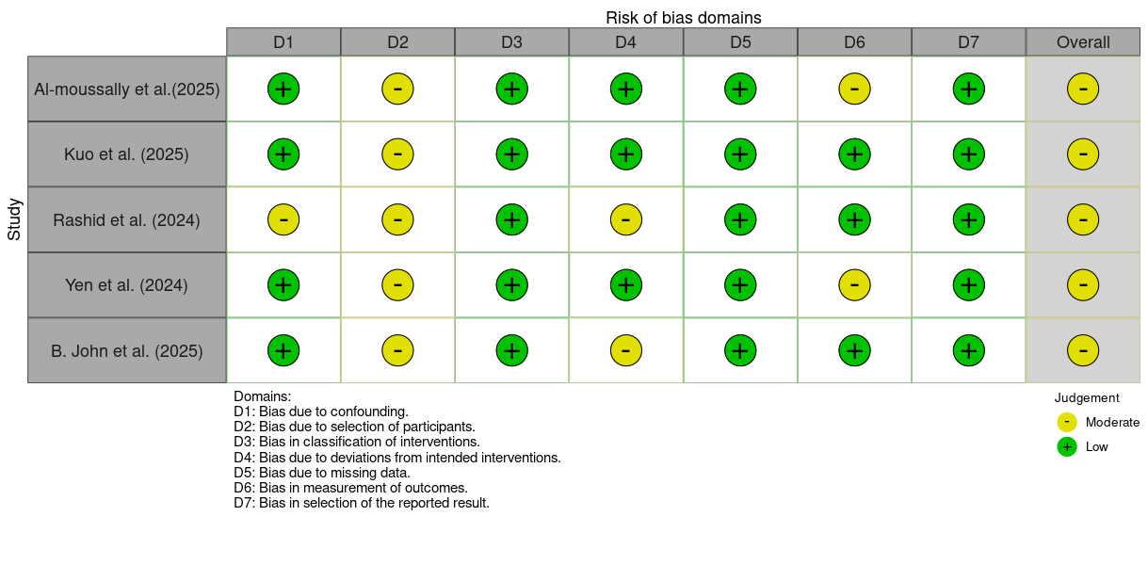
Supplementary Figure 1. Risk of bias assessment in observational studies according to the ROBINS-I
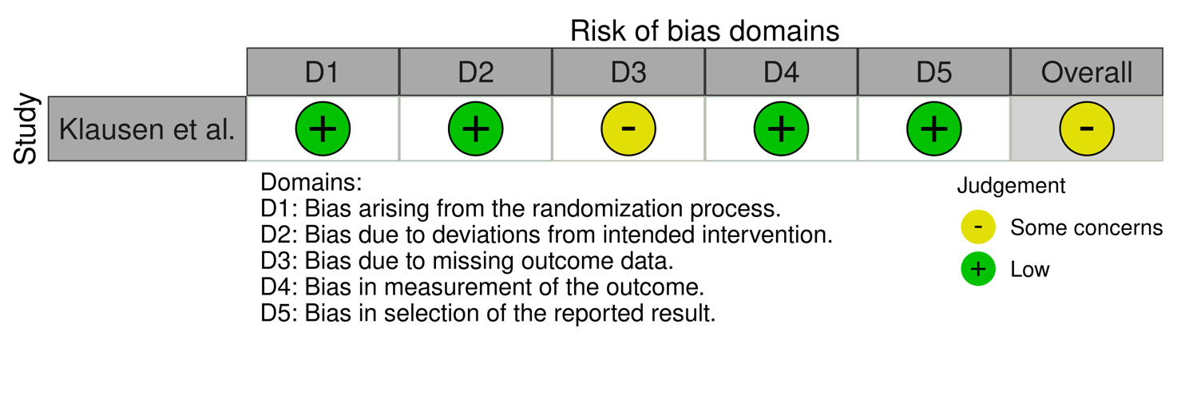
Supplementary Figure 2. Risk of bias in Klausen et al (2022) according to the Cochrane risk-of-bias tool for randomized trials (RoB-2)
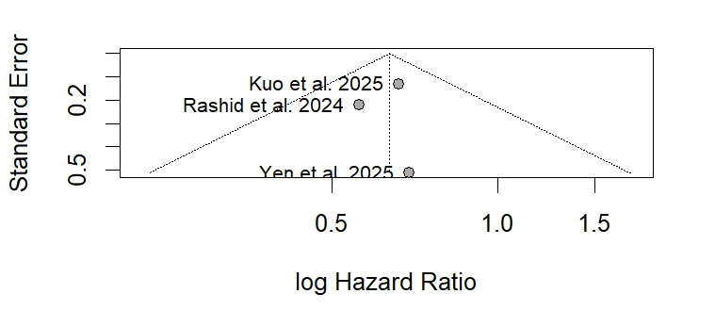
Supplementary Figure 3. Publication bias assessment regarding the hepatic decompensation finsings in alcohol-related liver disease.

References
1. O’Farrell M, Almohaileb FI, le Roux CW. Glucagon-like peptide-1 analogues reduce alcohol intake. Diabetes Obes Metab [Internet]. 2025 Mar 1 [cited 2025 Apr 19];27(3):1601–4. Available from: https://onlinelibrary.wiley.com/doi/full/10.1111/dom.16152
2. Quddos F, Hubshman Z, Tegge A, Sane D, Marti E, Kablinger AS, et al. Semaglutide and Tirzepatide reduce alcohol consumption in individuals with obesity. Sci Rep. 2023 Nov 28;13(1):20998.
3. Richards JR, Dorand MF, Royal K, Mnajjed L, Paszkowiak M, Simmons WK. Significant Decrease in Alcohol Use Disorder Symptoms Secondary to Semaglutide Therapy for Weight Loss. J Clin Psychiatry. 2023 Nov 27;85(1).
4. Wium‐Andersen IK, Wium‐Andersen MK, Fink‐Jensen A, Rungby J, Jørgensen MB, Osler M. Use of GLP‐1 receptor agonists and subsequent risk of alcohol‐related events. A nationwide register‐based cohort and self‐controlled case series study. Basic Clin Pharmacol Toxicol. 2022 Nov 30;131(5):372–9.
5. Qeadan F, McCunn A, Tingey B. The association between glucose‐dependent insulinotropic polypeptide and/or glucagon‐like peptide‐1 receptor agonist prescriptions and substance‐related outcomes in patients with opioid and alcohol use disorders: A real‐world data analysis. Addiction. 2025 Feb 16;120(2):236–50.
6. Lähteenvuo M, Tiihonen J, Solismaa A, Tanskanen A, Mittendorfer-Rutz E, Taipale H. Repurposing Semaglutide and Liraglutide for Alcohol Use Disorder. JAMA Psychiatry. 2025 Jan 1;82(1):94.
7. Wang JY, Wang QW, Yang XY, Yang W, Li DR, Jin JY, et al. GLP−1 receptor agonists for the treatment of obesity: Role as a promising approach. Front Endocrinol (Lausanne). 2023 Feb 1;14.
8. Farokhnia M, Tazare J, Pince CL, Bruns N, Gray JC, Lo V, et al. Glucagon-like peptide-1 receptor agonists but not dipeptidyl peptidase-4 inhibitors reduce alcohol intake.
9. Jensen ME, Klausen MK, Bergmann ML, Knudsen GM, Vilsbøll T, Stove C, et al. Blood phosphatidylethanol measurements indicate GLP-1 receptor stimulation causes delayed decreases in alcohol consumption. Alcohol, clinical & experimental research [Internet]. 2025 [cited 2025 Apr 18]; Available from: https://pubmed.ncbi.nlm.nih.gov/40123107/
10. Probst L, Monnerat S, Vogt DR, Lengsfeld S, Burkard T, Meienberg A, et al. Effects of dulaglutide on alcohol consumption during smoking cessation. JCI Insight [Internet]. 2023 [cited 2025 Apr 15];8(22). Available from: https://pubmed.ncbi.nlm.nih.gov/37991022/
11. Hendershot CS, Bremmer MP, Paladino MB, Kostantinis G, Gilmore TA, Sullivan NR, et al. Once-Weekly Semaglutide in Adults With Alcohol Use Disorder: A Randomized Clinical Trial. JAMA Psychiatry [Internet]. 2025 Apr 1 [cited 2025 Apr 15];82(4):395–405. Available from: https://jamanetwork.com/journals/jamapsychiatry/fullarticle/2829811

