S1
Questionnaire
1. Mode of delivery:
○ Natural birth
○ Cesarean section
2. Monthly household income:
○ < 5,000 RMB
○ 5,000–9,999 RMB
○ 10,000–14,999 RMB
○ ≥ 15,000 RMB
3. Father’s vision status (based on the eye with higher refractive error):
○ Normal
○ Myopia < 300 degrees
○ Myopia 300–599 degrees
○ Myopia ≥ 600 degrees
○ Hyperopia
4. Mother’s vision status (based on the eye with higher refractive error): ○ Normal
○ Myopia < 300 degrees
○ Myopia 300–599 degrees
○ Myopia ≥ 600 degrees
○ Hyperopia
5. Average daily screen time of your child (including mobile phones, TV, computers, etc.): \_\_\_\_\_ minutes
○ < 1 hour
○ 1–2 hours
○ 2 hours or more
6. Total daily outdoor activity time of your child (including any activities, not limited to sports):
○ < 1 hour
○ 1–2 hours
○ 2–<3 hours
○ 3 hours or more
7. How often does your child usually consume the following foods?

Food Item | <1 time/week | 1 time/week | 2–3 times/week | 4–6 times/week | ≥2 times/day
Refined grains (white rice, noodles, steamed buns, bread etc.) | ○ | ○ | ○ | ○ | ○
Whole grains (brown rice, whole wheat, oats, corn, buckwheat etc.) | ○ | ○ | ○ | ○ | ○
Red meat (pork, beef, lamb, and their products) | ○ | ○ | ○ | ○ | ○
Poultry (chicken, duck, goose and their products) | ○ | ○ | ○ | ○ | ○
Processed/cured meat products (sausages, ham, etc.) | ○ | ○ | ○ | ○ | ○
Seafood (fish, shrimp, crab, shellfish etc.) | ○ | ○ | ○ | ○ | ○
Dairy products | ○ | ○ | ○ | ○ | ○
Eggs and egg products | ○ | ○ | ○ | ○ | ○
Soybeans and soy products | ○ | ○ | ○ | ○ | ○
Leafy vegetables (spinach, bok choy, cabbage etc.) | ○ | ○ | ○ | ○ | ○
Root vegetables (carrots, lotus root, yam etc.) | ○ | ○ | ○ | ○ | ○
Fresh fruits | ○ | ○ | ○ | ○ | ○
Nuts (walnuts, almonds, peanuts etc.) | ○ | ○ | ○ | ○ | ○
Sweets (snacks, desserts, cakes, ice cream) | ○ | ○ | ○ | ○ | ○
Fried or grilled foods | ○ | ○ | ○ | ○ | ○
Fast food (instant noodles, packaged snacks etc.) | ○ | ○ | ○ | ○ | ○
Sugary beverages (juice, soda, cola, milk tea etc.) | ○ | ○ | ○ | ○ | ○
Sugar-free/diet beverages (diet soda etc.) | ○ | ○ | ○ | ○ | ○

Table S2
Variable | Model 1 | Model 2 | Model 3
rice | 0.75
coarse grains (maize, sorghum etc) |  |  | 0.541
meat(Pork, Lamb, Beef) | 0.678
chicken
sausage
seafood |  |  | 0.526
milk | 0.676
egg | 0.752
beans |  |  | 0.638
vegetable | 0.607
carrots |  |  | 0.72
fruits | 0.802
nuts |  |  | 0.659
dessert |  | 0.606
fired |  | 0.815
quick meal |  | 0.797
soda |  | 0.785
diet(coke) |  | 0.673

Figure S3
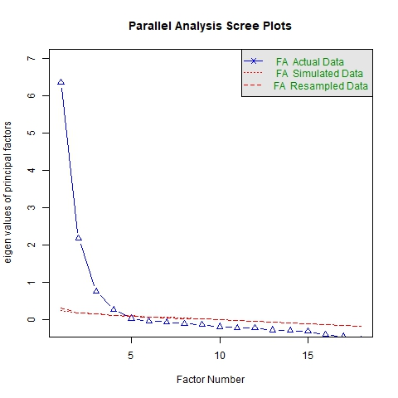

Table S4
Item | Statistics
Kaiser-Meyer-Olkin (KMO) Measure | 0.91
Bartlett's Test of Sphericity
Approx. Chi-Square | 11777.65
Degrees of Freedom (df) | 153
p-value | < 0.001

S5
Variable | β Coefficient | Standard Error (SE) | Wald χ2 | p-value | Odds Ratio (OR) (95% CI)
Intercept | -3.45 | 0.82 | 17.61 | <0.001 | -
Sex (Male) | 0.05 | 0.03 | 2.78 | 0.096 | 1.05 (0.99-1.11)
Duration_outdoors | -0.12 | 0.04 | 9.00 | 0.003 | 0.89 (0.82-0.96)
Sleep_time_hour | 0.18 | 0.06 | 9.00 | 0.003 | 1.20 (1.06-1.35)
Pattern Score | -0.21 | 0.09 | 5.44 | 0.020 | 0.81 (0.68-0.97)
Digit_device_time | 0.25 | 0.08 | 9.77 | 0.002 | 1.28 (1.10-1.50)
Vision_father (Myopic) | 0.35 | 0.11 | 10.13 | 0.001 | 1.42 (1.14-1.76)
Vision_mother (Myopic) | 0.42 | 0.10 | 17.64 | <0.001 | 1.52 (1.25-1.86)
Age (years) | 0.12 | 0.04 | 9.00 | 0.003 | 1.13 (1.04-1.22)
Height (cm) | -0.01 | 0.02 | 0.25 | 0.617 | 0.99 (0.95-1.03)
Waist Circumference (WC) | 0.03 | 0.01 | 9.00 | 0.003 | 1.03 (1.01-1.05)

