Supplementary Results
Supplementary Comparison Between the Proposed Nomogram and TIMI Risk Score
To further contextualize the discriminative performance of the proposed model, we conducted comparative analyses with the established TIMI risk score. The nomogram demonstrated substantial superiority over TIMI across both training and validation cohorts. In the training cohort, the nomogram achieved a C-index of 0.785 (95% CI: 0.736–0.834) compared to TIMI's C-index of 0.518 (95% CI: 0.461–0.574), representing a clinically meaningful improvement (ΔC-index = 0.267, P < 0.001). This superiority was confirmed in the independent external validation cohort, where the nomogram maintained a C-index of 0.769 (95% CI: 0.690–0.847) versus TIMI's C-index of 0.555 (95% CI: 0.467–0.643), achieving a significant discrimination improvement (ΔC-index = 0.245, P < 0.001). Time-dependent ROC analyses further demonstrated the nomogram's consistent outperformance across prediction horizons. For 2- and 3-year MACE prediction in the training cohort, the nomogram achieved AUCs of 0.768 (95% CI: 0.697–0.840) and 0.804 (95% CI: 0.748–0.859), respectively, substantially exceeding TIMI's corresponding AUCs of 0.478 (95% CI: 0.399–0.557) and 0.519 (95% CI: 0.457–0.581) (Supplemental Figure 5A, 5C). Similar superiority was observed in the independent external validation cohort, where the nomogram demonstrated AUCs of 0.784 (95% CI: 0.663–0.904) and 0.786 (95% CI: 0.705–0.868), markedly outperforming TIMI's AUCs of 0.464 (95% CI: 0.353–0.576) and 0.565 (95% CI: 0.469–0.660) (Supplemental Figure 5B, 5D).

Supplemental Table 1. Baseline variables stratified by 2-year MACE status in the total cohort are presented.
Characteristic or Outcome | Total cohort  (N=719) | Non-MACE  (n=656) | MACE  (n=63) | P
Male sex, n (%) | 403 (56.05%) | 366 (55.79%) | 37 (58.73%) | 0.752
Age, years | 69.00 [62.00;74.00] | 69.00 [62.00;74.00] | 69.00 [62.00;73.50] | 0.831
Hypertension, n (%) | 460 (63.98%) | 416 (63.41%) | 44 (69.84%) | 0.380
Diabetes mellitus, n (%) | 152 (21.14%) | 127 (19.36%) | 25 (39.68%) | <0.001
Current smoking, n (%) | 120 (16.69%) | 111 (16.92%) | 9 (14.29%) | 0.720
Current alcohol drinking, n (%) | 62 (8.62%) | 53 (8.08%) | 9 (14.29%) | 0.149
Family history of CAD, n (%) | 30 (4.17%) | 26 (3.96%) | 4 (6.35%) | 0.324
Subtypes of acute coronary syndromes, n (%) |  |  |  | 0.010
Unstable angina | 584 (81.22%) | 541 (82.47%) | 43 (68.25%)
Non–ST-segment elevation myocardial infarction | 135 (18.78%) | 115 (17.53%) | 20 (31.75%)
Use of Aspirin, n (%) | 647 (89.99%) | 587 (89.48%) | 60 (95.24%) | 0.217
Use of Clopidogrel, n (%) | 237 (32.96%) | 212 (32.32%) | 25 (39.68%) | 0.295
Use of Ticagrelor, n (%) | 287 (39.92%) | 260 (39.63%) | 27 (42.86%) | 0.716
Use of Beta blockers, n (%) | 513 (71.35%) | 467 (71.19%) | 46 (73.02%) | 0.873
Use of ACEI, n (%) | 158 (21.97%) | 144 (21.95%) | 14 (22.22%) | 1.000
Use of ARB, n (%) | 226 (31.43%) | 209 (31.86%) | 17 (26.98%) | 0.513
Use of CCB, n (%) | 183 (25.45%) | 171 (26.07%) | 12 (19.05%) | 0.284
SBP, mmHg | 130.00 [119.00;141.50] | 130.00 [119.00;142.00] | 124.00 [116.00;134.00] | 0.100
DBP, mmHg | 80.00 [71.00;89.00] | 80.00 [72.00;90.00] | 79.00 [70.00;80.00] | 0.003
White blood count, ×10⁹/L | 6.65 [5.52;8.21] | 6.59 [5.50;8.13] | 7.19 [5.62;9.44] | 0.040
Neutrophil count, ×10⁹/L | 4.27 [3.37;5.64] | 4.19 [3.29;5.54] | 4.88 [3.70;7.46] | 0.004
Lymphocyte count, ×10⁹/L | 1.58 [1.20;2.09] | 1.62 [1.22;2.09] | 1.34 [1.01;1.96] | 0.022
Monocyte count, ×10⁹/L | 0.43 [0.33;0.57] | 0.44 [0.33;0.57] | 0.41 [0.32;0.50] | 0.092
Platelet count, ×10⁹/L | 203.00 [164.00;244.00] | 203.00 [166.00;244.00] | 207.00 [156.50;250.50] | 0.911
NLR | 2.64 [1.86;4.10] | 2.60 [1.83;4.05] | 3.17 [2.18;6.93] | 0.003
SII | 534.88 [362.21;867.82] | 528.14 [356.96;833.72] | 625.27 [429.90;1383.59] | 0.008
PLR | 124.63 [97.30;171.90] | 124.06 [95.15;170.34] | 136.57 [101.92;211.54] | 0.076
SIRI | 1.16 [0.72;1.94] | 1.16 [0.71;1.91] | 1.14 [0.82;2.52] | 0.084
Mean platelet volume, fL | 10.50 [9.60;11.50] | 10.50 [9.58;11.50] | 10.84 [10.20;11.74] | 0.061
Thrombocytocrit, % | 0.22 [0.19;0.26] | 0.22 [0.19;0.26] | 0.23 [0.20;0.26] | 0.258
Large platelet ratio, % | 30.40 [23.90;37.82] | 30.05 [23.25;37.70] | 33.04 [27.15;38.85] | 0.050
Hemoglobin, g/L | 133.00 [123.00;144.00] | 133.00 [123.00;144.00] | 132.00 [122.00;140.00] | 0.553
Creatinine, μmol/L | 68.00 [58.00;82.00] | 67.95 [58.00;81.00] | 75.50 [57.85;91.60] | 0.023
Uric acid, μmol/L | 311.50 [259.55;383.10] | 308.50 [256.88;379.25] | 334.20 [295.65;419.00] | 0.005
Fasting blood glucose, mmol/L | 6.00 [5.15;7.44] | 6.00 [5.13;7.38] | 6.00 [5.25;8.12] | 0.404
Heart rate, bpm | 70.00 [65.00;79.00] | 70.00 [65.00;79.00] | 68.00 [65.00;75.50] | 0.145
NT-proBNP, pg/ml | 395.00 [147.00;641.50] | 388.00 [143.75;605.00] | 663.00 [211.50;2687.50] | <0.001
Total cholesterol, mmol/L | 4.04 [3.22;4.90] | 4.08 [3.28;4.94] | 3.50 [2.55;4.43] | 0.015
Triglyceride, mmol/L | 1.44 [1.02;2.07] | 1.44 [1.01;2.06] | 1.44 [1.04;2.08] | 0.974
HDL-C, mmol/L | 1.20 [0.98;1.42] | 1.20 [0.98;1.43] | 1.13 [0.98;1.36] | 0.466
TG/HDL-C | 1.21 [0.79;1.88] | 1.21 [0.79;1.89] | 1.25 [0.82;1.85] | 0.936
LDL-C, mmol/L | 2.35 [1.85;2.90] | 2.36 [1.86;2.92] | 2.23 [1.83;2.76] | 0.384
Lipoprotein (a), g/L | 193.00 [95.50;260.00] | 190.00 [89.75;255.25] | 218.00 [146.50;311.50] | 0.014
Apolipoprotein A1, g/L | 1.17 [1.00;1.35] | 1.17 [1.00;1.35] | 1.15 [0.92;1.35] | 0.593
Apolipoprotein B, g/L | 0.82 [0.64;1.03] | 0.83 [0.64;1.03] | 0.75 [0.56;1.00] | 0.112
Total bilirubin, μmol/L | 12.10 [9.20;15.80] | 12.10 [9.00;15.72] | 12.60 [10.60;16.80] | 0.125
Direct bilirubin, μmol/L | 4.40 [3.00;6.10] | 4.30 [2.90;6.00] | 5.10 [3.45;6.90] | 0.035
Indirect bilirubin, μmol/L | 7.50 [5.20;10.30] | 7.50 [5.20;10.30] | 7.40 [5.65;10.70] | 0.504
Left ventricular ejection fraction,% | 55.00 [51.00;60.00] | 55.00 [51.00;60.00] | 52.00 [50.00;58.50] | 0.113
LVEDD,mm | 46.00 [42.00;51.00] | 46.00 [42.00;51.00] | 49.00 [43.50;52.50] | 0.009
Left atrial diameter,mm | 40.00 [37.00;43.00] | 40.00 [37.00;43.00] | 38.00 [35.00;41.00] | 0.022
Percutaneous coronary intervention, n (%) | 253 (35.19%) | 216 (32.93%) | 37 (58.73%) | <0.001
Number of implanted stents, n (%) | 0.00 [0.00;1.00] | 0.00 [0.00;1.00] | 1.00 [0.00;2.00] | 0.001
The number of coronary arteries with≥50% stenosis, n (%) |  |  |  | <0.001
1 | 444 (61.75%) | 426 (64.94%) | 18 (28.57%)
2 | 96 (13.35%) | 81 (12.35%) | 15 (23.81%)
3 | 179 (24.90%) | 149 (22.71%) | 30 (47.62%)
LAD stenosis, n (%) | 682 (94.85%) | 623 (94.97%) | 59 (93.65%) | 0.556
LCX stenosis, n (%) | 235 (32.68%) | 203 (30.95%) | 32 (50.79%) | 0.002
RCA stenosis, n (%) | 256 (35.61%) | 219 (33.38%) | 37 (58.73%) | <0.001
* Mean (Standard Deviation, SD), for normally distributed data. Median [Interquartile Range (IQR)], for non-normally distributed data. Categorical variables is presented as frequencies and percentages: n (%).
Abbreviations: CAD, coronary artery disease; ACEI angiotensin-converting enzyme inhibitor; ARB, angiotensin receptor blocker; CCB, calcium channel blocker; HDL-C, high-density lipoprotein cholesterol; LDL-C, low-density lipoprotein cholesterol; NT-proBNP, N-terminal pro brain natriuretic peptide; SII, systemic immune-inflammation index; SIRI, systemic inflammation response index;
TG, triglyceride; LAD,left anterior descending artery; LCX, left circumflex artery; RCA,right coronary artery; LVEDD,left ventricular end-diastolic dimension; MACE, major adverse cardiovascular events.
Supplemental Table 2. Baseline variables stratified by 3-year MACE status in the total cohort are presented.
Characteristic or Outcome | Total cohort  (N=719) | Non-MACE  (n=611) | MACE  (n=108) | P
Male sex, n (%) | 403 (56.05%) | 341 (55.81%) | 62 (57.41%) | 0.839
Age, years | 69.00 [62.00;74.00] | 69.00 [62.00;74.00] | 69.50 [65.00;74.00] | 0.225
Hypertension, n (%) | 460 (63.98%) | 384 (62.85%) | 76 (70.37%) | 0.164
Diabetes mellitus, n (%) | 152 (21.14%) | 111 (18.17%) | 41 (37.96%) | <0.001
Current smoking, n (%) | 120 (16.69%) | 98 (16.04%) | 22 (20.37%) | 0.331
Current alcohol drinking, n (%) | 62 (8.62%) | 45 (7.36%) | 17 (15.74%) | 0.008
Family history of CAD, n (%) | 30 (4.17%) | 26 (4.26%) | 4 (3.70%) | 1.000
Subtypes of acute coronary syndromes, n (%) |  |  |  | 0.054
Unstable angina | 584 (81.22%) | 504 (82.49%) | 80 (74.07%)
Non–ST-segment elevation myocardial infarction | 135 (18.78%) | 107 (17.51%) | 28 (25.93%)
Use of Aspirin, n (%) | 647 (89.99%) | 547 (89.53%) | 100 (92.59%) | 0.421
Use of Clopidogrel, n (%) | 237 (32.96%) | 196 (32.08%) | 41 (37.96%) | 0.277
Use of Ticagrelor, n (%) | 287 (39.92%) | 248 (40.59%) | 39 (36.11%) | 0.442
Use of Beta blockers, n (%) | 513 (71.35%) | 436 (71.36%) | 77 (71.30%) | 1.000
Use of ACEI, n (%) | 158 (21.97%) | 132 (21.60%) | 26 (24.07%) | 0.656
Use of ARB, n (%) | 226 (31.43%) | 197 (32.24%) | 29 (26.85%) | 0.317
Use of CCB, n (%) | 183 (25.45%) | 161 (26.35%) | 22 (20.37%) | 0.232
SBP, mmHg | 130.00 [119.00;141.50] | 130.00 [119.00;142.00] | 125.00 [118.00;139.00] | 0.131
DBP, mmHg | 80.00 [71.00;89.00] | 80.00 [72.00;90.00] | 80.00 [70.00;84.00] | 0.021
White blood count, ×10⁹/L | 6.65 [5.52;8.21] | 6.56 [5.51;8.06] | 7.16 [5.56;9.32] | 0.017
Neutrophil count, ×10⁹/L | 4.27 [3.37;5.64] | 4.15 [3.26;5.47] | 4.89 [3.75;7.23] | <0.001
Lymphocyte count, ×10⁹/L | 1.58 [1.20;2.09] | 1.64 [1.23;2.12] | 1.36 [1.03;1.79] | 0.001
Monocyte count, ×10⁹/L | 0.43 [0.33;0.57] | 0.44 [0.33;0.57] | 0.42 [0.33;0.52] | 0.168
Platelet count, ×10⁹/L | 203.00 [164.00;244.00] | 202.00 [166.00;244.00] | 209.50 [162.75;249.25] | 0.691
NLR | 2.64 [1.86;4.10] | 2.57 [1.82;3.91] | 3.36 [2.19;5.35] | <0.001
SII | 534.88 [362.21;867.82] | 522.54 [352.09;824.34] | 670.42 [437.18;1207.05] | <0.001
PLR | 124.63 [97.30;171.90] | 122.91 [93.19;167.53] | 136.58 [103.90;195.81] | 0.009
SIRI | 1.16 [0.72;1.94] | 1.15 [0.69;1.87] | 1.33 [0.83;2.71] | 0.004
Mean platelet volume, fL | 10.50 [9.60;11.50] | 10.40 [9.50;11.50] | 10.87 [10.20;11.70] | 0.012
Thrombocytocrit, % | 0.22 [0.19;0.26] | 0.22 [0.18;0.26] | 0.23 [0.20;0.26] | 0.174
Large platelet ratio, % | 30.40 [23.90;37.82] | 29.80 [23.00;37.70] | 32.90 [27.01;38.05] | 0.018
Hemoglobin, g/L | 133.00 [123.00;144.00] | 133.00 [123.00;144.00] | 129.00 [119.75;140.00] | 0.044
Creatinine, μmol/L | 68.00 [58.00;82.00] | 67.00 [57.75;80.35] | 75.70 [60.47;90.53] | 0.001
Uric acid, μmol/L | 311.50 [259.55;383.10] | 308.60 [256.00;379.50] | 329.05 [280.28;408.92] | 0.014
Fasting blood glucose, mmol/L | 6.00 [5.15;7.44] | 6.01 [5.14;7.36] | 5.97 [5.19;7.95] | 0.643
Heart rate, bpm | 70.00 [65.00;79.00] | 70.00 [65.00;79.00] | 68.00 [65.00;73.25] | 0.020
NT-proBNP, pg/ml | 395.00 [147.00;641.50] | 371.00 [135.50;590.00] | 639.00 [246.85;2926.50] | <0.001
Total cholesterol, mmol/L | 4.04 [3.22;4.90] | 4.08 [3.30;4.94] | 3.71 [2.65;4.80] | 0.050
Triglyceride, mmol/L | 1.44 [1.02;2.07] | 1.42 [1.02;2.02] | 1.50 [1.02;2.29] | 0.624
HDL-C, mmol/L | 1.20 [0.98;1.42] | 1.20 [0.98;1.44] | 1.17 [0.98;1.37] | 0.409
TG/HDL-C | 1.21 [0.79;1.88] | 1.20 [0.79;1.85] | 1.28 [0.81;1.99] | 0.508
LDL-C, mmol/L | 2.35 [1.85;2.90] | 2.39 [1.87;2.92] | 2.30 [1.82;2.81] | 0.205
Lipoprotein (a), g/L | 193.00 [95.50;260.00] | 190.00 [90.00;255.00] | 216.00 [128.25;281.75] | 0.041
Apolipoprotein A1, g/L | 1.17 [1.00;1.35] | 1.18 [1.01;1.35] | 1.13 [0.92;1.34] | 0.057
Apolipoprotein B, g/L | 0.82 [0.64;1.03] | 0.83 [0.64;1.03] | 0.78 [0.57;0.99] | 0.067
Total bilirubin, μmol/L | 12.10 [9.20;15.80] | 12.00 [8.95;15.55] | 12.50 [10.60;16.47] | 0.049
Direct bilirubin, μmol/L | 4.40 [3.00;6.10] | 4.30 [2.90;5.90] | 5.00 [3.40;6.45] | 0.024
Indirect bilirubin, μmol/L | 7.50 [5.20;10.30] | 7.40 [5.05;10.30] | 8.05 [5.80;10.60] | 0.157
Left ventricular ejection fraction,% | 55.00 [51.00;60.00] | 55.00 [51.00;60.00] | 54.50 [50.00;60.00] | 0.677
LVEDD,mm | 46.00 [42.00;51.00] | 46.00 [41.00;51.00] | 48.00 [44.00;53.00] | 0.001
Left atrial diameter,mm | 40.00 [37.00;43.00] | 40.00 [37.00;44.00] | 38.00 [35.00;41.00] | <0.001
Percutaneous coronary intervention, n (%) | 253 (35.19%) | 196 (32.08%) | 57 (52.78%)
Number of implanted stents, n (%) | 0.00 [0.00;1.00] | 0.00 [0.00;1.00] | 0.00 [0.00;1.00] | 0.025
The number of coronary arteries with≥50% stenosis, n (%) |  |  |  | <0.001
1 | 444 (61.75%) | 408 (66.78%) | 36 (33.33%)
2 | 96 (13.35%) | 71 (11.62%) | 25 (23.15%)
3 | 179 (24.90%) | 132 (21.60%) | 47 (43.52%)
LAD stenosis, n (%) | 682 (94.85%) | 580 (94.93%) | 102 (94.44%) | 1.000
LCX stenosis, n (%) | 235 (32.68%) | 187 (30.61%) | 48 (44.44%) | 0.007
RCA stenosis, n (%) | 256 (35.61%) | 201 (32.90%) | 55 (50.93%) | <0.001

* Mean (Standard Deviation, SD), for normally distributed data. Median [Interquartile Range (IQR)], for non-normally distributed data. Categorical variables is presented as frequencies and percentages: n (%).
Abbreviations: CAD, coronary artery disease; ACEI angiotensin-converting enzyme inhibitor; ARB, angiotensin receptor blocker; CCB, calcium channel blocker; HDL-C, high-density lipoprotein cholesterol; LDL-C, low-density lipoprotein cholesterol; NT-proBNP, N-terminal pro brain natriuretic peptide; SII, systemic immune-inflammation index; SIRI, systemic inflammation response index;
TG, triglyceride; LAD,left anterior descending artery; LCX, left circumflex artery; RCA,right coronary artery; LVEDD,left ventricular end-diastolic dimension; MACE, major adverse cardiovascular events.
Supplemental Table 3. Baseline variables stratified by 2-year MACE status in the training cohort are presented.
Characteristic or Outcome | Training cohort  (N=466) | Non-MACE  (n=424) | MACE  (n=42) | P
Male sex, n (%) | 266 (57.08%) | 245 (57.78%) | 21 (50.00%) | 0.419
Age, years | 69.00 [63.00;74.00] | 69.00 [63.00;74.00] | 68.00 [60.25;72.00] | 0.336
Hypertension, n (%) | 308 (66.09%) | 281 (66.27%) | 27 (64.29%) | 0.929
Diabetes mellitus, n (%) | 105 (22.53%) | 88 (20.75%) | 17 (40.48%) | 0.006
Current smoking, n (%) | 74 (15.88%) | 68 (16.04%) | 6 (14.29%) | 0.940
Current alcohol drinking, n (%) | 35 (7.51%) | 31 (7.31%) | 4 (9.52%) | 0.542
Family history of CAD, n (%) | 19 (4.08%) | 16 (3.77%) | 3 (7.14%) | 0.240
Subtypes of acute coronary syndromes, n (%) |  |  |  | 0.348
Unstable angina | 375 (80.47%) | 344 (81.13%) | 31(73.81%)
Non–ST-segment elevation myocardial infarction | 91 (19.53%) | 80 (18.87%) | 11 (26.19%)
Use of Aspirin, n (%) | 420 (90.13%) | 379 (89.39%) | 41 (97.62%) | 0.105
Use of Clopidogrel, n (%) | 150 (32.19%) | 130 (30.66%) | 20 (47.62%) | 0.038
Use of Ticagrelor, n (%) | 196 (42.06%) | 181 (42.69%) | 15 (35.71%) | 0.478
Use of Beta blockers, n (%) | 340 (72.96%) | 309 (72.88%) | 31 (73.81%) | 1.000
Use of ACEI, n (%) | 93 (19.96%) | 85 (20.05%) | 8 (19.05%) | 1.000
Use of ARB, n (%) | 153 (32.83%) | 142 (33.49%) | 11 (26.19%) | 0.430
Use of CCB, n (%) | 109 (23.39%) | 104 (24.53%) | 5 (11.90%) | 0.098
SBP, mmHg | 129.00 [117.00;143.00] | 129.00 [117.00;144.00] | 127.00 [116.50;137.75] | 0.527
DBP, mmHg | 80.00 [73.00;89.00] | 80.00 [73.00;89.00] | 80.00 [70.00;80.00] | 0.066
White blood count, ×10⁹/L | 6.68 [5.47;8.18] | 6.64 [5.47;8.12] | 7.11 [5.58;9.22] | 0.174
Neutrophil count, ×10⁹/L | 4.26 [3.42;5.61] | 4.19 [3.41;5.50] | 4.78 [3.54;6.26] | 0.105
Lymphocyte count, ×10⁹/L | 1.56 [1.20;2.03] | 1.56 [1.22;2.03] | 1.38 [1.07;1.94] | 0.158
Monocyte count, ×10⁹/L | 0.44 [0.35;0.56] | 0.45 [0.35;0.56] | 0.41 [0.34;0.45] | 0.016
Platelet count, ×10⁹/L | 209.00 [166.00;248.00] | 208.50 [167.00;247.25] | 214.00 [156.25;251.75] | 0.987
NLR | 2.62 [1.91;3.95] | 2.60 [1.88;3.93] | 2.74 [2.12;6.49] | 0.130
SII | 547.52 [368.34;831.87] | 549.29 [365.57;826.81] | 518.50 [427.61;1403.25] | 0.262
PLR | 126.89 [98.10;172.85] | 126.75 [97.91;172.04] | 133.06 [100.07;218.92] | 0.536
SIRI | 1.13 [0.77;1.87] | 1.16 [0.77;1.87] | 1.00 [0.80;1.89] | 0.942
Mean platelet volume, fL | 10.30 [9.40;11.30] | 10.20 [9.30;11.30] | 10.55 [10.10;11.67] | 0.104
Thrombocytocrit, % | 0.22 [0.18;0.26] | 0.22 [0.18;0.26] | 0.23 [0.20;0.27] | 0.238
Large platelet ratio, % | 29.30 [23.02;36.35] | 29.10 [22.70;36.12] | 31.27 [26.41;37.90] | 0.051
Hemoglobin, g/L | 133.02 (16.56) | 133.26 (16.59) | 130.55 (16.32) | 0.309
Creatinine, μmol/L | 66.00 [56.00;80.00] | 65.50 [56.00;78.00] | 75.25 [57.17;89.90] | 0.116
Uric acid, μmol/L | 311.45 [256.50;387.00] | 308.50 [255.00;383.25] | 344.50 [295.25;411.70] | 0.027
Fasting blood glucose, mmol/L | 6.02 [5.18;7.54] | 6.02 [5.17;7.56] | 6.02 [5.40;7.53] | 0.546
Heart rate, bpm | 71.00 [65.00;80.00] | 71.00 [64.75;80.00] | 67.00 [65.00;76.50] | 0.332
NT-proBNP, pg/ml | 393.00 [114.50;713.92] | 349.00 [104.00;681.75] | 698.50 [492.25;2866.25] | <0.001
Total cholesterol, mmol/L | 3.98 [3.17;4.95] | 4.00 [3.21;4.96] | 3.71 [2.70;4.49] | 0.128
Triglyceride, mmol/L | 1.43 [1.05;2.07] | 1.42 [1.04;2.07] | 1.48 [1.12;2.08] | 0.475
HDL-C, mmol/L | 1.19 [0.98;1.42] | 1.19 [0.98;1.42] | 1.13 [1.00;1.39] | 0.974
TG/HDL-C | 1.24 [0.83;1.83] | 1.24 [0.83;1.82] | 1.26 [0.86;1.85] | 0.831
LDL-C, mmol/L | 2.38 [1.79;2.96] | 2.40 [1.79;2.98] | 2.34 [1.92;2.82] | 0.778
Lipoprotein (a), g/L | 200.50 [104.25;261.50] | 199.50 [97.50;260.00] | 217.50 [143.75;314.25] | 0.166
Apolipoprotein A1, g/L | 1.14 [0.97;1.34] | 1.14 [0.98;1.33] | 1.16 [0.91;1.35] | 0.976
Apolipoprotein B, g/L | 0.84 [0.63;1.04] | 0.85 [0.63;1.04] | 0.81 [0.69;1.05] | 0.649
Total bilirubin, μmol/L | 11.85 [8.83;15.10] | 11.75 [8.67;15.10] | 12.50 [10.50;14.92] | 0.215
Direct bilirubin, μmol/L | 4.40 [3.00;6.40] | 4.40 [2.90;6.33] | 5.00 [3.42;6.70] | 0.161
Indirect bilirubin, μmol/L | 6.85 [4.80;9.40] | 6.80 [4.80;9.40] | 7.30 [4.85;9.62] | 0.561
LVEF,% | 52.00 [51.00;60.00] | 52.00 [51.00;59.25] | 51.00 [51.00;60.00] | 0.584
LVEDD,mm | 46.00 [42.00;50.00] | 46.00 [42.00;50.00] | 48.00 [43.00;50.75] | 0.223
Left atrial diameter,mm | 40.00 [37.00;43.00] | 40.00 [37.00;43.00] | 38.00 [36.25;41.00] | 0.054
Percutaneous coronary intervention, n (%) | 160 (34.33%) | 134 (31.60%) | 26 (61.90%)
Number of implanted stents, n (%) | 0.00 [0.00;1.00] | 0.00 [0.00;1.00] | 0.00 [0.00;1.75] | 0.080
The number of coronary arteries with≥50% stenosis, n (%) |  |  |  | <0.001
1 | 288 (61.80%) | 275 (64.86%) | 13 (30.95%)
2 | 58 (12.45%) | 50 (11.79%) | 8 (19.05%)
3 | 120 (25.75%) | 99 (23.35%) | 21 (50.00%)
LAD stenosis, n (%) | 444 (95.28%) | 406 (95.75%) | 38 (90.48%) | 0.126
LCX stenosis, n (%) | 153 (32.83%) | 132 (31.13%) | 21 (50.00%) | 0.021
RCA stenosis, n (%) | 161 (34.55%) | 141 (33.25%) | 20 (47.62%) | 0.090
* Mean (Standard Deviation, SD), for normally distributed data. Median [Interquartile Range (IQR)], for non-normally distributed data. Categorical variables is presented as frequencies and percentages: n (%).
Abbreviations: CAD, coronary artery disease; ACEI angiotensin-converting enzyme inhibitor; ARB, angiotensin receptor blocker; CCB, calcium channel blocker; HDL-C, high-density lipoprotein cholesterol; LDL-C, low-density lipoprotein cholesterol; NT-proBNP, N-terminal pro brain natriuretic peptide; SII, systemic immune-inflammation index; SIRI, systemic inflammation response index;
TG, triglyceride; LAD,left anterior descending artery; LCX, left circumflex artery; RCA,right coronary artery; LVEDD,left ventricular end-diastolic dimension; MACE, major adverse cardiovascular events
Supplemental Table 4. Baseline variables stratified by 3-year MACE status in the training cohort are presented.
Characteristic or Outcome | Training cohort  (N=466) | Non-MACE  (n=392) | MACE  (n=74) | P
Male sex, n (%) | 266 (57.08%) | 226 (57.65%) | 40 (54.05%) | 0.656
Age, years | 69.00 [63.00;74.00] | 69.00 [63.00;74.00] | 69.00 [63.25;72.00] | 0.489
Hypertension, n (%) | 308 (66.09%) | 257 (65.56%) | 51 (68.92%) | 0.670
Diabetes mellitus, n (%) | 105 (22.53%) | 77 (19.64%) | 28 (37.84%) | 0.001
Current smoking, n (%) | 74 (15.88%) | 58 (14.80%) | 16 (21.62%) | 0.194
Current alcohol drinking, n (%) | 35 (7.51%) | 26 (6.63%) | 9 (12.16%) | 0.157
Family history of CAD, n (%) | 19 (4.08%) | 16 (4.08%) | 3 (4.05%) | 1.000
Subtypes of acute coronary syndromes, n (%) |  |  |  | 0.512
Unstable angina | 375 (80.47%) | 318 (81.12%) | 57 (77.03%)
Non–ST-segment elevation myocardial infarction | 91 (19.53%) | 74 (18.88%) | 17 (22.97%)
Use of Aspirin, n (%) | 420 (90.13%) | 351 (89.54%) | 69 (93.24%) | 0.443
Use of Clopidogrel, n (%) | 150 (32.19%) | 118 (30.10%) | 32 (43.24%) | 0.037
Use of Ticagrelor, n (%) | 196 (42.06%) | 171 (43.62%) | 25 (33.78%) | 0.149
Use of Beta blockers, n (%) | 340 (72.96%) | 286 (72.96%) | 54 (72.97%) | 1.000
Use of ACEI, n (%) | 93 (19.96%) | 75 (19.13%) | 18 (24.32%) | 0.386
Use of ARB, n (%) | 153 (32.83%) | 132 (33.67%) | 21 (28.38%) | 0.450
Use of CCB, n (%) | 109 (23.39%) | 97 (24.74%) | 12 (16.22%) | 0.150
SBP, mmHg | 129.00 [117.00;143.00] | 129.00 [117.00;144.00] | 127.00 [118.25;140.50] | 0.831
DBP, mmHg | 80.00 [73.00;89.00] | 81.00 [73.00;89.00] | 80.00 [70.00;84.75] | 0.138
White blood count, ×10⁹/L | 6.68 [5.47;8.18] | 6.64 [5.47;8.04] | 7.09 [5.48;9.20] | 0.111
Neutrophil count, ×10⁹/L | 4.26 [3.42;5.61] | 4.15 [3.38;5.43] | 4.77 [3.56;6.84] | 0.014
Lymphocyte count, ×10⁹/L | 1.56 [1.20;2.03] | 1.58 [1.23;2.04] | 1.40 [1.07;1.80] | 0.043
Monocyte count, ×10⁹/L | 0.44 [0.35;0.56] | 0.46 [0.35;0.56] | 0.41 [0.35;0.51] | 0.070
Platelet count, ×10⁹/L | 209.00 [166.00;248.00] | 207.00 [166.00;246.25] | 216.50 [164.00;253.75] | 0.597
NLR | 2.62 [1.91;3.95] | 2.57 [1.86;3.77] | 3.13 [2.15;5.23] | 0.005
SII | 547.52 [368.34;831.87] | 537.89 [364.30;801.29] | 638.89 [438.39;1099.32] | 0.010
PLR | 126.89 [98.10;172.85] | 126.45 [97.34;170.16] | 135.96 [102.25;195.59] | 0.179
SIRI | 1.13 [0.77;1.87] | 1.16 [0.76;1.84] | 1.06 [0.81;2.72] | 0.401
Mean platelet volume, fL | 10.30 [9.40;11.30] | 10.20 [9.30;11.30] | 10.60 [10.12;11.57] | 0.007
Thrombocytocrit, % | 0.22 [0.18;0.26] | 0.22 [0.18;0.26] | 0.23 [0.20;0.26] | 0.092
Large platelet ratio, % | 29.30 [23.02;36.35] | 28.80 [22.48;36.12] | 31.55 [26.13;37.00] | 0.014
Hemoglobin, g/L | 133.02 (16.56) | 133.52 (16.51) | 130.38 (16.74) | 0.141
Creatinine, μmol/L | 66.00 [56.00;80.00] | 65.00 [56.00;77.00] | 76.25 [59.50;87.80] | 0.002
Uric acid, μmol/L | 311.45 [256.50;387.00] | 308.50 [254.93;382.25] | 336.65 [280.55;410.18] | 0.031
Fasting blood glucose, mmol/L | 6.02 [5.18;7.54] | 6.02 [5.17;7.47] | 6.03 [5.27;7.88] | 0.486
Heart rate, bpm | 71.00 [65.00;80.00] | 72.00 [64.00;80.00] | 67.00 [65.00;77.00] | 0.196
NT-proBNP, pg/ml | 393.00 [114.50;713.92] | 311.00 [95.75;665.25] | 751.50 [390.75;3060.50] | <0.001
Total cholesterol, mmol/L | 3.98 [3.17;4.95] | 4.00 [3.20;4.94] | 3.80 [3.03;4.94] | 0.648
Triglyceride, mmol/L | 1.43 [1.05;2.07] | 1.41 [1.04;2.02] | 1.60 [1.09;2.29] | 0.111
HDL-C, mmol/L | 1.19 [0.98;1.42] | 1.20 [0.98;1.44] | 1.15 [0.99;1.36] | 0.443
TG/HDL-C | 1.24 [0.83;1.83] | 1.21 [0.82;1.77] | 1.33 [0.98;2.00] | 0.154
LDL-C, mmol/L | 2.38 [1.79;2.96] | 2.40 [1.77;2.98] | 2.35 [1.94;2.92] | 0.995
Lipoprotein (a), g/L | 200.50 [104.25;261.50] | 199.50 [103.25;256.50] | 217.50 [119.25;287.00] | 0.292
Apolipoprotein A1, g/L | 1.14 [0.97;1.34] | 1.14 [0.98;1.33] | 1.15 [0.92;1.35] | 0.666
Apolipoprotein B, g/L | 0.84 [0.63;1.04] | 0.85 [0.63;1.05] | 0.81 [0.64;1.03] | 0.415
Total bilirubin, μmol/L | 11.85 [8.83;15.10] | 11.75 [8.60;15.10] | 12.10 [10.50;15.05] | 0.132
Direct bilirubin, μmol/L | 4.40 [3.00;6.40] | 4.35 [2.90;6.33] | 4.70 [3.30;6.40] | 0.250
Indirect bilirubin, μmol/L | 6.85 [4.80;9.40] | 6.70 [4.77;9.33] | 7.40 [5.35;9.65] | 0.150
LVEF,% | 52.00 [51.00;60.00] | 51.00 [51.00;59.00] | 54.50 [51.00;61.00] | 0.420
LVEDD,mm | 46.00 [42.00;50.00] | 46.00 [42.00;50.00] | 47.50 [43.00;51.75] | 0.117
Left atrial diameter,mm | 40.00 [37.00;43.00] | 40.00 [37.00;43.00] | 38.00 [36.25;41.00] | 0.009
Percutaneous coronary intervention, n (%) | 160 (34.33%) | 119 (30.36%) | 41 (55.41%)
Number of implanted stents, n (%) | 0.00 [0.00;1.00] | 0.00 [0.00;1.00] | 0.00 [0.00;1.00] | 0.488
The number of coronary arteries with≥50% stenosis, n (%) |  |  |  | <0.001
1 | 288 (61.80%) | 262 (66.84%) | 26 (35.14%)
2 | 58 (12.45%) | 44 (11.22%) | 14 (18.92%)
3 | 120 (25.75%) | 86 (21.94%) | 34 (45.95%)
LAD stenosis, n (%) | 444 (95.28%) | 376 (95.92%) | 68 (91.89%) | 0.139
LCX stenosis, n (%) | 153 (32.83%) | 123 (31.38%) | 30 (40.54%) | 0.160
RCA stenosis, n (%) | 161 (34.55%) | 130 (33.16%) | 31 (41.89%) | 0.189

* Mean (Standard Deviation, SD), for normally distributed data. Median [Interquartile Range (IQR)], for non-normally distributed data. Categorical variables is presented as frequencies and percentages: n (%).
Abbreviations: CAD, coronary artery disease; ACEI angiotensin-converting enzyme inhibitor; ARB, angiotensin receptor blocker; CCB, calcium channel blocker; HDL-C, high-density lipoprotein cholesterol; LDL-C, low-density lipoprotein cholesterol; NT-proBNP, N-terminal pro brain natriuretic peptide; SII, systemic immune-inflammation index; SIRI, systemic inflammation response index;
TG, triglyceride; LAD,left anterior descending artery; LCX, left circumflex artery; RCA,right coronary artery; LVEDD,left ventricular end-diastolic dimension; MACE, major adverse cardiovascular events.

Supplemental Table 5. Variance inflation factor and proportional hazards assumption test.
 | Variance Inflation Factor | Proportional Hazards Assumption Test
 | Variance Inflation Factor | χ² | df | P
Diabetes mellitus | 1.0116 | 0.0004 | 1 | 0.984
NLR | 1.0386 | 3.5326 | 1 | 0.060
NT-proBNP | 1.0421 | 5.8584 | 1 | 0.016
The number of coronary arteries with≥50% stenosis | 1.0678 | 0.2094 | 1 | 0.647
Prediction nomogram |  | 8.9542 | 4 | 0.062

Supplemental Figure 1. The Schoenfeld residuals test for proportional hazards assumption. The plot illustrates the temporal variation in the beta coefficient for four dependent variables (Diabetes mellitus, NLR, NT-proBNP and the number of coronary arteries with≥50% stenosis), with residuals depicted as red dots and a smoothed trend indicated by a black line. The confidence intervals are represented by dashed lines.
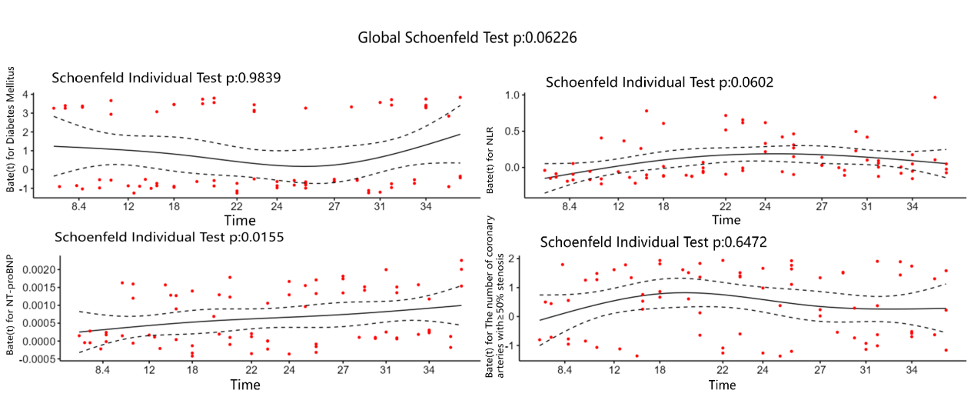

Supplemental Figure 2. Prediction of 2- and 3-year MACE in the training (A and B) and validation (C and D) cohorts. The net benefit rates were determined for the prediction nomogram and separate models for each of the four dependent variables ( diabetes mellitus, NLR, NT-proBNP and the number of coronary arteries with≥50% stenosis) in the training and independent external validation cohorts.
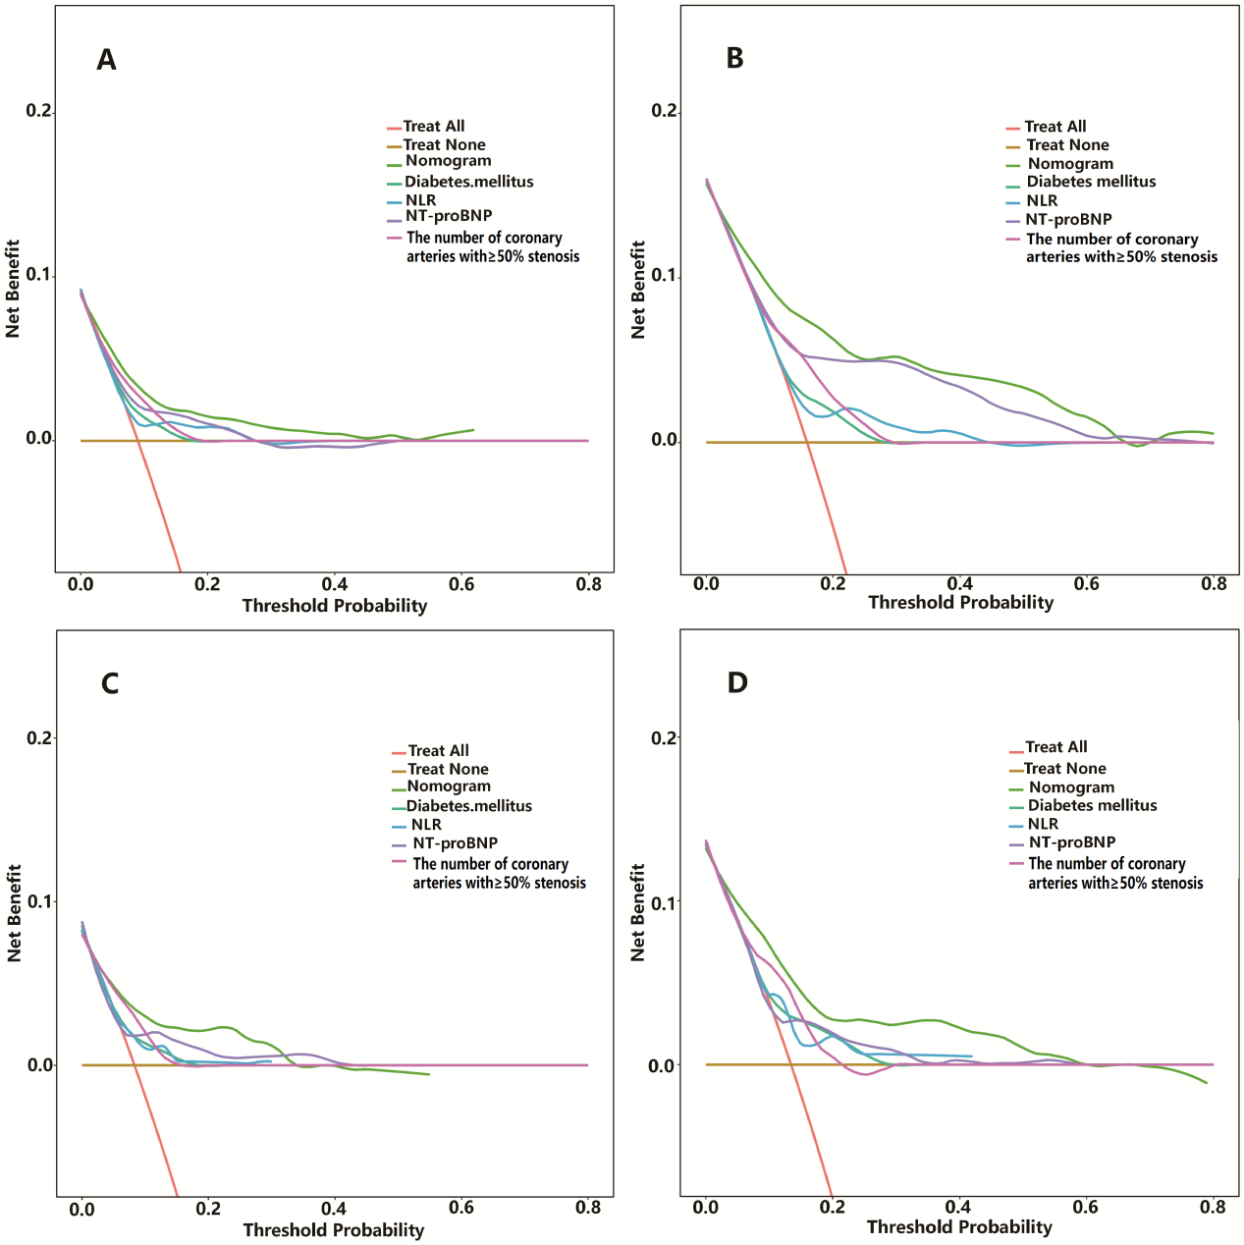

Supplemental Figure 3. MACE-free survival among high-risk and low-risk patient groups stratified by the median of nomogram score in the training (A) and independent external validation (B) cohorts.

Supplemental Figure 4. This webpage presents a web-based clinical decision support platform that implements our MACE prediction nomogram for patients with NSTE-ACS who also have concurrent mild to moderate aortic regurgitation.
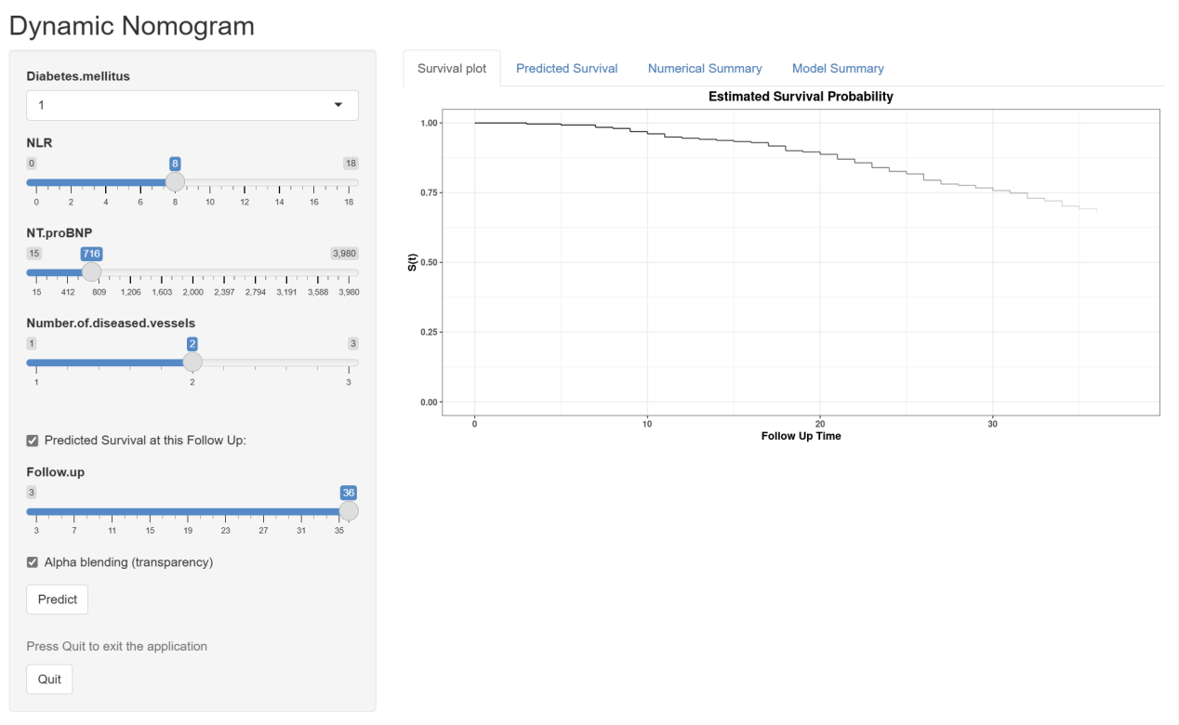

Supplemental Figure 5. ROC curve analysis comparing the predictive performance of the nomogram and the TIMI risk score for 2- and 3-year MACE prediction in the training cohort (A, C) and independent external validation cohort (B, D). The area under the curve (AUC) values are presented with 95% confidence intervals.

