Supplementary data

- Supplementary figures
- Supplementary tables

Supplementary figures:

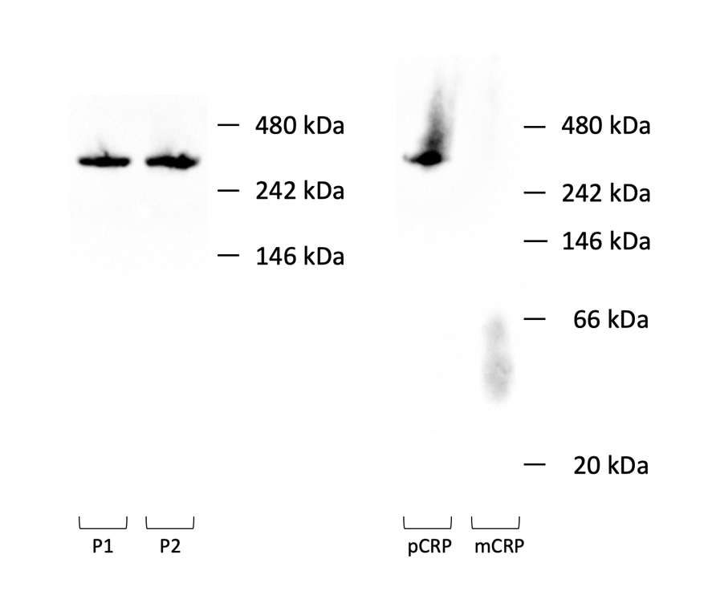
Fig. S1: Endogenous CRP from patient plasma is predominantly present in its pentameric form. Western blots of C-reactive protein (CRP) of patient 1 and 2 (P1, P2) separated by native blue polyacrylamide gel electrophoresis (BN-PAGE) (n = 2 out of n = 6). Human pentameric CRP (pCRP, Merck Millipore) was used as a positive control. pCRP was dissociated into monomeric CRP (mCRP) by urea and ethylenediaminetetraacetic acid (EDTA); kDa, kilodalton

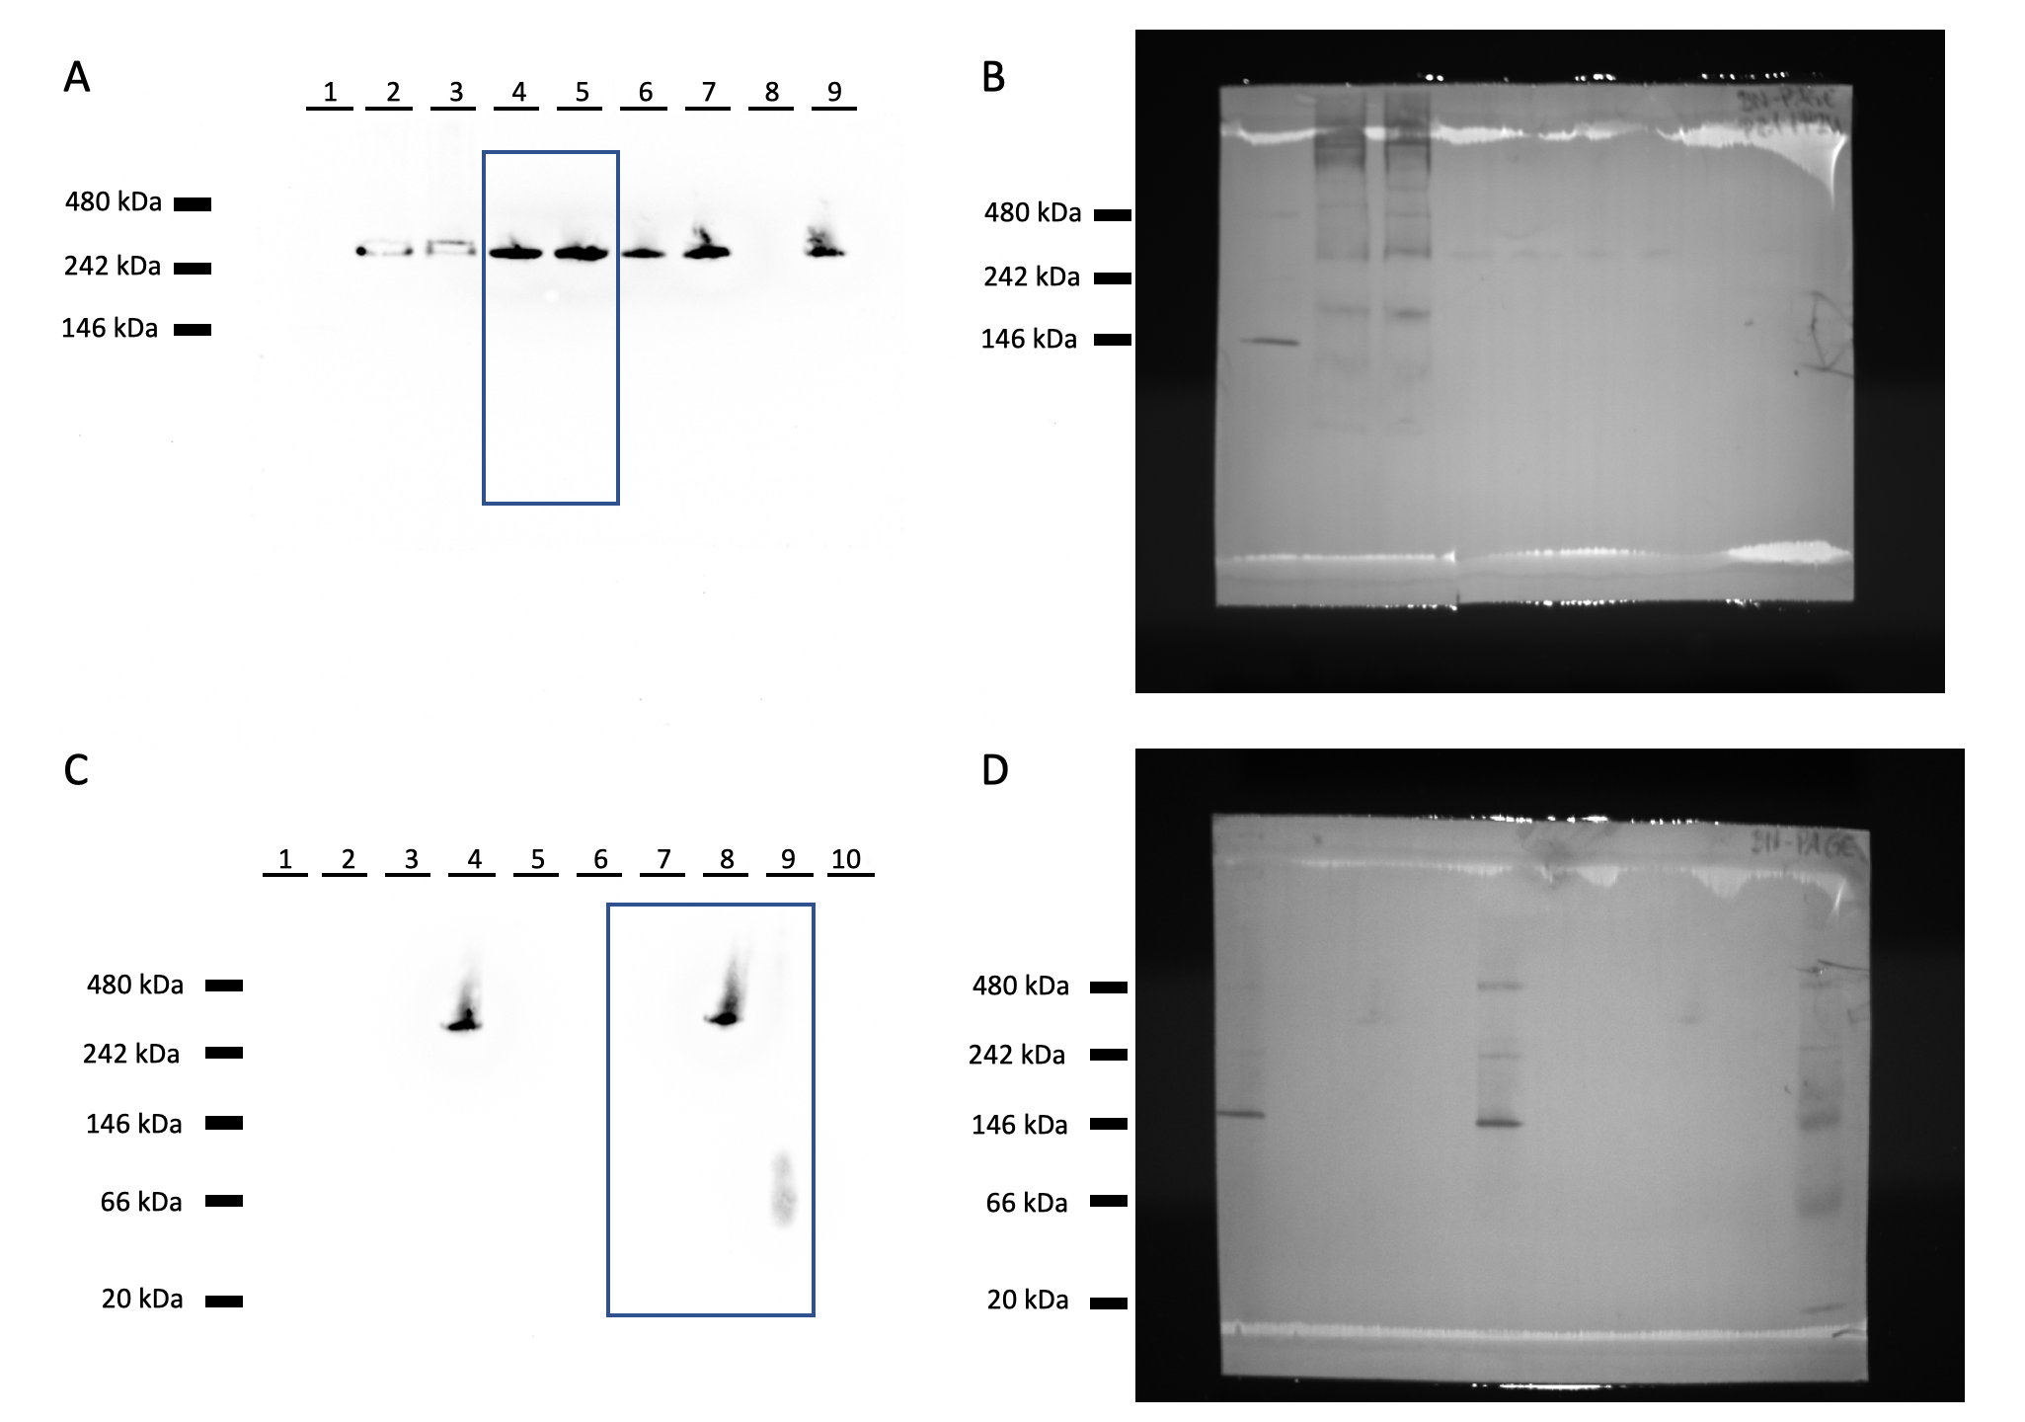
Fig. S2: Uncropped raw blots corresponding to Fig S1.
(A) Chemiluminescence image and (B) visible-light (RGB) marker image of the uncropped blot corresponding to the left panel of Fig. S1. The blue rectangle marks the region used in Fig. S1.
Samples for the native blot in (A) and (B) were loaded in the following order: 1 – molecular-weight marker; 2–3 – plasma from patients P1 and P2, respectively, each diluted to 0.3 µg CRP and supplemented with 0.001% SDS; 4–5 – CRP from P1 and P2, respectively, eluted after precipitation on PC-agarose, diluted to 0.3 µg CRP and supplemented with 0.001% SDS; 6–7 – ultrafiltrates of samples 4 and 5, respectively, obtained using an Amicon filter (3-kDa cutoff), adjusted to 0.3 µg CRP and supplemented with 0.001% SDS; 8–9 – 1:10 dilutions of samples 6 and 7, respectively.
Note: Migration in lane 8 was impaired due to a defect in the corresponding gel well.
(C) Chemiluminescence image and (D) visible-light (RGB) marker image of the uncropped blot corresponding to the right panel of Fig. S1. The blue rectangle indicates the region used in Fig. S1.
Samples for the native blot in (C) and (D) were loaded as follows: 1 – molecular-weight marker; 2–3 – blank lanes; 4 – pCRP preparation with Coomassie G-250; 5 – mCRP preparation with Coomassie G-250; 6 – molecular-weight marker; 7 – blank lane; 8 – nCRP preparation with SDS; 9 – mCRP preparation with SDS; 10 – molecular-weight marker.

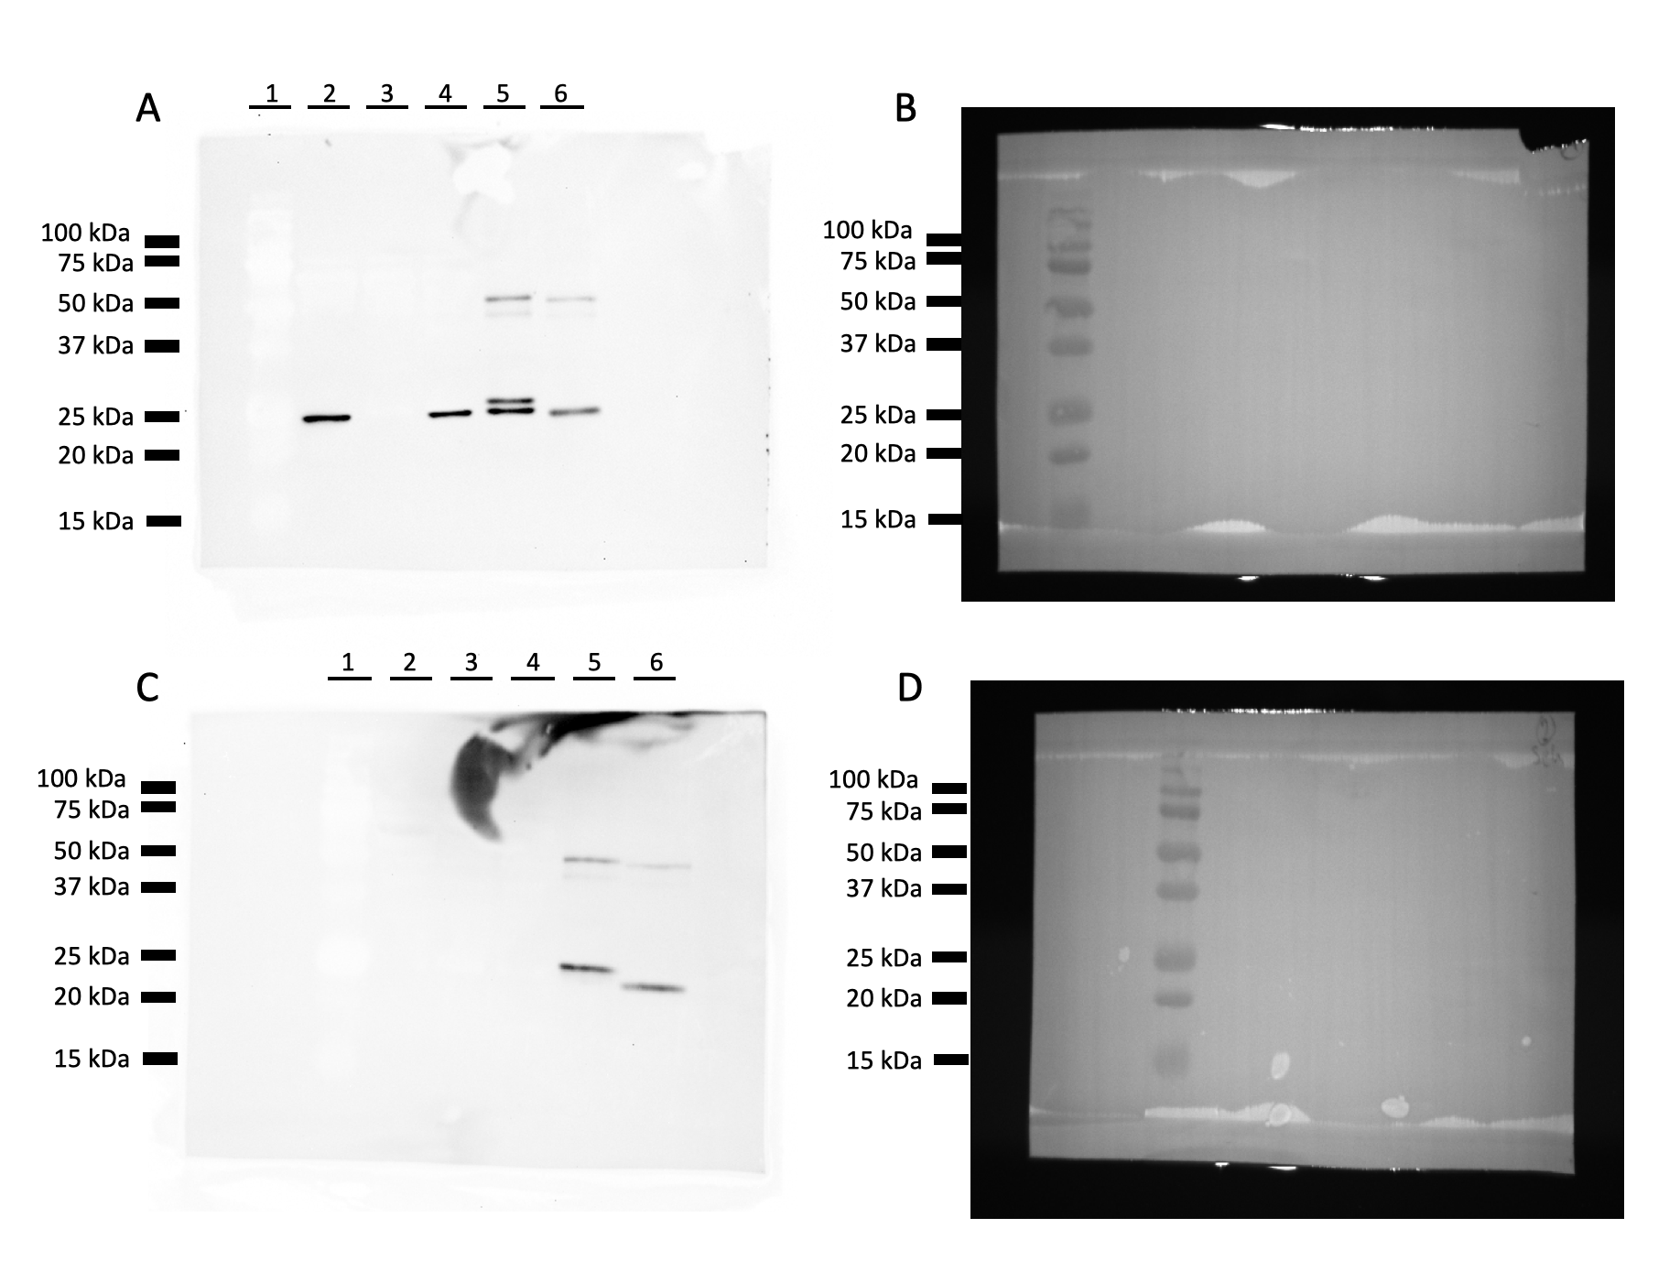
Fig. S3: Uncropped raw blots corresponding to Fig. 2.
(A) Chemiluminescence image and (B) visible-light (RGB) marker image of the uncropped blot corresponding to Figure 2, panel A. Sample loading was as follows: 1 – molecular-weight marker;
2 – untreated plasma; 3 – plasma after immunoprecipitation using anti-CRP antibodies; 4 – plasma after immunoprecipitation using irrelevant control IgG; 5 – immunoprecipitate obtained with anti-CRP antibodies; 6 – immunoprecipitate obtained with control IgG.
(C) Chemiluminescence image and (D) visible-light (RGB) marker image corresponding to Figure 2, panel B. The same samples in the same loading order (lanes 1–6) were applied as in panels A and B; however, primary antibodies were omitted during the Western blotting procedure to serve as a technical control.
Fig. S4: 3D representation of the in silico dockings of C-reactive protein (CRP) and phosphocholine, caffeine or paracetamol via DiffDock. Molecular docking was performed via DiffDock using the structure of one protomer of CRP as well as the structures of the ligands phosphocholine, caffeine and paracetamol. CRP-ligand conformations of the second and the third best rank of the confidence sores are depicted. The molecular docking results were visualized with UCSF Chimera (version 1.17.3).

Fig. S5: 3D representation of the in silico dockings of C-reactive protein (CRP) and phosphocholine, caffeine or paracetamol via AutoDock Vina. Molecular docking was performed via AutoDock Vina (SwissDock-Server) using the structure of one protomer of CRP as well as the structures of the ligands phosphocholine, caffeine and paracetamol. CRP-ligand conformations of the three best ranks of the confidence sores are depicted. The molecular docking results were visualized with UCSF Chimera (version 1.17.3).

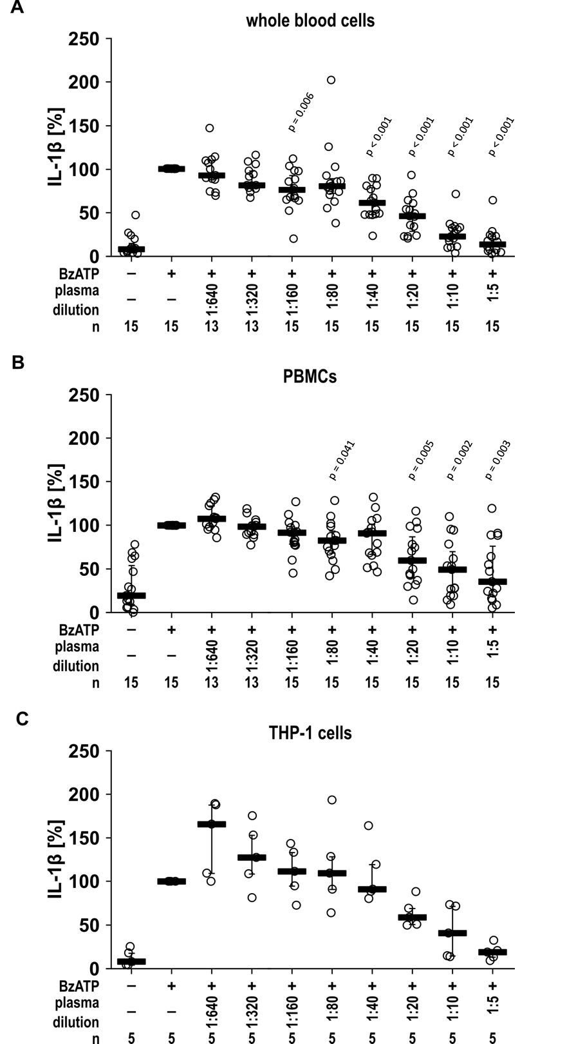
Fig. S6: Blood plasma obtained on postoperative day 2 dose-dependently inhibits the BzATP-induced release of IL-1β by autologous blood cells. Blood was drawn from patients on day 2 after elective visceral surgery to obtain blood plasma and cells. (A) Whole blood cells were primed with lipopolysaccharide (LPS; 5 ng/ml, 3 h) and stimulated with 2‘(3‘)-O-(4-benzoyl-benzoyl)adenosine-5‘-triphosphate (BzATP; 100 µM, 40 min). IL-1β levels in supernatants of whole blood cells amounted to a median of 4.74 µg/ml (minimum 1.00 µg/ml, maximum 11.58 µg/ml; n = 15). (B) Freshly isolated peripheral blood mononuclear cells (PBMCs; 5 x 10⁵ cells/0.15 ml) were primed with LPS (5 ng/ml, 3 h) and stimulated with BzATP (100 µM, 30 min). IL-1β levels in supernatants of PBMCs amounted to a median of 2.62 µg/ml (minimum 0.74 µg/ml, maximum 9.90 µg/ml; n = 15) (C) Monocytic THP-1 cells (2 x 10⁵ cells/0.15 ml) were primed with LPS (1 µg/ml, 5 h) and stimulated with BzATP (100 µM, 40 min). (A - C) Shortly before adding BzATP dilutions of autologous blood plasma was added to the cells. Interleukin-1β (IL-1β) in cell culture supernatants was quantified via ELISA. Significant p-values (p ≤ 0.05) are indicated in the figure (compared with cells treated with LPS and BzATP). Statistical significance was assessed using the Skillings–Mack test followed by pairwise Wilcoxon signed-rank tests with Holm correction for multiple comparisons. IL-1β concentrations in supernatants from cells treated with LPS & BzATP were set to 100% and all other data were calculated accordingly. Individual data points are depicted; bars indicate median and whiskers percentiles 25 and 75.

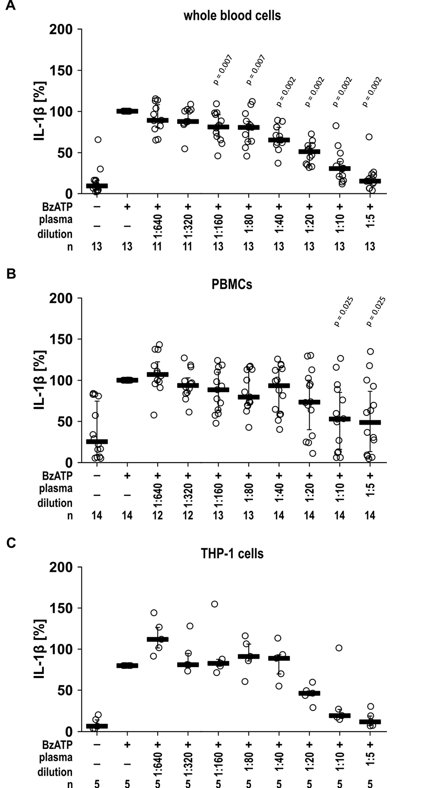
Fig. S7: Blood plasma obtained on postoperative day 5 dose-dependently inhibits the BzATP-induced release of IL-1β by autologous blood cells. Blood was drawn from patients on day 5 after elective visceral surgery to obtain blood plasma and cells. (A) Whole blood cells were primed with lipopolysaccharide (LPS; 5 ng/ml, 3 h) and stimulated with 2‘(3‘)-O-(4-benzoyl-benzoyl)adenosine-5‘-triphosphate (BzATP; 100 µM, 40 min). IL-1β levels in supernatants of whole blood cells amounted to a median of 6.55 µg/ml (minimum 0.35 µg/ml, maximum1.13 µg/ml; n = 13). (B) Freshly isolated peripheral blood mononuclear cells (PBMCs; 5 x 10⁵ cells/0.15 ml) were primed with LPS (5 ng/ml, 3 h) and stimulated with BzATP (100 µM, 30 min). IL-1β levels in supernatants of PBMCs amounted to a median of 3.25 µg/ml (minimum 0.10 µg/ml, maximum 7.26 µg/ml; n = 14) (C) Monocytic THP-1 cells (2 x 10⁵ cells/0.15 ml) were primed with LPS (1 µg/ml, 5 h) and stimulated with BzATP (100 µM, 40 min). (A - C) Shortly before adding BzATP dilutions of autologous blood plasma was added to the cells. Interleukin-1β (IL-1β) in cell culture supernatants was quantified via ELISA. Significant p-values (p ≤ 0.05) are indicated in the figure (compared with cells treated with LPS and BzATP). Statistical significance was assessed using the Skillings–Mack test followed by pairwise Wilcoxon signed-rank tests with Holm correction for multiple comparisons. IL-1β concentrations in supernatants from cells treated with LPS & BzATP were set to 100% and all other data were calculated accordingly. Individual data points are depicted; bars indicate median and whiskers percentiles 25 and 75.

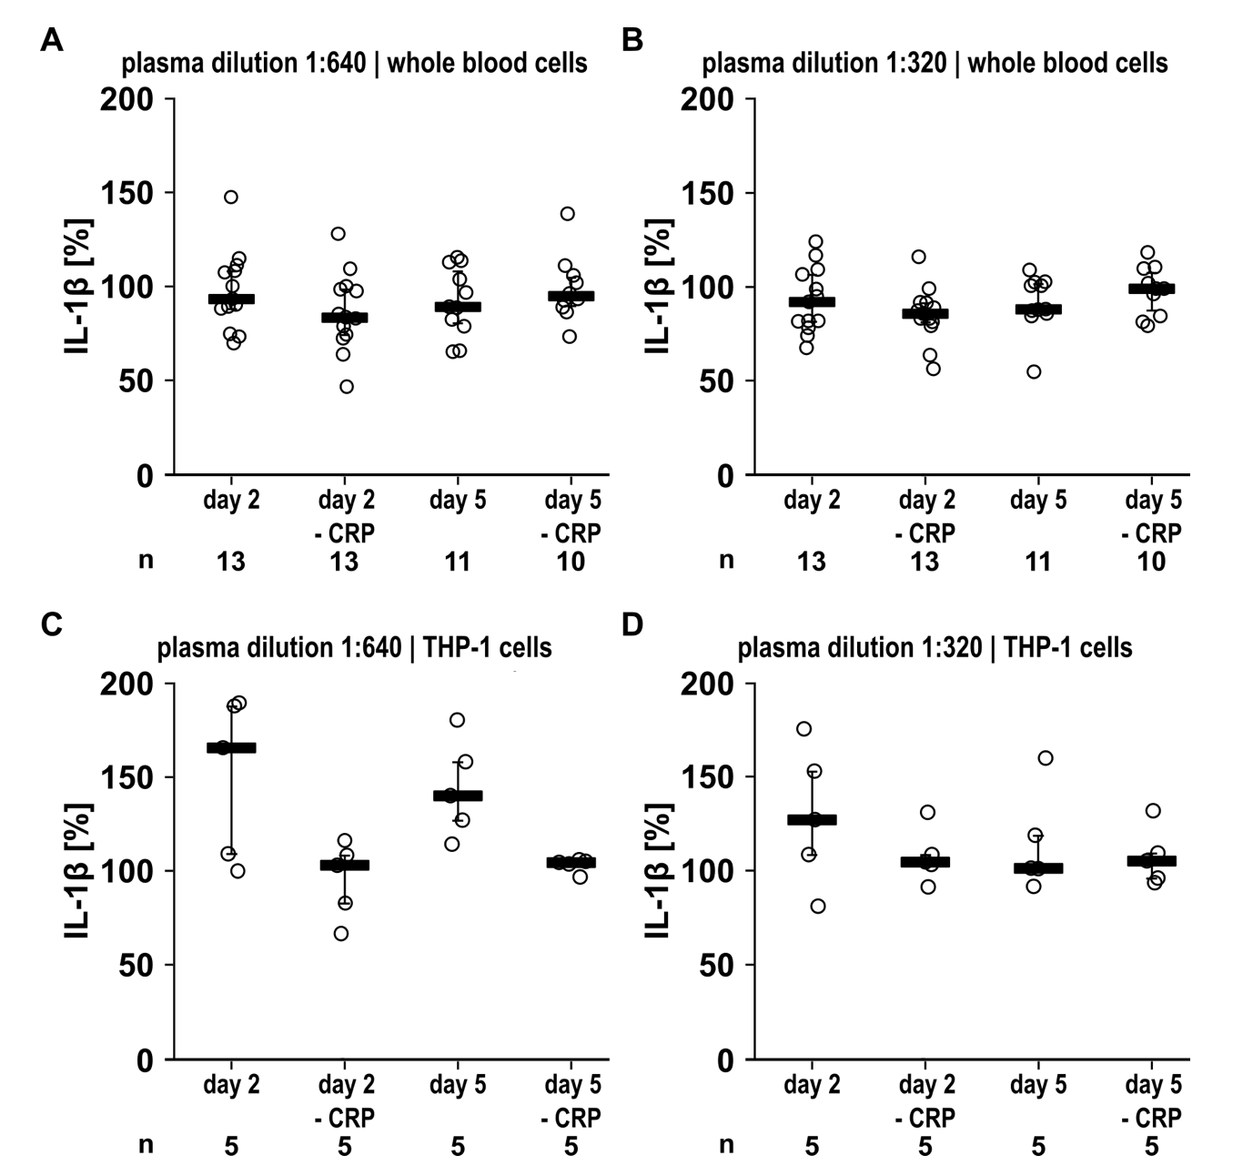
Fig. S8: Patient blood plasma inhibits IL-1β release by primary blood cells independent of CRP. Blood was drawn from patients on days 2 and 5 after elective visceral surgery to obtain blood plasma and cells. C-reactive protein (CRP) was depleted from the plasmas by immunoprecipitation (- CRP). (A, B) Whole blood cells were primed with lipopolysaccharide (LPS; 5 ng/ml, 3 h) and stimulated with 2‘(3‘)-O-(4-benzoyl-benzoyl)adenosine-5‘-triphosphate (BzATP; 100 µM, 40 min). (C, D) Monocytic THP-1 cells (2 x 10⁵/0,15 ml) were primed with LPS (1 µg/ml, 5 h) and stimulated with BzATP (100 µM, 40 min). Shortly before application of BzATP autologous native blood plasmas or plasmas depleted of CRP (- CRP) were added at dilutions of 1:640 (A, C) or 1:320 (B, D). Thereafter, interleukin-1β (IL-1β) was quantified in cell culture supernatants. IL-1β concentrations obtained after LPS-priming and stimulation with BzATP were set to 100% and all other data were calculated accordingly. Statistical analysis was performed using the Skillings–Mack or Friedman test, followed by pairwise Wilcoxon signed-rank tests. No statistically significant differences were observed between plasma and CRP-depleted plasma. Individual data points are depicted; bars indicate median and whiskers percentiles 25 and 75.

Fig. S9: Patient blood plasma inhibits IL-1β release by primary blood cells independent of CRP. Blood was drawn from patients on days 2 and 5 after elective visceral surgery to obtain blood plasma and cells. C-reactive protein (CRP) was depleted from the plasmas by immunoprecipitation (- CRP). (A, B) Whole blood cells were primed with lipopolysaccharide (LPS; 5 ng/ml, 3 h) and stimulated with 2‘(3‘)-O-(4-benzoyl-benzoyl)adenosine-5‘-triphosphate (BzATP; 100 µM, 40 min). (C, D) Monocytic THP-1 cells (2 x 10⁵/0.15 ml) were primed with LPS (1 µg/ml, 5 h) and stimulated with BzATP (100 µM, 40 min). Shortly before application of BzATP autologous native blood plasmas or plasmas depleted of CRP (- CRP) were added at dilutions of 1:160 (A, C) or 1:80 (B, D). Thereafter, interleukin-1β (IL-1β) was quantified in cell culture supernatants. IL-1β concentrations obtained after LPS-priming and stimulation with BzATP were set to 100% and all other data were calculated accordingly. Statistical analysis was performed using the Skillings–Mack or Friedman test, followed by pairwise Wilcoxon signed-rank tests. No statistically significant differences were observed between plasma and CRP-depleted plasma. Individual data points are depicted; bars indicate median and whiskers percentiles 25 and 75.

Fig. S10: Patient blood plasma inhibits IL-1β release by primary blood cells independent of CRP. Blood was drawn from patients on days 2 and 5 after elective visceral surgery to obtain blood plasma and cells. C-reactive protein (CRP) was depleted from the plasmas by immunoprecipitation (- CRP). (A) Whole blood cells were primed with lipopolysaccharide (LPS; 5 ng/ml, 3 h) and stimulated with 2‘(3‘)-O-(4-benzoyl-benzoyl)adenosine-5‘-triphosphate (BzATP; 100 µM, 40 min). (B) Monocytic THP-1 cells (2 x 10⁵/0.15 ml) were primed with LPS (1 µg/ml, 5 h) and stimulated with BzATP (100 µM, 40 min). Shortly before application of BzATP autologous native blood plasmas or plasmas depleted of CRP (- CRP) were added at dilutions of 1:10. Thereafter, interleukin-1β (IL-1β) was quantified in cell culture supernatants. IL-1β concentrations obtained after LPS-priming and stimulation with BzATP were set to 100% and all other data were calculated accordingly. Statistical analysis was performed using the Skillings–Mack or Friedman test, followed by pairwise Wilcoxon signed-rank tests. No statistically significant differences were observed between plasma and CRP-depleted plasma. Individual data points are depicted; bars indicate median and whiskers percentiles 25 and 75.

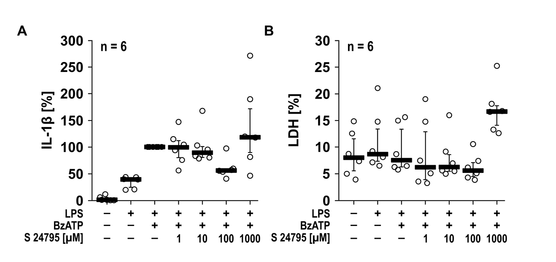
Fig. S11: Dose-dependent effect of S 24795 on BzATP-induced IL-1β release by monocytic THP-1 cells. Monocytic THP-1 cells (5 x 10⁵/0.5 ml) were primed with lipopolysaccharide (LPS; 1 µg/ml, 5 h) and stimulated with 2‘(3‘)-O-(4-benzoyl-benzoyl)adenosine-5‘-triphosphate (BzATP; 100 µM, 40 min). Interleukin-1β (IL-1β) was quantified in cell culture supernatants and lactate dehydrogenase (LDH) activity was measured. (A) IL-1β concentration in the cell culture supernatants after addition of S 24795 (1 - 1000 µM) shortly before stimulation with BzATP. (B) Corresponding LDH activity. Statistical analysis was performed using the Friedman test, followed by pairwise Wilcoxon signed-rank tests with Holm correction for multiple comparisons. Individual data points are depicted, bars indicate median and whiskers percentiles 25 and 75.

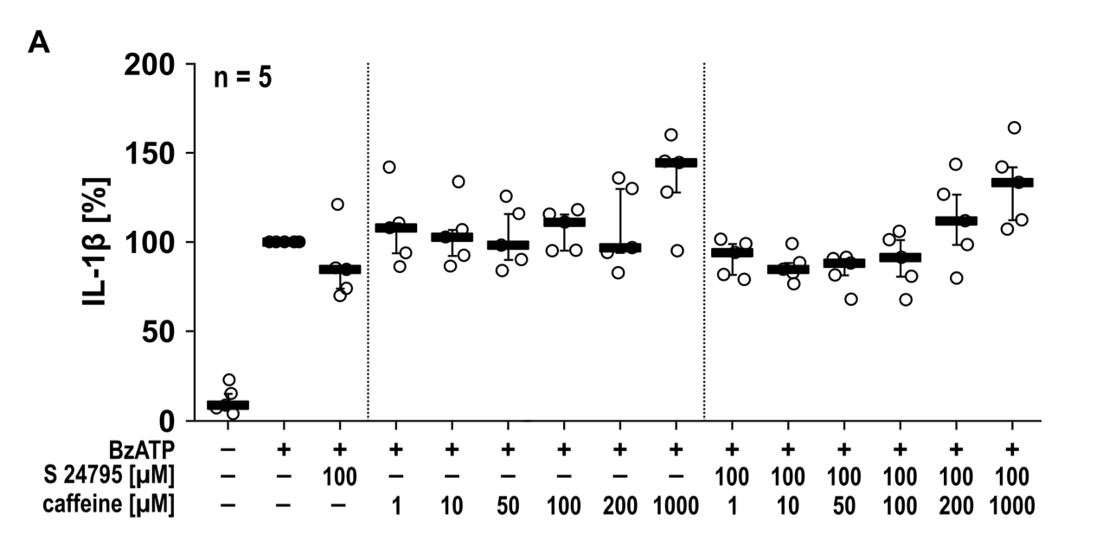
Fig S12: Dose-dependent effect of caffeine on the BzATP-induced IL-1β release by human PBMCs. Freshly isolated human peripheral blood mononuclear cells (PBMCs) from healthy volunteers were pulsed with lipopolysaccharide (LPS; 1 µg/ml, 3 h) and stimulated with 2‘(3‘)-O-(4-benzoyl-benzoyl)adenosine-5‘-triphosphate (BzATP; 100 µM, 30 min). Caffeine (1 - 1000 µM) or caffeine followed by S 24795 (100 µM) were added shortly before stimulation with BzATP. Interleukin-1β (IL-1β) was quantified in the cell culture supernatants. Statistical analysis was performed using the Friedman test, followed by pairwise Wilcoxon signed-rank tests with Holm correction for multiple comparisons. No statistically significant differences were observed. Individual data points are depicted, bars indicate median and whiskers percentiles 25 and 75.

Supplementary tables
Table S1. Clinical characteristics, medication prior to sampling, and UPLC-MS/MS findings of patients included in the CRP immunoprecipitation analysis.
Patient | Sampling  time point | CRP (mg/L) | Paracetamol administered before sampling | Last paracetamol dose (h) | Cumulative paracetamol dose  (24 h, g) | Administration  route | Paracetamol Area max.† | ICU stay (days) | Caffeine Area max.† | Other relevant medication
P1 | POD2 | 149.67 | Yes | 3.5 | 4 | IV | 3,020,731,916 | 3 | 3,023,597 | Acetylsalicylic acid, acetylcysteine, metamizole
P2 | POD2 | 67.16 | Yes | 1 | 3 | IV | 16,072,612,783 | 1 | 119,262,302 | Piritramide, metamizole, furosemide, acetylcysteine
P3 | POD2 | 226.15 | Yes | 3 | 2 | IV | 5,656,783,891 | 7 | 22,989,500 | Acetylcysteine, dimenhydrinate, dextromethorphan
P4 | POD2 | 119.12 | Yes | 5 | 3 | IV | 288,351,522 | 1 | 114,102 | Furosemide, candesartan, pancreatin, metamizole, acetylcysteine
P5 | POD2 | 182.15 | Yes | 7 | 1 | IV | 32,884,544 | 7 | 125,623,931 | Pantoprazole, amantadine, torasemide, noradrenaline, metamizole, piritramide
P6 | POD2 | 272.00 | Yes | 11 | 1 | IV | 26,087,630 | 1 | 581,200,456 | Pantoprazole, oxycodone/naloxone, hydrochlorothiazide, bisoprolol, amlodipine, metamizole, piritramide
P7 | POD2 | 137.51 | Yes | 3 | 1 | IV | 2,017,805,790 | 1 | 28,648,126 | Pantoprazole, piritramide
P1 | POD5 | 100.00 | Yes | 16 | 1 | IV | 535,055,656 | 3 | 519,516,481 | Acetylsalicylic acid, metamizole
P2 | POD5 | 10.32 | No | >48 | 0 | IV | 2,138,013 | 1 | 998,221,282 | Pantoprazole, pancreatin
P4 | POD5 | 8.53 | Yes | 23 | 1 | IV | 70,669,833 | 1 | 3,533,245 | Pantoprazole, oxycodone/naloxone, pancreatin, candesartan, acetylcysteine, metamizole
P6 | POD5 | 160.00 | Yes | 3 | 1 | IV | 2,371,979,397 | 1 | 20,183,023,844 | Furosemide, piperacillin/tazobactam, ramipril, hydrochlorothiazide, pantoprazole, amlodipine, zopiclone, metamizole
P7 | POD5 | 60.43 | Yes | 17 | 1 | IV | 225,392,959 | 1 | 2,990,474,926 | Metamizole, pantoprazole
CRP, C-reactive protein; IP, immunoprecipitate; IV, intravenous; POD, postoperative day.
† Area max. denotes the maximum chromatographic peak area (counts × seconds) reported by Compound Discoverer for a given compound across the analyzed input files. It represents the integrated extracted ion chromatographic signal and serves as a relative measure of compound abundance. Oral caffeine intake was routinely documented only during the ICU stay. Therefore, reliable information regarding caffeine exposure was available only for patients who remained in the ICU until the time of sampling. For patients transferred to the surgical ward before sampling, caffeine intake could not be assessed reliably from the medical records.

Table S2: Confidence scores of the interaction of ligands of C-reactive protein predicted by DiffDock web.
Ligand | Rank 1 | Rank 2 | Rank 3
Phosphocholine | 0.06 | 0.02 | -0.05
Caffeine | -0.51 | -0.51 | -0.51
Paracetamol | 0.24 | 0.23 | 0.23
Molecular docking was performed using one protomer of C-reactive protein (CRP; PDB-Code 1GNH, Chain A) as well as the simplified molecular input line entry system (SMILES) structure codes of the ligands phosphocholine (PubChem-ID 1014), caffeine (PubChem-ID 2519) and paracetamol (acetaminophen, PubChem-ID 1983). Rank 1 confidence scores are also reported in Table 3.
Table S3: Affinities [kcal/mol] of the interaction of ligands of C-reactive protein predicted by AutoDock Vina.
Ligand | Rank 1 | Rank 2 | Rank 3
Phosphocholine | -3.78 | -3.62 | -3.58
Caffeine | -4.32 | -4.18 | -4.13
Paracetamol | -4.53 | -4.33 | -4.17
Molecular docking was performed via using one protomer of C-reactive protein (CRP; PDB-Code 1GNH, Chain A) as well as the simplified molecular input line entry system (SMILES) structure codes of the ligands phosphocholine (PubChem-ID 1014), caffeine (PubChem-ID 2519) and paracetamol (acetaminophen, PubChem-ID 1983). Rank 1 affinities are also reported in Table 3.
Table S4: LDH activity in cell culture supernatants of patient PBMCs and monocytic THP-1 cells for estimation of cell death.
Figure | Cells; treatment | LDH activity [%]  median (min - max) | n
Figures 5 B, 6 C, 6 D | PBMCs; LPS | 3.0 (1.2 - 10.6) | 13
Figures 5 B, 6 C, 6 D | PBMCs; LPS, BzATP | 4.5 (0.7 - 14.1) | 13
Figures 5 B, 6 C, 6 D | PBMCs; LPS, BzATP, plasma preop 1:640 | 3.7 (0.0 - 13.4) | 12
Figures 5 B, 6 C, 6 D | PBMCs; LPS, BzATP, plasma preop 1:320 | 2.8 (0.0 - 11.9) | 12
Figures 5 B, 6 C, 6 D | PBMCs; LPS, BzATP, plasma preop 1:160 | 1.3 (0.0 - 15.8) | 12
Figures 5 B, 6 C, 6 D | PBMCs; LPS, BzATP, plasma preop 1:80 | 2.5 (0.0 - 11.7) | 12
Figures 5 B, 6 C, 6 D | PBMCs; LPS, BzATP, plasma preop 1:40 | 0.9 (0.0 - 12.8) | 13
Figures 5 B, 6 C, 6 D | PBMCs; LPS, BzATP, plasma preop 1:20 | 2.6 (0.0 - 12.0) | 13
Figures 5 B, 6 C, 6 D | PBMCs; LPS, BzATP, plasma preop 1:10 | 2.2 (0.0 - 12.0) | 13
Figures 5 B, 6 C, 6 D | PBMCs; LPS, BzATP, plasma preop 1:5 | 0.0 (0.0 - 23.4) | 13
Figures 5 B, 6 C, 6 D | PBMCs; LPS, BzATP, plasma preop 1:640 + PC 1 µM | 0.6 (0.0 - 9.7) | 11
Figures 5 B, 6 C, 6 D | PBMCs; LPS, BzATP, plasma preop 1:320 + PC 1 µM | 1.3 (0.0 - 9.3) | 11
Figures 5 B, 6 C, 6 D | PBMCs; LPS, BzATP, plasma preop 1:160 + PC 1 µM | 0.7 (0.0 - 10.6) | 11
Figures 5 B, 6 C, 6 D | PBMCs; LPS, BzATP, plasma preop 1:80 + PC 1 µM | 0.8 (0.0 - 13.1) | 11
Figures 5 B, 6 C, 6 D | PBMCs; LPS, BzATP, plasma preop 1:40 + PC 1 µM | 1.9 (0.0 - 11.9) | 11
Figures 5 B, 6 C, 6 D | PBMCs; LPS, BzATP, plasma preop 1:20 + PC 1 µM | 0.0 (0.0 - 12.5) | 11
Figures 5 B, 6 C, 6 D | PBMCs; LPS, BzATP, plasma preop 1:10 + PC 1 µM | 0.0 (0.0 - 10.3) | 11
Figures 5 B, 6 C, 6 D | PBMCs; LPS, BzATP, plasma preop 1:5 + PC 1 µM | 0.0 (0.0 - 14.2) | 11
Figures 6 C, 6 D, S3 B | PBMCs; LPS | 6.2 (1.6 - 18.3) | 13
Figures 6 C, 6 D, S3 B | PBMCs; LPS, BzATP | 5.3 (0.3 - 13.0) | 13
Figures 6 C, 6 D, S3 B | PBMCs; LPS, BzATP, plasma POD2 1:640 | 1.8 (0.0 - 14.2) | 13
Figures 6 C, 6 D, S3 B | PBMCs; LPS, BzATP, plasma POD2 1:320 | 5.1 (0.0 - 15.9) | 13
Figures 6 C, 6 D, S3 B | PBMCs; LPS, BzATP, plasma POD2 1:160 | 4.1 (0.0 - 12.1) | 14
Figures 6 C, 6 D, S3 B | PBMCs; LPS, BzATP, plasma POD2 1:80 | 6.5 (0.0 - 18.6) | 14
Figures 6 C, 6 D, S3 B | PBMCs; LPS, BzATP, plasma POD2 1:40 | 3.9 (0.0 - 31.1) | 14
Figures 6 C, 6 D, S3 B | PBMCs; LPS, BzATP, plasma POD2 1:20 | 1.9 (0.0 - 24.1) | 14
Figures 6 C, 6 D, S3 B | PBMCs; LPS, BzATP, plasma POD2 1:10 | 0.1 (0.0 - 10.9) | 14
Figures 6 C, 6 D, S3 B | PBMCs; LPS, BzATP, plasma POD2 1:5 | 0.0 (0.0 - 18.0) | 14
Figures 6 C, 6 D, S3 B | PBMCs; LPS, BzATP, plasma POD2 1:640 + PC 1 µM | 2.5 (0.0 - 9.3) | 13
Figures 6 C, 6 D, S3 B | PBMCs; LPS, BzATP, plasma POD2 1:320 + PC 1 µM | 1.5 (0.0 - 13.2) | 13
Figures 6 C, 6 D, S3 B | PBMCs; LPS, BzATP, plasma POD2 1:160 + PC 1 µM | 4.6 (0.0 - 15.9) | 14
Figures 6 C, 6 D, S3 B | PBMCs; LPS, BzATP, plasma POD2 1:80 + PC 1 µM | 6.0 (0.0 - 23.6) | 14
Figures 6 C, 6 D, S3 B | PBMCs; LPS, BzATP, plasma POD2 1:40 + PC 1 µM | 5.5 (0.0 - 23.8) | 14
Figures 6 C, 6 D, S3 B | PBMCs; LPS, BzATP, plasma POD2 1:20 + PC 1 µM | 2.5 (0.0 - 14.5) | 14
Figures 6 C, 6 D, S3 B | PBMCs; LPS, BzATP, plasma POD2 1:10 + PC 1 µM | 0.0 (0.0 - 8.1) | 14
Figures 6 C, 6 D, S3 B | PBMCs; LPS, BzATP, plasma POD2 1:5 + PC 1 µM | 0.0 (0.0 - 15.6) | 14
Figures 6 C, 6 D, S4 B | PBMCs; LPS | 3.7 (1.1 - 9.4) | 11
Figures 6 C, 6 D, S4 B | PBMCs; LPS, BzATP | 4.6 (0.5 - 14.1) | 11
Figures 6 C, 6 D, S4 B | PBMCs; LPS, BzATP, plasma POD5 1:640 | 2.7 (0.0 - 15.4) | 11
Figures 6 C, 6 D, S4 B | PBMCs; LPS, BzATP, plasma POD5 1:320 | 3.5 (0.0 - 19.4) | 11
Figures 6 C, 6 D, S4 B | PBMCs; LPS, BzATP, plasma POD5 1:160 | 7.3 (0.0 - 25.2) | 11
Figures 6 C, 6 D, S4 B | PBMCs; LPS, BzATP, plasma POD5 1:80 | 2.9 (0.0 - 19.4) | 11
Figures 6 C, 6 D, S4 B | PBMCs; LPS, BzATP, plasma POD5 1:40 | 7.1 (0.0 - 20.6) | 12
Figures 6 C, 6 D, S4 B | PBMCs; LPS, BzATP, plasma POD5 1:20 | 3.7 (0.0 - 25.2) | 12
Figures 6 C, 6 D, S4 B | PBMCs; LPS, BzATP, plasma POD5 1:10 | 1.8 (0.0 - 24.6) | 12
Figures 6 C, 6 D, S4 B | PBMCs; LPS, BzATP, plasma POD5 1:5 | 0.0 (0.0 - 12.3) | 12
Figures 6 C, 6 D, S4 B | PBMCs; LPS, BzATP, plasma POD5 1:640 + PC 1 µM | 2.9 (0.0 - 11.4) | 11
Figures 6 C, 6 D, S4 B | PBMCs; LPS, BzATP, plasma POD5 1:320 + PC 1 µM | 1.2 (0.0 - 12.8) | 11
Figures 6 C, 6 D, S4 B | PBMCs; LPS, BzATP, plasma POD5 1:160 + PC 1 µM | 3.4 (0.0 - 21.7) | 11
Figures 6 C, 6 D, S4 B | PBMCs; LPS, BzATP, plasma POD5 1:80 + PC 1 µM | 1.7 (0.0 - 18.9) | 11
Figures 6 C, 6 D, S4 B | PBMCs; LPS, BzATP, plasma POD5 1:40 + PC 1 µM | 3.6 (0.0 - 18.3) | 11
Figures 6 C, 6 D, S4 B | PBMCs; LPS, BzATP, plasma POD5 1:20 + PC 1 µM | 3.0 (0.0 - 24.0) | 11
Figures 6 C, 6 D, S4 B | PBMCs; LPS, BzATP, plasma POD5 1:10 + PC 1 µM | 0.0 (0.0 - 12.7) | 11
Figures 6 C, 6 D, S4 B | PBMCs; LPS, BzATP, plasma POD5 1:5 + PC 1 µM | 0.0 (0.0 - 24.0) | 11
Figure 8 A | THP-1; untreated | 7.0 (4.0 - 14.3) | 12
Figure 8 A | THP-1; LPS | 7.7 (3.5 - 17) | 12
Figure 8 A | THP-1; LPS, BzATP | 7.2 (3.0 - 15.1) | 12
Figure 8 A | THP-1; LPS, BzATP, S 24795 100 µM | 6.4 (2.2 - 13.2) | 12
Figure 8 A | THP-1; LPS, BzATP, caffeine 1 µM | 12.4 (2.8 - 15.8) | 6
Figure 8 A | THP-1; LPS, BzATP, caffeine 10 µM | 12.5 (3.1 - 14.9) | 6
Figure 8 A | THP-1; LPS, BzATP, caffeine 50 µM | 13.3 (4.0 - 14.9) | 6
Figure 8 A | THP-1; LPS, BzATP, caffeine 100 µM | 12.4 (5.3 - 15.2) | 6
Figure 8 A | THP-1; LPS, BzATP, caffeine 200 µM | 12.2 (3.1 - 15.8) | 6
Figure 8 A | THP-1; LPS, BzATP, S 24795 100 µM, caffeine 1 mM | 11.0 (1.1 - 12.8) | 6
Figure 8 A | THP-1; LPS, BzATP, S 24795 100 µM, caffeine 1 µM | 4.7 (2.2 - 7.1) | 6
Figure 8 A | THP-1; LPS, BzATP, S 24795 100 µM, caffeine 10 µM | 5.7 (3.1 - 7.2) | 6
Figure 8 A | THP-1; LPS, BzATP, S 24795 100 µM, caffeine 50 µM | 5.6 (3.0 - 6.9) | 6
Figure 8 A | THP-1; LPS, BzATP, S 24795 100 µM, caffeine 100 µM | 5.6 (4.9 - 7.2) | 6
Figure 8 A | THP-1; LPS, BzATP, S 24795 100 µM, caffeine 200 µM | 3.5 (2.7 - 5.5) | 6
Figure 8 A | THP-1; LPS, BzATP, S 24795 100 µM, caffeine 1 mM | 2.8 (2.2 - 3.2) | 6
Figure 8 B | THP-1; untreated | 9.5 (5.0 - 13.0) | 6
Figure 8 B | THP-1; LPS | 9.0 (5.0 - 10.0) | 6
Figure 8 B | THP-1; LPS, paracetamol 200 µg/ml | 6.0 (4.0 - 9.0) | 6
Figure 8 B | THP-1; LPS, BzATP | 7.8 (4.5 - 11.0) | 6
Figure 8 B | THP-1; LPS, BzATP, S 24795 100 µg/ml | 7.3 (4.5 - 10.5) | 6
Figure 8 B | THP-1; LPS, BzATP, paracetamol 1 µg/ml | 8.0 (6.0 - 11.0) | 6
Figure 8 B | THP-1; LPS, BzATP, paracetamol 10 µg/ml | 6.5 (6.0 - 10.0) | 6
Figure 8 B | THP-1; LPS, BzATP, paracetamol 20 µg/ml | 8.5 (4.0 - 11.0) | 6
Figure 8 B | THP-1; LPS, BzATP, paracetamol 50 µg/ml | 7.0 (6.0 - 10.0) | 6
Figure 8 B | THP-1; LPS, BzATP, paracetamol 100 µg/ml | 4.5 (3.0 - 9.0) | 6
Figure 8 B | THP-1; LPS, BzATP, S 24795 100 µM, paracetamol 200 µg/ml | 2.5 (1.0 - 6.0) | 6
Figure 8 B | THP-1; LPS, BzATP, S 24795 100 µM, paracetamol 1 µg/ml | 8.5 (4.0 - 14.0) | 6
Figure 8 B | THP-1; LPS, BzATP, S 24795 100 µM, paracetamol 10 µg/ml | 9.0 (5.0 - 13.0) | 6
Figure 8 B | THP-1; LPS, BzATP, S 24795 100 µM, paracetamol 20 µg/ml | 7.5 (5.0 - 11.0) | 6
Figure 8 B | THP-1; LPS, BzATP, S 24795 100 µM, paracetamol 50 µg/ml | 6.0 (3.0 - 12.0) | 6
Figure 8 B | THP-1; LPS, BzATP, S 24795 100 µM, paracetamol 100 µg/ml | 5.5 (2.0 - 7.0) | 6
Figure 8 B | THP-1; LPS, BzATP, S 24795 100 µM, paracetamol 200 µg/ml | 2.5 (1.0 - 4.0) | 6
Figure S9 | THP-1; LPS | 1.0 (0.0 - 2.4) | 5
Figure S9 | THP-1; LPS, BzATP | 2.0 (0.3 - 2.7) | 5
Figure S9 | THP-1; LPS, BzATP, S 24795 100 µM | 2.0 (0.3 - 2.1) | 5
Figure S9 | THP-1; LPS, BzATP, caffeine 1 µM | 2.0 (0.4 - 3.0) | 5
Figure S9 | THP-1; LPS, BzATP, caffeine 10 µM | 2.0 (0.4 - 3.0) | 5
Figure S9 | THP-1; LPS, BzATP, caffeine 50 µM | 2.0 (0.5 - 3.0) | 5
Figure S9 | THP-1; LPS, BzATP, caffeine 100 µM | 2.0 (0.4 - 2.7) | 5
Figure S9 | THP-1; LPS, BzATP, caffeine 200 µM | 2.0 (0.3 - 3.3) | 5
Figure S9 | THP-1; LPS, BzATP, S 24795 100 µM, caffeine 1 mM | 1.0 (0.2 - 3.0) | 5
Figure S9 | THP-1; LPS, BzATP, S 24795 100 µM, caffeine 1 µM | 2.0 (0.4 - 3.4) | 5
Figure S9 | THP-1; LPS, BzATP, S 24795 100 µM, caffeine 10 µM | 2.0 (0.3 - 3.1) | 5
Figure S9 | THP-1; LPS, BzATP, S 24795 100 µM, caffeine 50 µM | 2.0 (0.3 - 5.0) | 5
Figure S9 | THP-1; LPS, BzATP, S 24795 100 µM, caffeine 100 µM | 2.0 (0.3 - 2.9) | 5
Figure S9 | THP-1; LPS, BzATP, S 24795 100 µM, caffeine 200 µM | 2.0 (0.4 - 3.1) | 5
Figure S9 | THP-1; LPS, BzATP, S 24795 100 µM, caffeine 1 mM | 1.0 (0.3 - 3.3) | 5
Peripheral blood mononuclear cells (PBMCs) from patient blood samples were pulsed with lipopolysaccharide (LPS, 5 ng/ml) and cultured for 3 hours (5 x 10⁵ cells/0.15 ml) before stimulation with 2’(3’)-O-(4-benzoylbenzoyl)adenosine-5’-triphosphate (BzATP, 100 µM) for another 30 minutes. Monocytic THP-1 cells (2 x 10⁵ cells/0.15 ml; 5 x 10⁵ cells/0.5 ml) were primed with LPS (1 µg/ml, 5 h) and further stimulated with BzATP (100 µM, 40 min). Shortly before stimulation with BzATP, cells were treated according to the treatment listed in this table. LDH activity was measured in the cell culture supernatants. The data shown in this table correspond to the experiments shown in the respective figures. n, number of individual experiments; PC, phosphocholine; POD, postoperative day; preop, preoperative; S 24795, 2-[2-(4-bromophenyl)-2-oxoethyl]-1-methylpyridinium iodide.

