Supplementary Figure S1. RCS Curves of ALB and GLB with HHcy Risk.
(A–C) ALB and (D–F) GLB associations with HHcy across unadjusted, partially adjusted, and fully adjusted models. Solid lines represent odds ratios; shaded areas indicate 95% confidence intervals. P-values for nonlinearity are displayed.
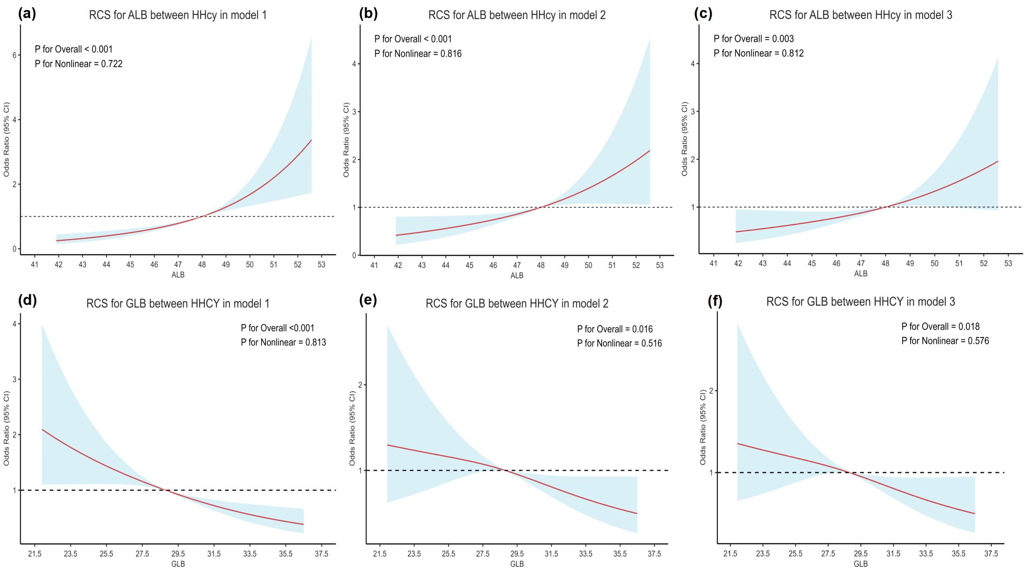
Supplementary Figure S2. Subgroup Analysis by Age.
RCS curves for ALB (A–C) and GLB (D–F) associations with HHcy risk stratified by age groups: 20–29, 30–39, and ≥40 years.
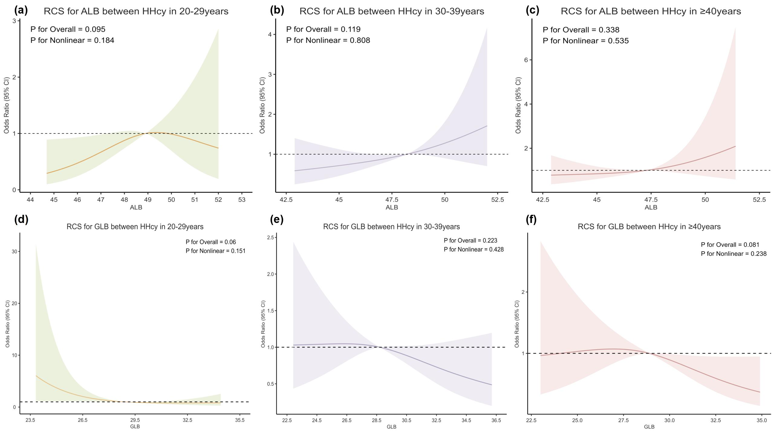
Supplementary Figure S3. Subgroup Analyses by Metabolic Status and Sex.
RCS curves depicting associations in subgroups defined by dyslipidemia (A–D), hyperuricemia (E–H), and sex (I–L).
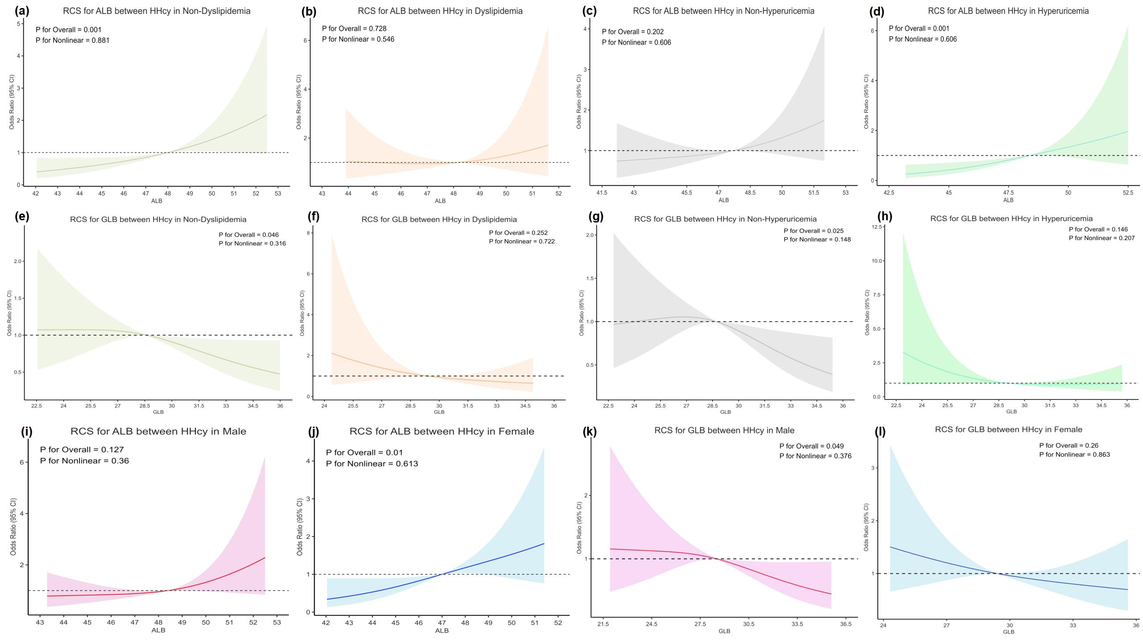
Supplementary Figure S4. Random Forest Variable Importance.
Variable importance ranked by mean decrease in Gini impurity and accuracy. Sex, eGFR, and ALB identified as top predictors.
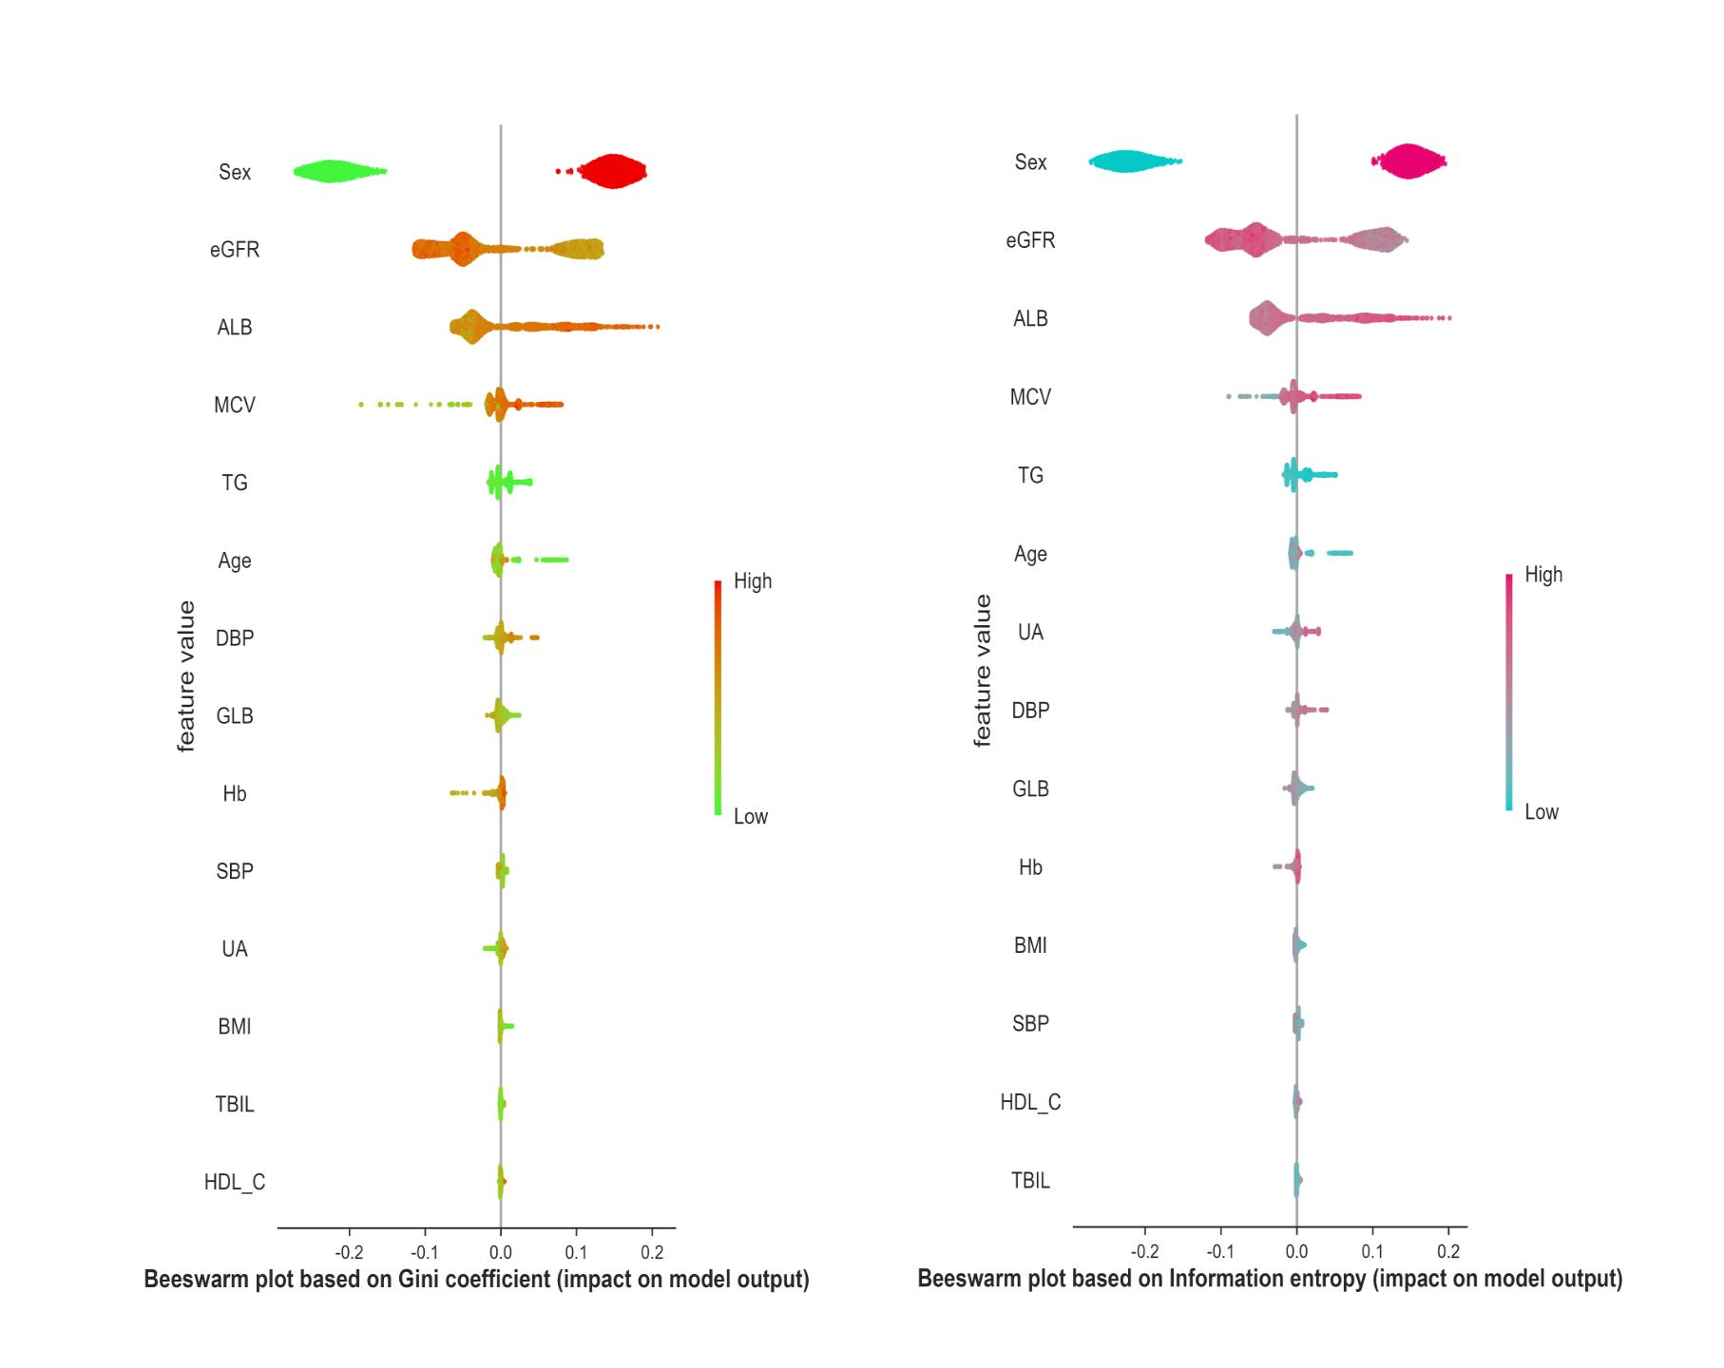
Supplementary Figure S5. Boruta Algorithm Feature Selection.
- scores boxplot identifying important predictors (red): eGFR, Sex, Hb, UA, ALB, DBP, Age, GLB, MCV, TBIL, SBP, and BMI. Shadow features (green/blue) define the decision boundary.
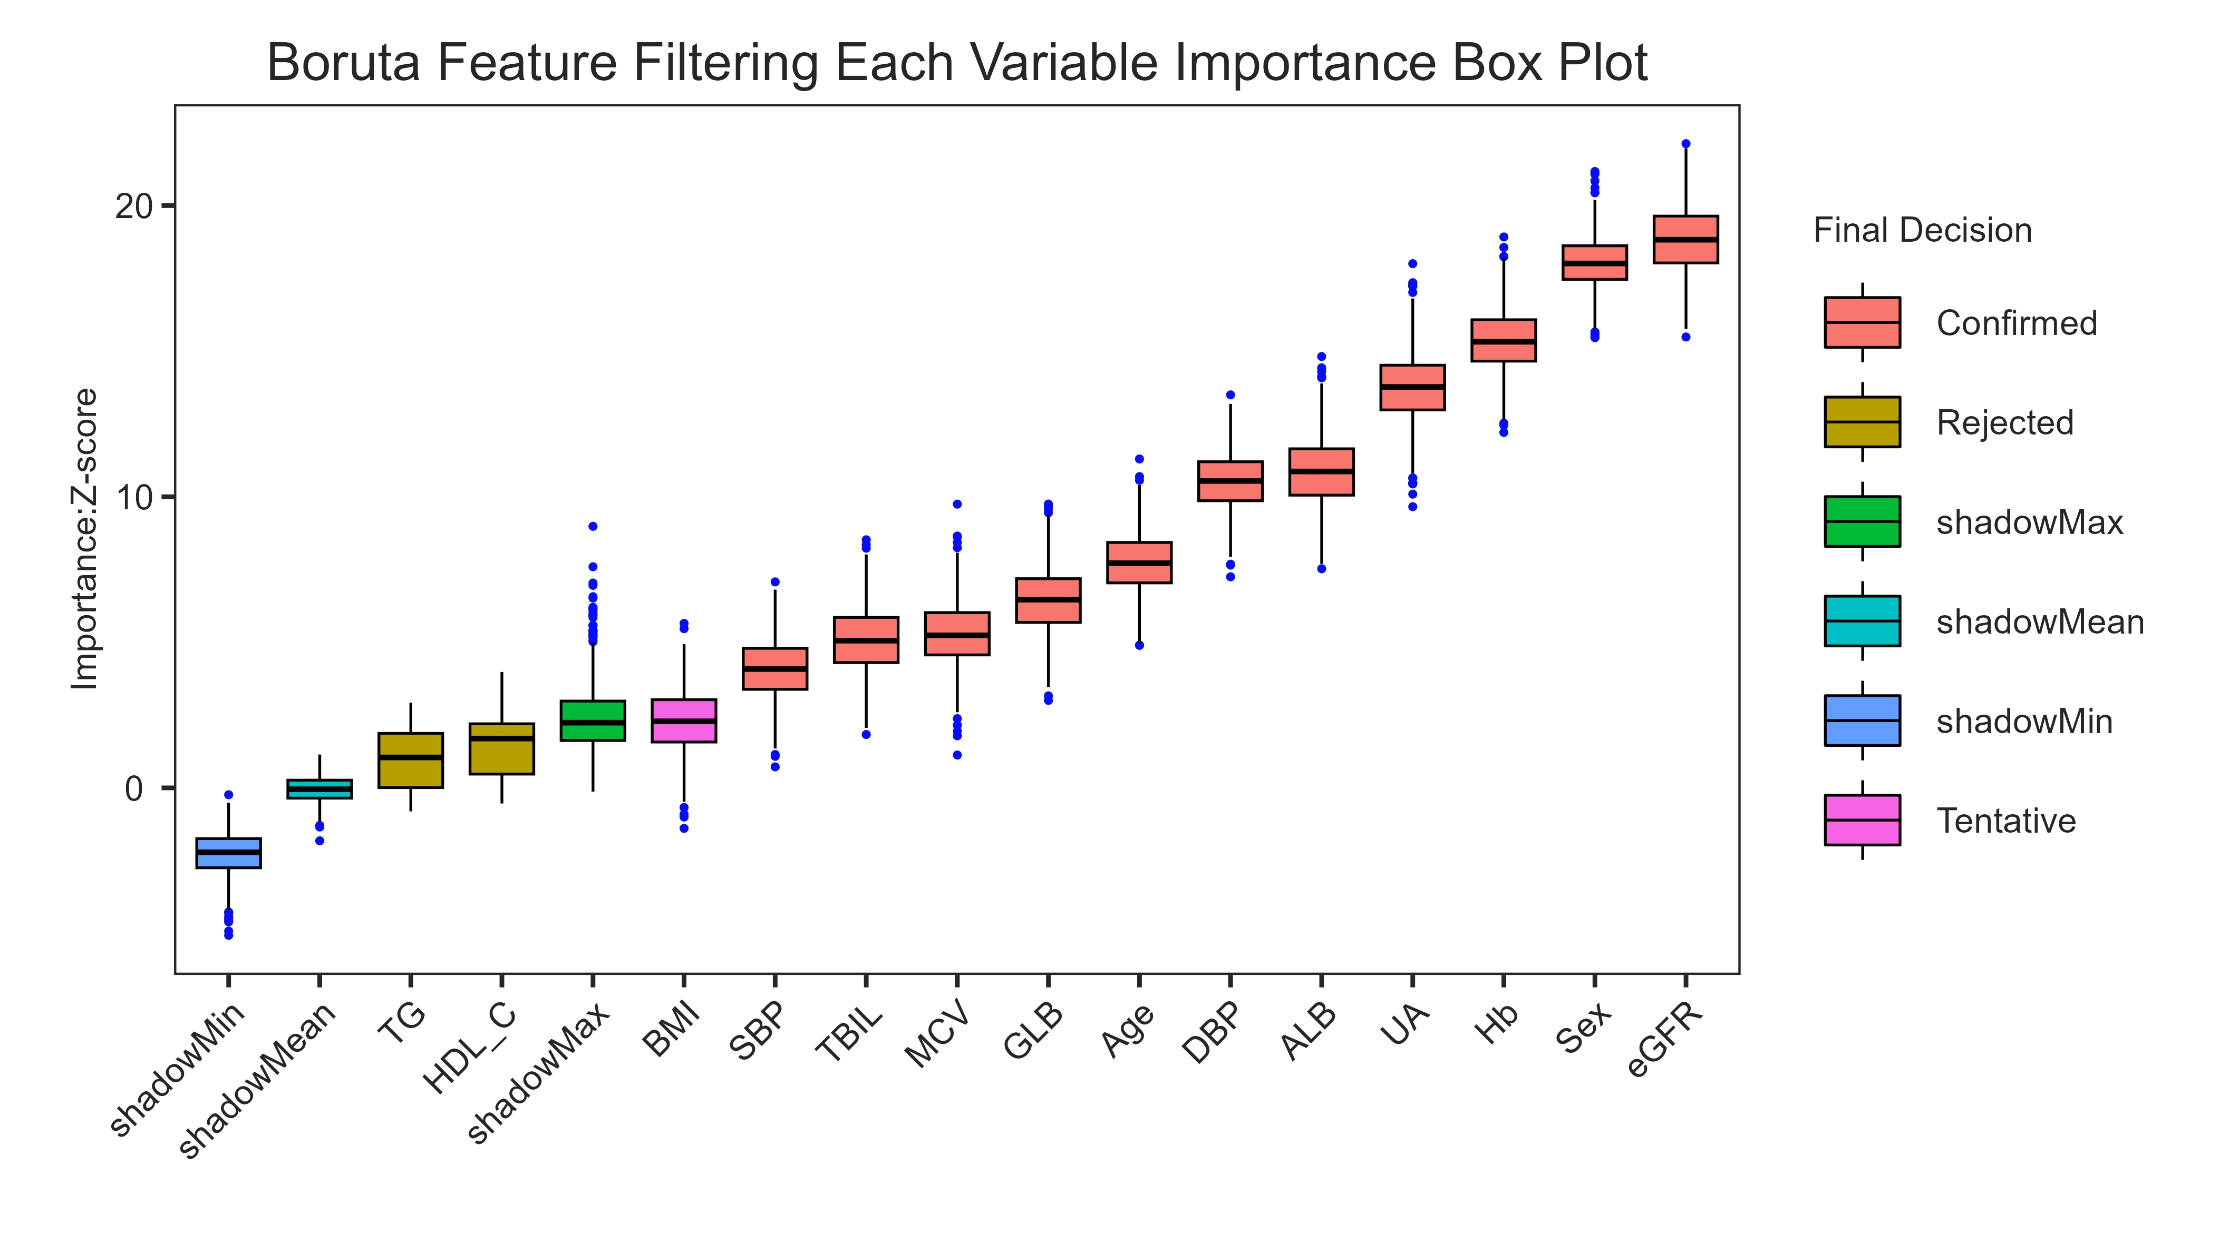
Supplementary Figure S6. Logistic Regression Performance.
- ROC curves for training and test sets demonstrating consistency without overfitting. (B) Performance metrics including precision, accuracy, recall, and F1-score.
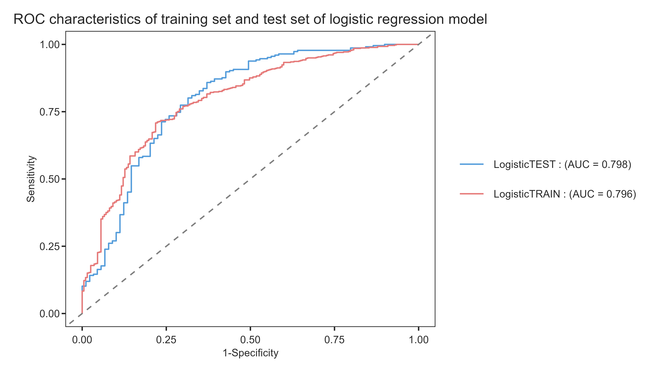

Supplementary Table S1. Relationship of GLB Index with HHcy group
 |  | model 1 |  | model 2 |  | model 3
 |  | OR (95% CI) | P - value | OR (95% CI) | P - value | OR (95% CI) | P - value
GLB |  | 0.91(0.87,0.94) | <0.001 | 0.94(0.91,0.99) | 0.009 | 0.94(0.89,0.98) | 0.006
Q1 | 24.90±1.52 | reference |  | reference |  | reference
Q2 | 27.83±0.67 | 0.62(0.41,0.94) | 0.027 | 0.82(0.51,1.31) | 0.414 | 0.78(0.48,1.24) | 0.291
Q3 | 30.07±0.70 | 0.50(0.33,0.75) | <0.001 | 0.62(0.39,0.99) | 0.048 | 0.62(0.39,0.99) | 0.048
Q4 | 33.82±2.64 | 0.36(0.24,0.54) | <0.001 | 0.57(0.36,0.90) | 0.017 | 0.55(0.35,0.89) | 0.014
P for trend |  | <0.001 |  | 0.008 |  | 0.009
95% CI: 95% confidence interval
Model 1: no covariates were adjusted
Model 2: adjusted for Age、Sex、BMI、SBP、DBP、ALB、eGFR
Model 3:Additionally adjusted for SUA、MCV、Hb、TG、HDL-C、TBIL

Supplementary Table S2. Comparison of characteristics between training and test set
Variable Names | Overall | Training set | Test set | P
N | 1050 | 735 | 315
Age (year) | 36.00 (30.00 - 43.00) | 36.00 (30.00 - 43.00) | 35.00 (31.00 - 43.00) | 0.964
Age group |  |  |  | 0.340
20-29years | 226.00 (21.52%) | 163.00 (22.18%) | 63.00 (20.00%)
30-39years | 464.00 (44.19%) | 314.00 (42.72%) | 150.00 (47.62%)
≥40years | 360.00 (34.29%) | 258.00 (35.10%) | 102.00 (32.38%)
Sex |  |  |  | 0.290
Male | 719.00 (68.48%) | 496.00 (67.48%) | 223.00 (70.79%)
Female | 331.00 (31.52%) | 239.00 (32.52%) | 92.00 (29.21%)
SBP (mmHg) | 119.00 (110.00 - 129.00) | 119.00 (109.00 - 129.00) | 120.00 (111.00 - 129.00) | 0.2758
DBP (mmHg) | 78.00 (73.00 - 85.00) | 78.00 (72.00 - 85.00) | 78.00 (73.00 - 85.00) | 0.653
Comorbidities
Dyslipidemia | 223.00 (21.24%) | 163.00 (22.18%) | 60.00 (19.05%) | 0.256
Diabetes | 37.00 (3.52%) | 27.00 (3.67%) | 10.00 (3.17%) | 0.688
Hypertension | 154.00 (14.67%) | 111.00 (15.10%) | 43.00 (13.65%) | 0.542
Hyperuricemia | 508.00 (48.38%) | 360.00 (48.98%) | 148.00 (46.98%) | 0.553
Obesity-related index
BMI (kg/㎡) | 23.84 (21.67 - 26.47) | 23.84 (21.64 - 26.50) | 23.83 (21.78 - 26.47) | 0.9245
BMI group |  |  |  | 0.998
<24 (kg/㎡) | 544.00 (51.81%) | 381.00 (51.84%) | 163.00 (51.75%)
24–28 (kg/㎡) | 352.00 (33.52%) | 246.00 (33.47%) | 106.00 (33.65%)
≥28 (kg/㎡) | 154.00 (14.67%) | 108.00 (14.69%) | 46.00 (14.60%)
Laboratory parameters
TC ( mmol/L) | 5.39 (1.00) | 5.41 (1.02) | 5.35 (0.95) | 0.3370
TC group |  |  |  | 0.906
Elevated TC | 211.00 (20.10%) | 147.00 (20.00%) | 64.00 (20.32%)
TG ( mmol/L) | 1.22 (0.86 - 1.74) | 1.22 (0.84 - 1.73) | 1.22 (0.91 - 1.78) | 0.285
TG group |  |  |  | 0.718
Elevated TG | 136.00 (12.95%) | 97.00 (13.20%) | 39.00 (12.38%)
HDL-C ( mmol/L) | 1.26 (1.08 - 1.46) | 1.26 (1.09 - 1.46) | 1.24 (1.07 - 1.44) | 0.2557
HDL-C group |  |  |  | 0.792
Lower HDL-C | 158.00 (15.05%) | 112.00 (15.24%) | 46.00 (14.60%)
LDL-C ( mmol/L) | 3.35 (0.89) | 3.37 (0.90) | 3.32 (0.87) | 0.4353
LDL-C group |  |  |  | 0.268
Elevated LDL-C | 212.00 (20.19%) | 155.00 (21.09%) | 57.00 (18.10%)
SUA (mg/dL) | 404.34 (106.11) | 403.74 (104.68) | 405.75 (109.55) | 0.7820
GLU (mol/L) | 5.08 (4.76 - 5.43) | 5.07 (4.74 - 5.42) | 5.13 (4.81 - 5.44) | 0.359
Hcy (μmol/L) | 11.66 (9.80 - 13.95) | 11.62 (9.80 - 14.02) | 11.84 (9.60 - 13.88) | 0.948
eGFR (mL/min/1.73㎡) | 111.76 (100.40 - 120.13) | 111.05 (100.50 - 120.02) | 112.50 (100.27 - 120.18) | 0.766
TBIL (μmol/L) | 11.10 (8.50 - 14.30) | 11.10 (8.50 - 14.20) | 11.00 (8.40 - 14.90) | 0.8792
ALB (g/L) | 47.95 (2.61) | 47.98 (2.55) | 47.87 (2.74) | 0.5290
GLB (g/L) | 28.90 (26.70 - 31.30) | 28.90 (26.70 - 31.30) | 29.00 (26.60 - 31.40) | 0.6441
HbA1C (%) | 5.30 (5.10 - 5.60) | 5.30 (5.10 - 5.60) | 5.30 (5.10 - 5.60) | 0.829
MCV, median (p25 - p75) | 87.60 (84.60 - 90.60) | 87.70 (84.80 - 90.80) | 87.00 (84.40 - 90.20) | 0.088
BLD Group |  |  |  | 0.908
Elevated BLD | 148.00 (14.10%) | 103.00 (14.01%) | 45.00 (14.29%)
Note: Median (interquartile range) for continuous variables and % for categorical variables.
SBP, systolic blood pressure; DBP, diastolic blood pressure; BMI, body mass index; TC, total cholesterol; TG, triglyceride; HDL-C, high-density lipoprotein cholesterol; LDL-C, low-density lipoprotein cholesterol; SUA, serum uric acid; GLU, glucose; Hcy, homocysteine; eGFR, estimated glomerular filtration rate;TBIL，total bilirubin；HbA1c, glycated hemoglobin A1c;ALB,albumin;GLB,globulin;MCV,Mean Corpuscular Volume;BLD,Blood.

