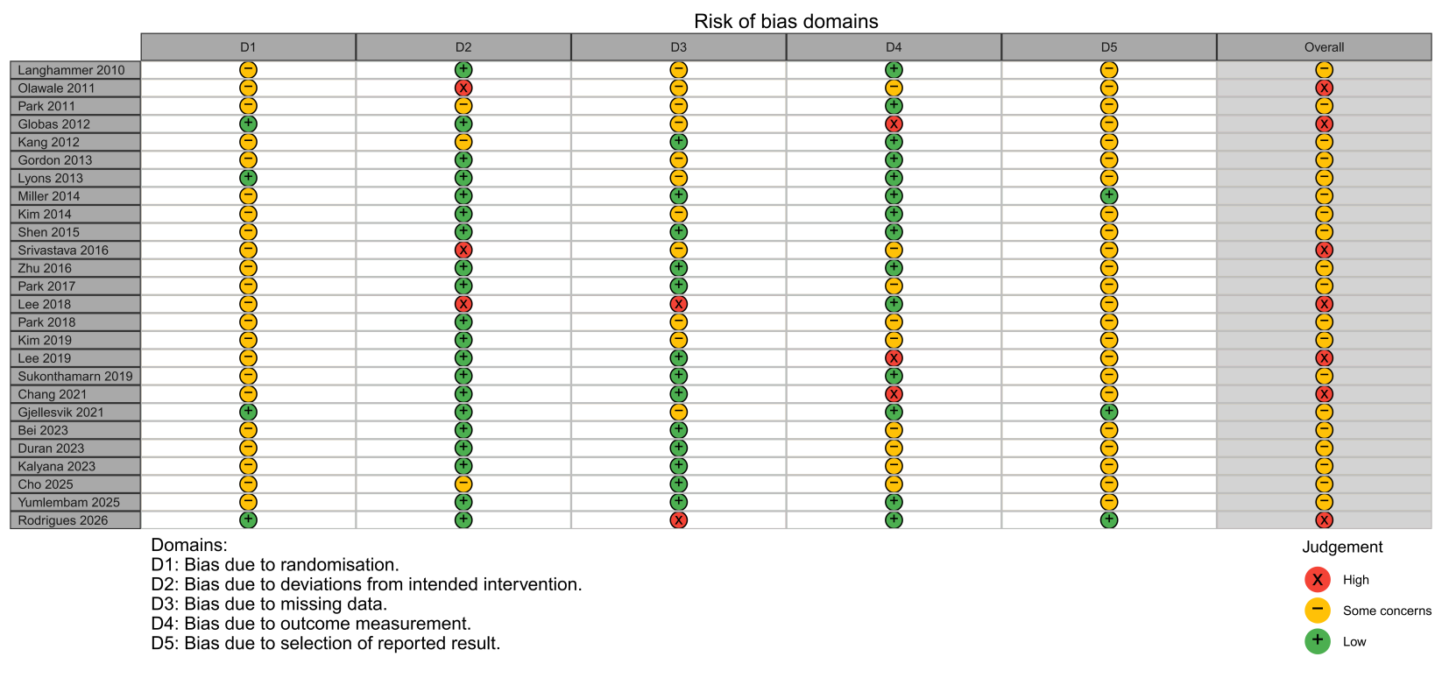

Supplementary Figure S1. Risk-of-bias judgments for each included study based on the RoB 2.0 tool.

A:6MWT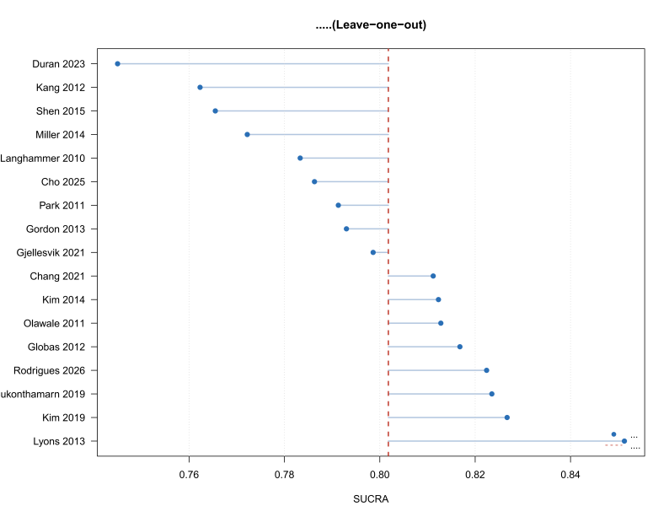 | B:10-m walking speed  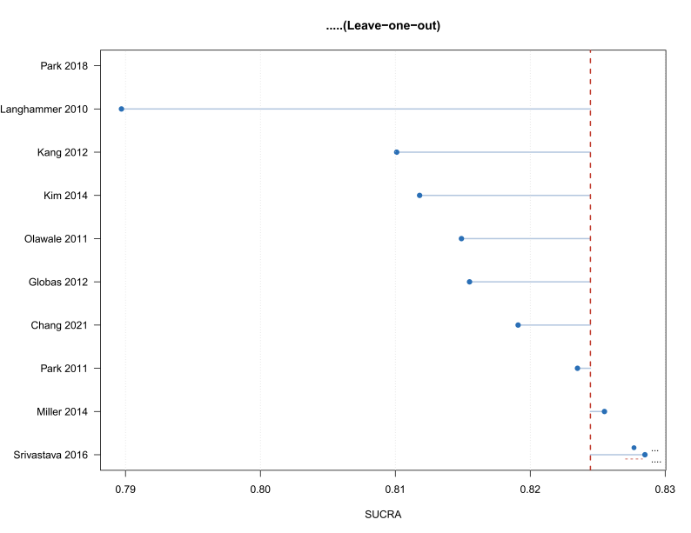
C:BBS  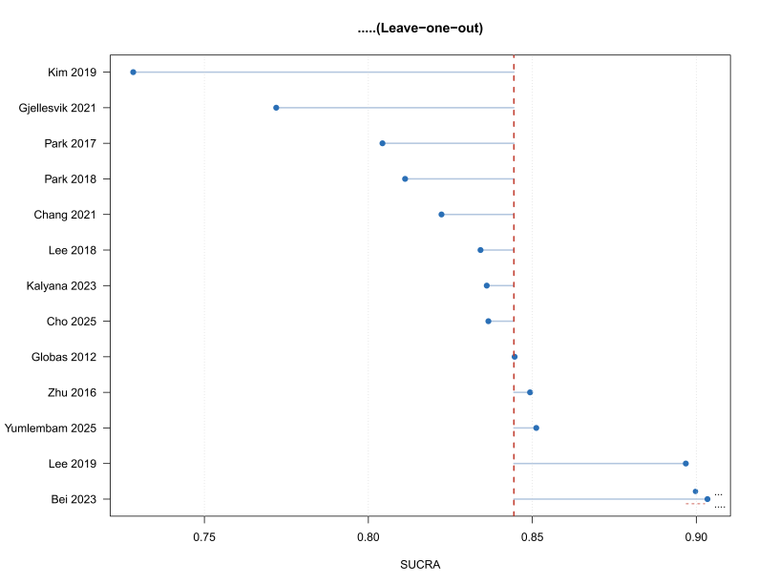 | D:TUG  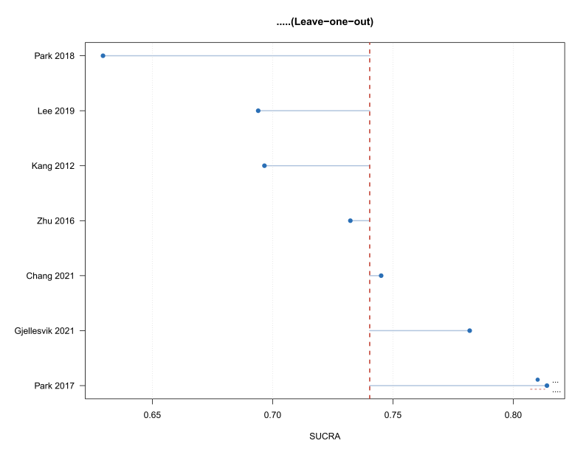

Supplementary Figure S2. Leave-one-out sensitivity analyses of treatment rankings for the quantitatively synthesized outcomes: (A) 6-Minute Walk Test; (B) 10-m walking speed; (C) Berg Balance Scale; and (D) Timed Up and Go test. Each network meta-analysis was repeated after sequentially excluding one study. The dashed vertical line represents the SUCRA value of the highest-ranked intervention in the primary analysis. When exclusion of a study removed the only evidence for an intervention node or disconnected the network, the corresponding ranking estimate was not available.

