Supplementary Data 3

Table S1. Mean normalized ΔCt values (mean ± SD) of the selected miRNAs for the control, early OA, and late OA groups.
 | AVG Delta(Ct) |  |  | Standard Deviation
 | Control Group | Early OA | Late OA | Control Group | Group 1 | Group 2
miR-10b-5p | -4.22 | -4.44 | 0.83 | 0.687848 | 0.135110 | 0.295190
miR-148b-3p | 0.53 | 0.10 | 5.18 | 0.834071 | 0.638733 | 0.576699
miR-154-5p | 0.40 | 0.67 | 4.99 | 0.825205 | 0.236956 | 0.374200
let-7g-5p | -4.99 | -4.98 | -0.50 | 0.502067 | 0.217775 | 0.649093
miR-369-5p | 1.03 | 1.20 | 5.52 | 0.922414 | 0.234544 | 0.924148
miR-7-5p | 0.38 | 2.05 | 4.85 | 0.348508 | 0.419995 | 1.166072
miR-376a-3p | 0.80 | 0.98 | 5.18 | 0.796417 | 0.177867 | 0.576699
miR-342-3p | -3.42 | -3.11 | 0.78 | 0.621930 | 0.193137 | 0.451808
miR-20b-5p | 1.44 | 3.31 | 5.18 | 0.693359 | 0.657401 | 0.576699

Table S2. miRNAs selected for in-silico target gene prediction

miRNA | Early OA vs Control |  | Late OA vs Control |  | Late OA vs Early OA
 | Fold regulation | adj. P-value | Fold regulation | adj. P-value | Fold regulation | adj. P-value
miR-10b-5p | - | - | -33.22 | 0.02287 | -38.69 | 0.000102
miR-148b-3p | - | - | -25.06 | 0.01925 | -33.9 | 0.011977
miR-154-5p | - | - | -24.08 | 0.03543 | -20.04 | 0.000503
let-7g-5p | - | - | -22.56 | 0.01925 | -22.42 | 0.000459
miR-369-5p | - | - | -22.47 | 0.02584 | -19.96 | 0.000516
miR-7-5p | -3.18 | 0.19795 | -22.09 | 0.01071 | -6.96 | 0.008120
miR-376a-3p | - | - | -20.79 | 0.01925 | -18.36 | 0.000306
miR-342-3p | - | - | -18.47 | 0.01925 | -14.87 | 0.000317
miR-20b-5p | -3.66 | 0.36520 | -13.38 | 0.01925 | -3.65 | 0.041313

Fold regulation of selected miRNAs in cartilage tissue was analysed using miRNA arrays. The comparisons included early OA versus control, late OA versus control, and late OA versus early OA groups. Data represent fold changes calculated from cartilage samples (n=4 for control and early OA groups; n=5 for the late OA group). Benjamini-Hochberg false discovery rate (FDR) correction was applied to account for multiple testing, and the adjusted p-values (q-values) are reported.

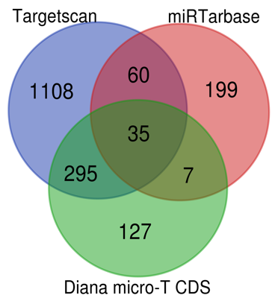
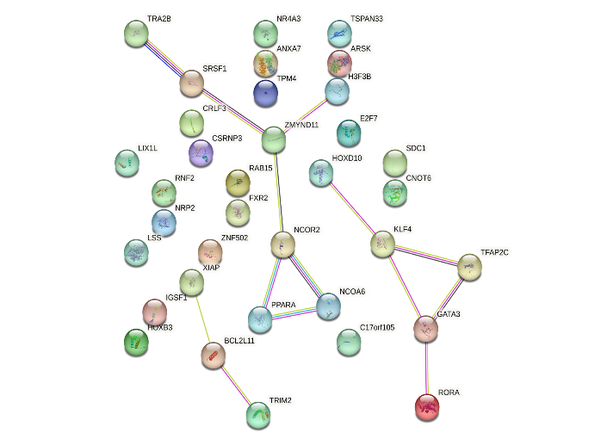
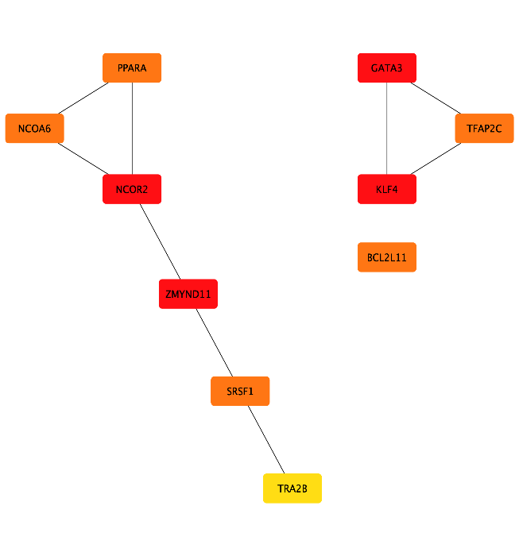
A
miR-10b-5p -33.22
Gene set enrichment analysis revealed no significant pathways
OA related genes found from OsteoDIP = 16
- NCOR2- Nuclear Receptor Corepressor 2
- KLF4- Kruppel-Like Factor 4
- BCL2L11-BCL2 Like 11
Hub Genes
Target Genes

B
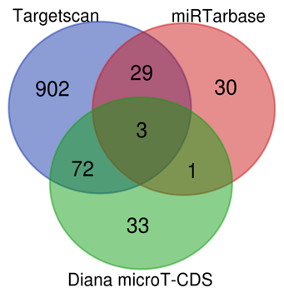
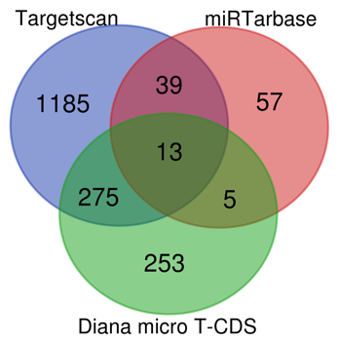
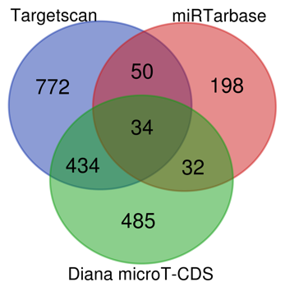
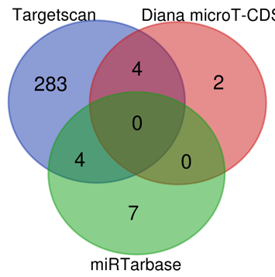
miR-154-5p -24.08
miR-376a-3p -20.79
miR-342-3p -18.47
miR-369-5p -22.47
OA related genes found from OsteoDIP
3
6
17
Poor PPI network by string analysis
Gene set enrichment analysis revealed no significant pathways

Figure S1 Representative analysis of the miRNAs with poor OA focused In-silico target gene prediction of (A) miR-10b-5p and (B) miR-154-5p, miR-376a-3p, miR-342-3p and miR-369-5p. Venn diagram shows the overlap of predicted gene targets among TargetScan, miRTarBase, and Diana microT-CDS databases.

A) miR-148b-3p

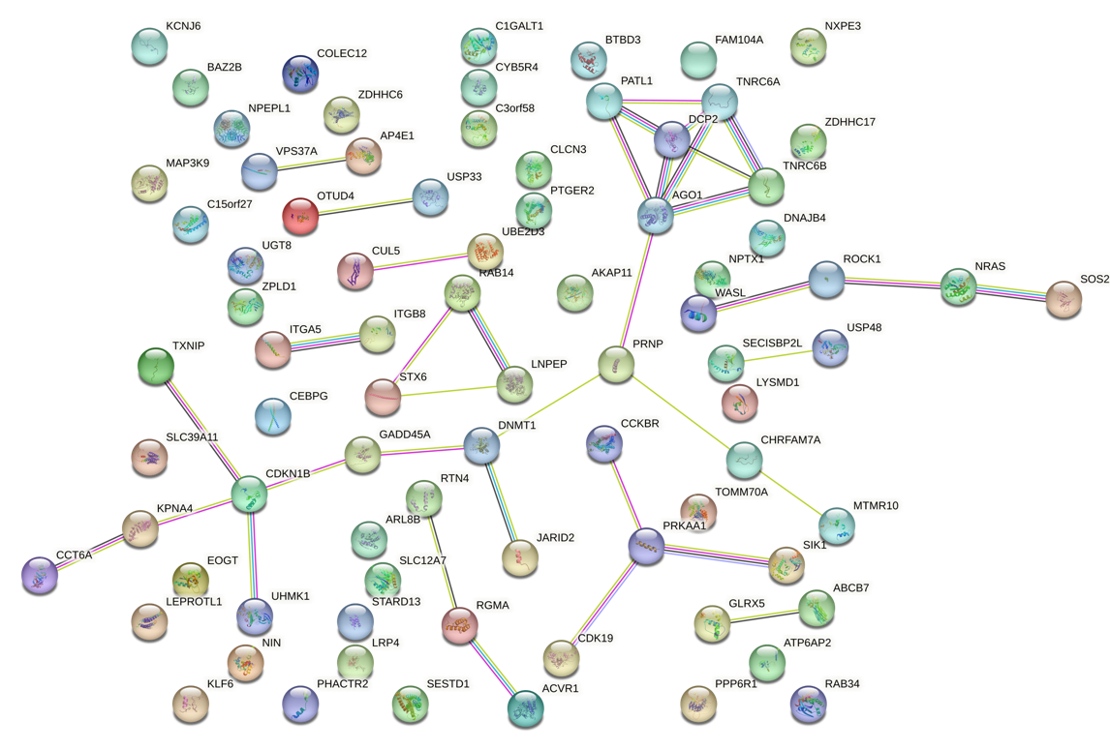

B) Let-7g-5p

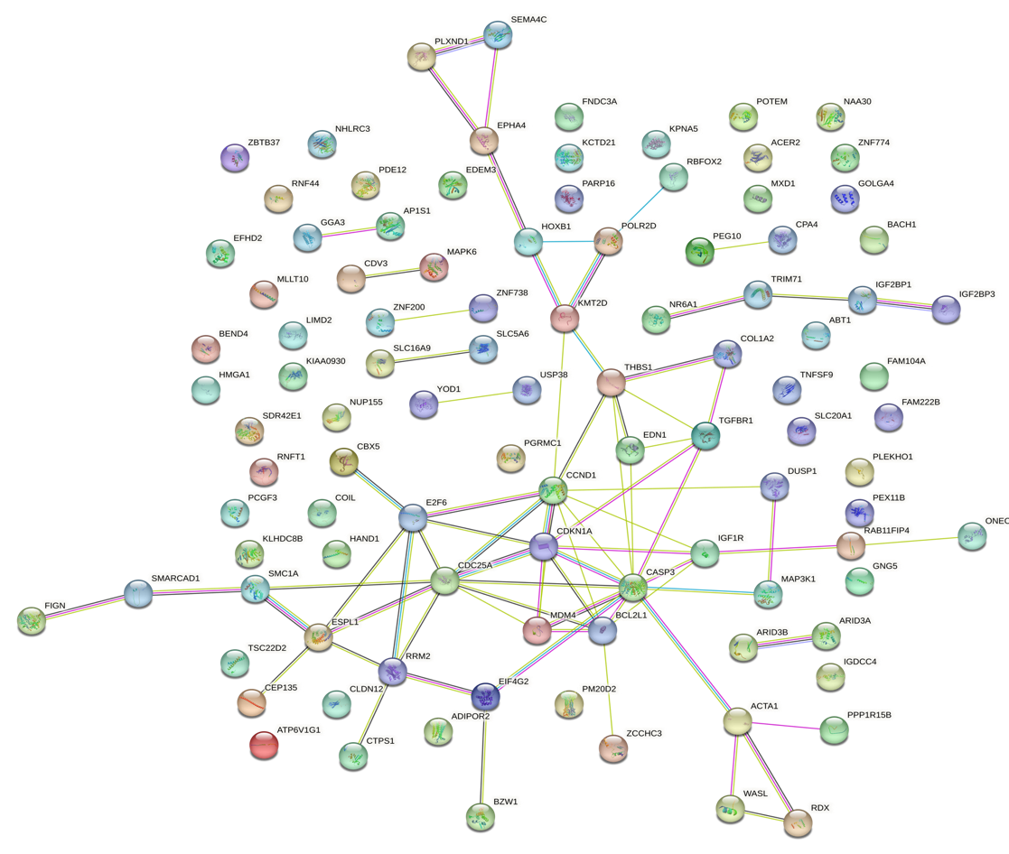

C) miR-7-5p
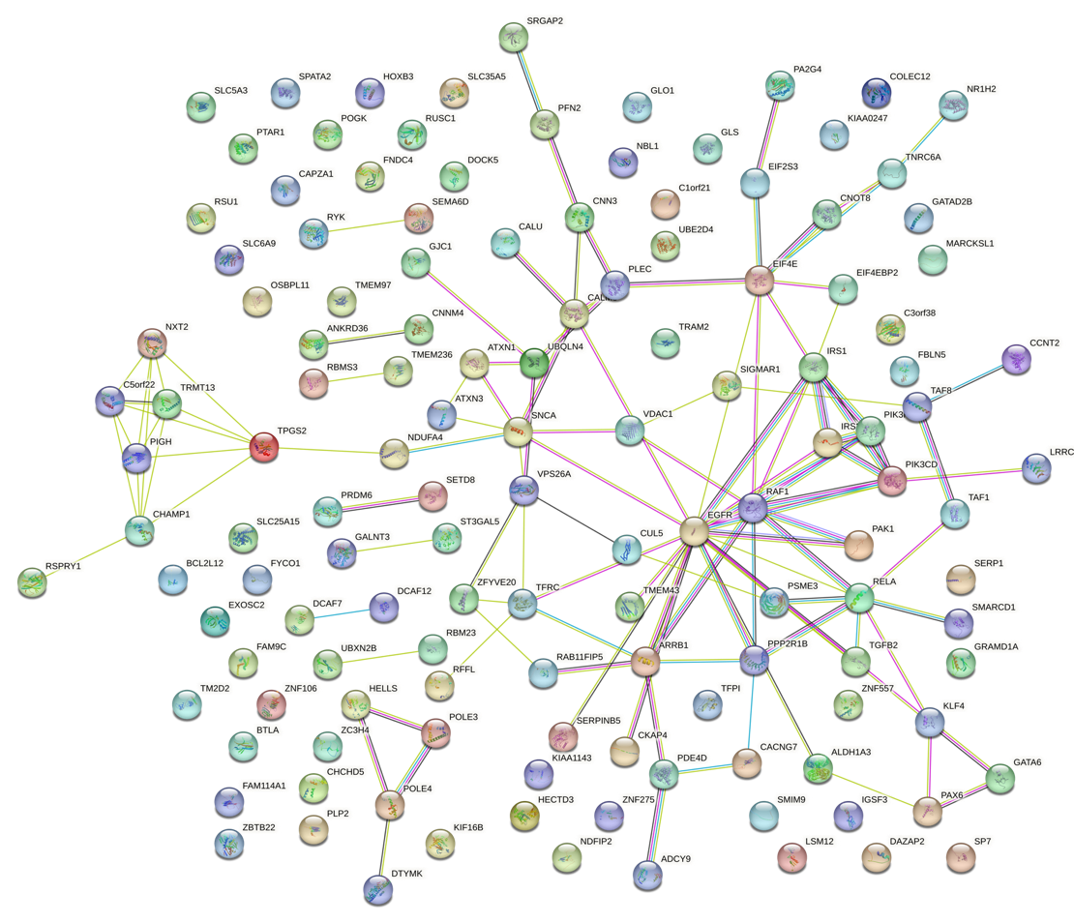

B) miR-20b-5p
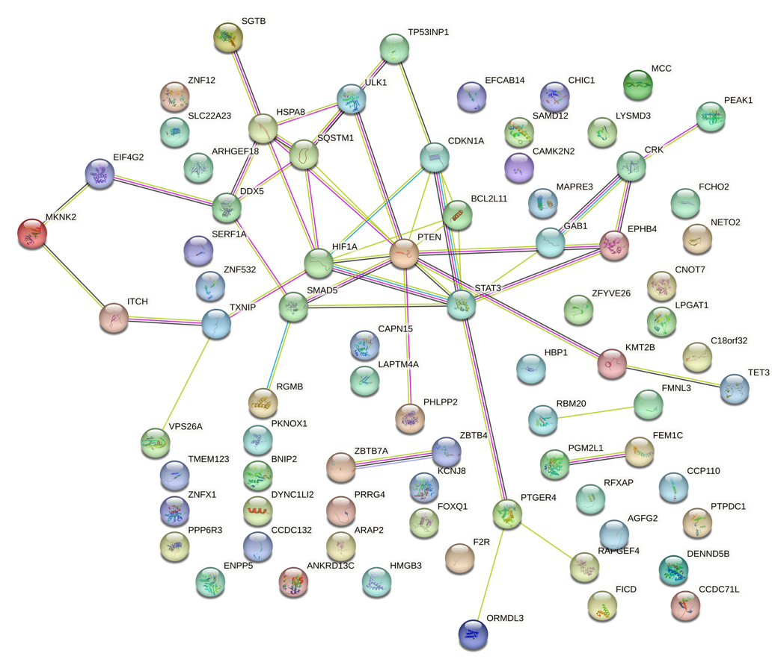
Figure S2. The PPI network analysis of A) miR-148b-3p B) let-7g-5p C) miR-7-5p and D) miE-20b-5p as also given in Fig. 7 and Fig. 8 of the main data.

Full Forms of the target genes mentioned in Table 1.

GATA3: GATA binding protein 3, NCOR2: Nuclear receptor co-repressor 2, KLF4: Krüppel-like factor 4, ZMYND11: Zinc finger MYND-type containing 11, NCOA6: Nuclear receptor coactivator 6, PPARA: Peroxisome proliferator-activated receptor alpha, TFAP2C: Transcription factor AP-2 gamma, BCL2L11: Bcl-2-like protein 11, SRSF1: Serine and arginine-rich splicing factor 1, TRA2B: Transformer 2 beta homolog, AGO1: Argonaute RISC catalytic component 1, TNRC6A: Trinucleotide repeat containing 6A, CDKN1B: Cyclin-dependent kinase inhibitor 1B, DCP2: mRNA-decapping enzyme 2, DNMT1: DNA (cytosine-5)-methyltransferase 1, PRKAA1: AMP-activated protein kinase alpha 1, PATL1: Protein PAT1 homolog 1, PRNP: Prion protein, TNRC6B: Trinucleotide repeat containing 6B, KPNA4: Karyopherin subunit alpha 4, THBS1: Thrombospondin 1, CASP3: Caspase-3, IGF1R: Insulin-like growth factor 1 receptor, CCND1: Cyclin D1, E2F6: E2F transcription factor 6, CDC25A: Cell division cycle 25A, MDM4: MDM4, BCL2L1: Bcl-2-like protein 1, CDKN1A: Cyclin-dependent kinase inhibitor 1A, TGFBR1: Transforming growth factor-beta receptor 1, ARRB1: Arrestin beta 1, IRS1: Insulin receptor substrate 1, PIK3CD: Phosphoinositide-3-kinase catalytic delta, EGFR: Epidermal growth factor receptor, EIF4E: Eukaryotic translation initiation factor 4E, RELA: V-rel avian reticuloendotheliosis viral oncogene homolog A, RAF1: RAF proto-oncogene serine/threonine kinase, SNCA: Synuclein alpha, TPGS2: Tocopheryl phosphate synthase 2, CHAMP1: Chromosome alignment-maintaining phosphoprotein 1, HIF1A: Hypoxia-inducible factor 1-alpha, PTEN: Phosphatase and tensin homolog, SMAD5: SMAD family member 5, STAT3: Signal transducer and activator of transcription 3, HSPA8: Heat shock protein family A member 8, DDX5: DEAD-box helicase 5, SQSTM1: Sequestosome 1, ROCK1: Rho-associated protein kinase 1, RGMA: Repulsive guidance molecule family member A, SOS2: Son of sevenless homolog 2, ITGB8: Integrin subunit beta 8, NRAS: NRAS proto-oncogene, GTPase, TXNIP: Thioredoxin interacting protein, PPP1CC: Protein phosphatase 1 catalytic subunit gamma, PCGF5: Polycomb group ring finger 5, NRBF2: Nuclear receptor binding factor 2, PIK3R3: Phosphoinositide-3-kinase regulatory subunit 3, TGFB2: Transforming growth factor-beta 2.

