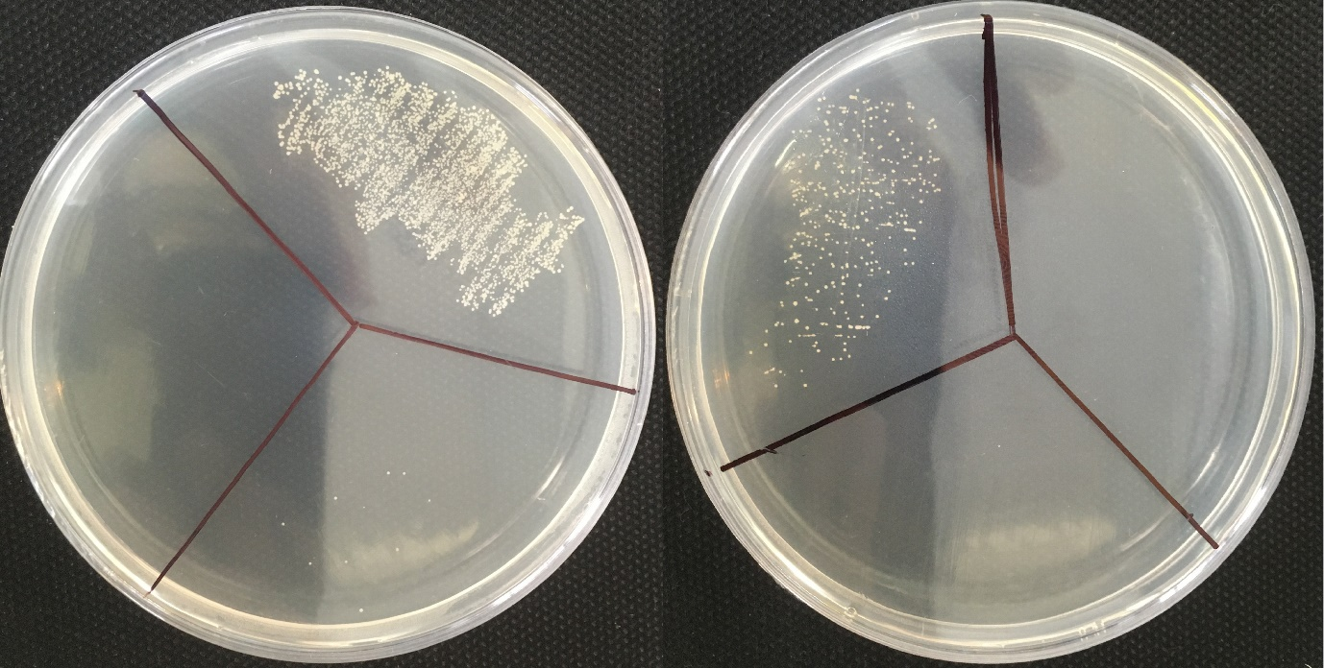
32 µg/ml
2 µg/ml
4 µg/ml
1 µg/ml
16 µg/ml
64 µg/ml
Figure S1. Minimum Bactericidal Concentration (MBC) assay of free formulation (right) and Van‑Nios Gel (left) against VRSA isolate. After MIC determination, 100‑ μL aliquots from the wells at the MIC and the two higher concentrations were cultured onto MHA and incubated overnight at 37 °C. The MBC was defined as the lowest antimicrobial concentration that resulted in ≥ 99.99% reduction in bacterial viability. Serial two‑fold dilutions are shown. The Van‑Nios Gel exhibited lower MBC compared to free formulation, confirming its enhanced bactericidal activity against investigated VRSA isolate.

