Supplementary Materials

DNA methylation-derived CRP captures chronic inflammatory pathways from
metabolic risk to impaired lung function: a community-based prospective cohort study
Supplementary Method 1. Detailed information of covariates
Supplementary Figure 1. Flow diagram of study participant selection
Supplementary Figure 2. Directed acyclic graph (DAG) of the metabolic component count-inflammation-lung function pathway
Supplementary Figure 3. Representative diagnostic plots for the linear regression models
Supplementary Figure 4. The associations between metabolic component count (Waves 1–5) and lung function (Wave 7), including Wave 5 lung function and the follow-up interval adjustment
Supplementary Figure 5. Sensitivity analysis of the associations between metabolic component count (Waves 1–5) and lung function (Waves 5 and 7), excluding BMI adjustment
Supplementary Figure 6. Sensitivity analysis of the associations between metabolic component count (Waves 1–5) and DNAm-CRP and hs-CRP, excluding BMI adjustment
Supplementary Figure 7. Sensitivity analysis of the associations between metabolic component count (Waves 1–5) and lung function (Waves 5 and 7) using inverse probability weighting
Supplementary Figure 8. Sensitivity analysis of the associations between metabolic component count (Waves 1–5) and DNAm-CRP and hs-CRP using inverse probability weighting
Supplementary Figure 9. Mediation analysis of hs-CRP and DNAm-CRP in the association between categorical metabolic component count (Wave 1) and lung function
Supplementary Table 1. Characteristics of study participants with DNAm data (N=1,520) and those included in the final analytic sample (N=664) at Wave 5
Supplementary Table 2. Characteristics of participants included in and excluded from the final analytic sample at Wave 5
Supplementary Table 3. Metabolic profile of study participants at Waves 1-5 and lung function at Wave 7
Supplementary Table 4. Association between each metabolic risk factor at Wave 1 and lung function at Waves 5 and 7
Supplementary Table 5. Sensitivity analysis of the associations between hs-CRP and DNAm-CRP with lung function, excluding BMI adjustment
Supplementary Table 6. Sensitivity analysis of the associations between hs-CRP and DNAm-CRP with lung function using inverse probability weighting
Supplementary Table 7. Mediation analysis of hs-CRP and DNAm-CRP in the associations between mean metabolic component count and lung function
Supplementary Table 8. Individual mediation analyses for each metabolic risk factor (Wave 1)
Supplementary Table 9. Association of LASSO-selected CpG associations with FVC at Wave 7
Supplementary Table 10. Association of LASSO-selected CpG associations with FEV₁ at Wave 7
Supplementary Method 1. Detailed information of covariates
Basic sociodemographic (chronological age, sex, education level and recruitment site), health-related behaviors (smoking pack-years, current smoking status, alcohol consumption, and physical activity), anthropometric measurements (height [cm] and body mass index [BMI; kg/m²]), and cell-type composition (CD4+ and CD8+ T lymphocytes, natural killer cells, B-cells, monocytes, and granulocytes) were included as potential confounders
Covariates included in the models were defined as follows: Recruitment site was categorized as Ansan or Ansung according to the community in which participants were recruited. Current smoking status was categorized as current smoker or non-current smoker. Smoking pack-years were calculated based on smoking duration and amount among ever-smokers, with never-smokers assigned a value of 0. Alcohol consumption was categorized as current, former, or never drinker, based on whether individuals had ever consumed alcohol in their lifetime and were currently drinking. Physical activity was categorized as none or regular, according to whether participants reported engaging in regular exercise sufficient to induce sweating, consistent with KoGES survey definitions. Education level was categorized as less than high school graduate or high school graduate and above, based on the highest level of education attained.

Supplementary Figure 1. Flow diagram of study participant selection
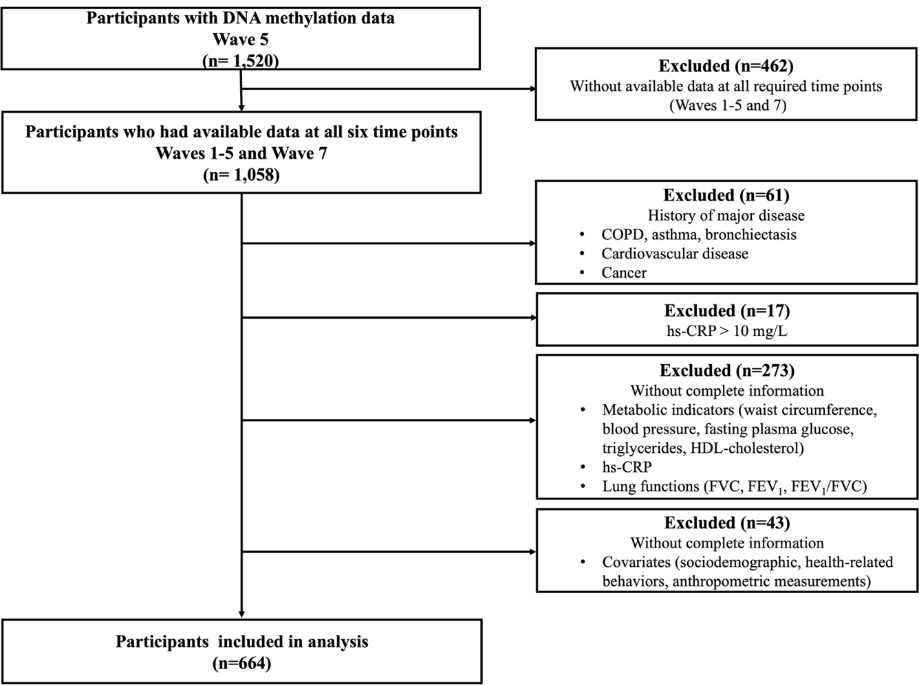
Abbreviations: COPD, Chronic obstructive pulmonary disease; FVC, Forced vital capacity; FEV₁, Forced expiratory volume in 1 second
Supplementary Figure 2. Directed acyclic graph (DAG) of the metabolic component count-inflammation-lung function pathway

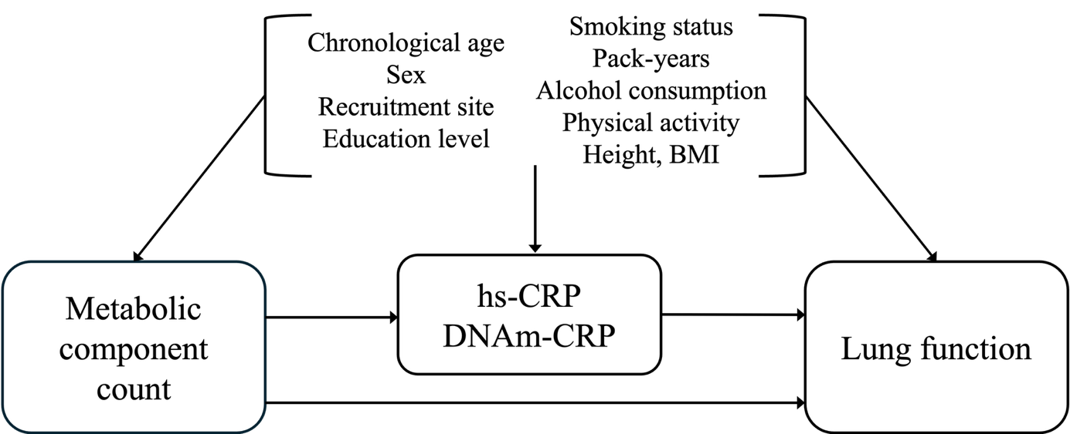
Abbreviations: BMI, Body mass index (calculated as weight in kilograms divided by height in meters squared); DNAm-CRP, DNA methylation–derived CRP score

Supplementary Figure 3. Representative diagnostic plots for the linear regression models
A) Metabolic component count (Wave 1) ➜ Lung function (Wave 5)
FVC FEV₁ FEV₁ /FVC
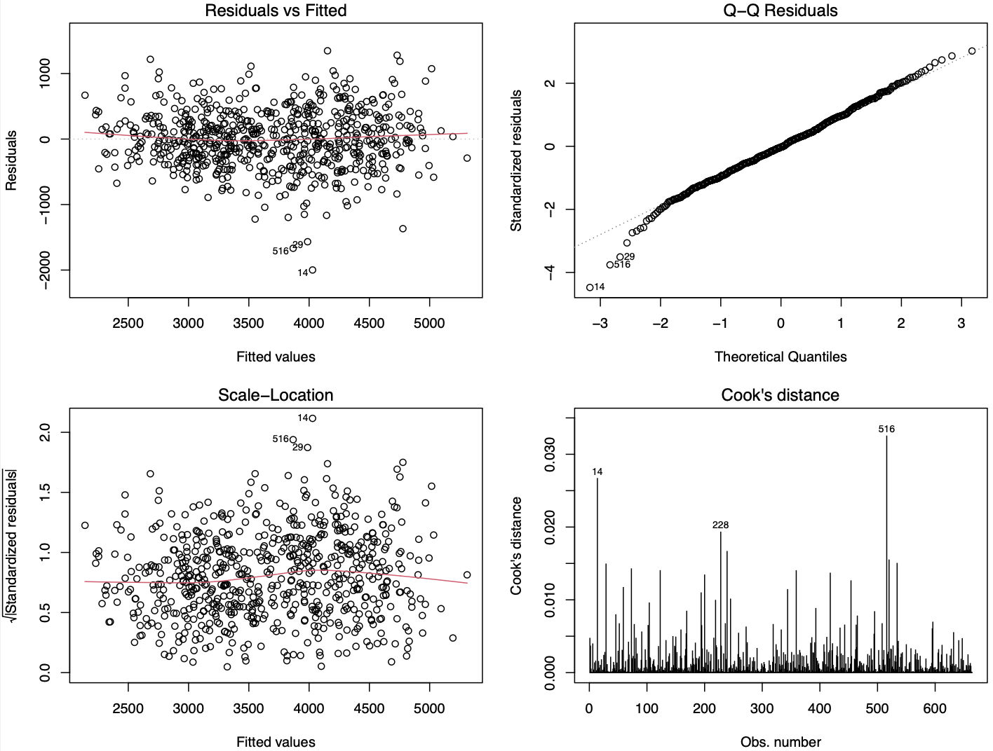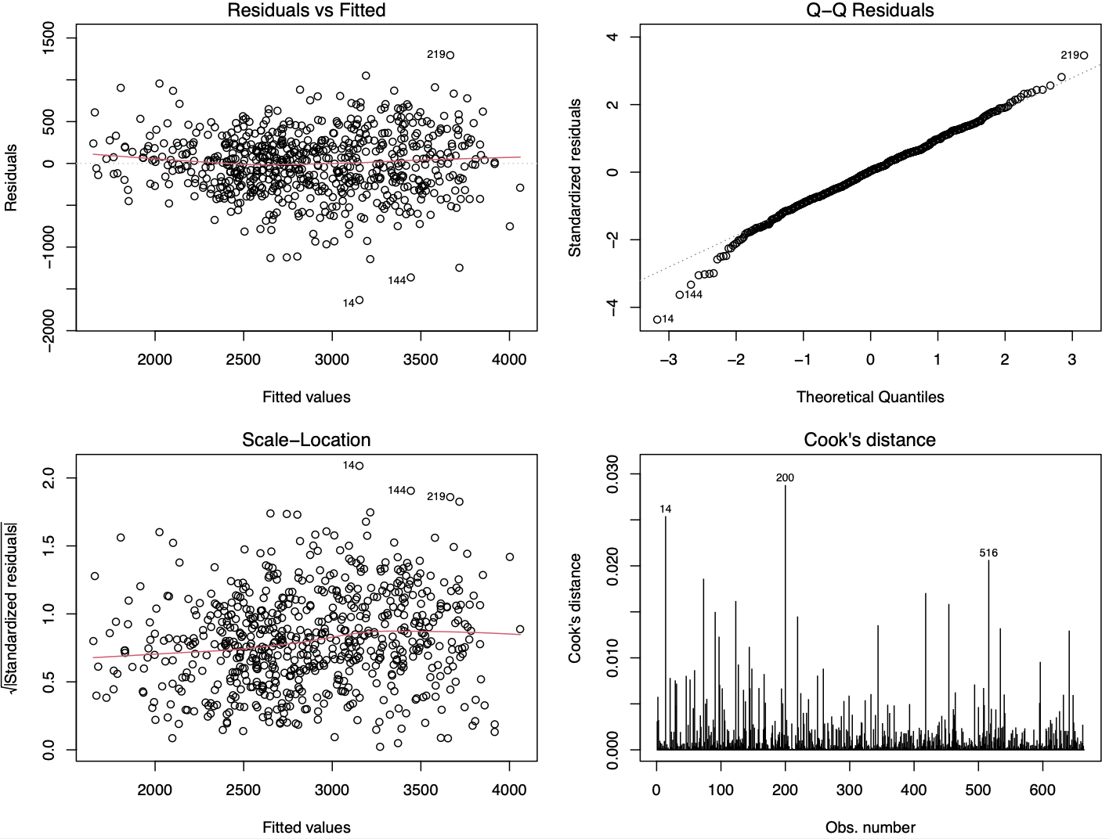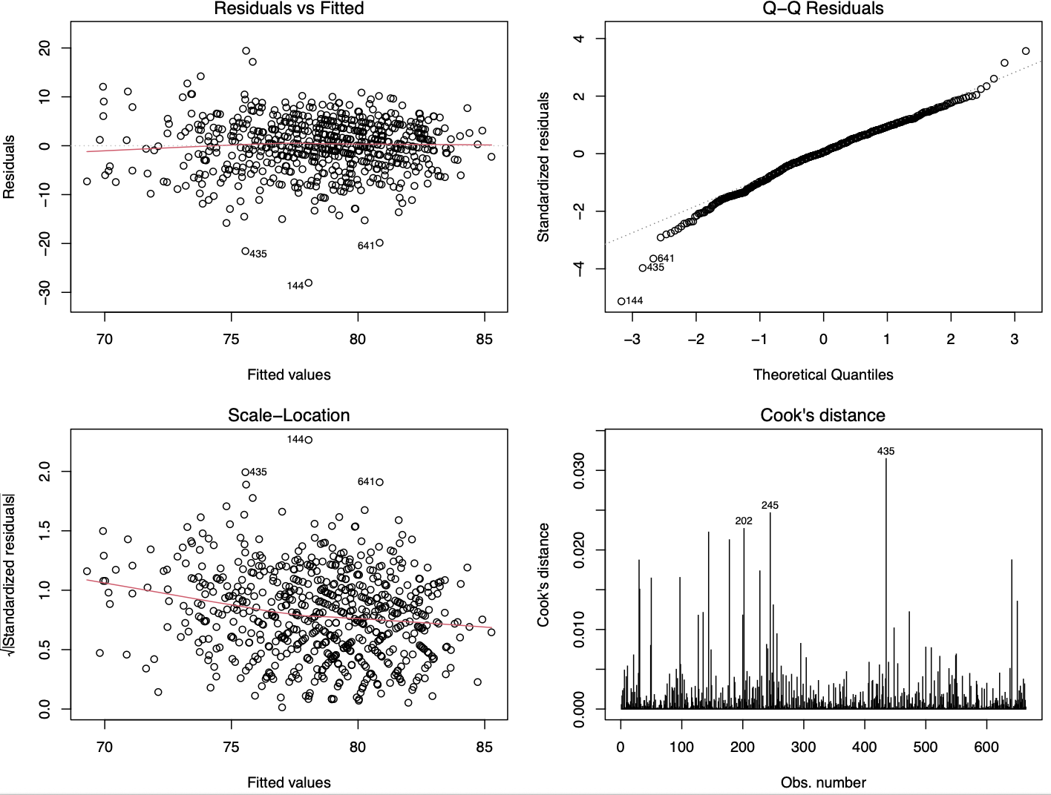
B) DNAm-CRP (Wave5) ➜ Lung function (Wave 7)
FVC FEV₁ FEV₁ /FVC
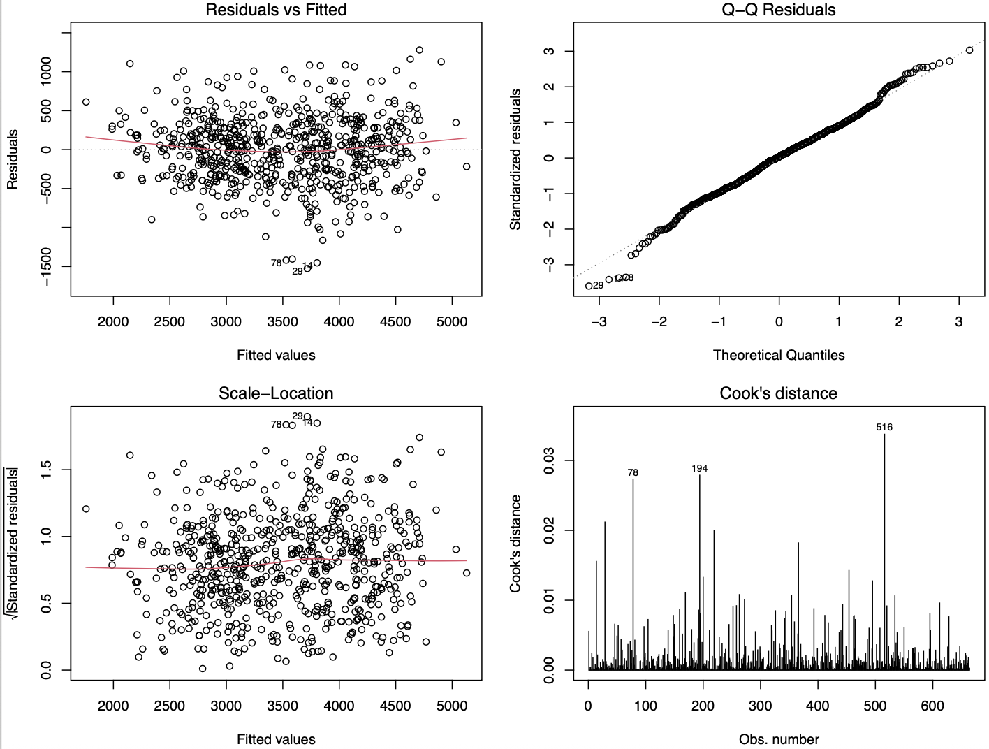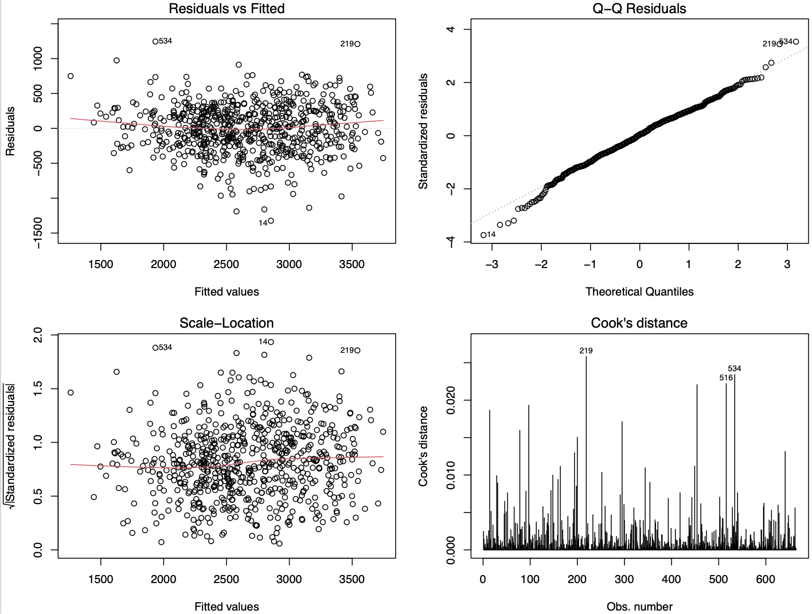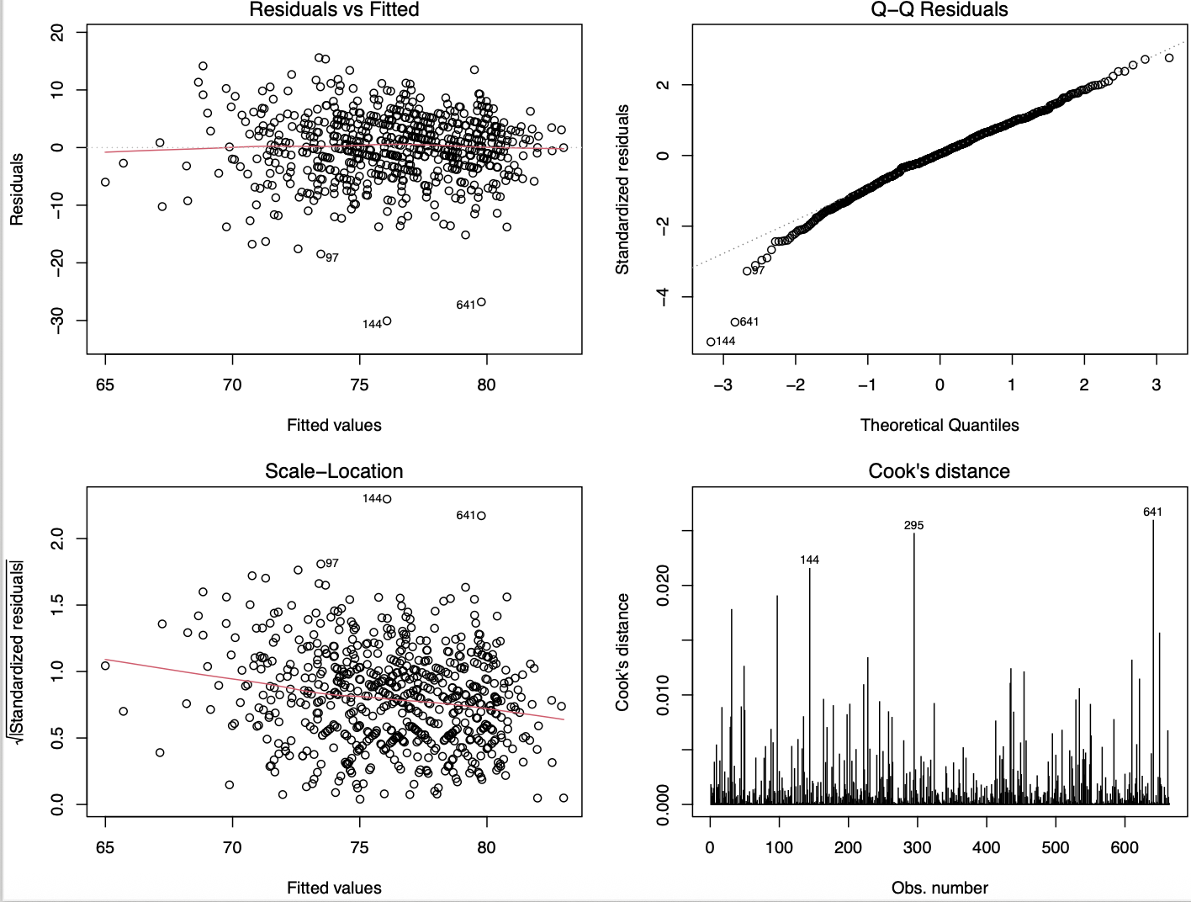
C) Metabolic component count (Wave1) ➜ inflammatory biomarkers (Wave 5)
DNAm-CRP hs-CRP
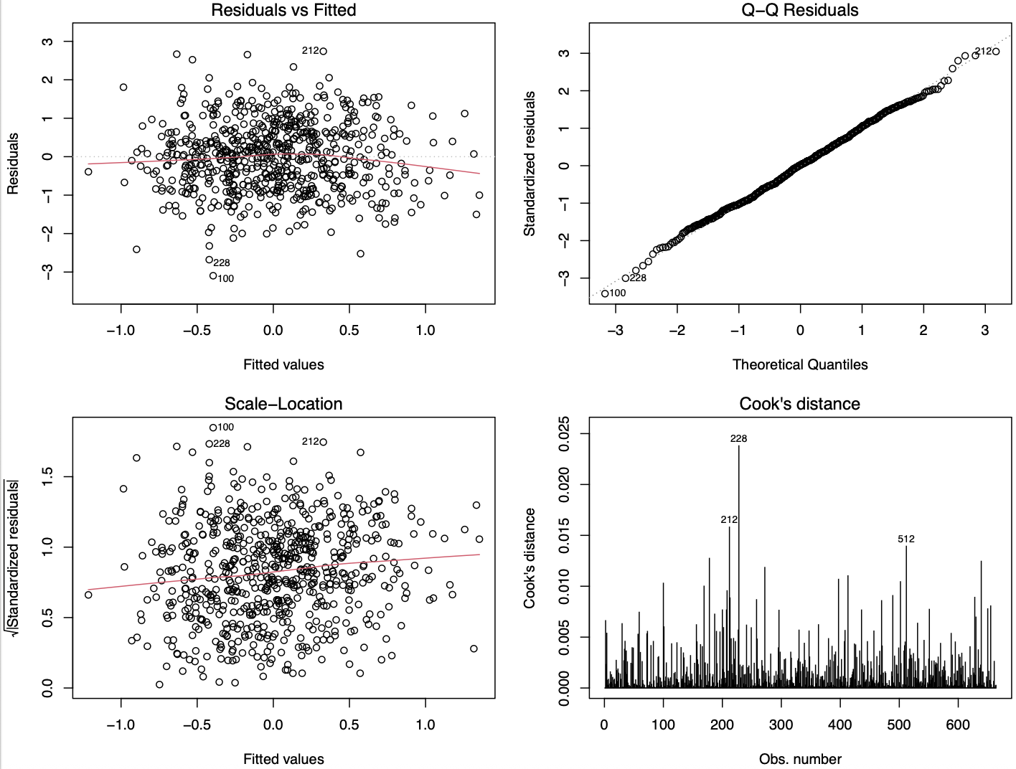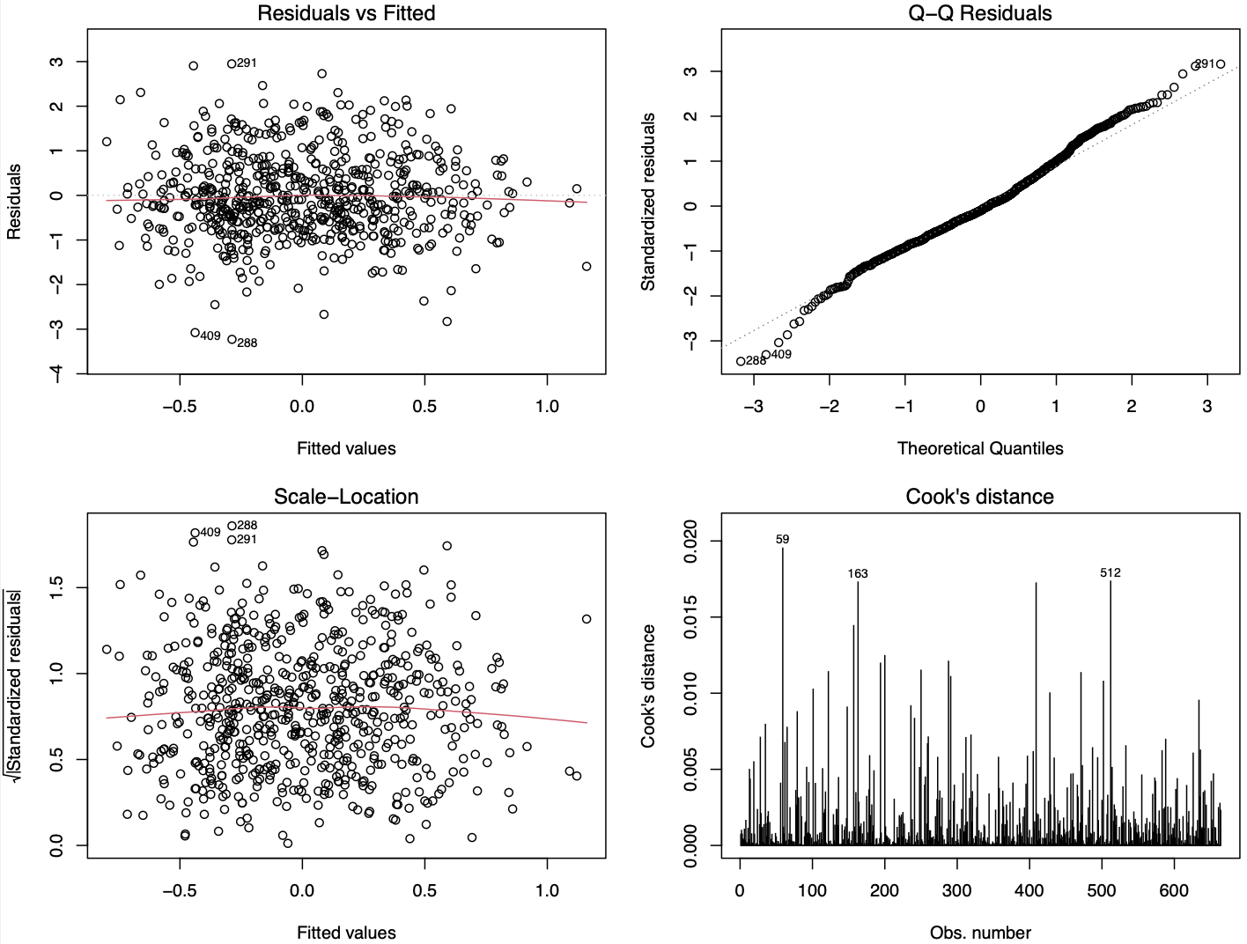
For each model, residuals-versus-fitted plots, normal Q-Q plots, Scale-Location plots, and Cook’s distance plots are presented to assess linearity, residual distribution, heteroscedasticity, and influential observations, respectively.

Supplementary Figure 4. The associations between metabolic component count (Waves 1–5) and lung function (Wave 7), including Wave 5 lung function and the follow-up interval adjustment
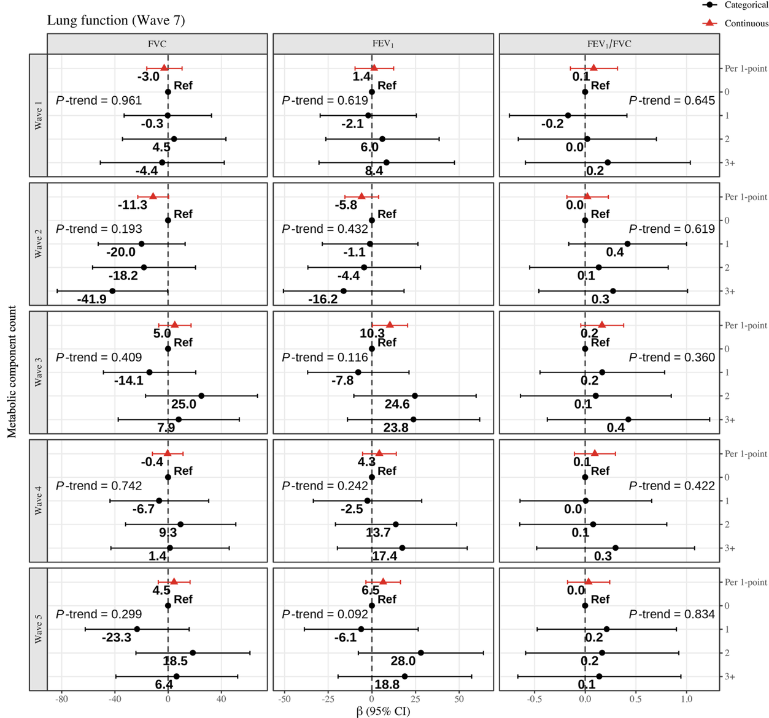
β represents the change in lung function for each one-point increase in metabolic component count and the effect size for groups 1, 2, and 3+ compared with group 0. Model were adjusted for chronological age, sex, area, height, education level, alcohol consumption, pack-year, current smoking status, exercise, BMI, lung function measurement at Wave 5, and the participant-specific follow-up interval between Waves 5 and 7. 95% CI and p-values were calculated using HC3 heteroscedasticity-consistent standard errors.
Abbreviations: Forced vital capacity; FEV₁, Forced expiratory volume in 1 second

Supplementary Figure 5. Sensitivity analysis of the associations between metabolic component count (Waves 1–5) and lung function (Waves 5 and 7), excluding BMI adjustment
A) Lung function wave 5 B) Lung function wave 7
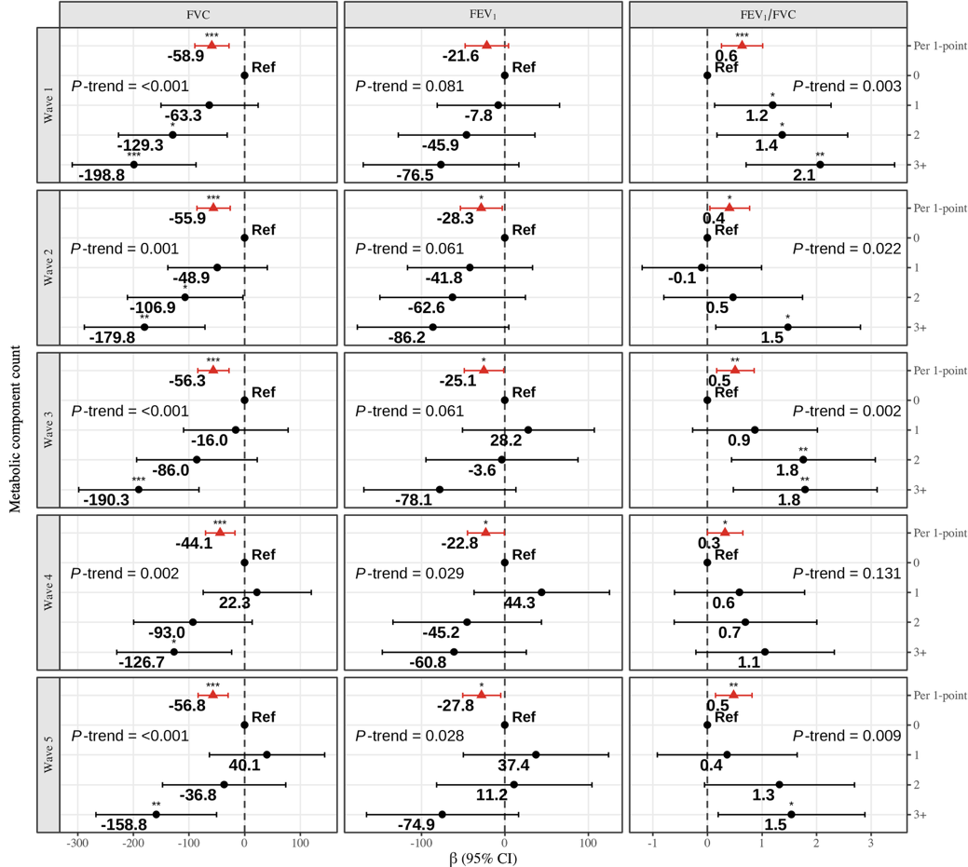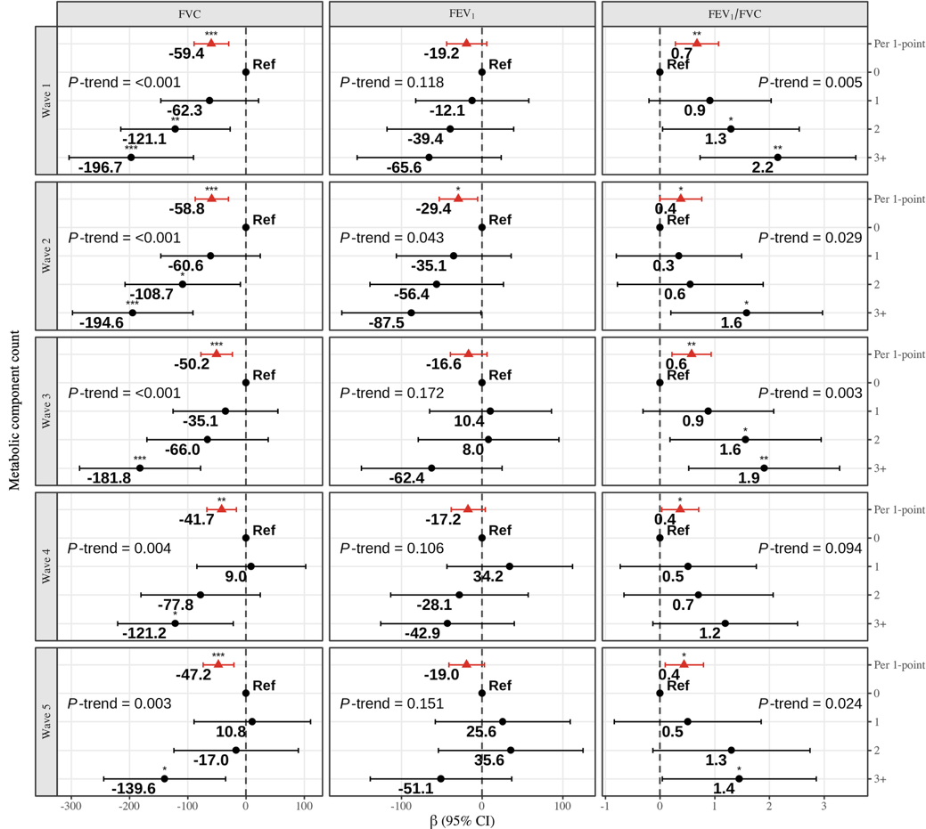
β represents the change in lung function for each one-point increase in metabolic component count and the effect size for groups 1, 2, and 3+ compared with group 0. Model were adjusted for chronological age, sex, area, height, education level, alcohol consumption, pack-year, current smoking status, and exercise. 95% CI and p-values were calculated using HC3 heteroscedasticity-consistent standard errors.
Abbreviations: Forced vital capacity; FEV₁, Forced expiratory volume in 1 second

Supplementary Figure 6. Sensitivity analysis of the associations between metabolic component count (Waves 1–5) and DNAm-CRP and hs-CRP, excluding BMI adjustment
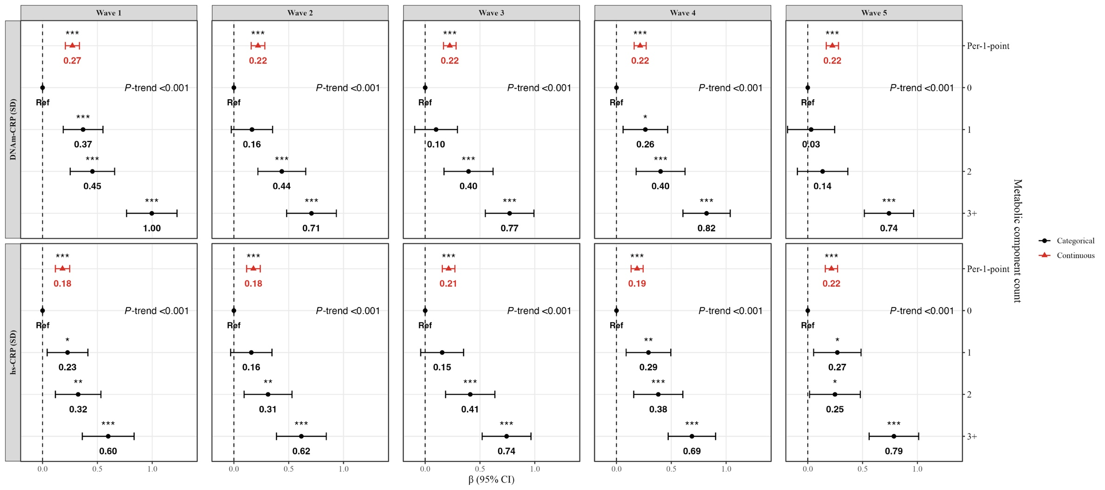
β represents the change in DNAm-CRP and hs-CRP in metabolic component count for each one-point increase and the effect size for groups 1, 2, and 3+ compared with group 0. Models were adjusted for chronological age, sex, area, height, education level, alcohol consumption, pack-years, current smoking status and exercise. Models for for DNAm-CRP were additionally adjusted for cell composition. 95% CI and p-values were calculated using HC3 heteroscedasticity-consistent standard errors.
*P-value <0.05, **P-value < 0.01, *** P-value < 0.001
Abbreviations: SD; Standard deviation; DNAm-CRP; DNA methylation–derived CRP score

Supplementary Figure 7. Sensitivity analysis of the associations between metabolic component count (Waves 1–5) and lung function (Waves 5 and 7) using inverse probability weighting
A) Lung function wave 5 B) Lung function wave 7
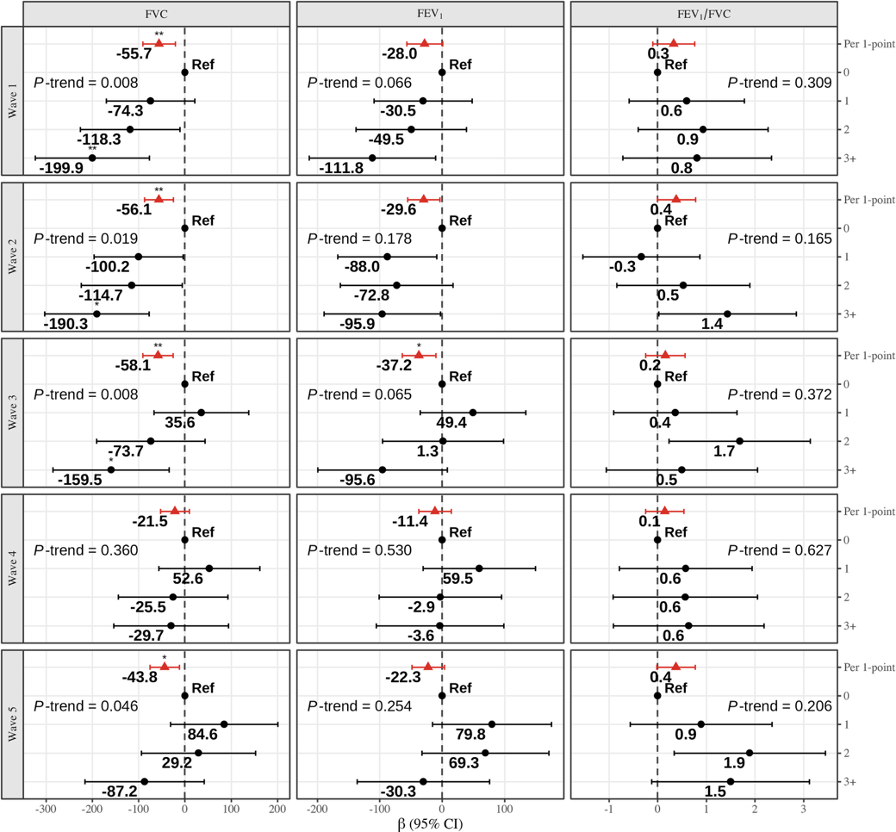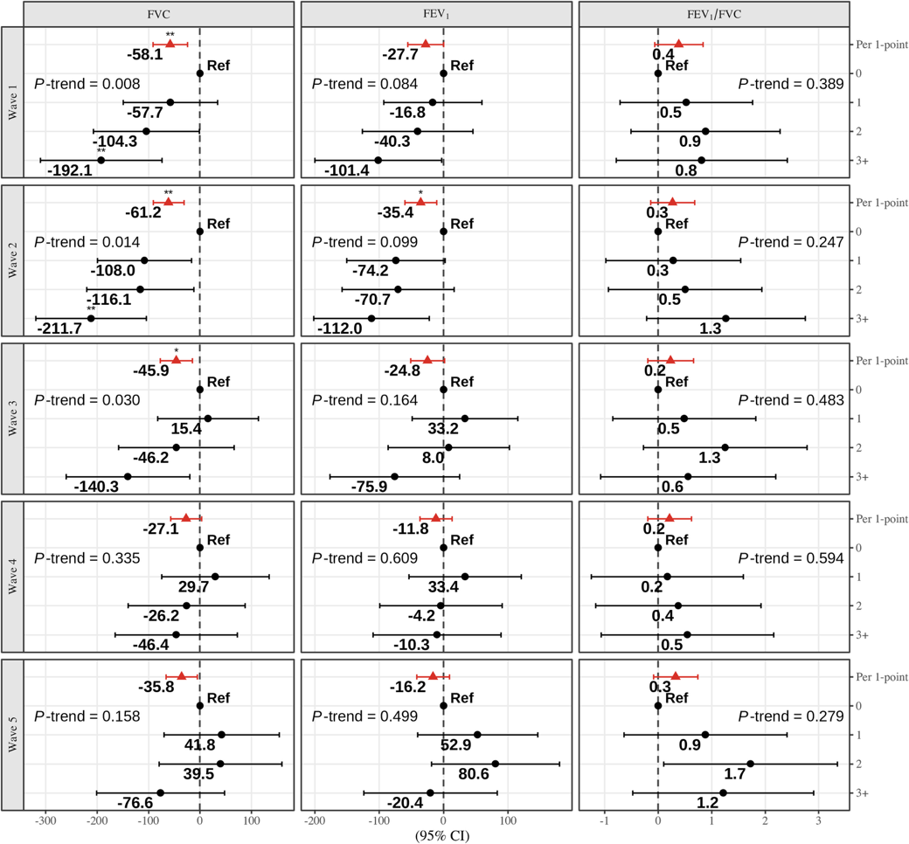
β represents the change in lung function for each one-point increase in metabolic component count and the effect size for groups 1, 2, and 3+ compared with group 0. Models were adjusted for chronological age, sex, area, height, education level, alcohol consumption, pack-year, current smoking status, exercise, and BMI. 95% CI and p-values were calculated using HC3 heteroscedasticity-consistent standard errors.
Abbreviations: Forced vital capacity; FEV₁, Forced expiratory volume in 1 second

Supplementary Figure 8. Sensitivity analysis of the associations between metabolic component count (Waves 1–5) and DNAm-CRP and hs-CRP using inverse probability weighting
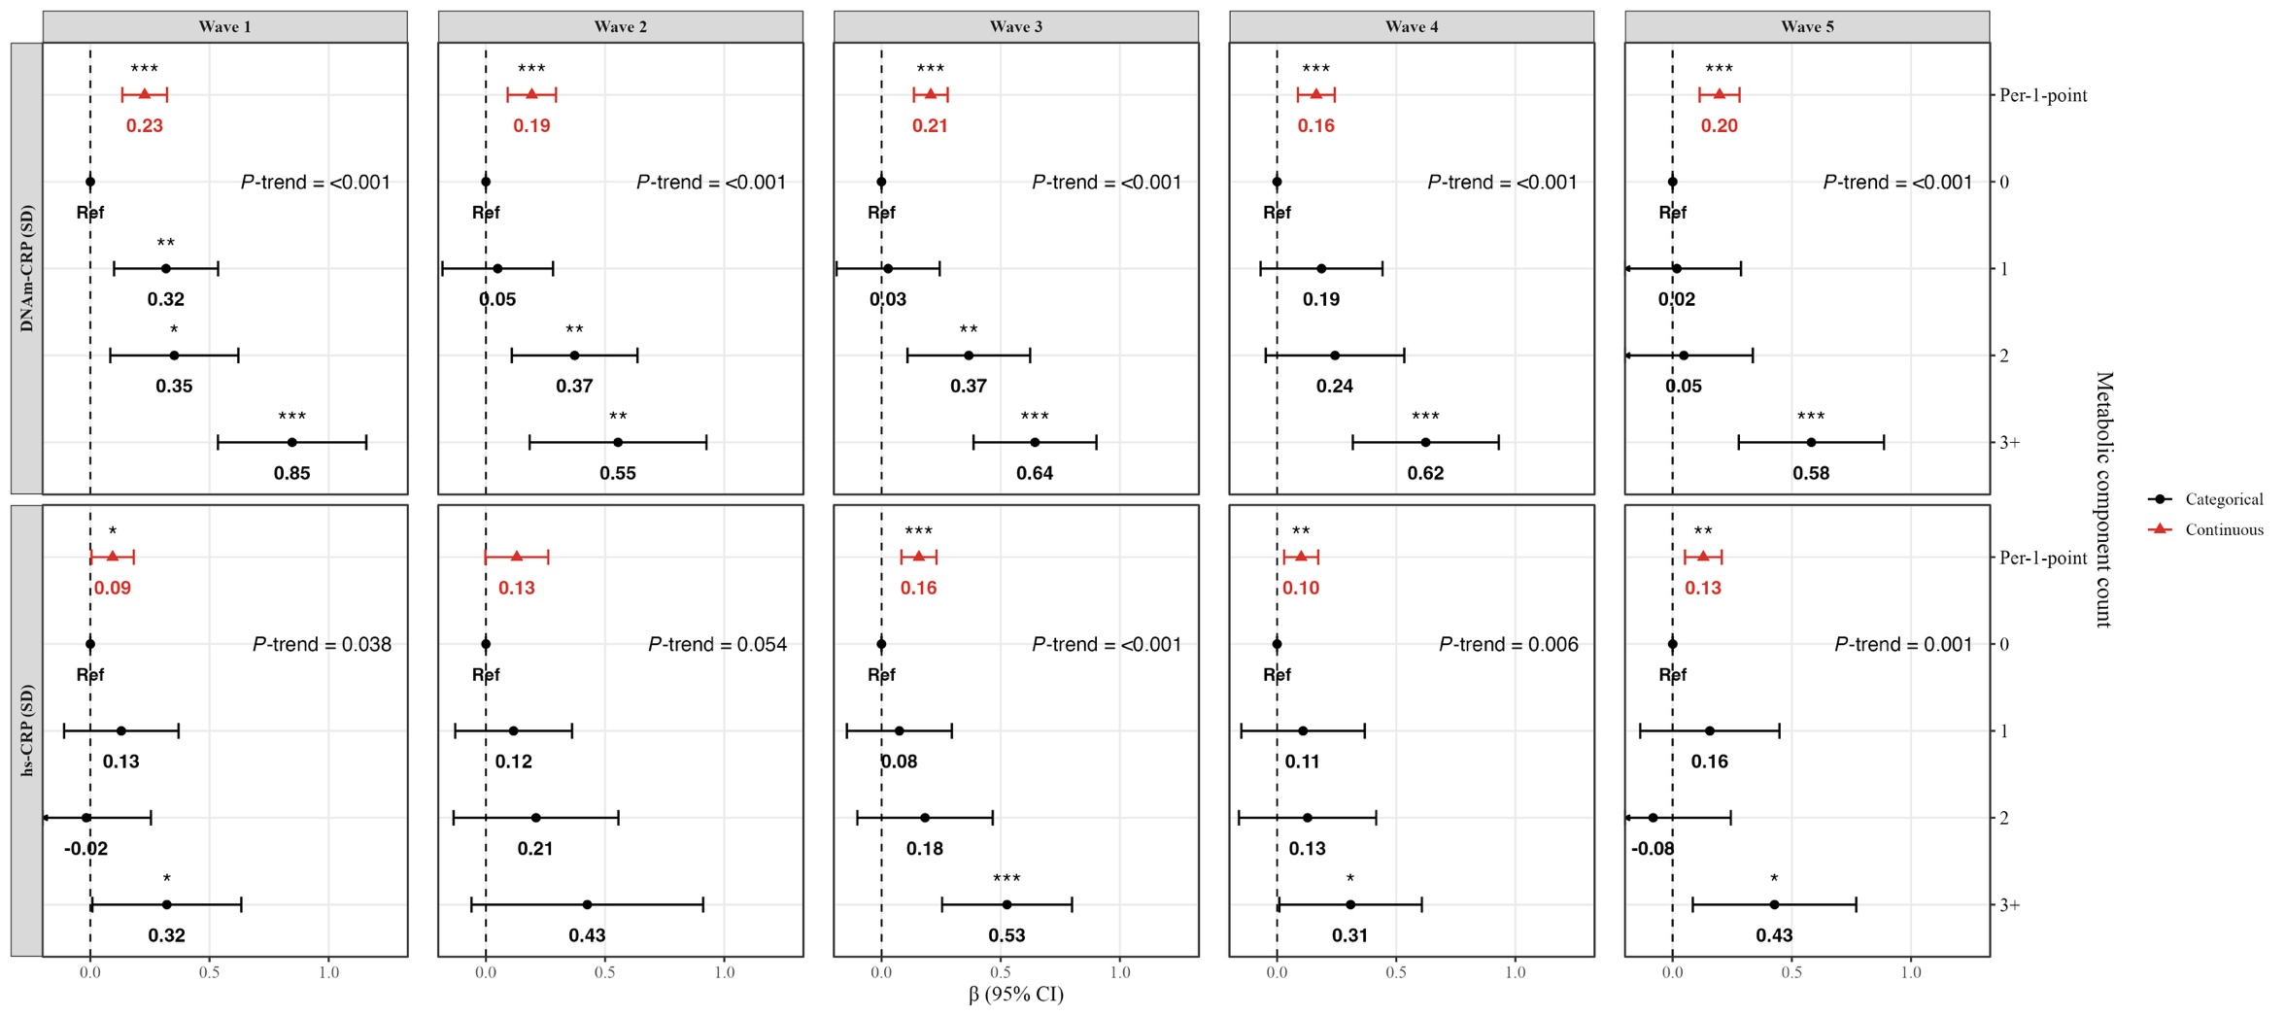
β represents the change in DNAm-CRP and hs-CRP in metabolic component count for each one-point increase and the effect size for groups 1, 2, and 3+ compared with group 0. Models were adjusted for chronological age, sex, area, height, education level, alcohol consumption, pack-years, current smoking status, exercise and BMI. Models for for DNAm-CRP were additionally adjusted for cell composition. 95% CI and p-values were calculated using HC3 heteroscedasticity-consistent standard errors.
*P-value <0.05, **P-value < 0.01, *** P-value < 0.001
Abbreviations: SD; Standard deviation; DNAm-CRP; DNA methylation–derived CRP score

Supplementary Figure 9. Mediation analysis of hs-CRP and DNAm-CRP in the association between categorical metabolic component count (Wave 1) and lung function
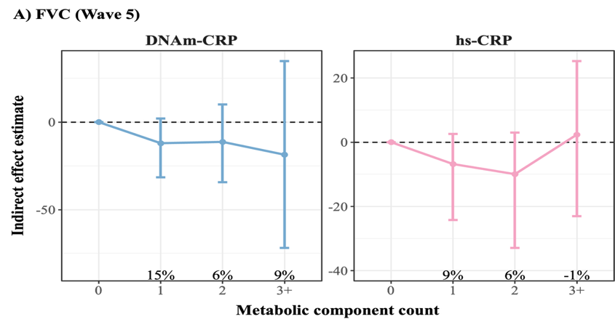 | 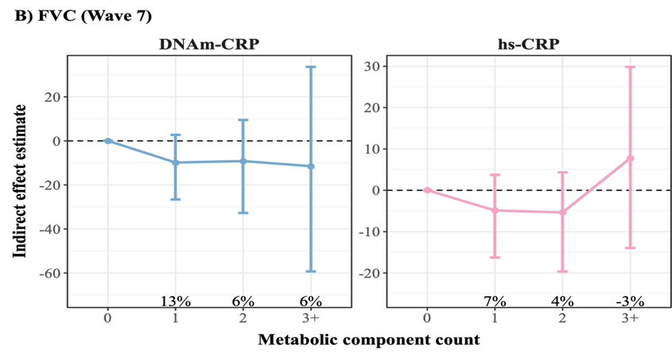
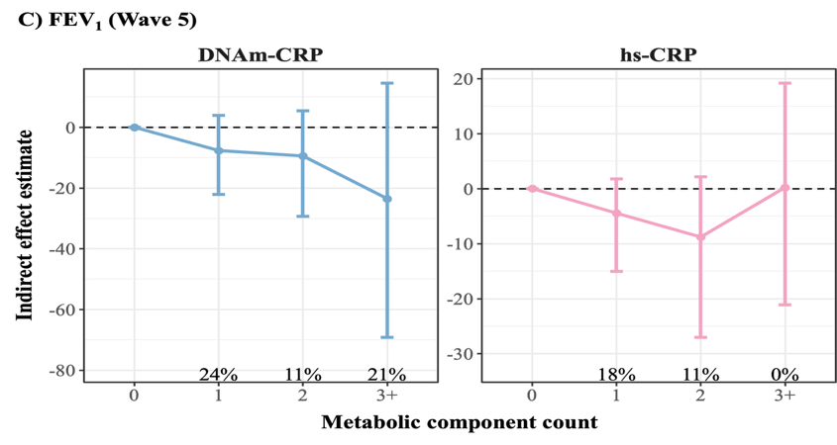 | 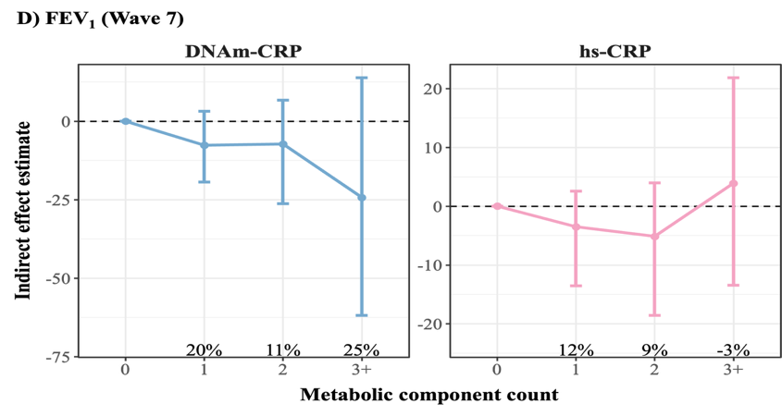
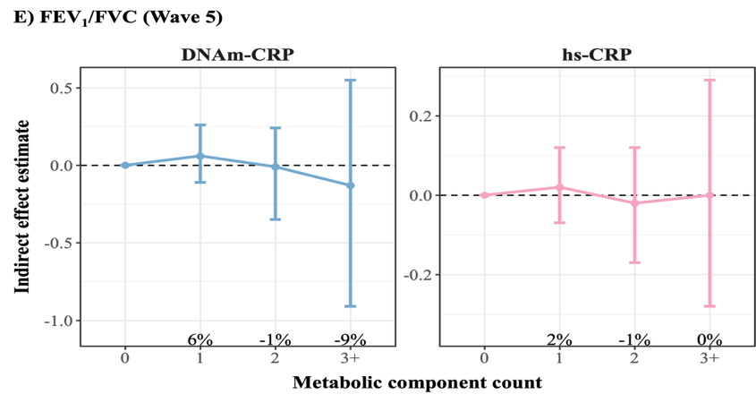 | 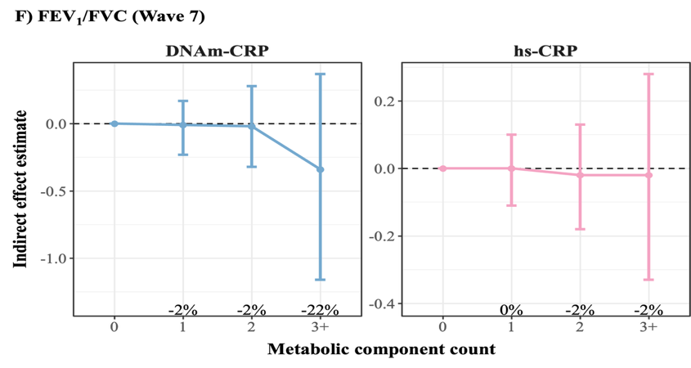
Models were adjusted for chronological age, sex, area, height, education level, alcohol consumption, pack-year, current smoking status, exercise and BMI. Models for for DNAm-CRP were additionally adjusted for cell composition.
Abbreviations: FVC, Forced vital capacity; FEV₁, Forced expiratory volume in 1 second; DNAm-CRP, DNA methylation–derived CRP score
Supplementary Table 1. Characteristics of study participants with DNAm data (N=1,520) and those included in the final analytic sample (N=664) at Wave 5
Characteristic |  | Participants with DNAm data*  (N=1,520) | Final analytic sample  (N=664)
Age (year), mean (SD) |  | 59.8 (8.8) | 56.3 (7.2)
Sex, n (%) | Male | 803 (52.8%) | 357 (53.8)
Sex, n (%) | Female | 717 (47.2%) | 307 (46.2)
Recruitment site, n (%) | Ansan | 695 (45.7%) | 358 (53.9)
Recruitment site, n (%) | Ansung | 825 (54.3%) | 306 (46.1)
Education, n (%) | < High school | 791 (52.0%) | 279 (42.0)
Education, n (%) | ≥ High school | 718 (47.2%) | 385 (58.0)
Smoking status, n (%) | Not current smoker | 1231 (81.0%) | 545 (82.1)
Smoking status, n (%) | Current smoker | 288 (18.9%) | 119 (17.9)
Packyear, mean (SD) |  | 11.7 (18.8) | 10.0 (15.9)
Alcohol consumption, n (%) | Non drinker | 743 (48.9%) | 302 (45.5)
Alcohol consumption, n (%) | Former drinker | 80 (5.3%) | 23 (3.5)
Alcohol consumption, n (%) | Current drinker | 696 (45.8%) | 339 (51.1)
BMI (kg/m²), mean (SD) |  | 24.3 (3.0) | 24.3 (2.9)
Height (cm), mean (SD) |  | 160 (8.8) | 162 (8.0)
Exercise participation, n (%) | None | 882 (58.0%) | 339 (51.1)
Exercise participation, n (%) | Regular | 638 (42.0%) | 325 (48.9)
Lung function, mean (SD) | FVC (mL) | 3550 (834) | 3680 (807)
Lung function, mean (SD) | FEV₁ (mL) | 2760 (652) | 2880 (623)
Lung function, mean (SD) | FEV₁/FVC (%) | 77.9 (7.2) | 78.6 (6.2)
DNAm-CRP, mean (SD) | Raw score | -0.2 (0.0) | -0.2 (0.0)
DNAm-CRP, mean (SD) | Standardized score† | 0.3 (1.0) | 0.0 (1.0)
hs-CRP‡, mean (SD) |  | -0.3 (1.1) | -0.5 (1.0)
* Participants with DNAm data: Participants were excluded because of missing information on education (n = 11), smoking status (n = 1), packyear (n = 5), alcohol consumption (n = 1), and lung function (n = 182).
† DNAm-CRP was standardized using the mean and SD of the final analytic sample.
‡ hs-CRP levels were natural log-transformed.
Abbreviations: SD, Standard deviation; BMI, Body mass index (calculated as weight in kilograms divided by height in meters squared); FVC, Forced vital capacity; FEV1, Forced expiratory volume in 1 second; DNAm-CRP, DNA methylation–derived CRP score

Supplementary Table 2. Characteristics of participants included in and excluded from the final analytic sample at Wave 5
Characteristic |  | Final analytic sample  (N=664) | Excluded from final analysis (N= 856) | P value
Age (year), mean (SD) |  | 56.3 (7.2) | 62.5 (9.0) | <0.001
Sex, n (%) | Male | 357 (53.8) | 446 (52.1%) | 0.554
Sex, n (%) | Female | 307 (46.2) | 410 (47.9%) | 0.554
Recruitment site, n (%) | Ansan | 358 (53.9) | 337 (39.4%) | <0.001
Recruitment site, n (%) | Ansung | 306 (46.1) | 519 (60.6%) | <0.001
Education, n (%) | < High school | 279 (42.0) | 512 (59.8%) | <0.001
Education, n (%) | ≥ High school | 385 (58.0) | 333 (38.9%) | <0.001
Smoking status, n (%) | Not current smoker | 545 (82.1) | 686 (80.1%) | 0.399
Smoking status, n (%) | Current smoker | 119 (17.9) | 169 (19.7%) | 0.399
Packyear, mean (SD) |  | 10.0 (15.9) | 13.0 (20.7) | 0.001
Alcohol consumption, n (%) | Non drinker | 302 (45.5) | 441 (51.5%) | <0.001
Alcohol consumption, n (%) | Former drinker | 23 (3.5) | 57 (6.7%) | <0.001
Alcohol consumption, n (%) | Current drinker | 339 (51.1) | 357 (41.7%) | <0.001
BMI (kg/m²), mean (SD) |  | 24.3 (2.9) | 24.4 (3.1) | 0.329
Height (cm), mean (SD) |  | 162 (8.0) | 159 (9.3) | <0.001
Exercise participation, n (%) | None | 339 (51.1) | 543 (63.4%) | <0.001
Exercise participation, n (%) | Regular | 325 (48.9) | 313 (36.6%) | <0.001
Lung function, mean (SD) | FVC (mL) | 3680 (807) | 3430 (841) | <0.001
Lung function, mean (SD) | FEV₁ (mL) | 2880 (623) | 2630 (658) | <0.001
Lung function, mean (SD) | FEV₁/FVC (%) | 78.6 (6.2) | 77.3 (8.0) | 0.001
DNAm-CRP, mean (SD) | Raw score | -0.19 (0.0) | -0.188 (0.0) | <0.001
hs-CRP‡, mean (SD) |  | -0.47 (1.0) | -0.133 (1.2) | <0.001
† Among participants excluded from the final analysis, data were missing for education (n = 11), packyear (n = 5), smoking status (n = 1) and alcohol consumption (n=1). Percentage were calculated based on available data for each characteristic.
‡ hs-CRP levels were natural log-transformed.
Abbreviations: SD, Standard deviation; BMI, Body mass index (calculated as weight in kilograms divided by height in meters squared); FVC, Forced vital capacity; FEV₁, Forced expiratory volume in 1 second; DNAm-CRP, DNA methylation–derived CRP score

Supplementary Table 3. Metabolic profile of study participants at Waves 1-5 and lung function at Wave 7
Characteristic |  | Wave 1  (2001-2002) | Wave 2  (2003-2004) | Wave 3  (2005-2006) | Wave 4  (2007-2008) | Wave 5  (2009-2010) | Wave 7  (2013-2014)
Blood pressure (mmHg), mean (SD) | Diastolic BP | 78.5 (11.9) | 76.4 (11.6) | 77.0 (10.8) | 76.7 (9.7) | 77.8 (10.0) | -
 | Systolic BP | 117 (17.9) | 113 (16.0) | 113 (16.3) | 114 (15.3) | 116 (15.7) | -
Fasting glucose (mg/dL), mean (SD) |  | 87.4 (10.0) | 90.6 (12.4) | 90.3 (15.1) | 93.3 (15.8) | 95.8 (17.0) | -
HDL cholesterol (mg/dL), mean (SD) |  | 49.5 (11.4) | 46.7 (10.2) | 44.2 (10.4) | 44.8 (10.6) | 43.6 (11.2) | -
Triglyceride (mg/dL), mean (SD) |  | 136 (82.8) | 125 (83.9) | 128 (97.3) | 132 (83.7) | 137 (91.3) | -
Waist circumference (cm), mean (SD) |  | 81.4 (8.4) | 82.1 (8.8) | 83.0 (8.6) | 83.0 (9.3) | 83.2 (9.0) | -
Metabolic component count, mean (SD) |  | 1.3 (1.2) | 1.4 (1.2) | 1.5 (1.3) | 1.7 (1.4) | 1.8 (1.3) | -
Metabolic component count , n (%) | 0 | 207 (31.2) | 190 (28.6) | 151 (22.7) | 145 (21.8) | 114 (17.2) | -
 | 1 | 210 (31.6) | 224 (33.7) | 237 (35.7) | 204 (30.7) | 205 (30.9) | -
 | 2 | 145 (21.8) | 127 (19.1) | 135 (20.3) | 142 (21.4) | 154 (23.2) | -
 | 3-5 | 102 (15.4) | 123 (18.5) | 141 (21.2) | 173 (26.1) | 191 (28.8) | -
Lung function, mean (SD) | FVC (mL) | - | - | - | - | - | 3500 (788)
 | FEV₁ (mL) | - | - | - | - | - | 2660 (590)
 | FEV₁/FVC (%) | - | - | - | - | - | 76.4 (6.5)
Abbreviations: SD, Standard deviation; BP, Blood pressure; FVC, Forced vital capacity; FEV₁, Forced expiratory volume in 1 second

Supplementary Table 4. Association between each metabolic risk factor at Wave 1 and lung function at Waves 5 and 7
 |  | Wave 5 |  | Wave 7
 |  | β (95% CI) | P value | β (95% CI) | P value
Abdominal obesity | FVC | -83.4 (-193.8, 27.1) | 0.139 | -113.8 (-219.7, -7.9) | 0.035
Abdominal obesity | FEV₁ | -9.0 (-101.2, 83.2) | 0.848 | -37.4 (-125.4, 50.5) | 0.404
Abdominal obesity | FEV₁/FVC | 1.4 (0.1, 2.7) | 0.04 | 1.3 (-0.1, 2.7) | 0.063
High blood pressure | FVC | -97.3 (-177.6, -17.0) | 0.018 | -66.4 (-143.7, 10.8) | 0.092
High blood pressure | FEV₁ | -37.1 (-104.3, 30.0) | 0.278 | -17.3 (-81.4, 46.8) | 0.597
High blood pressure | FEV₁/FVC | 0.9 (-0.0, 1.9) | 0.058 | 0.8 (-0.2, 1.8) | 0.114
High fasting glucose | FVC | -86.7 (-214.5, 41.1) | 0.183 | -69.9 (-192.8, 53.0) | 0.264
High fasting glucose | FEV₁ | -106.5 (-212.8, -0.2) | 0.05 | -98.6 (-200.1, 3.0) | 0.057
High fasting glucose | FEV₁/FVC | -1.0 (-2.6, 0.5) | 0.194 | -1.3 (-2.9, 0.3) | 0.115
Hypertriglyceridemia | FVC | -96.5 (-177.0, -16.0) | 0.019 | -93.2 (-170.6, -15.8) | 0.018
Hypertriglyceridemia | FEV₁ | -42.7 (-109.9, 24.6) | 0.213 | -35.3 (-99.6, 29.0) | 0.281
Hypertriglyceridemia | FEV₁/FVC | 0.8 (-0.1, 1.8) | 0.093 | 0.9 (-0.2, 1.9) | 0.102
Low HDL-C | FVC | -64.1 (-142.8, 14.5) | 0.11 | -65.5 (-141.0, 10.1) | 0.089
Low HDL-C | FEV₁ | -49.1 (-114.7, 16.4) | 0.141 | -37.1 (-99.8, 25.5) | 0.245
Low HDL-C | FEV₁/FVC | -0.1 (-1.0, 0.9) | 0.894 | 0.4 (-0.6, 1.4) | 0.447
Abbreviations: FVC, Forced vital capacity; FEV₁, Forced expiratory volume in 1 second
Abdominal obesity: waist circumference ≥90 cm (men), ≥85 cm (women)
High blood pressure: SBP ≥130/DBP ≥85 mmHg or antihypertensive medication use
High fasting glucose: fasting glucose ≥ 100 mg/dL or glucose lowering medication
Hypertriglyceridemia: triglycerides ≥150 mg/dL or lipid-lowering medication
Low HDL cholesterol: HDL-C <40 mg/dL(men), <50mg/dL(women)
Model were adjusted for chronological age, sex, area, height, education level, alcohol consumption, pack-year, current smoking status, exercise and BMI.

Supplementary Table 5. Sensitivity analysis of the associations between hs-CRP and DNAm-CRP with lung function, excluding BMI adjustment
 |  |  | Wave 5 |  |  | Wave 7
 |  | Tertile | βª (95%CI) | P value | P trend | βª (95%CI) | p-value | P trend
FVC | hs-CRP | T1 (<-0.48) | Ref. |  | 0.003 | Ref. |  | 0.014
 |  | T2 (-0.48, 0.39) | -70.1 (-153.4, 13.3) | 0.099 |  | -60.5 (-142.5, 21.5) | 0.148
 |  | T3 (≥0.39) | -135.6 (-226.1, -45.0) | 0.003 |  | -111.0 (-199.5, -22.6) | 0.014
 |  | per 1-SD increase | -61.5 (-98.7, -24.2) | 0.001 |  | -52.2 (-87.6, -16.8) | 0.004
 | DNAm-CRP | T1 (<-0.46) | Ref. |  | 0.001 | Ref. |  | 0.008
 |  | T2 (-0.46, 0.40) | -74.4 (-162.6, 13.8) | 0.098 |  | -63.3 (-147.4, 20.8) | 0.14
 |  | T3 (≥0.40) | -140.2 (-226.5, -53.9) | 0.001 |  | -115.1 (-199.9, -30.2) | 0.008
 |  | per 1-SD increase | -59.2 (-95.1, -23.4) | 0.001 |  | -52.8 (-87.4, -18.1) | 0.003
FEV₁ | hs-CRP | T1 (<-0.48) | Ref. |  | 0.036 | Ref. |  | 0.059
 |  | T2 (-0.48, 0.39) | -24.0 (-94.2, 46.3) | 0.503 |  | -28.2 (-95.5, 39.1) | 0.412
 |  | T3 (≥0.39) | -81.5 (-158.0, -5.1) | 0.037 |  | -70.5 (-143.7, 2.7) | 0.059
 |  | per 1-SD increase | -33.7 (-64.7, -2.8) | 0.033 |  | -27.1 (-56.5, 2.2) | 0.07
 | DNAm-CRP | T1 (<-0.46) | Ref. |  | 0.027 | Ref. |  | 0.044
 |  | T2 (-0.46, 0.40) | -55.6 (-130.5, 19.2) | 0.145 |  | -50.1 (-120.8, 20.5) | 0.164
 |  | T3 (≥0.40) | -82.1 (-154.8, -9.4) | 0.027 |  | -71.8 (-141.4, -2.2) | 0.043
 |  | per 1-SD increase | -35.4 (-63.5, -7.2) | 0.014 |  | -32.8 (-59.8, -5.9) | 0.017
FEV₁/FVC | hs-CRP | T1 (<-0.48) | Ref. |  | 0.291 | Ref. |  | 0.606
 |  | T2 (-0.48, 0.39) | 0.9 (-0.1, 1.9) | 0.09 |  | 0.5 (-0.5, 1.6) | 0.328
 |  | T3 (≥0.39) | 0.6 (-0.5, 1.8) | 0.287 |  | 0.3 (-0.9, 1.5) | 0.602
 |  | per 1-SD increase | 0.4 (-0.0, 0.8) | 0.077 |  | 0.3 (-0.1, 0.8) | 0.144
 | DNAm-CRP | T1 (<-0.46) | Ref. |  | 0.180 | Ref. |  | 0.604
 |  | T2 (-0.46, 0.40) | 0.0 (-1.1, 1.1) | 0.94 |  | -0.3 (-1.4, 0.9) | 0.659
 |  | T3 (≥0.40) | 0.8 (-0.4, 1.9) | 0.182 |  | 0.3 (-0.9, 1.5) | 0.609
 |  | per 1-SD increase | 0.3 (-0.2, 0.8) | 0.186 |  | 0.2 (-0.3, 0.7) | 0.532
hs-CRP and DNAm-CRP were standardized to a mean of 0 and an SD of 1 within the final analytic sample. Tertiles were defined based on the standardized score. ªβ represents the change in hs-CRP and MRS-CRP for each one-SD increase and for comparisons across tertile group. Models were adjusted for chronological age, sex, area, height, education level, alcohol consumption, pack-year, current smoking status and exercise. Models for for DNAm-CRP were additionally adjusted for cell composition. 95% CI and p-values were calculated using HC3 heteroscedasticity-consistent standard errors.
Abbreviations: SD, Standard deviation; FVC, Forced vital capacity; FEV₁, Forced expiratory volume in 1 second; DNAm-CRP, DNA methylation–derived CRP score

Supplementary Table 6. Sensitivity analysis of the associations between hs-CRP and DNAm-CRP with lung function using inverse probability weighting
 |  |  | Wave 5 |  |  | Wave 7
 |  | Tertile | βª (95% CI) | P value | P trend | βª (95% CI) | P value | P trend
FVC | hs-CRP | T1 (<-0.48) | Ref. |  |  | Ref.
 |  | T2 (-0.48, 0.39) | -50.5 (-143.3, 42.3) | 0.286 |  | -41.3 (-134.4, 51.8) | 0.384
 |  | T3 (≥0.39) | -101.8 (-204.7, 1.2) | 0.053 | 0.054 | -90.7 (-195.1, 13.7) | 0.088 | 0.086
 |  | per 1-SD increase | -49.3 (-88.4, -10.2) | 0.014 |  | -45.8 (-84.4, -7.1) | 0.02
 | DNAm-CRP | T1 (<-0.46) | Ref. |  |  | Ref.
 |  | T2 (-0.46, 0.40) | -55.8 (-161.9, 50.2) | 0.302 |  | -33.0 (-132.1, 66.2) | 0.514
 |  | T3 (≥0.40) | -101.3 (-195.6, -7.0) | 0.035 | 0.036 | -83.1 (-175.8, 9.7) | 0.079 | 0.077
 |  | per 1-SD increase | -33.9 (-77.1, 9.3) | 0.124 |  | -34.6 (-75.4, 6.2) | 0.096
FEV₁ | hs-CRP | T1 (<-0.48) | Ref. |  |  | Ref.
 |  | T2 (-0.48, 0.39) | -4.0 (-78.2, 70.2) | 0.915 |  | -10.8 (-83.8, 62.2) | 0.771
 |  | T3 (≥0.39) | -68.3 (-150.2, 13.7) | 0.102 | 0.091 | -62.9 (-145.0, 19.1) | 0.132 | 0.122
 |  | per 1-SD increase | -32.4 (-65.2, 0.4) | 0.053 |  | -28.9 (-60.2, 2.5) | 0.071
 | DNAm-CRP | T1 (<-0.46) | Ref. |  |  | Ref.
 |  | T2 (-0.46, 0.40) | -46.7 (-132.2, 38.7) | 0.283 |  | -33.6 (-116.3, 49.2) | 0.426
 |  | T3 (≥0.40) | -64.1 (-138.4, 10.1) | 0.09 | 0.096 | -49.8 (-121.0, 21.3) | 0.17 | 0.177
 |  | per 1-SD increase | -18.65 (-50.1, 12.8) | 0.245 |  | -16.6 (-46.9, 13.6) | 0.281
FEV₁/FVC | hs-CRP | T1 (<-0.48) | Ref. |  |  | Ref.
 |  | T2 (-0.48, 0.39) | 0.86 (-0.4, 2.1) | 0.164 |  | 0.5 (-0.8, 1.8) | 0.442
 |  | T3 (≥0.39) | 0.0 (-1.5, 1.6) | 0.968 | 0.936 | -0.1 (-1.6, 1.4) | 0.89 | 0.825
 |  | per 1-SD increase | 0.07 (-0.6, 0.7) | 0.828 |  | 0.1 (-0.5, 0.7) | 0.762
 | DNAm-CRP | T1 (<-0.46) | Ref. |  |  | Ref.
 |  | T2 (-0.46, 0.40) | -0.1 (-1.4, 1.1) | 0.835 |  | -0.5 (-1.9, 0.9) | 0.511
 |  | T3 (≥0.40) | 0.2 (-1.2, 1.6) | 0.765 | 0.753 | 0.1 (-1.3, 1.5) | 0.903 | 0.869
 |  | per 1-SD increase | 0.1 (-0.4, 0.7) | 0.61 |  | 0.2 (-0.4, 0.8) | 0.546
hs-CRP and DNAm-CRP were standardized to a mean of 0 and an SD of 1 within the final analytic sample. Tertiles were defined based on the standardized score. ªβ represents the change in hs-CRP and MRS-CRP for each one-SD increase and for comparisons across tertile group. Models were adjusted for chronological age, sex, area, height, education level, alcohol consumption, pack-year, current smoking status and exercise. Models for for DNAm-CRP were additionally adjusted for cell composition. 95% CI and p-values were calculated using HC3 heteroscedasticity-consistent standard errors.
Abbreviations: SD, Standard deviation; FVC, Forced vital capacity; FEV₁, Forced expiratory volume in 1 second; DNAm-CRP, DNA methylation–derived CRP score
Supplementary Table 7. Mediation analysis of hs-CRP and DNAm-CRP in the associations between mean metabolic component count and lung function
 |  | Wave 5 |  | Wave 7
 |  | β (95% CI) | P value | β (95% CI) | P value
FVC
hs-CRP | ACME | -9.5 (-20.7, -1.7) | 0.02 | -7.1 (-15.9, -0.1) | 0.044
 | ADE | -83.1 (-128.0, -41.8) | <0.001 | -70.3 (-110.0, -25.9) | <0.001
 | Total Effect | -92.6 (-135.4, -53.7) | <0.001 | -77.4 (-117.8, -34.9) | <0.001
 | Proportion Mediated | 0.1 (0.0, 0.3) | 0.020 | 0.1 (0, 0.3) | 0.044
DNAm-CRP | ACME | -10.9 (-22.8, -0.2) | 0.048 | -8.3 (-19.3, 1.7) | 0.144
 | ADE | -84.7 (-128.8, -39.4) | <0.001 | -73.7 (-118.0, -34.3) | <0.001
 | Total Effect | -95.6 (-138.3, -53.0) | <0.001 | -82.0 (-124.1, -44.3) | <0.001
 | Proportion Mediated | 0.1 (0, 0.3) | 0.048 | 0.1 (-0.0, 0.3) | 0.144
FEV₁
hs-CRP | ACME | -6.3 (-14.3, 0.1) | 0.056 | -4.7 (-12.9, 1.4) | 0.12
 | ADE | -49.8 (-80.6, -17.3) | 0.004 | -35.4 (-67.7, -3.0) | 0.04
 | Total Effect | -56.0 (-89.4, -23.6) | <0.001 | -40.1 (-74.0, -8.8) | 0.016
 | Proportion Mediated | 0.1 (0, 0.4) | 0.056 | 0.1 (-0.1, 0.6) | 0.136
DNAm-CRP | ACME | -8.2 (-17.3, 0.8) | 0.084 | -7.3 (-17.0, 1.1) | 0.072
 | ADE | -51.2 (-85.6, -16.1) | <0.001 | -37.6 (-70.6, -2.8) | 0.028
 | Total Effect | -59.5 (-93.2, -26.3) | <0.001 | -44.9 (-76.7, -11.8) | 0.004
 | Proportion Mediated | 0.1 (-0.0, 0.4) | 0.084 | 0.2 (-0.0, 0.7) | 0.076
FEV₁ /FVC
hs-CRP | ACME | 0.0 (-0.1, 0.1) | 0.46 | 0.0 (-0.1, 0.1) | 0.7
 | ADE | 0.4 (-0.1, 0.9) | 0.092 | 0.5 (-0.1, 1.0) | 0.096
 | Total Effect | 0.4 (0, 0.9) | 0.052 | 0.5 (-0.0, 1.0) | 0.072
 | Proportion Mediated | 0.1 (-0.2, 0.8) | 0.488 | 0.0 (-0.5, 0.9) | 0.716
DNAm-CRP | ACME | 0.0 (-0.1, 0.2) | 0.852 | -0.0 (-0.2, 0.1) | 0.688
 | ADE | 0.4 (-0.2, 0.9) | 0.168 | 0.5 (-0.1, 1.0) | 0.096
 | Total Effect | 0.4 (-0.1, 0.9) | 0.120 | 0.4 (-0.1, 0.9) | 0.108
 | Proportion Mediated | 0.0 (-1.4, 1.1) | 0.892 | -0.1 (-2.2, 0.5) | 0.716
Models were adjusted for chronological age, sex, area, height, education level, alcohol consumption, pack-year, current smoking status, exercise and BMI. Models for for DNAm-CRP were additionally adjusted for cell composition.
Abbreviations: SD, Standard deviation; FVC, Forced vital capacity; FEV₁, Forced expiratory volume in 1 second; DNAm-CRP, DNA methylation–derived CRP score; ACME, Average causal mediation effect; ADE, Average direct effect.

Supplementary Table 8. Individual mediation analyses for each metabolic risk factor (Wave 1)
 |  | Wave 5 |  |  | Wave 7
 |  | β (95% CI) |  | P value | β (95% CI) | P value
Abdominal obesity
FVC
hs-CRP | ACME | -19.4 (-41.7, -4.6) | 0.004 |  | -14.3 (-31, -1.3) | 0.04
 | ADE | -64 (-176.8, 36.1) | 0.216 |  | -99.3 (-193.1, -1.3) | 0.052
 | Total Effect | -83.4 (-194.1, 20.1) | 0.124 |  | -113.6 (-202.4, -15.2) | 0.024
 | Proportion Mediated | 0.2 (-1.7, 2.1) | 0.128 |  | 0.1 (0, 0.7) | 0.064
DNAm-CRP | ACME | -9.4 (-28.1, 2.5) | 0.128 |  | -7.4 (-25.1, 2.1) | 0.192
 | ADE | -74 (-184, 43.7) | 0.196 |  | -104.4 (-207.2, -14.4) | 0.024
 | Total Effect | -83.4 (-193.2, 34.3) | 0.136 |  | -111.8 (-212.4, -21.2) | 0.012
 | Proportion Mediated | 0.1 (-0.6, 1.1) | 0.248 |  | 0.1 (0, 0.4) | 0.204
FEV₁
hs-CRP | ACME | -13 (-30.3, -1.6) | 0.008 |  | -9.3 (-23.8, 0.8) | 0.076
 | ADE | 4 (-72.3, 85.3) | 0.936 |  | -27.9 (-111.1, 50.2) | 0.496
 | Total Effect | -9 (-90, 76.3) | 0.868 |  | -37.2 (-122.4, 38.9) | 0.376
 | Proportion Mediated | 1.4 (-4.2, 3.2) | 0.868 |  | 0.2 (-2.1, 2.2) | 0.412
DNAm-CRP | ACME | -6.8 (-19.2, 1.8) | 0.14 |  | -5.6 (-16.6, 2.1) | 0.16
 | ADE | 3.7 (-88.7, 90.1) | 0.86 |  | -23.2 (-111.3, 60.8) | 0.5
 | Total Effect | -3.1 (-95.1, 78.6) | 0.972 |  | -28.9 (-115.6, 49.7) | 0.42
 | Proportion Mediated | 2.2 (-2.8, 3.8) | 0.976 |  | 0.2 (-1.7, 1.6) | 0.524
FEV₁ /FVC
hs-CRP | ACME | 0.1 (-0.1, 0.2) | 0.472 |  | 0 (-0.1, 0.2) | 0.64
 | ADE | 1.3 (-0.1, 2.6) | 0.072 |  | 1.3 (-0.2, 2.6) | 0.088
 | Total Effect | 1.4 (0.1, 2.7) | 0.032 |  | 1.3 (-0.1, 2.6) | 0.076
 | Proportion Mediated | 0 (-0.1, 0.5) | 0.496 |  | 0 (-0.1, 0.3) | 0.66
DNAm-CRP | ACME | 0 (-0.1, 0.1) | 0.668 |  | 0 (-0.1, 0.1) | 0.972
 | ADE | 1.5 (0.2, 2.8) | 0.024 |  | 1.5 (0.1, 2.8) | 0.04
 | Total Effect | 1.5 (0.2, 2.8) | 0.024 |  | 1.5 (0.1, 2.8) | 0.044
 | Proportion Mediated | 0 (0, 0.1) | 0.676 |  | 0 (-0.1, 0.1) | 0.984
High blood pressure
FVC
hs-CRP | ACME | 1.6 (-8.5, 13) | 0.74 |  | 1.2 (-7.7, 9.9) | 0.832
 | ADE | -98.9 (-182.9, -27.7) | 0.004 |  | -68.1 (-155.5, 9) | 0.092
 | Total Effect | -97.3 (-182.7, -22.7) | 0.004 |  | -66.8 (-153.7, 9.3) | 0.104
 | Proportion Mediated | 0 (-0.2, 0.1) | 0.744 |  | 0 (-0.5, 0.3) | 0.872
DNAm-CRP | ACME | -10.1 (-23.7, -1.3) | 0.016 |  | -8.2 (-20.1, 0.1) | 0.052
 | ADE | -86 (-170.7, -4) | 0.044 |  | -59.8 (-130.5, 11) | 0.132
 | Total Effect | -96.2 (-181.9, -12.1) | 0.024 |  | -67.9 (-141.3, 3.4) | 0.068
 | Proportion Mediated | 0.1 (0, 0.5) | 0.04 |  | 0.1 (-0.2, 1.6) | 0.112
FEV₁
hs-CRP | ACME | 1 (-5.1, 10.1) | 0.732 |  | 0.8 (-5, 8.4) | 0.772
 | ADE | -38.2 (-101, 26.4) | 0.24 |  | -18.8 (-90.4, 44.8) | 0.58
 | Total Effect | -37.1 (-103, 27.9) | 0.276 |  | -18.1 (-90.4, 48.4) | 0.608
 | Proportion Mediated | 0 (-0.4, 0.5) | 0.856 |  | 0 (-0.5, 1.4) | 0.988
DNAm-CRP | ACME | -7.3 (-17.8, -0.4) | 0.036 |  | -6.2 (-15.3, -0.1) | 0.048
 | ADE | -32.6 (-103.4, 41.3) | 0.348 |  | -18.3 (-86, 48.4) | 0.576
 | Total Effect | -39.9 (-109.6, 36) | 0.288 |  | -24.5 (-94.5, 41.4) | 0.468
 | Proportion Mediated | 0.2 (-1.8, 1) | 0.316 |  | 0.3 (-2, 2.1) | 0.452
FEV₁ /FVC
hs-CRP | ACME | 0 (-0.1, 0) | 0.756 |  | 0 (-0.1, 0) | 0.772
 | ADE | 0.9 (0, 1.9) | 0.044 |  | 0.8 (-0.2, 1.9) | 0.132
 | Total Effect | 0.9 (0, 1.9) | 0.044 |  | 0.8 (-0.2, 1.9) | 0.132
 | Proportion Mediated | 0 (-0.1, 0.1) | 0.776 |  | 0 (-0.3, 0.1) | 0.76
DNAm-CRP | ACME | 0 (-0.1, 0.1) | 0.776 |  | 0 (-0.1, 0.1) | 0.88
 | ADE | 0.8 (-0.2, 1.7) | 0.096 |  | 0.7 (-0.4, 1.6) | 0.256
 | Total Effect | 0.8 (-0.1, 1.8) | 0.084 |  | 0.7 (-0.5, 1.6) | 0.28
 | Proportion Mediated | 0 (-0.2, 0.3) | 0.804 |  | 0 (-1, 0.6) | 0.944
High fasting glucose
FVC
hs-CRP | ACME | -11.1 (-28.2, 3.6) | 0.124 |  | -8.5 (-22.5, 2.6) | 0.152
 | ADE | -75.6 (-172.4, 37.3) | 0.176 |  | -59.6 (-160.3, 56.9) | 0.336
 | Total Effect | -86.7 (-186, 26.3) | 0.132 |  | -68.2 (-172.7, 51.6) | 0.28
 | Proportion Mediated | 0.1 (-0.6, 0.7) | 0.24 |  | 0.1 (-0.9, 1.2) | 0.384
DNAm-CRP | ACME | -31.1 (-59.6, -7.1) | <0.001 |  | -24.9 (-49.8, -4.5) | 0.012
 | ADE | -53.3 (-162.2, 65.9) | 0.396 |  | -41.8 (-142.3, 73.6) | 0.476
 | Total Effect | -84.4 (-194.5, 38.6) | 0.148 |  | -66.6 (-167.1, 40) | 0.24
 | Proportion Mediated | 0.4 (-1.6, 3.8) | 0.148 |  | 0.4 (-3.2, 3.4) | 0.252
FEV1
hs-CRP | ACME | -7 (-20, 2.5) | 0.152 |  | -5.1 (-17.5, 2.5) | 0.232
 | ADE | -99.5 (-202.8, -15.3) | 0.012 |  | -90.4 (-187, 9.3) | 0.064
 | Total Effect | -106.5 (-210.6, -22) | 0.016 |  | -95.5 (-195, 5) | 0.056
 | Proportion Mediated | 0.1 (0, 0.3) | 0.16 |  | 0.1 (-0.1, 0.4) | 0.264
DNAm-CRP | ACME | -20.5 (-43.3, -3.9) | 0.016 |  | -17.1 (-37, -2.8) | 0.008
 | ADE | -82.2 (-189.1, 14.8) | 0.112 |  | -75.2 (-161.6, 11.9) | 0.1
 | Total Effect | -102.7 (-213, -13.8) | 0.028 |  | -92.3 (-177.2, -5.1) | 0.036
 | Proportion Mediated | 0.2 (0, 1.2) | 0.044 |  | 0.2 (0, 1.2) | 0.044
FEV₁ /FVC
hs-CRP | ACME | 0 (0, 0.2) | 0.388 |  | 0 (-0.1, 0.2) | 0.464
 | ADE | -1.1 (-2.6, 0.2) | 0.1 |  | -1.3 (-3.2, 0.7) | 0.176
 | Total Effect | -1 (-2.6, 0.3) | 0.128 |  | -1.2 (-3.1, 0.7) | 0.184
 | Proportion Mediated | 0 (-0.6, 0.3) | 0.476 |  | 0 (-0.5, 0.2) | 0.576
DNAm-CRP | ACME | 0.1 (-0.2, 0.4) | 0.468 |  | 0 (-0.3, 0.4) | 0.824
 | ADE | -1.1 (-2.8, 0.4) | 0.18 |  | -1.3 (-3.4, 0.5) | 0.152
 | Total Effect | -1 (-2.6, 0.5) | 0.252 |  | -1.2 (-3.2, 0.5) | 0.18
 | Proportion Mediated | -0.1 (-1.1, 1.7) | 0.624 |  | 0 (-0.8, 1) | 0.884
Hypertriglyceridemia
FVC
hs-CRP | ACME | -10.9 (-27.7, -0.8) | 0.02 |  | -8.3 (-20.3, -0.7) | 0.02
 | ADE | -85.6 (-171, -3.3) | 0.044 |  | -83.2 (-161.4, -10.2) | 0.028
 | Total Effect | -96.5 (-183.6, -12.6) | 0.024 |  | -91.5 (-169.6, -18.3) | 0.024
 | Proportion Mediated | 0.1 (0, 0.6) | 0.044 |  | 0.1 (0, 0.4) | 0.044
DNAm-CRP | ACME | -22.7 (-44.4, -6.9) | 0.008 |  | -17.2 (-32.9, -1.8) | 0.036
 | ADE | -81.8 (-169.1, 14.2) | 0.092 |  | -85.4 (-177.1, -6.7) | 0.028
 | Total Effect | -104.4 (-193.9, -14.2) | 0.032 |  | -102.7 (-191.4, -21.6) | 0.016
 | Proportion Mediated | 0.2 (0, 1.1) | 0.04 |  | 0.2 (0, 0.7) | 0.052
FEV₁
hs-CRP | ACME | -7.2 (-19, 0.1) | 0.06 |  | -5.3 (-14.2, 0.8) | 0.116
 | ADE | -35.5 (-107.4, 34.1) | 0.32 |  | -27.5 (-94.3, 36.5) | 0.436
 | Total Effect | -42.7 (-112.5, 26.2) | 0.244 |  | -32.8 (-97.4, 27.3) | 0.34
 | Proportion Mediated | 0.2 (-1.8, 1.3) | 0.256 |  | 0.2 (-1.4, 2.2) | 0.44
DNAm-CRP | ACME | -16.9 (-32.8, -4) | 0.008 |  | -14.2 (-30.1, -1.4) | 0.036
 | ADE | -33.9 (-105.4, 37.5) | 0.4 |  | -29.1 (-96.3, 36.6) | 0.352
 | Total Effect | -50.8 (-123.3, 15.8) | 0.136 |  | -43.3 (-111.9, 21.3) | 0.188
 | Proportion Mediated | 0.3 (-2.1, 4.1) | 0.144 |  | 0.3 (-2.3, 3.2) | 0.216
FEV₁ /FVC
hs-CRP | ACME | 0 (-0.1, 0.1) | 0.396 |  | 0 (-0.1, 0.1) | 0.544
 | ADE | 0.8 (-0.1, 1.8) | 0.084 |  | 0.9 (-0.1, 1.8) | 0.08
 | Total Effect | 0.8 (-0.1, 1.8) | 0.072 |  | 0.9 (0, 1.8) | 0.064
 | Proportion Mediated | 0 (-0.1, 0.4) | 0.468 |  | 0 (-0.1, 0.4) | 0.568
DNAm-CRP | ACME | 0 (-0.2, 0.2) | 0.816 |  | 0 (-0.3, 0.2) | 0.716
 | ADE | 0.8 (-0.2, 1.9) | 0.144 |  | 0.9 (-0.1, 1.9) | 0.112
 | Total Effect | 0.8 (-0.2, 1.8) | 0.116 |  | 0.8 (-0.2, 1.9) | 0.12
 | Proportion Mediated | 0 (-0.6, 0.8) | 0.844 |  | 0 (-1.3, 0.8) | 0.78
Low HDL cholesterol
FVC
hs-CRP | ACME | -4 (-15.9, 7.7) | 0.444 |  | -3.1 (-12.5, 4.8) | 0.352
 | ADE | -60.1 (-137.2, 11.3) | 0.104 |  | -61.5 (-131.8, 5.9) | 0.072
 | Total Effect | -64.1 (-142.4, 7.8) | 0.088 |  | -64.6 (-137.4, 0.9) | 0.052
 | Proportion Mediated | 0.1 (-0.4, 1) | 0.452 |  | 0 (-0.2, 0.4) | 0.388
DNAm-CRP | ACME | -9 (-21.5, 0.1) | 0.056 |  | -7.1 (-17.7, 0.9) | 0.068
 | ADE | -55.9 (-123.5, 21.1) | 0.116 |  | -62.3 (-131.6, 14.3) | 0.1
 | Total Effect | -64.9 (-138, 12.4) | 0.096 |  | -69.4 (-138.4, 6.9) | 0.068
 | Proportion Mediated | 0.1 (-0.3, 0.7) | 0.128 |  | 0.1 (-0.3, 0.8) | 0.136
FEV₁
hs-CRP | ACME | -2.6 (-10.7, 3.5) | 0.38 |  | -1.9 (-10.3, 3) | 0.388
 | ADE | -46.6 (-105.5, 14.6) | 0.12 |  | -33.8 (-87.8, 30.2) | 0.304
 | Total Effect | -49.1 (-108.7, 12.8) | 0.112 |  | -35.7 (-92.1, 25.6) | 0.272
 | Proportion Mediated | 0.1 (-0.2, 0.4) | 0.404 |  | 0.1 (-0.5, 0.7) | 0.524
DNAm-CRP | ACME | -6.3 (-15.5, 0) | 0.052 |  | -5.3 (-14.3, 0.6) | 0.088
 | ADE | -47.3 (-106.7, 9.1) | 0.124 |  | -38.2 (-92.2, 18.6) | 0.184
 | Total Effect | -53.6 (-114.2, 4.3) | 0.076 |  | -43.4 (-99.5, 11.7) | 0.14
 | Proportion Mediated | 0.1 (-0.3, 1) | 0.128 |  | 0.1 (-0.6, 1) | 0.212
FEV₁ /FVC
hs-CRP | ACME | 0 (0, 0.1) | 0.62 |  | 0 (0, 0.1) | 0.584
 | ADE | -0.1 (-0.9, 0.8) | 0.908 |  | 0.4 (-0.5, 1.2) | 0.4
 | Total Effect | -0.1 (-0.9, 0.8) | 0.928 |  | 0.4 (-0.5, 1.3) | 0.396
 | Proportion Mediated | -0.2 (-0.6, 0.7) | 0.996 |  | 0 (-0.3, 0.6) | 0.74
DNAm-CRP | ACME | 0 (-0.1, 0.1) | 0.604 |  | 0 (-0.1, 0.1) | 0.996
 | ADE | -0.2 (-1.1, 0.8) | 0.688 |  | 0.3 (-0.7, 1.2) | 0.508
 | Total Effect | -0.2 (-1.1, 0.8) | 0.724 |  | 0.3 (-0.7, 1.2) | 0.532
 | Proportion Mediated | -0.1 (-1, 0.9) | 0.896 |  | 0 (-1, 1.1) | 0.976
Abdominal obesity: waist circumference ≥90 cm (men), ≥85 cm (women)
High blood pressure: SBP ≥130/DBP ≥85 mmHg or antihypertensive medication use
High fasting glucose: fasting glucose ≥ 100 mg/dL or glucose lowering medication
Hypertriglyceridemia: triglycerides ≥150 mg/dL or lipid-lowering medication
Low HDL cholesterol: HDL-C <40 mg/dL (men), <50mg/dL (women)
Models were adjusted for chronological age, sex, area, height, education level, alcohol consumption, pack-year, exercise, current smoking status, and BMI. Models for for DNAm-CRP were additionally adjusted for cell composition.
Abbreviations: FVC, Forced vital capacity; FEV₁, Forced expiratory volume in 1 second; DNAm-CRP, DNA methylation–derived CRP score

Supplementary Table 9. Association of LASSO-selected CpG associations with FVC at Wave 7
CpG | Genes | chromosome | Pomoter* | β (95% CI) | P value | FDR P_value
cg03432464 | SNORD116-2 | chr15 | TRUE | 63.1 (31.0, 95.3) | 0.001 | 0.007
cg11404039 | PLRG1 | chr4 | TRUE | -68.6 (-103.9, -33.3) | 0.001 | 0.007
cg16336066 |  | chr14 | FALSE | 57.4 (20.4, 94.3) | 0.002 | 0.046
cg19931106 | CCDC75;HEATR5B | chr2 | TRUE | -49.2 (-81.4, -17.1) | 0.003 | 0.046
cg20891771 |  | chr15 | FALSE | 57.4 (19.9, 94.9) | 0.003 | 0.046
cg04003500 | TJP2 | chr9 | TRUE | -51.0 (-85.3, -16.7) | 0.004 | 0.046
cg04562976 | C1orf9 | chr1 | TRUE | -51.4 (-85.9, -16.8) | 0.004 | 0.046
cg23685994 |  | chr2 | FALSE | 52.3 (16.3, 88.3) | 0.005 | 0.046
cg14476101 | PHGDH | chr1 | FALSE | 52.0 (15.3, 88.7) | 0.006 | 0.046
cg14586993 |  | chr7 | FALSE | 53.5 (15.3, 91.76) | 0.006 | 0.046
cg16585333 | TLR5 | chr1 | TRUE | 45.0 (12.2, 77.9) | 0.007 | 0.046
cg22530146 | ZNF469 | chr16 | FALSE | 46.7 (12.5, 80.9) | 0.008 | 0.046
cg23795429 | ABHD11 | chr7 | FALSE | -48.4 (-84.0, -12.9) | 0.008 | 0.046
cg18739950 |  | chr15 | FALSE | 50.2 (13.3, 87.1) | 0.008 | 0.046
cg03698681 |  | chr8 | FALSE | 46.5 (12.2, 80.9) | 0.008 | 0.046
cg00679738 | FAM89A | chr1 | FALSE | 47.2 (12.0, 82.4) | 0.009 | 0.046
cg08545213 | CTDSPL | chr3 | FALSE | -51.3 (-90.1, -12.4) | 0.01 | 0.046
cg00498155 | ZNF461 | chr19 | TRUE | -39.3 (-69.1, -9.5) | 0.01 | 0.046
cg20041612 | EGFR | chr7 | FALSE | -44.7 (-78.9, -10.6) | 0.01 | 0.046
cg14656297 | FXN | chr9 | FALSE | 50.3 (11.6, 89.1) | 0.011 | 0.046
cg12482375 | CLTC | chr17 | FALSE | 47.8 (10.8, 84.8) | 0.011 | 0.046
cg23265009 |  | chr7 | FALSE | 44.9 (10.1, 79.7) | 0.012 | 0.046
cg10290868 | NCAPH2;LMF2 | chr22 | TRUE | 46.7 (10.0, 83.3) | 0.013 | 0.046
cg06935199 | TBC1D24 | chr16 | TRUE | -43.2 (-77.2, -9.3) | 0.013 | 0.046
cg01526748 | FGF12 | chr3 | FALSE | -45.5 (-81.3, -9.7) | 0.013 | 0.046
cg19936157 |  | chr1 | FALSE | 45.8 (9.5, 82.1) | 0.013 | 0.047
cg09716038 | MINA | chr3 | FALSE | 45.9 (9.2, 82.7) | 0.014 | 0.047
cg04737759 |  | chr6 | FALSE | -42.8 (-77.4, -8.3) | 0.015 | 0.047
cg09411366 | PEPD | chr19 | FALSE | -44.5 (-80.5, -8.6) | 0.015 | 0.047
cg07460095 | UBA5;ACAD11 | chr3 | TRUE | -43.7 (-79.5, -7.8) | 0.017 | 0.051
cg26204448 | MAD1L1 | chr7 | FALSE | 42.4 (6.8, 77.9) | 0.02 | 0.057
cg15742496 | TRIM6-TRIM34;TRIM6 | chr11 | TRUE | -44.6 (-82.4, -6.8) | 0.021 | 0.058
cg17001717 | CSMD1 | chr8 | FALSE | -40.2 (-74.5, -5.8) | 0.022 | 0.06
cg02527881 | PTH1R | chr3 | FALSE | -39.1 (-73.1, -5.1) | 0.024 | 0.063
cg04765422 | RAD18 | chr3 | FALSE | -40.1 (-75.2, -5.0) | 0.025 | 0.063
cg11787522 | STRA6 | chr15 | TRUE | 41.4 (5.2, 77.67) | 0.025 | 0.063
cg01368219 | CACNA2D3 | chr3 | FALSE | -38.8 (-73.2, -4.4) | 0.027 | 0.066
cg23479056 | INO80 | chr15 | FALSE | 31.0 (2.5, 59.5) | 0.033 | 0.073
cg08818130 | ZNF654 | chr3 | TRUE | -37.7 (-72.4, -3.0) | 0.033 | 0.073
cg13507563 | SERGEF | chr11 | FALSE | -44.0 (-84.5, -3.5) | 0.033 | 0.073
cg16299576 | XKR6 | chr8 | FALSE | 40.8 (2.9, 78.7) | 0.035 | 0.073
cg06175912 | MUC4 | chr3 | FALSE | -43.9 (-85.1, -2.8) | 0.036 | 0.073
cg09282338 | NXT1 | chr20 | TRUE | -38.3 (-74.2, -2.5) | 0.036 | 0.073
cg25942879 |  | chr2 | FALSE | 38.6 (2.4, 74.8) | 0.037 | 0.073
cg20585830 | SDF2L1 | chr22 | FALSE | 40.5 (2.3, 78.7) | 0.038 | 0.073
cg19756663 |  | chr5 | FALSE | 36.4 (2.0, 70.7) | 0.038 | 0.073
cg14162417 |  | chr1 | FALSE | 37.8 (2.1, 73.6) | 0.038 | 0.073
cg22800295 | TSPAN9 | chr12 | FALSE | 34.2 (1.4, 67.0) | 0.041 | 0.076
cg14037440 | FREM1 | chr9 | TRUE | -36.5 (-71.9, -1.1) | 0.043 | 0.079
cg22465341 | BFSP2 | chr3 | TRUE | 39.5 (1.1, 77.9) | 0.044 | 0.079
cg07822074 |  | chr17 | FALSE | 36.2 (0.7, 71.7) | 0.046 | 0.079
cg21487856 | SPTBN1 | chr2 | FALSE | -41.1 (-81.5, -0.7) | 0.046 | 0.079
cg22207405 |  | chr2 | FALSE | 46.2 (0.8, 91.6) | 0.046 | 0.079
cg22549881 | SRD5A2 | chr2 | TRUE | -35.3 (-70.4, -0.3) | 0.048 | 0.08
cg26049092 | BARD1 | chr2 | FALSE | -30.8 (-61.7, 0.0) | 0.05 | 0.081
cg19103704 | FCGBP | chr19 | TRUE | 37.0 (-0.0, 74.1) | 0.05 | 0.081
cg01365152 | CRP | chr1 | FALSE | -38.3 (-76.7, 0.2) | 0.051 | 0.081
cg12949461 |  | chr6 | FALSE | 31.8 (-0.3, 63.8) | 0.052 | 0.081
cg24861866 | TUBGCP2 | chr10 | FALSE | -34.8 (-70.1, 0.6) | 0.054 | 0.082
cg11983196 |  | chr1 | FALSE | 35.2 (-1.0, 71.4) | 0.057 | 0.084
cg15357118 | UGGT1 | chr2 | FALSE | -37.0 (-75.0, 1.1) | 0.057 | 0.084
cg03651292 |  | chr18 | FALSE | -33.4 (-69.2, 2.5) | 0.069 | 0.099
cg19416795 |  | chr18 | FALSE | 27.7 (-2.4, 57.8) | 0.071 | 0.102
cg20651995 |  | chr2 | FALSE | 34.3 (-3.6, 72.1) | 0.076 | 0.106
cg00873678 | CCDC88C | chr14 | FALSE | -30.6 (-65.6, 4.4) | 0.086 | 0.116
cg07984380 | HLA-DRB1 | chr6 | FALSE | 28.1 (-4.0, 60.3) | 0.086 | 0.116
cg16492417 | FLRT2 | chr14 | TRUE | 31.0 (-4.4, 66.4) | 0.086 | 0.116
cg08265769 | SNTG1 | chr8 | TRUE | -31.1 (-66.7, 4.6) | 0.087 | 0.116
cg16144345 |  | chr10 | FALSE | 28.8 (-4.8, 62.5) | 0.093 | 0.12
cg13435229 | C4orf51 | chr4 | FALSE | 35.9 (-6.2, 78.0) | 0.094 | 0.12
cg14325649 | RBMS1 | chr2 | TRUE | 32.2 (-5.6, 70.0) | 0.095 | 0.12
cg15158859 | JAKMIP3 | chr10 | FALSE | 30.9 (-5.8, 67.6) | 0.098 | 0.123
cg20396053 | AQP12B | chr2 | TRUE | 27.7 (-5.3, 60.7) | 0.1 | 0.123
cg05745134 | BOP1 | chr8 | FALSE | -30.8 (-67.7, 6.2) | 0.103 | 0.125
cg02701019 | STX11 | chr6 | TRUE | 28.8 (-6.3, 64.0) | 0.108 | 0.129
cg11549958 | DNAH10 | chr12 | FALSE | -21.0 (-46.8, 4.8) | 0.111 | 0.131
cg26041493 | ZDHHC24 | chr11 | FALSE | -29.0 (-65.0, 7.0) | 0.114 | 0.133
cg08088801 |  | chr12 | FALSE | 29.0 (-7.2, 65.1) | 0.116 | 0.134
cg17328438 |  | chr8 | FALSE | -28.5 (-64.4, 7.4) | 0.119 | 0.134
cg02119220 |  | chr5 | FALSE | 28.5 (-7.4, 64.3) | 0.119 | 0.134
cg12032191 | TMEM69;GPBP1L1 | chr1 | TRUE | 26.9 (-7.4, 61.2) | 0.125 | 0.137
cg09709951 | ATF7 | chr12 | TRUE | 26.3 (-7.3, 59.9) | 0.125 | 0.137
cg23649140 | GPR124 | chr8 | FALSE | -23.2 (-56.1, 9.6) | 0.166 | 0.18
cg14796406 | SEMA3C | chr7 | TRUE | 23.1 (-10.2, 56.3) | 0.173 | 0.185
cg05400556 |  | chr11 | FALSE | -24.3 (-60.9, 12.3) | 0.193 | 0.204
cg08946989 | TBC1D7 | chr6 | TRUE | 22.4 (-11.8, 56.5) | 0.199 | 0.208
cg08268692 | GDPD4 | chr11 | TRUE | -21.2 (-58.4, 16.1) | 0.265 | 0.274
cg13604445 | RGS3 | chr9 | TRUE | 19.8 (-15.2, 54.7) | 0.268 | 0.274
cg18376896 | TUBAL3 | chr10 | TRUE | -17.3 (-53.6, 19.0) | 0.35 | 0.354
cg27423411 | KHSRP | chr19 | TRUE | 13.1 (-22.4, 48.5) | 0.47 | 0.47
Models were adjusted for chronological age, sex, area, height, education level, alcohol consumption, pack-year, current smoking status, exercise, BMI, and cell composition.
*Promoter indicates that the CpG site is annotated to the promoter region of the corresponding gene (TRUE, promoter; FALSE, non-promoter) based on the Illumina HumanMethylationEPIC annotation (hg19; IlluminaHumanMethylationEPICanno.ilm10b4.hg19, version 0.6.0).

Abbreviations: FVC, Forced vital capacity; FDR, False discovery rate

Supplementary Table 10. Association of LASSO-selected CpG associations with FEV₁ at Wave 7
CpG | Genes | chr | Promoter* | β (95% CI) | P value | FDR_pvalue
cg11404039 | PLRG1 | chr4 | TRUE | -52.2 (-81.6, -22.8) | 0.001 | 0.011
cg22530146 | ZNF469 | chr16 | FALSE | 49.5 (21.2, 77.8) | 0.001 | 0.011
cg09012125 | KCNJ5 | chr11 | TRUE | -60.1 (-95.3, -24.9) | 0.001 | 0.011
cg10927968 |  | chr11 | FALSE | -52.6 (-83.5, -21.7) | 0.001 | 0.011
cg01526748 | FGF12 | chr3 | FALSE | -47.5 (-77.2, -17.8) | 0.002 | 0.017
cg09716038 | MINA | chr3 | FALSE | 47.7 (17.2, 78.1) | 0.002 | 0.018
cg07460095 | UBA5;ACAD11 | chr3 | TRUE | -46.0 (-75.7, -16.3) | 0.002 | 0.018
cg03531754 | FAM83A | chr8 | TRUE | -38.9 (-65.8, -12.1) | 0.005 | 0.026
cg04737759 |  | chr6 | FALSE | -41.1 (-69.8, -12.4) | 0.005 | 0.026
cg01368219 | CACNA2D3 | chr3 | FALSE | -40.7 (-69.2, -12.2) | 0.005 | 0.026
cg23795429 | ABHD11 | chr7 | FALSE | -41.4 (-70.9, -11.9) | 0.006 | 0.027
cg02527881 | PTH1R | chr3 | FALSE | -39.1 (-67.3, -10.9) | 0.007 | 0.027
cg16336066 |  | chr14 | FALSE | 41.2 (10.5, 72.0) | 0.009 | 0.031
cg20041612 | EGFR | chr7 | FALSE | -37.8 (-66.2, -9.4) | 0.009 | 0.031
cg10290868 | NCAPH2;LMF2 | chr22 | TRUE | 40.3 (9.9, 70.8) | 0.009 | 0.031
cg04003500 | TJP2 | chr9 | TRUE | -37.4 (-65.9, -8.8) | 0.01 | 0.032
cg20585830 | SDF2L1 | chr22 | FALSE | 41.2 (9.5, 72.9) | 0.011 | 0.032
cg00873678 | CCDC88C | chr14 | FALSE | -36.8 (-65.8, -7.8) | 0.013 | 0.034
cg21487856 | SPTBN1 | chr2 | FALSE | -42.5 (-76.0, -8.9) | 0.013 | 0.034
cg26956535 | LAG3 | chr12 | TRUE | -39.7 (-71.3, -8.2) | 0.014 | 0.034
cg19936157 |  | chr1 | FALSE | 37.7 (7.6, 67.9) | 0.014 | 0.034
cg13457651 | C1orf198 | chr1 | FALSE | -39.5 (-71.4, -7.5) | 0.016 | 0.034
cg18739950 |  | chr15 | FALSE | 37.9 (7.2, 68.6) | 0.016 | 0.034
cg20934520 |  | chr17 | FALSE | 36.7 (5.6, 67.9) | 0.021 | 0.039
cg00679738 | FAM89A | chr1 | FALSE | 34.4 (5.1, 63.697) | 0.022 | 0.039
cg19931106 | CCDC75;HEATR5B | chr2 | TRUE | -31.4 (-58.2, -4.6) | 0.022 | 0.039
cg14656297 | FXN | chr9 | FALSE | 37.6 (5.4, 69.8) | 0.022 | 0.039
cg22800295 | TSPAN9 | chr12 | FALSE | 31.6 (4.4, 58.8) | 0.023 | 0.039
cg13507563 | SERGEF | chr11 | FALSE | -38.9 (-72.6, -5.3) | 0.023 | 0.039
cg03432464 | SNORD116-2 | chr15 | TRUE | 31.1 (4.2, 58.0) | 0.024 | 0.039
cg04152326 | TPO | chr2 | FALSE | 36.9 (3.5, 70.2) | 0.03 | 0.049
cg23265009 |  | chr7 | FALSE | 31.0 (2.0, 60.0) | 0.036 | 0.05
cg26204448 | MAD1L1 | chr7 | FALSE | 31.6 (2.0, 61.2) | 0.036 | 0.05
cg00498155 | ZNF461 | chr19 | TRUE | -26.5 (-51.3, -1.7) | 0.036 | 0.05
cg05603985 | SKI | chr1 | TRUE | 33.7 (2.1, 65.3) | 0.037 | 0.05
cg23685994 |  | chr2 | FALSE | 32.0 (2.0, 62.0) | 0.037 | 0.05
cg17999393 | SLC20A2 | chr8 | FALSE | 32.1 (1.9, 62.2) | 0.037 | 0.05
cg03698681 |  | chr8 | FALSE | 29.8 (1.1, 58.4) | 0.042 | 0.052
cg07822074 |  | chr17 | FALSE | 30.4 (1.0, 59.9) | 0.043 | 0.052
cg23649140 | GPR124 | chr8 | FALSE | -28.1 (-55.4, -0.9) | 0.043 | 0.052
cg09411366 | PEPD | chr19 | FALSE | -30.7 (-60.6, -0.8) | 0.044 | 0.052
cg04151469 | CUX1 | chr7 | FALSE | -30.1 (-59.4, -0.8) | 0.044 | 0.052
cg05745134 | BOP1 | chr8 | FALSE | -31.3 (-62.0, -0.6) | 0.045 | 0.052
cg04823152 | FAM172A | chr5 | TRUE | 31.9 (0.6, 63.3) | 0.046 | 0.052
cg19756663 |  | chr5 | FALSE | 28.3 (-0.3, 56.8) | 0.052 | 0.058
cg16585333 | TLR5 | chr1 | TRUE | 25.8 (-1.6, 53.2) | 0.065 | 0.071
cg15085372 | ATP2C1 | chr3 | TRUE | 25.1 (-3.0, 53.2) | 0.08 | 0.085
cg12032191 | TMEM69;GPBP1L1 | chr1 | TRUE | 22.0 (-6.5, 50.5) | 0.131 | 0.136
cg20651995 |  | chr2 | FALSE | 22.7 (-8.7, 54.2) | 0.156 | 0.159
cg09709951 | ATF7 | chr12 | TRUE | 17.3 (-10.6, 45.3) | 0.223 | 0.223
Models were adjusted for chronological age, sex, area, height, education level, alcohol consumption, pack-year, current smoking status, exercise, BMI, and cell composition.
*Promoter indicates that the CpG site is annotated to the promoter region of the corresponding gene (TRUE, promoter; FALSE, non-promoter) based on the Illumina HumanMethylationEPIC annotation (hg19; IlluminaHumanMethylationEPICanno.ilm10b4.hg19, version 0.6.0).

Abbreviations: FEV₁, Forced expiratory volume in 1 second; FDR, False discovery rate

