Supplementary Table S1. Unit conversion of laboratory variables
Variable | MIMIC-IV cohort | Kunshan cohort | Conversion
WBC | 10⁹/L | 10⁹/L | —
Platelet count | 10⁹/L | 10⁹/L | —
BUN | mg/dL | mmol/L | Converted to mg/dL
Creatinine | mg/dL | μmol/L | Converted to mg/dL
Hemoglobin | g/dL | g/L | Converted to g/dL
Troponin T | ng/mL | ng/mL | —
Glucose | mg/dL | mmol/L | Converted to mg/dL
Albumin | g/dL | g/L | Converted to g/dL
Lactate | mmol/L | mmol/L | —

Supplementary Table S2. Variance inflation factors for multicollinearity assessment
Variables | Variance Inflation Factor (VIF)
Demographics and Vital Signs
Age | 1.25
Sex | 1.13
BMI | 1.13
Heart rate | 1.11
SBP | 1.23
Clinical Characteristics
AMI type | 1.56
Congestive heart failure | 1.25
Peripheral vascular disease | 1.04
Cerebrovascular disease | 1.08
Diabetes mellitus | 1.44
Chronic kidney disease | 1.67
Hypertension | 1.25
Laboratory Findings
LAR | 1.41
WBC | 1.17
Platelet count | 1.13
BUN | 2.00
Creatinine | 1.97
Hemoglobin | 1.28
Troponin T | 1.34
Glucose | 1.39
Albumin | 1.21
Note: Serum lactate excluded due to collinearity with LAR; all remaining variables had VIF < 5.

Supplementary Table S3. Missing data in the MIMIC-IV cohort
Variable | Missing values, n (%)
Laboratory parameters and vital signs
Hemoglobin | 87 (11.18%)
Glucose | 81 (10.41%)
Albumin | 63 (8.10%)
Creatinine | 61 (7.84%)
Troponin T | 44 (5.66%)
Blood urea nitrogen (BUN) | 43 (5.53%)
Variables with complete data
LAR | 0 (0.00%)
Age | 0 (0.00%)
Sex | 0 (0.00%)
Body mass index (BMI) | 0 (0.00%)
Heart rate | 0 (0.00%)
SBP | 0 (0.00%)
WBC | 0 (0.00%)
Platelet count | 0 (0.00%)
Lactate | 0 (0.00%)
AMI type | 0 (0.00%)
Hypertension | 0 (0.00%)
Congestive heart failure | 0 (0.00%)
Cerebrovascular disease | 0 (0.00%)
Chronic kidney disease | 0 (0.00%)
Peripheral vascular disease | 0 (0.00%)
Diabetes mellitus | 0 (0.00%)
Note: Values are presented as n (%).

Supplementary Table S4. Sensitivity analysis using different imputation methods
Imputation Strategy | HR (95% CI) | P-value
Complete-Case Analysis | 1.290 (1.172–1.419) | <0.001
MICE | 1.309 (1.197–1.432) | <0.001
missForest imputation | 1.310 (1.198–1.433) | <0.001
Note: HRs represent risk per 1-SD increase in LAR (Model 4). MICE, multiple imputation by chained equations.

Supplementary Table S5. Baseline characteristics by LAR quartiles in the Kunshan cohort
Variables | Overall | Quartile 1 | Quartile 2 | Quartile 3 | Quartile 4 | P-value
(Kunshan cohort) |  | < 0.66 | 0.66 ≤ LAR < 1.25 | 1.25 ≤ LAR < 1.85 | ≥ 1.85
 | N=201 | N=51 | N=50 | N=50 | N=50
Demographic data
Age, years | 65.0 (49.0–75.0) | 64.0 (49.0–74.0) | 60.0 (50.5–75.0) | 66.5 (50.8–76.0) | 68.0 (47.8–74.8) | 0.878
Male sex, n (%) | 144 (71.6) | 37 (72.6) | 37 (74.0) | 39 (78.0) | 31 (62.0) | 0.329
BMI, kg/m² | 24.0 (22.6–26.0) | 23.8 (22.7–25.3) | 23.6 (22.5–25.9) | 24.5 (22.8–26.0) | 24.9 (23.1–26.1) | 0.672
Heart rate, bpm | 93.8 (81.0–108.0) | 93.8 (79.0–111.5) | 98.7 (87.0–110.8) | 92.0 (84.5–107.8) | 88.0 (78.0–105.0) | 0.181
SBP, mmHg | 111.0 (102.4–121.0) | 114.8 (106.0–120.7) | 110.7 (101.4–123.0) | 113.1 (103.7–126.9) | 108.8 (100.7–115.9) | 0.152
AMI type |  |  |  |  |  | 0.004
NSTEMI | 76 (37.8) | 25 (49.0) | 24 (48.0) | 18 (36.0) | 9 (18.0)
STEMI | 125 (62.2) | 26 (51.0) | 26 (52.0) | 32 (64.0) | 41 (82.0)
Comorbidities, n (%)
Hypertension | 84 (41.8) | 19 (37.3) | 21 (42.0) | 22 (44.0) | 22 (44.0) | 0.889
Diabetes mellitus | 56 (27.9) | 15 (29.4) | 16 (32.0) | 14 (28.0) | 11 (22.0) | 0.719
Congestive heart failure | 63 (31.3) | 17 (33.3) | 21 (42.0) | 10 (20.0) | 15 (30.0) | 0.124
Chronic kidney disease | 92 (45.8) | 25 (49.0) | 20 (40.0) | 23 (46.0) | 24 (48.0) | 0.804
Peripheral vascular disease | 12 (6.0) | 4 (7.8) | 3 (6.0) | 3 (6.0) | 2 (4.0) | 0.882
Cerebrovascular disease | 78 (38.8) | 19 (37.3) | 12 (24.0) | 15 (30.0) | 32 (64.0) | <0.001
Laboratory data
WBC, 10⁹/L | 13.8 (8.8–20.1) | 13.8 (8.7–16.1) | 12.9 (8.5–19.2) | 14.3 (9.2–20.9) | 17.5 (8.9–26.5) | 0.227
Platelet count, 10⁹/L | 204 (145–266) | 207 (157–252) | 197 (155–243) | 217 (151–284) | 185 (114–278) | 0.555
Hemoglobin, g/dL | 12.5 ± 2.6 | 12.1 ± 2.5 | 12.5 ± 2.6 | 12.7 ± 2.6 | 12.5 ± 2.7 | 0.722
Albumin, g/dL | 3.6 (3.1–3.9) | 3.6 (3.3–4.0) | 3.7 (3.3–4.0) | 3.7 (3.4–3.9) | 3.1 (2.6–3.7) | <0.001
BUN, mg/dL | 23.9 (18.5–37.8) | 26.2 (18.5–39.1) | 30.6 (21.0–44.0) | 21.6 (17.4–41.6) | 20.7 (17.3–26.3) | 0.005
Creatinine, mg/dL | 1.29 (0.94–1.95) | 1.22 (0.87–1.73) | 1.37 (0.92–2.08) | 1.08 (0.89–1.61) | 1.41 (1.11–1.95) | 0.256
Troponin T, ng/mL | 7.80 (3.50–13.30) | 4.40 (0.70–9.05) | 5.80 (3.40–9.05) | 10.00 (5.10–14.28) | 12.70 (7.43–18.48) | <0.001
Glucose, mg/dL | 212 (166–266) | 166 (138–190) | 214 (174–254) | 233 (207–257) | 257 (200–288) | <0.001
Note: Continuous variables are expressed as median (interquartile range) or mean ± standard deviation, as appropriate. Categorical variables are presented as frequencies (percentages).
Abbreviations: AMI, acute myocardial infarction; BMI, body mass index; BUN, blood urea nitrogen; LAR, lactate-to-albumin ratio; NSTEMI, non-ST-segment elevation myocardial infarction; SBP, systolic blood pressure; STEMI, ST-segment elevation myocardial infarction; WBC, white blood cell.

Supplementary Table S6. Schoenfeld residual test for proportional hazards assumption
Variables | χ2 (Chi-square) | df | P-value
LAR | 16.42 | 2 | <0.001
AMI type | 7.79 | 1 | 0.005
Age | 0.35 | 1 | 0.556
Sex | 0.44 | 1 | 0.508
BMI | 1.26 | 1 | 0.262
Heart rate | 0.22 | 1 | 0.636
SBP | 0.75 | 1 | 0.386
Congestive heart failure | 1.26 | 1 | 0.261
Peripheral vascular disease | 0.08 | 1 | 0.773
Cerebrovascular disease | 5.35 | 1 | 0.021
Diabetes mellitus | 0.91 | 1 | 0.340
Chronic kidney disease | 3.10 | 1 | 0.078
Hypertension | 0.17 | 1 | 0.682
WBC | 6.44 | 1 | 0.011
Platelet count | 0.00 | 1 | 0.975
BUN | 2.98 | 1 | 0.084
Creatinine | 0.00 | 1 | 0.960
Hemoglobin | 1.27 | 1 | 0.261
Troponin T | 9.69 | 1 | 0.002
Glucose | 6.56 | 1 | 0.010
Global test | 42.23 | 21 | 0.004
Note: A global P < 0.05 suggests violation of the proportional hazards assumption.
Abbreviations: AMI, acute myocardial infarction; BMI, body mass index; BUN, blood urea nitrogen; df, degrees of freedom; LAR, lactate-to-albumin ratio; SBP, systolic blood pressure; WBC, white blood cell.

Supplementary Table S7. Time-specific hazard ratios for 28-day mortality per 1-SD increase in LAR from the flexible spline-based time-varying Cox model
Follow-up time (days) | HR per 1-SD increase in LAR | 95% CI
1 | 1.401 | 1.236–1.588
3 | 1.483 | 1.260–1.746
7 | 1.182 | 0.935–1.493
14 | 1.291 | 0.987–1.688
21 | 1.193 | 0.867–1.643
28 | 1.086 | 0.600–1.968
Abbreviations: LAR, lactate-to-albumin ratio; HR, hazard ratio; CI, confidence interval; SD, standard deviation.
Note: HRs represent time-specific hazard ratios per 1-SD increase in LAR estimated from the flexible spline-based time-varying Cox model and indicate the adjusted association between a 1-SD increase in LAR and 28-day mortality at the indicated follow-up times.

Supplementary Figure S1. LASSO regression for feature selection
Note: (A) Coefficient path profiles; (B) cross-validation curve.
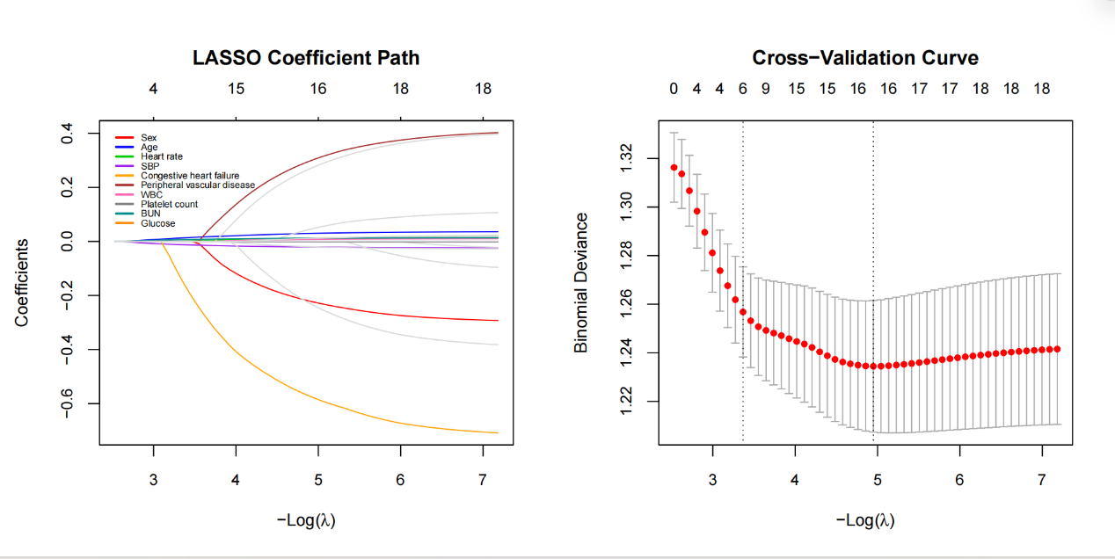

Supplementary Figure S2. Calibration curve of the final logistic regression model (internal validation)
