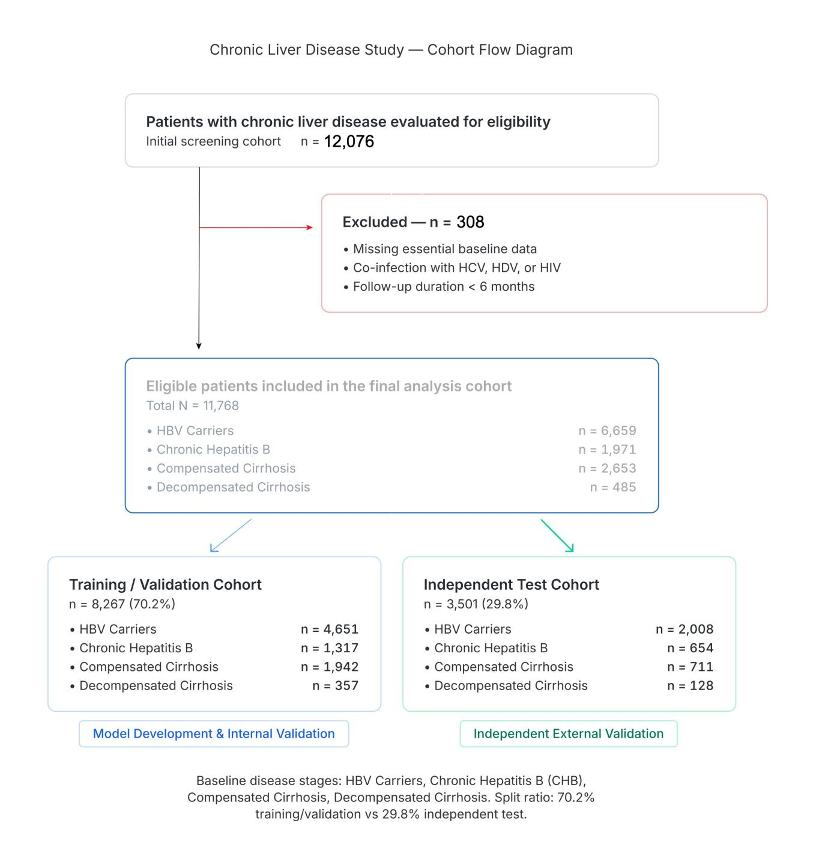
Figure S1. Flow diagram of the study cohort selection and data partitioning.
A total of 12,076 patients with HBV-related chronic liver disease were initially evaluated for eligibility. After applying predefined exclusion criteria, 308 patients were excluded. The final analysis cohort comprised 11,768 eligible patients, stratified into four baseline disease stages: HBV carriers (n=6,659), chronic hepatitis B (n=1,971), compensated cirrhosis (n=2,653), and decompensated cirrhosis (n=485). The total cohort was subsequently randomly partitioned into a training/validation cohort (n=8,267, 70.2%) and an independent test cohort (n=3,501, 29.8%). Because this distribution includes a large proportion of HBV carriers, model performance should be interpreted as internal risk stratification across a heterogeneous HBV-related disease spectrum. Abbreviations: HBV, hepatitis B virus; HCV, hepatitis C virus; HDV, hepatitis D virus; HIV, human immunodeficiency virus.

