Internal Validation Results
Table S1. Five-Fold Cross-Validation Results of Five Single CNN Models Using Gastric Body Images for Infection Classification.
Methods | Accuracy  (95% CIs) | Precision  (95% CIs) | Recall  (95% CIs) | F1-score  (95% CIs) | AUC  (95% CIs)
AlexNet | 0.6417(0.5554,0.7279) | 0.6360(0.5403,0.7317) | 0.7667(0.6032,0.9301) | 0.6748(0.5906,0.7589) | 0.7359(0.6494,0.8224)
DenseNet121 | 0.7608(0.6853,0.8364) | 0.7555(0.6505,0.8606) | 0.8217(0.7431,0.9002) | 0.7774(0.7187,0.8361) | 0.8464(0.7813,0.9115)
EfficientNetV2-m | 0.6775(0.5918,0.7632) | 0.6717(0.5774,0.7659) | 0.7833(0.6685,0.8982) | 0.7092(0.6447,0.7736) | 0.7620(0.6771,0.8469)
ResNet50 | 0.7450(0.6769,0.8131) | 0.7526(0.6472,0.8580) | 0.7867(0.6633,0.9101) | 0.7537(0.6882,0.8193) | 0.8563(0.7932,0.9193)
VGG19 | 0.6167(0.5260,0.7073) | 0.5631(0.3175,0.8086) | 0.6217(0.2981,0.9452) | 0.5429(0.2999,0.7858) | 0.7118(0.5899,0.8337)

Table S2. Five-Fold Cross-Validation Results of Five Single CNN Models Using Gastric Fundus Images for Infection Classification.
Methods | Accuracy  (95% CIs) | Precision  (95% CIs) | Recall  (95% CIs) | F1-score  (95% CIs) | AUC  (95% CIs)
AlexNet | 0.6285(0.5555,0.7015) | 0.6425(0.5463,0.7387) | 0.6972(0.5269,0.8675) | 0.6429(0.5647,0.7212) | 0.7184(0.6472,0.7895)
DenseNet121 | 0.7530(0.6795,0.8265) | 0.7511(0.6498,0.8524) | 0.8084(0.7145,0.9023) | 0.7670(0.7091,0.8249) | 0.8305(0.7713,0.8898)
EfficientNetV2-m | 0.6598(0.5800,0.7395) | 0.6622(0.5669,0.7576) | 0.7531(0.6194,0.8867) | 0.6871(0.6238,0.7503) | 0.7368(0.6606,0.8129)
ResNet50 | 0.7367(0.6734,0.8000) | 0.7452(0.6521,0.8383) | 0.7599(0.6409,0.8789) | 0.7399(0.6762,0.8037) | 0.8287(0.7681,0.8892)
VGG19 | 0.6018(0.5050,0.6986) | 0.5597(0.3136,0.8058) | 0.5852(0.2644,0.9059) | 0.5188(0.2764,0.7612) | 0.6979(0.5903,0.8055)

Table S3. Five-Fold Cross-Validation Results of Five Single CNN Models Using Gastric Angle Images for Infection Classification.
Methods | Accuracy  (95% CIs) | Precision  (95% CIs) | Recall  (95% CIs) | F1-score  (95% CIs) | AUC  (95% CIs)
AlexNet | 0.5944(0.5083,0.6806) | 0.6080(0.4911,0.7250) | 0.6811(0.4780,0.8841) | 0.6105(0.4991,0.7218) | 0.6706(0.5643,0.7769)
DenseNet121 | 0.7011(0.6133,0.7889) | 0.7160(0.5973,0.8346) | 0.7325(0.5922,0.8728) | 0.7061(0.6170,0.7952) | 0.7722(0.6750,0.8695)
EfficientNetV2-m | 0.6364(0.5548,0.7180) | 0.6440(0.5420,0.7459) | 0.7208(0.5646,0.8771) | 0.6584(0.5757,0.7410) | 0.7089(0.6188,0.7990)
ResNet50 | 0.6923(0.6075,0.7771) | 0.7228(0.6041,0.8415) | 0.6918(0.5396,0.8439) | 0.6852(0.5908,0.7797) | 0.7748(0.6707,0.8789)
VGG19 | 0.5849(0.4901,0.6797) | 0.5397(0.3023,0.7772) | 0.5930(0.2860,0.8999) | 0.5198(0.2905,0.7491) | 0.6708(0.5528,0.7887)

Table S4. Five-Fold Cross-Validation Results of Five Single CNN Models Using Gastric Antrum Images for Infection Classification.
Methods | Accuracy  (95% CIs) | Precision  (95% CIs) | Recall  (95% CIs) | F1-score  (95% CIs) | AUC  (95% CIs)
AlexNet | 0.6024(0.5250,0.6798) | 0.6064(0.5067,0.7061) | 0.7185(0.5365,0.9005) | 0.6327(0.5424,0.7231) | 0.6860(0.5875,0.7845)
DenseNet121 | 0.7069(0.6142,0.7996) | 0.7046(0.5975,0.8118) | 0.7675(0.6474,0.8876) | 0.7230(0.6396,0.8064) | 0.7726(0.6728,0.8724)
EfficientNetV2-m | 0.6327(0.5525,0.7129) | 0.6335(0.5416,0.7254) | 0.7391(0.5951,0.8831) | 0.6641(0.5913,0.7368) | 0.7091(0.6223,0.7960)
ResNet50 | 0.6992(0.6170,0.7814) | 0.7045(0.6044,0.8047) | 0.7361(0.6118,0.8604) | 0.7082(0.6321,0.7842) | 0.7742(0.6728,0.8757)
VGG19 | 0.5809(0.4918,0.6701) | 0.5300(0.2994,0.7606) | 0.6000(0.2821,0.9179) | 0.5147(0.2808,0.7485) | 0.6742(0.5648,0.7837)

Table S5. Five-Fold Cross-Validation Results of Five Single CNN Models for Infection Classification Using All Images from Four Gastric Regions.
Methods | Accuracy  (95% CIs) | Precision  (95% CIs) | Recall  (95% CIs) | F1-score  (95% CIs) | AUC  (95% CIs)
AlexNet | 0.6175(0.5553,0.6797) | 0.6193(0.5521,0.6864) | 0.6700(0.5632,0.7768) | 0.6339(0.5790,0.6887) | 0.6560(0.5772,0.7348)
DenseNet121 | 0.6775(0.6146,0.7404) | 0.6790(0.6045,0.7534) | 0.7050(0.6759,0.7341) | 0.6889(0.6445,0.7332) | 0.7424(0.6798,0.8049)
EfficientNetV2-m | 0.5500(0.5190,0.5810) | 0.5503(0.5174,0.5832) | 0.6050(0.5158,0.6942) | 0.5703(0.5341,0.6064) | 0.5794(0.5553,0.6034)
ResNet50 | 0.6650(0.5809,0.7491) | 0.6796(0.5843,0.7748) | 0.6400(0.5699,0.7101) | 0.6581(0.5784,0.7378) | 0.7412(0.6498,0.8327)
VGG19 | 0.5825(0.5024,0.6626) | 0.6051(0.5083,0.7018) | 0.5950(0.4290,0.7610) | 0.5753(0.4809,0.6697) | 0.6430(0.5335,0.7525)

Table S6. Five-Fold Cross-Validation Results of Five CNN Models with Integrated Radiomics Features on Gastric Body Images.
Methods | Accuracy  (95% CIs) | Precision  (95% CIs) | Recall  (95% CIs) | F1-score  (95% CIs) | AUC  (95% CIs)
AlexNet  +Radiomics | 0.7350(0.6611,0.8089) | 0.7407(0.6409,0.8405) | 0.7567(0.6982,0.8152) | 0.7436(0.6821,0.8050) | 0.8148(0.7306,0.8990)
DenseNet121  +Radiomics | 0.7450(0.6659,0.8241) | 0.7539(0.6491,0.8586) | 0.7583(0.6817,0.8350) | 0.7506(0.6792,0.8220) | 0.8184(0.7338,0.9030)
EfficientNetV2-m  +Radiomics | 0.7283(0.6537,0.8030) | 0.7413(0.6377,0.8449) | 0.7367(0.6611,0.8122) | 0.7325(0.6665,0.7985) | 0.8134(0.7323,0.8945)
ResNet50  +Radiomics | 0.7383(0.6653,0.8114) | 0.7502(0.6491,0.8513) | 0.7517(0.6835,0.8199) | 0.7443(0.6841,0.8045) | 0.8178(0.7336,0.9020)
VGG19  +Radiomics | 0.7333(0.6586,0.8081) | 0.7470(0.6455,0.8485) | 0.7400(0.6769,0.8031) | 0.7380(0.6750,0.8010) | 0.8103(0.7255,0.8951)

Table S7. Five-Fold Cross-Validation Results of Five CNN Models with Integrated Radiomics Features on Gastric Fundus Images.
Methods | Accuracy  (95% CIs) | Precision  (95% CIs) | Recall  (95% CIs) | F1-score  (95% CIs) | AUC  (95% CIs)
AlexNet  +Radiomics | 0.6978(0.6186,0.7771) | 0.7028(0.6024,0.8032) | 0.7090(0.6090,0.8089) | 0.7001(0.6180,0.7821) | 0.7755(0.6913,0.8596)
DenseNet121  +Radiomics | 0.7059(0.6232,0.7887) | 0.7139(0.6123,0.8154) | 0.7099(0.6018,0.8180) | 0.7054(0.6191,0.7917) | 0.7804(0.6960,0.8647)
EfficientNetV2-m  +Radiomics | 0.6950(0.6153,0.7746) | 0.7023(0.5999,0.8048) | 0.6995(0.5972,0.8019) | 0.6950(0.6118,0.7782) | 0.7764(0.6947,0.8581)
ResNet50  +Radiomics | 0.7052(0.6263,0.7840) | 0.7134(0.6127,0.8142) | 0.7106(0.6109,0.8104) | 0.7058(0.6257,0.7858) | 0.7806(0.6974,0.8637)
VGG19  +Radiomics | 0.6970(0.6190,0.7751) | 0.7054(0.6052,0.8056) | 0.7025(0.6052,0.7998) | 0.6979(0.6185,0.7773) | 0.7733(0.6902,0.8565)

Table S8. Five-Fold Cross-Validation Results of Five CNN Models with Integrated Radiomics Features on Gastric Angle Images.
Methods | Accuracy  (95% CIs) | Precision  (95% CIs) | Recall  (95% CIs) | F1-score  (95% CIs) | AUC  (95% CIs)
AlexNet  +Radiomics | 0.6585(0.5704,0.7466) | 0.6648(0.5613,0.7683) | 0.6611(0.5504,0.7718) | 0.6573(0.5660,0.7485) | 0.7211(0.6100,0.8322)
DenseNet121  +Radiomics | 0.6638(0.5724,0.7552) | 0.6738(0.5674,0.7802) | 0.6529(0.5328,0.7730) | 0.6569(0.5588,0.7550) | 0.7287(0.6187,0.8387)
EfficientNetV2-m  +Radiomics | 0.6574(0.5683,0.7464) | 0.6641(0.5597,0.7685) | 0.6554(0.5392,0.7716) | 0.6538(0.5587,0.7488) | 0.7222(0.6128,0.8316)
ResNet50  +Radiomics | 0.6667(0.5772,0.7562) | 0.6768(0.5718,0.7818) | 0.6609(0.5446,0.7772) | 0.6621(0.5689,0.7554) | 0.7288(0.6187,0.8390)
VGG19  +Radiomics | 0.6596(0.5705,0.7487) | 0.6683(0.5641,0.7726) | 0.6551(0.5398,0.7703) | 0.6554(0.5612,0.7496) | 0.7190(0.6081,0.8298)

Table S9. Five-Fold Cross-Validation Results of Five CNN Models with Integrated Radiomics Features on Gastric Antrum Images.
Methods | Accuracy  (95% CIs) | Precision  (95% CIs) | Recall  (95% CIs) | F1-score  (95% CIs) | AUC  (95% CIs)
AlexNet  +Radiomics | 0.6545(0.5616,0.7475) | 0.6587(0.5543,0.7632) | 0.6603(0.5457,0.7749) | 0.6546(0.5586,0.7506) | 0.7193(0.6087,0.8299)
DenseNet121  +Radiomics | 0.6617(0.5668,0.7567) | 0.6686(0.5625,0.7747) | 0.6565(0.5322,0.7808) | 0.6568(0.5551,0.7585) | 0.7266(0.6181,0.8352)
EfficientNetV2-m  +Radiomics | 0.6517(0.5588,0.7446) | 0.6591(0.5522,0.7660) | 0.6473(0.5279,0.7667) | 0.6475(0.5489,0.7460) | 0.7215(0.6139,0.8292)
ResNet50  +Radiomics | 0.6616(0.5667,0.7565) | 0.6700(0.5627,0.7772) | 0.6579(0.5400,0.7758) | 0.6582(0.5604,0.7561) | 0.7259(0.6164,0.8354)
VGG19  +Radiomics | 0.6534(0.5613,0.7455) | 0.6617(0.5559,0.7674) | 0.6499(0.5336,0.7662) | 0.6499(0.5537,0.7461) | 0.7169(0.6075,0.8262)

Table S10. Five-Fold Cross-Validation Results of Five CNN Models Integrated with Radiomics Features for Infection Classification Using All Images from Four Gastric Regions.
Methods | Accuracy  (95% CIs) | Precision  (95% CIs) | Recall  (95% CIs) | F1-score  (95% CIs) | AUC  (95% CIs)
AlexNet  +Radiomics | 0.6275(0.5564,0.6986) | 0.6341(0.5597,0.7084) | 0.6100(0.5359,0.6841) | 0.6208(0.5506,0.6910) | 0.7033(0.6019,0.8046)
DenseNet121  +Radiomics | 0.6475(0.5881,0.7069) | 0.6542(0.5937,0.7148) | 0.6300(0.5523,0.7077) | 0.6401(0.5787,0.7014) | 0.7135(0.6201,0.8069)
EfficientNetV2-m  +Radiomics | 0.6225(0.5437,0.7013) | 0.6304(0.5455,0.7153) | 0.6050(0.5325,0.6775) | 0.6166(0.5411,0.6921) | 0.7014(0.6009,0.8019)
ResNet50  +Radiomics | 0.6350(0.5606,0.7094) | 0.6477(0.5691,0.7263) | 0.6000(0.5146,0.6854) | 0.6209(0.5451,0.6967) | 0.7109(0.6185,0.8033)
VGG19  +Radiomics | 0.6225(0.5474,0.6976) | 0.6336(0.5508,0.7164) | 0.6000(0.5280,0.6720) | 0.6145(0.5444,0.6846) | 0.7077(0.6105,0.8050)

Independent External Validation Results
Table S11. Five-Fold Cross-Validation Results of Five Single CNN Models Using Gastric Body Images for Infection Classification.
Methods | Accuracy  (95% CIs) | Precision  (95% CIs) | Recall  (95% CIs) | F1-score  (95% CIs) | AUC  (95% CIs)
AlexNet | 0.4762(0.4413,0.5111) | 0.3595(0.3468,0.3721) | 0.8769(0.8112,0.9427) | 0.5087(0.4952,0.5223) | 0.6879(0.6716,0.7042)
DenseNet121 | 0.5254(0.4935,0.5572) | 0.3936(0.3791,0.4082) | 0.9744(0.9543,0.9945) | 0.5603(0.5484,0.5721) | 0.6201(0.5929,0.6473)
EfficientNetV2-m | 0.5429(0.4752,0.6105) | 0.4033(0.3648,0.4419) | 0.9333(0.8849,0.9817) | 0.5611(0.5252,0.5970) | 0.7836(0.7217,0.8455)
ResNet50 | 0.5429(0.5234,0.5623) | 0.4012(0.3916,0.4109) | 0.9641(0.9461,0.9821) | 0.5665(0.5570,0.5759) | 0.6393(0.6240,0.6546)
VGG19 | 0.5556(0.4343,0.6768) | 0.4356(0.3446,0.5266) | 0.8103(0.6347,0.9859) | 0.5347(0.5134,0.5561) | 0.6654(0.6227,0.7082)
Table S12. Five-Fold Cross-Validation Results of Five Single CNN Models Using Gastric Fundus Images for Infection Classification.
Methods | Accuracy  (95% CIs) | Precision  (95% CIs) | Recall  (95% CIs) | F1-score  (95% CIs) | AUC  (95% CIs)
AlexNet | 0.5413(0.5301,0.5524) | 0.3984(0.3936,0.4032) | 0.9436(0.9174,0.9698) | 0.5601(0.5553,0.5649) | 0.7732(0.7617,0.7847)
DenseNet121 | 0.5746(0.5633,0.5859) | 0.4158(0.4090,0.4226) | 0.9231(0.8913,0.9549) | 0.5731(0.5635,0.5828) | 0.6554(0.5996,0.7112)
EfficientNetV2-m | 0.5571(0.5115,0.6027) | 0.4029(0.3749,0.4309) | 0.8769(0.7770,0.9768) | 0.5498(0.5125,0.5871) | 0.7125(0.6453,0.7797)
ResNet50 | 0.5730(0.5678,0.5782) | 0.4143(0.4114,0.4171) | 0.9179(0.8679,0.9680) | 0.5705(0.5586,0.5823) | 0.6960(0.6441,0.7480)
VGG19 | 0.5524(0.5013,0.6034) | 0.4095(0.3807,0.4384) | 0.9744(0.9497,0.9990) | 0.5757(0.5479,0.6036) | 0.7359(0.7073,0.7644)

Table S13. Five-Fold Cross-Validation Results of Five Single CNN Models Using Gastric Antrum Images for Infection Classification.
Methods | Accuracy  (95% CIs) | Precision  (95% CIs) | Recall  (95% CIs) | F1-score  (95% CIs) | AUC  (95% CIs)
AlexNet | 0.4746(0.4349,0.5143) | 0.3343(0.3166,0.3521) | 0.6923(0.6605,0.7241) | 0.4499(0.4372,0.4626) | 0.6012(0.5655,0.6370)
DenseNet121 | 0.4476(0.4148,0.4804) | 0.2963(0.2675,0.3251) | 0.5744(0.4957,0.6530) | 0.3905(0.3489,0.4320) | 0.4618(0.4103,0.5133)
EfficientNetV2-m | 0.4413(0.3965,0.4861) | 0.2656(0.2204,0.3109) | 0.4872(0.3125,0.6619) | 0.3387(0.2598,0.4175) | 0.4763(0.4027,0.5499)
ResNet50 | 0.4460(0.4170,0.4750) | 0.2821(0.2700,0.2942) | 0.5128(0.4461,0.5795) | 0.3624(0.3377,0.3872) | 0.5129(0.4893,0.5366)
VGG19 | 0.5270(0.3972,0.6567) | 0.2796(0.1431,0.4161) | 0.4872(0.1820,0.7924) | 0.3263(0.1764,0.4761) | 0.5713(0.4963,0.6463)

Table S14. Five-Fold Cross-Validation Results of Five Single CNN Models Using Gastric Angle Images for Infection Classification.
Methods | Accuracy  (95% CIs) | Precision  (95% CIs) | Recall  (95% CIs) | F1-score  (95% CIs) | AUC  (95% CIs)
AlexNet | 0.4143(0.3741,0.4545) | 0.3048(0.2891,0.3204) | 0.7179(0.5398,0.8961) | 0.4227(0.3748,0.4706) | 0.5307(0.4551,0.6064)
DenseNet121 | 0.4556(0.4371,0.4740) | 0.3109(0.2905,0.3313) | 0.6308(0.5509,0.7107) | 0.4158(0.3809,0.4506) | 0.4994(0.4651,0.5337)
EfficientNetV2-m | 0.5365(0.4500,0.6230) | 0.3776(0.3371,0.4182) | 0.7231(0.5111,0.9351) | 0.4776(0.3967,0.5586) | 0.6154(0.5683,0.6626)
ResNet50 | 0.4841(0.4709,0.4973) | 0.3241(0.2995,0.3487) | 0.6308(0.5238,0.7377) | 0.4267(0.3799,0.4734) | 0.5441(0.4978,0.5905)
VGG19 | 0.5127(0.3780,0.6474) | 0.1898(0.0539,0.3256) | 0.4923(0.1240,0.8606) | 0.2716(0.0765,0.4668) | 0.5586(0.4481,0.6690)
Table S15. Five-Fold Cross-Validation Results of Five Single CNN Models for Infection Classification Using All Images from Four Gastric Regions.
Methods | Accuracy  (95% CIs) | Precision  (95% CIs) | Recall  (95% CIs) | F1-score  (95% CIs) | AUC  (95% CIs)
AlexNet | 0.5317(0.4928,0.5707) | 0.3807(0.3627,0.3986) | 0.7974(0.7528,0.8420) | 0.5138(0.5051,0.5225) | 0.6517(0.6299,0.6735)
DenseNet121 | 0.4766(0.4678,0.4853) | 0.3441(0.3350,0.3533) | 0.7654(0.7144,0.8163) | 0.4745(0.4565,0.4925) | 0.5416(0.5024,0.5808)
EfficientNetV2-m | 0.4972(0.4559,0.5386) | 0.3528(0.3254,0.3802) | 0.7436(0.6703,0.8169) | 0.4776(0.4416,0.5137) | 0.5991(0.5313,0.6668)
ResNet50 | 0.4944(0.4813,0.5076) | 0.3510(0.3476,0.3545) | 0.7462(0.6991,0.7932) | 0.4769(0.4660,0.4878) | 0.5591(0.5244,0.5939)
VGG19 | 0.4702(0.4356,0.5049) | 0.3188(0.2833,0.3543) | 0.6731(0.4679,0.8782) | 0.4257(0.3502,0.5012) | 0.5332(0.4909,0.5755)

Methods | Accuracy  (95% CIs) | Precision  (95% CIs) | Recall  (95% CIs) | F1-score  (95% CIs) | AUC  (95% CIs)
AlexNet  +Radiomics | 0.5444(0.5231,0.5658) | 0.3974(0.3869,0.4079) | 0.9077(0.8848,0.9306) | 0.5525(0.5431,0.5618) | 0.6965(0.6926,0.7004)
DenseNet121  +Radiomics | 0.5365(0.5197,0.5533) | 0.3942(0.3876,0.4008) | 0.9231(0.8985,0.9477) | 0.5522(0.5495,0.5549) | 0.7010(0.6904,0.7116)
EfficientNetV2-m  +Radiomics | 0.5444(0.5205,0.5684) | 0.3980(0.3868,0.4092) | 0.9128(0.8948,0.9308) | 0.5540(0.5457,0.5623) | 0.6964(0.6932,0.6996)
ResNet50  +Radiomics | 0.5397(0.5251,0.5543) | 0.3950(0.3896,0.4003) | 0.9128(0.8823,0.9433) | 0.5511(0.5477,0.5545) | 0.7001(0.6960,0.7041)
VGG19  +Radiomics | 0.5397(0.5168,0.5625) | 0.3953(0.3846,0.4060) | 0.9128(0.8948,0.9308) | 0.5514(0.5435,0.5593) | 0.6930(0.6862,0.6997)
Table S16. Five-Fold Cross-Validation Results of Five CNN Models with Integrated Radiomics Features on Gastric Body Images.

Table S17. Five-Fold Cross-Validation Results of Five CNN Models with Integrated Radiomics Features on Gastric Fundus Images.
Methods | Accuracy  (95% CIs) | Precision  (95% CIs) | Recall  (95% CIs) | F1-score  (95% CIs) | AUC  (95% CIs)
AlexNet  +Radiomics | 0.5714(0.5523,0.5906) | 0.4094(0.3991,0.4196) | 0.8615(0.8199,0.9032) | 0.5544(0.5445,0.5643) | 0.7020(0.6947,0.7092)
DenseNet121  +Radiomics | 0.5857(0.5696,0.6018) | 0.4186(0.4083,0.4290) | 0.8667(0.8307,0.9026) | 0.5642(0.5520,0.5764) | 0.7023(0.6936,0.7109)
EfficientNetV2-m  +Radiomics | 0.5857(0.5663,0.6051) | 0.4178(0.4069,0.4287) | 0.8513(0.8183,0.8843) | 0.5599(0.5516,0.5683) | 0.7028(0.6950,0.7106)
ResNet50  +Radiomics | 0.5794(0.5686,0.5901) | 0.4143(0.4087,0.4200) | 0.8667(0.8280,0.9053) | 0.5603(0.5508,0.5697) | 0.7085(0.7015,0.7156)
VGG19  +Radiomics | 0.5810(0.5621,0.5998) | 0.4153(0.4044,0.4261) | 0.8615(0.8279,0.8952) | 0.5600(0.5483,0.5717) | 0.7030(0.6954,0.7106)

Table S18. Five-Fold Cross-Validation Results of Five CNN Models with Integrated Radiomics Features on Gastric Antrum Images.
Methods | Accuracy  (95% CIs) | Precision  (95% CIs) | Recall  (95% CIs) | F1-score  (95% CIs) | AUC  (95% CIs)
AlexNet  +Radiomics | 0.5524(0.5265,0.5783) | 0.3825(0.3663,0.3986) | 0.7179(0.6862,0.7497) | 0.4985(0.4835,0.5134) | 0.6278(0.6046,0.6510)
DenseNet121  +Radiomics | 0.5556(0.5319,0.5792) | 0.3796(0.3620,0.3971) | 0.6821(0.6358,0.7283) | 0.4869(0.4665,0.5074) | 0.6116(0.5916,0.6316)
EfficientNetV2-m  +Radiomics | 0.5413(0.5320,0.5505) | 0.3770(0.3694,0.3845) | 0.7385(0.7216,0.7553) | 0.4991(0.4888,0.5094) | 0.6284(0.6129,0.6438)
ResNet50  +Radiomics | 0.5429(0.5260,0.5597) | 0.3694(0.3600,0.3788) | 0.6718(0.6388,0.7048) | 0.4762(0.4649,0.4875) | 0.6233(0.6062,0.6405)
VGG19  +Radiomics | 0.5444(0.5240,0.5649) | 0.3774(0.3629,0.3919) | 0.7231(0.6969,0.7493) | 0.4957(0.4793,0.5122) | 0.6275(0.6075,0.6475)

Table S19. Five-Fold Cross-Validation Results of Five CNN Models with Integrated Radiomics Features on Gastric Angle Images.
Methods | Accuracy  (95% CIs) | Precision  (95% CIs) | Recall  (95% CIs) | F1-score  (95% CIs) | AUC  (95% CIs)
AlexNet  +Radiomics | 0.5032(0.4847,0.5216) | 0.3533(0.3398,0.3668) | 0.7282(0.7012,0.7552) | 0.4758(0.4582,0.4933) | 0.5882(0.5652,0.6111)
DenseNet121  +Radiomics | 0.5095(0.4805,0.5385) | 0.3539(0.3344,0.3733) | 0.7026(0.6796,0.7255) | 0.4705(0.4495,0.4914) | 0.5923(0.5631,0.6214)
EfficientNetV2-m  +Radiomics | 0.5143(0.4837,0.5449) | 0.3575(0.3364,0.3786) | 0.7077(0.6897,0.7257) | 0.4748(0.4525,0.4972) | 0.5955(0.5700,0.6209)
ResNet50  +Radiomics | 0.5190(0.4981,0.5400) | 0.3605(0.3466,0.3744) | 0.7128(0.6866,0.7390) | 0.4786(0.4627,0.4945) | 0.5936(0.5677,0.6196)
VGG19  +Radiomics | 0.5095(0.4873,0.5317) | 0.3562(0.3398,0.3725) | 0.7231(0.6900,0.7561) | 0.4772(0.4559,0.4985) | 0.5915(0.5628,0.6202)

Table S20. Five-Fold Cross-Validation Results of Five CNN Models Integrated with Radiomics Features for Infection Classification Using All Images from Four Gastric Regions.
Methods | Accuracy  (95% CIs) | Precision  (95% CIs) | Recall  (95% CIs) | F1-score  (95% CIs) | AUC  (95% CIs)
AlexNet  +Radiomics | 0.5210(0.5042,0.5379) | 0.3688(0.3591,0.3786) | 0.7679(0.7403,0.7956) | 0.4981(0.4865,0.5097) | 0.6520(0.6436,0.6604)
DenseNet121  +Radiomics | 0.5131(0.4963,0.5299) | 0.3634(0.3550,0.3718) | 0.7603(0.7313,0.7893) | 0.4915(0.4817,0.5012) | 0.6346(0.6245,0.6447)
EfficientNetV2-m  +Radiomics | 0.5286(0.5126,0.5445) | 0.3722(0.3622,0.3822) | 0.7603(0.7340,0.7865) | 0.4996(0.4875,0.5116) | 0.6470(0.6407,0.6533)
ResNet50  +Radiomics | 0.5238(0.5056,0.5421) | 0.3700(0.3583,0.3816) | 0.7641(0.7351,0.7931) | 0.4983(0.4843,0.5124) | 0.6487(0.6383,0.6590)
VGG19  +Radiomics | 0.5258(0.5103,0.5413) | 0.3707(0.3630,0.3785) | 0.7603(0.7394,0.7812) | 0.4982(0.4916,0.5047) | 0.6475(0.6393,0.6556)

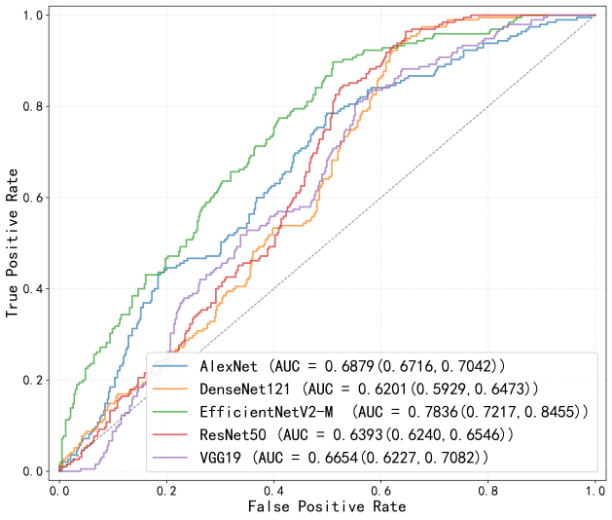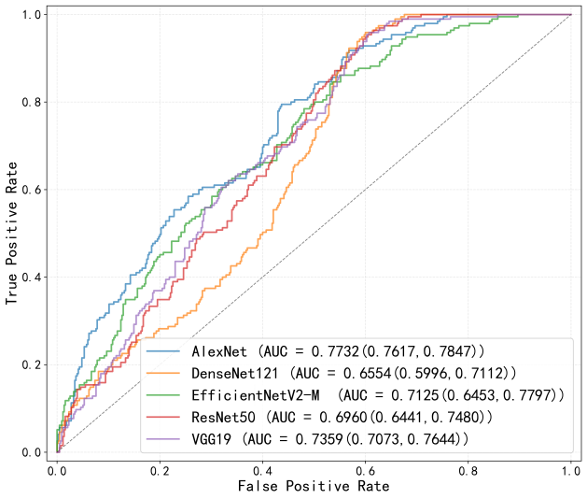
(a) (b)
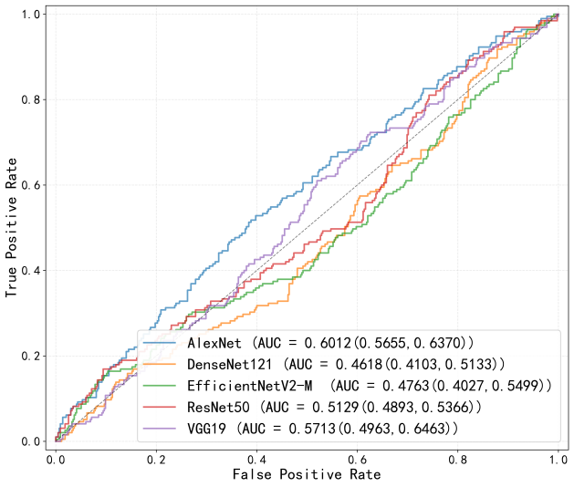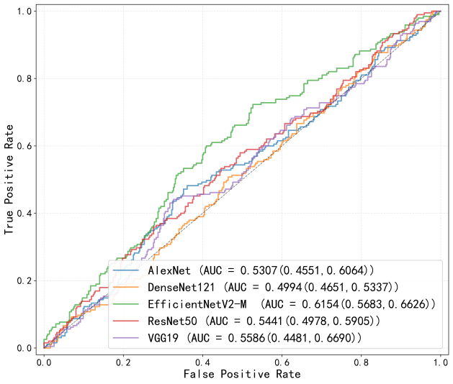
(c) (d)
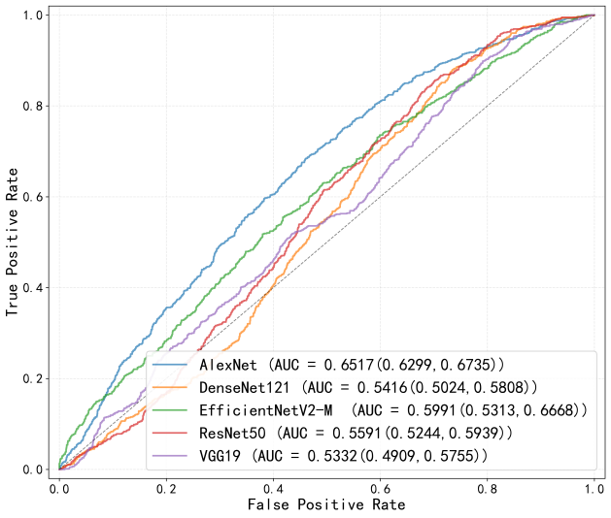
(e)
Figure S1. Comparison of ROC curves for infection classification based on five single deep learning models in the external validation cohort: (a) gastric body; (b) gastric fundus; (c) gastric antrum; (d) gastric angle; (e) combined four-region dataset.

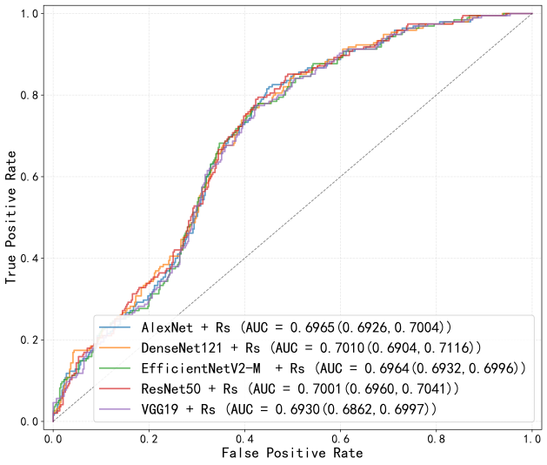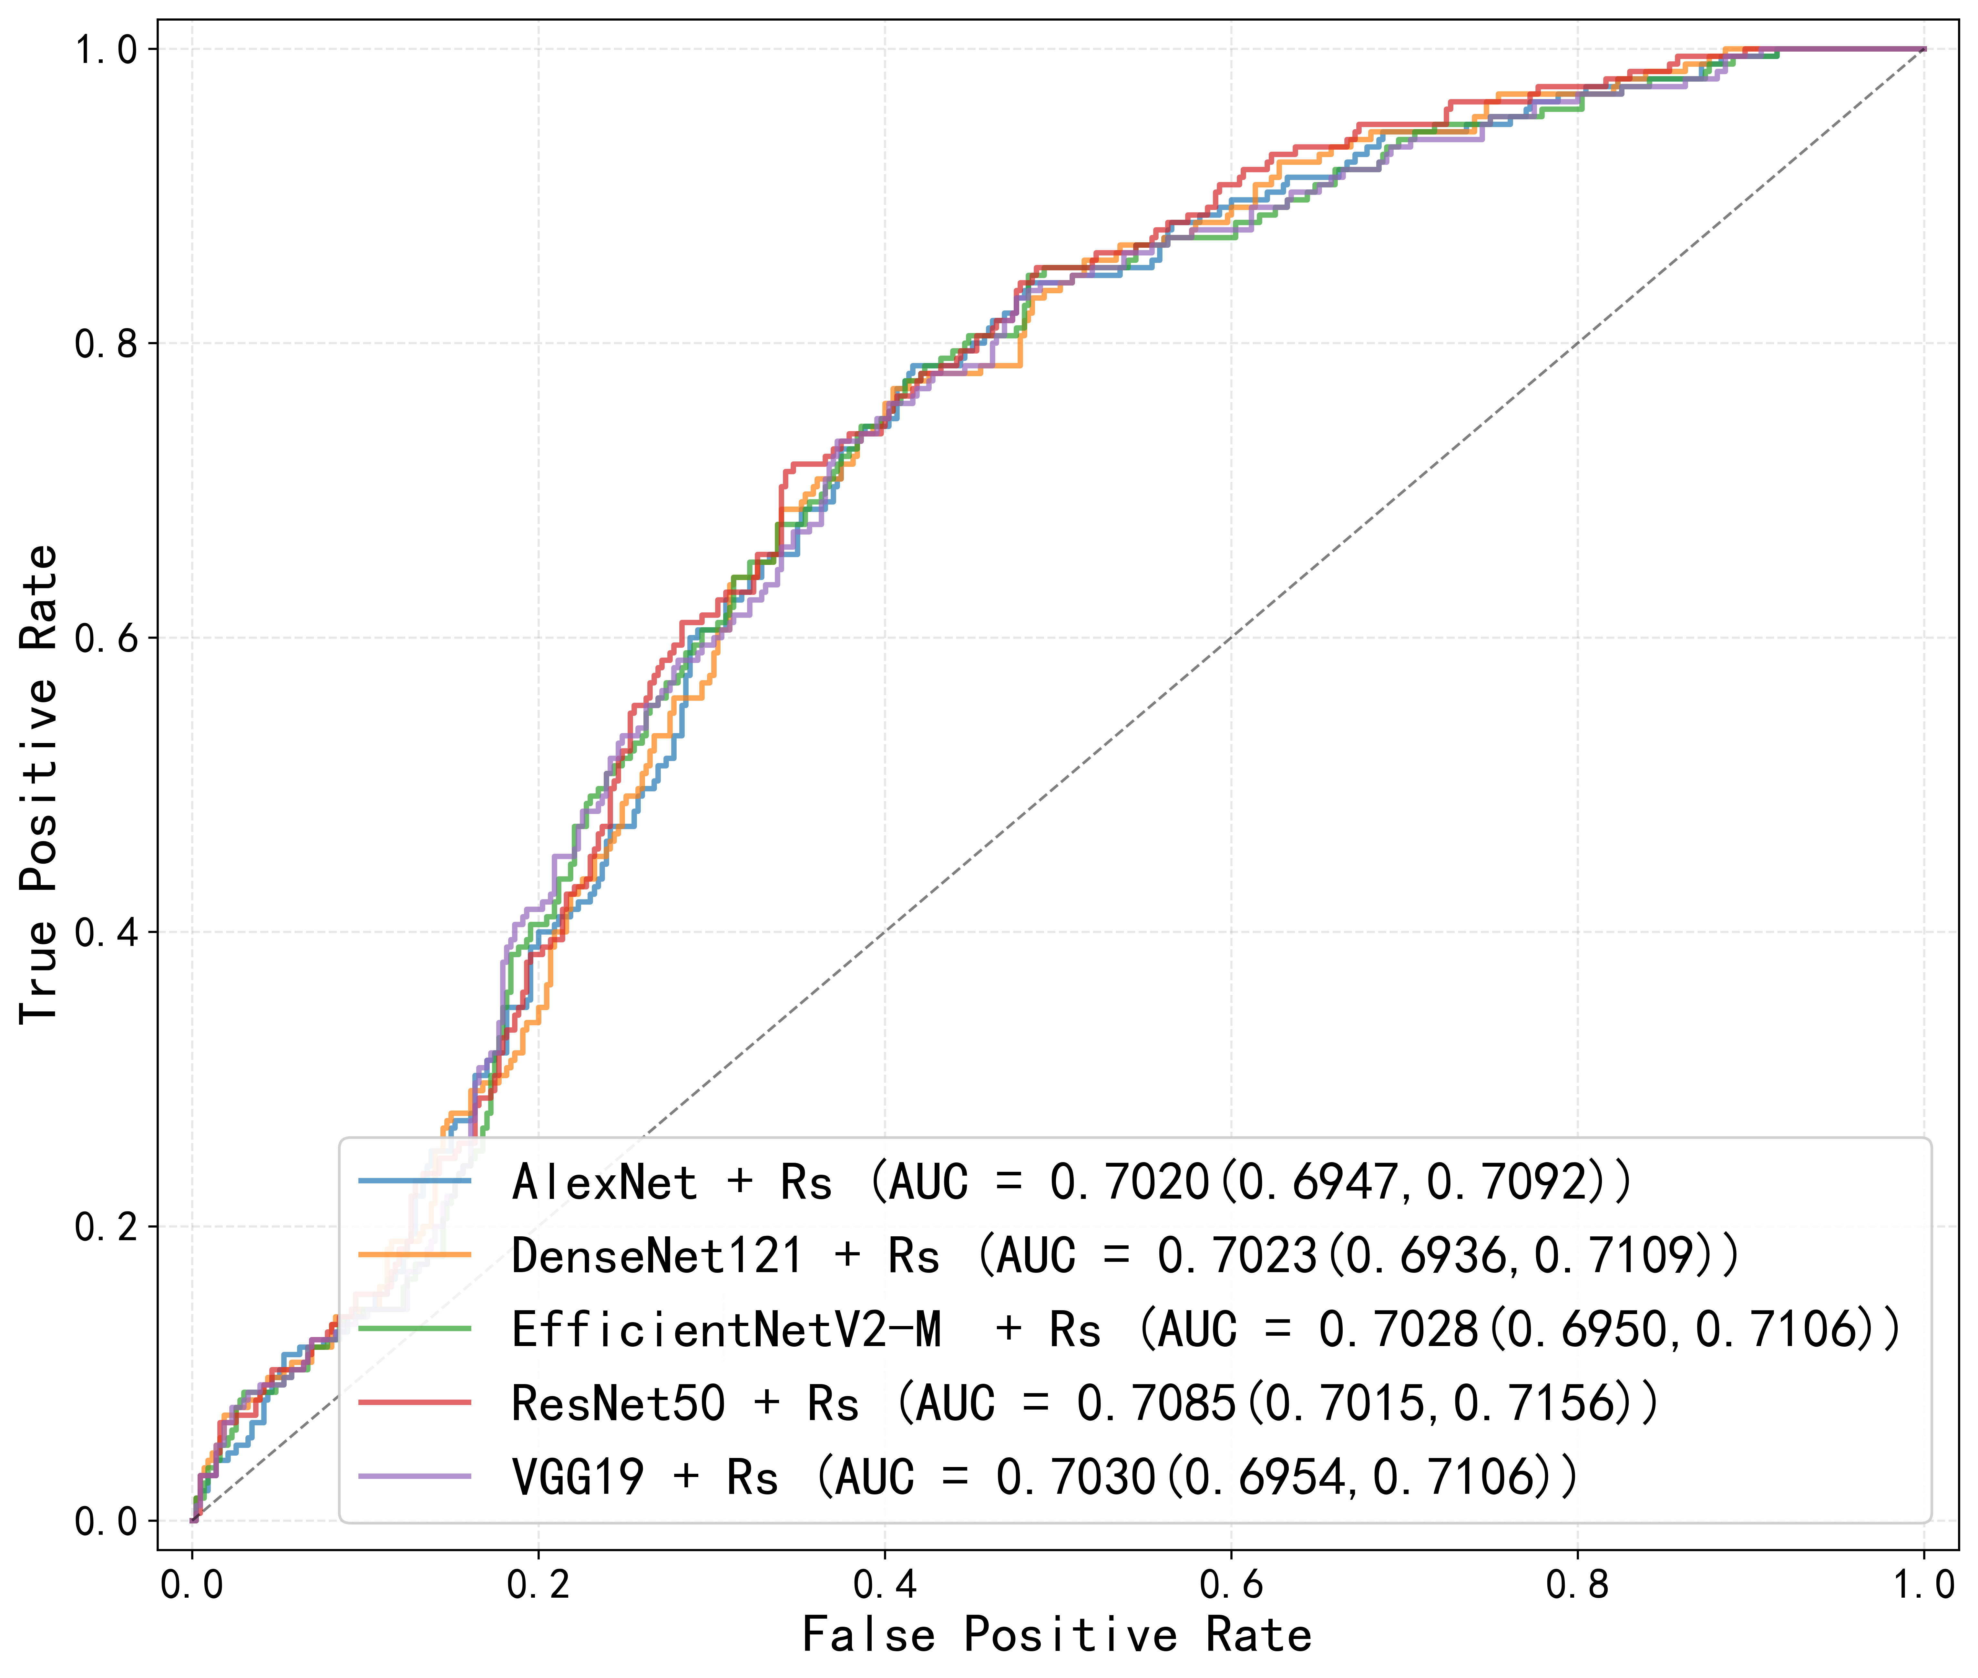
(a) (b)
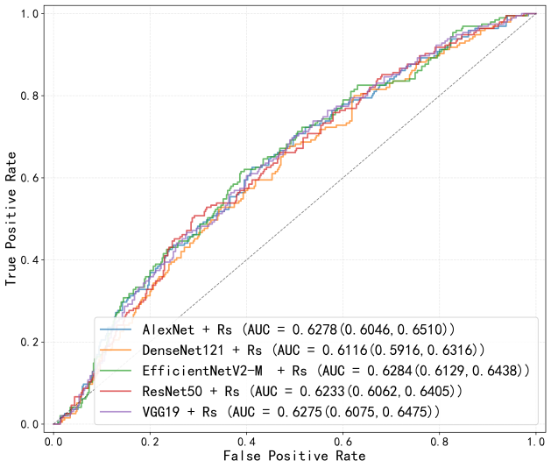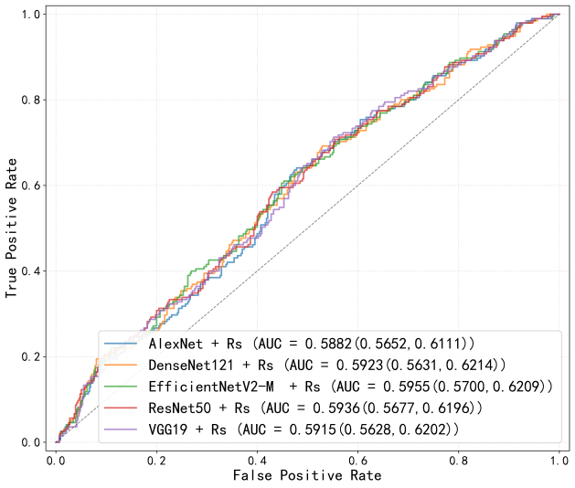
(c) (d)

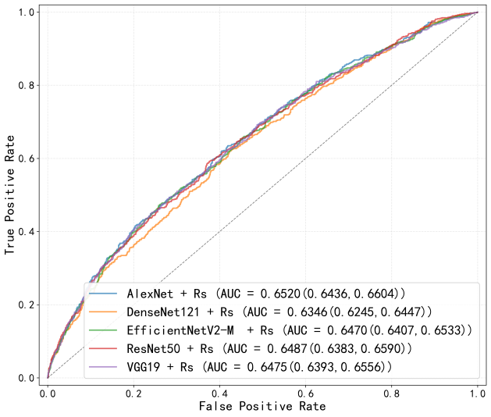
(e)
Figure S2. Comparison of ROC curves for infection classification based on five deep learning models incorporating radiomics features in the external validation cohort: (a) gastric body; (b) gastric fundus; (c) gastric antrum; (d) gastric angle; (e) combined four-region dataset.

