Fig. S3
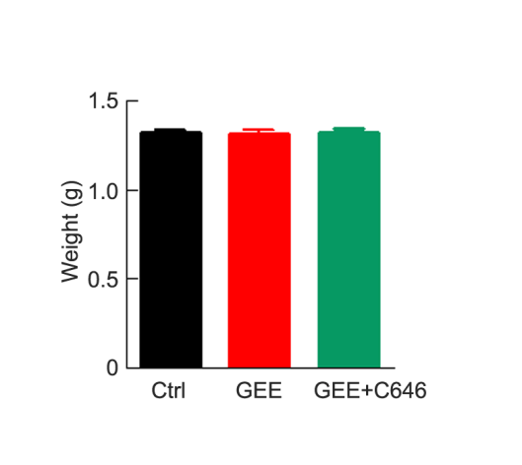
Fig. S3: Inhibiting HAT during GEE exposure has no effect on embryos’ weight. Embryos were weighed at E19 after GEE exposure with or without C646 treatment (HAT inhibitor). No difference of the embryo weights were detected among the groups. n=8-15 per group, One–way ANOVA, Tukey's multiple comparisons test. Data were presented as mean ± s.e.m.

