Supplement Figure 1- No Aβ was observed in the hippocampus and retina of the WT group for the same time-points.

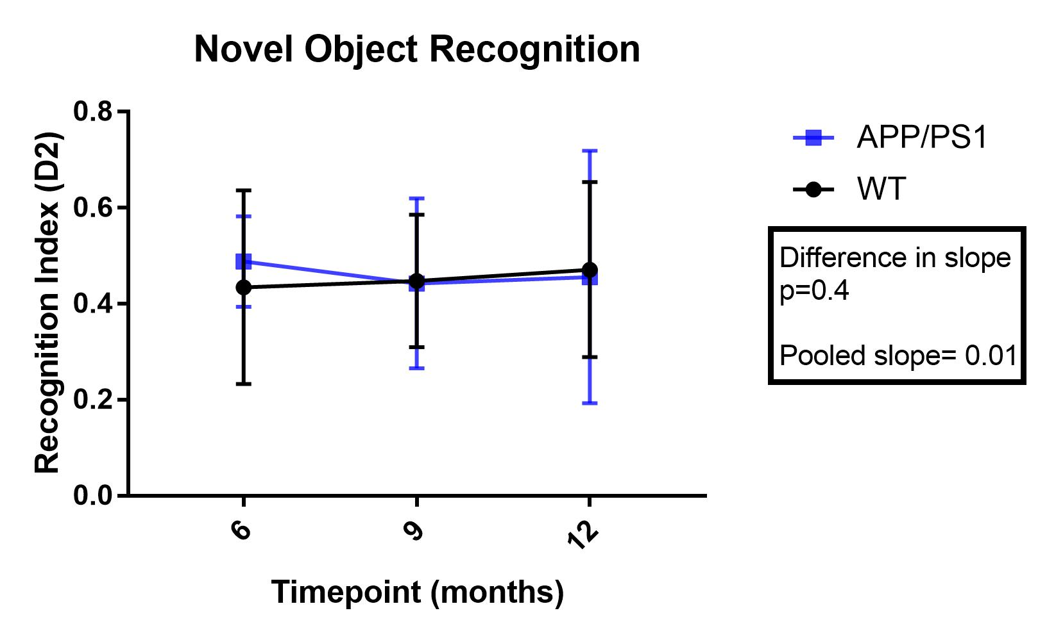

Supplement Figure 2- Slope analysis (ANCOVA) for Novel Object Recognition test from 6 to 12 months. We observed no significant difference between the two animal groups and across age.

