Additional File 3

Figure S1 Pathway analysis in Tai Chi group relative to the Control group from baseline to six-month visit

Figure S2 Pathway analysis in Tai Chi group relative to the Control group from six-month visit to one-year visit

Figure S3 Pathway analysis in the Tai Chi group relative to the Control group from baseline to one-year visit

Figure S4 Enrichment analysis in the Tai Chi group relative to the Control group from baseline to six-month visit

Figure S5 Enrichment analysis in the Tai Chi group relative to the Control group from six-month visit to one-year visit

Figure S6 Enrichment analysis in the Tai Chi group relative to the Control group from baseline to one-year visit

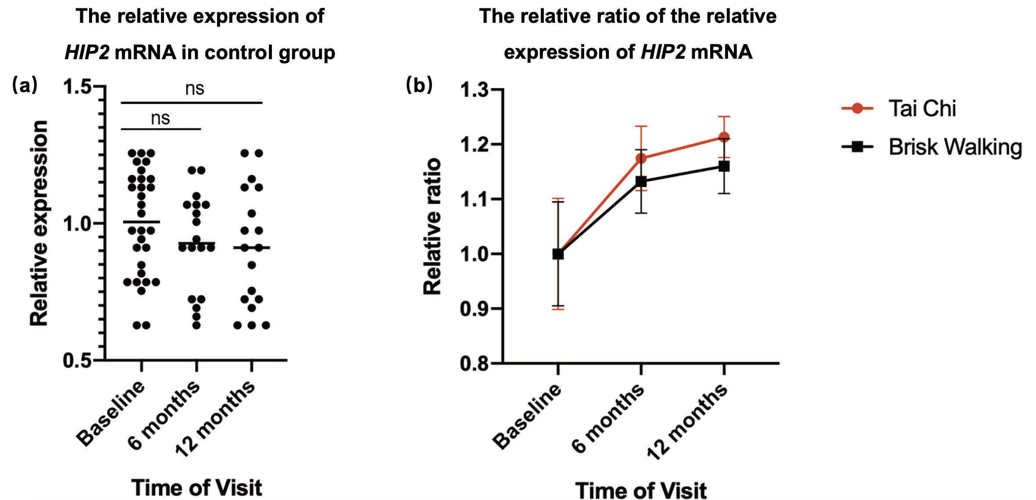

Figure S7 Comparison between 3 groups in change of HIP2 mRNA level.
(a) There was no significant difference in the relative expression of HIP2 mRNA among the 3 visits in the control group. The mean expression level at baseline was taken as the reference line. (b) The relative ratio of the relative expression of HIP2 mRNA. The relative expression of HIP2 mRNA were referenced to the mean expression of controls at the corresponding time of visit. The relative ratio was then referenced to the relative expression of baseline in each group. Data were shown as mean ± SEM.

