Table S1 Culture medium formula for B. coprocola
Ingredients Dosage
Trypticase peptone | 5.00 g
Peptone | 5.00 g
Yeast extract | 10.00 g
Beef extract | 5.00 g
Glucose | 5.00 g
K2HPO4 | 2.00 g
Tween 80 | 1.00 ml
Salt solution | 40.00 ml
Resazurin | 1.00 mg
Vitamin K1 solution | 0.20 ml
Haemin solution | 10.00 ml
Cysteine-HCl x H2O | 0.50 g
Distilled water | 950.00ml

Table S2 Paired primers for qPCR
Gene | Primer sequence (5′-3′)
 | Forward | Reverse
Gapdh | AGGTCGGTGTGAACGGATTTG | GGGGTCGTTGATGGCAACA
Nfkb | ATGGCAGACGATGATCCCTAC | CGGAATCGAAATCCCCTCTGTT
Il-1β | TTCAGGCAGGCAGTATCACTC | GAAGGTCCACGGGAAAGACAC
Nlrp3 | ATCAACAGGCGAGACCTCTG | GTCCTCCTGGCATACCATAGA
Il-6 | TAGTCCTTCCTACCCCAATTTCC | TTGGTCCTTAGCCACTCCTTC
Zo-1 | GCCGCTAAGAGCACAGCAA | GCCCTCCTTTTAACACATCAGA
Occludin | TGAAAGTCCACCTCCTTACAGA | CCGGATAAAAAGAGTACGCTGG
Ffar2 | ATCCTCCTGCTTAATCTGACCC | CGCACACGATCTTTGGTAGGT

Table S3 Primers for FFAR2/3 siRNA
FFAR2 | Primer sequence (5′-3′)
 | Sense（5'-3'） | Antisense（5'-3'）
NO.1 | AUCGUCAUCAUCGUUCAGUTT | ACUGAACGAUGAUGACGAUTT
NO.2 | ACGGCCUACAUCCUCAUCUTT | AGAUGAGGAUGUAGGCCGUTT
NO.3 | UUGUGACGCUUCUUAAUUUTT | AAAUUAAGAAGCGUCACAATT
NO.4 | ACAGGCUUCGGCUUCUACATT | UGUAGAAGCCGAAGCCUGUTT

FFAR3 | Primer sequence (5′-3′)
 | Sense（5'-3'） | Antisense（5'-3'）
NO.1 | GCCUGGAACUGAAGGUAAATT | UUUACCUUCAGUUCCAGGCTT
NO.2 | GCACCCUCAACUCUUGUAUTT | AUACAAGAGUUGAGGGUGCTT
NO.3 | GUGGUUUACAUCACUGAAUTT | AUUCAGUGAUGUAAACCACTT
NO.4 | CCCUGUGUAUCACGAGUUATT | UAACUCGUGAUACACAGGGTT

Table S4 B. coprocola Whole Genome Feature Values
Name | Value
Genome Length | 4591311 bp
Number of scaffold(contig) | 87
G+C content | 41.70%
Num of CDS | 4021
CDS num | 4021
CDS total length | 4062465 bp
CDS density | 0.875 genes per kb
CDS average length | 1010 bp
Intergenetic region length | 528846 bp
CDS/Genome(coding percentage) | 88.50%
Intergenetic length/Genome | 11.50%
GC content in gene region | 42.70%
GC content in intergenetic region | 34.20%

Table S5 B. coprocola fatty acid synthesis enrichment gene
KO id  (Gene id) | KO name  (Gene name) | Name | EC
K00645 | fabD, MCAT,  MCT1 | [acyl-carrier-protein] S-malonyltransferase | 2.3.1.39
K01961 | accC | acetyl-CoA carboxylase, biotin carboxylase subunit | 6.4.1.2 6.3.4.14
K00208 | fabI | enoyl-[acyl-carrier protein] reductase I | 1.3.1.9 1.3.1.10
K09458 | fabF, OXSM,  CEM1 | 3-oxoacyl-[acyl-carrier-protein] synthase II | 2.3.1.179
K00648 | fabH | 3-oxoacyl-[acyl-carrier-protein] synthase III | 2.3.1.180
K00059 | fabG, OAR1 | 3-oxoacyl-[acyl-carrier protein] reductase | 1.1.1.100
K16363 | lpxC-fabZ | UDP-3-O-[3-hydroxymyristoyl]  N-acetylglucosamine deacetylase /  3-hydroxyacyl-[acyl-carrier-protein] dehydratase | 3.5.1.108 4.2.1.59
K02371 | fabK | enoyl-[acyl-carrier protein] reductase II | 1.3.1.9

Table S6 B. coprocola butyric acid biosynthesis enrichment gene
KO id  (Gene id) | KO name  (Gene name) | Name | EC
K01653 | E2.2.1.6S, ilvH, ilvN | acetolactate synthase I/III small subunit | 2.2.1.6
K01652 | E2.2.1.6L, ilvB, ilvG, ilvI | acetolactate synthase I/II/III large subunit | 2.2.1.6
K00240 | sdhB, frdB | succinate dehydrogenase iron-sulfur subunit | 1.3.5.1
K00239 | sdhA, frdA | succinate dehydrogenase flavoprotein subunit | 1.3.5.1
K00241 | sdhC, frdC | succinate dehydrogenase cytochrome b subunit
K00634 | ptb | phosphate butyryltransferase | 2.3.1.19
K00929 | buk | butyrate kinase | 2.7.2.7
K00656 | E2.3.1.54, pflD | formate C-acetyltransferase | 2.3.1.54

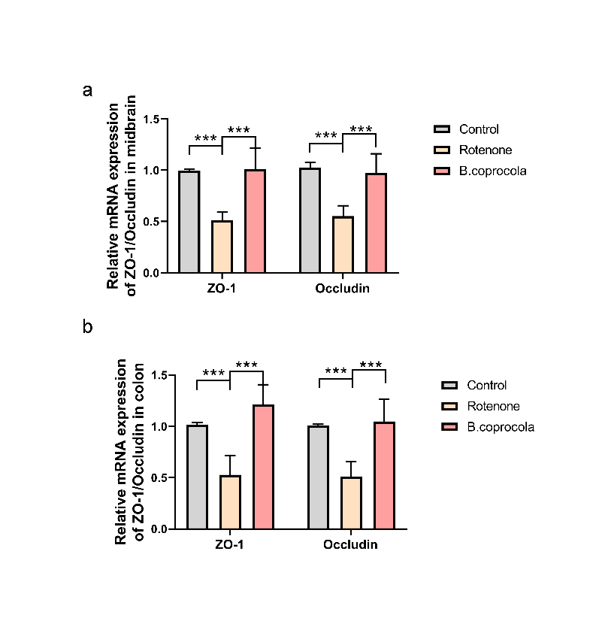

Fig. S1 Effects of B. coprocola treatment on mRNA expression of occludin and ZO-1 in midbrain and colon, detected by qRT-PCR. n=5 for each group. Data are presented as mean ± SD. One-way ANOVA was used to assess differences among multiple groups. ***P < 0.001.

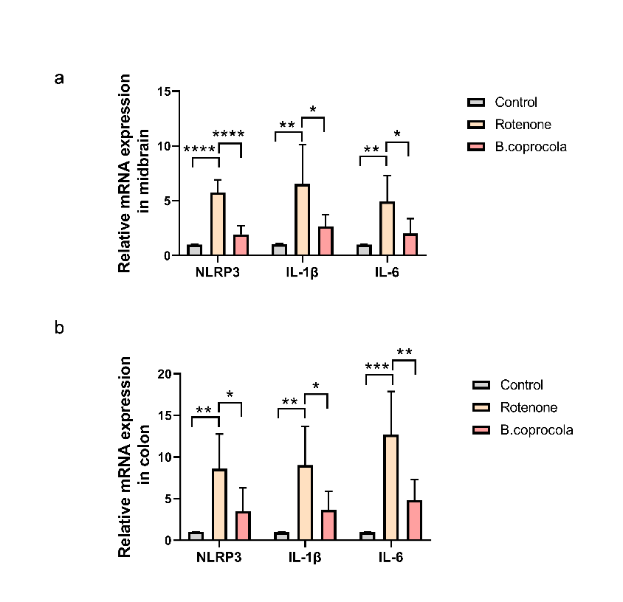

Fig. S2 Effects of B. coprocola treatment on mRNA expression of NLRP3, IL-1β and IL-6 in the midbrain and colon, detected by qRT-PCR. n=5 for each group. Data are presented as mean ± SD. *P < 0.05, **P < 0.01, ***P < 0.001, ****P < 0.0001, one-way ANOVA followed by Tukey's test.

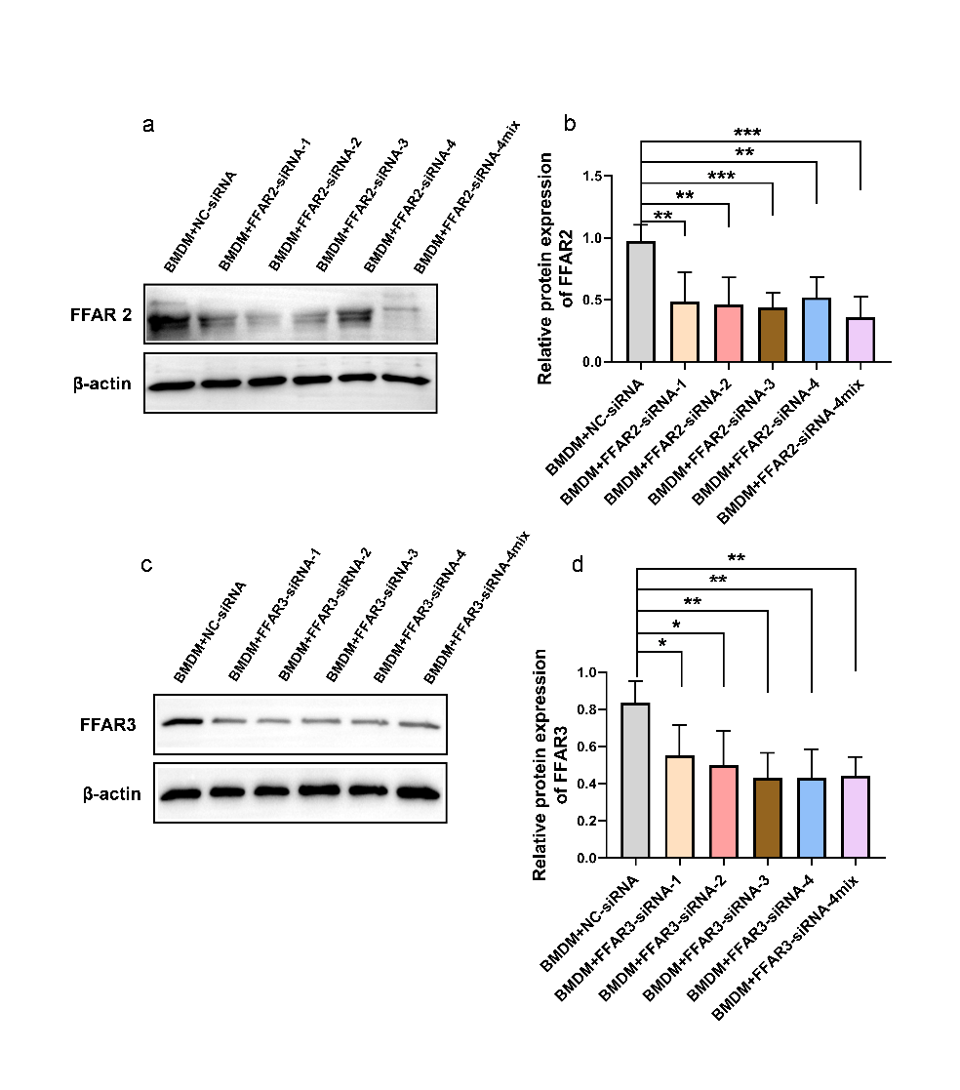

Fig. S3 Representative Western blot bands and density analysis of FFAR2 and FFAR3 siRNA knockdown efficiency. n=5 for each group. Data are presented as mean ± SD. *P < 0.05, **P < 0.01, ***P < 0.001, one-way ANOVA followed by Tukey's test.

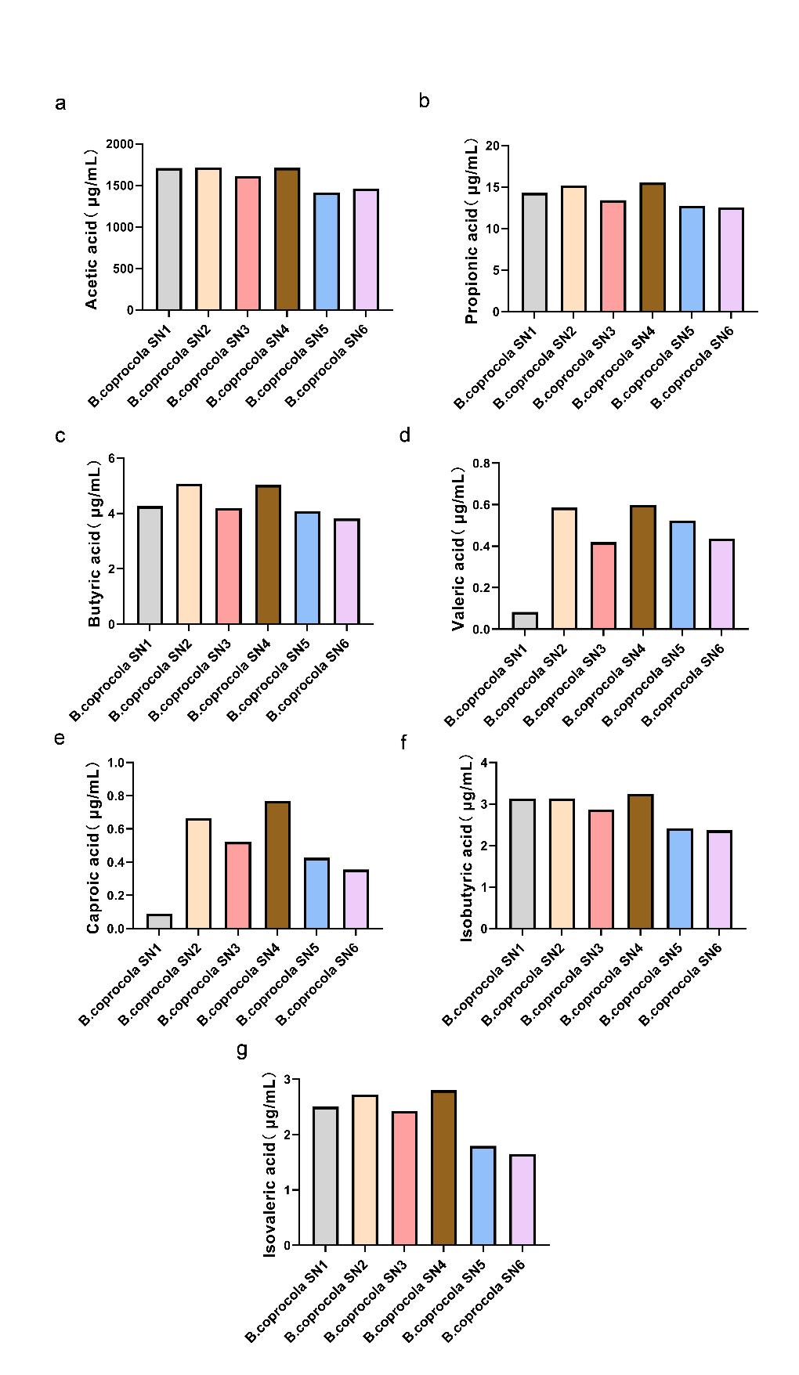

Fig. S4 Metabolomics analysis of short-chain fatty acids in the liquid supernatant of B. coprocola. n=6 for each group.

Fig. S5 Gating strategy of flow cytometry. a Gating strategy of animal tissue flow cytometry. b Gating strategy of BMDMs flow cytometry.

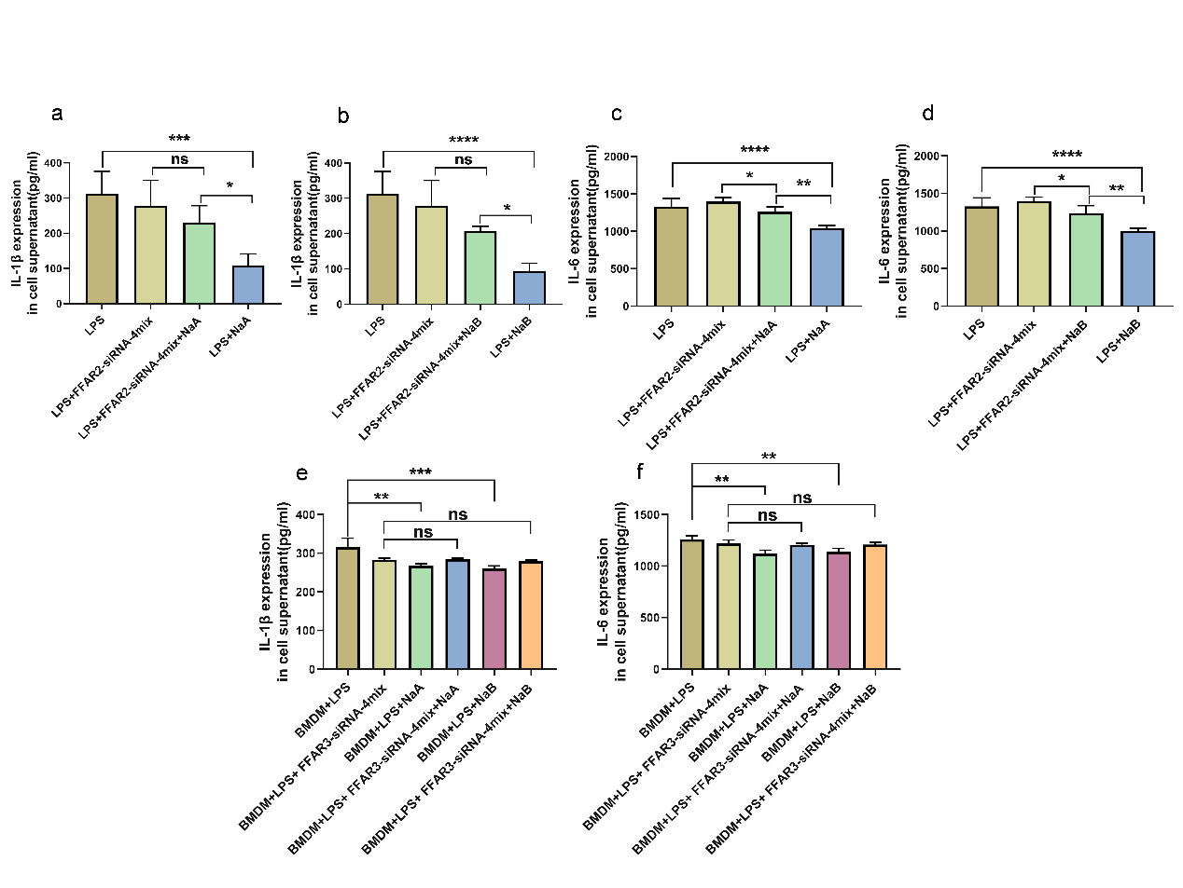

Fig. S6 ELISA results of IL-1β and IL-6 levels in the cell supernatant. n = 5 for each group. Data are presented as mean ± SD. *P < 0.05, **P < 0.01, ***P < 0.001, ****P < 0.0001 (LPS model=LPS+ATP), one-way ANOVA followed by Tukey's test.

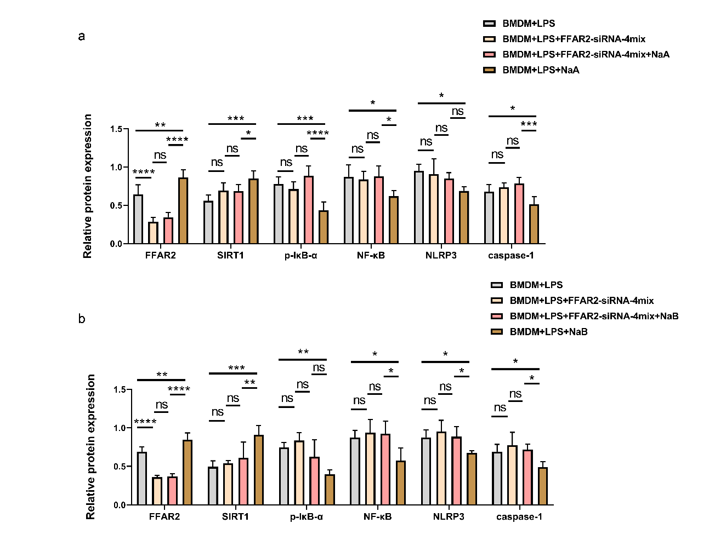

Fig. S7 Western blot statistical analysis. a,b The density analysis result of FFAR2, SIRT1, p-IκB-α, NF-κB, NLRP3 and caspase-1. n=5 for each group. Data are presented as mean ± SD. *P < 0.05, **P < 0.01, ***P < 0.001, ****P < 0.0001, one-way ANOVA followed by Tukey's test. (LPS model=LPS+ATP).

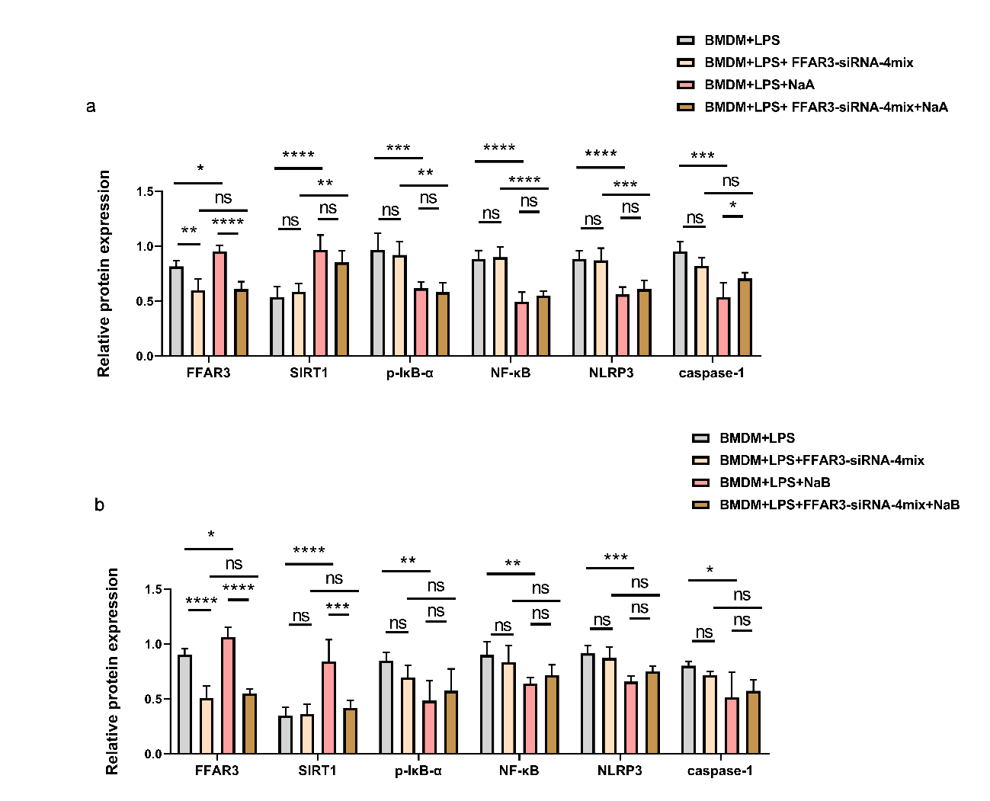
Fig. S8 Western blot statistical analysis. a,b The density analysis results of FFAR3, SIRT1, p-IκB-α, NF-κB, NLRP3 and caspase-1. n=5 for each group. Data are presented as mean ± SD. *P < 0.05, **P < 0.01, ***P < 0.001, ****P < 0.0001, one-way ANOVA followed by Tukey's test. (LPS model=LPS+ATP).

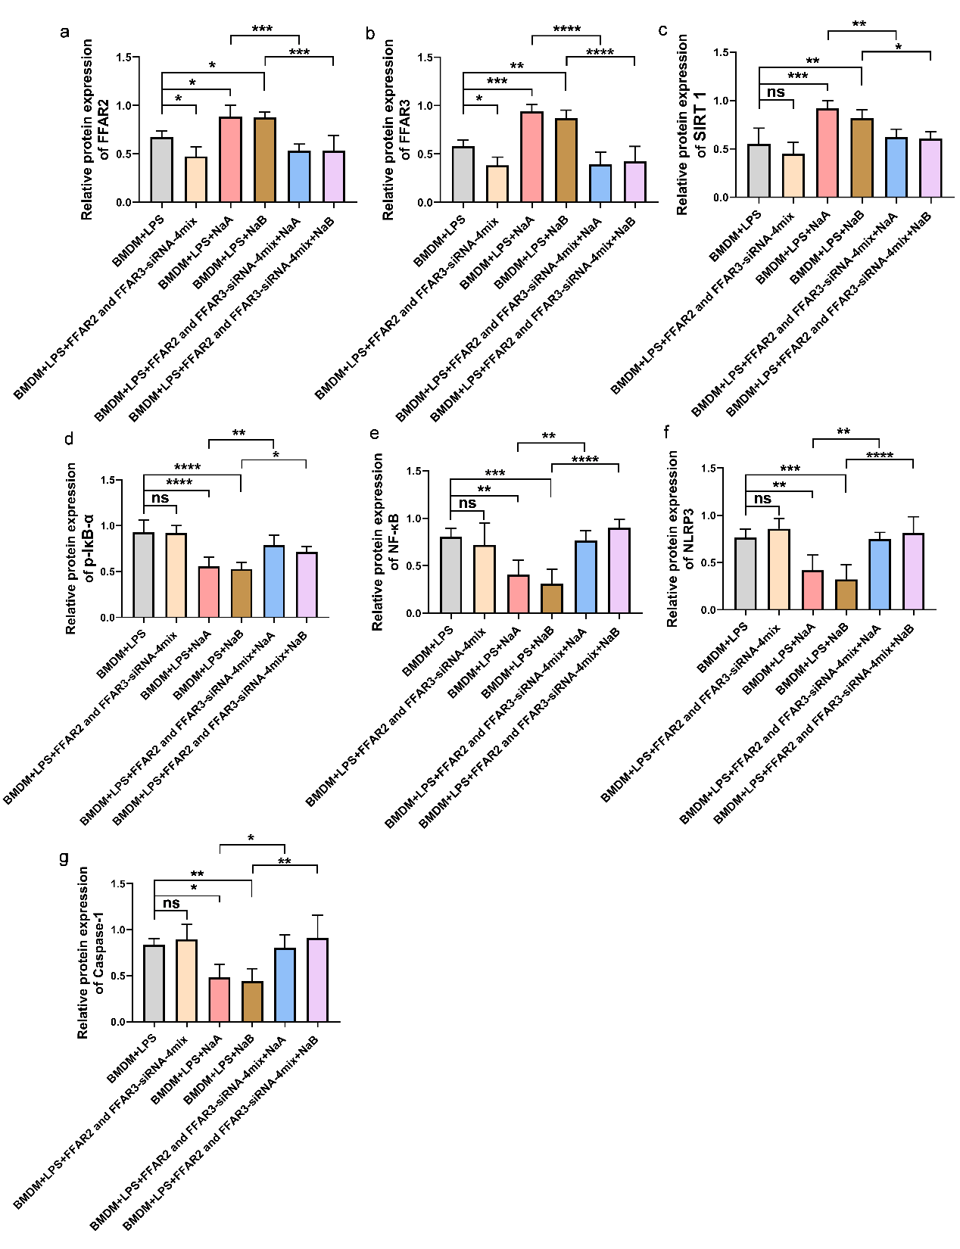

Fig. S9 Western blot statistical analysis. a–g Density analysis results of FFAR2, FFAR3, SIRT1, p-IκB-α, NF-κB, NLRP3 and caspase-1 Western blots. n=5 for each group. Data are presented as mean ± SD. *P < 0.05, **P < 0.01, ***P < 0.001, ****P < 0.0001, one-way ANOVA followed by Tukey's test. (LPS model=LPS+ATP).

