Supplementary materials of Exercise promotes lipophagy and mitigates cognitive impairment in Alzheimer's disease through downregulating microglial TMEM9
Supplementary Figures and Figure legends

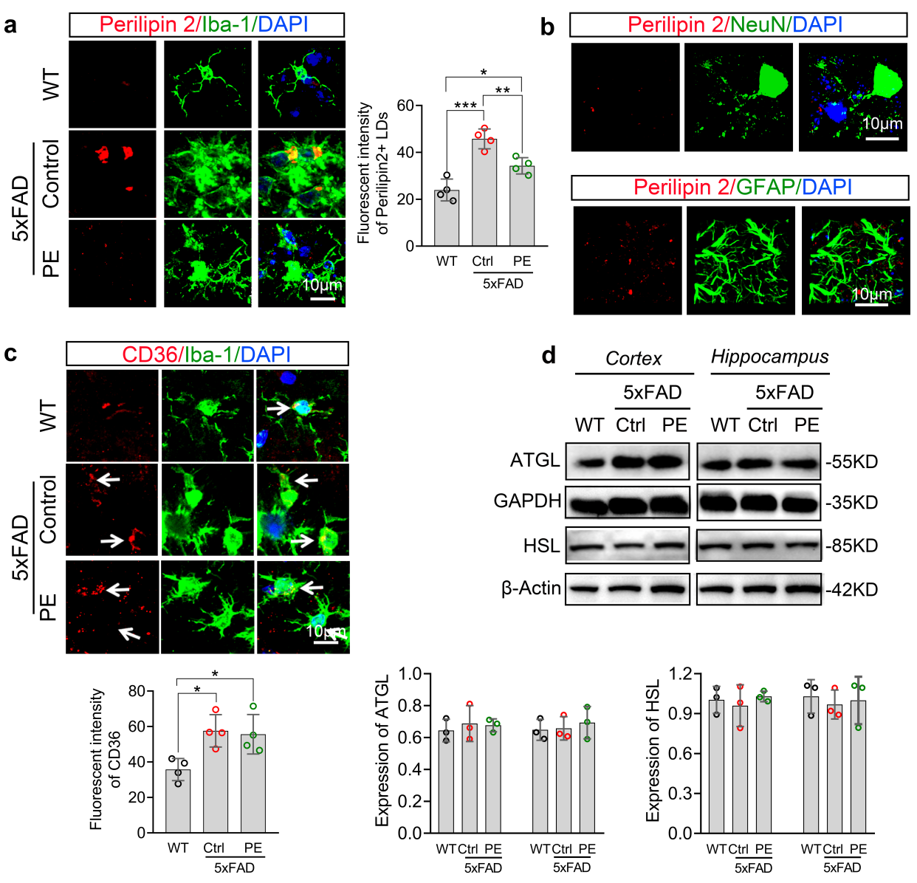
Fig. S1. Physical exercise (PE) enhanced microglial lipophagy in 5xFAD mice. a Co-Immunofluorescent staining and analysis of the Perilipin 2 positive LDs in microglia across WT, control (Ctrl)- and PE-5xFAD groups, n = 4 male mice per experimental group, aged 8 months (100 x oil objective, 3 x magnification) . b Co-Immunofluorescent staining of Perilipin 2 positive LDs and NeuN or GFAP in 5xFAD mice. c Co-Immunofluorescent staining and analysis of CD36 expressions in microglia across WT, control (Ctrl)- and PE-5xFAD groups, n = 4 male mice per experimental group, aged 8 months (100 x oil objective, 3 x magnification). d Western blotting analysis of ATGL, HSL in cortex and hippocampus across WT, Ctrl-5xFAD and PE-5xFAD group, n = 3 male mice per experimental group, aged 8 months. Data are expressed as the mean ± SD, statistical significance was assessed using one-way analysis of variance (ANOVA), followed by Tukey’s multiple comparisons test.*P<0.05; **P<0.01; ***P<0.001; ****P<0.0001.

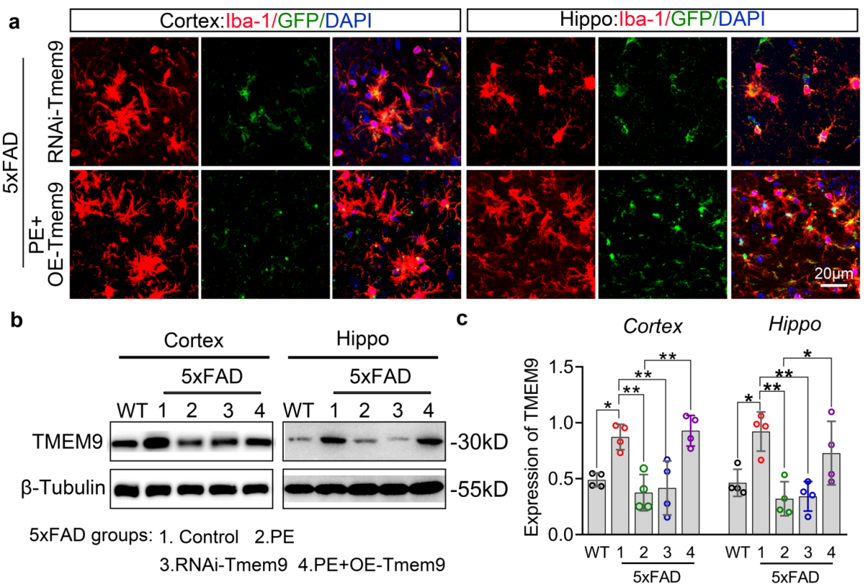
Fig. S2. Verification of adeno-associated lentivirus transfection. a Immunofluorescent staining of GFP expressions in microglia between RNAi-Tmem9 and PE + OE-Tmem9 groups (20 x objective, 5 x magnification). b-c Western blotting analysis of TMEM9 in cortex and hippocampus across WT, Ctrl-5xFAD, PE-5xFAD, RNAi-Tmem9 and PE+OE-Tmem9 groups, n = 4 male mice per group, aged 8 months. Data are expressed as the mean ± SD, statistical significance was assessed using one-way analysis of variance (ANOVA), followed by Tukey’s multiple comparisons test. *P<0.05; **P<0.01; ***P<0.001; ****P<0.0001.

Fig. S3. Physical exercise enhanced microglial lipophagy in 5xFAD mice by down-regulating microglia TMEM9. a Immunofluorescent staining of LC3 and Bodipy in microglia between WT, Ctrl-5xFAD, PE-5xFAD, RNAi-Tmem9 and PE+OE-Tmem9 groups, left pannel: 20 x objective, 5 x magnification; white dotted boxes label the magnified regions displayed in the right panel. Right panel: Higher-magnification views of the areas boxed in the left panel. b Bodipy fluorescent intensity and bodipy co-localized with LC3 in microglia across WT, Ctrl-5xFAD, PE-5xFAD, RNAi-Tmem9 and PE+OE-Tmem9 groups. n = 4 male mice per group, 2 field per mice, aged 8 months. Data are expressed as the mean ± SD, statistical significance was assessed using one-way analysis of variance (ANOVA), followed by Tukey’s multiple comparisons test. *P<0.05; **P<0.01; ***P<0.001; ****P<0.0001.

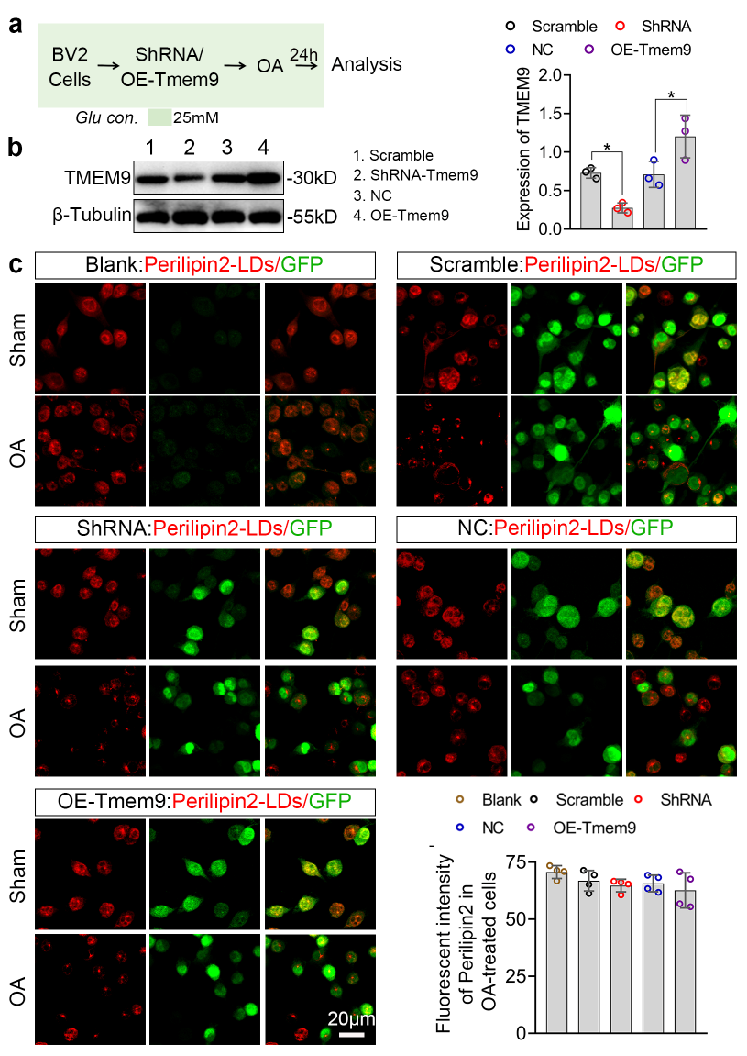
Fig. S4. Transfection of lentivirus did not affect the LDs formation induced by Oleic Acid (OA) in BV2 cells. a Experimental design for ShRNA-Tmem9 and OE-Tmem9 lentiviral transfection, as well as OA treatment, in BV2 Cells. b Western blotting analysis of TMEM9 expressions across Scramble, ShRNA-Tmem9 , Negative Control (NC), and OE-Tmem9 groups, n=3 wells per groups. c-d Immunofluorescent staining and analysis of the Perilipin 2+ LDs induced by OA treatment across Blank, Scramble, ShRNA-Tmem9, NC and OE-Tmem9 groups (20 x objective, 5 x magnification), n = 4 wells per groups. Tmem9 knockdown and overexpression were achieved via lentivirus transfection. Data are expressed as the mean ± SD, statistical significance was assessed using one-way analysis of variance (ANOVA), followed by Tukey’s multiple comparisons test. *P<0.05; **P<0.01; ***P<0.001; ****P<0.0001.

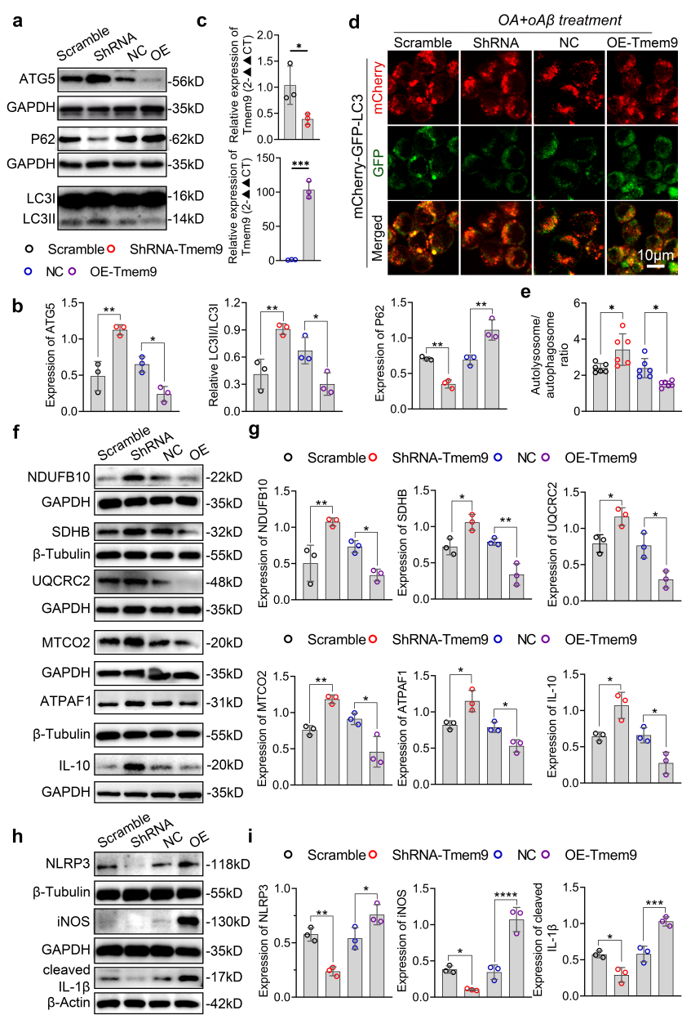
Fig. S5. Knockdown of Tmem9 promoted autophagy, increased mitochondrial proteins and decreased pro-inflammatory cytokines induced by oAβ in BV2 Cells under glucose-insufficiency conditions, whereas overexpression of Tmem9 exerted opposing effects. a-b Western blotting analysis for ATG5, P62, and LC3II/LC3I in Scramble, ShRNA-Tmem9, NC and OE-Tmem9 groups after treatment with OA and oAβ (n = 3 well per group). c Quantitative Real-time PCR (qPCR) validation of transfection efficiency for shRNA-Tmem9 and OE-Tmem9 plasmids, statistical significance was assessed using independent-samples t test, n = 3 well per group. d-e Immunofluorescent analysis for autolysosome/autophagosome ratio (100 x oil objective, 3 x magnification) (n = 3 well per group, 2 field per well). f-g Western blotting analysis of mitochondrial complex I-V-related proteins (NDUFB10, SDHB, UQCRC2, MTCO2, and ATPAF1) and the anti-inflammatory cytokine IL-10 in the Scramble, shRNA-Tmem9, NC, and OE-Tmem9 groups, n = 3 well per group. h-i Western blottings analysis of proteins related to pro-inflammatory cytokines, including NLRP3, iNOS and cleaved IL-1β among Scramble, ShRNA-Tmem9, NC and OE-Tmem9 groups, n = 3 well per group. For western blotting, Tmem9 knockdown and overexpression were achieved via lentiviral transfection. For immunofluorescent staining, Tmem9 knockdown and overexpression were achieved via plasmid transfection. Data are expressed as the mean±SD, statistical significance was assessed using one-way analysis of variance (ANOVA), followed by Tukey’s multiple comparisons test. *P<0.05; **P<0.01; ***P<0.001; ****P<0.0001.

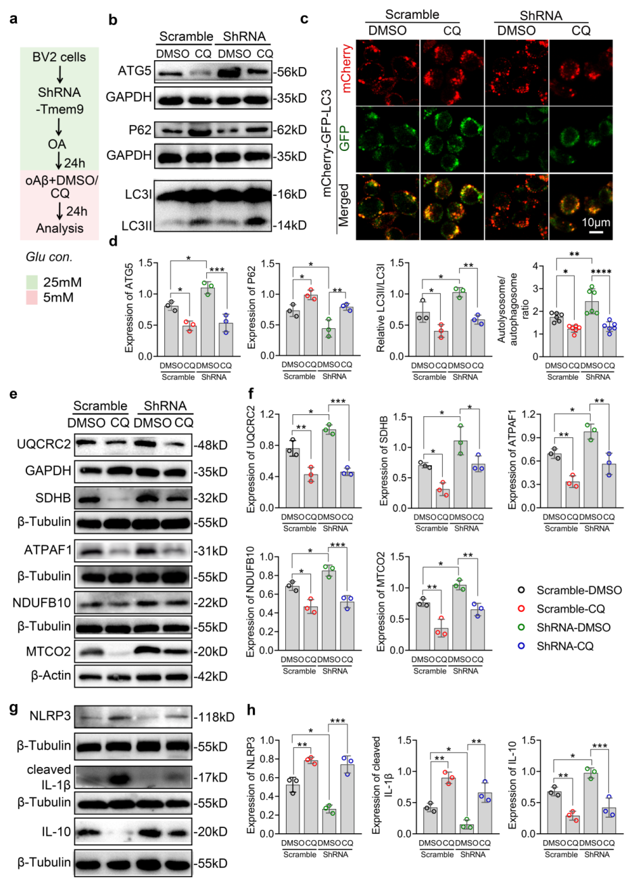
Fig. S6. Knockdown of Tmem9 promoted autophagy, increased mitochondrial protein and decreased pro-inflammatory cytokines induced by oAβ in BV2 Cells under glucose-insufficiency conditions, whereas chloroquine treatment diminished its effects. a Experimental design for ShRNA-Tmem9 lentiviral/plasmid transfection in BV2 cells, followed by treatment with OA, oAβ with DMSO/CQ. b-d Western blotting analysis of ATG5, P62, LC3II/LC3I and immunofluorescent analysis of autolysosome/autophagosome ratio among Scramble and ShRNA-Tmem9 groups treated with OA+oAβ with DMSO or CQ. e-f Western blotting analysis the proteins related to mitochondrial complex I-V including UQCRC2, SDHB, ATPAF1, NDUFB10 and MTCO2 across Scramble, ShRNA-Tmem9, NC and OE-Tmem9 groups treated with OA+oAβ with DMSO or CQ. g-h Western blotting analysis of proteins related to pro-inflammatory cytokines, including NLRP3, Cleaved IL-1β, and the anti- inflammatory cytokine IL-10 among Scramble and ShRNA-Tmem9 groups treated with OA+oAβ with DMSO or CQ. For western blotting, Tmem9 knockdown was achieved via lentivirus transfection; for immunofluorescent staining, Tmem9 knockdown was achieved via plasmid transfection. Data are expressed as the mean±SD, statistical significance was assessed using one-way analysis of variance (ANOVA), followed by Tukey’s multiple comparisons test. *P<0.05; **P<0.01; ***P<0.001; ****P<0.0001.

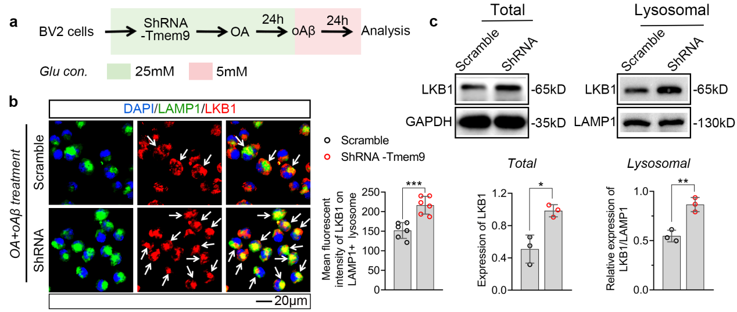Fig. S7. Knockdown of Tmem9 promotes LKB1 translocation to lysosome in vitro. a Experimental design for shRNA-Tmem9 lentiviral/Plasmid transfection, as well as OA and oAβ treatment in BV2 cells. b Immunofluorescence co-localization analysis of LAMP1 and LKB1 in Scramble and ShRNA-Tmem9 cells, n=3 wll per group, 2 field per well. c Western blotting analysis the total LKB1 and lysosmal LKB1 proteins in Scramble and ShRNA-Tmem9 cells, n = 3 wells per group. For western blotting, Tmem9 knockdown was achieved via lentivirus transfection; for immunofluorescent staining, Tmem9 knockdown was achieved via plasmid transfection. Data are expressed as the mean±SD, statistical significance was assessed using independent-samples t test. *P<0.05; **P<0.01; ***P<0.001; ****P<0.0001.

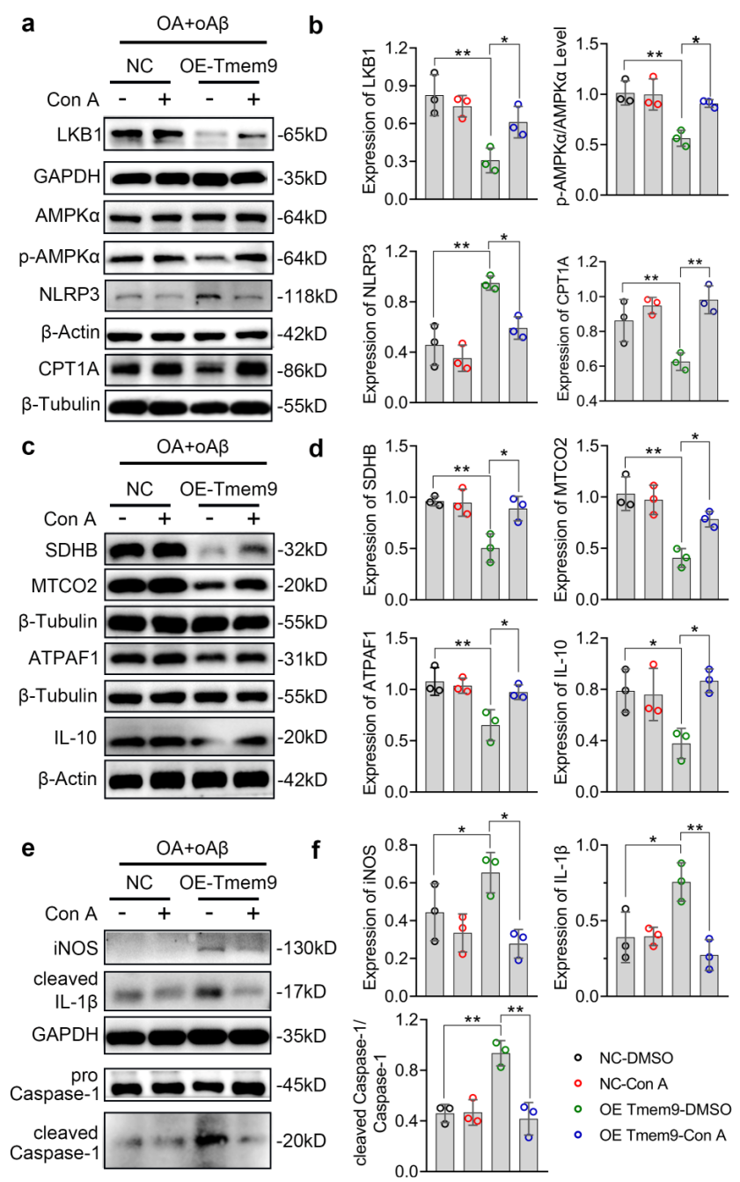
Fig. S8. Concanamycin A (Con A) treatment reactivated AMPKα signaling, maintained mitochondrial homeostasis, and reduced pro-inflammatory cytokines in BV2 cells with Tmem9 overexpression following oleic acid (OA) and oAβ incubation. a-b Western blotting analysis of LKB1, p-AMPKα/AMPKα, NLRP3, and CPT1A in NC and OE-Tmem9 cells treated with DMSO or Con A. c-d Western blots analysis of SDHB, MTCO2, ATPAF1 and IL-10 in NC and OE-Tmem9 cells treated with DMSO or Con A. e-f Western blotting analysis of iNOS, IL-1β, cleaved Caspase-1 in NC and OE-Tmem9 cells treated with DMSO or Con A. Tmem9 overexpression was implemented through lentiviral transfection. n = 3 wells per group. The results are expressed as the mean ± SD, statistical significance was assessed using one-way analysis of variance (ANOVA), followed by Tukey’s multiple comparisons test. *P<0.05; **P<0.01; ***P<0.001; ****P<0.0001.

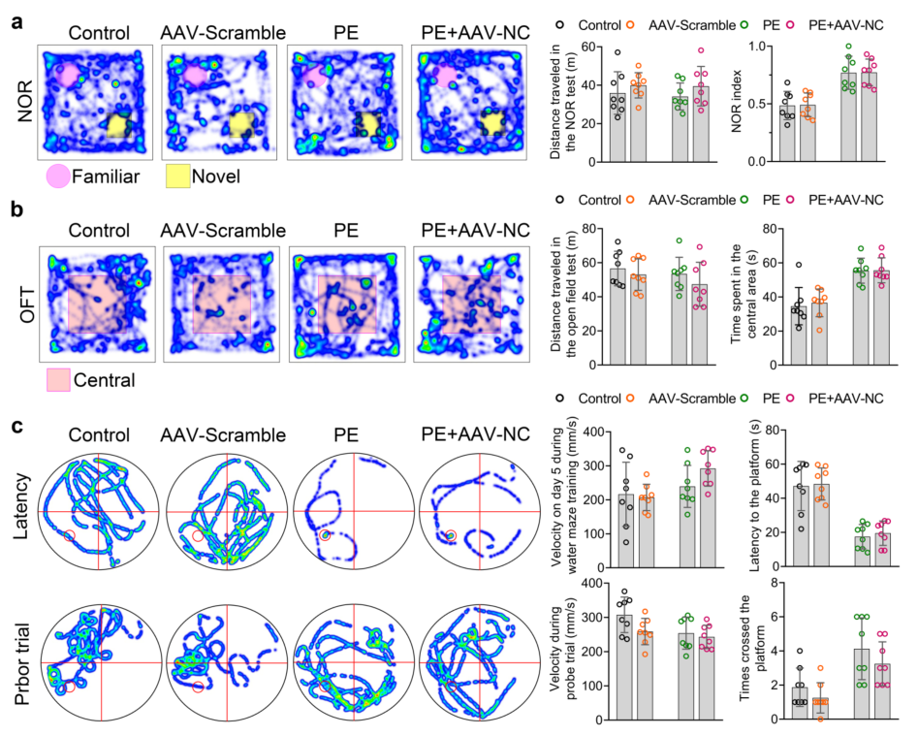
Fig. S9. AAV injection itself had no effect on motor capacity in behavioral tests. a Travel path tracings of mice during the novel object recognition (NOR) test. Quantitative analysis of distance traveled and novel object recognition index in the NOR test: comparison between control vs. AAV-Scramble, and PE vs. PE+AAV-NC groups, n =8 male mice per group, at age of 8 months. b Travel path tracings of mice during open field test (OFT). Quantitative analysis of distance traveled and time spent in the central area during OFT, comparison between control vs. AAV-Scramble, and PE vs. PE+AAV-NC groups, n =8 male mice per group, at age of 8 months. c Spatial learning trajectories during water maze training and probe trial in the Morris water maze. Quantitative analysis of velocity and latency to the platform on day 5 of water maze training, as well as swimming velocity and platform crossings during the probe trial, n =8 male mice per group, at age of 8 months. Data are expressed as the mean±SD, statistical significance was assessed using one-way analysis of variance (ANOVA), followed by Tukey’s multiple comparisons test. *P<0.05; **P<0.01; ***P<0.001; ****P<0.0001.

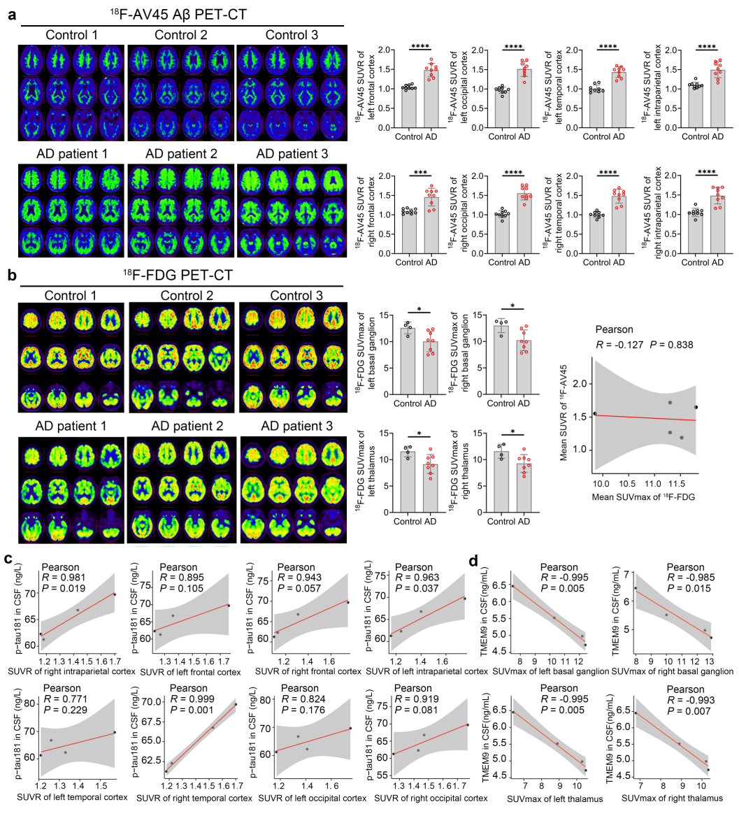
Fig. S10. CSF TMEM9 levels are negatively correlated with SUVR on ¹⁸F-FDG PET-CT. a ¹⁸F-AV45 PET-CT montage (Scale bar = 5cm) and SUVR analysis of amyloid-β (Aβ) deposition betweeen healthy control individuals (n=9) and AD patients (n=9), statistical significance was assessed using independent-samples t test. b ¹⁸F-FDG PET-CT montage (Scale bar = 5cm) and SUVmax analysis of glucose metabolism in healthy control individuals (n=4) and AD patients (n=8), statistical significance was assessed using independent-samples t test. Correlation between average standardized uptake value ratio (SUVR) of ¹⁸F-AV45 and maximum standardized uptake value (SUVmax) of ¹⁸F-FDG in AD (n=5). c Correlation of CSF p-tau181 levels with regional brain SUVR on ¹⁸F-AV45 PET-CT (n=4). d Correlation of CSF TMEM9 levels with regional brain SUVmax on ¹⁸F-FDG PET-CT, the relevant analysis was conducted using Pearson correlation analysis (n=4). The results are expressed as the mean ± SD. *P<0.05; **P<0.01; ***P<0.001; ****P<0.0001.

Supplementary Tables
Table S1. Antibodies for IF and WB
Host | Antibody | Manufacturer | Catalog No. | Dilution
Rabbit | Perilipin-2 Antibody | Servicebio | GB115593 | 1: 400 for IF and 1:1000 for WB
Rabbit | TMEM9 Antibody | Affinity Biosciences | DF12540 | 1: 400 for IF and 1:1000 for WB
Mouse | Iba1 Antibody | Servicebio | GB12105 | 1: 400 for IF
Mouse | NeuN Antibody | Sigma-Aldrich | MAB377 | 1: 400 for IF
Mouse | GFAP Antibody | Servicebio | GB12096 | 1: 400 for IF
Rabbit | CD36 Antibody | Servicebio | GB112562 | 1: 400 for IF
Rabbit | Iba1 Antibody | WAKO | 019-19741 | 1: 400 for IF
Mouse | LC3b Antibody | ABclonal | A17424 | 1: 400 for IF
Rat | LAMP1 Antibody | Abcam | AB24871 | 1: 400 for IF
Rabbit | LKB1Antibody | Affinity Biosciences | AF6453 | 1: 400 for IF, 1:1000 for WB
Mouse | AXIN Antibody | Proteintech | 68093-1-IG | 1: 400 for IF, 1:1000 for WB
Mouse | Aβ1-42 Antibody | Biolegend | 805501 | 1: 400 for IF, 1:1000 for WB
Rabbit | LC3 Antibody | Cell signaling Technology | 12741S | 1:1000 for WB
Rabbit | APG5L/ATG5 Antibody | Affinity Biosciences | DF6010 | 1:1000 for WB
Rabbit | β-actin Antibody | Affinity Biosciences | AF7018 | 1:1000 for WB
Rabbit | β-tubulin Antibody | Affinity Biosciences | AF7011 | 1:1000 for WB
Rabbit | GAPDH Antibody | Affinity Biosciences | AF7021 | 1:1000 for WB
Rabbit | LIPA (LAL) Antibody | Proteintech | 12956-1-AP | 1:1000 for WB
Rabbit | ATGL Antibody | Affinity Biosciences | DF7756 | 1:1000 for WB
Rabbit | HSL Antibody | Affinity Biosciences | AF6403 | 1:1000 for WB
Rabbit | NLRP3 Antibody | Affinity Biosciences | DF15549 | 1:1000 for WB
Rabbit | Caspase-1 Antibody | Affinity Biosciences | AF5418 | 1:1000 for WB
Rabbit | Cleaved-Caspase 1 (Asp296), p20 Antibody | Affinity Biosciences | AF4005 | 1:1000 for WB
Rabbit | IL18 Antibody | Affinity Biosciences | DF6252 | 1:1000 for WB
Rabbit | IL10 Antibody | Abcolonal | A20723 | 1:1000 for WB
Rabbit | CPT1A Antibody | Affinity Biosciences | DF12004 | 1:1000 for WB
Rabbit | NDUFB10 Antibody | ABclonal | A3982 | 1:1000 for WB
Rabbit | SDHB Antibody | Servicebio | GB111344 | 1:1000 for WB
Rabbit | UQCRC2 Antibody | Affinity Biosciences | DF12339 | 1:1000 for WB
Rabbit | MTCO2 Antibody | Affinity Biosciences | DF7867 | 1:1000 for WB
Rabbit | ATPAF1 Antibody | Proteintech | 18016-1-AP | 1:1000 for WB
Rabbit | AMPK alpha Antibody | Affinity Biosciences | AF6423 | 1:1000 for WB
Rabbit | Phospho-AMPK alpha (Thr172) Antibody | Affinity Biosciences | AF3423 | 1:1000 for WB
Rabbit | iNOS Antibody | Affinity Biosciences | AF0199 | 1:1000 for WB
Rabbit | IL-1β Antibody | Servicebio | GB11113-100 | 1:1000 for WB
Rabbit | Cleaved-IL-1 beta (Asp116) Antibody | Affinity Biosciences | AF4006 | 1:1000 for WB
Rabbit | ATP6AP1 Antibody | Affinity Biosciences | DF6341 | 1:1000 for WB
Rabbit | SQSTM1/p62 Antibody | Affinity Biosciences | AF5384 | 1:1000 for WB
Mouse | Tau Antibody | Proteintech | 66499-1-Ig | 1:1000 for WB
Rabbit | Phospho-Tau (Thr217) antibody | Proteintech | 31138-1-AP | 1:1000 for WB
/ | Anti-rabbit lgG, HRP-linked Antibody | Cell Signaling Technology | 70745 | 1:5000 for WB
/ | Anti-mouse IgG, HRP-linked Antibody | Cell Signaling Technology | 7076S | 1:5000 for WB
/ | Anti-mouse IgG (H+L), F(ab')2 Fragment (Alexa Fluor® 647 Conjugate) | Cell Signaling Technology | 4410S | 1: 400 for IF
/ | Anti-mouse IgG (H+L), F(ab')2 Fragment (Alexa Fluor® 488 Conjugate) | Cell Signaling Technology | 4408S | 1: 400 for IF
/ | Anti-rabbit IgG (H+L), F(ab')2 Fragment (Alexa Fluor® 555 Conjugate) | Cell Signaling Technology | 4413S | 1: 400 for IF

Table S2. Characteristics of control and AD patients cohort
Group | Sex | Age | Plasma | CSF | ¹⁸F-AV45 PET-CT | ¹⁸F-FDG PET-CT | MMSE Score | MoCA-B Score
Control 1 | Male | 69 | Yes | No | No | No | / | 26
Control 2 | Female | 41 | Yes | No | No | No | 25 | 26
Control 3 | Female | 62 | Yes | No | No | No | 28 | 27
Control 4 | Male | 72 | Yes | No | No | No | / | 18
Control 5 | Female | 70 | Yes | No | No | No | / | 26
Control 6 | Female | 62 | Yes | No | No | No | / | /
Control 7 | Male | 69 | Yes | No | No | No | 27 | 20
Control 8 | Male | 68 | Yes | No | No | No | 29 | 26
Control 9 | Female | 60 | Yes | No | No | No | / | 23
Control 10 | Male | 33 | Yes | No | No | No | 29 | 30
Control 11 | Female | 76 | Yes | No | No | No | / | /
Control 12 | Female | 55 | Yes | No | No | No | 30 | 24
Control 13 | Female | 75 | Yes | No | No | No | 14 | 11
Control 14 | Male | 64 | Yes | No | No | No | / | 26
Control 15 | Female | 60 | Yes | No | No | No | / | 25
Control 16 | Male | 60 | Yes | Yes | No | No | / | /
Control 17 | Female | 69 | Yes | No | No | No | / | 24
Control 18 | Male | 71 | Yes | No | No | No | / | 29
Control 19 | Female | 72 | Yes | No | No | No | / | 27
Control 20 | Male | 79 | Yes | No | No | No | / | 23
Control 21 | Female | 67 | Yes | No | No | No | / | 26
Control 22 | Female | 71 | Yes | No | No | No | / | 23
Control 23 | Female | 62 | Yes | No | No | No | / | 23
Control 24 | Male | 67 | Yes | No | No | No | / | /
Control 25 | Male | 72 | Yes | No | No | No | / | 17
Control 26 | Male | 63 | Yes | No | No | No | / | 23
Control 27 | Male | 81 | Yes | No | No | No | / | 23
Control 28 | Female | 55 | Yes | No | No | No | / | 25
Control 29 | Male | 61 | No | Yes | No | No | / | /
Control 30 | Male | 57 | No | Yes | No | No | / | /
Control 31 | Female | 61 | No | Yes | No | No | / | 29
Control 32 | Female | 70 | No | Yes | No | No | / | /
Control 33 | Male | 69 | No | Yes | No | No | 20 | 17
Control 34 | Female | 61 | No | No | Yes | No | / | /
Control 35 | Female | 68 | No | No | Yes | No | / | /
Control 36 | Male | 67 | No | No | Yes | Yes | / | /
Control 37 | Female | 55 | No | No | Yes | Yes | / | /
Control 38 | Female | 70 | No | No | Yes | No | / | /
Control 39 | Male | 80 | No | No | Yes | No | / | /
Control 40 | Female | 62 | No | No | Yes | Yes | / | /
Control 41 | Male | 88 | No | No | Yes | Yes | / | /
Control 42 | Female | 57 | No | No | Yes | No | / | /
AD1 | Female | 70 | Yes | No | No | No | / | /
AD2 | Female | 87 | Yes | No | No | No | 18 | 11
AD3 | Male | 61 | Yes | No | No | No | 25 | 19
AD4 | Female | 53 | Yes | Yes | No | No | 27 | 23
AD5 | Female | 68 | Yes | Yes | No | No | 3 | /
AD6 | Male | 73 | Yes | Yes | Yes | Yes | / | /
AD7 | Female | 66 | Yes | No | Yes | Yes | 8 | /
AD8 | Male | 67 | Yes | No | No | No | 6 | /
AD9 | Male | 64 | Yes | No | No | No | 29 | 25
AD10 | Male | 60 | Yes | No | Yes | No | 29 | 22
AD11 | Male | 76 | Yes | No | No | No | 29 | 23
AD12 | Female | 75 | Yes | No | No | No | 22 | 19
AD13 | Female | 86 | Yes | No | No | No | 9 | /
AD14 | Female | 85 | Yes | No | No | No | 19 | 19
AD15 | Female | 84 | Yes | Yes | No | Yes | / | /
AD16 | Female | 74 | Yes | No | Yes | Yes | 9 | 8
AD17 | Male | 73 | Yes | No | No | No | / | /
AD18 | Male | 92 | Yes | No | No | No | / | /
AD19 | Female | 72 | Yes | No | Yes | No | 11 | /
AD20 | Female | 68 | Yes | No | Yes | No | 30 | 29
AD21 | Male | 75 | Yes | No | No | No | 17 | 14
AD22 | Male | 73 | Yes | No | No | No | 27 | 26
AD23 | Female | 69 | Yes | No | No | No | 6 | /
AD24 | Male | 70 | Yes | No | No | No | 28 | 25
AD25 | Male | 74 | Yes | Yes | No | No | / | /
AD26 | Female | 58 | Yes | No | No | No | / | /
AD27 | Female | 57 | No | Yes | No | No | 29 | 26
AD28 | Female | 52 | No | Yes | Yes | No | / | 23
AD29 | Female | 64 | No | Yes | No | No | 17 | /
AD30 | Male | 83 | No | Yes | No | No | 9 | 6
AD31 | Male | 75 | No | Yes | Yes | Yes | / | 21
AD32 | Female | 75 | No | Yes | No | No | 20 | 13
AD33 | Male | 75 | No | Yes | No | No | / | /
AD34 | Female | 40 | No | Yes | Yes | Yes | / | 23
AD35 | Female | 50 | No | Yes | No | No | 29 | 22
AD36 | Male | 76 | No | Yes | No | No | 20 | 17
AD37 | Male | 66 | No | Yes | No | No | / | /
AD38 | Female | 68 | No | No | No | Yes | / | /
AD39 | Female | 76 | No | No | No | Yes | / | /

Table S3. Correlation analyses between biomarkers and ¹⁸F-AV45 PET-CT
¹⁸F-AV45 PET-CT | TMEM9 in plasma  (ng/mL)  (n = 6) | ATP6AP1 in plasma  (ng/mL)  (n = 6) | p-tau217 in plasma  (ng/L)  (n = 5) | TMEM9 in CSF  (ng/mL)  (n = 4) | ATP6AP1 in CSF  (ng/mL)  (n = 4) | p-tau181 in CSF  (ng/L)  (n = 3)
SUVR of left frontal cortex | R = -0.042,  P = 0.937 | R = 0.605,  P = 0.203 | R= -0.062,  P = 0.921 | R = -0.167,  P = 0.833 | R = -0.404,  P = 0.596 | R = 0.895,  P = 0.105
SUVR of right frontal cortex | R = -0.121,  P = 0.819 | R = 0.300,  P = 0.564 | R= -0.584,  P = 0.302 | R = -0.124,  P = 0.876 | R = -0.374,  P = 0.626 | R = 0.943,  P = 0.057
SUVR of left intraparietal cortex | R = -0.471,  P = 0.345 | R = 0.388,  P = 0.447 | R = 0.583, P = 0.302 | R = -0.080,  P = 0.920 | R = -0.338,  P = 0.662 | R = 0.963,  P = 0.037
SUVR of right intraparietal cortex | R = -0.471,  P = 0.345 | R = 0.335,  P = 0.516 | R = 0.674, P = 0.212 | R = -0.279,  P = 0.721 | R = -0.521,  P = 0.479 | R = 0.981,  P = 0.019
SUVR of left temporal cortex | R = -0.531,  P = 0.279 | R = -0.032,  P = 0.953 | R = 0.070, P = 0.911 | R = 0.280,  P = 0.720 | R = 0.034,  P = 0.966 | R = 0.771,  P = 0.229
SUVR of right temporal cortex | R = -0.465,  P = 0.353 | R = 0.443,  P = 0.380 | R = 0.796, P = 0.107 | R = -0.268,  P = 0.732 | R = -0.511,  P = 0.489 | R = 0.999,  P = 0.001
SUVR of left occipital cortex | R = -0.463,  P = 0.356 | R = 0.501,  P = 0.312 | R= -0.637,  P = 0.248 | R = 0.294,  P = 0.706 | R = 0.037,  P = 0.963 | R = 0.824,  P = 0.176
SUVR of right occipital cortex | R = 0.111,  P = 0.834 | R = 0.187,  P = 0.723 | R= -0.619, P = 0.266 | R = 0.135,  P = 0.865 | R = -0.129,  P = 0.871 | R = 0.919,  P = 0.081
Footnote: R values represent Spearman’s correlation coefficients. P values are two‑sided, and *P <0.05 indicates statistical significance. SUVR = standardized uptake value ratio; CSF = cerebrospinal fluid; TMEM9 = transmembrane protein 9; ATP6AP1 = ATPase H⁺transporting accessory protein 1; p-tau217 = phosphorylated tau at threonine 217; p-tau181 = phosphorylated tau at threonine 181.

Table S4. Correlation analyses between biomarkers and ¹⁸F-FDG PET-CT
¹⁸F-FDG PET-CT | TMEM9 in plasma  (ng/mL)  （n = 4） | ATP6AP1 in plasma  (ng/mL)  （n = 4） | p-tau217 in plasma  (ng/L)  （n = 3） | TMEM9 in CSF  (ng/mL)  （n = 4） | ATP6AP1 in CSF  (ng/mL)  （n = 4） | p-tau181 in CSF  (ng/L)  （n = 4）
SUVmax of left basal ganglion | R = 0.736,  P = 0.264 | R = -0.08,  P = 0.92 | R = 0.054,  P = 0.966 | R = -0.995,  P = 0.005 | R = 0.53,  P = 0.47 | R = 0.319,  P = 0.793
SUVmax of right basal ganglion | R = -0.623,  P = 0.377 | R = 0.083,  P = 0.917 | R = -0.095,  P = 0.94 | R = -0.985,  P = 0.015 | R = 0.386,  P = 0.614 | R = 0.28,  P = 0.82
SUVmax of left thalamus | R = -0.699,  P = 0.301 | R = -0.276,  P = 0.724 | R = -0.106,  P = 0.932 | R = -0.995,  P = 0.005 | R = 0.567,  P = 0.433 | R = 0.292,  P = 0.811
SUVmax of right thalamus | R = -0.770,  P = 0.230 | R = -0.408,  P = 0.592 | R = 0.006,  P = 0.996 | R = -0.993,  P = 0.007 | R = 0.553,  P = 0.447 | R = 0.34,  P = 0.779
Footnote: R values represent Spearman’s correlation coefficients. P values are two‑sided, and P <0.05 indicates statistical significance. SUVmax = maximum standardized uptake value; CSF = cerebrospinal fluid; TMEM9 = transmembrane protein 9; ATP6AP1 = ATPase H⁺transporting accessory protein 1; p‑tau217 = phosphorylated tau at threonine 217; p‑tau181 = phosphorylated tau at threonine 181.

