Supplementary figures and figure legends
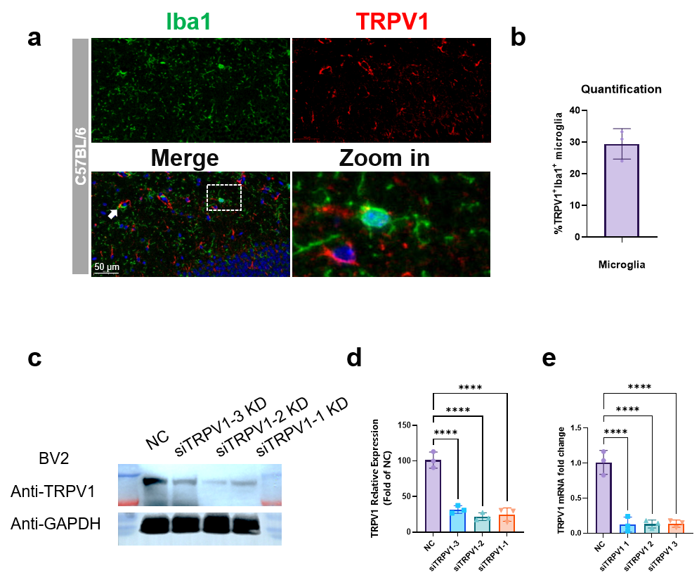
Fig. S1 TRPV1 receptor expression in microglia populations.
a Fluorescence co-expression of TRPV1 (red) and Iba1 (green). Scale bars, 50 μm. b The percentage of TRPV1-positive microglia was calculated as the number of TRPV1-positive Iba1-positive cells divided by the total number of Iba1-positive cells. c-d The knockdown efficiency of three TRPV1 siRNAs was assessed by western blotting. e The knockdown efficiency of three TRPV1 siRNAs was assessed by qPCR. NC: non-targeting negative-control siRNA.

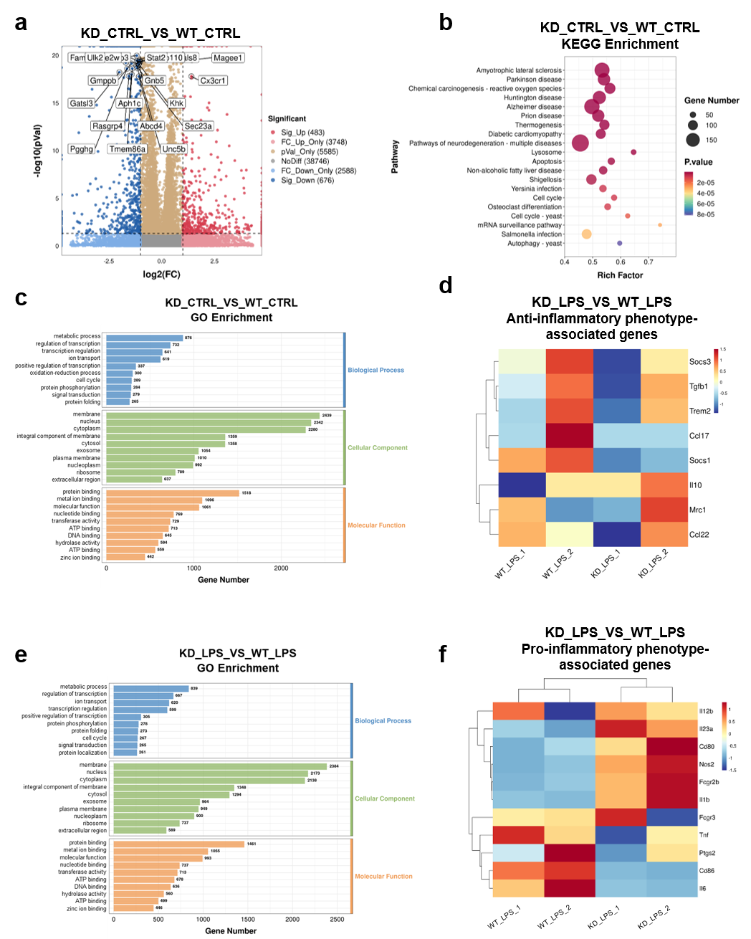
Fig. S2 TRPV1 deficiency modulates microglial transcriptomic profiles.
a-c Changes in transcriptional profiles (a), KEGG pathway enrichment (b), and GO term enrichment (c) in BV2 cells following TRPV1 knockdown under control conditions. d, f Changes in anti-inflammatory (d) and pro-inflammatory genes (f) in BV2 cells following TRPV1 knockdown under LPS stimulation. e Changes in GO enrichment in BV2 cells following TRPV1 knockdown under LPS stimulation.

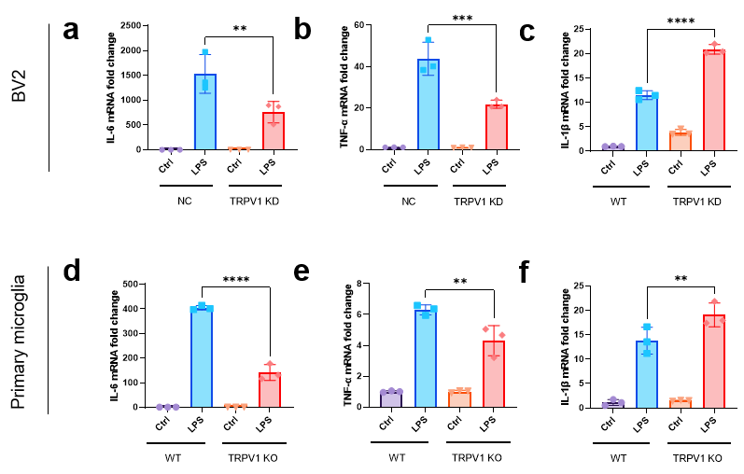
Fig. S3 TRPV1 deficiency modulates glial inflammatory factor secretion.
a-c The impact of TRPV1 KD on IL-6 (a), TNF-α (b), and IL-1β (c) levels in BV2. d-f The impact of TRPV1 KO on IL-6 (d), TNF-α (e), and IL-1β (f) levels in primary microglia. (n = 3 independent biological replicates). Data represent mean ± SD, P < 0.05, **P < 0.01, ***P < 0.001, ****P < 0.0001, ns: not significant. P values were obtained with one-way ANOVA followed by Tukey’s multiple comparisons tests.

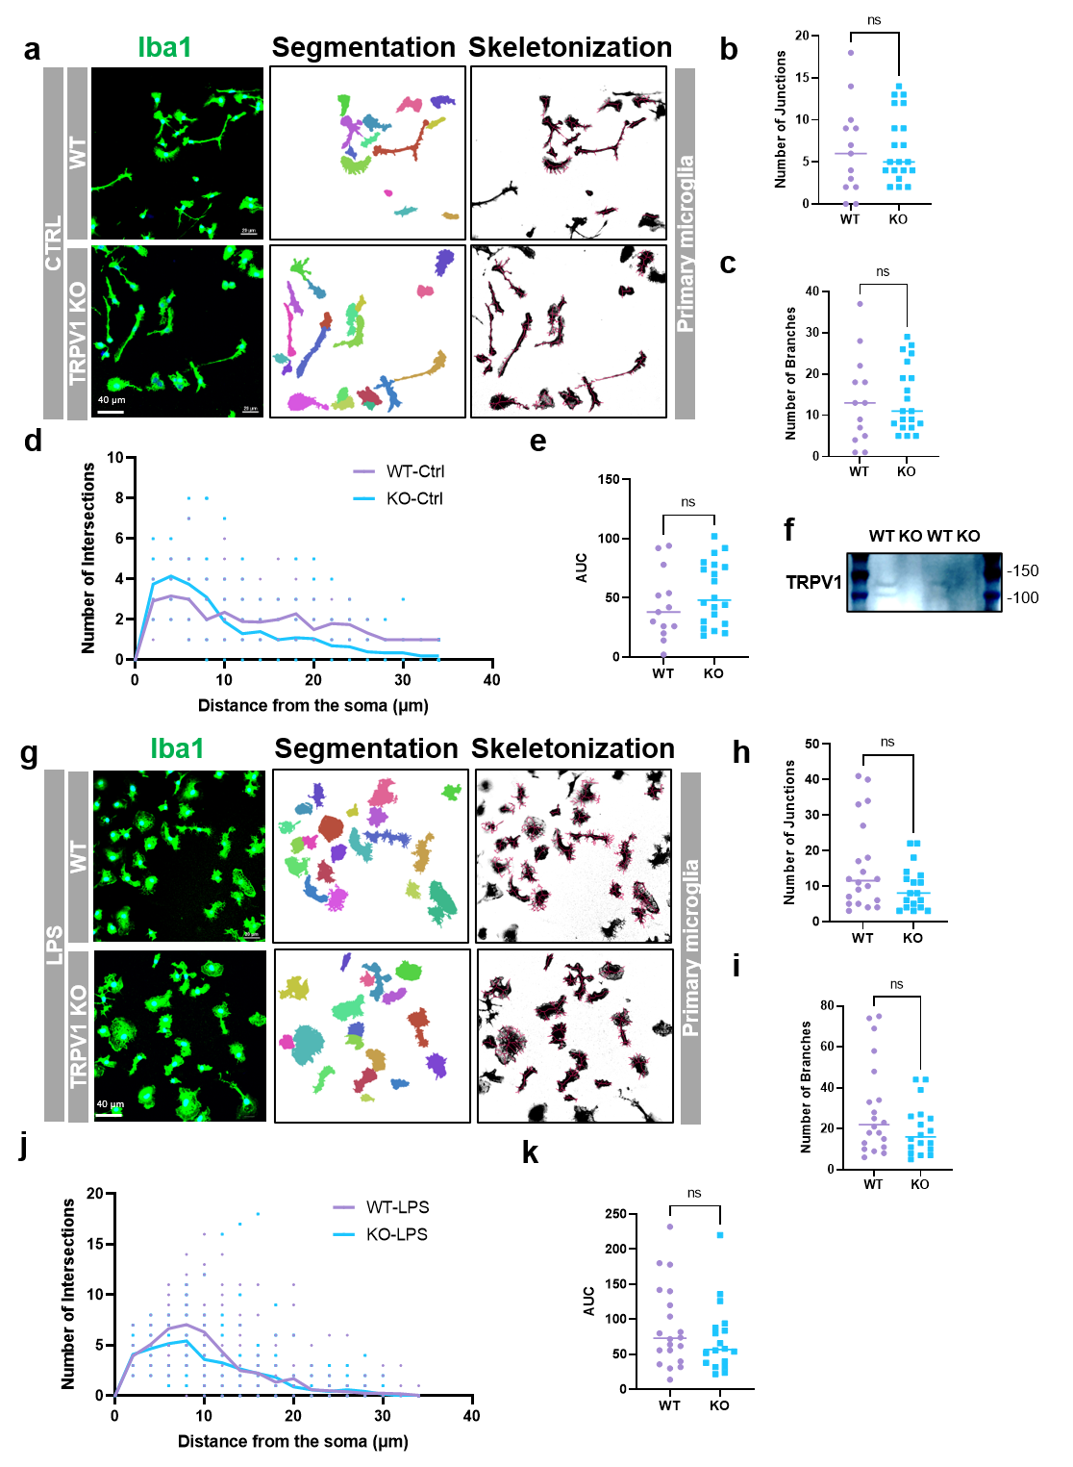
Fig. S4 Effects of TRPV1 deficiency on primary microglial morphology in vitro.
a Iba1 immunofluorescence staining, segmentation and skeletonization analysis of primary microglia in WT and TRPV1 KO groups. Scale bars, 40 μm. b-e Junction number (b), branch number (c), intersection number within the range from soma to dendritic terminals (d), with the corresponding area under the curve calculated (e) (Each dot represents one individual cell. A total of n = 13-20 cells were analyzed from n = 3 independent biological replicates). f TRPV1 protein levels were detected in the brain from the WT and TRPV1 KO mice (n = 3 independent biological replicates ). g Iba1 immunofluorescence staining and skeletonization analysis of primary microglia in WT and TRPV1 KO groups under inflammatory conditions. Scale bars, 40 μm. h-k Junction number (h), branch number (i), intersection number within the range from soma to dendritic terminals (j), with the corresponding area under the curve calculated (k) (Each dot represents one individual cell. A total of n = 18-20 cells were analyzed from n = 3 independent biological replicates). Data represent mean ± SD, ns: not significant. P values were obtained with two-sided paired ratio Student’s t-test.

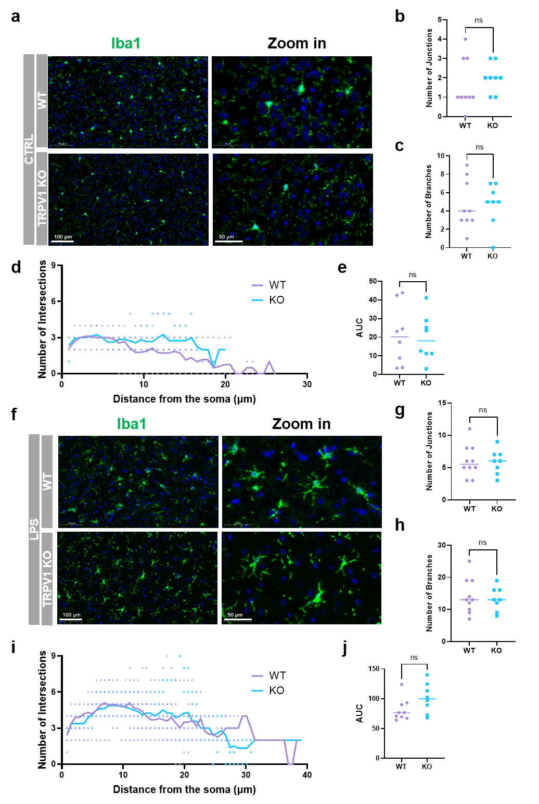
Fig. S5 Effects of TRPV1 deficiency on microglial morphology in vivo.
a Iba1 immunofluorescence staining and sholl analysis of microglia in WT and TRPV1 KO mice. Scale bars, 100 μm and 50 μm. b-e Sholl analysis of primary microglia junction number (b), branch number (c), and intersection number within the range from soma to dendritic terminals (d), with the corresponding area under the curve calculated (e) (Each dot represents one individual cell. A total of n = 8-10 cells were analyzed from n = 3 independent biological replicates). f Iba1 immunofluorescence staining and sholl analysis of primary microglia in WT and TRPV1 KO mice under inflammatory conditions. Scale bars, 100 μm and 50 μm. g-j Sholl analysis of microglia junction number (g), branch number (h), and intersection number within the range from soma to dendritic terminals (i), with the corresponding area under the curve calculated (j) (Each dot represents one individual cell. A total of n = 8-10 cells were analyzed from n = 3 independent biological replicates). Data represent mean ± SD, ns: not significant. P values were obtained with two-sided paired ratio Student’s t-test.

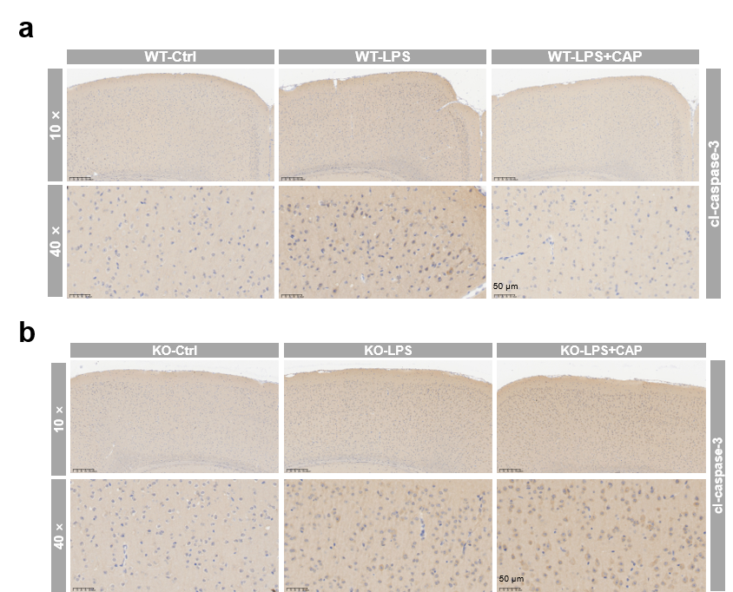
Fig. S6 Capsaicin exerts anti-neuroinflammatory effects through TRPV1 in murine models.
a Immunohistochemical staining of cl-caspase-3 in brain tissues of mice from the WT group, LPS group, LPS + CAP group. Scale bars, 50 μm. b Immunohistochemical staining of cl-caspase-3 in brain tissues of mice from the Ctrl group, LPS group, and LPS+CAP group after TRPV1 KO. Scale bars, 50 μm.

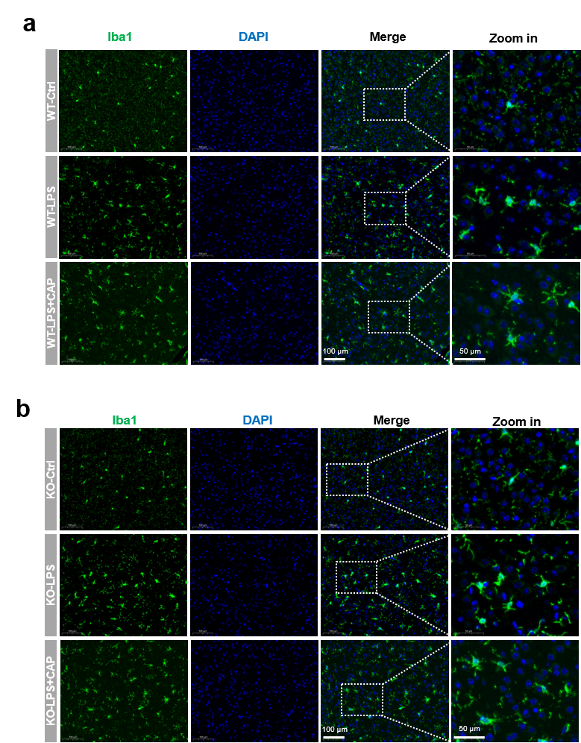
Fig. S7 The TRPV1 receptor is crucial for the anti-neuroinflammatory effects of capsaicin in vivo.
a Iba1 immunofluorescence staining of WT mouse brain tissue sections. b Iba1 immunofluorescence staining of mouse brain tissue sections after TRPV1 KO. Scale bars, 100 μm in overview images and 50 μm in enlarged images.

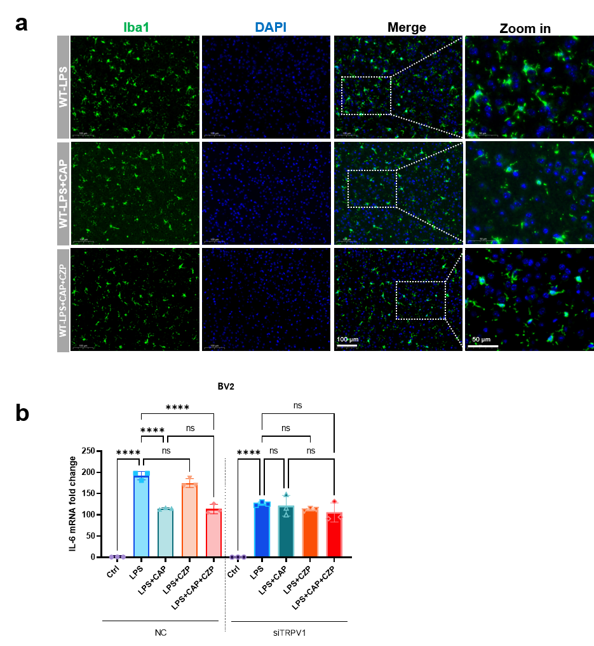
Fig. S8 Blocking the channel function of TRPV1 cannot reverse the anti-neuroinflammatory effects of capsaicin.
a Immunofluorescence staining of microglial Iba1. Scale bars, 100 μm in overview images and 50 μm in enlarged images. b BV2 cells transfected with control siRNA or TRPV1 siRNA were treated with LPS, CAP, capsazepine (CZP), or CAP plus CZP as indicated. IL-6 mRNA expression was measured by RT-qPCR.

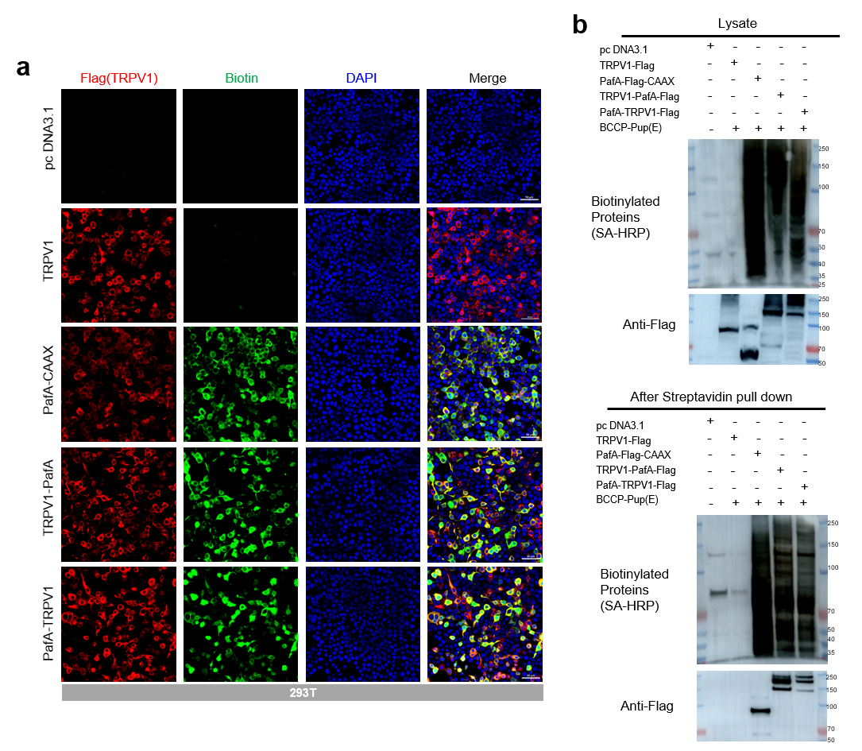
Fig. S9 Development of an engineered PUP-IT system to map chaperone interactions with TRPV1.
a Fluorescence expression of Flag and biotin in HEK-293T cells after transfection with PafA proximity labeling-related plasmids. TRPV1–PafA denotes the construct in which PafA was fused to the C terminus of TRPV1, whereas PafA–TRPV1 denotes the construct in which PafA was fused to the N terminus of TRPV1. Scale bars, 50 μm. b Pull-down assay verification of PafA proximity labeling system activity (n = 3 independent biological replicates). Western blotting analysis of Flag and biotin-labeled protein expression in different groups (upper). Flag and biotin-labeled protein expression in different groups after pull-down with streptavidin magnetic beads (lower).

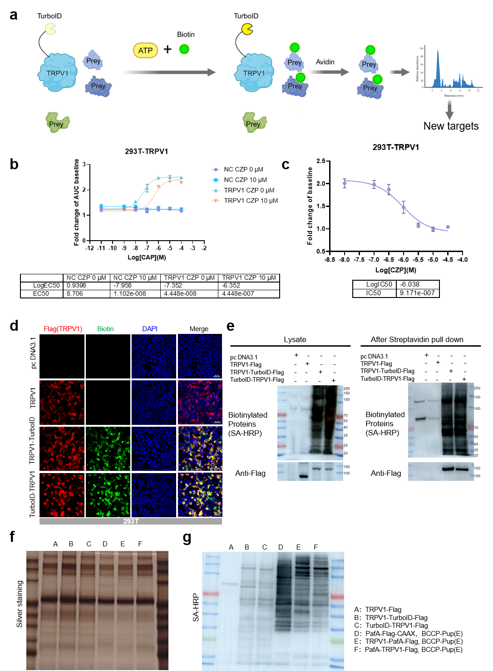
Fig. S10 A proximity-labeling system for systematic identification of TRPV1-associated chaperones.
a Schematic diagram of the TurboID system for identifying potential TRPV1-interacting proteins (created in https://BioRender.com). b-c Verification of the plasmid activity in the proximity labeling system (n = 3 independent biological replicates). Changes in intracellular calcium levels after treatment with gradient concentrations of capsaicin and a fixed concentration of capsazepine (b). Changes in intracellular calcium levels after treatment with a fixed concentration of capsaicin and gradient concentrations of capsazepine (c) in 293T. d Immunofluorescence verification of TurboID proximity labeling system activity. Fluorescence expression of Flag and biotin in HEK-293T cells after transfection with TurboID proximity labeling-related plasmids (n = 3 independent biological replicates). Scale bars, 50 μm. e Pull-down assay verification of TurboID proximity labeling system activity (n = 3 independent biological replicates). Western blotting analysis of Flag and biotin-labeled protein expression in different groups (left). Flag and biotin-labeled protein expression in different groups after pull-down with streptavidin magnetic beads (right). f-g Comparison of the PUP-IT and TurboID proximity labeling systems (n = 3 independent biological replicates). Silver staining to detect biotinylated proteins in each group (f). Western blotting to detect biotinylated proteins in each group (g).

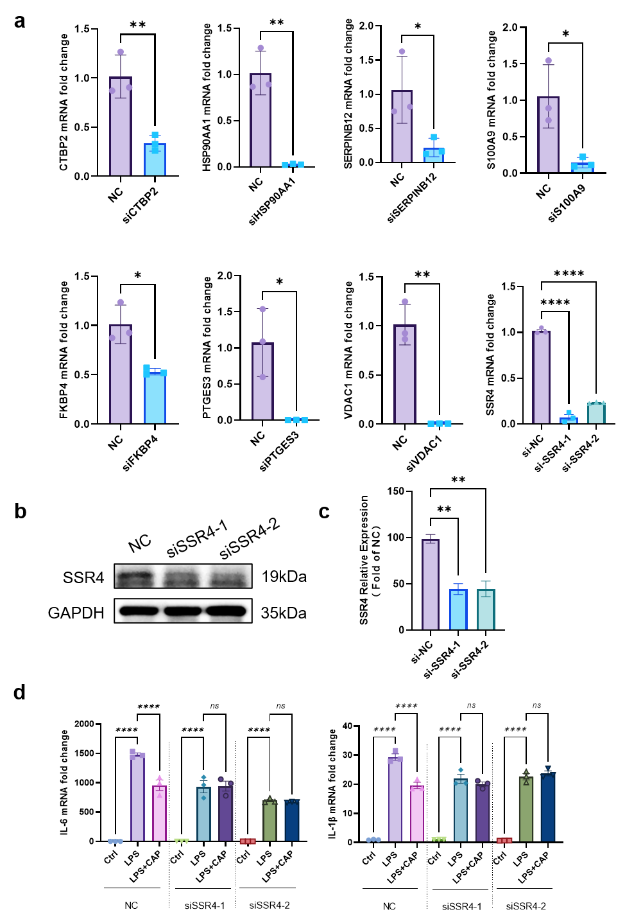
Fig. S11 KD efficiency of chaperones.
a Design siRNA targeting CTBP2, HSP90AA1, SERPINB12, S100A9, SSR4 (siSSR4-1, siSSR4-2), FKBP4, PTGES3, and VDAC1; transfect siRNA into CHO-K1 cells and assess the KD efficiency. b-c Western blot analysis of the knockdown efficiency of two SSR4 siRNAs. d IL-6 and IL-1β mRNA expression following LPS stimulation with or without capsaicin. Data represent three independent experiments. ns, not significant. *P < 0.05, **P < 0.01 and **** P < 0.0001. (n = 3 independent biological replicates).

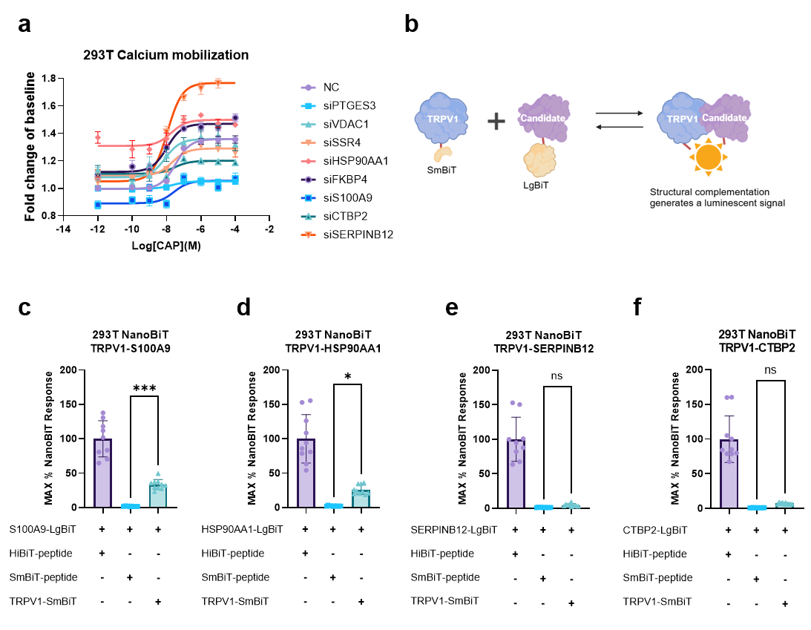
Fig. S12 TRPV1-chaperone interactions in live cells were validated.
a Effect of candidate proteins on TRPV1 calcium mobilization in 293T. Fluo4-AM assay to detect the impact of candidate protein KD on intracellular calcium levels (n = 3 independent biological replicates). b Exploring the interaction between candidate proteins and TRPV1 based on NanoBiT technology (created in https://BioRender.com). c-f Interactions of S100A9 (c), HSP90AA1 (d), SERPINB12 (e), and CTBP2 (f) with TRPV1 (n = 9-16 independent biological replicates). Data represent mean ± SD. * P < 0.05, **P < 0.01, ***P < 0.001, ****P < 0.0001, ns: not significant. P values were obtained with one-way ANOVA followed by Tukey’s multiple comparisons tests.

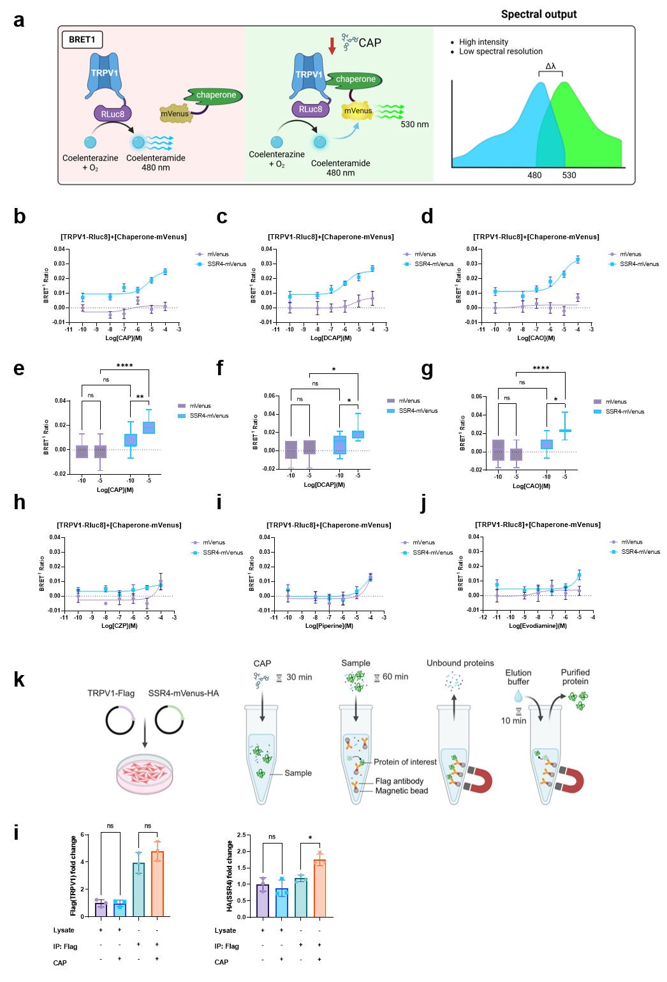
Fig. S13 Capsaicin facilitates direct binding of TRPV1 to SSR4.
a Schematic diagram of exploring the regulation of capsaicin on the TRPV1-chaperone axis based on BRET technology (created in https://BioRender.com ) in 293T. b-j Exploring the regulation of TRPV1–SSR4 interaction by different ligands based on BRET technology. Capsaicin (b, e), Dihydrocapsaicin (DCAP) (c, f), Mixture of capsaicin and dihydrocapsaicin (CAO) (d, g), capsazepine (capsazepine) (h), Piperine (i), and Evodiamine (j) on the BRET signal response of TRPV1-Rluc8 with mVenus, and TRPV1-Rluc8 with SSR4-mVenus (n = 3 independent biological replicates). k Schematic diagram illustrating the effect of capsaicin on TRPV1–SSR4 binding based on CO-IP technology (created in https://BioRender.com). l CO-IP analysis of the relative levels of Flag- and HA-tagged proteins after capsaicin treatment (n = 3 independent biological replicates). Data represent mean ± SD. *P < 0.05, **P < 0.01, ***P < 0.001, ****P < 0.0001, ns: not significant. P values were obtained with one-way ANOVA followed by Tukey’s multiple comparisons tests.

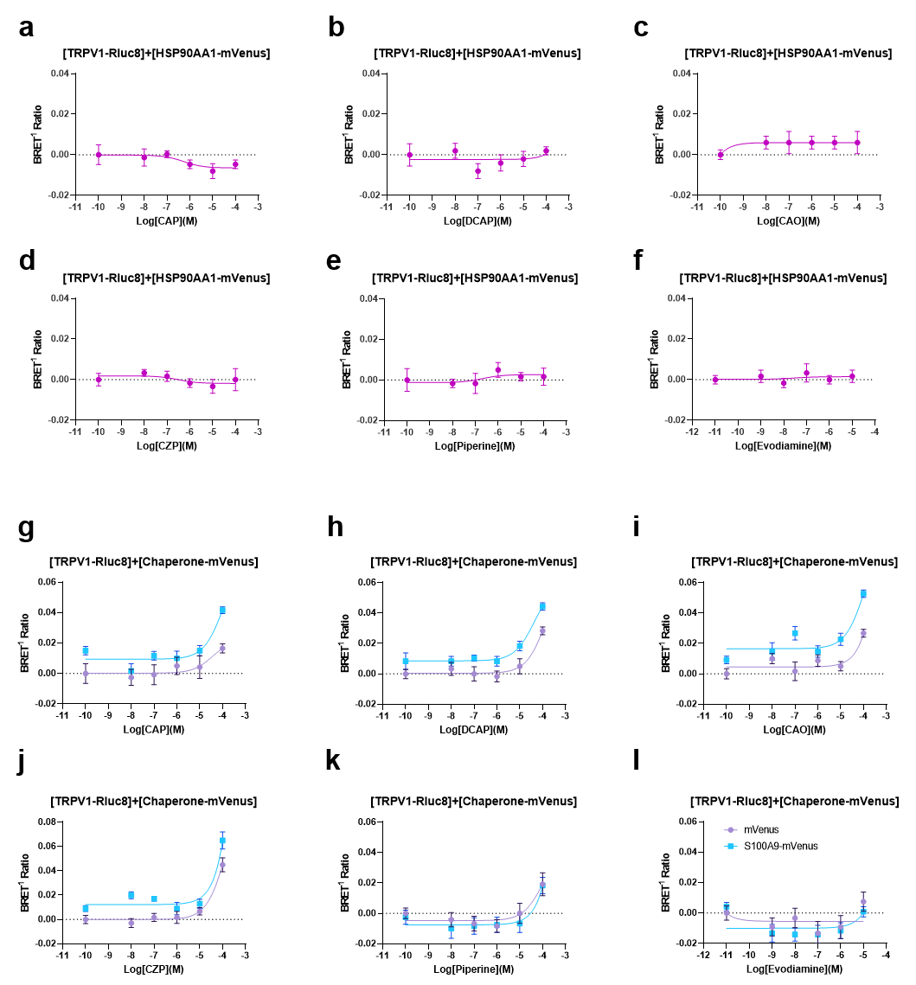
Fig. S14 Capsaicin cannot promote the binding between TRPV1 and other chaperones.
a-f Exploring the regulation of TRPV1-HSP90AA1 interaction by different ligands based on BRET technology in 293T. Capsaicin (a), DCAP (b), CAO (c), capsazepine (d), Piperine (e), and Evodiamine (f) on the BRET signal response of TRPV1-Rluc8 and HSP90AA1-mVenus (n = 3 independent biological replicates). g-l Exploring the regulation of TRPV1-S100A9 interaction by different ligands based on BRET technology. Capsaicin (g), DCAP (h), CAO (i), capsazepine (j), Piperine (k), and Evodiamine (l) on the BRET signal response of TRPV1-Rluc8 with mVenus, and TRPV1-Rluc8 with S100A9-mVenus (n = 3 independent biological replicates).

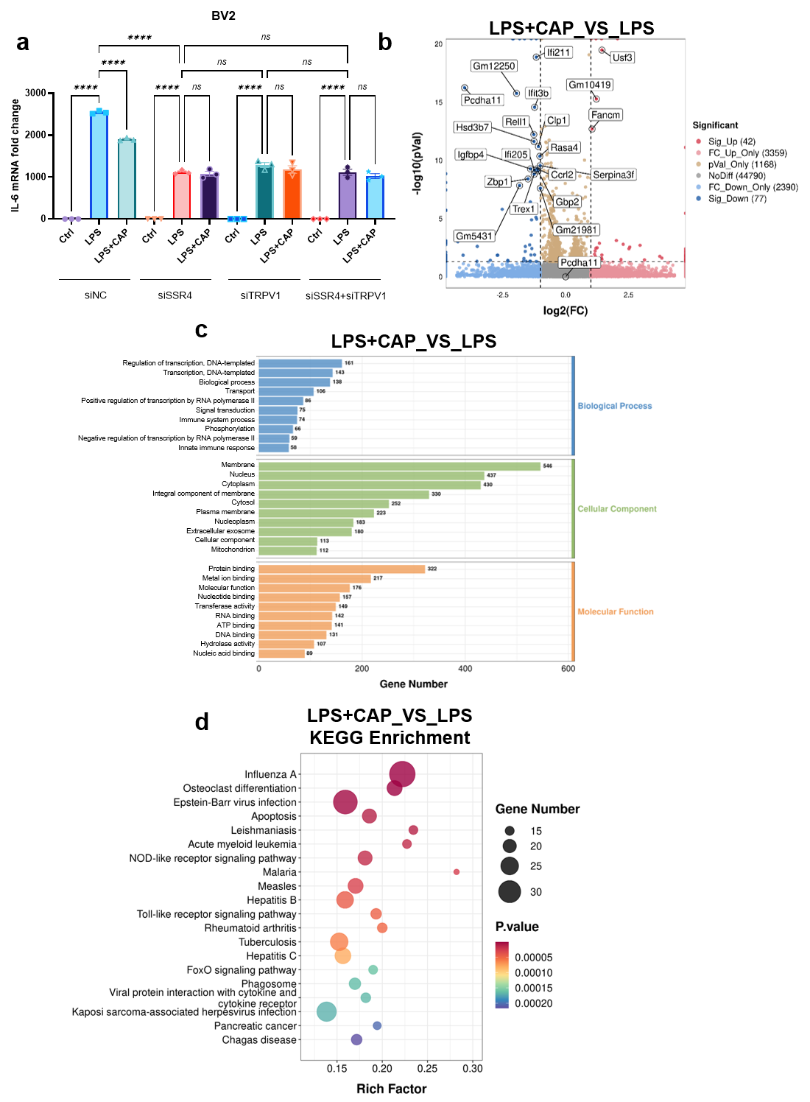
Fig. S15 Transcriptomic remodeling of BV2 microglial inflammatory responses following capsaicin treatment.
a IL-6 mRNA expression detection after single and combined knockdown of SSR4 and TRPV1 in LPS-stimulated BV2 cells. b Volcano plot of differentially expressed genes (DEGs). The plot shows the DEGs between the LPS + CAP group and LPS group. Red dots indicate significantly upregulated genes, blue dots indicate significantly downregulated genes and gray dots represent genes with no significant changes. c GO functional enrichment analysis. CAP exerts differential effects on LPS-induced BV2 microglia across Biological Process (BP), Cellular Component (CC), and Molecular Function (MF) categories. d KEGG pathway enrichment analysis. Pathways enriched among DEGs in the LPS + CAP vs. LPS comparison. The rich factor represents the ratio of DEGs in a pathway to the total number of genes in that pathway. The dot size corresponds to the number of significantly enriched genes, and the color indicates the P-value. CAP, capsaicin.

Table S1. Key resources
REAGENT or RESOURCE | SOURCE | IDENTIFIER
Antibodies
Anti Iba1, Rabbit (for Immunocytochemistry) | FUJIFILM Wako | Cat# 019-19741
Anti-TRPV1 antibody, Rabbit | Abcam | Cat# ab3487
Anti-TRPV1 antibody, Rabbit | Alomone labs | Cat# ACC-030
Anti-TRPV1 antibody, Mouse | Santa Cruz | Cat# sc-398417
Goat anti-Mouse IgG (H+L)  Secondary Antibody, Alexa Fluor™ Plus 488 | Cell Signaling Technology | Cat# 4408S
Goat anti-Rabbit IgG (H+L)  Secondary Antibody, Alexa Fluor™ Plus 594 | Cell Signaling Technology | Cat# 8889S
Cleaved Caspase-3 (Asp175) Antibody | Cell Signaling Technology | Cat# 9661S
Multi-rAb® Polymer HRP-Goat Anti-Rabbit Recombinant Secondary Antibody (H+L) | Proteintech | Cat# RGAR011
CoraLite®594-conjugated DYKDDDDK Monoclonal antibody | Proteintech | Cat# CL594-66008
Anti-DDDDK tag (Binds to FLAG® tag sequence) | Abcam | Cat# ab205606
Anti-HA Tag Rabbit Polyclonal Antibody | Adamas life | Cat# P9125
Chemicals
Capsaicin | MedChemExpress LLC | Cat# HY-10448
Capsazepine | MedChemExpress LLC | Cat# HY-15640
DMEM | BasalMedia | Cat# L110KJ
DMEM/F12 (1:1) | Gibco | Cat# 11320-033
Opti-MEM | Gibco | Cat# 31985-070
FBS | Ozfan | Cat# FBSKM0502
1% L-alanyl-L-glutamine solution | BasalMedia | Cat# S240JV
Penicillin–Streptomycin 100× | BasalMedia | Cat# S110JV
PBS | BasalMedia | Cat# B320KJ
0.25%-Typsin-EDTA | Gibco | Cat# 25200-072
4% PFA | Titan Scientific Co. Ltd | Cat# F8011
DMSO | Titan Scientific Co. Ltd | Cat# F8011
TritonX-100 | Merck | Cat# T8787
ProLong™ Gold Antifade Mountant | Thermo Fisher Scientific | Cat# P36930
HBSS | BasalMedia | Cat# B410KJ
LPS | Merck | Cat# L4391-1MG
Serum-free Cell Cryopreservation Medium | Epizyme | Cat# BY002P
DNA Marker D (100~2000 bp) | Sangon | Cat# B600335-0250
Agarose, Regular | Sangon | Cat# A620014-0100
5X TBE Buffer | Sangon | Cat# B548102-0500
4S Green Plus Nucleic Acid Stain | Sangon | Cat# A616696-0500
Protease inhibitor cocktail | APExBIO | Cat# K1007
Phosphatase inhibitor cocktail | APExBIO | Cat# K1015-A/B
PMSF | Beyotime | Cat# ST505
DAPI | Sangon | Cat# E607303-0020
PEG300 | MCE | Cat# HY-Y0873
Tween 80 | MCE | Cat# HY-Y1891
HRP-conjugated Biotin | Sangon | Cat# D111127
Biotin | MCE | Cat# HY-B0511
HRP Streptavidin | Yeasen | Cat# 35103ES60
Streptavidin Beads T3 | APExBIO | Cat# K1301
MonoRab™ Anti-DYKDDDDK Magnetic Beads | Genscript | Cat# L00835-1
Western Rapid Transfer Buffer | Beyotime | Cat# P0575-10L
SDS-PAGE Electrophoresis Buffer | Beyotime | Cat# P0014B
Fluo 4-AM | DOJINDO | Cat# F311
Probenecid | Sigma-Aldrich | Cat# P8761
Pluronic F-127 | Sigma-Aldrich | Cat# P2443
Furimazine | ChemShuttle | Cat# 185252
Hieff Trans™ Liposomal Transfection Reagent | Yeasen | Cat# 40802ES
Coelenterazine h | Yeasen | Cat# 40906ES10
Rapamycin | MedChemExpress LLC | Cat# HY-10219
Aqueous suspension | Merck | Cat# L2778
Critical commercial assays
FastPure Cell/Tissue total RNA Isolation Kit V2 | Vazyme | Cat# RC112-01
HiScript Q RT SuperMix for qPCR (+gDNA wiper) | Vazyme | Cat# R323-01
Taq Pro universal SYBR qPCR master mix | Vazyme | Cat# Q712-03
BCA Protein Assay Kit | Beyotime | Cat# P0012
Multicolor prestained protein ladder | Epizyme | Cat# WJ101
Quick Genotyping Assay Kit for Mouse Tail | Beyotime | Cat# D7283M
RIPA lysis buffer | Epizyme | Cat# PC102
Mouse TNF-α ELISA Kit | MultiScience | Cat# EK282
Mouse IL-6 ELISA Kit | MultiScience | Cat# EK206
Hematoxylin and Eosin (H&E) Staining Kit | Huntz Jaha | Cat# HJ-H0750-4
Fast Silver Stain Kit | Beyotime | Cat# P0017S
CALNP™ RNAi in vitro | D-nano Therapeutics | Cat# DN001-01
Deposited data
RNA-seq data of primary astrocytes | This paper | SUB15639787
RNA-seq data of microglia | This paper | SUB15644420
DARTS data of HEK-293T | This paper | PXD066698
Experimental models: Cell lines/Organisms
Primary microglia | This paper | N/A
BV2 | This paper | N/A
Primary astrocytes | This paper | N/A
TRPV1^{-/-} primary astrocytes | This paper | N/A
HEK-293T | This paper | N/A
CHO-K1 | This paper | N/A
Mouse: TRPV1^{-/-} | This paper | N/A
Oligonucleotides
siRNA | This paper | Table S2
Primers for qRT-PCR analysis | This paper | Table S3
Recombinant DNA
TRPV1-PafA-Flag | This paper | N/A
pc DNA3.1 | This paper | N/A
TRPV1-Flag | This paper | N/A
BCCP-Pup(E) | This paper | N/A
PafA-Flag-CAAX | This paper | N/A
TRPV1-TurboID-Flag | This paper | N/A
TurboID-TRPV1-Flag | This paper | N/A
TRPV1-SmBiT | This paper | N/A
SSR4-LgBiT | This paper | N/A
S100A9-LgBiT | This paper | N/A
HSP90AA1-LgBiT | This paper | N/A
SERPINB12-LgBiT | This paper | N/A
SSR4-mVenus-HA | This paper | N/A
S100A9-mVenus-HA | This paper | N/A
HSP90AA1- mVenus-HA | This paper | N/A
TRPV1-Rluc8 | This paper | N/A
Software and algorithms
GraphPad Prism | GraphPad Software | http://www.graphpad.com/
ImageJ | NIH | https://imagej.nih.gov/ij/
BioRender | Website | https://www.biorender.com/
Instruments | Manufacturer | Identifier
Ultra-low temperature freezer | Haier | DW-86L626
NanoDrop™ One/OneC Microvolume UV-Vis Spectrophotometer | Thermo Fisher Scientific | ND-ONE-W
NanoDrop 2000 UV-Vis spectrophotometer | Thermo Fisher Scientific | ND-2000
Benchtop high-speed refrigerated centrifuge | Eppendorf | 5424 R
Biosafety cabinet | Haier | HR1200-IIA2
Two-photon imaging microscope | Nikon | A1R MP+
Axio Imager A2 microscope | Carl Zeiss Microscopy GmbH | Axio Imager A2
PHERAstar FSX multimode microplate reader | BMG LABTECH GmbH | PHERAstar FSX
Histological microtome | Leica | Leica RM2235
Digital slide scanner | KFBIO | KFBIO KF-PRO-005
qPCR instrument | Applied Biosystems | A28571
Amersham ImageQuant | Cytiva | ImageQuant 800
Magnetic rack | Cytiva | MagRack 6
HPLC system | Thermo Scientific | UltiMate 3000
Q Exactive HF mass spectrometer | Thermo Scientific | Q Exactive HF

Table S2. Sequences of siRNAs used in the study.
siRNA | Sense sequence | Antisense sequence
CTBP2 | GGUGGAUGAGAAAGCCUUA | UAAGGCUUUCUCAUCCACC
SSR4-1/SSR4 | GGAAGGCUCAGAGAAAUAA | UUAUUUCUCUGAGCCUUCC
SSR4-2 | ACCUAUGAGGUCAGAUUCU | AGAAUCUGACCUCAUAGGU
VDAC1 | UGGAAUUUCAAGCAUAAAU | AUUUAUGCUUGAAAUUCCA
HSP90AA1 | GGAUCUACAGGAUGAUCAA | UUGAUCAUCCUGUAGAUCC
FKBP4 | GCUCUAUCCCAGCAACAAA | UUUGUUGCUGGGAUAGAGC
SERPINB12 | AGUGGGAGAGAGAAUUCAA | UUGAAUUCUCUCUCCCACU
S100A9 | GAAAGAGAAGAGAAAUGAA | UUCAUUUCUCUUCUCUUUC
PTGES3 | GGCUCAGUGUGGACUUCAA | UUGAAGUCCACACUGAGCC
TRPV1-1/TRPV1 | GCGCAUCUUCUACUUCAACUUTT | AAGUUGAAGUAGAAGAUGCGCTT
TRPV1-2 | CCAUCCCUCAAGAGUUUGUUUTT | AAACAAACUCUUGAGGGAUGGTT
TRPV1-3 | GCCAUGCUCAAUCUGCACAAUTT | AUUGUGCAGAUUGAGCAUGGCTT

Table S3. Sequences of primers used for quantitative real-time PCR.
Primer | Forward sequence | Reverse sequence
TRPV1 | CACCACGGCTGCTTACTATCG | AGAAGAAGTAGACTCCTCCTGACAC
IL-6 | TTCTTGGGACTGATGCTGGTGAC | CAGGTCTGTTGGGAGTGGTATCC
TNF-α | CGCTCTTCTGTCTACTGAACTTCGG | GTGGTTTGTGAGTGTGAGGGTCTG
CTBP2 | GGCAGAGGGTGTGGCAGAG | GGCTAGGCGGCTTAGGACTC
SSR4 | GGCGGCGATGGCATCTTTC | TCTGTAGAAATGACGGCATCTGAAG
VDAC1 | GTGAATGACGGGACAGAGTTTGG | CGACCTGATACTTGGCTGCTATTC
HSP90AA1 | ATCACGAAGCATAACGACGATGAG | TAACCTTTGTTCCACGACCCATTG
FKBP4 | GGCGTGCTCAAGGTCATCAAG | TAGCAGCCAGCCAGTGTAGTG
SERPINB12 | TTGTGGAGGTGGATGAGATGGG | AGGAAAGGGTGGTTGGCATTAAAC
S100A9 | GAAGCACAGTTGGCAACCTTTATG | ATCAGCATCATACACTCCTCAAAGC
PTGES3 | GGCTCAGTGTGGACTTCAATAATTG | TCATCATCTGCTCCATCTACTTCTG
18S | AGGGGAGAGCGGGTAAGAGA | GGACAGGACTAGGCGGAACA

Table S5. Effect of candidate protein knockdown on intracellular calcium levels
siRNA | Top | Bottom | LogEC₅₀ | EC₅₀ (M) | Span
NC | 1.359 | 0.9955 | -7.471 | 3.38×10⁻⁸ | 0.363
siPTGES3 | 1.051 | 0.9961 | -7.664 | 2.17×10⁻⁸ | 0.055
siVDAC1 | 1.359 | 1.08 | -8.068 | 8.55×10⁻⁹ | 0.279
siSSR4 | 1.29 | 1.09 | -7.668 | 2.15×10⁻⁸ | 0.2
siHSP90AA1 | 1.498 | 1.309 | -7.729 | 1.87×10⁻⁸ | 0.19
siFKBP4 | 1.469 | 1.12 | -7.984 | 1.04×10⁻⁸ | 0.35
siS100A9 | 1.055 | 0.8903 | -7.576 | 2.66×10⁻⁸ | 0.165
siCTBP2 | 1.2 | 1.106 | -7.527 | 2.97×10⁻⁸ | 0.095

