Capsaicin suppresses microglial inflammation through TRPV1–SSR4 interaction

The full uncropped Gels and Blots images
Fig.3g:
Anti-Flag：
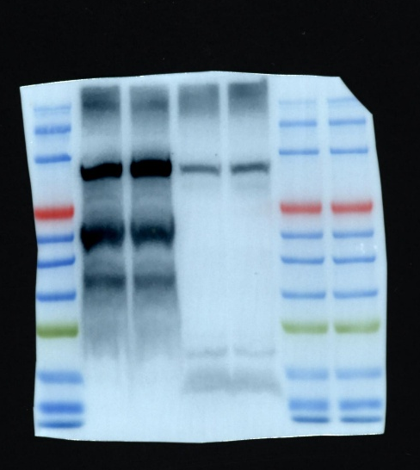
Anti-HA:
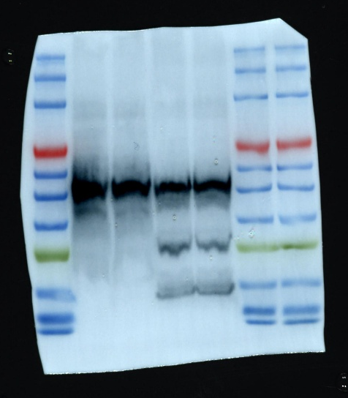

Fig.S1c:
Anti-TRPV1：
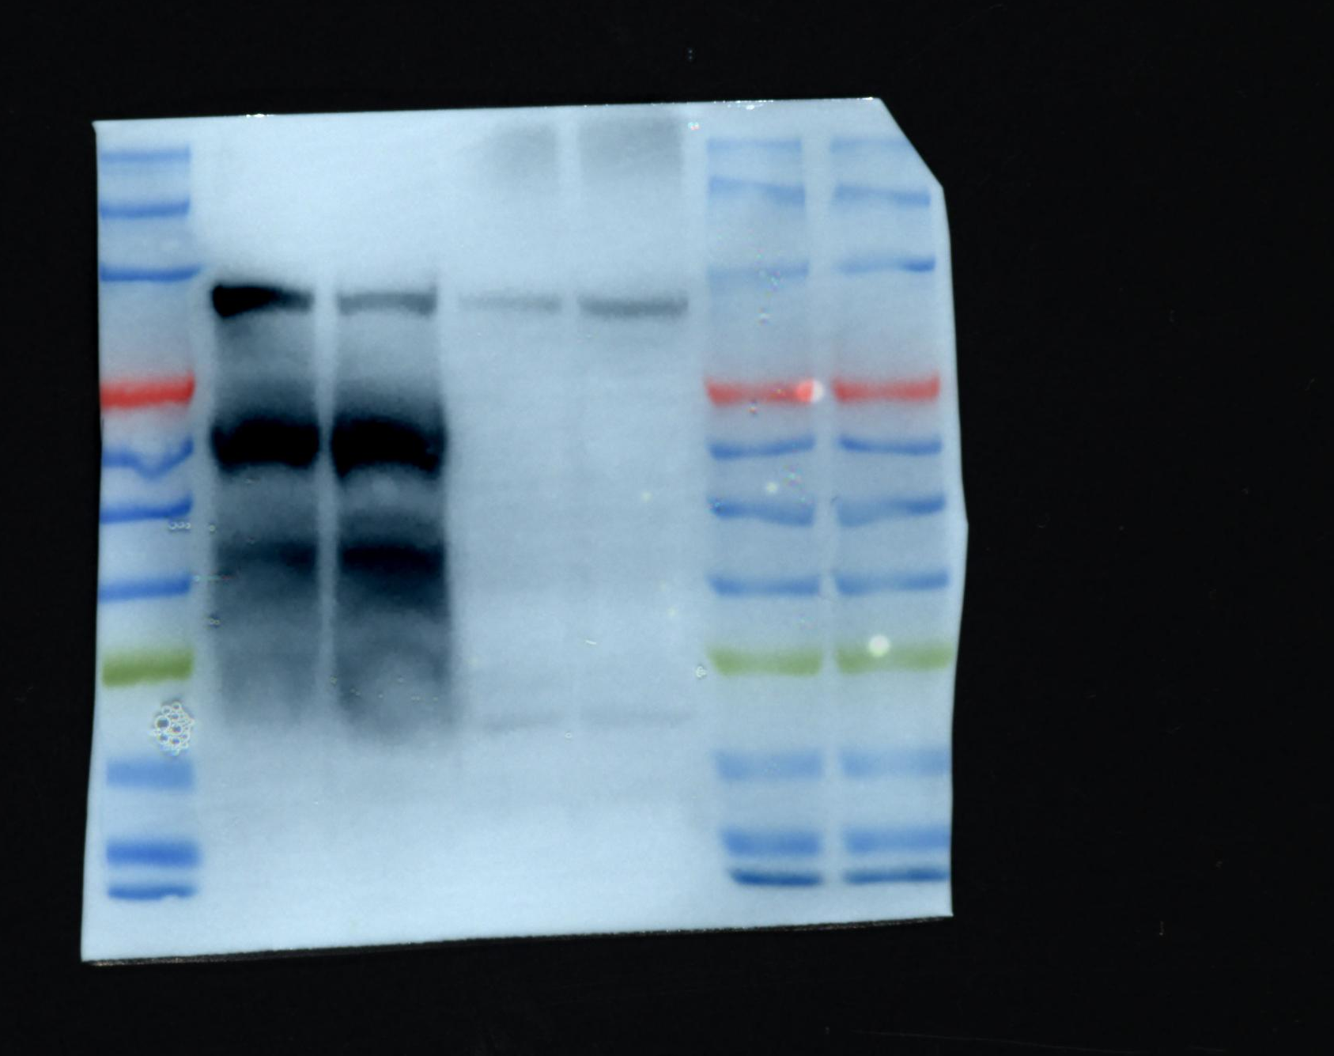
Anti-GAPDH：
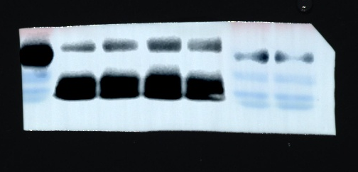
Fig.S4f:
Anti-TRPV1：
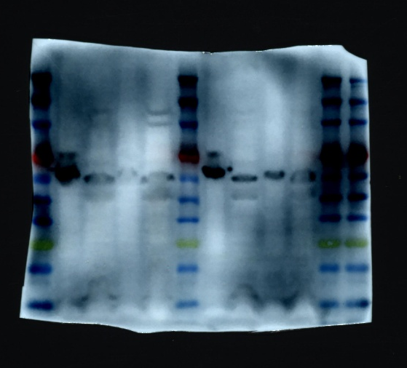
Fig.S9b:
Lysate Biotinylated Proteins (SA-HRP):
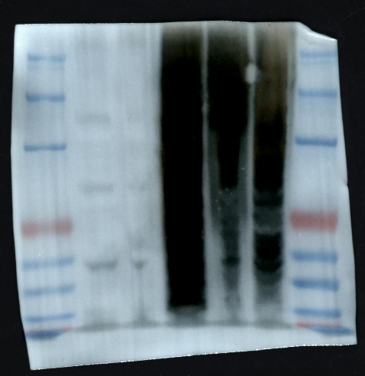
Lysate Anti-Flag：
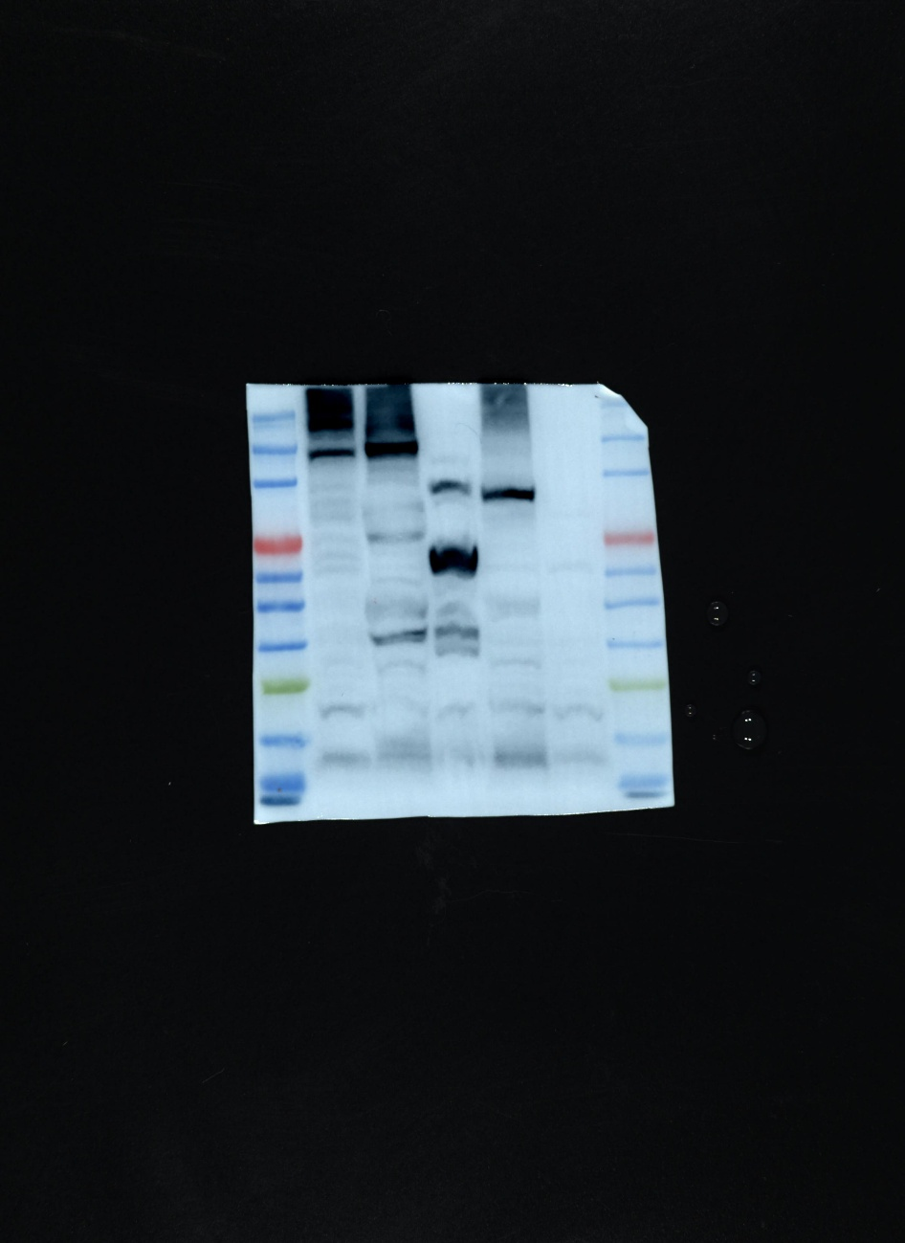
After streptavidin pull down Biotinylated Proteins (SA-HRP):
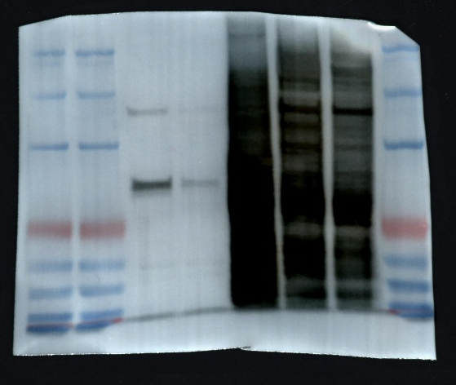
After streptavidin pull down Anti-Flag：
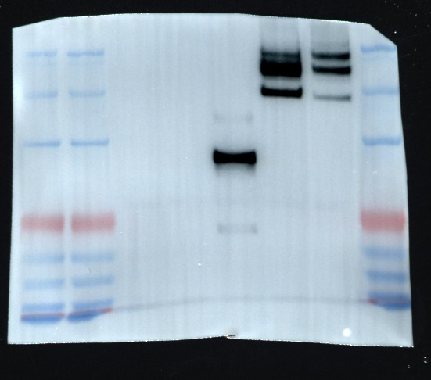
Fig.S10e:
Lysate Biotinylated Proteins (SA-HRP):
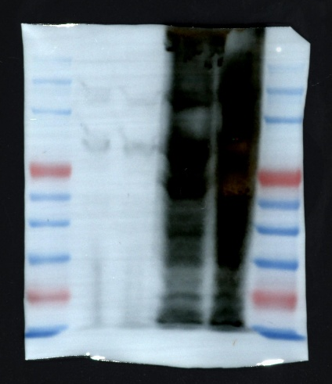
Lysate Anti-Flag：
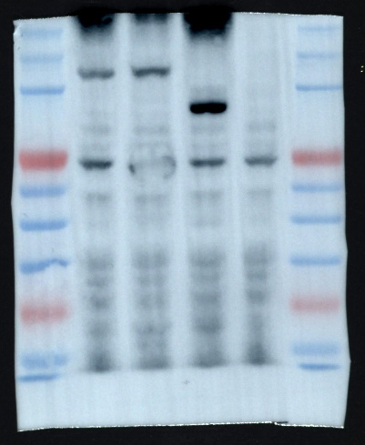
After streptavidin pull down Biotinylated Proteins (SA-HRP):
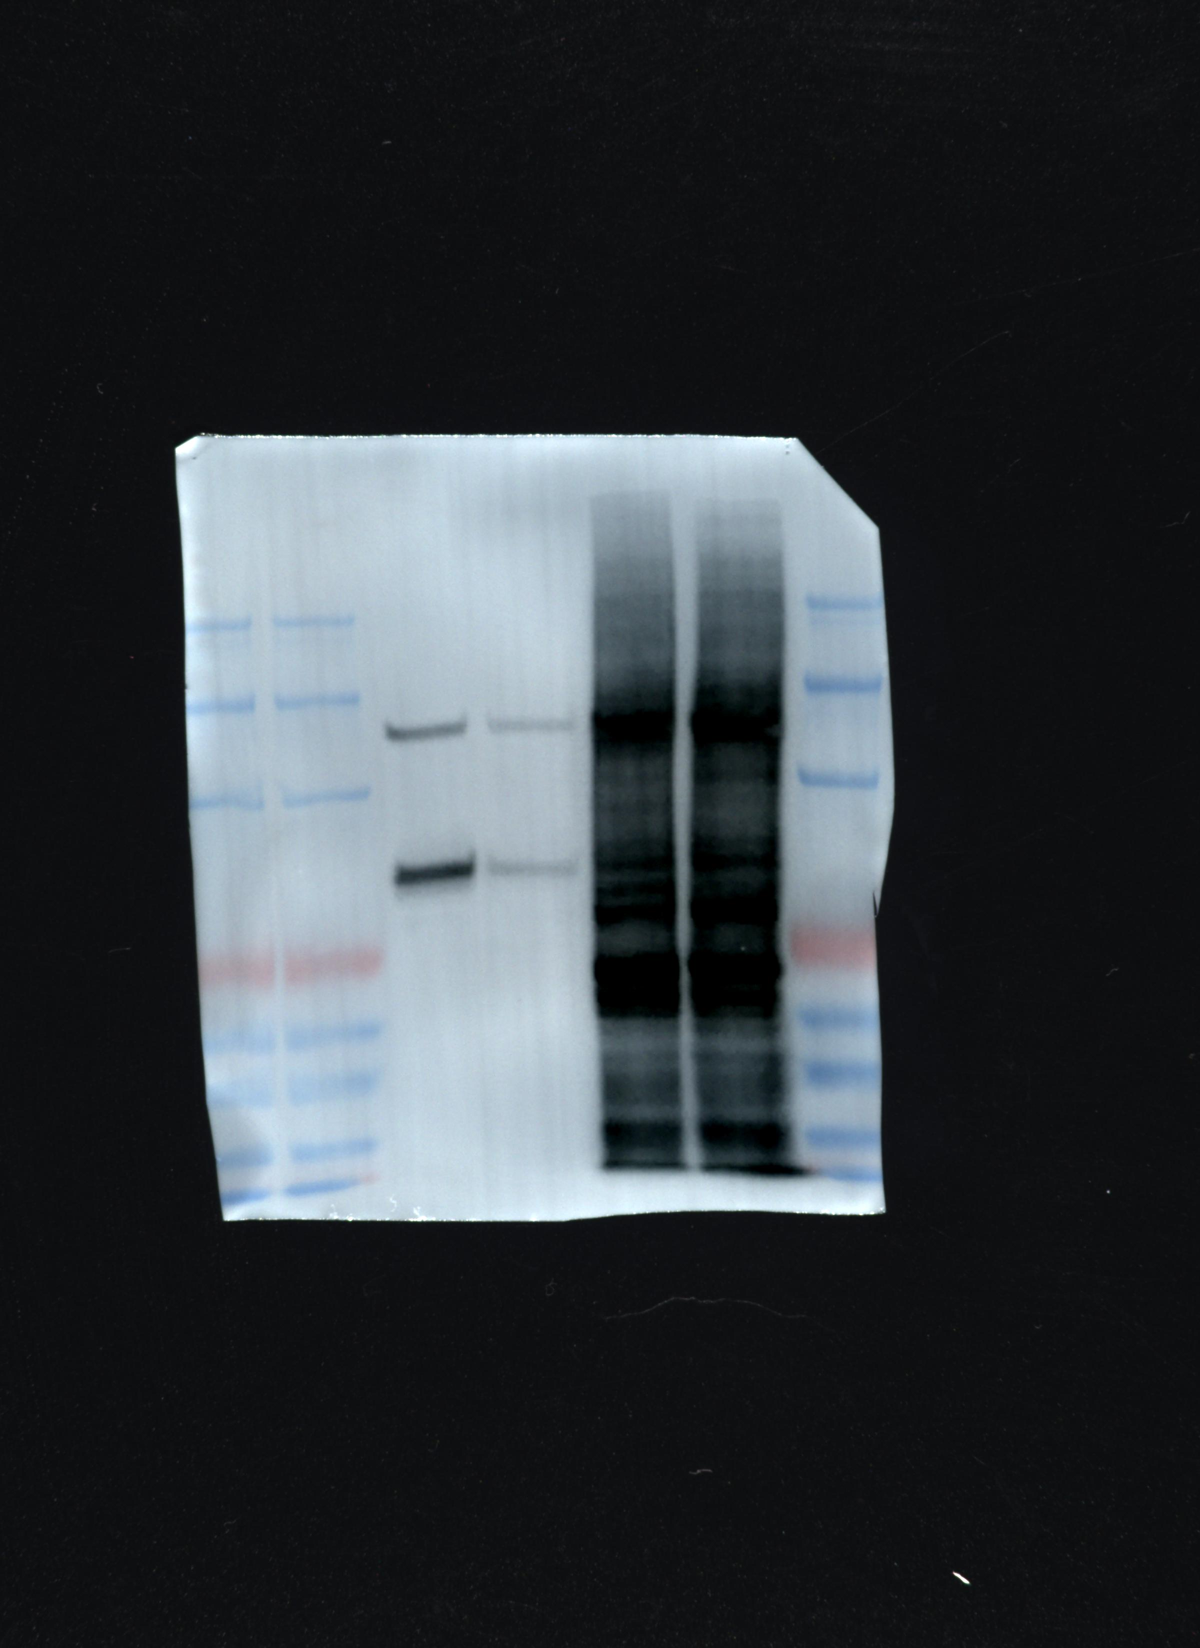
After streptavidin pull down Anti-Flag：
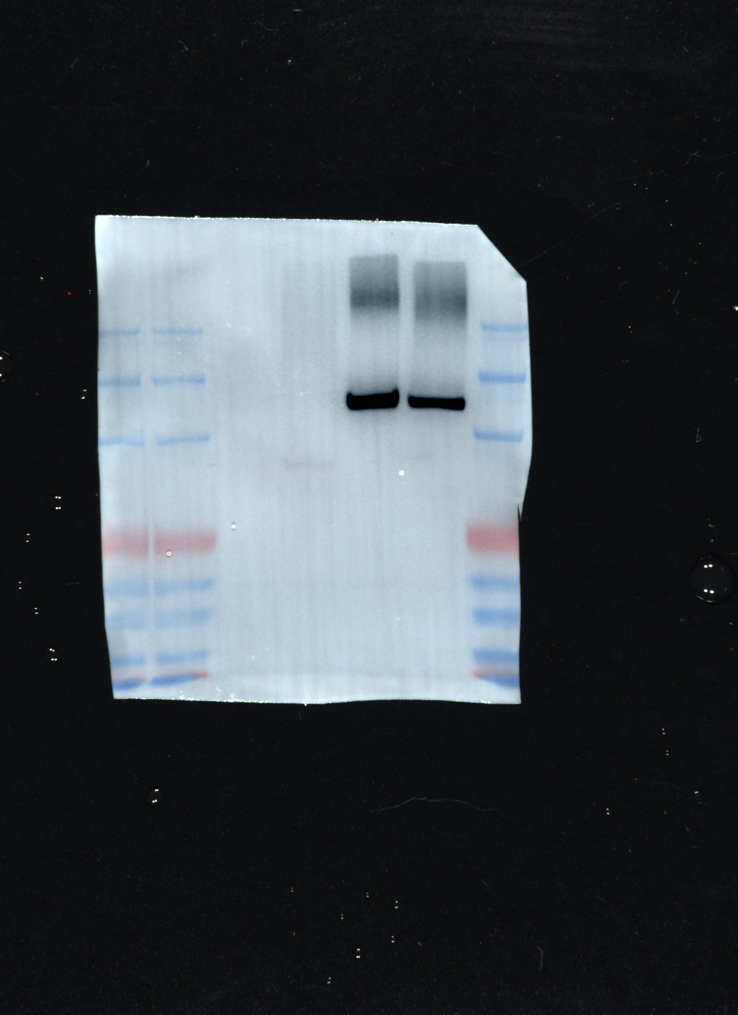
Fig.S10f:
Silver staining:
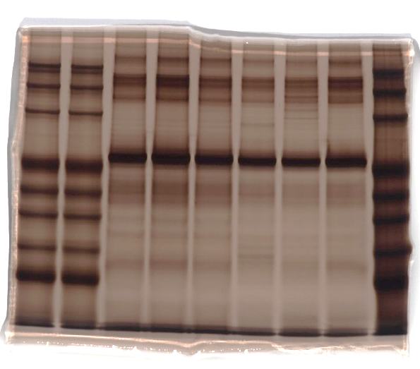
Fig.S10g:
SA-HRP:
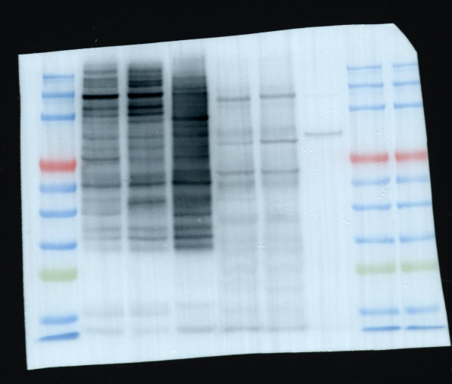

Fig.S11b:
Anti-GAPDH:

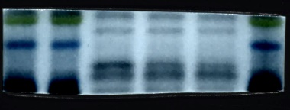
Anti-SSR4:

