Additional file 5
Proton NMR spectra of compounds 2a-2l.
(E)-4-phenylbut-3-en-2-one (2a)
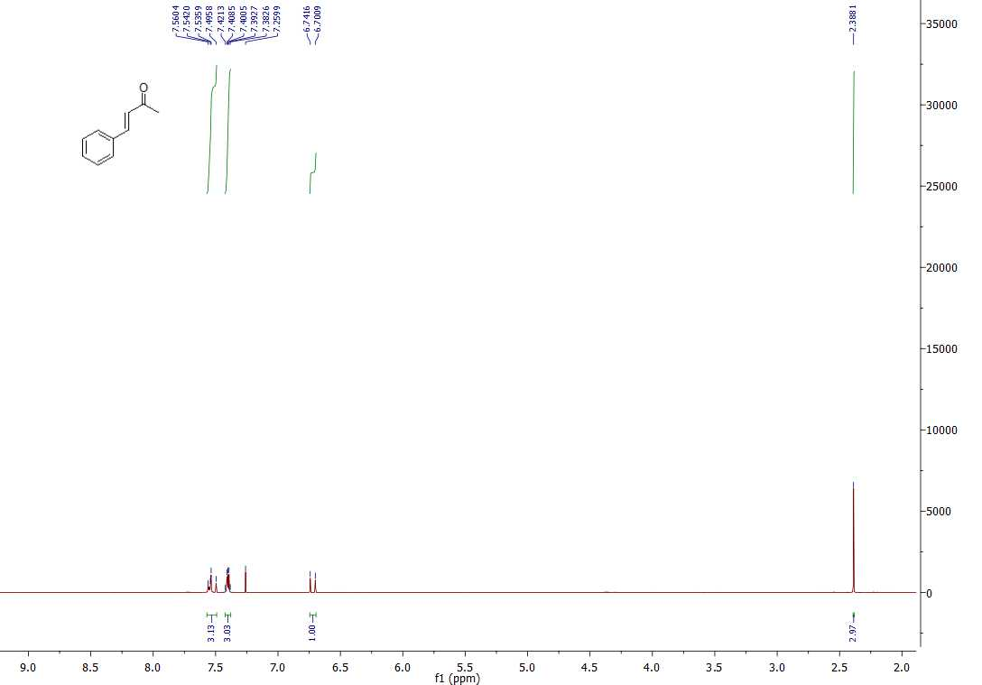

(E)-4-p-tolylbut-3-en-2-one (2b)

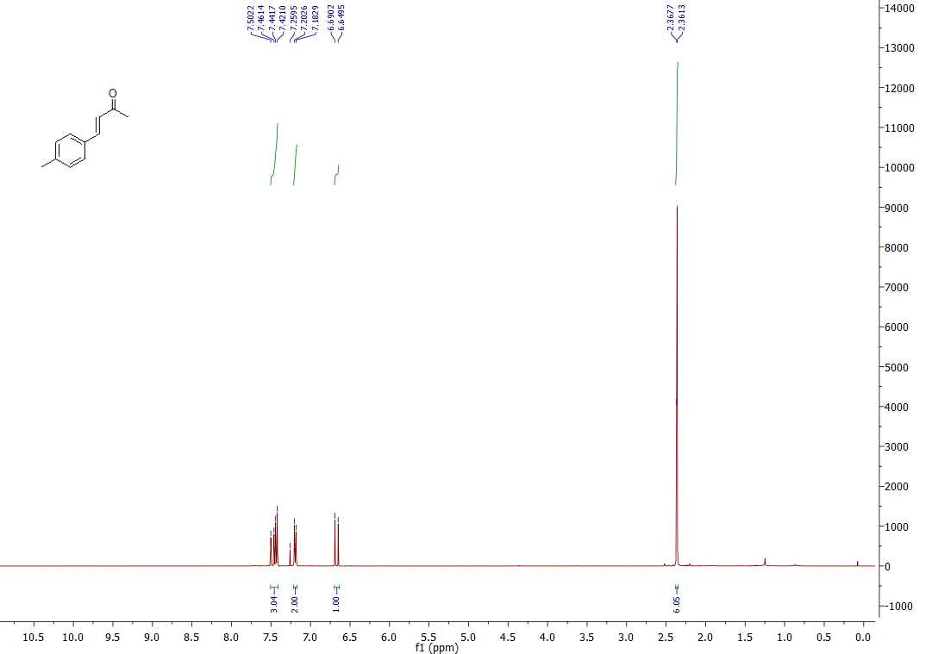

(E)-4-(4-tert-butylphenyl)but-3-en-2-one (2c)

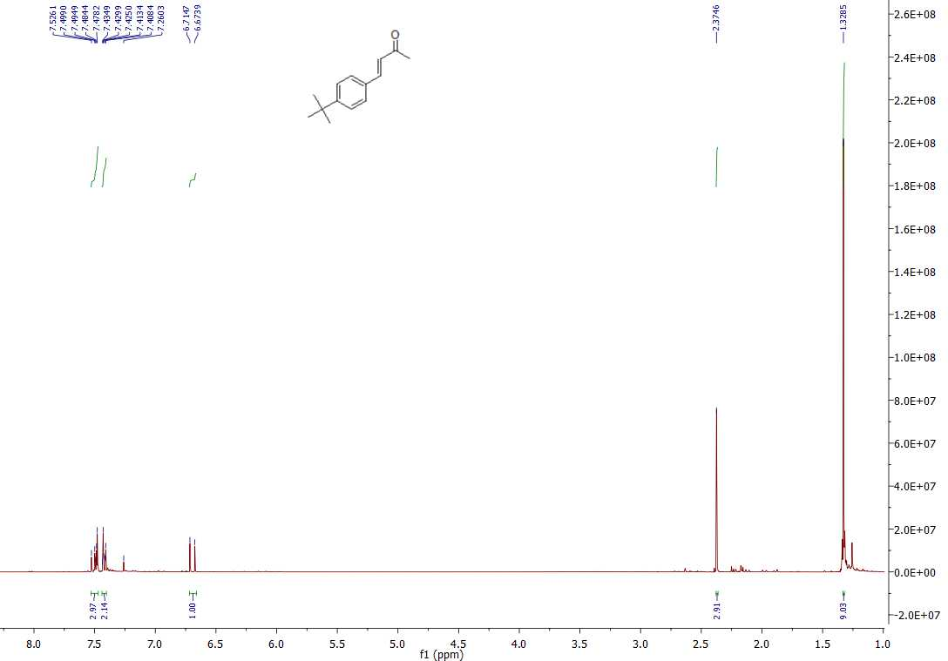

(E)-4-(4-fluorophenyl)but-3-en-2-one (2d)
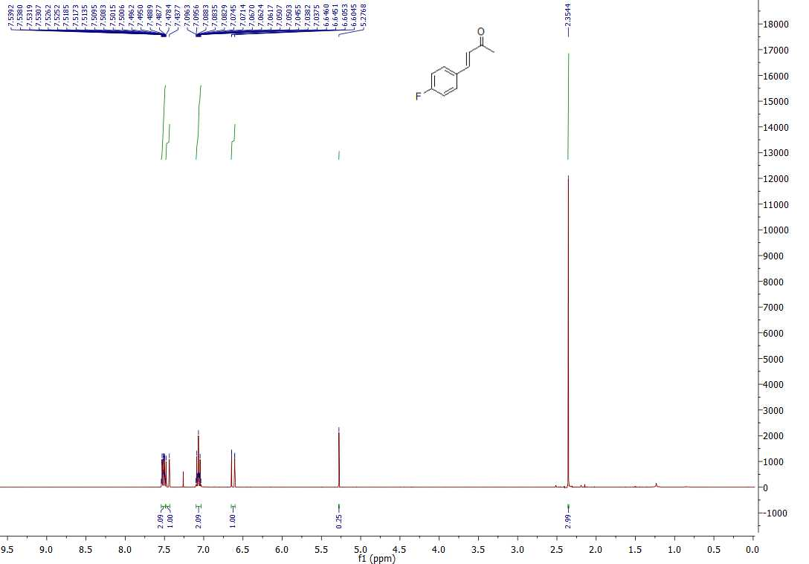

(E)-4-(4-bromophenyl)but-3-en-2-one (2e)

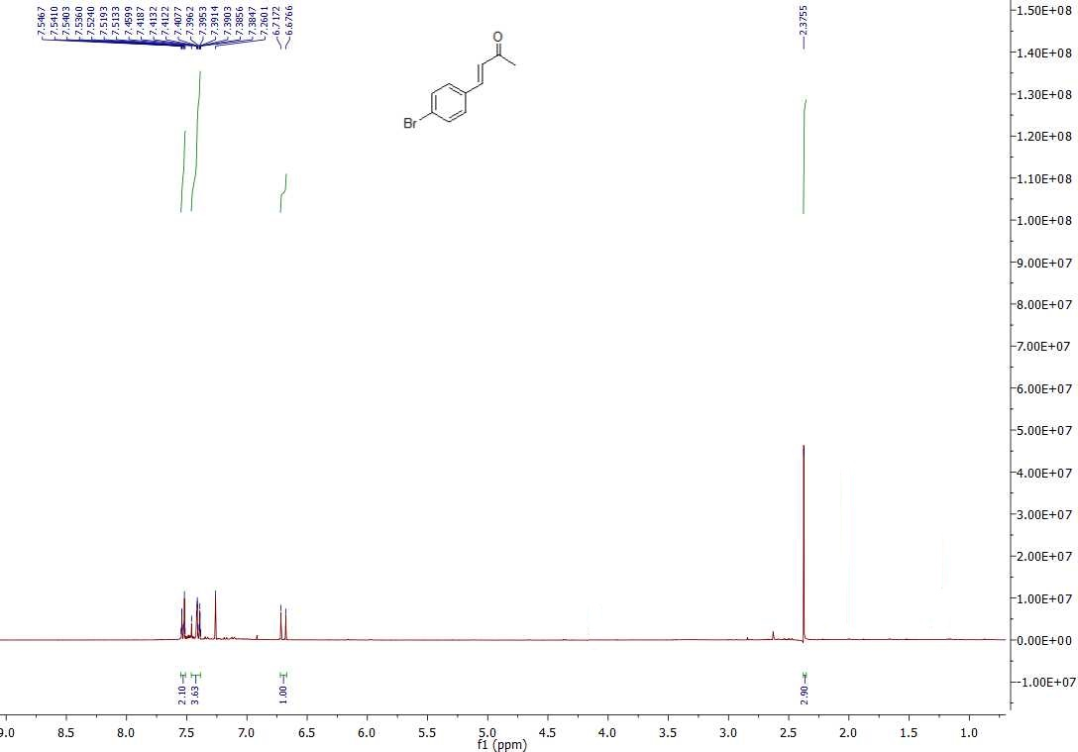

(E)-4-(4-methoxyphenyl)but-3-en-2-one (2f)
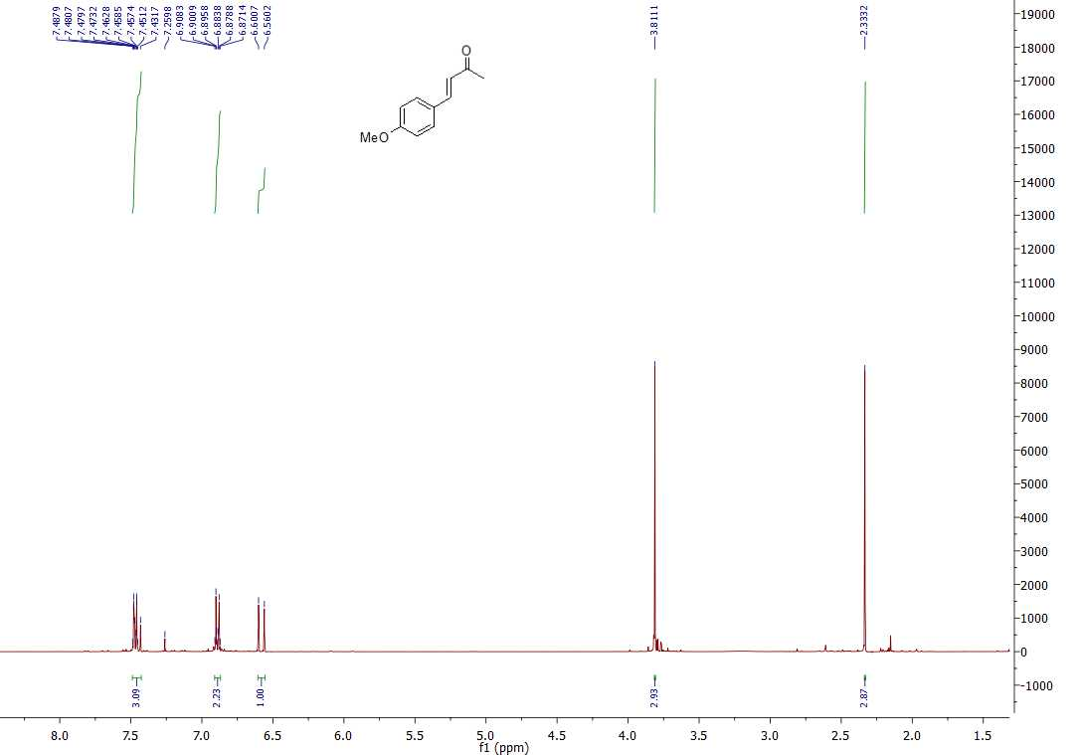

(E)-4-(3-chlorophenyl)but-3-en-2-one (2g)

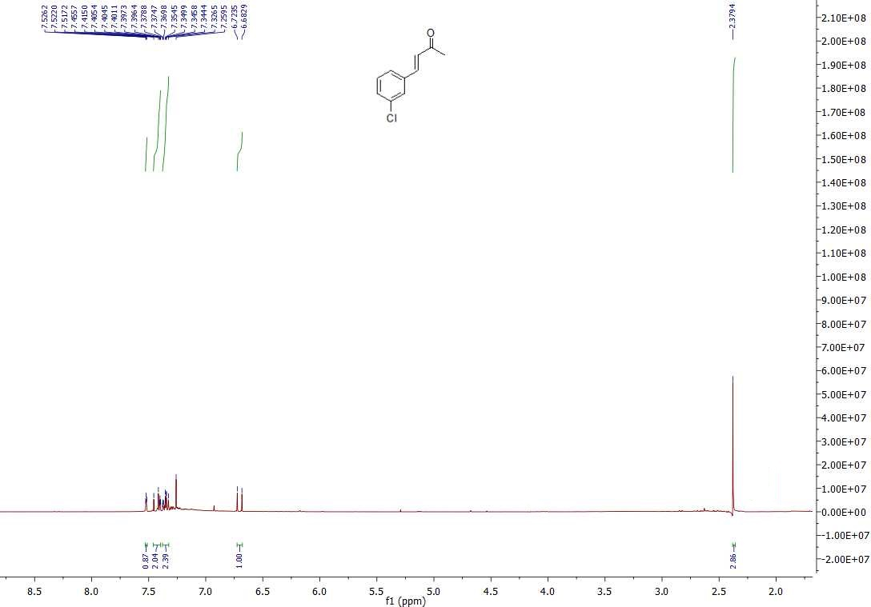

(E)-4-(4-nitrophenyl)but-3-en-2-one (2h)

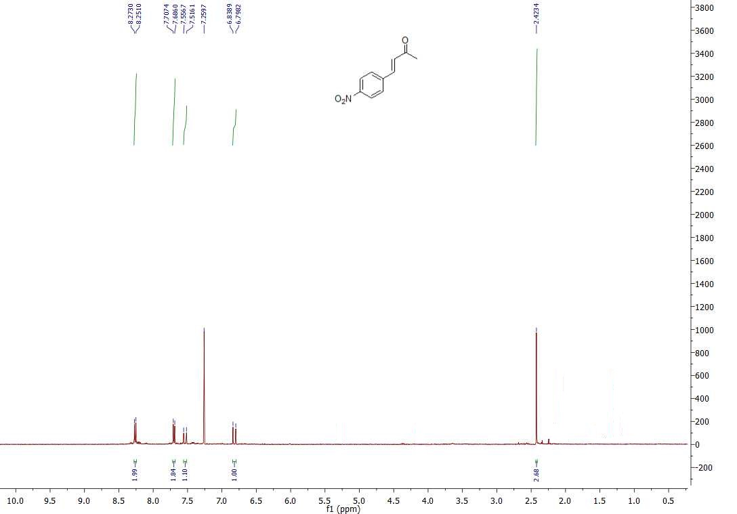

(E)-4-(4-(trifluoromethyl)phenyl)but-3-en-2-one (2i)

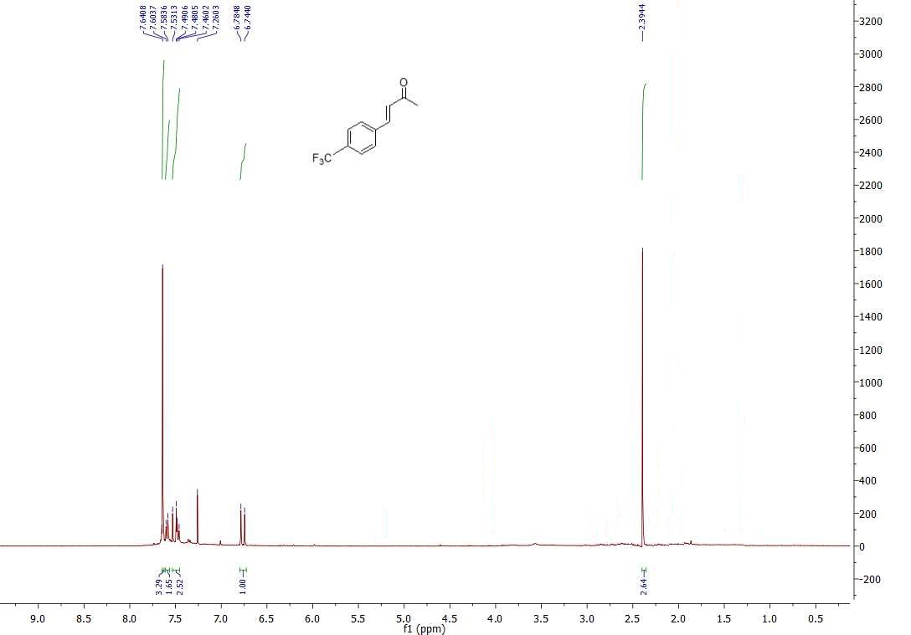

(E)-4-(3,4-dimethoxyphenyl)but-3-en-2-one (2j)

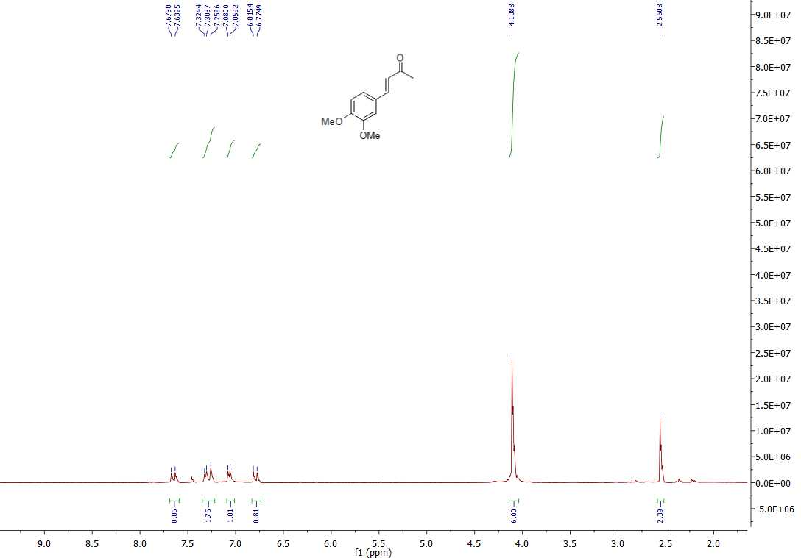

(E)-4-(5-chloro-2-nitrophenyl)but-3-en-2-one (2k)*

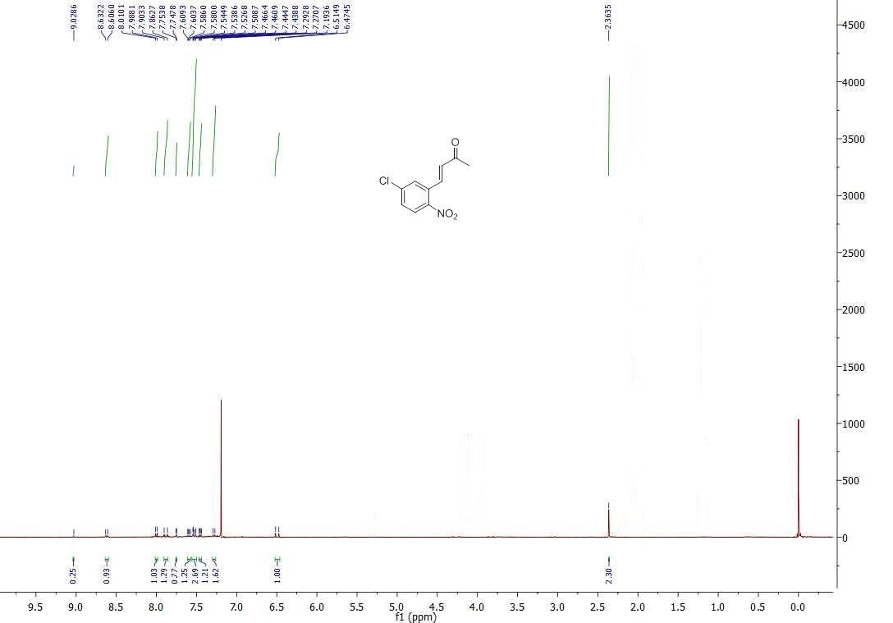
*12% of non-reacted aldehyde was recovered (Table 2, entry 5)

(E)-4-(naphthalen-1-yl)but-3-en-2-one (2l)
