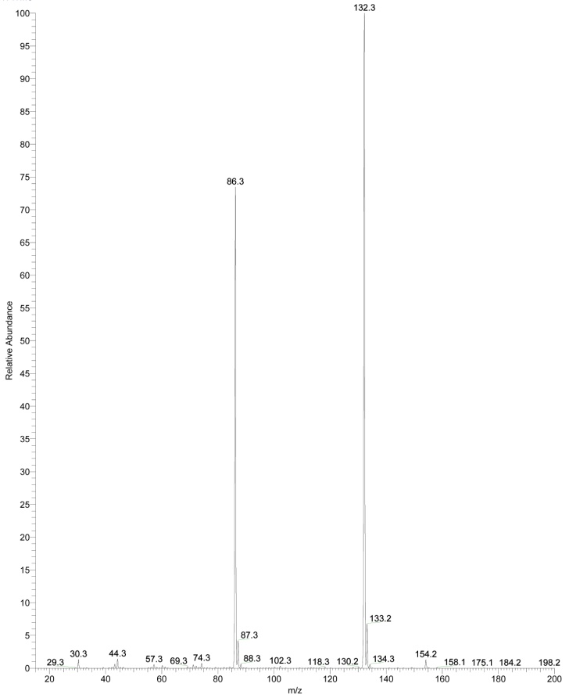
Mass spectrum of L-Leu standard in positive ion mode at low mass range (m/z 15-200). The standard L-Leu was dissolved into a solution 1:1 of MeOH-AcNH₄ 45 mM to obtain a concentration of 7.8 mM

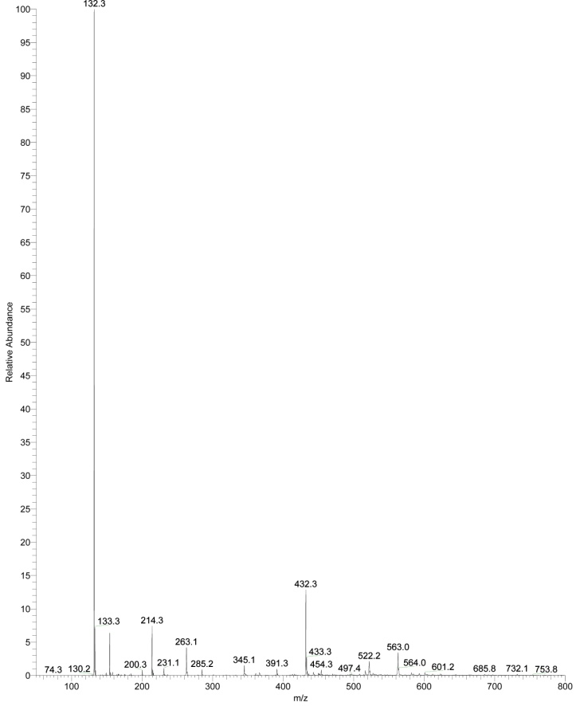
Mass spectrum of L-Leu standard in positive ion mode at normal mass range (m/z 50-800). The standard L-Leu was dissolved into a solution 1:1 of MeOH-AcNH₄ 45 mM to obtain a concentration of 7.8 mM
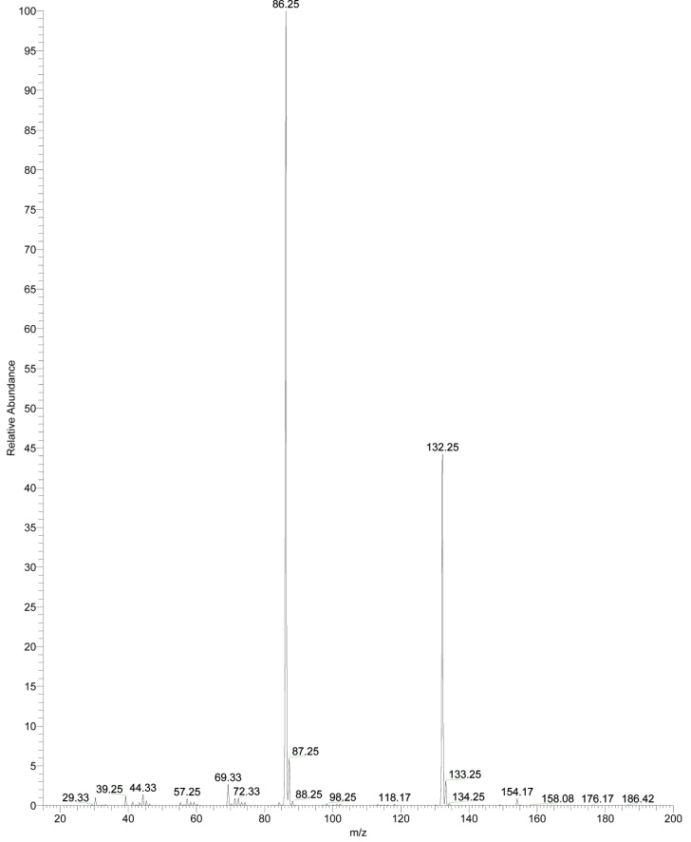
Mass spectrum of L-Ile in positive ion mode at low mass range (m/z 15-200). The concentration for the samples was 6.7 mM in a solution 1:1 MeOH-AcNH₄ 45 mM

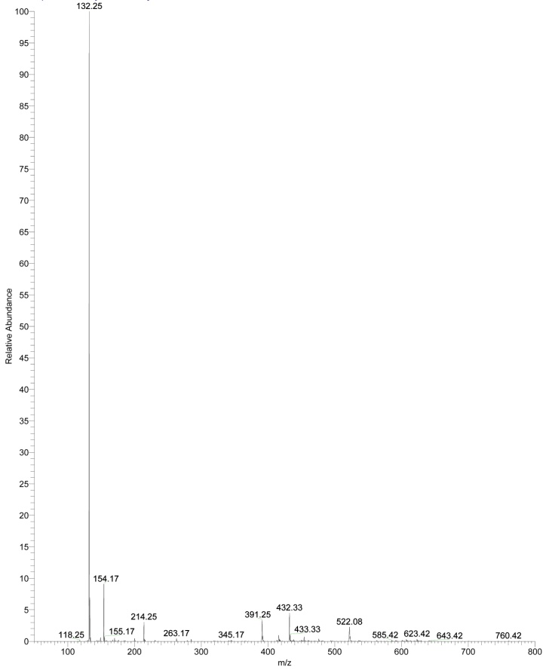
Mass spectrum of L-Ile in positive ion mode at normal mass range (m/z 50-800). The concentration for the samples was 6.7 mM in a solution 1:1 MeOH-AcNH₄ 45 mM
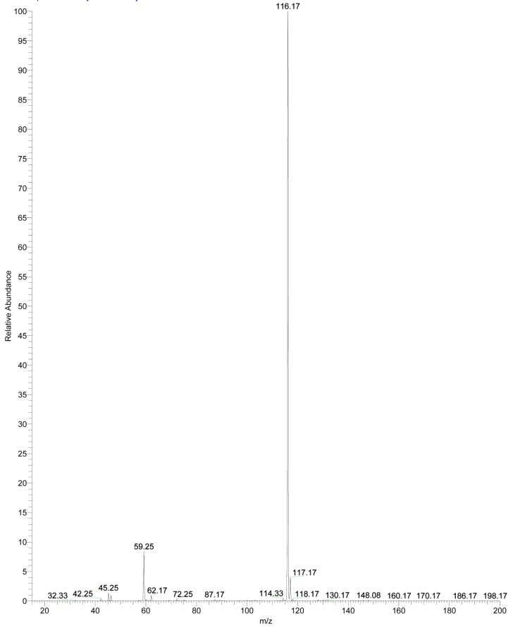
Mass spectrum of L-Val standard at low mass range (m/z 15-200), in negative ion mode. The concentration was 10mM in a solution 1:1 MeOH-AcNH₄
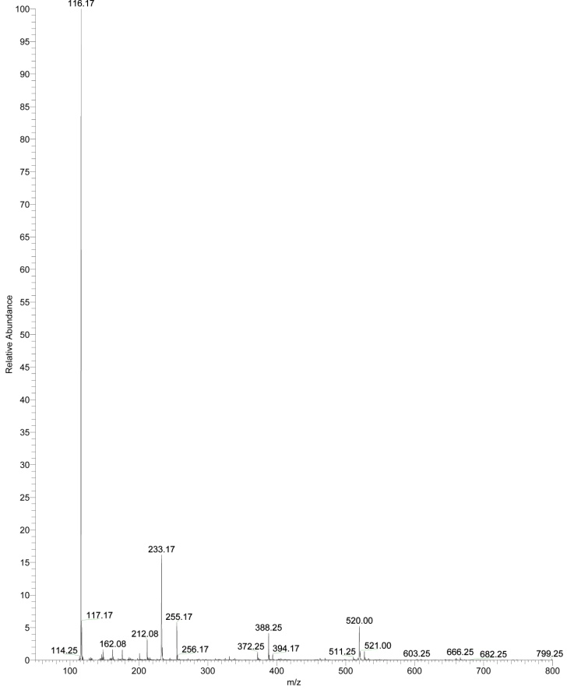
Mass spectrum of L-Val standard at normal mass range (m/z 50-800), in negative ion mode. The concentration was 10mM in a solution 1:1 MeOH-AcNH₄
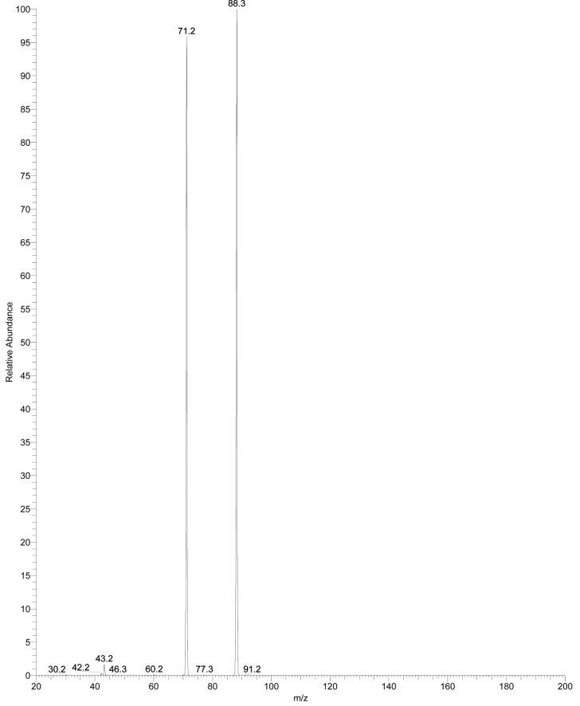
Fragmentation mass spectrum of the ion m/z 88 (2A) detected in positive ion mode, low mass range, for L-Leu irradiated in vacuum condition
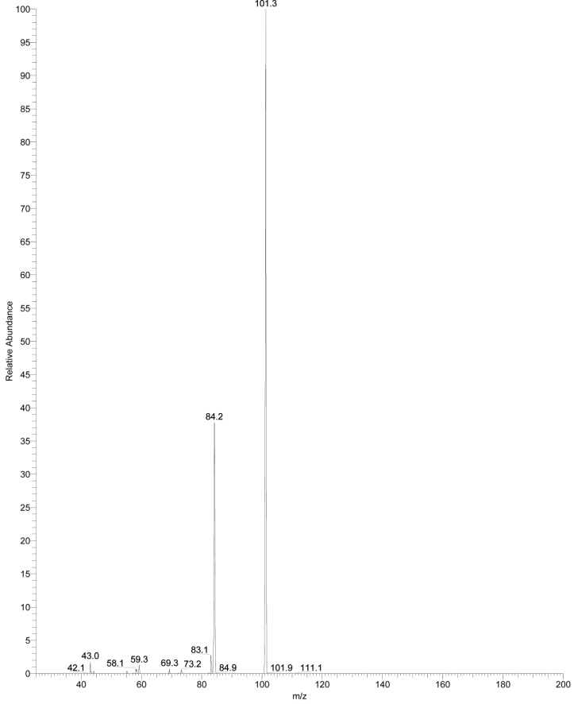
Fragmentation mass spectrum of the ion m/z 101 (2B) detected in positive ion mode, low mass range, for L-Leu irradiated in vacuum condition
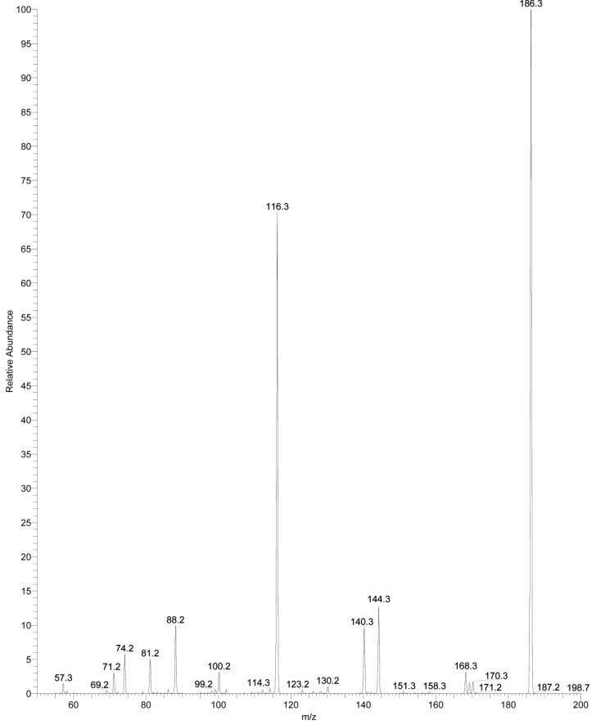
Fragmentation mass spectrum of the ion m/z 186 (2C) detected in positive ion mode, normal mass range, for L-Leu irradiated in vacuum condition
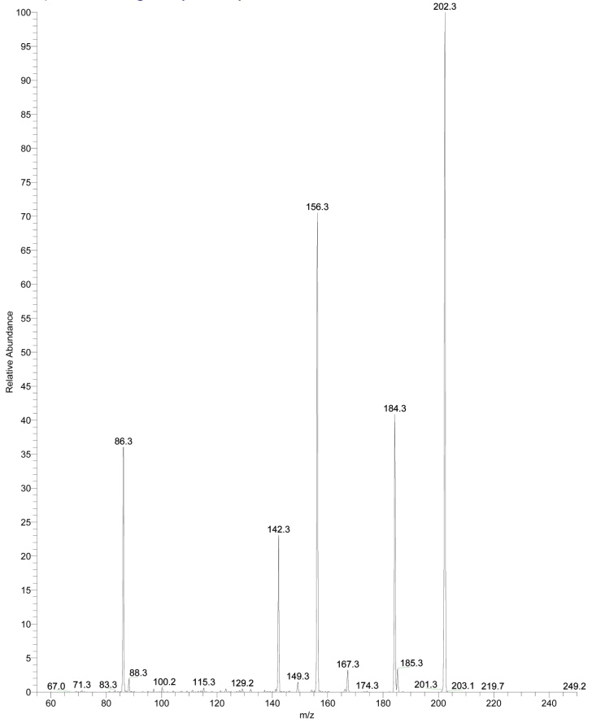
Fragmentation mass spectrum of the ion m/z 202 (2D) detected in positive ion mode, normal mass range, for L-Leu irradiated in vacuum condition
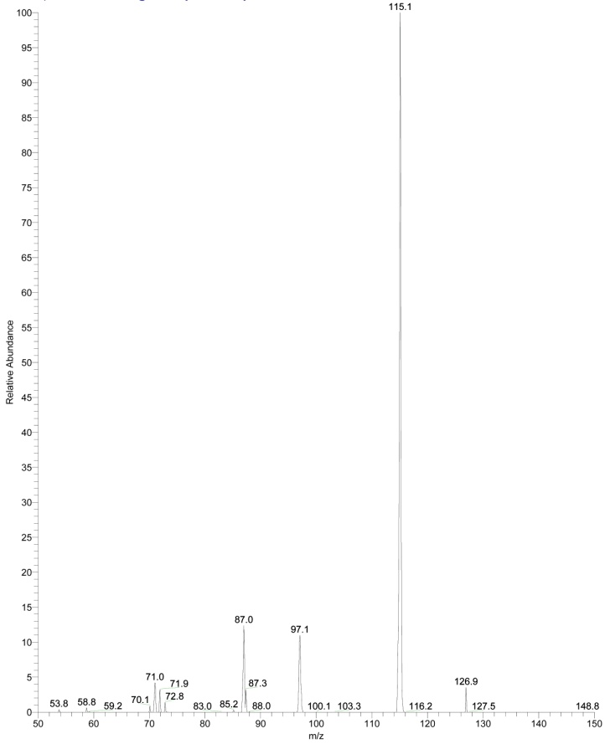
Fragmentation mass spectrum of the ion m/z 115 (2E) detected in negative ion mode, normal mass range, for L-Leu irradiated in vacuum condition
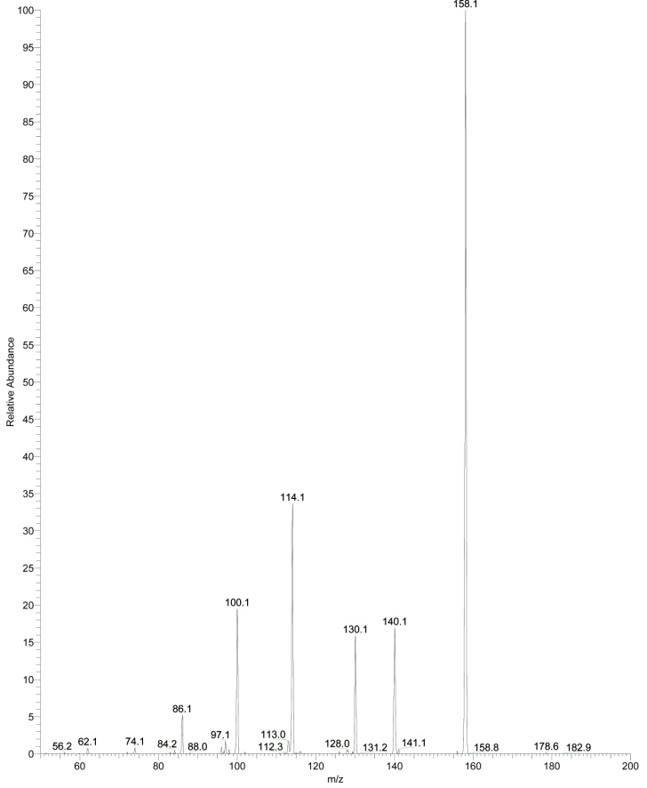
Fragmentation mass spectrum of the ion m/z 158 (2F) detected in negative ion mode, normal mass range, for L-Leu irradiated in vacuum condition
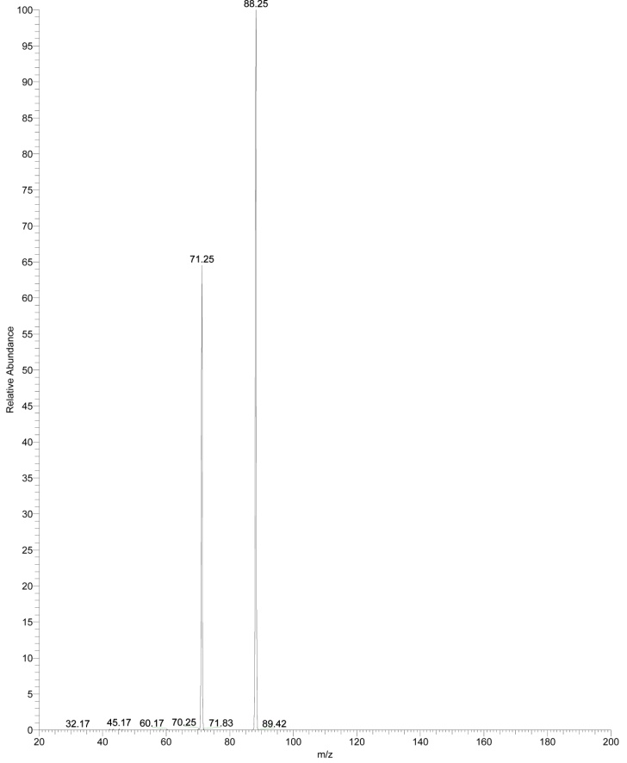
Fragmentation mass spectrum of the ion m/z 88 (4A) detected in positive ion mode, low mass range, for L-Ile irradiated in vacuum condition
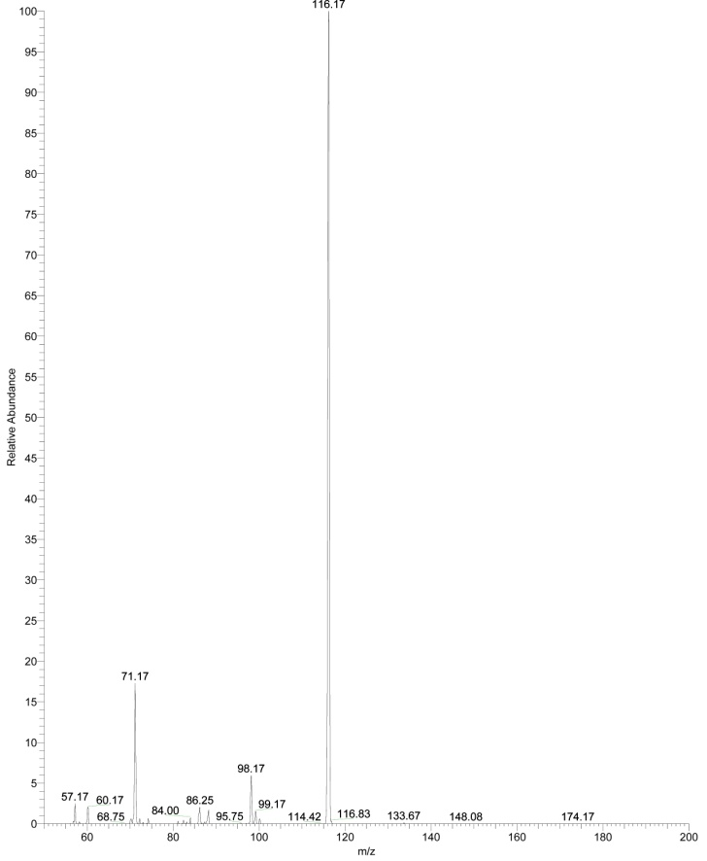
Fragmentation mass spectrum of the ion m/z 101 (4B) detected in positive ion mode, low mass range, for L-Ile irradiated in vacuum condition
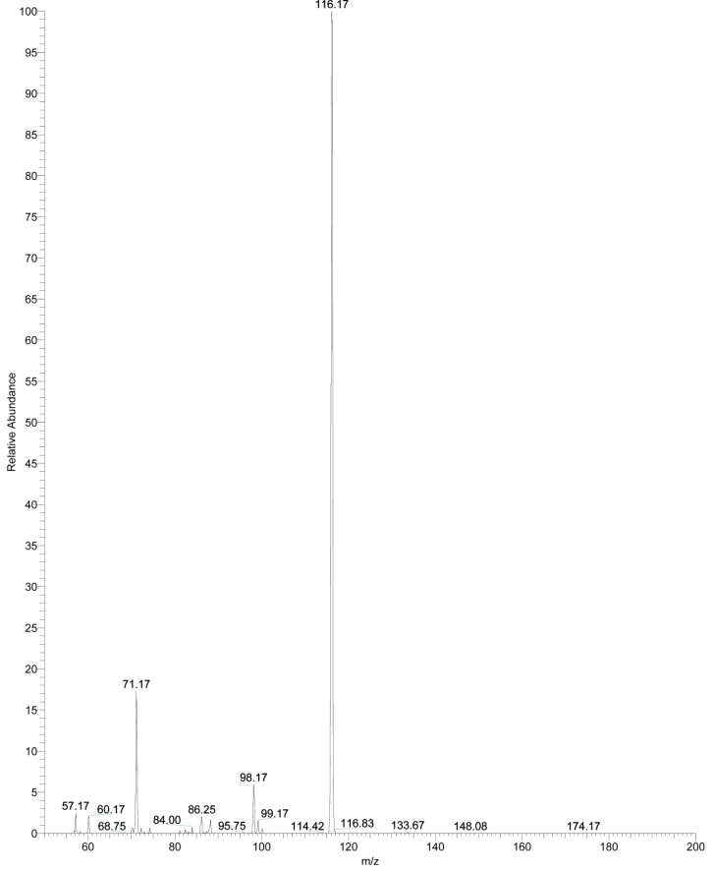
Fragmentation mass spectrum of the ion m/z 116 (4C) detected in positive ion mode, low and normal mass range, for L-Ile irradiated in vacuum condition
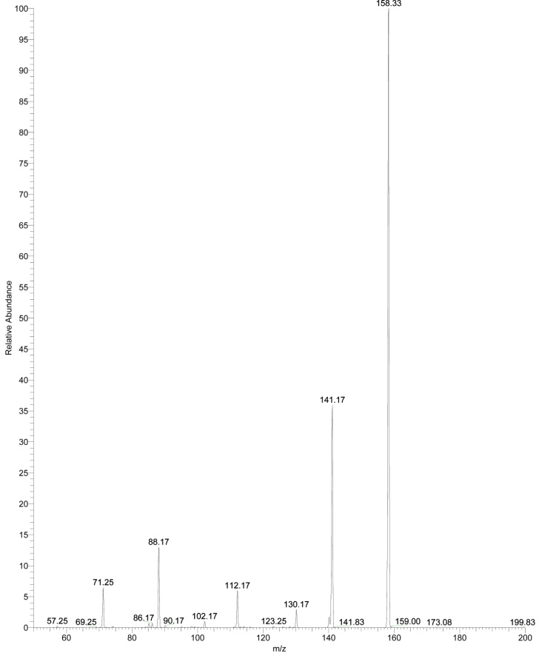
Fragmentation mass spectrum of the ion m/z 158 (4D) detected in negative ion mode, normal mass range, for L-Ile irradiated in vacuum condition

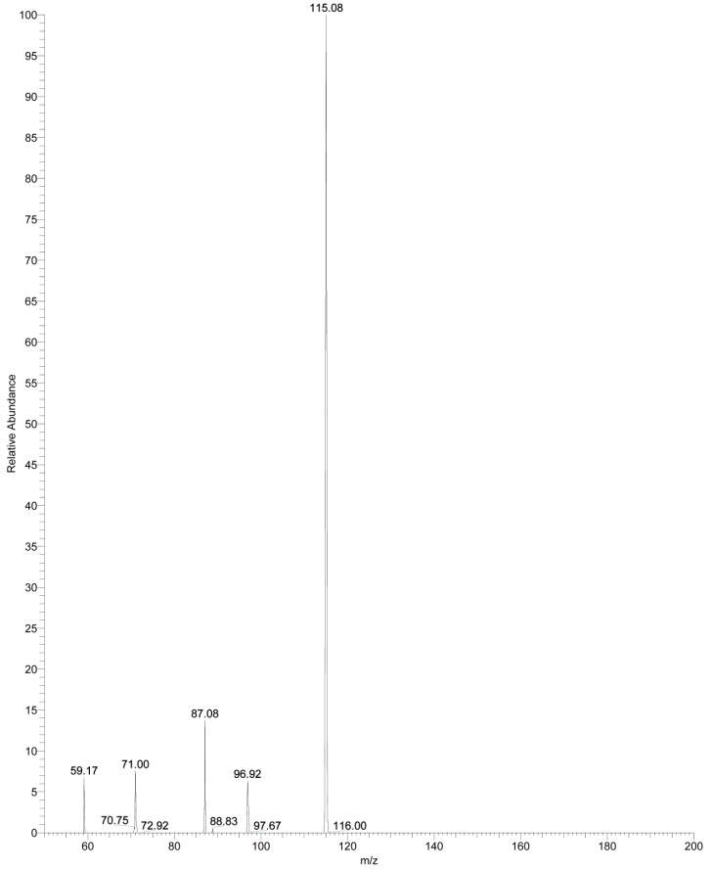
Fragmentation mass spectrum of the ion m/z 115 (4F) detected in negative ion mode, normal mass range, for L-Ile irradiated in vacuum condition
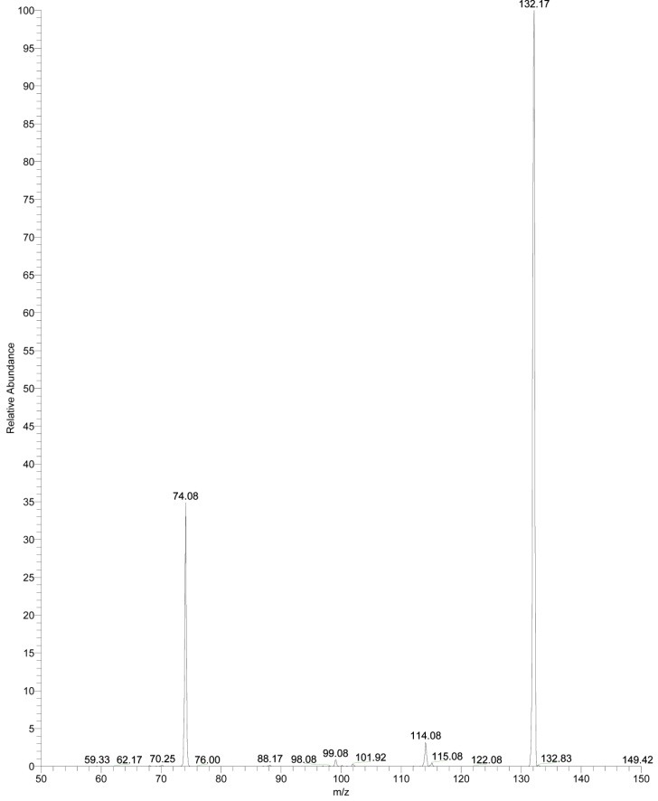
Fragmentation mass spectrum of the ion m/z 132 (6A) detected in negative ion mode, normal mass range, for L-Val irradiated in vacuum condition
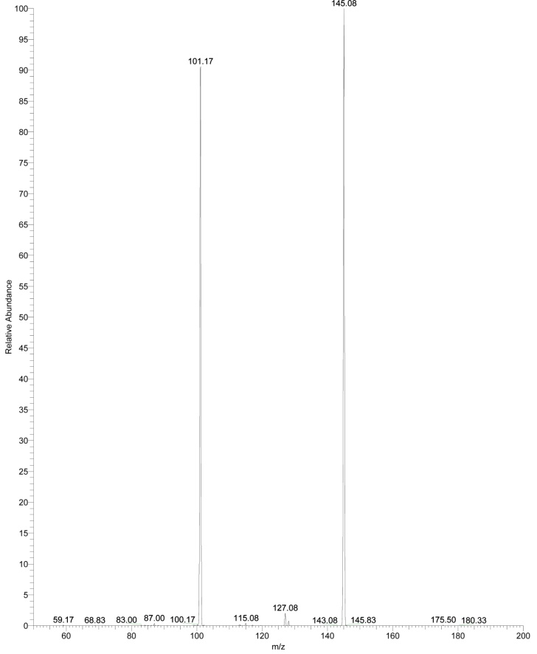
Fragmentation mass spectrum of the ion m/z 145 (6B) detected in negative ion mode, normal mass range, for L-Val irradiated in vacuum condition
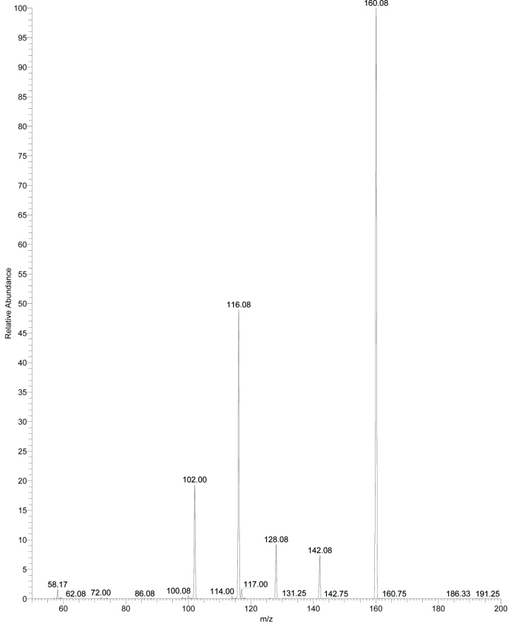
Fragmentation mass spectrum of the ion m/z 160 (6C) detected in negative ion mode, normal mass range, for L-Val irradiated in vacuum condition
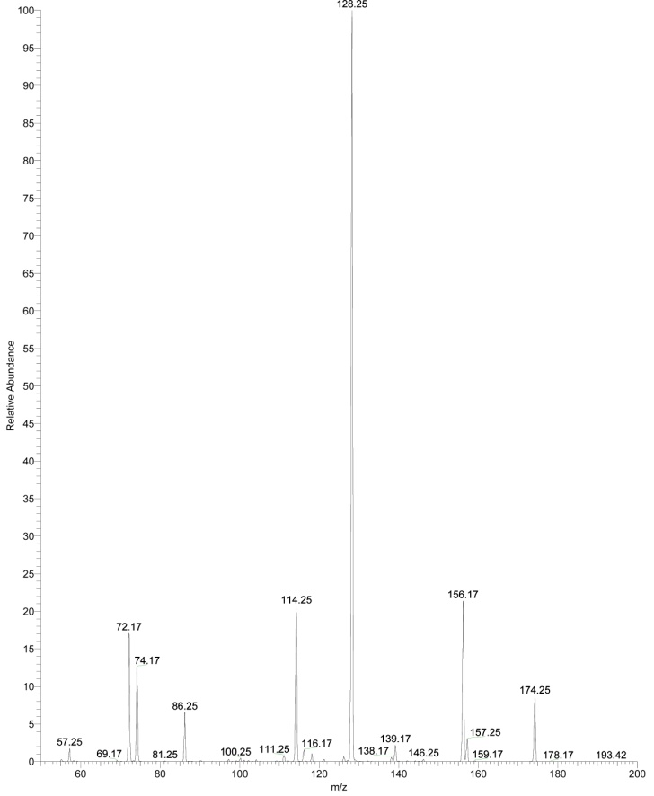
Fragmentation mass spectrum of the ion m/z 174 (6D) detected in positive ion mode, normal mass range, for L-Val irradiated in vacuum condition
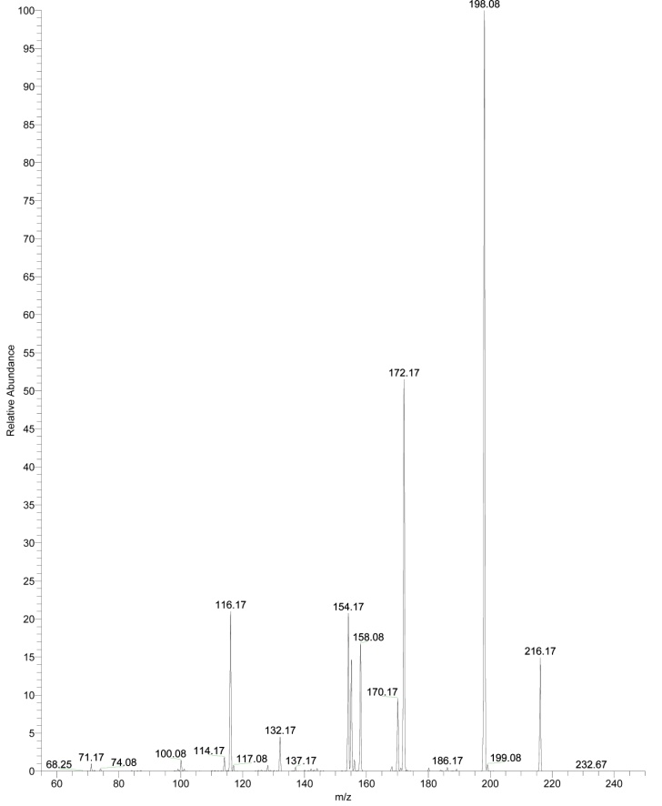
Fragmentation mass spectrum of the ion m/z 216 (6E) detected in negative ion mode, normal mass range, for L-Val irradiated in vacuum condition
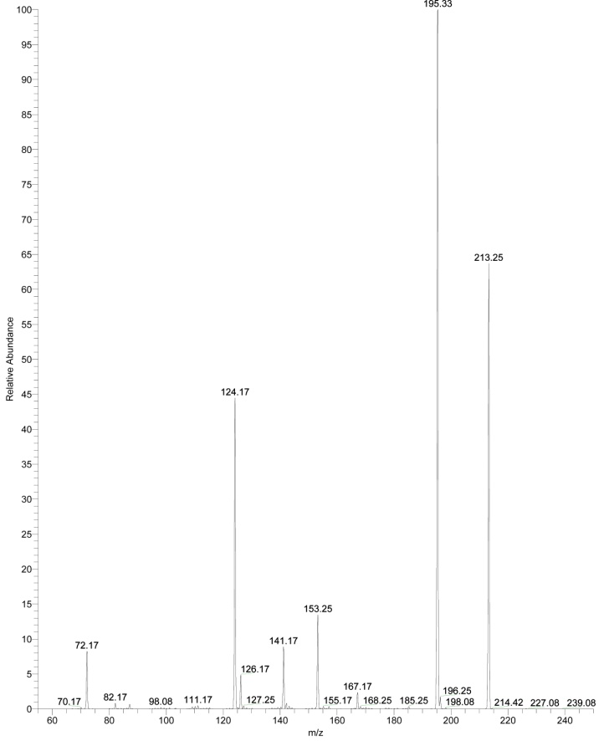
Fragmentation mass spectrum of the ion m/z 213 (6F) detected in positive ion mode, normal mass range, for L-Val irradiated in vacuum condition

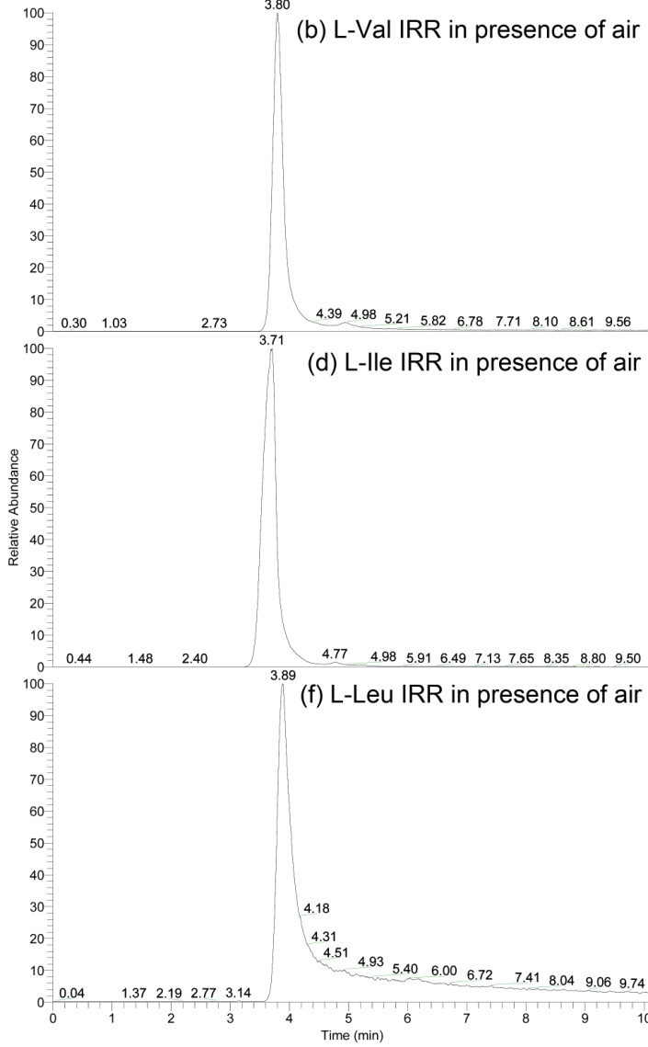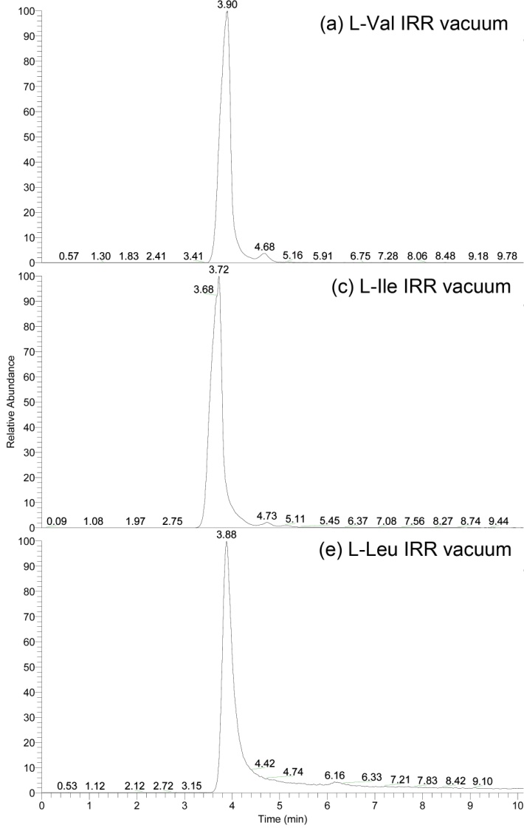
Chromatograms of L-Val, L-Ile and L-Leu irradiated in vacuum condition (a, c, e) and in presence of air (b, d, f)

