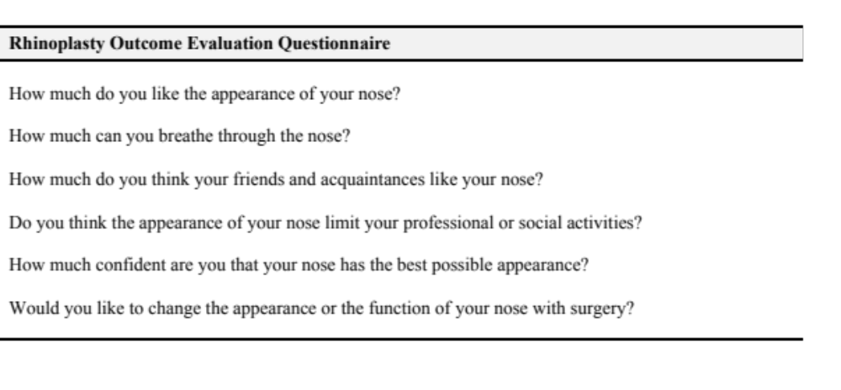Additional file 1. Rhinoplasty Outcome Evaluation (ROE) Questionnaire.

