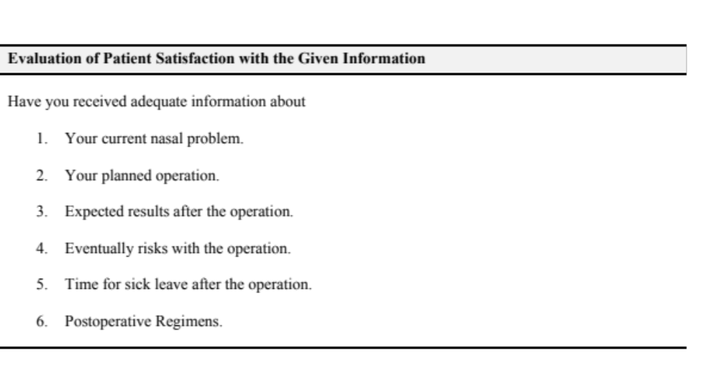 Additional file 2. Evaluation of patient satisfaction with the given information.

