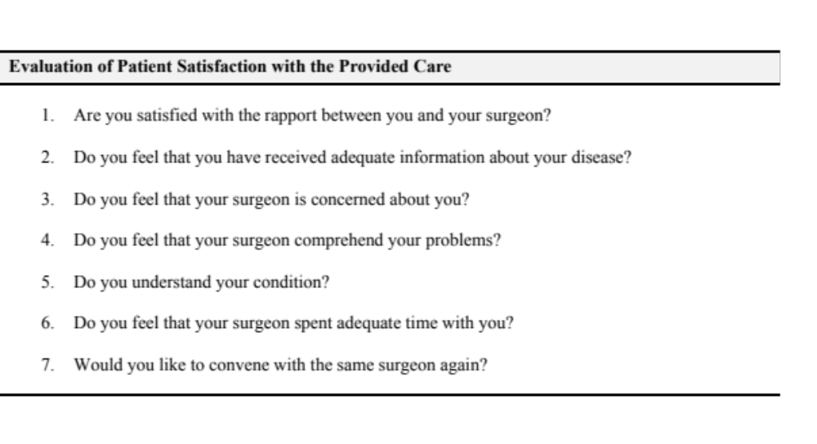 Additional file 3. Evaluation of patient satisfaction with the provided care.

