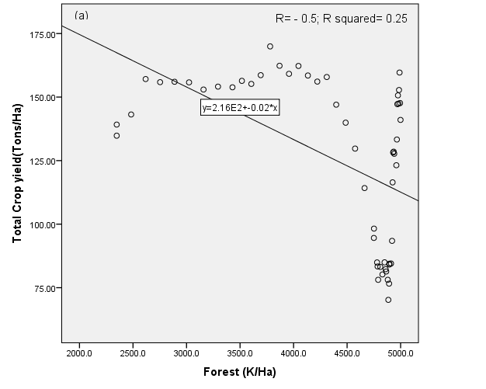
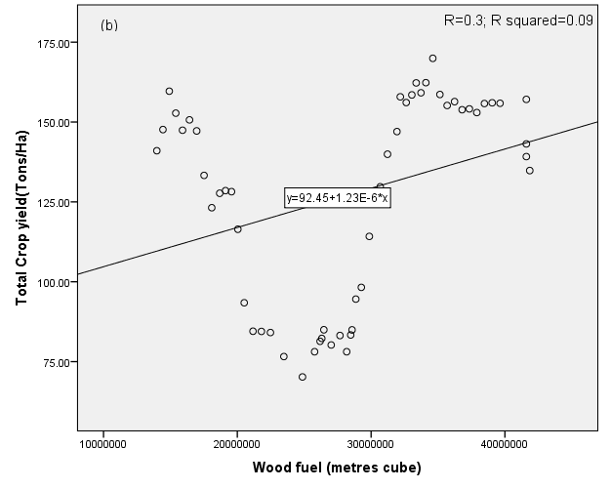
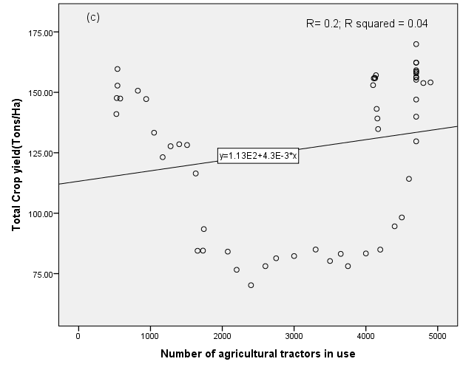
Fig. S2a. Scatter plots of (a): forest area and yield; (b): wood fuel and yield; (c) agricultural tractors and yield.

Table S2a. Correlation matrix and summary of variables used in this study and their sources.
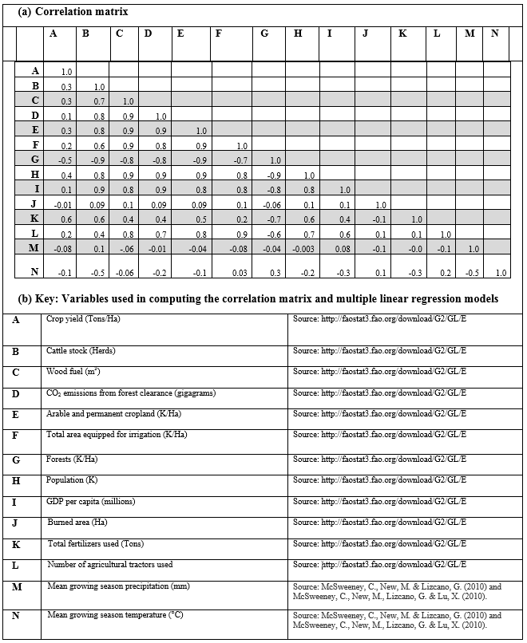

Table S2b. Outputs of the optimised regression model based on the 3 most significant climatic variables
Independent variables | Unstandardized coefficients | Standard error | Standardised coefficients | t-value | p-value | Rank of
 |  |  |  |  |  | t-value
CO₂ emissions from forest clearance | 0.0012 | 0.0013 | 12.21 | 0.95 | 0.34 | 3
Precipitation | -0.378 | 0.38 | 3455.026 | -0.99 | 0.32 | 2
Temperature | -9.33 | 9.19 | 83382.33 | -1.01 | 0.31 | 1

R= 0.24; Adjusted R²= 0.05; ƒ statistics =1.0

